Compiler Construction Lab Practicals
Document

Submitted by

Poorva Pohekar, 22070521108

B. Tech Computer Science and Engineering

Under the Guidance of

Dr.Snehlata K Wankhade

Symbiosis Institute of Technology, Nagpur.



Wathoda, Nagpur
2025

PRACTICAL -01
Aim: Theory Assignment for writing details about Lex and Yacc compiler

Code:

%{
#include<stdio.h>
%}
%%
zero|ZERO printf("0");
one|ONE printf("1");
two|TWO printf("2");
three|THREE printf("3");
four|FOUR printf("4");
five|FIVE printf("5");
six|SIX printf("6");
seven|SEVEN printf("7");
eight|EIGHT printf("8");
nine|NINE printf("9");
%%
int main(){
yylex();
return 0;
};

Gedit Code(number_1108.l):

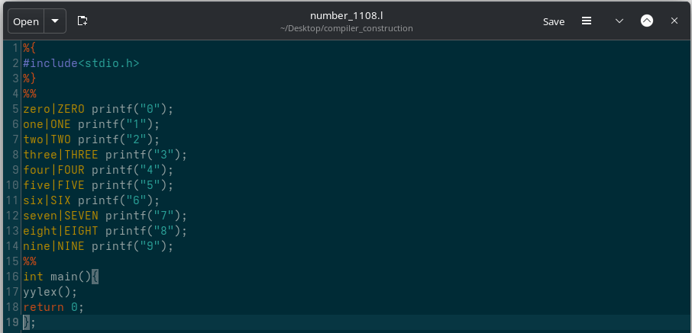

Output:

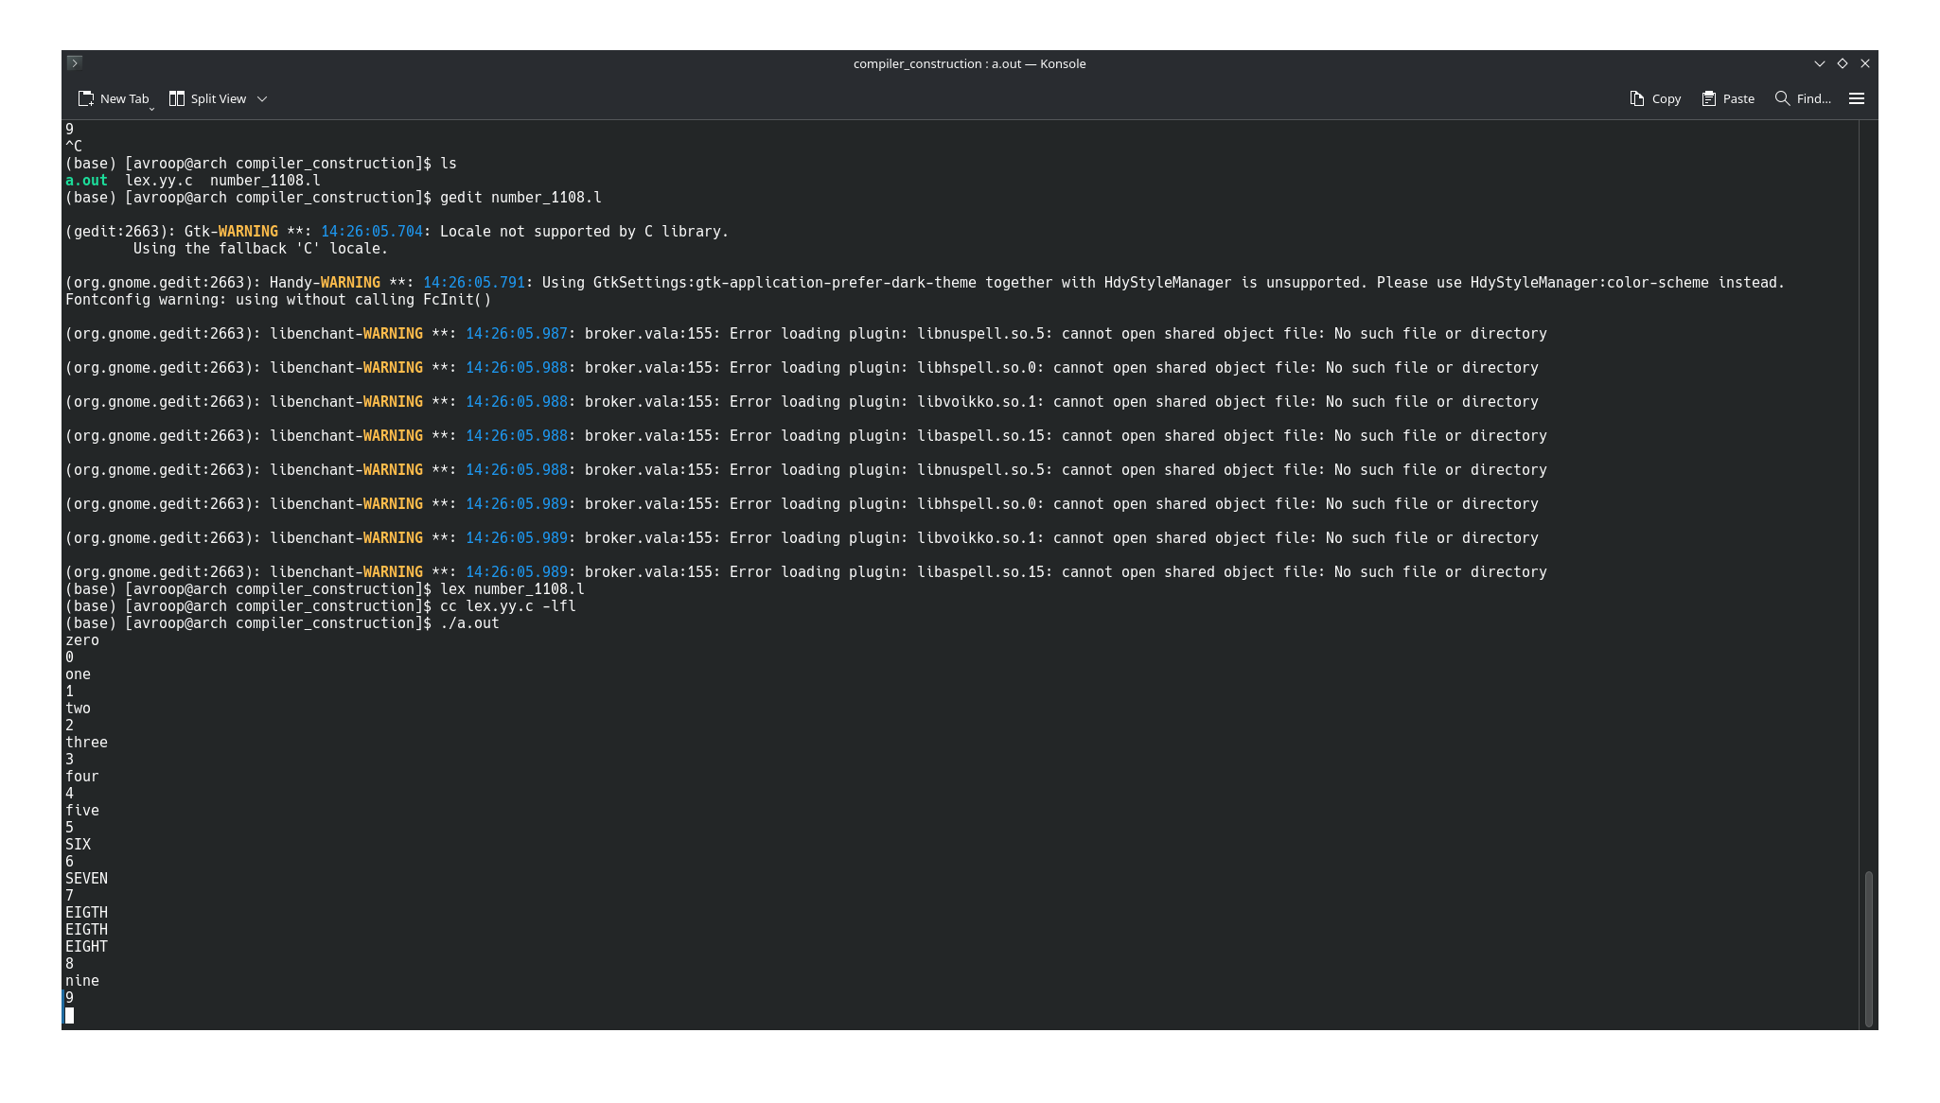

Practical-02
Aim: Count the numbers of comments, keywords, identifiers, word and space line from users input.

Code:

%{
#include <stdio.h>
int lc = 0;
int sc = 0;
int cmnt = 0;
int kw = 0;
int id = 0;
int wc = 0;
int tc = 0;
%}

%%
"/*"([^*]|\*+[^*/])*\*+"/" { cmnt++; }
"int"|"float"|"char"|"if"|"else"|"while"|"for"|"return"|"void"|"do"|"main"|"break"|"continue" {
kw++;
wc++;
}
\t {tc++; }
[a-zA-Z_][a-zA-Z0-9_]* {
id++;
wc++;
}
[ \t]+ { sc += yyleng; }
\n { lc++; }
%%
int main() {
printf("Enter a sentence: (press ctrl+d to end)");
yylex();
printf("\n--- Result ---\n");
printf("Lines: %d\n", lc);
printf("Spaces: %d\n", sc);
printf("Comments: %d\n", cmnt);
printf("Keywords: %d\n", kw);
printf("Identifiers: %d\n", id);
printf("Words: %d\n", wc);
printf("Tab count: %d\n", tc);
return 0;
}
int yywrap() {
return 1;
}

Gedit Code(count_1108.l):

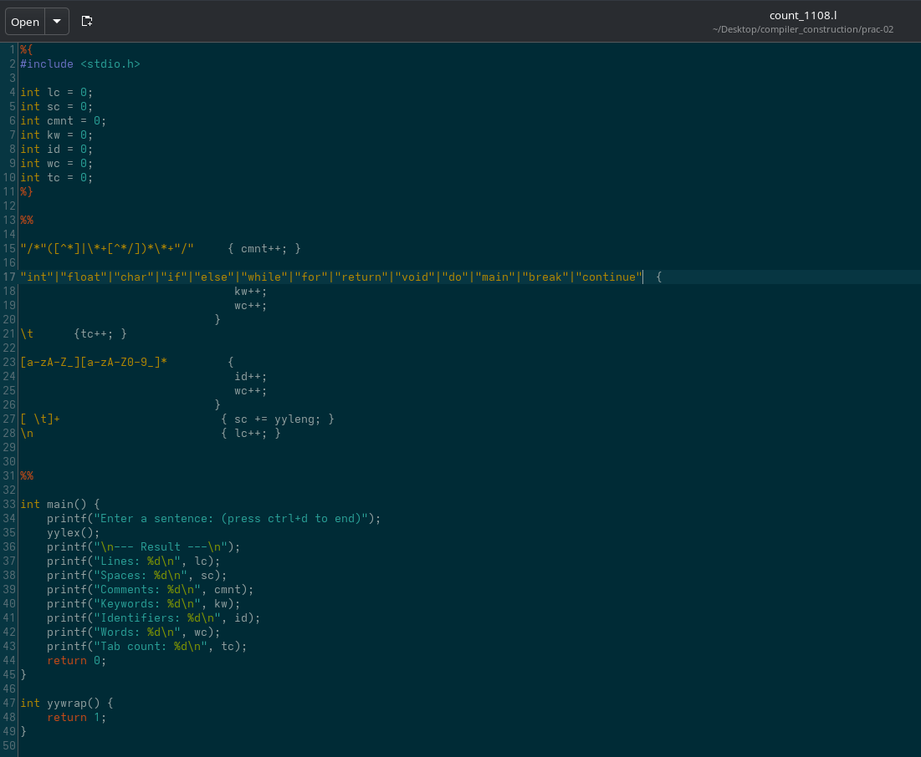

Output:

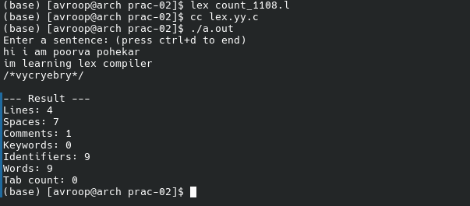
Prcatical-03
Aim: To write lex program that counts number of words starting with the letter ‘a’ or ‘A’ from given input text.

Code:

%{
#include <stdio.h>
int count = 0;
%}
%%
[aA][a-zA-Z]* { count++; } // Count word starting with 'a' or 'A'
[^a-zA-Z]+ { /* Skip non-words */ }
[a-zA-Z]+ { /* Skip other words */ }
%%
int yywrap() {
return 1;
}
int main() {
printf("Enter text (Press Ctrl+D to end input):\n");
yylex();
printf("\nNumber of words starting with 'a' or 'A': %d\n", count);
return 0;
}
Gedit Code(prac_3_1108.l):
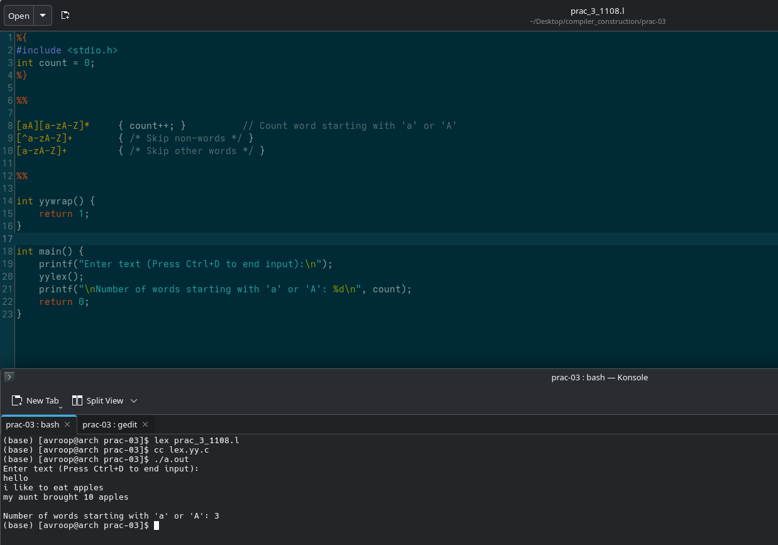

Output:

Practical-04
Aim: Conversion of lowercase to uppercase and vice-versa.

Code:

%{
#include <stdio.h>
%}

%%
[A-Z] { putchar(yytext[0] + 32); } // Uppercase to lowercase
[a-z] { putchar(yytext[0] - 32); } // Lowercase to uppercase
.|\n { ECHO; } // Print all other characters as-is
%%
int yywrap() {
return 1;
}
int main() {
printf("Enter text (Press Ctrl+D to end input):\n");
yylex();
return 0;
}

Gedit Code(upp_low_1108.l):

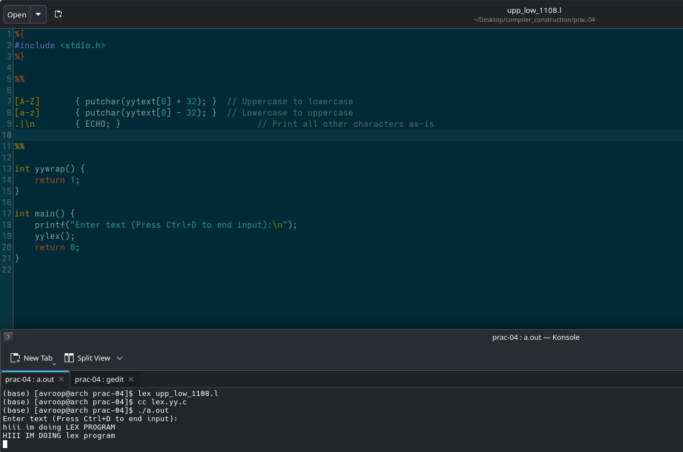

Output:

Practical-05
Aim: Conversion of Decimal number to it’s Hexadecimal equivalent from user input.

Code:

%{
#include <stdio.h>
#include <string.h>
void decimal_to_hex(int num) {
char hex[100];
int i = 0, remainder;
if(num == 0) {
printf("0x0\n");
return;
}
while(num != 0) {
remainder = num % 16;
if(remainder < 10)
hex[i++] = remainder + '0';
else
hex[i++] = remainder - 10 + 'A';
num = num / 16;
}
printf("0x");
int j;
for(j = i - 1; j >= 0; j--)
printf("%c", hex[j]);
printf("\n");
}
int string_to_int(char* str) {
int result = 0;
for(int i = 0; str[i] != '\0'; i++) {
result = result * 10 + (str[i] - '0');
}
return result;
}
%}

%%
[0-9]+ {
int num = string_to_int(yytext);
decimal_to_hex(num);
}

.|\n { ECHO; }
%%

int main() {
yylex();
return 0;
}
int yywrap() {
return 1;
}

Gedit Code(hexa_1108.l):

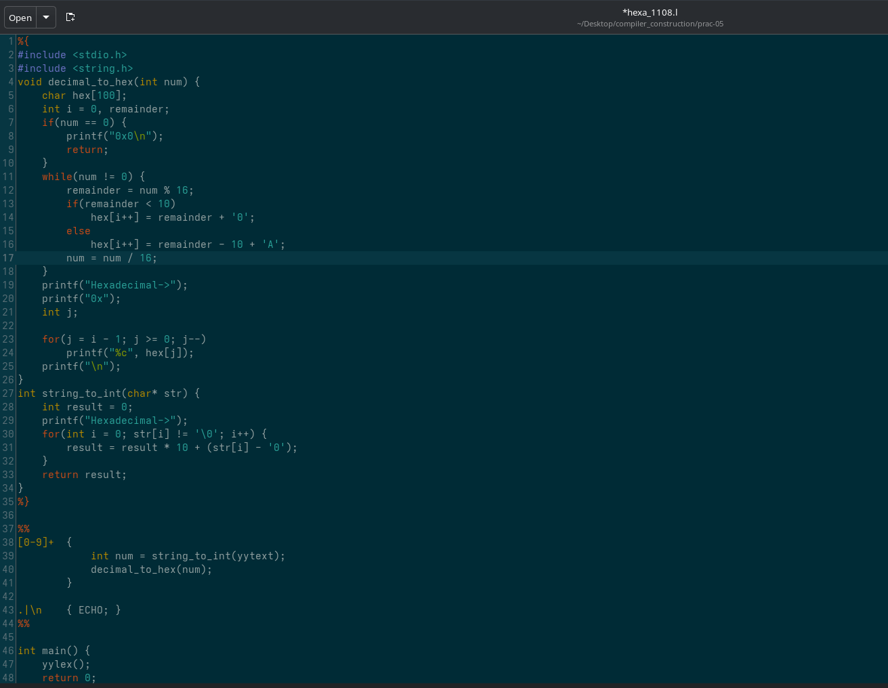

Output:

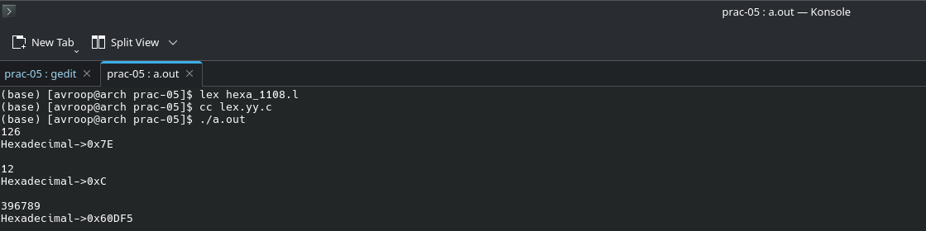
Practical-06
Aim: To write a Lex program that identifies and counts lines ending with the substring "com" from the input text and prints the matched lines.

Code:
%{
#include <stdio.h>
int ln=0;
%}
%%
.*com$ { ln++; printf("Matched line: %d %s",ln, yytext); }
.*
%%
int main() {
printf("Enter text here: \n");
yylex();
return 0;
}
int yywrap() {
return 1;
}

Gedit Code(com_1108.l):

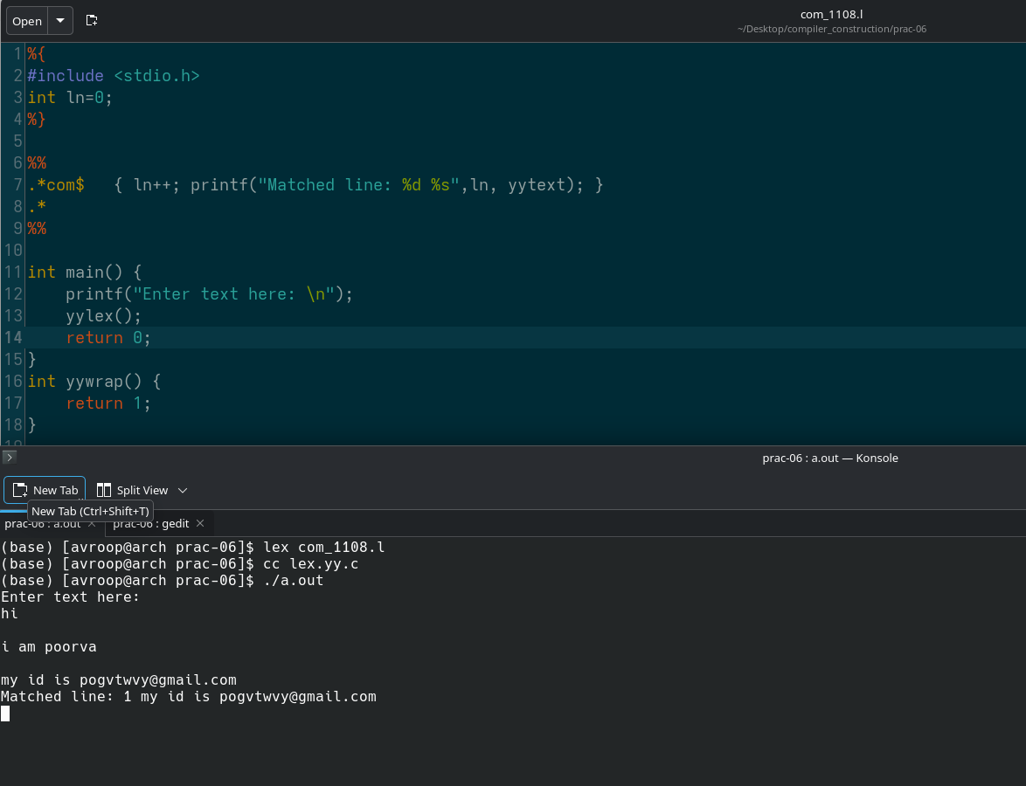

Output:

Practical-07
Aim: To write a Lex and Yacc program that identifies and evalutes the Postfix Expression.

Lex code:
%{
#include "y.tab.h" // Include the token definitions
%}

%%

[0-9]+ { yylval = atoi(yytext); return NUMBER; }
[ \t\n]+ ; // Ignore whitespace
"+" return PLUS;
"*" return MUL;
"(" return LPAREN;
")" return RPAREN;
"/" return DIV;
"-" return SUB;

. return yytext[0];

%%

Yacc Code:
%{
#include <stdio.h>
#include <stdlib.h>

int yylex(void);
void yyerror(const char *s);
int res;
%}

%token NUMBER
%token PLUS MULT LPAREN RPAREN DIV SUB

%left PLUS
%left SUB
%left MUL
%left DIV

%%

expr:
expr expr PLUS { $$ = $1 + $3;res = $$; }
| expr expr MUL { $$ = $1 * $3;res = $$; }
| LPAREN expr RPAREN { $$ = $2;res = $$; }
| NUMBER { $$ = $1; }
| expr expr SUB { $$ = $1 - $3;res = $$; }
| expr expr DIV { $$ = $1 / $3;res = $$; }
;

%%

void yyerror(const char *s) {
fprintf(stderr, "Error: %s\n", s);
}

int main() {
printf("Enter an expression:\n");
if (yyparse() == 0)
printf("Valid expression.\n");
printf("Result = %d\n",res);
return 0;
}

Gedit lexer.l:

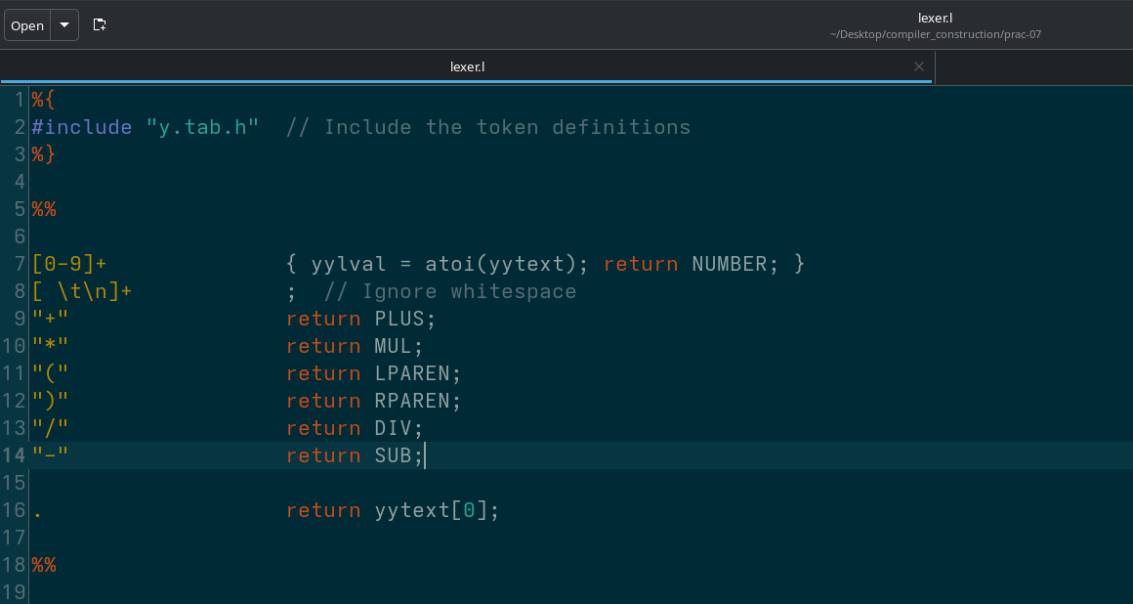

Gedit parser.y:

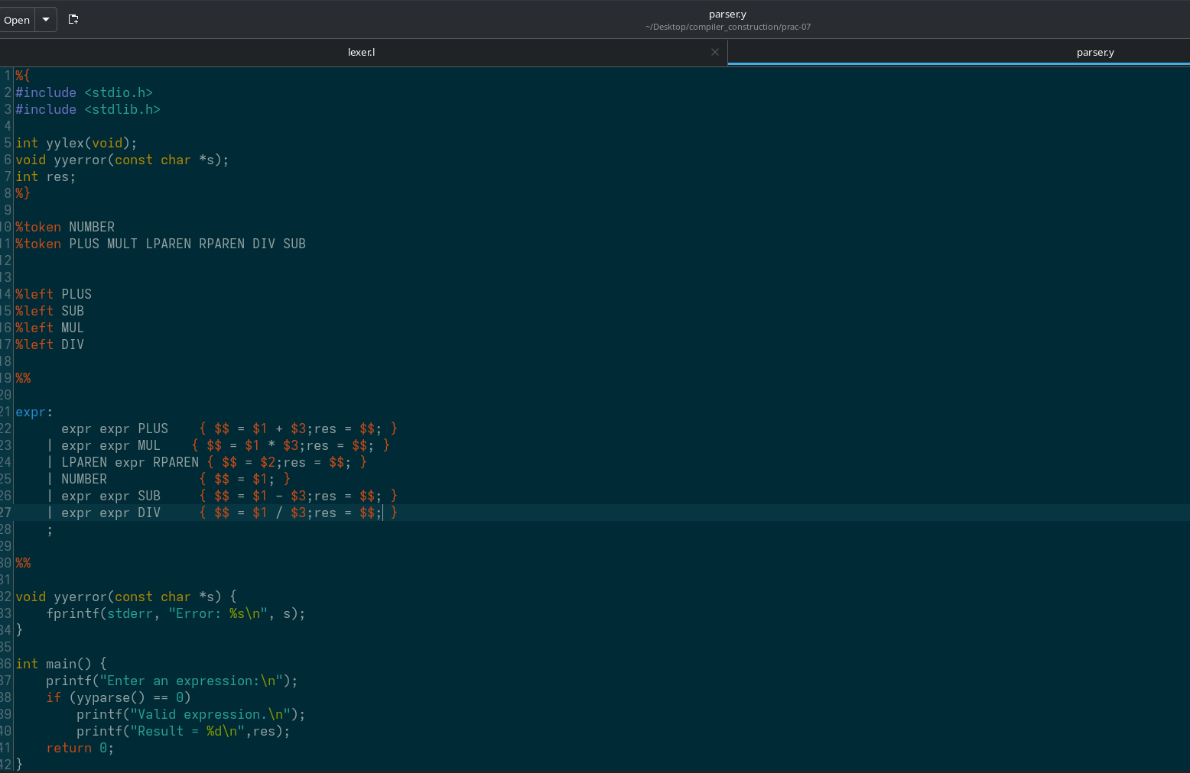
Output:

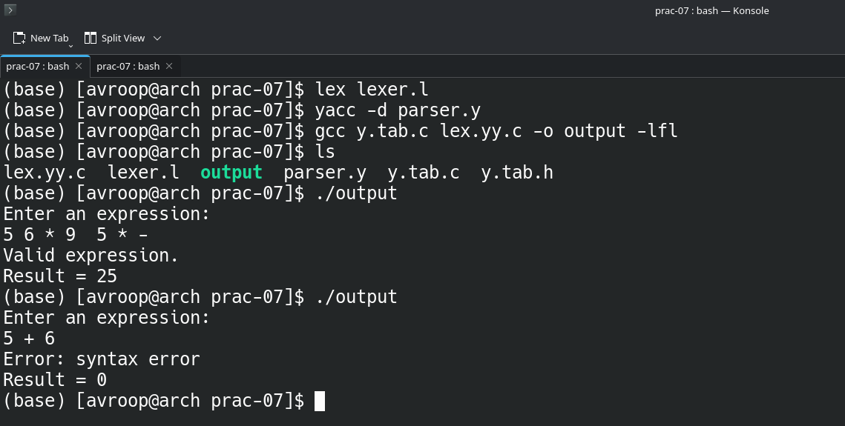

PRACTICAL-08
Aim: To build a Desk Calculator with Error Recovery

Lex Code:
%{
#include "y.tab.h"
#include <stdlib.h>
%}

DIGIT [0-9]

%%

[ \t\r]+ ; /* ignore whitespace */

\n { return '\n'; }

"+" { return '+'; }
"-" { return '-'; }
"*" { return '*'; }
"/" { return '/'; }
"^" { return '^'; }
"(" { return '('; }
")" { return ')'; }

{DIGIT}+("."{DIGIT}+)? {
yylval.dval = atof(yytext);
return NUMBER;
}

. { return yytext[0]; }

%%

int yywrap(void) { return 1; }

Yacc Code:
%{
#include <stdio.h>
#include <stdlib.h>
#include <math.h>

extern int yylex(void);
extern int yylineno;
void yyerror(const char *s);

void print_result(double v) {
printf("= %.10g\n", v);
}
%}

%union {
double dval;
}

%token <dval> NUMBER
%left '+' '-'
%left '*' '/'
%right '^'
%right UMINUS
%type <dval> expr

%%

input:
/* empty */
| input line
;

line:
'\n'
| expr '\n' { print_result($1); }
| error '\n' {
fprintf(stderr, "Syntax error on line %d — skipping\n", yylineno);
yyerrok;
}
;

expr:
NUMBER { $$ = $1; }
| expr '+' expr { $$ = $1 + $3; }
| expr '-' expr { $$ = $1 - $3; }
| expr '*' expr { $$ = $1 * $3; }
| expr '/' expr {
if ($3 == 0.0) {
fprintf(stderr, "Runtime error: division by zero\n");
$$ = 0.0;
} else $$ = $1 / $3;
}
| expr '^' expr { $$ = pow($1, $3); }
| '-' expr %prec UMINUS { $$ = -$2; }
| '(' expr ')' { $$ = $2; }
;

%%

void yyerror(const char *s) {
fprintf(stderr, "Parse error: %s (line %d)\n", s, yylineno);
}

int main(void) {
printf("Desk Calculator (operators: + - * / ^)\n");
printf("Enter one expression per line, Ctrl+D to quit.\n");
return yyparse();
}
Lexer.l Gedit Code:

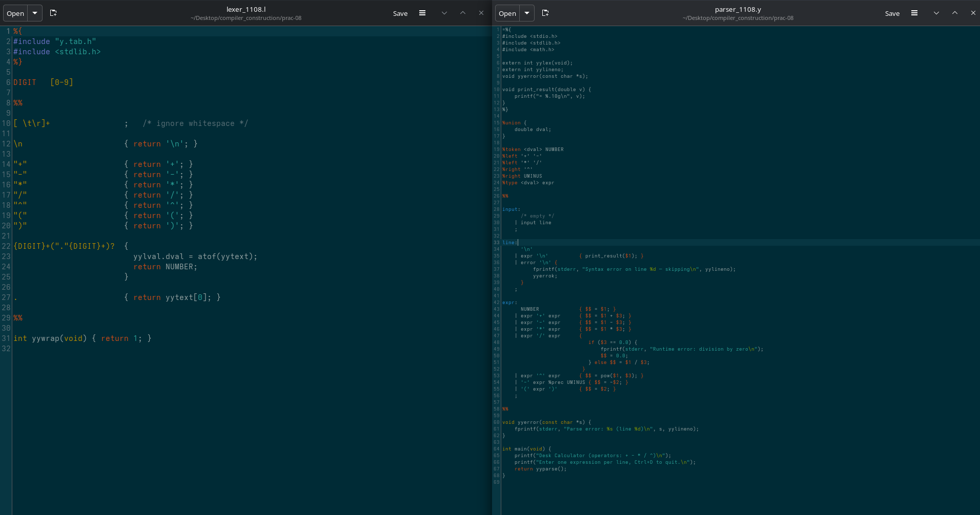

Parser.y Gedit Code:

Output:

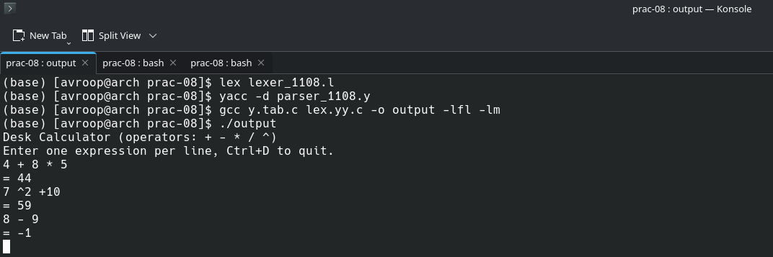

PRACTICAL-09
Aim: To implement for loop statement and check its syntax.

Lex Code:
%{
#include "y.tab.h"
%}

%%
"for" { return FOR; }
"(" { return LPAREN; }
")" { return RPAREN; }
";" { return SEMICOLON; }
"<" { return LT; }
">" { return GT; }
"=" { return ASSIGN; }
"++" { return INC; }
"--" { return DEC; }
[0-9]+ { yylval = atoi(yytext); return NUMBER; }
[a-zA-Z_][a-zA-Z0-9_]* { return ID; }
[ \t\n] ; // ignore whitespace
. { return yytext[0]; }
%%
Yacc Code:
%{
#include <stdio.h>
#include <stdlib.h>

int yylex();
void yyerror(const char *s);
%}
%token FOR ID NUMBER ASSIGN LT GT INC DEC LPAREN RPAREN SEMICOLON
%%
program : for_stmt
;
for_stmt : FOR LPAREN expr SEMICOLON condition SEMICOLON update RPAREN
{
printf("Valid FOR loop syntax.\n");
}
;
expr : ID ASSIGN NUMBER
;
condition : ID LT NUMBER
| ID GT NUMBER
;
update : ID INC
| ID DEC
| ID ASSIGN ID
;
%%
void yyerror(const char *s)
{
fprintf(stderr, "Error: %s\n", s);
}

int main()
{
printf("Enter a FOR loop statement:\n");
yyparse();
return 0;
}

Lexer.l Gedit Code:
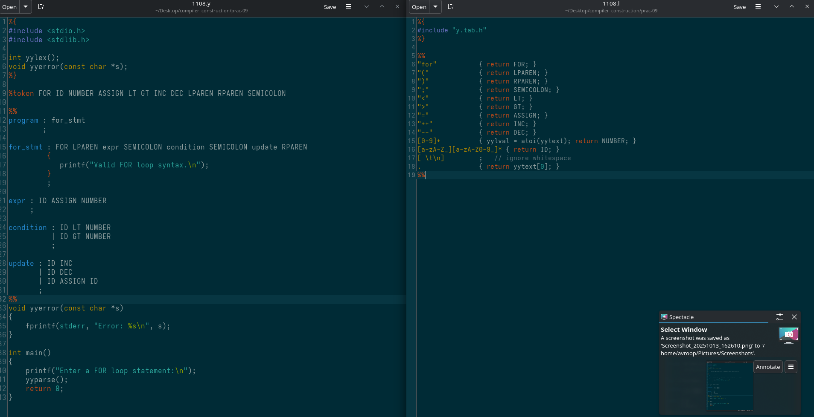
Yacc.y Gedit Code:

Output:
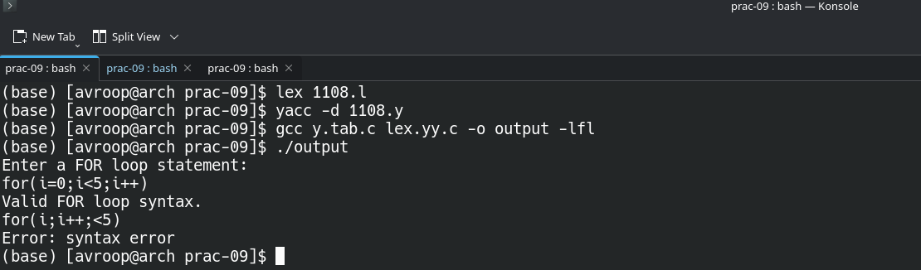

PRACTICAL-10
Aim: Intermediate Code Generator (ICG) for arithmetic expression.

Lex Code:
%{
#include "y.tab.h"
#include <stdlib.h>
#include <string.h>
%}

%%
[a-zA-Z][a-zA-Z0-9]* { yylval.sval = strdup(yytext); return ID; }
[0-9]+ { yylval.sval = strdup(yytext); return NUM; }
"=" { return ASSIGN; }
"+" { return PLUS; }
"-" { return MINUS; }
"*" { return MUL; }
"/" { return DIV; }
"(" { return LPAREN; }
")" { return RPAREN; }
[ \t\n] ; /* ignore whitespace */
. { return yytext[0]; }
%%

int yywrap() { return 1; }

Yacc Code:

%{
#include <stdio.h>
#include <stdlib.h>
#include <string.h>

int yylex();
void yyerror(const char *s);

int tempCount = 0;

char* newTemp() {
char *temp = malloc(10);
sprintf(temp, "t%d", tempCount++);
return temp;
}
%}

%union {
char *sval;
}

%token <sval> ID NUM
%token ASSIGN PLUS MINUS MUL DIV LPAREN RPAREN
%type <sval> expr

// Add operator precedence ↓
%left PLUS MINUS
%left MUL DIV

%%

stmt : ID ASSIGN expr
{
printf("%s = %s\n", $1, $3);
}
;

expr : expr PLUS expr
{
char *t = newTemp();
printf("%s = %s + %s\n", t, $1, $3);
$$ = t;
}
| expr MINUS expr
{
char *t = newTemp();
printf("%s = %s - %s\n", t, $1, $3);
$$ = t;
}
| expr MUL expr
{
char *t = newTemp();
printf("%s = %s * %s\n", t, $1, $3);
$$ = t;
}
| expr DIV expr
{
char *t = newTemp();
printf("%s = %s / %s\n", t, $1, $3);
$$ = t;
}
| LPAREN expr RPAREN
{
$$ = $2;
}
| ID
{
$$ = $1;
}
| NUM
{
$$ = $1;
}
;

%%

void yyerror(const char *s)
{
fprintf(stderr, "Error: %s\n", s);
}

int main()
{
printf("Enter an arithmetic expression:\n");
yyparse();
return 0;
}

Lexer.l Gedit Code:
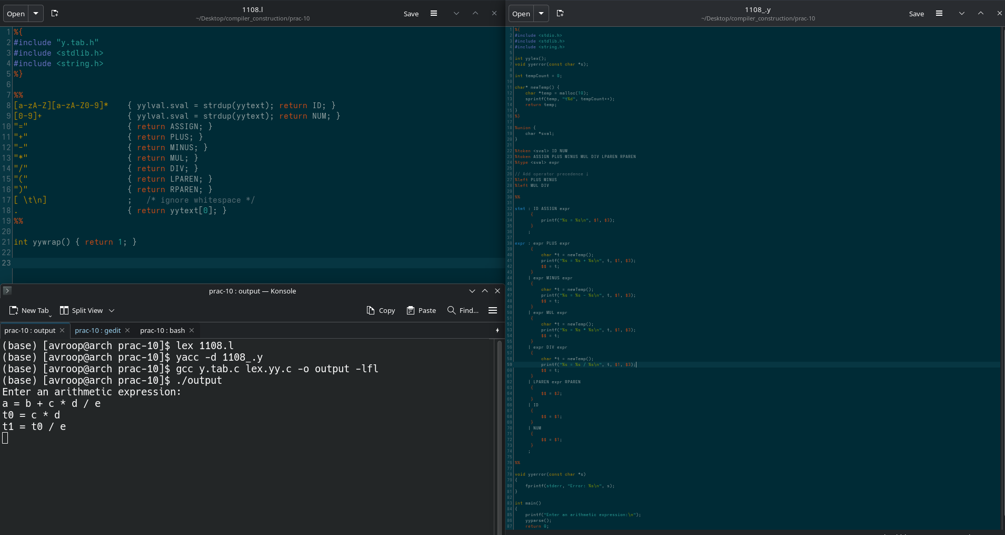

Yacc.y Gedit Code:

Output:

