**LAB EXERCISE 6**

Exercise 6.1: **Draw DD Path for the following program.**

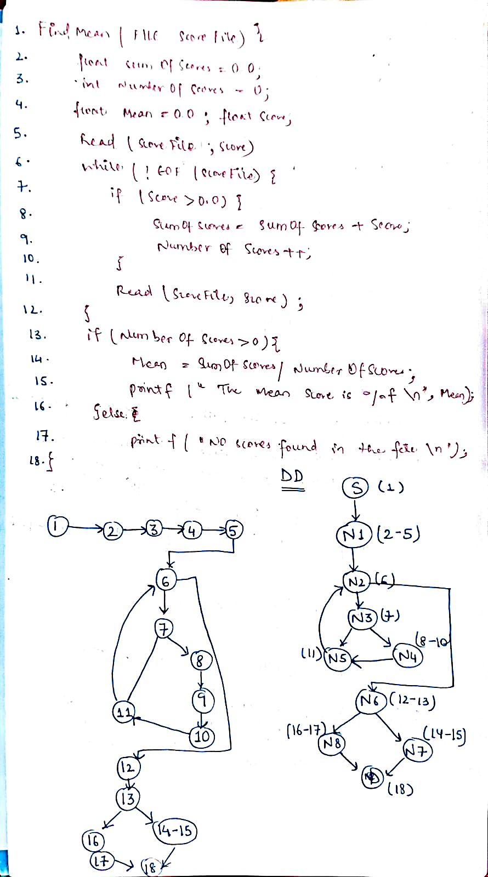

Exercise 6.2: **Write a program for the determination of division of a student. Its input is a triple of positive integers (mark1, mark2, mark3) and values are from interval [0, 100]. The output may be one of the following words:**

* **[First division with distinction, First division, Second division, Third division, Fail, Invalid marks].**

**Draw the program graph and the DD path graph**.

#include <stdio.h>

1. int **main**() {
2. int m1, m2, m3;
3. **printf**("Enter marks in three subjects (0-100): ");
4. **scanf**("%d %d %d", &m1, &m2, &m3);
5. if (m1 < 0 || m1 > 100 || m2 < 0 || m2 > 100 || m3 < 0 || m3 > 100) {
6. **printf**("Invalid marks\n");
7. return 0;
8. }
9. float avg = (m1 + m2 + m3) / 3.0;
10. if (m1 < 33 || m2 < 33 || m3 < 33)
11. **printf**("Fail\n");
12. else if (avg >= 60 && m1 >= 75 && m2 >= 75 && m3 >= 75)
13. **printf**("First division with distinction\n");
14. else if (avg >= 60)
15. **printf**("First division\n");
16. else if (avg >= 50)
17. **printf**("Second division\n");
18. else if (avg >= 33)
19. **printf**("Third division\n");
20. else
21. **printf**("Fail\n");
22. return 0;
23. }

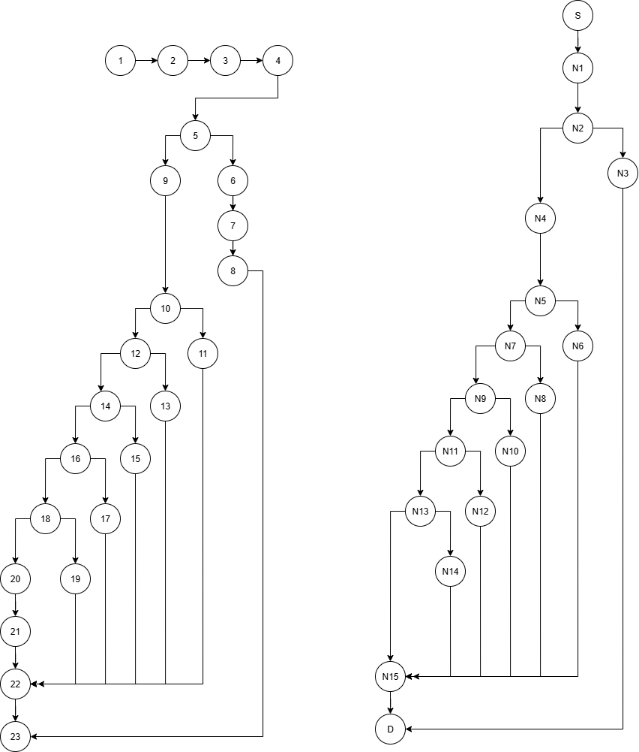

**PROGRAM FLOW GRAPH** **DECISION-TO-DECISION GRAPH**

|  |  |  |
| --- | --- | --- |
| Program graph nodes | DD path graph node | Remarks |
| 1 | S | Source |
| 2-4 | N1 | Sequential nodes |
| 5 | N2 | Decision node |
| 6-8 | N3 |  |
| 9 | N4 |  |
| 10 | N5 | Decision node |
| 11 | N6 |  |
| 12 | N7 | Decision node |
| 13 | N8 |  |
| 14 | N9 | Decision node |
| 15 | N10 |  |
| 16 | N11 | Decision node |
| 17 | N12 |  |
| 18 | N13 | Decision node |
| 19 | N14 |  |
| 20-22 | N15 | Sequential nodes |
| 23 | D | Destination Node |

Exercise 6.3: **Write a program for determining the day of the week. Its input is a triple of day, month and year with the values in the range 1 ≤month≥ 12 1 ≤ day≥ 31 1900 ≤ year ≥ 2058 The possible values of the output may be [Sunday, Monday, Tuesday, Wednesday, Thursday, Friday, Saturday, Invalid date].**

**Draw the program graph and the DD path graph.**

#include <stdio.h>

1. int **main**() {
2. int d, m, y;
3. **printf**("Enter day month year: ");
4. **scanf**("%d %d %d", &d, &m, &y);
5. int daysInMonth[] = {0,31,28,31,30,31,30,31,31,30,31,30,31};
6. *//leap year*
7. if ((y % 400 == 0) || (y % 4 == 0 && y % 100 != 0))
8. daysInMonth[2] = 29;
9. *// validate*
10. if (y < 1900 || y > 2058 || m < 1 || m > 12 || d < 1 || d > daysInMonth[m]) {
11. **printf**("Invalid date\n");
12. return 0;
13. }
14. *// Zeller’s Congruence*
15. if (m < 3) {
16. m += 12; y--;
17. }
18. int k = y % 100, j = y / 100;
19. int h = (d + (13*(m+1))/5 + k + k/4 + j/4 + 5*j) % 7;
20. char *days[] = {"Saturday","Sunday","Monday","Tuesday","Wednesday","Thursday","Friday"};
21. **printf**("%s\n", days[h]);
22. return 0;
23. }

