ChunkWise Feasibility Report
Content-defined storage deduplication prototype

1. Executive Summary
ChunkWise is feasible as a bounded, single-process course prototype. The implementation combines Rabin-style content-defined chunking, SHA-256 chunk identifiers, a SQLite metadata index, content-addressed local chunk files, ordered manifests, reference counts, and verified restore. It can demonstrate correctness and measure storage savings, write and restore time, and the effect of CDC versus fixed-size chunking on the benchmark datasets. It does not establish production scalability or general cost savings.
Evaluate the implementation against the project acceptance criteria and deterministic benchmark. Report observed results with the dataset and chunk parameters; do not generalize savings beyond those workloads.

2. Problem and Objectives
File-level deduplication stores a file once only when two files are byte-identical. Real data is often near-identical instead: a backup differs from the previous one by a few changed blocks, a VM image differs by a few modified sectors, and a log file differs by appended lines. File-level deduplication stores every version in full in these cases.
Chunk-level deduplication splits each file into pieces, identifies each piece by its hash, and stores each unique piece once. Fixed-size chunking is fragile, because a single inserted byte shifts later boundaries. Content-defined chunking uses a rolling fingerprint to place boundaries and can re-synchronize after an edit [1, 2].
This review focuses on whether the agreed local implementation can be built and evaluated within the course project, and what its measurements can support.
- Implement a content-defined chunker based on a Rabin rolling-window fingerprint.
- Identify chunks by SHA-256 and store each unique chunk once.
- Write ordered manifests so that files can be reconstructed exactly.
- Maintain per-chunk reference counts.
- Verify chunk and file integrity during restore.
- Measure storage savings and compare content-defined chunking with fixed-size chunking on deterministic datasets.

3. Scope and Assumptions

3.1 In Scope
The prototype includes Rabin-style content-defined chunking, SHA-256 chunk identifiers, deduplication-aware writes, a SQLite index, ordered manifests, per-chunk reference counts, verified reconstruction, and storage accounting. The benchmark compares CDC with fixed-size chunking.

3.2 Out of Scope
The project is limited to a single process on one machine. Distributed writers, cloud storage, authentication, resumable uploads, file deletion, garbage collection, and recovery workers are outside implementation scope.

3.3 Assumptions
- Input files are read as complete byte streams.
- The chunk store and SQLite index run locally on one machine.
- Chunk parameters are fixed per run: minimum 2 KiB, average 8 KiB, maximum 64 KiB, and a 48-byte rolling window.
- SHA-256 identifies chunks and verifies chunk and whole-file integrity [3].

4. System Overview
The write path reads a file, emits content-defined chunk boundaries, hashes each chunk, checks the index, writes only new chunks to the chunk store, and records an ordered manifest. The read path loads the manifest, fetches each chunk, verifies its hash, reassembles the file in sequence order, and verifies the whole-file checksum.

Table 1. Component responsibilities
Component | Responsibility | Prototype implementation
Chunker | Find content-defined boundaries in each input stream | Rabin rolling-window fingerprint; 2/8/64 KiB bounds; 48-byte window
Hasher | Create stable chunk and file IDs; verify data | Python hashlib SHA-256
Metadata index | Track chunks, files, manifests, and references | Local SQLite database with transactional file commit
Chunk store | Persist one copy of each unique chunk | Local content-addressed filesystem with atomic publish
Manifest | Record ordered chunk IDs, offsets, and lengths per file | SQLite manifest rows
Restore and verification | Reassemble files and detect missing or altered data | Verify each chunk and the whole-file SHA-256
Figure 1. Reference architecture, including components beyond the local prototype
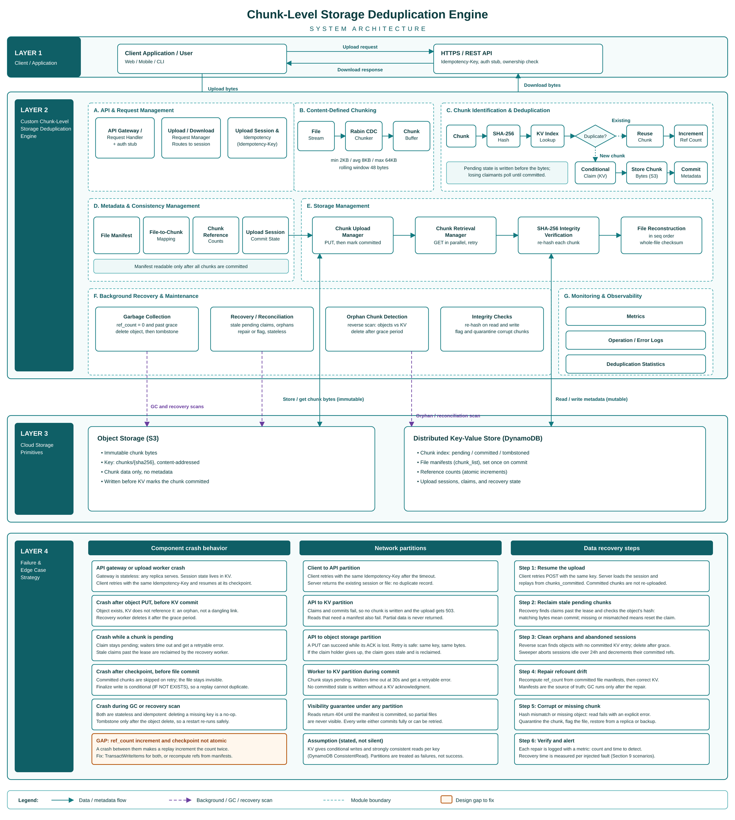

Figure 2. Reference data and control flow; background maintenance is outside prototype scope
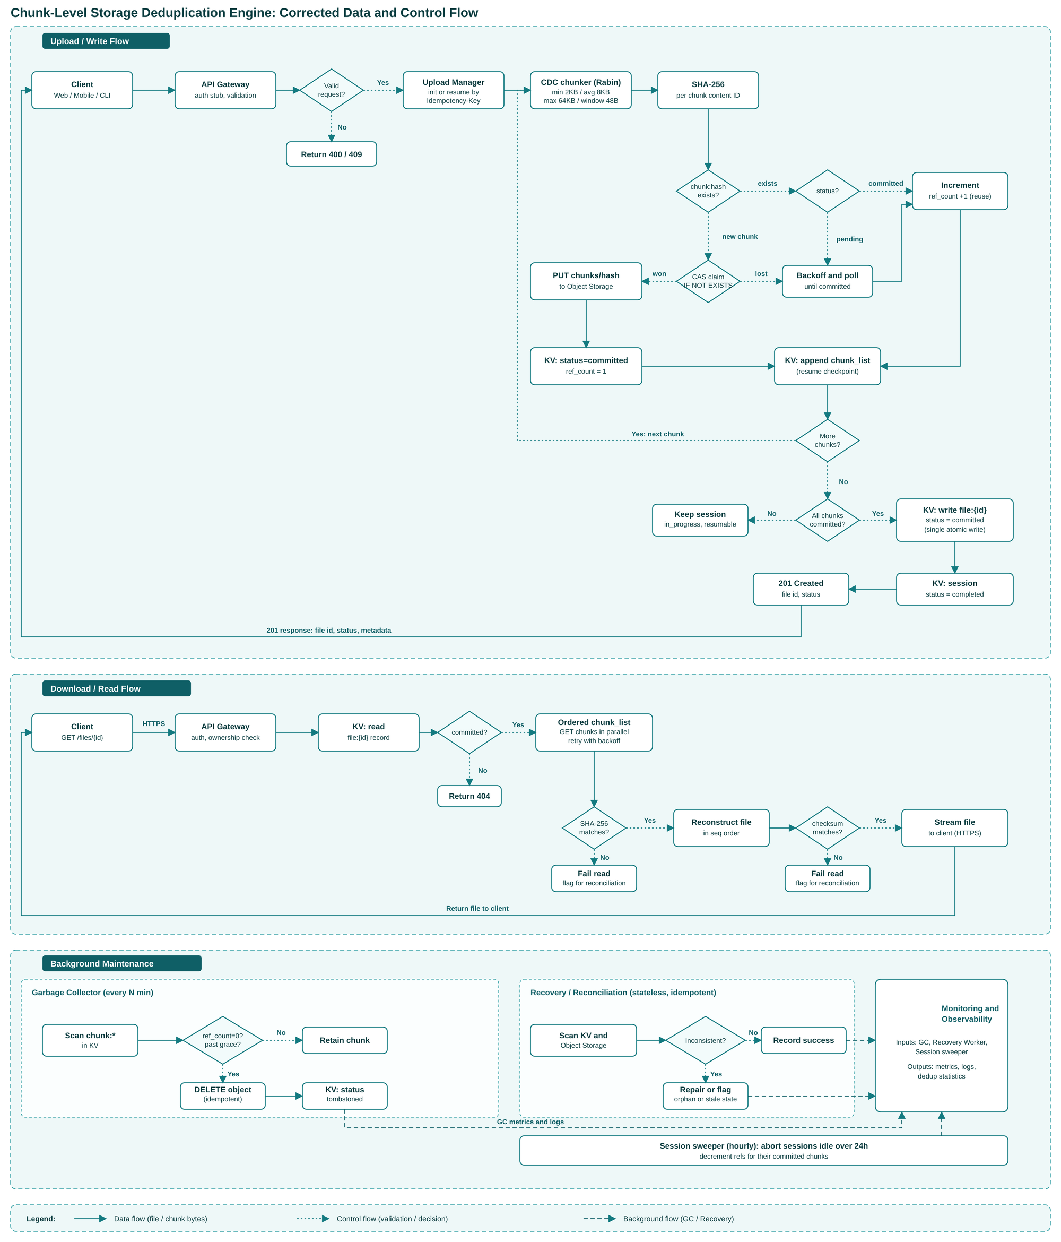

5. Technical Feasibility
Table 2. Technical feasibility by area
Area | Assessment | Basis
Chunking and fingerprinting | High | Rabin-style CDC is implemented; deterministic boundary and insertion-stability behavior is tested.
Index and metadata | High for prototype | SQLite transactions support the single-process scope; no distributed index is evaluated.
Chunk storage | High for prototype | Local hash-addressed files support unique-chunk writes and verified reads.
Restore and integrity | High | Ordered manifests, per-chunk hashes, and whole-file checksums provide verifiable reconstruction.
Performance evaluation | High | Deterministic benchmarks compare CDC and fixed-size chunking across five workload patterns.
Production scaling and security | Not evaluated | No multi-tenant service controls, distributed coordination, or cloud durability are implemented.
The main implementation risk is incorrect boundary handling. The Rabin-style rolling fingerprint follows the approach described by Rabin [1]. Chunker tests cover deterministic boundaries, boundary limits, and insertion stability; the benchmark compares CDC with a fixed-size baseline.

6. Operational Feasibility
Operational feasibility is demonstrated through the command-line workflow, persisted local index and chunk store, storage statistics, and verified restore. The benchmark records write and restore timing and checks restored data against its expected checksum. These measurements describe a local run, not a production service.
The prototype does not include background monitoring, an index-rebuild procedure, or multi-node recovery.

7. Storage Benefit and Cost Feasibility
This project evaluates storage and processing measurements rather than cloud pricing. Deduplication reduces stored bytes when the workload contains repeated chunks; hashing, indexing, and manifests add processing and metadata overhead.
Measured storage benefit compares logical bytes uploaded with unique physical chunk bytes stored.
The benchmark includes duplicate and edited inputs, plus random data as a low-redundancy baseline. Interpret results per dataset. The prototype does not model cloud prices, replication costs, or production operations, so it cannot establish monetary break-even.
Table 3. Prototype benefit and overhead measures
Measure | Prototype evidence | Interpretation
Storage benefit | Logical bytes, physical bytes, dedup ratio, and storage saved by dataset | Shows reuse for the disclosed benchmark inputs only.
Processing overhead | Observed write and restore elapsed time per dataset | Local measurements; results depend on machine and runtime.
Metadata and chunking behavior | Chunk count and unique chunk count for CDC and fixed-size runs | Shows storage and indexing trade-offs between chunking methods.
Monetary break-even | Not measured | Requires deployment-specific storage, compute, transfer, and operations prices.
The prototype shows byte savings and elapsed processing time for the benchmark workloads; it cannot establish production break-even economics.

8. Risks and Mitigations
Table 4. Prototype risk register
Risk | Effect on this project | Mitigation or treatment
Incorrect chunk boundaries | Reduced reuse or incorrect chunk output | Use deterministic and boundary-stability tests; compare with fixed-size baseline.
Chunk corruption or loss | Restore fails or returns invalid data | Verify chunk hashes and whole-file checksum; fail on missing or altered chunks.
Index and manifest inconsistency | Incorrect references or failed reconstruction | Commit file metadata, manifest rows, and reference counts in one SQLite transaction.
Low redundancy in test data | Little observed storage benefit | Include random data as a baseline and report each dataset separately.
Metadata growth from small chunks | More index rows and processing overhead | Measure chunk counts and elapsed time with fixed project parameters.
Concurrent writers or machine failure | Race conditions or unavailable data | Outside scope; state the single-process and local-storage limitation.
Production security exposure | Cross-tenant data-existence leakage | No multi-tenant service is implemented or claimed.

9. Acceptance Criteria and Evaluation Plan

9.1 Acceptance Criteria
- Adding identical input twice stores no additional chunk bytes. The index records the additional references.
- Restored output is byte-for-byte identical to the input.
- A small insertion into a large input preserve substantially more chunk reuse with CDC than with fixed-size chunking on the same input.
- Tampered or missing chunks cause an explicit integrity or restore error.
- The benchmark records chunk parameters, dataset, logical bytes, physical bytes, deduplication ratio, and storage saved.

9.2 Metrics
Deduplication ratio and storage saved are defined as:
Deduplication ratio = logical bytes uploaded / physical bytes stored.
Storage saved (%) = (1 - physical bytes stored / logical bytes uploaded) × 100.
Write and restore performance are measured as elapsed time per dataset and seconds per MiB.

9.3 Benchmark Datasets
Table 5. Benchmark datasets
Dataset | Benchmark pattern | Comparison | Expected redundancy
D1 Random | One deterministic random input with little expected redundancy | Baseline for CDC and fixed-size chunking | None (baseline, ratio ≈ 1.0)
D2 Duplicates | Four identical binary uploads | Measures reuse of repeated content | Near-total after first copy
D3 Edited text | A paragraph inserted into deterministic text input | Measures boundary resynchronization after a small edit | High
D4 Edited binary | A 4 KiB insertion into deterministic binary input | Measures reuse after a localized binary edit | High to moderate
D5 Small files | Deterministic 4 KiB files plus identical copies | Measures metadata and deduplication behavior for many small files | Depends on content

10. Limitations and Recommendation
The prototype runs as a single process with a local SQLite index and filesystem chunk store. It does not test concurrent writers, network partitions, replicated storage, or machine-failure recovery. Results apply only to the reported datasets, parameters, and execution environment.
If extended beyond the course prototype, the next feasibility questions are safe concurrent chunk claims, deletion and garbage collection, and recovery after partial failures.
ChunkWise is technically feasible as the agreed local prototype: its components use standard Python facilities, scope is bounded, and correctness and storage behavior can be measured with the acceptance criteria and benchmark. Storage benefit depends on redundancy in the tested data. Production readiness and monetary savings remain unproven.

11. References
[1] M. O. Rabin, "Fingerprinting by Random Polynomials," Technical Report TR-15-81, Center for Research in Computing Technology, Harvard University, 1981.
[2] A. Muthitacharoen, B. Chen, and D. Mazières, "A Low-bandwidth Network File System," in Proc. 18th ACM Symposium on Operating Systems Principles (SOSP), 2001.
[3] W. Xia, Y. Zhou, H. Jiang, D. Feng, Y. Hua, Y. Hu, Q. Liu, and Y. Zhang, "FastCDC: A Fast and Efficient Content-Defined Chunking Approach for Data Deduplication," in Proc. USENIX Annual Technical Conference (ATC), 2016.
[4] B. Zhu, K. Li, and H. Patterson, "Avoiding the Disk Bottleneck in the Data Domain Deduplication File System," in Proc. 6th USENIX Conference on File and Storage Technologies (FAST), 2008.
[5] National Institute of Standards and Technology, "Secure Hash Standard (SHS)," FIPS PUB 180-4, 2015.

