Feasibility Report
ChunkWise: Content-Aware Storage Deduplication Engine
Course: System Design
Team members: [Name (ID)], [Name (ID)]
Submission date: [DD Month YYYY]

1. Executive Summary
ChunkWise is feasible as a course prototype and not yet as a production service. It can be built from well-understood primitives: content-defined chunking (CDC), SHA-256 content identifiers, an index, immutable chunk storage, per-file manifests, and reference counting with garbage collection. Its main benefit is reduced stored bytes for repeated or near-duplicate data. Its main costs are hashing and indexing CPU, metadata growth, restore-time indirection, and security risk if deduplication crosses tenant boundaries.
We recommend proceeding with the educational prototype and the planned experiments. Results should be reported as measured values on a disclosed dataset, not as a general claim about storage savings.

2. Introduction and Problem Statement
File-level deduplication stores a file once only when two files are byte-identical. Real data is often near-identical instead: a backup differs from the previous one by a few changed blocks, a VM image differs by a few modified sectors, and a log file differs by appended lines. File-level deduplication stores every version in full in these cases.
Chunk-level deduplication splits each file into pieces, identifies each piece by its hash, and stores each unique piece once. Fixed-size chunking is fragile, because a single inserted byte shifts every later boundary and changes every later chunk hash. Content-defined chunking avoids this by placing boundaries according to a rolling hash over a small local window, so boundaries re-synchronize after an edit.
This report asks whether ChunkWise can be built within the course timeframe, whether its operational and economic costs are justified, and what the prototype can credibly demonstrate.

3. Project Objectives
- Implement a content-defined chunker based on a Rabin rolling-window fingerprint.
- Identify chunks by SHA-256 and store each unique chunk once.
- Write ordered manifests so that files can be reconstructed exactly.
- Maintain per-chunk reference counts.
- Verify chunk and file integrity during restore.
- Measure storage savings and compare content-defined chunking with fixed-size chunking on controlled datasets.

4. Scope

4.1 In Scope
The local prototype includes a Rabin rolling-window CDC chunker, SHA-256 chunk identifiers, deduplication-aware writes, ordered manifests, per-chunk reference counts, verified reconstruction, and size accounting.

4.2 Out of Scope
The prototype does not include distributed conditional writes, coordination between concurrent writers, resumable upload sessions, cloud storage, authentication, delete and garbage collection, or recovery workers. These are described in the production design and are listed as future work in Section 12.

4.3 Assumptions
- Input files are available as complete byte streams.
- The chunk store and index run on a single machine for the prototype.
- Chunk parameters are fixed per run: minimum 2 KB, average 8 KB, maximum 64 KB, rolling window 48 bytes. [Confirm against the final implementation.]
- SHA-256 collisions are treated as negligible, consistent with common practice in content-addressed systems.

5. System Overview
The write path reads a file, emits content-defined chunk boundaries, hashes each chunk, checks the index, writes only new chunks to the chunk store, and records an ordered manifest. The read path loads the manifest, fetches each chunk, verifies its hash, reassembles the file in sequence order, and verifies the whole-file checksum.
Table 1. Component responsibilities
Component | Responsibility | Prototype implementation
Chunker | Splits byte stream at content-defined boundaries | Rabin rolling-window fingerprint [Team to confirm]
Hasher | Computes SHA-256 per chunk | hashlib.sha256
Index | Maps chunk hash to status and reference count | [Local index, e.g. SQLite or JSON; confirm]
Chunk store | Stores unique chunk bytes keyed by hash | [Local directory; confirm]
Manifest store | Stores ordered chunk list per file | [Local file; confirm]
Restorer | Reassembles file and verifies integrity | Checks chunk hashes and whole-file checksum

Figure 1. System architecture
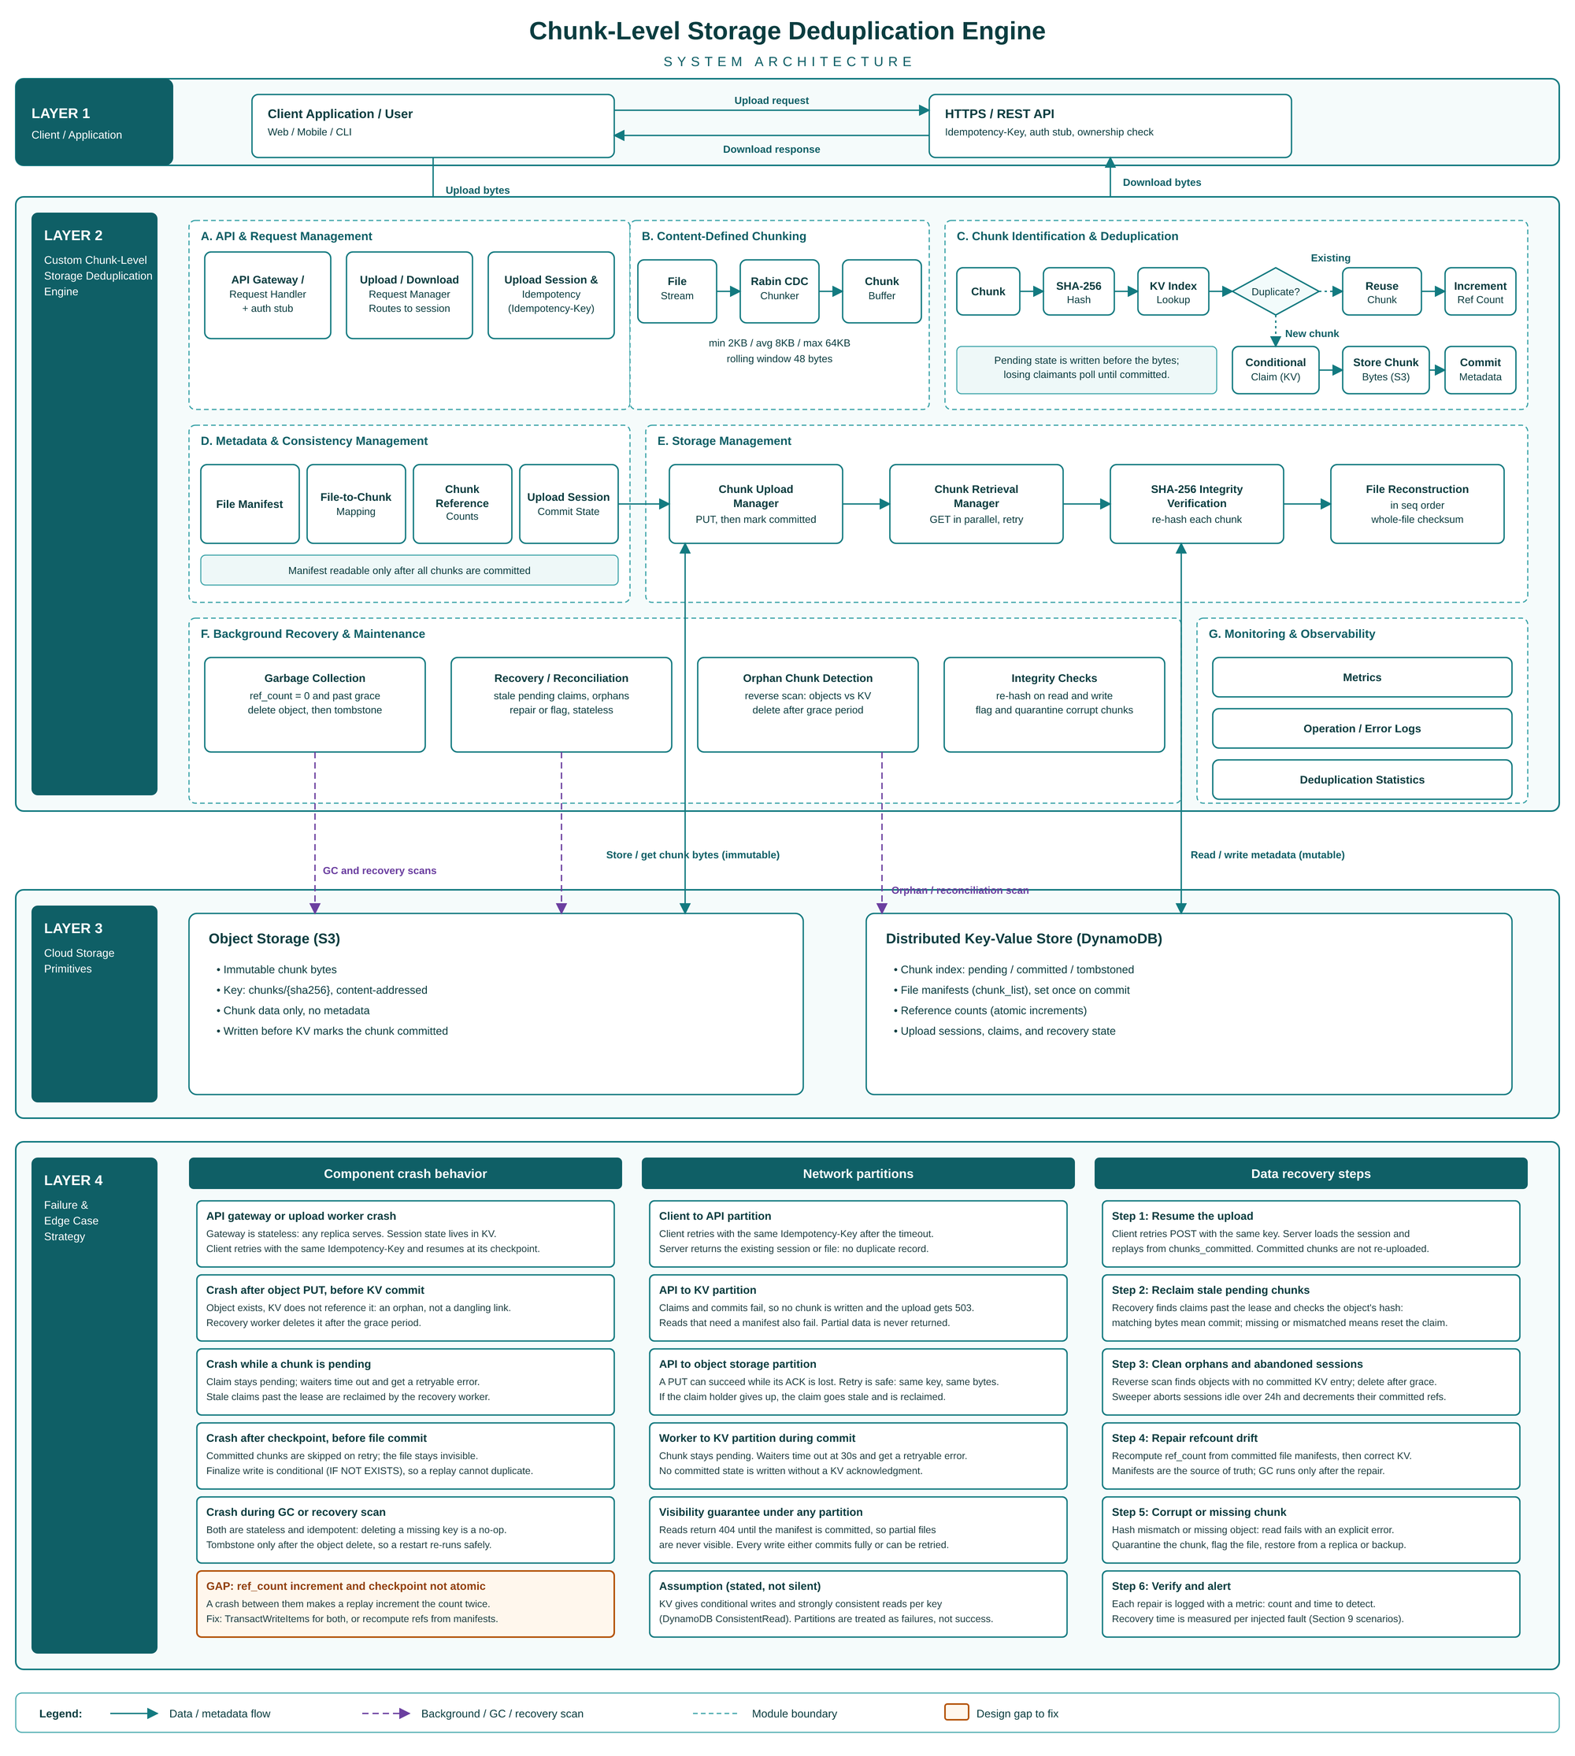

Figure 2. Data and control flow (upload, download, background maintenance)
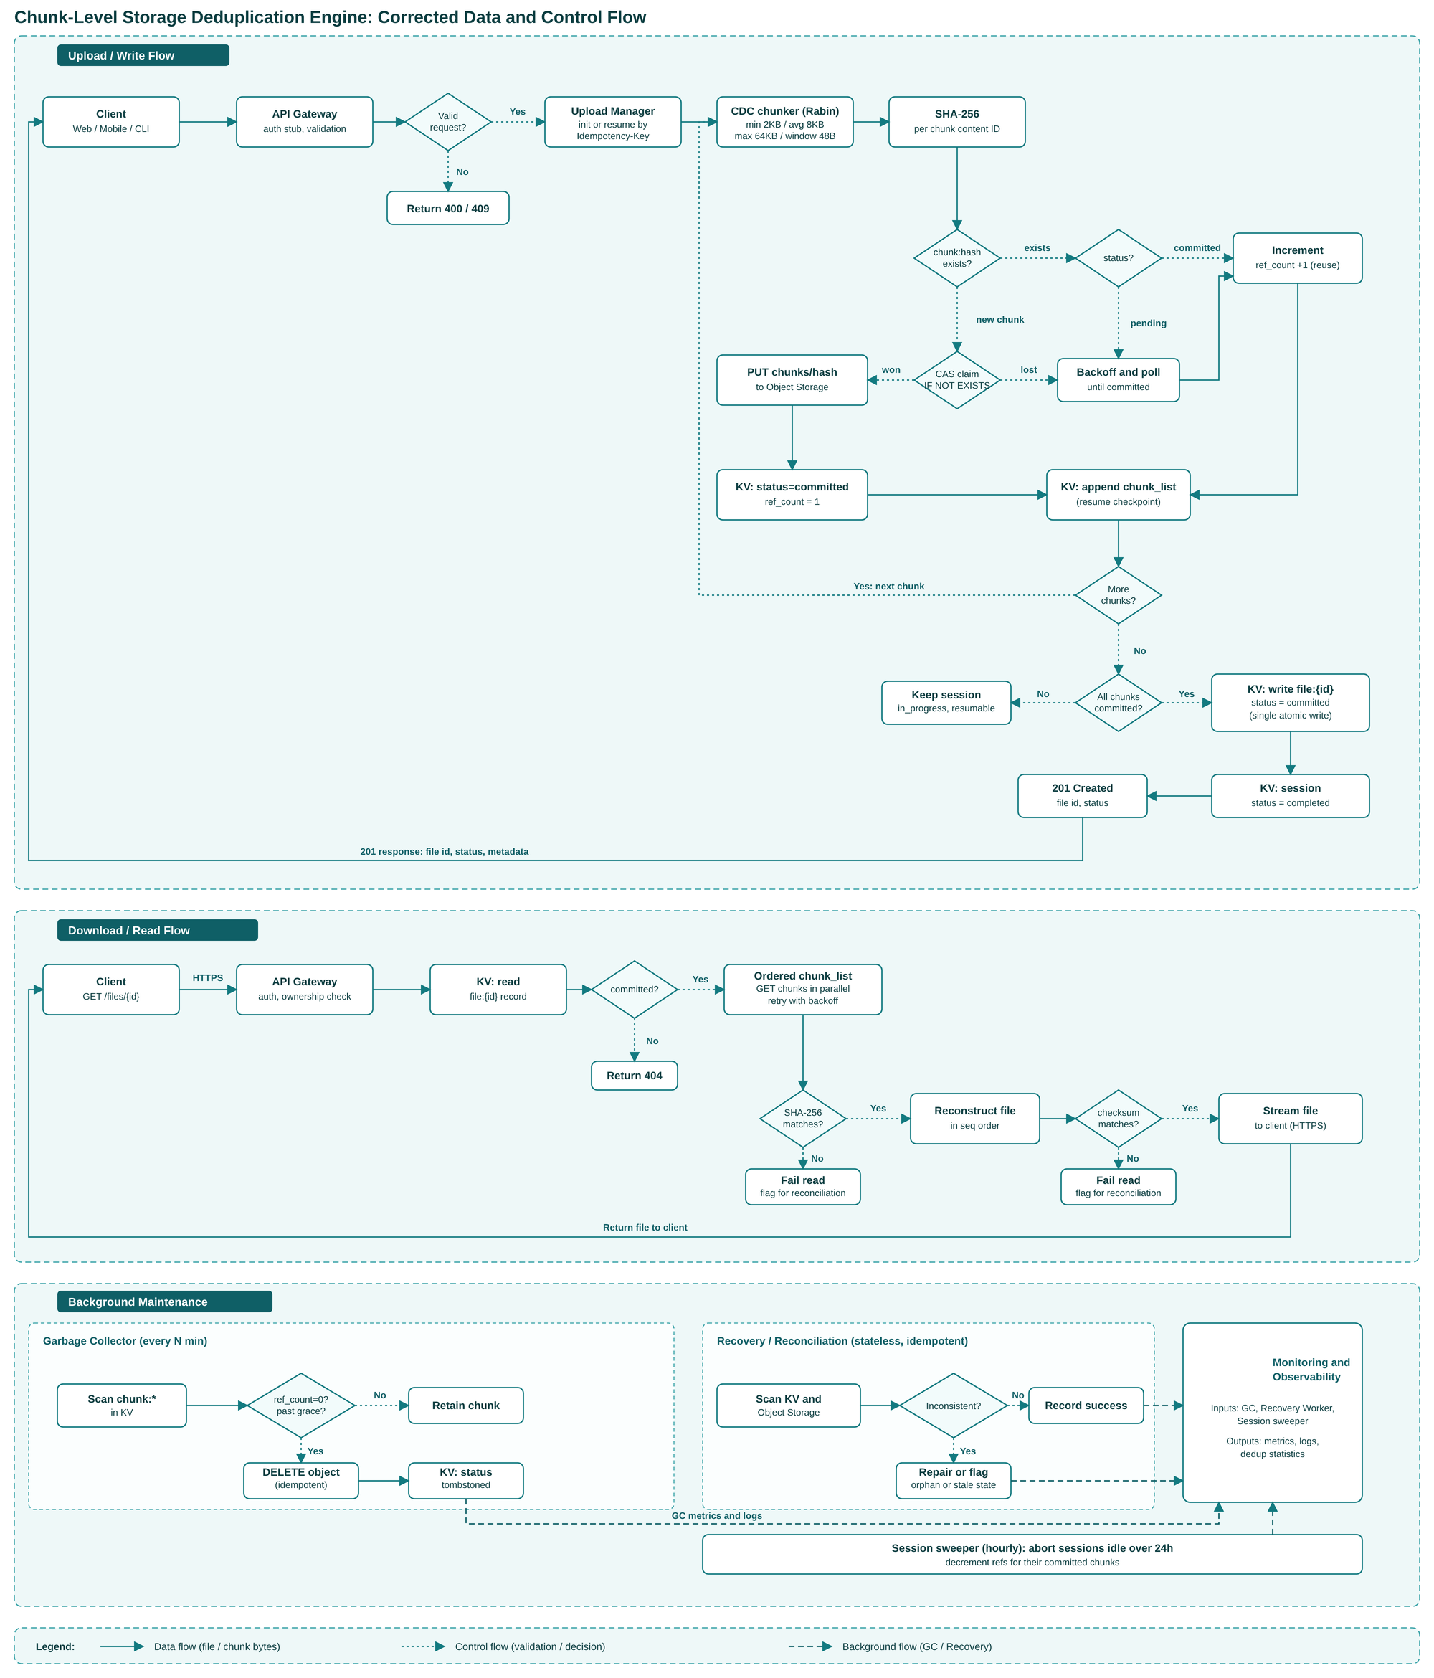

6. Technical Feasibility
Table 2. Technical feasibility by area
Area | Assessment | Notes
Chunking and fingerprinting | High | CDC limits re-chunking after small edits. SHA-256 provides a strong content identifier.
Index and metadata | Medium-high | A local index is sufficient for the prototype. Production use would require a highly available key-value index, partitioning, hot-key handling, and rebuild tooling.
Chunk storage | High | Immutable storage fits the write-once, read-many workloads.
Restore | High | Manifest traversal is straightforward. Parallel reads and bounded buffering are needed for throughput.
Consistency | Medium | Commit ordering, retries, orphan cleanup, and garbage collection races require careful state design. The prototype avoids these by running as a single process.
Security | Medium | Encrypt chunks, protect manifests and the index, and enforce tenant isolation. Avoid global deduplication without a threat analysis.

Implementation note. A Rabin fingerprint is simple to implement, but boundary stability is easy to get wrong and needs dedicated tests. FastCDC, a Gear-hash-based algorithm with similar content-defined properties and higher speed, is a documented alternative [3]. If implementation time is tight, the team may use it and state the substitution explicitly in this report.

7. Operational Feasibility
A production service would need monitoring for deduplication ratio, bytes ingested, hashing CPU, index hit and miss rates and latency, chunk-store read and write latency, restore throughput, integrity failures, orphaned bytes, and garbage-collection backlog. Operators would need backup and restore procedures for both manifests and the index, key rotation, capacity forecasting, and a way to rebuild the index from durable metadata.
For the prototype, operational needs are limited to logging the metrics above to structured logs, running the experiments from a script, and verifying that the index can be rebuilt from the stored manifests.

8. Economic Feasibility
Savings depend on workload redundancy. Deduplication is worthwhile when:
saved storage and transfer cost > hashing + index + metadata + replication + operational cost
Deduplication is most attractive for versioned backups, VM images, software artifacts, and repeated datasets. It is unattractive for data that is already compressed, encrypted, or mostly unique, because it produces no savings and still incurs hashing and indexing cost. For this reason, a production system should measure redundancy first and allow bypassing deduplication when it does not pay off.
Table 3. Cost factors for a production deployment (to be filled in)
Factor | Measured or estimated value | Source
Hashing CPU cost per GB | [value] | Prototype measurement
Index storage per million chunks | [value] | Prototype measurement
Storage saved per dataset | [value] | Section 11 experiments
Replication overhead | [value] | Assumption, state explicitly

The prototype cannot establish a production break-even point. It can establish whether the measured savings on each dataset are large enough to justify the measured overhead.

9. Schedule and Resource Feasibility
The prototype is split into four phases that match the acceptance criteria in Section 11. The team should adjust dates to the course timetable.
Table 4. Proposed milestones
Phase | Work | Owner | Target date
1. Chunker | Rabin CDC, boundary stability tests | [Name] | [Date]
2. Dedup writes | SHA-256 IDs, index, reference counts, manifests | [Name] | [Date]
3. Restore and integrity | Reconstruction, chunk and file verification, tamper tests | [Name] | [Date]
4. Experiments and report | Datasets, measurements, charts, this report | [Names] | [Date]

The main schedule risk is the chunker. Phase 1 should be completed before other phases depend on it.

10. Risks and Mitigations
Table 5. Risk register
Risk | Impact | Mitigation
Hash collision or corruption | Incorrect restore | Strong hash, length and checksum validation, periodic scrubbing, redundant copies in production
Cross-tenant side channel | Disclosure of data existence | Tenant-scoped deduplication, authorization before lookup, no externally visible timing differences
Index outage | Upload and restore degradation | Replication, cache, durable write path, index rebuild procedure
Garbage collection deletes referenced content | Data loss | Mark-and-sweep with grace period, generation tracking, concurrency-safe reference accounting
Low redundancy in test data | Little or no measured savings | Measure the dataset first, report results honestly, include a no-redundancy baseline
Tiny chunks | Metadata and index growth | Tune target chunk size, test CPU, metadata, and restore latency together
Chunker boundary bugs | Dedup ratio silently drops | Boundary-stability tests (insertion must not shift later boundaries)

11. Acceptance Criteria and Evaluation Plan

11.1 Acceptance Criteria
- Adding identical input twice stores no additional chunk bytes. The index records the additional references.
- Restored output is byte-for-byte identical to the input.
- A small insertion into a large input preserves most chunk references compared with whole-file hashing.
- Tampered or missing chunks cause an explicit integrity or restore error.
- The report records parameters, dataset, baseline bytes, stored bytes, and observed deduplication ratio.

11.2 Metrics
Deduplication ratio and storage saved are defined as:
dedup ratio = total logical bytes uploaded / total physical bytes stored
storage saved (%) = (1 − total physical bytes stored / total logical bytes uploaded) × 100
Throughput is measured end to end, from request to committed write and from request to fully reconstructed file.

11.3 Test Datasets
Table 6. Datasets (to be filled in)
Dataset | Description | Size | Expected redundancy
D1: Random | Independent random files | [size] | None (baseline, ratio ≈ 1.0)
D2: Duplicates | Same file uploaded N times | [size] | Near-total after first copy
D3: Edited text | Paragraph inserted into a text document | [size] | High
D4: Edited binary | Modified VM image or archive | [size] | High to moderate
D5: Small files | Thousands of small files | [size] | Depends on content

Figure 3. Deduplication ratio by dataset
[Insert Figure 3 here after measurements]

Figure 4. Content-defined chunking vs. fixed-size chunking on edited data
[Insert Figure 4 here after measurements. This is the central comparison of the project.]

12. Limitations and Future Work
The prototype runs on one machine, so it does not test concurrent writers, network partitions, or storage failures. Its results apply to the disclosed datasets and parameters only. The index is not replicated.
Future work, in order of expected value: resumable upload sessions with idempotency keys; conditional writes for concurrent chunk claims; garbage collection with grace periods; a recovery worker for orphaned objects; tenant-scoped deduplication; and migration of the chunk store and index to a managed cloud service.

13. Conclusion and Recommendation
The project is technically feasible as an educational prototype. Its core components are standard, its scope is bounded, and its acceptance criteria can be measured. The economic case is not established in general; it depends on workload redundancy, which the experiments must measure on disclosed data.

14. References
[1] M. O. Rabin, "Fingerprinting by Random Polynomials," Technical Report TR-15-81, Center for Research in Computing Technology, Harvard University, 1981.
[2] A. Muthitacharoen, B. Chen, and D. Mazières, "A Low-bandwidth Network File System," in Proc. 18th ACM Symposium on Operating Systems Principles (SOSP), 2001.
[3] W. Xia, Y. Zhou, H. Jiang, D. Feng, Y. Hua, Y. Hu, Q. Liu, and Y. Zhang, "FastCDC: A Fast and Efficient Content-Defined Chunking Approach for Data Deduplication," in Proc. USENIX Annual Technical Conference (ATC), 2016.
[4] B. Zhu, K. Li, and H. Patterson, "Avoiding the Disk Bottleneck in the Data Domain Deduplication File System," in Proc. 6th USENIX Conference on File and Storage Technologies (FAST), 2008.
[5] National Institute of Standards and Technology, "Secure Hash Standard (SHS)," FIPS PUB 180-4, 2015.
[Team to verify all citations against the course's required reference style before submission.]

