 College of Engineering, Pune 

Robot Study Circle

HYDRO-QUADROTOR

Abstract :-

In the recent years under water survelliance and under water landscape monitoring is a essential task, that has to performed when required. The HYDRO-QUADROTOR designed is a low cost solution for such problems. The HYDRO-QUADROTOR is integrated with various sensor for wireless transmission of data. The body of the HYDRO-QUADROTOR is 3D printed which makes it durable as well as light in weight.

Componenets:-

1) Micro-controller

2) BLDC motors

3) Electronic speed controller (ESC)

4) Lithium Polymer Battery (LiPo)

5) Polylactic Acid (PLA)

6) mpu-9250 (Gyro Sensor)

7) nRF24L01

8) Xigbee

CAD Design :-

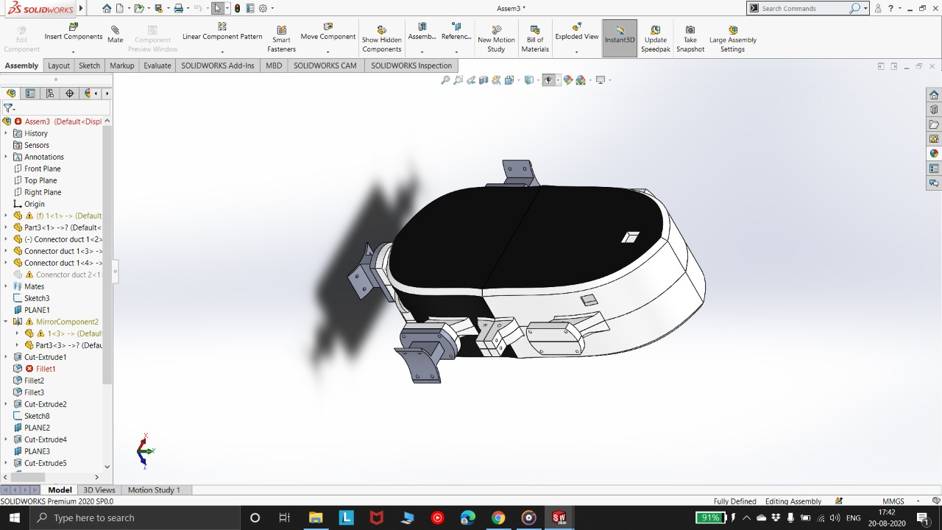

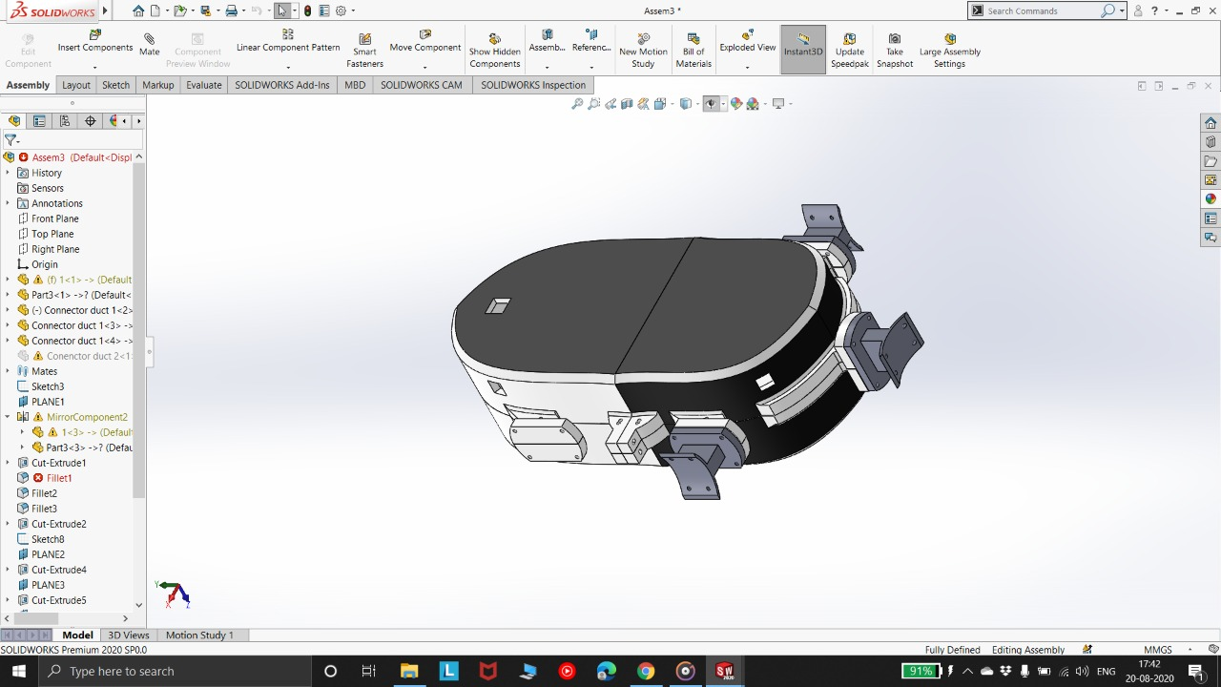

The design of the HYDRO-QUADROTOR is done is such manner that it has enough space to accommodate all the electrical components and the proper insulation can be provided. The design is pointed at the front end which provides good aerodynamics for the underwater maneuver.

The clamps provided on the body of the HYDRO-QUADROTOR are for the mounting of its rotors.

Printed Circuit Board :-

The first step of the printed circuit board design is the completion of the schematic. Schematic is the rough connection of the electrical components used in the project, which are then transferred into the PCB file for actual connection. The schematic diagram is shown below (Software used is Altium Designer)

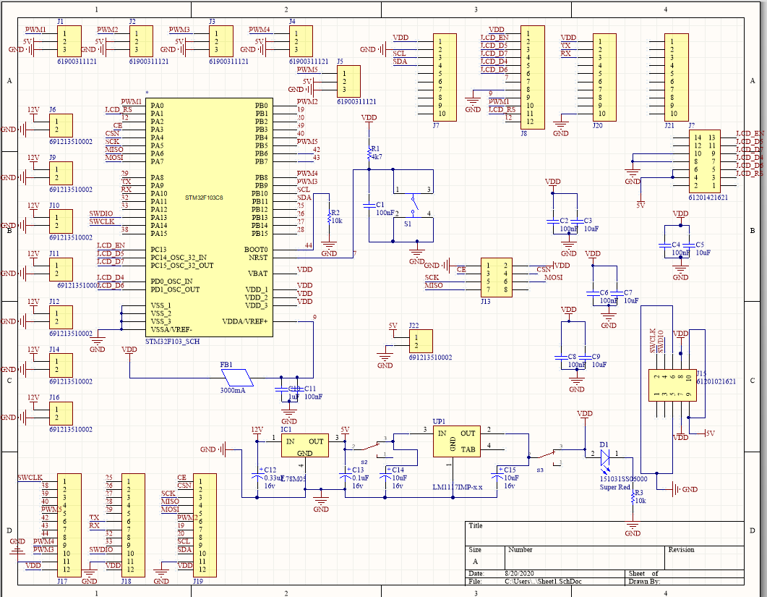

Fig.1 Schematic Diagram

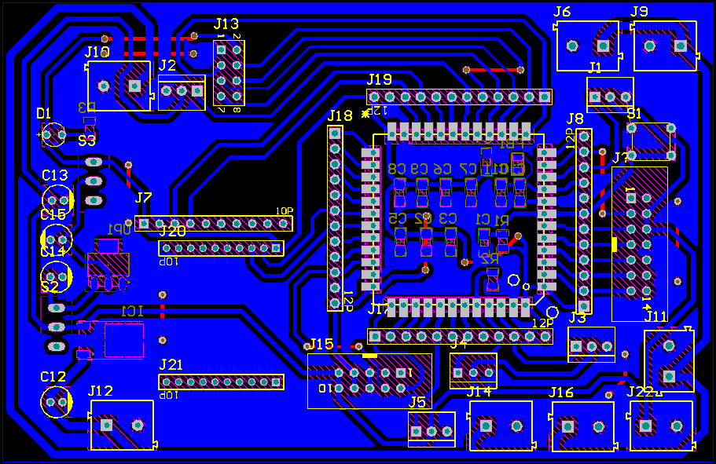

Fig.2 2D view

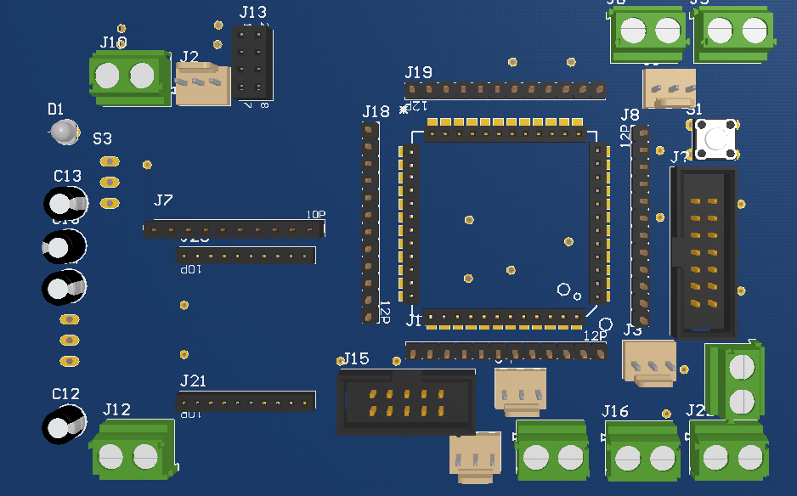

Fig.3 3D view

The routing of PCB should be done in such a manner that the paths carrying more current should be broad. So that when heating occurs the track does not get burned.

Sensors :-

1) nRF24L01 :-

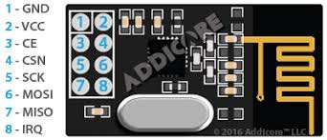

nRF24L01 is a single chip radio transceiver for the world wide 2.4 - 2.5 GHz ISM band. It requires a power supply of 3V. It works on SPI protocol which is good for wireless power transmission. It can work under water. It can transmit the data from the bot to the operator, which can further be analysed.

2) MPU-9250 :-

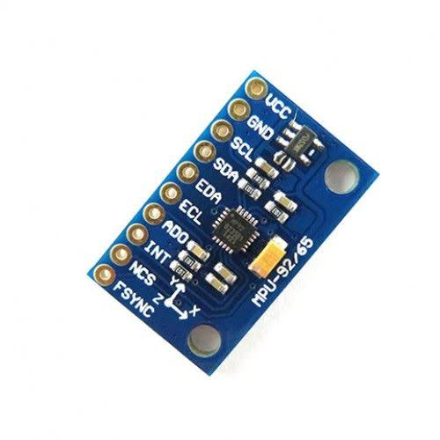

MPU-9250 is a gyro sensor that gives the values of role, yaw , bitch. It also consists of a accelerometer. Various filters can be used to obtain more accurate reading from the sensor .

3) Xigbee :-

Xigbee is low cost low power wireless transmission module. It works on UART protocol. It has an integrated wire antenna frequency band is 2.4 GHz

