Game Design Document

Fill up the following document

1. Write the title of your project.

## Jungle trapped

1. What is the goal of the game?

TO ESCAPE FROM THE ANIMALS

1. Write a brief story of your game.

## The story starts as a plane crashes and lands in an forest and as he wakes up wild animal chase him he is trying to run and there are many obstacles in his way and he has run and get help this is the story .

1. Which are the playing characters of this game?

* Playing characters are the ones who respond to the user based on the input from the user.
* Cars, monkeys, dinos, wizards, etc., are the playing characters in the game.

|  |  |  |
| --- | --- | --- |
| Number | Character Name | What can this character do? |
| 1 | MAN | HE IS THE MAIN CHARACTER IN THE GAME HE RUNS |
| 2 |  |  |
| 3 |  |  |
| 4 |  |  |
| 5 |  |  |
| 6 |  |  |
| 7 |  |  |
| 8 |  |  |

1. Which are the Non-Playing Characters of this game?

* Non-Playing characters are the ones that don't have an action or behavior when the user interacts with the game.
* Hurdles, stones, bananas, coins, etc., are non-playing characters in the game.

|  |  |  |
| --- | --- | --- |
| Number | Character Name | What can this character do? |
| 1 | STONE | IT SLOWS DOWN THE PLAYER |
| 2 | POND | IT SLOWS THE PLAYER AND ACTS AS AN OBSTACLE |
| 3 |  |  |
| 4 |  |  |
| 5 |  |  |
| 6 |  |  |
| 7 |  |  |
| 8 |  |  |

Draw your imagination of this game. What does this game look like?

* Draw the game either on your computer or on paper.
* Add images of the game scenes to show each of the playing and non-playing characters at least once.

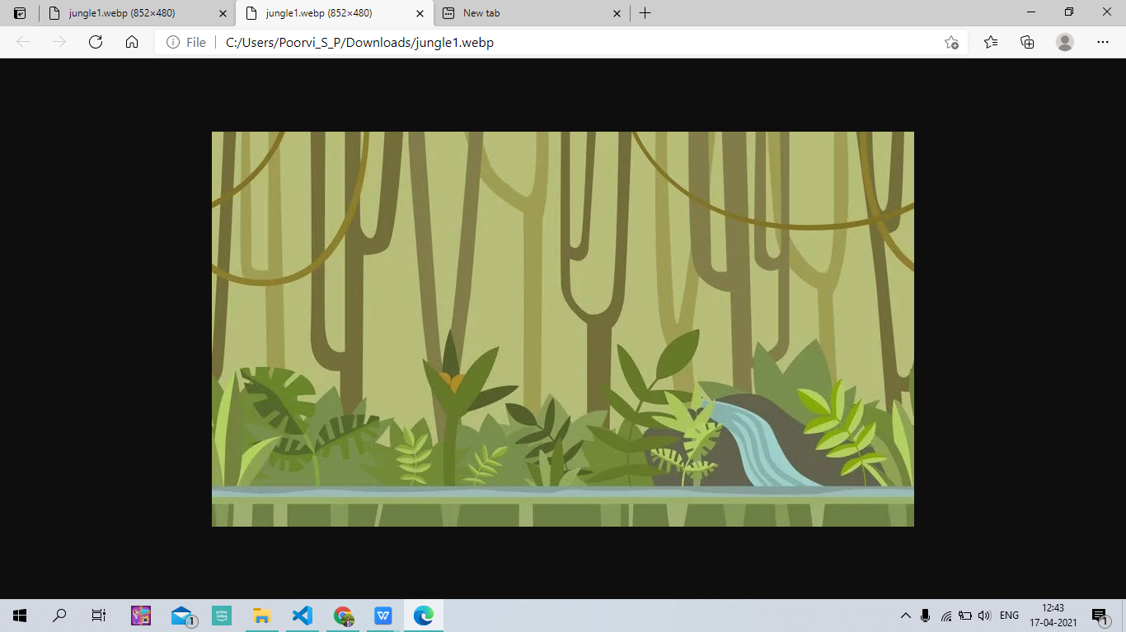

How do you plan to make your game engaging?