Project: Sales Record of Sales-Manager

NAME: POORVI-SHRIVASTAV

ENROLLMENT NO: 161B142

BATCH: B-5/B-Y

SUBJECT: ADVANCED PROGRAMMING LAB (PYTHON)

OBJECTIVE:

Objective of my project is to give rough idea about the orders taken by a Salesmen.

WORKING:

I had made project, where all the functions are just based on employee id’s.

Here are steps to run the projects:

INSERT DATA:

* Fill id, first name, last name and working district of employee.
* Press insert button.

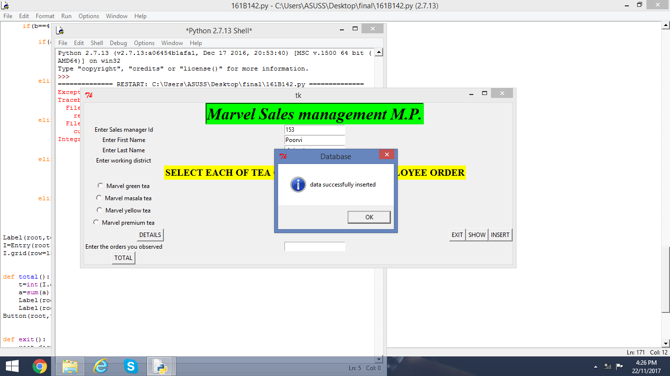

I had taken only few id’s in range to perform operation and if you don’t enter in range it will give you error.

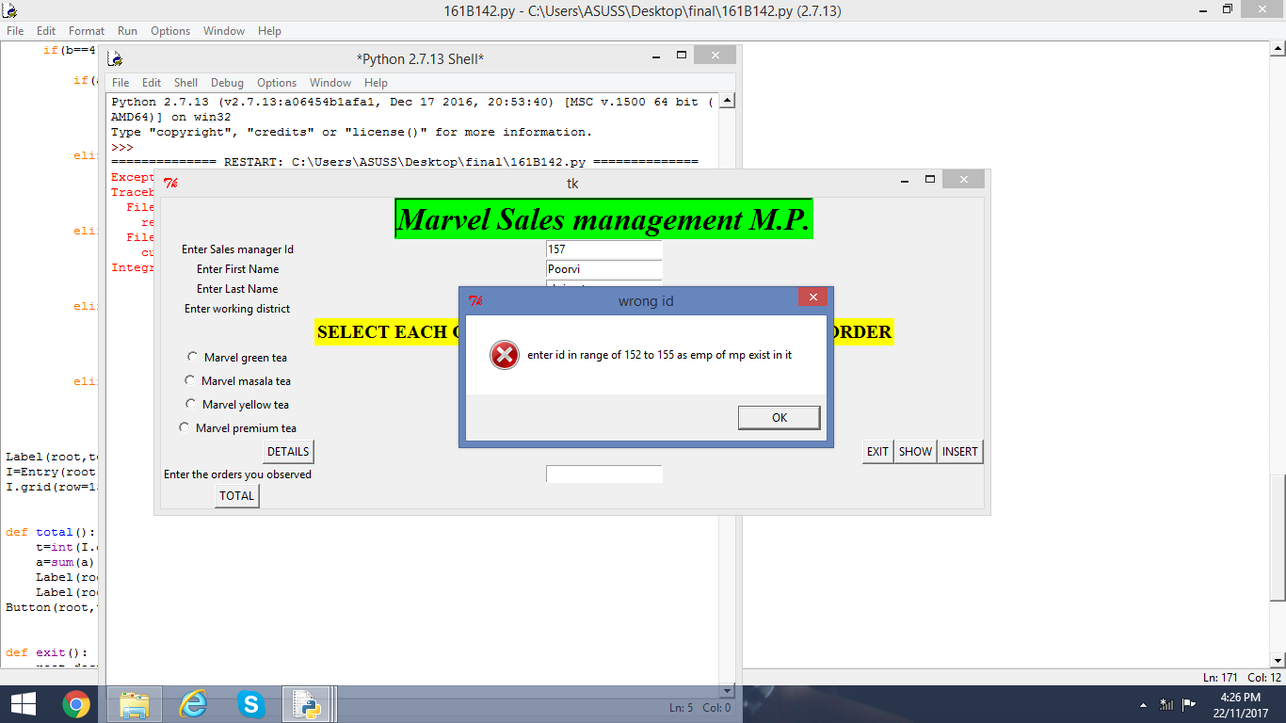

SELECTION OF TYPE OF TEA:

Employee had been taken orders for each tea type. So, select every type of tea once to see the order of the corresponding tea.

* Select tea, then press detail to see order.
* Each tea Once.

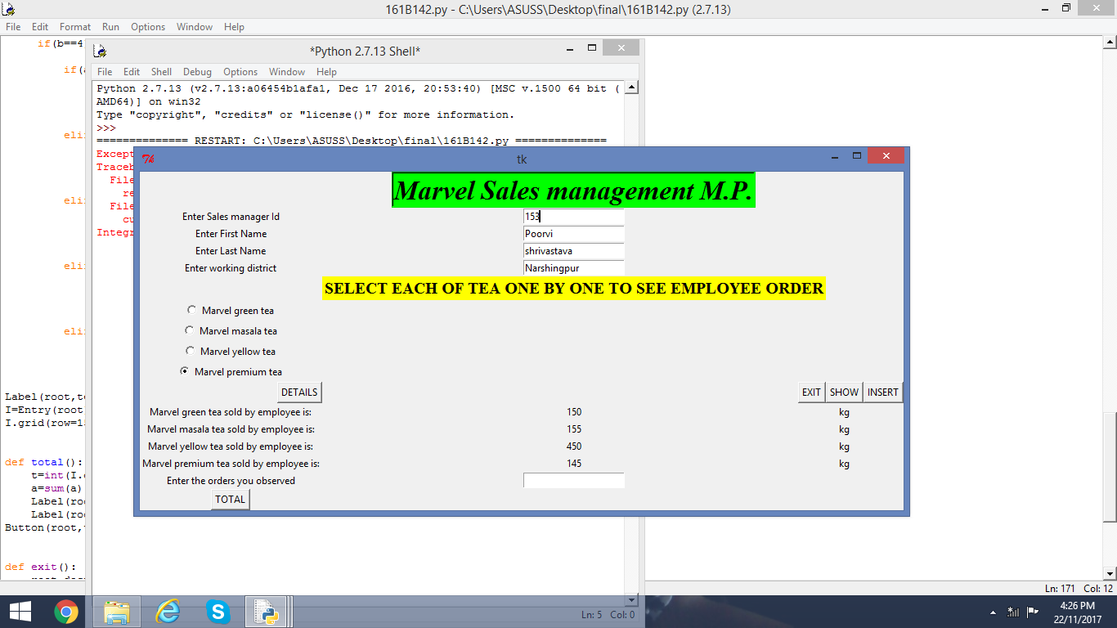

TOTAL ORDER OF AN EMPLOYEE:

1. After observing every tea’s order .
2. Fill them in corresponding entries.

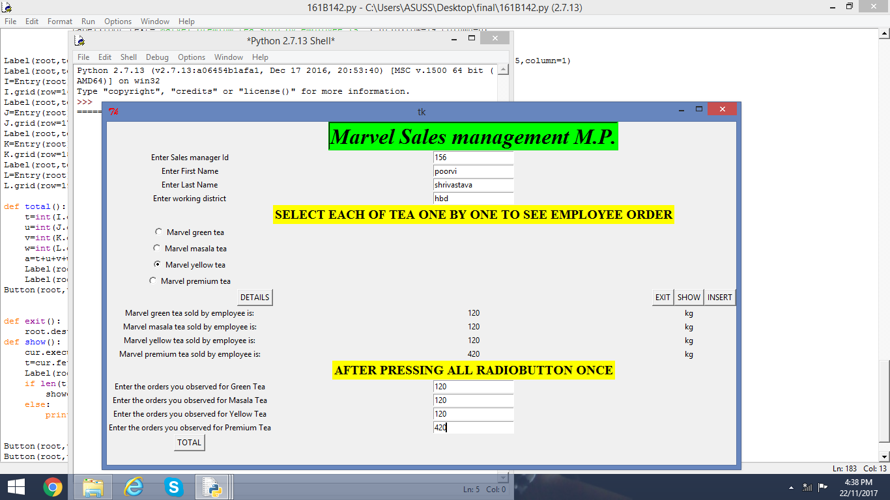

* Then press total button.

It will give you total of order by employee.

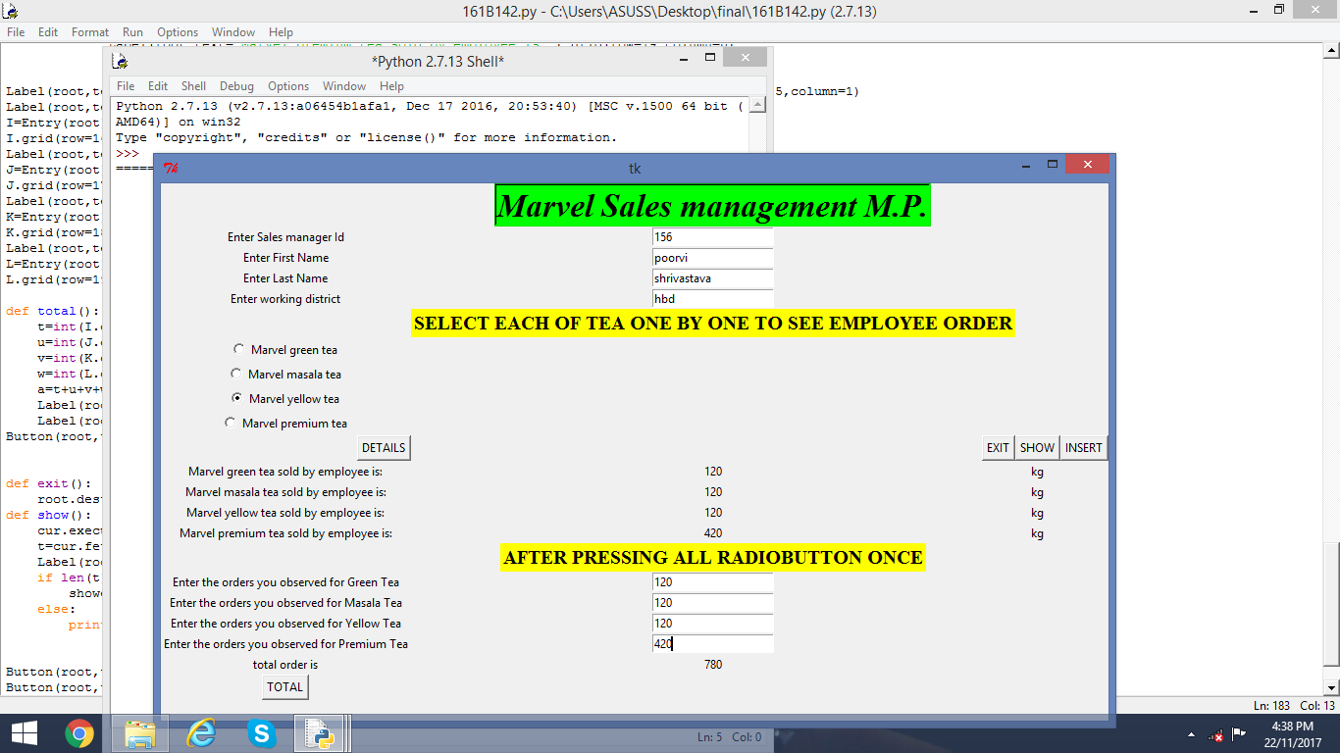

SHOW:

* Stored information of employee details stored.

EXIT:

* Exit you from GUI window.

Thank you, sir for giving opportunity to make our first project. It is my first attempt so, sorry for silly mistake. I will keep this project improving.