**Fix Bugs of the Application output:**

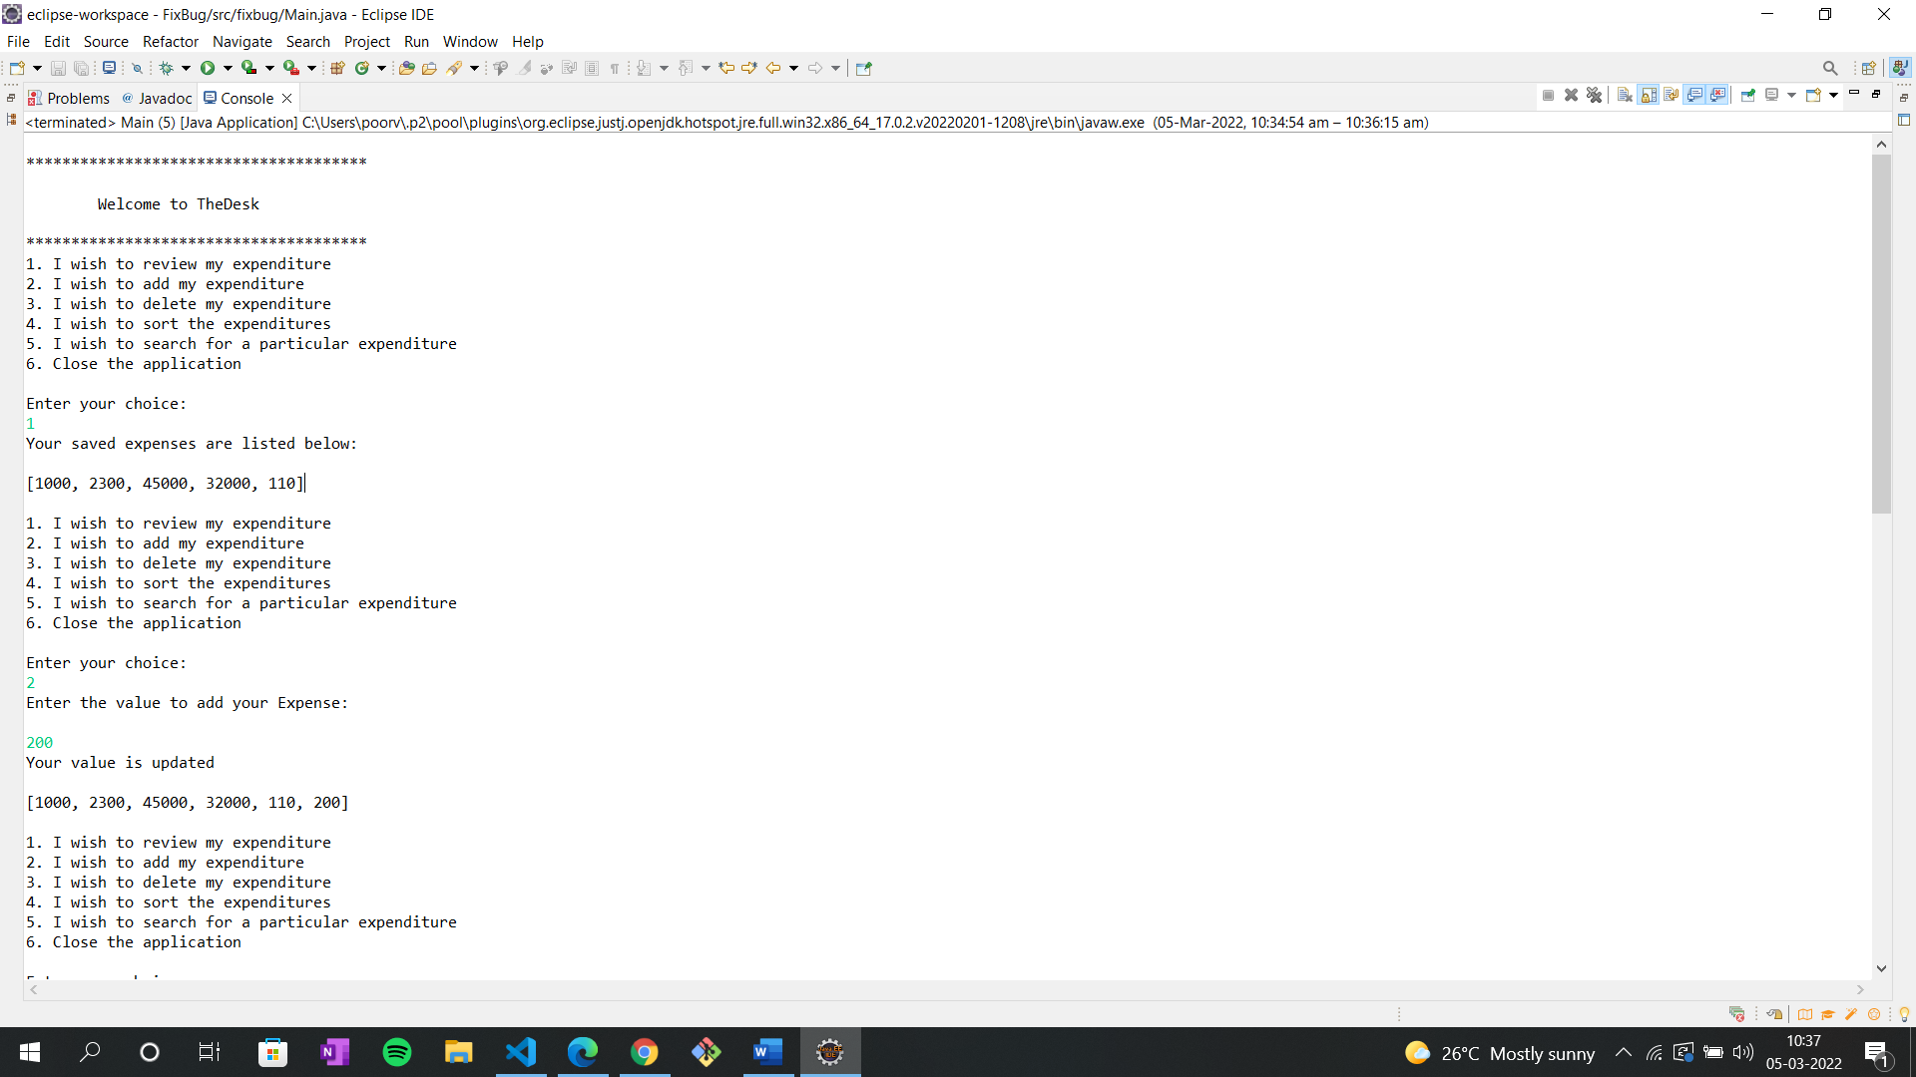

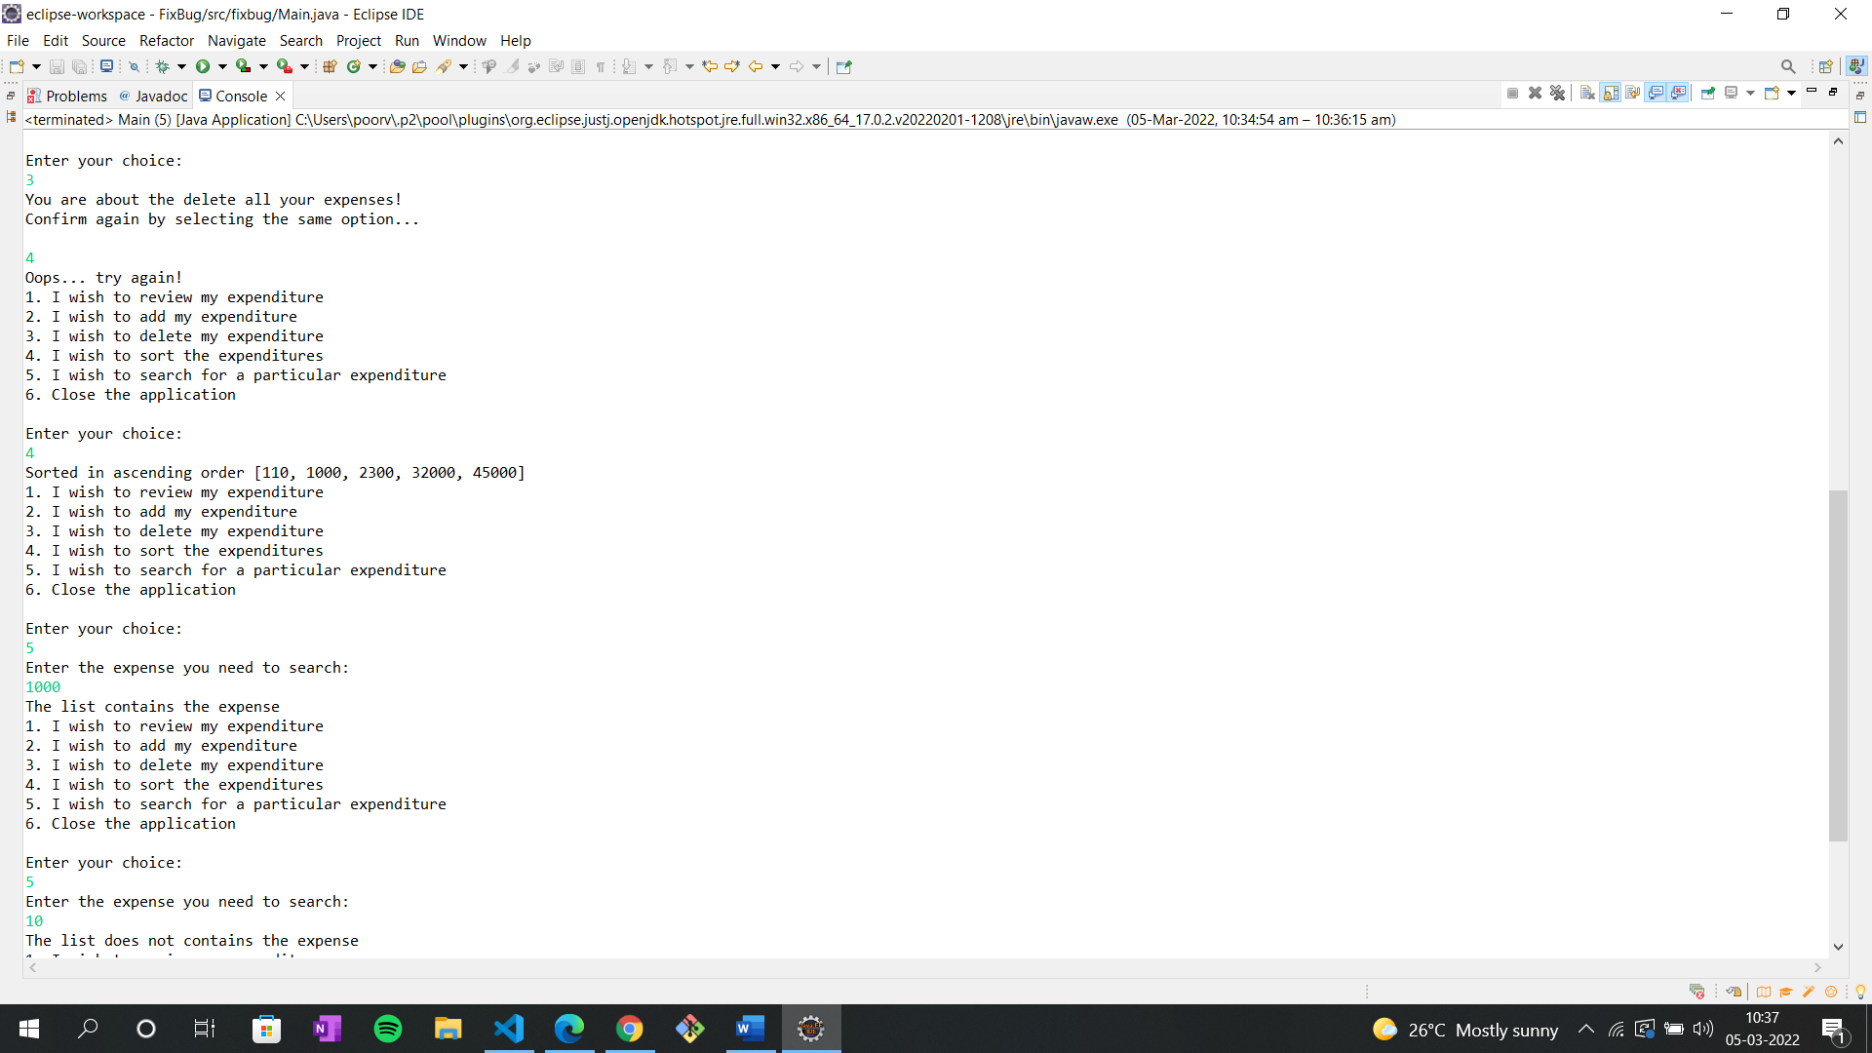 **Output**: When you enter your choice as 4, it sorts the expenses from the list in ascending order.

**Output**: When you enter your choice as 5, it searches the entered expenses from the list if its present it displays as list contains the expenses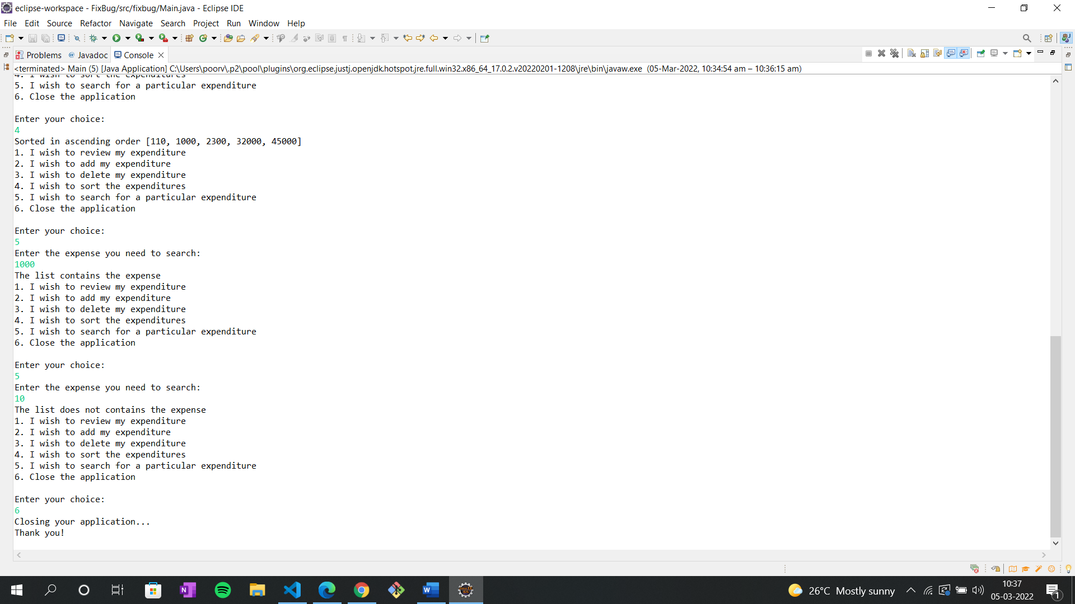 else it displays list doesn’t contains the expenses.