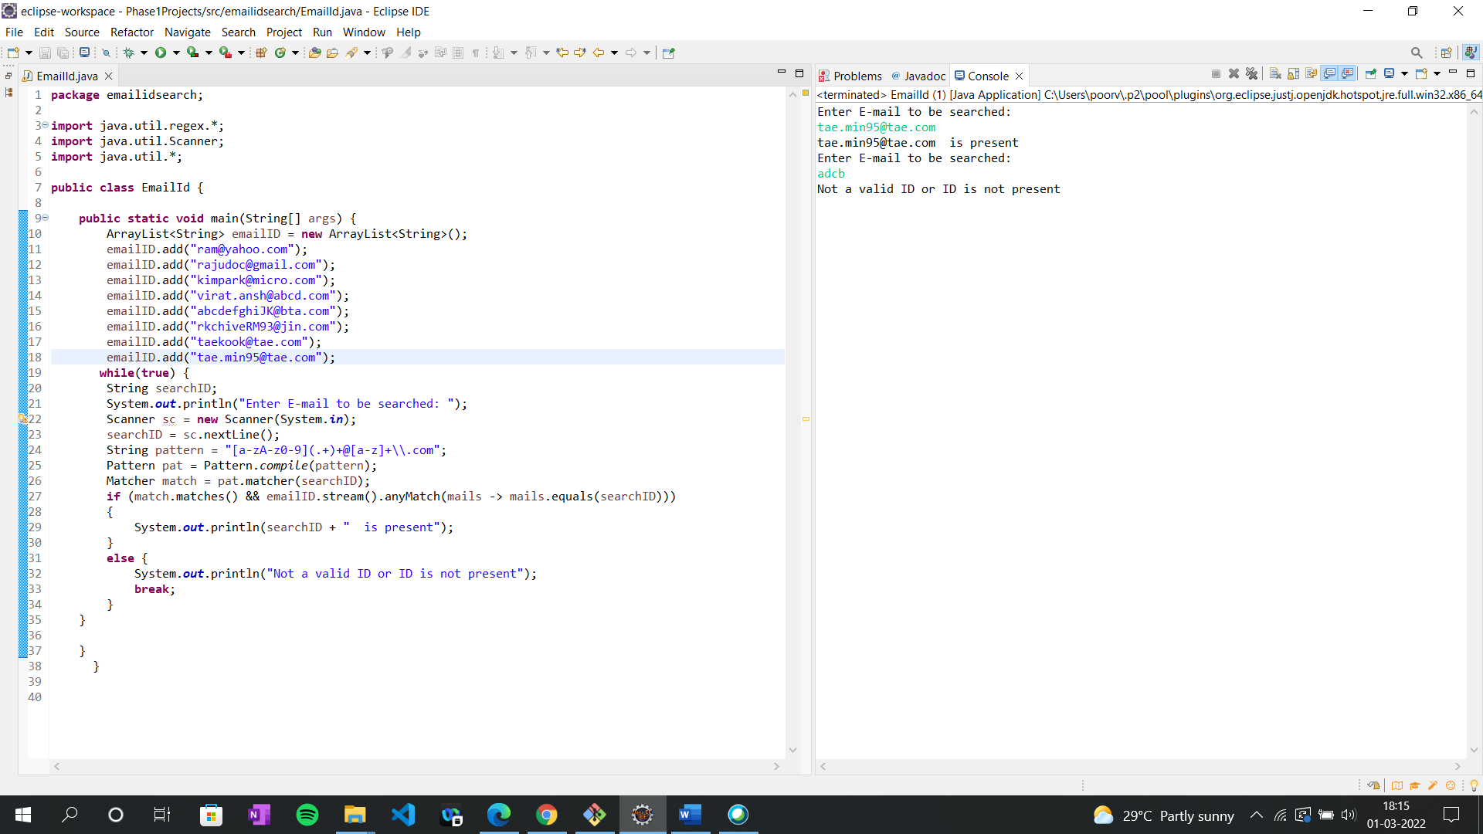

Output of **Validation of an Email ID**

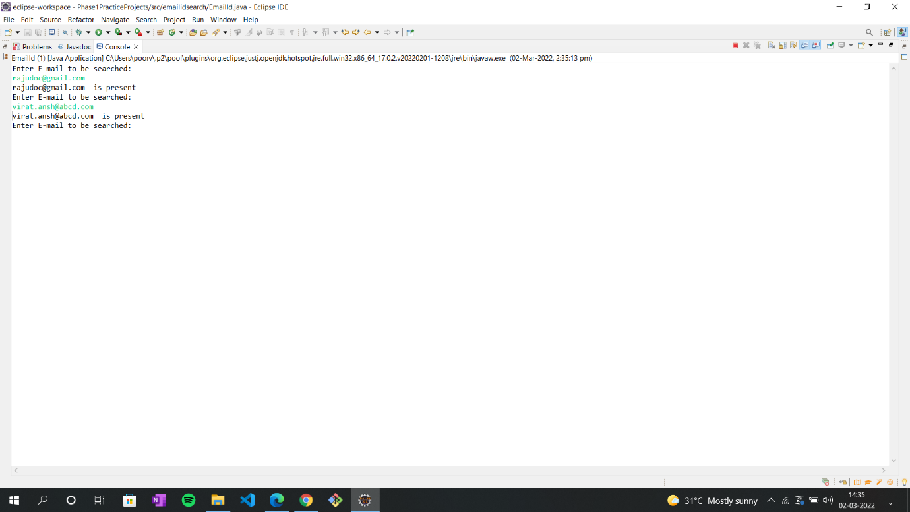

Output: When you enter the right Email ID which is present in the array list the asks for another ID till you enter the wrong ID.

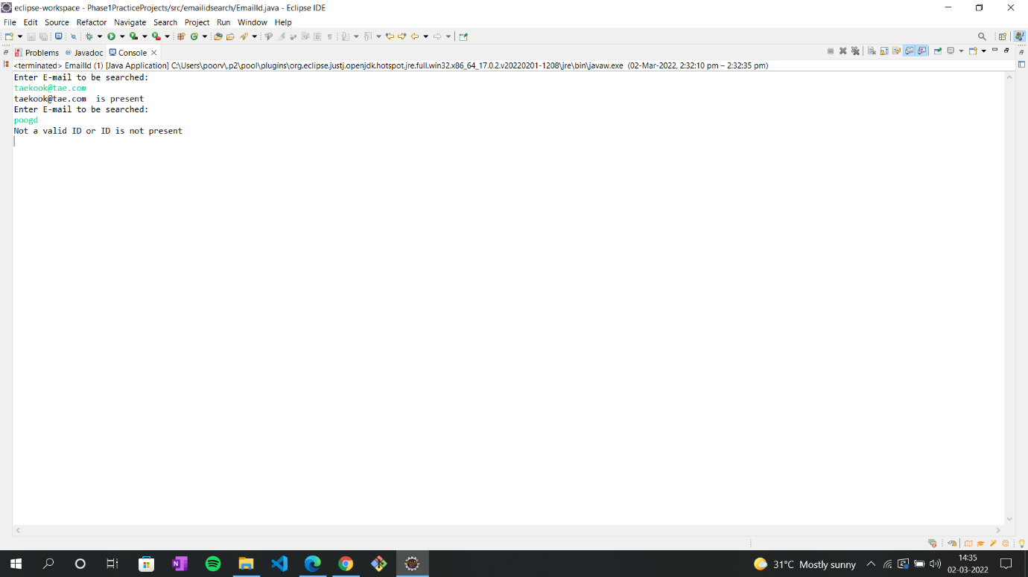

Output: Here when you enter wrong Email ID which is not present in the array of list it exits from the loop.