**Virtual Key for Your Repositories**

**Name: Poorvi R**

**Emp_Id: 2500928**

**Git:** [**https://github.com/poorviacharya44/Phase1PracticeProjects/tree/master/Phase1_VirtualKey_Project**](https://github.com/poorviacharya44/Phase1PracticeProjects/tree/master/Phase1_VirtualKey_Project)

**Description of the Project:**

**Project and Developer Details**

**Project Details:**

**Project Name: LockedMe.com**

It is file management system, which creates a root directory by creating a bin folder in the file application. It gives user the capability to list files/folder present in this root directory as well as add and remove files from this root directory. It also gives the user a capability to search all the files with a particular name in the directory.

**Developer Details:**

**Developer Name: Poorvi R**

**Company:** **Lockers Pvt. Ltd.**

**Developer Emp_Id: poorvir123**

**Sprint Details for the project**

**No. of Sprints Planned:** 2

* **Sprint 1 Details:**

In the first sprint a basic structure to the application was developed, with the simple capability of listing the files present in the directory.

The application has a three tier structure. The presentation layer, the business validation layer and the data access layer.

1. The presentation layer is the console, and the void main of the application corresponds to the presentation layer. It is responsible for taking the inputs from the user as well as showing the outcome/output to the user. Thus it is the layer which communicates with the user.
2. The Business Validation layer is responsible for validating the input from the user.
3. The data access layer process this user input and performs the operation as per the user input.

This basic structure was created using various classes and interfaces. Also the logic to list the files present in the root directory was developed.

* **Sprint 2 Details:**

The above application was enhanced to incorporate additional features like addition/ removal/ search of a file.

This included creating a submenu. And adding the above options. New methods had to be created for this purpose.

**Application Logic/flowchart**

The Application has a main menu, and a submenu/options. The main menu gives you an option to list all the files in the directory, navigate to the sub-menu/options and exit the application.

The sub-menu/options gives you an option to add a file, delete a file, search files from a directory.

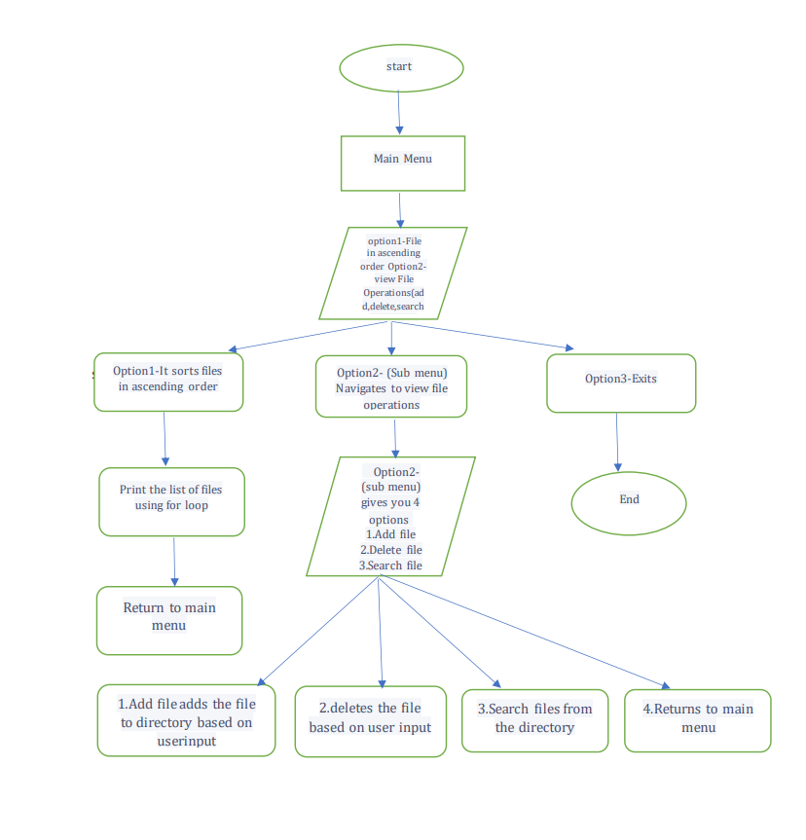

**Core concepts used in the project**

* Classes
* Exception Handling
* File class
* For, While, Switch Case, If-Else, and other logic related functions.

**Conclusion**

There is a huge scope of improvement in the present project. The USP of the project is that once fully developed it can act as a complete file management system and can be used by individuals to safe keep data. That is an additional feature that needs to be implemented thereby one can keep his data in a secure format in the lockedme app.