**Admin for Learner’s Academy**

**OUTPUT**

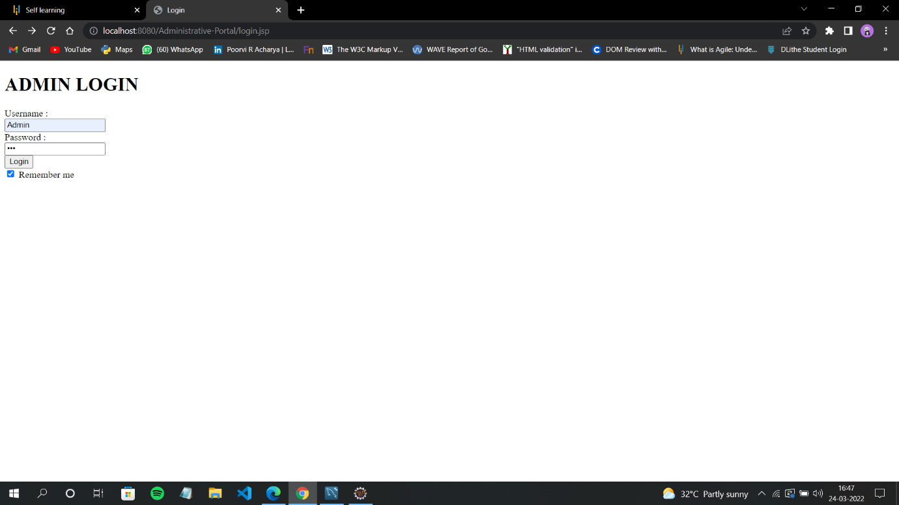**1.Admin logs in with username=Admin and Password=123**

**2.Administrative Portal will be displayed with other sections user is in classes section**

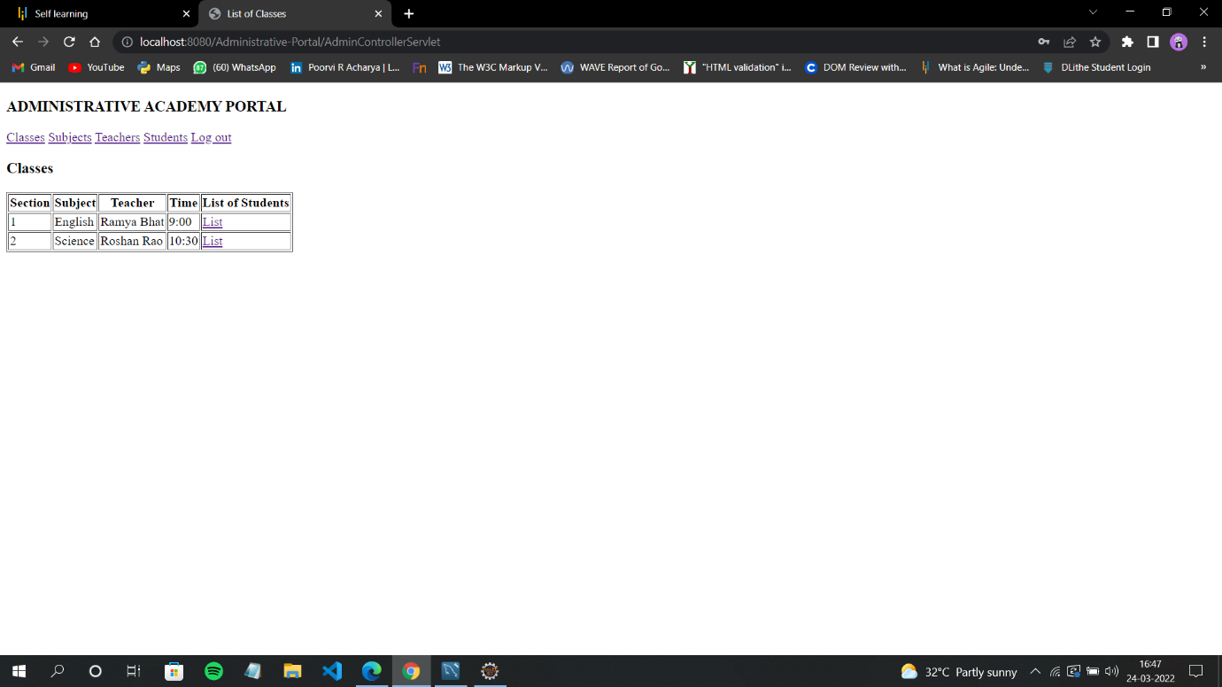

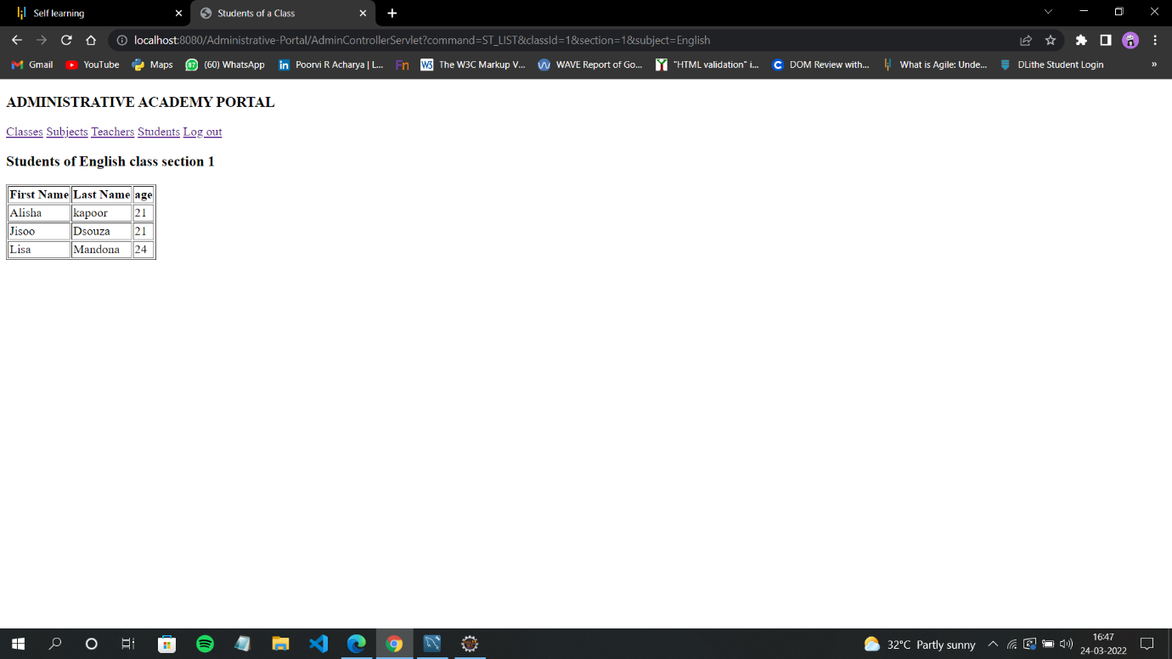**3.Admin clicks on list section 1**

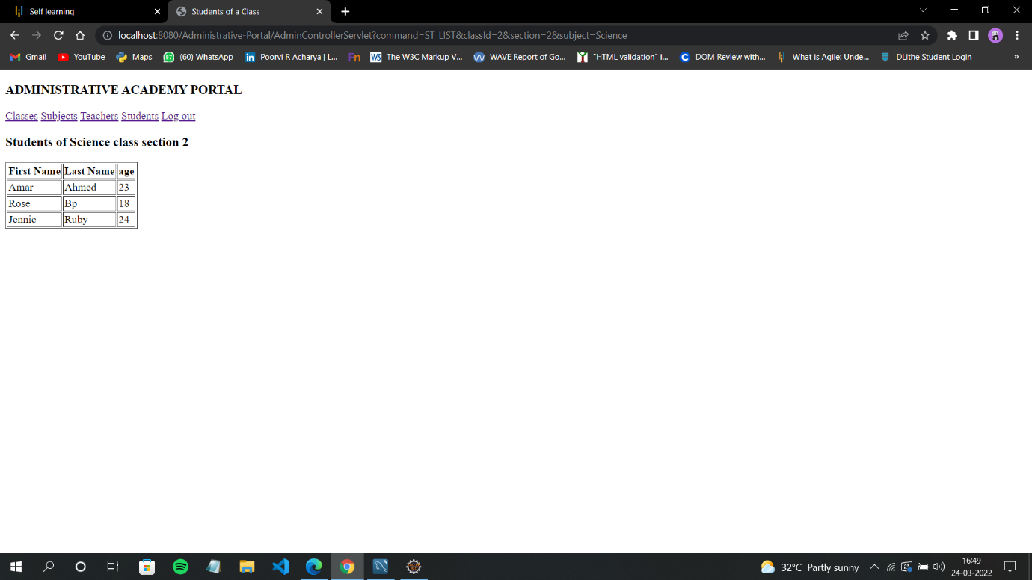4. **Admin clicks on list section 2**

**5.Admin navigates to subjects section**

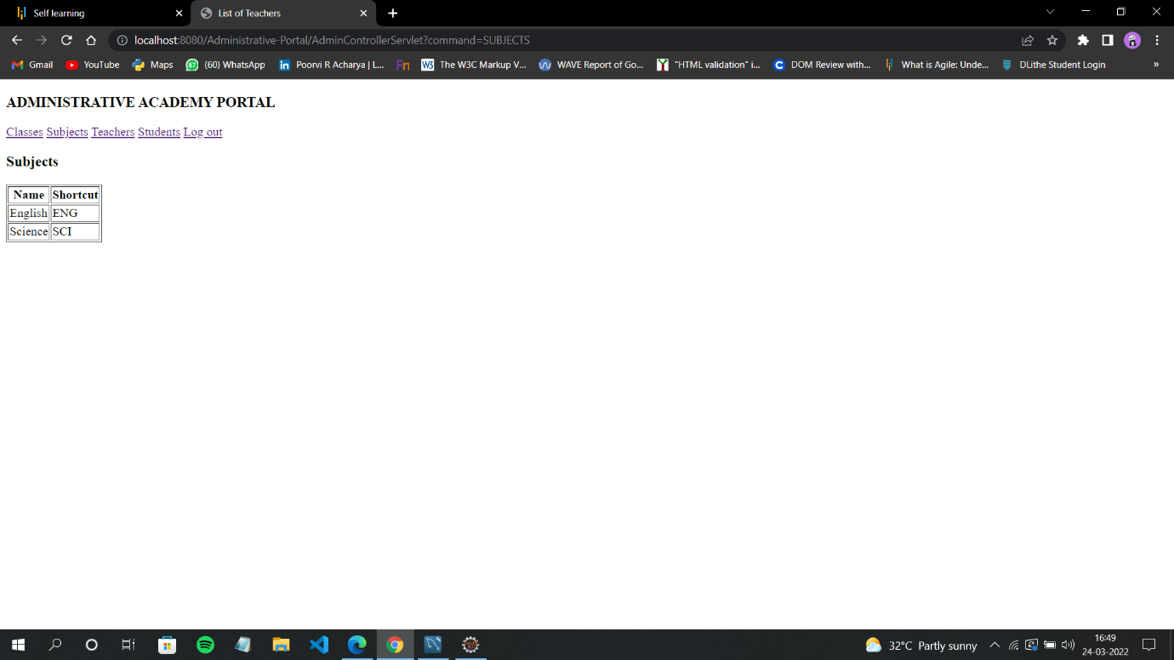

6. **Admin navigates to teachers section**

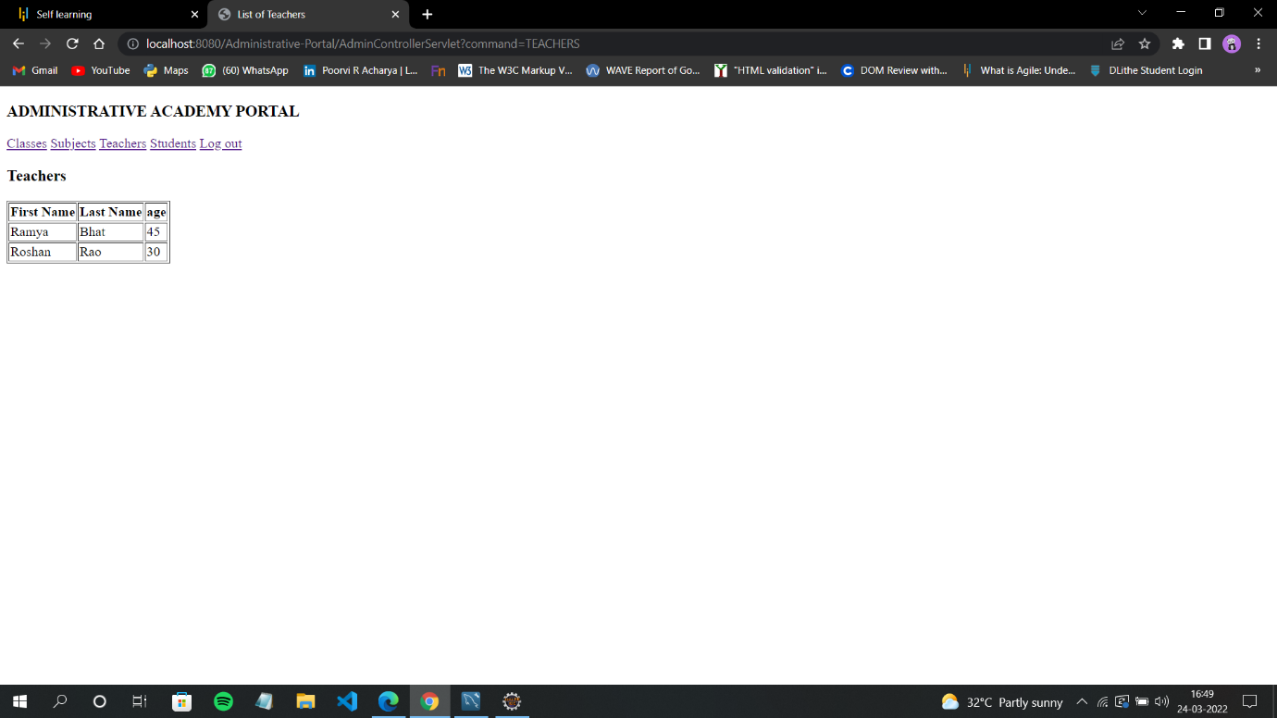

**7. Admin navigates to students section**

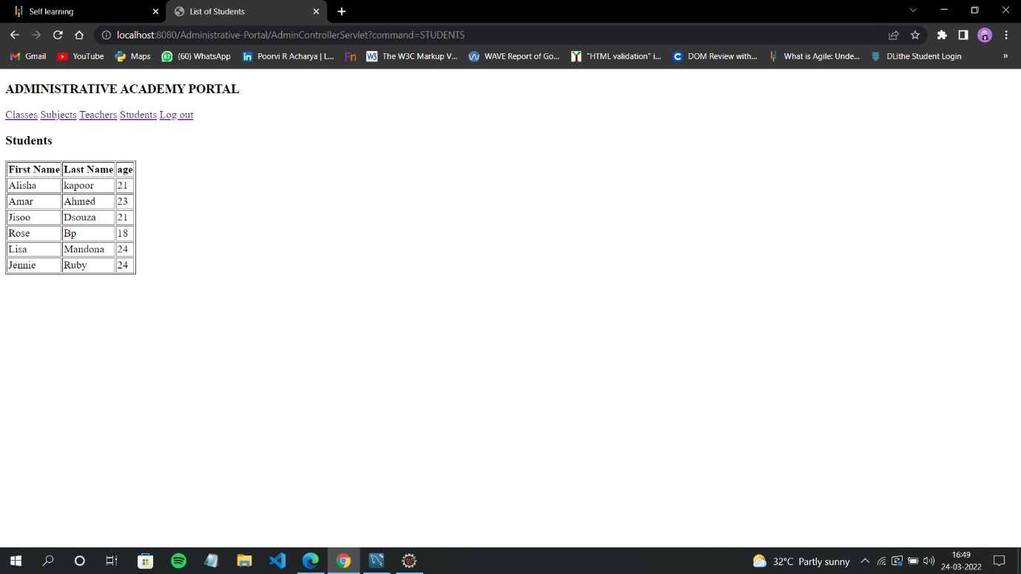

**8. Admin logs out of the portal**

