**Admin for Learner’s Academy**

**Name:Poorvi R**

**Github:** [**https://github.com/poorviacharya44/Phase1PracticeProjects/tree/master/Phase2-Admin_Learners_Academy_Project**](https://github.com/poorviacharya44/Phase1PracticeProjects/tree/master/Phase2-Admin_Learners_Academy_Project)

**Background of the problem statement:**

Learner’s Academy is a school that has an online management system. The system keeps track of its classes, subjects, students, and teachers. It has a back-office application with a single administrator login.

**Description of the Project:**

This project aims to design and develop a backend administrative portal for the Learner’s Academy using Java EE technologies. The goal of this project is to apply servlet, JSP and JDBC concepts.

**Technologies and tools Used**

* Servlet: to do the business logic and works a controller for the project.
* JSP: to handle the presentation view.
* SQL: to create and manage the database.
* JDBC: to make operations on the database for the project.
* Eclipse: to write and run the code.
* Tomcat: to run and deploy servlet application

**Core concepts used in the project.**

* Object-Oriented: used to create and model objects for users and their credentials.
* Databases: used to store and retrieve data.
* Data Sources: used to define a set of properties required to identify and access the database.
* Collections: used some collections such arraylist to store collection of data.
* Exception Handling: used to catch problems that arises in the code especially in I/O blocks.
* Cookies: to store log-in data on the client browser.

**Application Flowchart:**

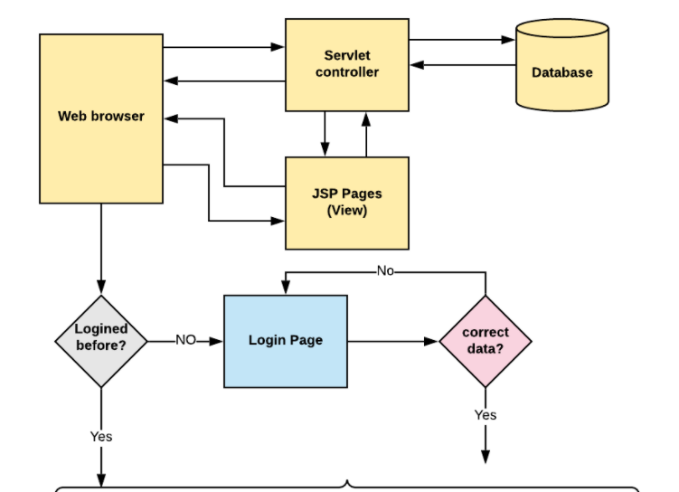

**Get Students data**

**GetTeachers data**

**Get Subjects data**

**Get classes data**

**Get class information**