**Searching for a Specific User and Updating the User Information.**

**Output**

**1.Main page**



**2.Users Page enter ID to be searched**

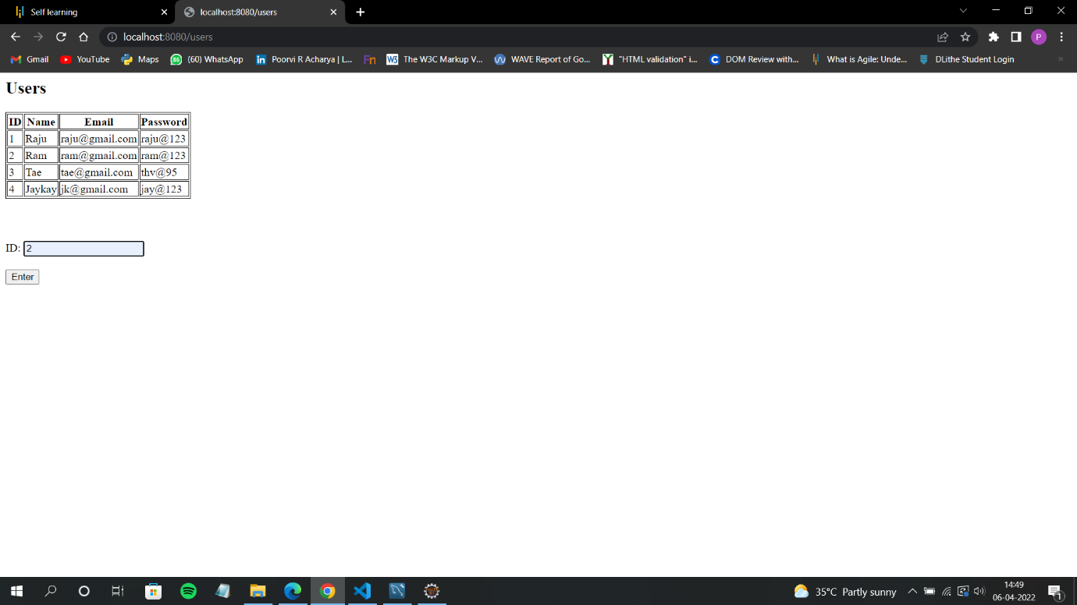

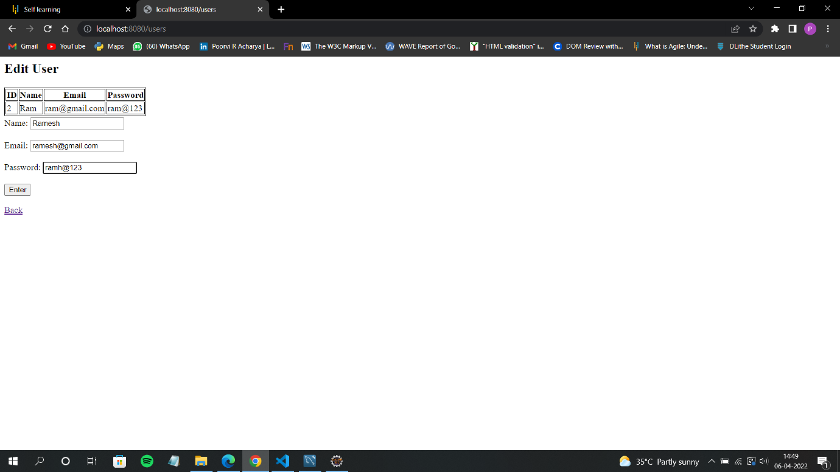**3.Update the User**

**4.Update Successful**



**Database Table:**

