**Displaying User Feedback**

**Output**

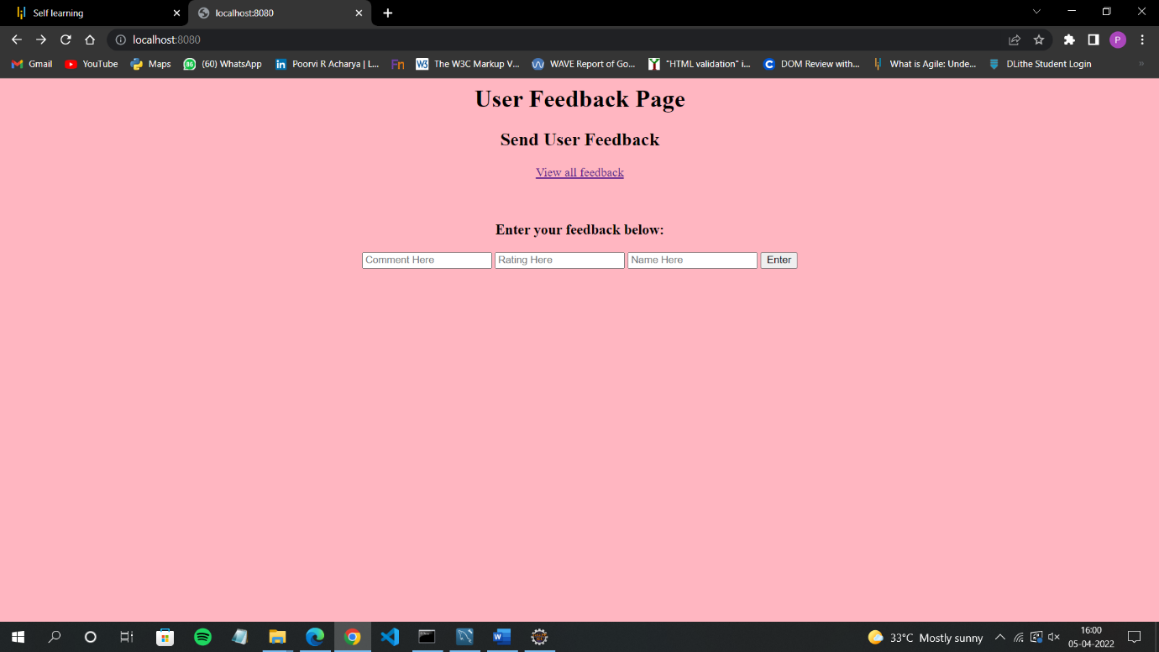**1.User feedback page**

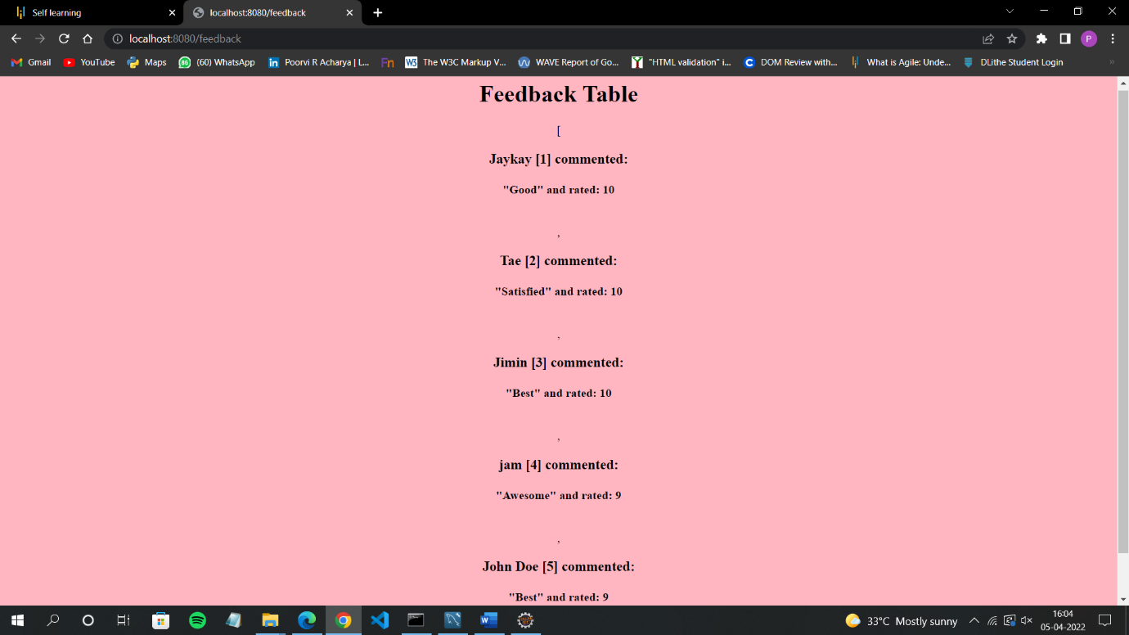**2.View feedback page**

**3.Enter your feedback**

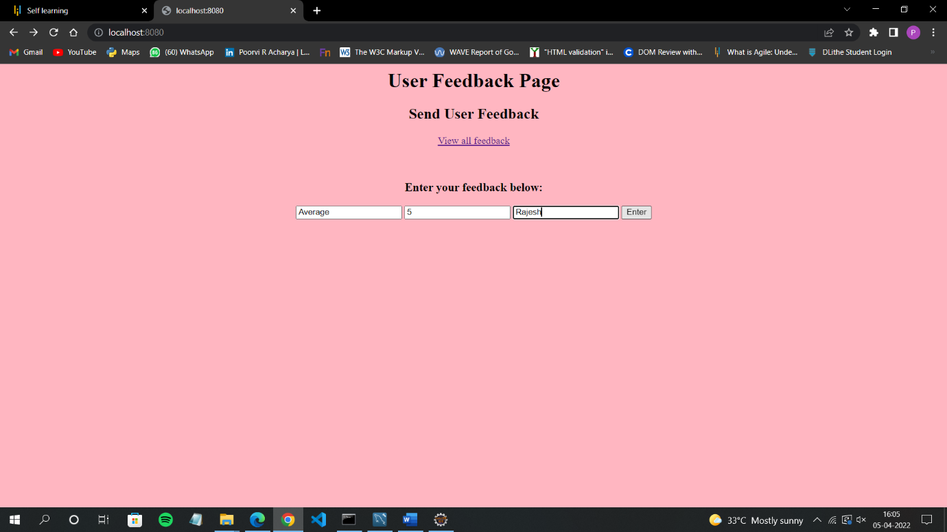

**4.Successfully added feedback**

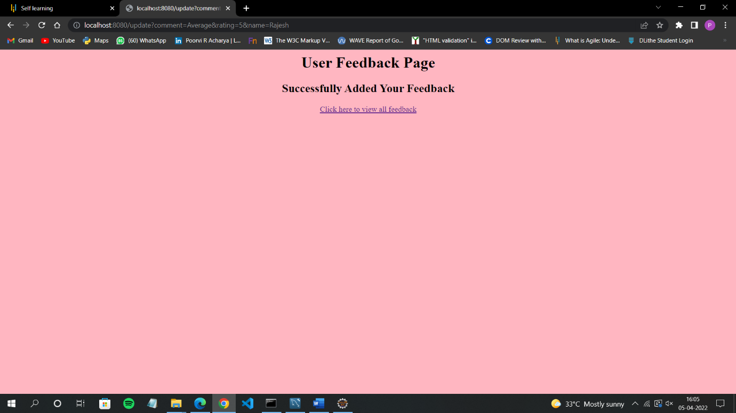

**5.View all feedback**

