VISVESVARAYA TECHNOLOGICAL UNIVERSITY


JNANA SANGAMA, BELAGAVI– 590018, KARNATAKA, INDIA
A MINI PROJECT REPORT
on
“ABC”
Submitted in partial fulfilment of the requirements for the award of
BACHELOR OF ENGINEERING
in
ARTIFICIAL INTELLIGENCE & MACHINE LEARNING
Submitted By
Name USN
ASWIN P 4VP21AI013
PUSHPAK K A 4VP21AI040
SHARADHI K 4VP21AI050
VINYAS U D 4VP21AI062
Under the Guidance of
Prof. ABC
Assistant Professor



DEPARTMENT OF ARTIFICIAL INTELLIGENCE & MACHINE LEARNING
VIVEKANANDA COLLEGE OF ENGINEERING & TECHNOLOGY
[A Unit of Vivekananda Vidyavardhaka Sangha Puttur (R)]
Affiliated to Visvesvaraya Technological University and Approved by AICTE New Delhi & Govt., of Karnataka
Nehru Nagar, Puttur - 574 203, DK, Karnataka, India.
NOVEMBER 2025

VIVEKANANDA COLLEGE OF ENGINEERING & TECHNOLOGY
[A Unit of Vivekananda VidyavardhakaSangha Puttur (R)]
Affiliated to Visvesvaraya Technological University and Approved by AICTE New Delhi & Govt. of Karnataka
Nehru Nagar, Puttur - 574203, DK, Karnataka, India

DEPARTMENT OF ARTIFICIAL ENGINEERING & MACHINE LEARNING


CERTIFICATE
Certified that the mini project work entitled “ABCDERF” is carried out by Mr. Aswin P, Mr. Pushpak K , Ms. Sharadhi K, Mr. Vinyas U D bearing USNs 4VP21AI013, 4VP21AI040, 4VP21AI050 and 4VP21AI062 respectively bonafide students of Vivekananda College of Engineering & Technology, Puttur in partial fulfilment for the award of Bachelor of Engineering in Artificial Intelligence & Machine Learning of the Visvesvaraya Technological University, Belagavi during the year 2025-26. It is certified that all corrections/suggestions indicated during Internal Assessment have been incorporated in the report deposited in the departmental library.
The project report has been approved as it satisfies the academic requirements in respect of Project work prescribed for the said Degree.

Signature of the Guide Signature of the HOD Signature of the Principal
Prof. Abcdefghijkl mnopq Prof. Abhishek Kumar K Dr. Mahesh Prasanna K

EXTERNAL VIVA
Name of the Examiners Signature with date

1…………………………….............. ....................................

2…………………………….............. ....................................

DECLARATION

We, Mr. Aswin P (4VP21AI013), Mr. Pushpak K A (4VP21AI040), Ms. Sharadhi K (4VP21AI050), Mr. Vinyas U D (4VP21AI062) students of B.E. 5th Semester in Artificial Intelligence & Machine Learning, Vivekananda College of Engineering & Technology, Puttur, hereby declare that the project work entitled “Arecanut Leaf Disease Detection And Classification Using Deep Learning” has been carried out by us at VCET, Puttur, under the guidance of Prof. ABC, Assistant Professor, Department of Artificial Intelligence & Machine Learning, Vivekananda College of Engineering & Technology, Puttur, and submitted in partial fulfillment of the requirements for the award of degree in Bachelor of Engineering in Artificial Intelligence & Machine Learning by Visvesvaraya Technological University, Belagavi during the academic year 2025-2026.

Name of the students | USN | Signature with date
Aswin P | 4VP21AI013
Pushpak K A | 4VP21AI040
Sharadhi K | 4VP21AI050
Vinyas U D | 4VP21AI062

Date:
Place: Puttur

ACKNOWLEDGEMENT

We take this opportunity to express our deep heartfelt gratitude to all those people who have helped us in the successful completion of the project.

First and foremost, we would like to express our sincere gratitude to our guide, Prof. Akshaya D Shetty for providing excellent guidance, encouragement and inspiration throughout the project work. Without her invaluable guidance, this work would never have been a successful one.

We would like to express our sincere gratitude towards our project coordinator, Prof. Ajay Shastry C G, Assistant Professor, Department of Artificial Intelligence & Machine Learning, for her guidance and inspiration.

We would like to express our sincere gratitude to Head of the Department, Department of Artificial Intelligence & Machine Learning, Prof. Abhishek Kumar K, for his guidance and inspiration.
We would like to thank our Principal, Dr. Mahesh Prasanna K for providing all the facilities and a proper environment to work in the college campus.

We would like to thank our management for providing the necessary infrastructure to carry out the project work

We are thankful to all the teaching and non-teaching staff members of Artificial Intelligence & Machine Learning Department for their help and needed support rendered throughout the project.

ABSTRACT

Arecanut is a vital commercial crop, extensively cultivated in tropical regions, particularly in parts of South India. Despite its significance, the crop is highly susceptible to several leaf diseases, such as yellow leaf disease and spot disease, which can severely affect plant health and reduce yield if not identified and treated in time. Traditional disease identification methods rely on manual inspection by farmers or agricultural experts, which can be time-consuming, inconsistent, and often inaccessible to those in remote areas. To address these challenges, this project proposes an intelligent and automated system that leverages deep learning techniques to detect and classify arecanut leaf diseases accurately.

The core of the system is a Convolutional Neural Network (CNN) model trained on a curated dataset of arecanut leaf images. The model is capable of classifying images into healthy, yellow leaf disease, or spot disease categories with high accuracy. This trained model is integrated into a user-friendly web interface built using Streamlit, allowing users to upload images or capture them directly using a device camera, external webcam, or IP webcam. The system not only provides immediate feedback on the health status of the leaf but also offers relevant precautionary measures and treatment recommendations based on the detected condition.

By combining real-time image processing with a lightweight and accessible application interface, the system empowers farmers with a practical tool for early disease diagnosis. This timely intervention helps prevent disease spread, reduces dependency on expert consultation, and supports more efficient crop management. The project demonstrates how AI and deep learning can be applied meaningfully in agriculture to enhance productivity, sustainability, and decision-making at the grassroots level.

TABLE OF CONTENTS

Title | Page No.
List of Figures | I
List of Tables | II
List of Abbreviations | III
CHAPTER 1 INTRODUCTION | 01
1.1 Introduction to the project | 01
1.2 Existing System | 01
1.3 Proposed System | 02
1.4 Scope of the Project | 03
1.5 Objectives of the Project | 03
1.6 Organization of The Report | 04
CHAPTER 2 LITERATURE SURVEY | 06
2.1 Summary of Literature Survey | 22
CHAPTER 3 ANALYSIS AND REQUIREMENT SPECIFICATION | 26
3.1 Introduction | 26
3.2 Existing System | 26
3.3 Non-Functional Requirements | 27
3.4 User Interface Requirements | 28
3.5 Software Requirements | 29
3.5.1 TensorFlow | 29
3.5.2 Keras | 30
3.5.3 OpenCV | 30
3.5.4 Numpy | 31
3.5.5 Streamlit | 32
3.6 Hardware Requirements | 33
CHAPTER 4 SYSTEM DESIGN | 35
4.1 Introduction | 35

  - Overview of the Proposed System 35
  - Block Diagram 35
CHAPTER 5 SYSTEM IMPLEMENTATION 38
  - Introduction 38
  - Algorithm Used 38
    - Convolutional Neural Network (CNN) 38
    - Image Pre-processing and Augmentation 39
    - Mel Spectrogram Feature Extraction 40
    - Adam Optimizer 41
    - Class Label Prediction 41
  - Implementation 41
    - About Dataset 42
    - Workflow 42
CHAPTER 6 RESULT AND DISCUSSIONS 45
  - Snapshots 45
CHAPTER 7 CONCLUSION AND SCOPE FOR 57
FUTURE ENHANCEMENT
  - Conclusion 57
  - Scope for future enhancement 57
REFERENCES 59
PERSONAL PROFILE 62

LIST OF FIGURES

Figure No. | Title | Page No.
4.1 | Block Diagram of Proposed System | 36
6.1 | GUI Window for Arecanut-leaf disease detection | 45
6.2 | Displays a File Explore for Image upload option | 46
6.3 | Capturing Image from IP Webcam and Prediction Display | 47
6.4 | Capturing Image from IP Webcam and Prediction Display | 48
6.5 | Capturing Image from External Camera and Disease Prediction | 49
6.6 | Result of Uploaded Image with Spot Disease Prediction and  Remedies | 50
6.7 | Detection of Non Arecanut Leaf | 51
6.8 | Remedies Page for Yellow Leaf Disease | 52
6.9 | Training and Validation Accuracy Across Epochs | 54
6.10 | Loss VS Epochs | 55

I

LIST OF TABLES

Table No. | Title | Page No.
2.1 | Summary of Literature Survey | 22
6.1 | Feature Values of Healthy Leaf | 53
6.2 | Feature Values of Yellow Diseased Leaf | 53
6.3 | Feature Values of Spot Diseased Leaf | 54

LIST OF ABBREVIATIONS

Abbreviation Description
CNN Convolutional Neural Network
MFCCs Mel-Frequency Cepstral
Coefficients
ROC curve Receiver Operating Characteristic curve
ReLU Rectified Linear Unit
Grad-CAM Gradient-weighted Class Activation Mapping
SVM Support Vector Machine
R-CNN Region Based CNN
GUI Graphical User Interface
YOLOv5 You Only Look Once version 5
MDSS Medical Decision Support System
MCC Matthews Correlation Coefficient
ANN Artificial Neural Network
CLAHE Contrast Limited Adaptive Histogram Equalization
Grad-CAM Gradient-weighted Class Activation Mapping
RNN Recurrent Neural Networks
NumPy Numerical Python
LSTM Long Short-Term Memory

CHAPTER 1

INTRODUCTION

Introduction to the Project

The world today faces a serious issue: too much good food is wasted while many people are still hungry. Every year, massive amounts of food are thrown away. This costs a lot of money and creates a big problem for the environment. The simple old-fashioned ways of donating leftover food are usually too slow and the food often spoils before it reaches anyone.

The ANNAMITRA project which we call the "Left Over Food Sharing App" is a smart tech-based answer to this problem. It is designed as one easy-to-use digital platform that quickly connects people who have extra food (like restaurants and homes) with people who need it (like charities or individuals).

The most important part of ANNAMITRA is the use of Artificial Intelligence (AI) and Machine Learning (ML), specifically a Convolutional Neural Network (CNN). This smart technology does two key jobs:

Dietary Classification: When a donor uploads a picture of the food, the CNN instantly analyzes the image. It figures out the food type and most importantly if it is Vegetarian (Veg) or Non-Vegetarian (Non-Veg). This makes sure that recipients receive food that matches their dietary needs right away.

Fastest Match Finding: The system takes the food details and the donor's exact location. It then uses a math rule called the Haversine formula to quickly calculate the shortest distance to all nearby receivers. This fast, planned matching ensures the extra food gets to the closest person quickly, keeping it fresh and avoiding waste.
ANNAMITRA uses digital tools and smart planning to turn an unorganized effort into a strong, reliable system that helps the community, reduces waste, and supports people in need.

Existing System

In the current system food donation is mostly done through manual communication or informal methods. People who want to donate leftover food usually contact nearby NGOs, orphanages or volunteers through phone calls or social media. These traditional methods are slow and unorganized. Many times, food donors are not aware of who actually needs food in their area and as a result good food often goes to waste.

There are a few mobile apps and organizations that try to connect donors and receivers, but they are limited in features. Most of these platforms do not use Artificial Intelligence (AI) or location-based systems to make the process faster. In such systems, users have to manually enter food details, location, and type, which takes time. There is also no way to automatically classify food as vegetarian or non-vegetarian. Because of this the chances of mismatched or delayed donations are high.

Moreover, existing systems do not focus on real-time tracking or quick matching between donors and receivers. The lack of smart features like automated classification, distance calculation, and notifications makes them less efficient. This leads to slow response time, and often, the food becomes unusable by the time it reaches those in need.

Overall, the current food donation process is less effective because it lacks automation, proper coordination, and real-time connection between donors and receivers. This is why a smarter AI-based system like ANNAMITRA is needed to make the process easier, faster, and more reliable.

Proposed System

The ANNAMITRA – Left Over Food Sharing App is designed to solve the problems faced in the existing food donation process by using modern technology. It provides a smart, automated, and easy-to-use digital platform that connects food donors and receivers directly. The system uses Artificial Intelligence (AI), Machine Learning (ML), and location services to make food sharing faster more accurate, and reliable.

In this system, donors can upload details of the food they want to share, such as food name, quantity, and location, along with a picture. When the image is uploaded the app uses a Convolutional Neural Network (CNN) model to analyze the photo and automatically identify the food type. It also classifies the food as Vegetarian or Non-Vegetarian. This automatic categorization helps receivers quickly decide what kind of food is available before requesting it.

The system also uses live location tracking with the help of GeoPy and OpenStreetMap API. This allows the application to show nearby food donations based on the receiver’s location. The distance between the donor and receiver is calculated using the Haversine formula which ensures that the nearest available food is shown first. This helps in reducing delivery time and prevents food from getting spoiled.

All data such as user details, food information, and locations are stored securely in a SQLite database. The backend of the system is developed using Flask which handles user authentication, data storage, and communication between users and the AI model. The system ensures that all user information and food details are safely managed.

Compared to the existing manual process, this system is faster, more accurate, and fully automated. It reduces human effort and ensures that leftover food reaches people in need before it goes to waste. Overall, ANNAMITRA creates a smart, efficient, and community-driven platform for responsible food sharing

Scope of the Project
This project has a wide scope as it aims to reduce food wastage and connect donors with people who need food in a simple and organized way. It can be used by individuals, restaurants, hotels, event organizers, and NGOs to share leftover food through a web or mobile platform. The system uses Artificial Intelligence to identify food type and category and location tracking to show nearby donations which makes the process quick and efficient. All user and food details are securely stored in a database ensuring smooth data management. In the future the app can be expanded to include delivery partners, volunteer groups, and automatic pickup scheduling to make food sharing even easier. It can also generate useful reports showing the total food shared and the number of people helped. By reducing food waste the project supports sustainable living and encourages social responsibility. Overall, ANNAMITRA has the potential to grow into a complete digital system that helps create a hunger-free and eco-friendly society.

Organization of the Report

This report is divided into several chapters, each explaining a different part of the project in a simple and logical order. It helps the reader clearly understand the purpose of the project the process followed during its development and the final outcomes achieved through the proposed system.
Chapter 1 introduces the project and gives an overall idea about the ANNAMITRA – Left Over Food Sharing App. It explains the growing problem of food wastage, the main goals of the project and how Artificial Intelligence and Machine Learning are used to make the food-sharing process smarter and faster. The chapter also highlights the motivation, objectives, and scope of the project.
Chapter 2 provides the literature survey explaining existing systems and related research work. It reviews different methods and tools that are currently used for food donation and classification. This chapter also compares traditional systems with the proposed ANNAMITRA system and shows how AI-based automation and location tracking make it more efficient.
Chapter 3 focuses on the system design and architecture. It explains the various modules, including user management, food detection using CNN, and location-based matching. The chapter also includes diagrams like data flow diagrams and use case diagrams to visually describe how the system works internally.
Chapter 4 discusses the system implementation, covering both the software and hardware requirements. It describes how the backend was developed using Flask how the AI model was trained using TensorFlow and Keras and how different components were integrated to form a complete working system. Screenshots and output results of the working application are also presented in this chapter.
Chapter 5 presents the results, advantages, and applications of the system. It summarizes the key achievements of the ANNAMITRA app such as accurate food classification, easy donation process, and real-time food tracking. This chapter also discusses the project’s benefits, future scope, and concludes by emphasizing how the system contributes to reducing food wastage and helping people in need.
The References section lists all the books, research papers, websites, and online materials that were used while developing and studying the project.

CHAPTER 2

LITERATURE SURVEY

P. Barbedo et al. [1], have proposed a model “Digital image processing techniques for detecting, quantifying and classifying plant diseases”. The study highlighted one of the major challenges in accurate disease diagnosis is the availability of uncontrolled variables like lighting variations, diverse backgrounds, and inconsistent leaf shapes in captured images. The paper proposes using a sequence of pre-processing techniques, such as image segmentation, color space transformation, and histogram equalization to enhance image quality before classification. These methods allow better isolation of disease-affected regions, especially in complex natural scenes. It demonstrates that effective segmentation and reducing noise can greatly enhance the reliability of traditional classifiers. Although the study does not use deep learning methods like CNNs, it provides a critical foundation for pre-processing pipelines used in later CNN-based models. The paper also discusses various metrics for evaluating classification performance, including precision and recall, while acknowledging that conventional image processing struggles with scalability and adaptability in highly variable conditions. The conclusion emphasizes that image pre- processing is not merely an optional step, but a fundamental necessity for any robust plant disease detection system. Future work is suggested in the direction of integrating these pre- processing pipelines with more advanced machine learning algorithms to achieve automation. This research is particularly relevant for early studies in the domain of plant pathology, offering a baseline understanding of how digital images can be leveraged for disease detection. In the context of arecanut disease detection, this paper reinforces the importance of pre-processing steps before CNN-based classification, especially for field- level data.

Ferentinos et al. [2], have designed a model “Deep learning models for plant disease detection and diagnosis”. This study used a dataset containing 87,848 images across 25 plant species and 58 disease classes, collected under both controlled and natural conditions. The author experimented with five CNN architectures including AlexNet, GoogLeNet, and VGGNet, comparing their accuracy in classifying plant diseases. The best-performing model, a fine-tuned AlexNet, achieved an average validation accuracy of 99.53%,

indicating deep learning's exceptional potential in agricultural diagnostics. The paper emphasizes that unlike traditional machine learning methods that require manual feature extraction, CNNs can automatically learn spatial hierarchies of features, significantly improving classification performance. The study also discusses the use of data augmentation techniques such as rotation and flipping to artificially expand the dataset and reduce overfitting. The results suggest that CNNs can reliably classify diseases even when the images are taken under non-ideal conditions such as poor lighting or background noise. Moreover, the findings reinforce the practicality of deploying such systems in mobile-based or field-ready applications for real-time disease detection. Ferentinos concludes that deep learning, with its scalability and robustness, offers a revolutionary approach to plant pathology. This paper directly supports the proposed arecanut leaf disease detection system by validating the effectiveness of CNNs in multi-class plant disease recognition and justifying the choice of image-based deep learning models for agricultural use cases.

Amara et al. [3], have explored a model “A Deep Learning-based approach for banana leaf diseases classification”. The researchers curated a dataset consisting of high-resolution banana leaf images captured under real-world agricultural settings, addressing common field challenges like background clutter and lighting variability. The model architecture was designed with multiple convolutional and pooling layers, followed by fully connected layers and a softmax output for multi-class classification. The proposed system achieved an accuracy of over 96%, highlighting CNNs' effectiveness in detecting visual disease symptoms like spots, discoloration, and texture irregularities. One of the key highlights of the study was the implementation of data normalization and augmentation strategies, which significantly improved generalization and reduced overfitting. The authors also emphasized the simplicity of the model, which makes it suitable for deployment on lightweight devices, such as mobile applications for farmers. Furthermore, the study compared the CNN model’s performance against traditional classifiers and found it superior in terms of precision, recall, and overall classification accuracy. The results support the hypothesis that deep learning can adapt to specific crops and disease patterns when provided with quality image data. This work provides an excellent case study in adapting CNNs to detect diseases in niche crops, reinforcing the relevance of deep learning in resource-constrained environments. The methodology and findings from this paper offer a solid reference for

designing similar systems for other crops like arecanut, validating the usage of dedicated CNN models in agricultural disease diagnosis.

Sladojevic et al. [4], have developed a model “Deep neural networks-based detecting plant diseases using leaf images classification”, proposed CNN model that classifies plant leaf diseases across 13 plant types including tomato, corn, grape, and others. The dataset was composed of thousands of labelled leaf images with varying symptoms and backgrounds. Their model architecture included four convolutional layers interleaved with max-pooling, ReLU activation, and dropout for regularization, followed by a fully connected output layer using softmax. The system achieved high classification accuracy of up to 96.3% across multiple classes, demonstrating the capability of deep learning to handle diverse visual disease patterns. A key contribution of this work was the intuitive and user-friendly implementation that allowed integration into desktop and mobile environments. The authors used TensorFlow and OpenCV for image processing and training, showing that deep learning systems could be designed with accessible open-source tools. The study also addressed challenges in differentiating between diseases with similar symptoms by increasing depth in the model to capture complex feature hierarchies. Furthermore, compared their model's performance with other standard Machine Learning algorithms and reported significant improvements in both accuracy and processing speed. The paper is often cited as one of the early implementations of CNNs in agricultural diagnostics, bridging academic research and real-world usability. For the current project, which aims to identify and classify arecanut leaf diseases, this paper provides a foundational understanding of CNN design, pre-processing requirements, and how to build scalable image-based disease classifiers for practical deployment.

Mohanty et al. [5], have explored a model “Using Deep Learning for image-based plant disease detection”, This model used deep CNN architectures AlexNet and GoogLeNet to classify 26 diseases across 14 crop species using 54,306 images from the PlantVillage dataset. The research showed that GoogLeNet achieved an impressive accuracy of 99.35% while AlexNet closely followed with 98.86%, setting new benchmarks in plant disease detection using image-based classification. The dataset included both healthy and diseased plant leaves captured in controlled and semi-natural conditions, providing a balance between ideal and real-world scenarios applied data augmentation and Transfer Learning

techniques to enhance generalization and overcome overfitting. The study highlighted that pretrained models on ImageNet could be fine-tuned effectively to agricultural datasets, reducing the need for massive labelled image collections. Performance was evaluated using metrics such as accuracy, precision, recall, and F1-score. The results demonstrated that deep CNNs can distinguish between disease classes with very similar visual symptoms, such as early and late blight in potatoes. Additionally, the authors proposed deploying the trained models through a web interface or mobile app to make disease diagnosis accessible to farmers. Their work laid the foundation for later mobile-based diagnostic applications in agriculture. For this project on arecanut leaf disease detection, the findings strongly support the choice of using pretrained CNN architectures and confirm that high classification performance is achievable with careful model tuning and data pre-processing.

Chouhan et al. [6], have developed a model “A hybrid model for plant disease detection using acoustic and image processing techniques”. The study aimed to expand disease monitoring beyond visual symptoms by including data from environmental sounds that could signal pest activity or stress. The model utilizes CNNs to process leaf images and extract spatial features such as texture, color, and disease spots. Simultaneously, it incorporates acoustic data using time-frequency signal analysis techniques like spectrograms and Mel-Frequency Cepstral Coefficients (MFCCs), which are then fed into a parallel CNN pipeline. The fusion of these modalities occurs at the feature level, creating a hybrid model capable of identifying disease-related patterns from both visual and audio signals. The model achieved an overall classification accuracy of 95.8% on a multi-crop dataset, outperforming traditional single-modality classifiers. The paper also explored the role of pre-processing such as background removal and noise filtering in both image and audio data. The hybrid model proved particularly effective in distinguishing between diseases with similar leaf symptoms but different acoustic environments, such as pest- related issues versus nutrient deficiencies. This multi-sensory approach offers a promising direction for future agricultural monitoring systems. The relevance of this study to the arecanut disease detection project lies in its demonstration of how CNNs can be adapted and extended into multimodal systems, allowing for greater flexibility and accuracy in detecting complex plant health conditions beyond visual symptoms alone.

Brahimi et al. [7], have introduced a model “Deep learning for tomato diseases:

Classification and symptoms visualization.” This used CNN-based approach for detecting tomato leaf diseases along with a built-in visualization mechanism to highlight diseased regions. The study curated a dataset composed of images reflecting early blight, late blight, and leaf mold, among others, collected under controlled and semi-controlled conditions. The authors trained a CNN architecture from scratch and also experimented with fine- tuning pre-trained models such as VGG16. The model achieved a classification accuracy of 95.22% when trained using original images and over 96% when supplemented with augmented images. A key innovation in this paper is the use of Class Activation Maps (CAMs), which visualize which parts of the leaf image influenced the model’s decision the most. This approach improves model interpretability and builds user trust, which is vital in agricultural settings where farmers need to understand predictions rather than blindly follow them. The study also focused on the effect of various preprocessing methods like contrast enhancement, background suppression, and leaf segmentation. Their results confirmed that a well-structured CNN model combined with careful preprocessing and data augmentation leads to significant performance gains. Additionally, the paper emphasized the potential for deploying such a system in mobile-based diagnostic tools. This work is highly relevant to the current arecanut leaf disease detection project as it reinforces the effectiveness of CNNs in disease classification and highlights the importance of interpretability, particularly for users in non-technical rural environments where trust in technology is critical.

Szegedy et al. [8], have proposed a model “Going deeper with convolutions”, introduced the revolutionary Inception architecture, also known as GoogLeNet, which changed the landscape of deep learning by improving model depth without increasing computational burden. The paper addresses the problem of vanishing gradients and excessive computational cost faced by earlier deep CNNs. The Inception model utilizes parallel convolutional layers with varying filter sizes (1x1, 3x3, and 5x5), allowing it to capture both fine and coarse details within the same layer. The use of 1x1 convolutions significantly reduces dimensionality, enabling deeper networks while maintaining efficiency. The model was tested on the ImageNet dataset and achieved a top-5 error rate of 6.67%, outperforming previous architectures like AlexNet and ZFNet. This innovation made it possible to train very deep models on limited hardware, which is particularly important in resource-

constrained environments such as agriculture. The authors also introduced auxiliary classifiers to combat overfitting and vanishing gradients, which serve as intermediate supervision for earlier layers in the network. Although the paper does not specifically target agriculture or plant disease detection, it provides the architectural backbone for many high- performing plant disease classifiers developed later. For the current arecanut project, the insights from this paper support the use of efficient, multi-scale feature extraction models like MobileNet or InceptionV3, especially when deploying the solution on mobile platforms. The study’s contribution lies not just in model performance but in making deep learning more accessible and scalable, both critical for real-time field applications in crop health monitoring.

Ravi et al. [9], have developed a model “Deep learning for health informatics”, explored the application of modern CNN architectures such as ResNet and InceptionV3 in health- related domains, with one section focusing on agricultural disease diagnostics. The study introduces a comprehensive pipeline that incorporates data preprocessing, model training, and prediction using Deep Learning models for identifying plant diseases. In the context of agriculture, they tested the models on multiple leaf image datasets across a variety of crops, achieving an accuracy range between 92% and 97% depending on the disease class and plant type. A major strength of their approach is the use of transfer learning, where pre- trained models on large datasets like ImageNet are fine-tuned on smaller, domain-specific datasets. This significantly reduces the need for large labeled agricultural datasets, which are often scarce or expensive to curate. The authors also integrated batch normalization and dropout layers to stabilize training and prevent overfitting, especially on smaller datasets. They further evaluated the models using ROC curves, precision-recall analysis, and class- wise confusion matrices to ensure robust performance across all disease categories. Additionally, the paper discusses the importance of building lightweight and portable models for real-world deployment, such as in rural farming communities. For the current project focused on arecanut leaf disease detection, the approach and results presented by Ravi et al. validate the use of ResNet-based architectures, especially when paired with transfer learning, and offer proven strategies for training robust CNNs under data- constrained conditions, which is often the case for region-specific crops like arecanut.

Pathak et al. [10], have proposed a model “Hybrid approach for plant disease detection

using ML and image processing”, proposed a model that combines traditional image processing with deep learning for accurate classification of plant diseases. Their approach uses Convolutional Neural Networks (CNNs) for extracting visual features from leaf images and then applies a decision tree classifier for final classification. The dataset consisted of 3,000 annotated leaf images from multiple crops including tomato, grape, and citrus, captured under natural lighting and varying backgrounds. Prior to classification, preprocessing steps such as noise reduction, color segmentation, and contrast enhancement were applied to highlight the symptomatic regions of interest. The CNN used in this hybrid framework included three convolutional layers with ReLU activation followed by max- pooling, and the resulting feature maps were flattened and fed into a decision tree for classification. The hybrid model achieved an overall accuracy of 94.7%, outperforming both standalone CNNs and classical machine learning models. The study highlighted that decision trees offered better interpretability and faster prediction times, while CNNs contributed superior feature extraction. Additionally, the model’s performance was evaluated using cross-validation, confusion matrices, and class-wise recall scores. A significant the value this paper brings is its balance between accuracy and computational efficiency, making it suitable for real-time agricultural applications. For the proposed arecanut leaf disease detection system, this study demonstrates the potential of hybridizing CNNs with classical classifiers to improve interpretability and model performance, especially in systems where model transparency and responsiveness are crucial for end- user trust and usability in field conditions.

Ghosal et al. [11], have introduced a model “An explainable deep machine vision framework for plant stress phenotyping”, applied transfer learning techniques to detect plant diseases and stress symptoms in crops like tomato and grapevine. The research emphasizes the use of pre-trained CNN architectures such as VGG16 and ResNet50, fine- tuned on a relatively small, domain-specific dataset. The authors collected around 1,500 labeled images reflecting various types of biotic and abiotic stress symptoms, including disease lesions, nutrient deficiency signs, and environmental stressors. By leveraging transfer learning, the models were highly accurate in classifying while avoiding the need for training from scratch. The paper also focuses on model interpretability by employing Grad-CAM (Gradient-weighted Class Activation Mapping), allowing the visualization of

areas in the input images that had the highest influential in the model’s decision-making. This helps users especially farmers and agronomists understand and trust the system’s predictions. The researchers also integrated a feedback mechanism that allowed users to validate predictions and suggest corrections, further refining the model over time. The results showed an overall classification accuracy of 93.2%, with high recall and precision scores across classes. This paper is particularly relevant to the proposed arecanut disease detection project as it demonstrates the effectiveness of transfer learning with small datasets and shows the added value of interpretability. The use of pre-trained networks like ResNet50 can help overcome dataset limitations, while the explainability tools help build user confidence in the system’s output, both which are critical for deploying practical diagnostic tools in agriculture.

Nicolas et al. [12], have examined a model “Automatic plant disease detection using CNNs with small datasets”, addressed a critical limitation in plant pathology research the lack of large, high-quality datasets for training deep learning models. The authors designed a CNN architecture that could effectively learn from as few as 800 images across three disease classes of bean and rice leaves. Their model consisted of three convolutional layers followed by two dense layers and a softmax output layer. The paper focused on achieving high accuracy with limited data by applying regularization techniques such as dropout and L2 weight penalties. Moreover, they applied aggressive data augmentation rotation, flipping, zooming, and brightness shifting to synthetically enlarge the dataset and improve the model’s generalization. The model was evaluated using 5-fold cross-validation and achieved a classification accuracy of 91.4%, outperforming other conventional classifiers such as SVM and Random Forest. A noteworthy aspect of the paper is its emphasis on accessibility; the authors built the model using TensorFlow Lite to ensure deployment on mobile devices, enabling real-time disease detection in low-resource settings. The study also highlights the usability aspect by designing a simple interface to interact with the model through image uploads or live camera capture. This paper supports the current arecanut project by demonstrating that accurate and reliable disease detection can still be achieved even when the available dataset is small. It emphasizes the importance of model simplicity, data augmentation, and mobile-readiness factors that are essential when designing tools for rural farmers with limited technical resources.

Sankaran et al. [13], have proposed a model “Deep learning-based classification of coffee leaf images for disease detection”, This CNN model identify major diseases affecting coffee plants, particularly coffee leaf rust and cercospora. The dataset comprised 2,100 high-resolution leaf images collected from coffee plantations in South India under different lighting, angle, and background conditions to simulate real-world environments. The CNN architecture featured five convolutional layers with ReLU activation and max-pooling, followed by two dense layers and a softmax output for classification into three classes healthy, rust-infected, and cercospora-infected. The model achieved an overall accuracy of 91.87%, with individual class precision and recall scores exceeding 90%. The study implemented various image preprocessing techniques including resizing, normalization, and background suppression to improve feature clarity. Furthermore, the authors compared the performance of their CNN model against other classifiers such as logistic regression and SVM, finding that deep learning outperformed traditional methods significantly. They also explored the impact of training size on model performance and concluded that a well- augmented medium-scale dataset was sufficient for accurate predictions. The practical implications of this study were highlighted through a prototype mobile application, demonstrating the model’s potential for field deployment. For the current arecanut leaf disease detection project, this study validates the feasibility of using CNNs in region- specific crops and underlines the importance of collecting high-quality images in diverse environmental conditions. The focus on practical deployment and field-readiness aligns well with the goals of building an efficient and farmer-friendly disease detection system.

Shoaib et al. [14], have analyzed a model “A survey on Deep Learning approaches for plant disease detection”, investigated a wide range of CNN architectures used in agricultural diagnostics. The authors examine both traditional deep learning models like AlexNet, VGGNet, ResNet, and GoogLeNet, as well as more compact models like MobileNet and SqueezeNet that are optimized for real-time, edge-level deployment. The paper emphasizes the advantages of deep learning models in detecting disease symptoms in leaf images with minimal preprocessing. Key challenges discussed include limited dataset availability, high inter-class similarity of leaf diseases, and the need for interpretability in agricultural models. The authors evaluate the strengths and weaknesses of various CNN models built using accuracy, memory footprint, and training time, providing valuable guidance for

selecting appropriate architectures based on deployment constraints. Data augmentation, transfer learning, and fine-tuning techniques are also reviewed as strategies for dealing with small, imbalanced datasets. Importantly, it suggests that although using more complex models may result in higher accuracy in controlled conditions, simpler and faster models are more practical in rural and field environments. For projects like arecanut disease detection, their insights help justify the use of lightweight, mobile-friendly CNNs. The study concludes with a discussion on future directions, encouraging more work on explainable AI and the integration of Deep Learning into IoT-based agricultural platforms. This paper is particularly helpful in shaping the design choices for systems targeting real- time plant disease monitoring with minimal infrastructure.

SandhyaRani et al. [15], have analyzed a model “Deep learning applications in Indian agriculture: Challenges and future scope”, explored how machine learning, particularly CNNs, is revolutionizing agriculture in India. They focus on the application of CNN-based models for diagnosing crop diseases, estimating yield, and monitoring plant health under real-world farm conditions. The authors highlight that although India has a wide variety of crops and disease types, most available deep learning systems are trained on datasets from other regions or commercial farms. This research identified the important barriers, like the lack of standardized datasets for Indian crops, limited access to high-quality imaging tools in rural areas, and the complexity of deploying deep learning models without technical support. Despite these hurdles, the paper presents successful case studies involving crops like rice, wheat, and cotton, where CNNs have been used for disease classification and nutrient deficiency analysis. A major contribution of the paper is the emphasis on designing farmer-friendly interfaces and multilingual mobile applications to encourage adoption. The authors advocate for collaborative data collection efforts between agricultural universities and research labs to build comprehensive image databases for native crops. For the proposed arecanut leaf disease detection system, this paper reinforces the importance of developing localized models tailored to specific regional crops. It also highlights the need to bridge the gap between high-tech solutions and grassroots agricultural practices by simplifying user interfaces and optimizing models for low-resource environments.

Rehana et al. [16], have proposed a model “Leaf disease detection using region-based convolutional neural networks”, introduced an innovative system that combines the

strengths of object detection and classification using a Region-Based CNN (R-CNN). Unlike traditional CNNs that process the entire image at once, their approach involves identifying specific regions of interest typically symptomatic parts of leaves and then classifying them. The authors use a dataset comprising diseased and healthy images of apple and maize leaves, annotated with bounding boxes around infected areas. The model incorporates selective search to generate candidate regions followed by a deep CNN for feature extraction and classification. The system achieved over 94% mean Average Precision (mAP), with high precision and recall values across classes. A significant advantage of this method is its ability to not only identify the disease but also localize the affected area, which is helpful for severity estimation and targeted treatment. The authors also highlight the role of data augmentation in enhancing the model’s robustness against variations in lighting and occlusion. Compared to vanilla CNN classifiers, the R-CNN provides better interpretability by visually indicating which part of the leaf contains the disease. For the arecanut leaf disease detection project, this paper provides a valuable perspective on the potential of localized disease detection. Although more computationally intensive, such region-based models can be adapted for cases where precise segmentation and diagnosis are crucial, especially when symptoms are small, scattered, or resemble multiple disease types.

Mustofa et al. [17], have introduced a model “A review of convolutional neural networks for plant leaf disease classification”, discussed how CNNs have become the preferred method for automating the classification of plant diseases. The authors examine a wide range of literature and identify common trends and practices in dataset preparation, preprocessing, model selection, and evaluation. The review covers both traditional CNNs and hybrid architectures and compares their effectiveness in handling common challenges like small dataset size, class imbalance, and subtle symptom differences. The paper places particular focus on preprocessing methods such as noise removal, background segmentation, color enhancement, and resizing steps shown to significantly improve model performance. It also discusses augmentation strategies including image flipping, scaling, and rotation, which help improve generalization. The authors explore the impact of using pre-trained models versus building architectures from scratch and recommend transfer learning for low-resource applications. Performance metrics like accuracy, F1-score, and

confusion matrix analysis are presented as best practices for evaluating disease classifiers. This paper is highly relevant for designing arecanut disease detection systems, as it provided a checklist of technical considerations and model tuning strategies for building robust CNN classifiers. Moreover, the paper highlights future research directions such as explainable AI, real-time deployment, and integration with drone-based imaging systems. Overall, this review acts as a technical roadmap for developing reliable and scalable CNN- based systems in agriculture.

Karuna et al. [18], have examined a model “Implementation of GUI-based tomato leaf disease classification using deep learning”, provided an overview of complete pipeline for developing and deploying a graphical user interface (GUI) application to detect plant diseases. The project focuses on tomato leaves and classifies them into three categories: healthy, early blight, and late blight. The authors utilized a CNN with three convolutional layers followed by max-pooling and dense layers, achieving a classification accuracy of 94.8% on their curated dataset. Images were collected in natural lighting from home gardens and research farms, making the dataset more representative of real-world conditions. The model was developed in Python using TensorFlow and Keras, while the GUI was built using Tkinter to make the application user-friendly and accessible for non- technical users. The GUI supports both real-time camera capture and image upload for disease analysis. The paper emphasizes ease of use and visual clarity, integrating color- coded result displays and confidence scores to help users interpret predictions. This approach is particularly important in field applications where users may not have formal training in plant pathology or data science. The system also includes a basic remedy recommendation section based on the detected disease. For arecanut disease detection, this study is a valuable reference for designing intuitive interfaces and deploying the model as a standalone desktop or mobile app. It bridges the gap between technical model development and actual usability in farming contexts by making disease detection accessible and interpretable.

Gohil et al. [19], have proposed a model “Real-time detection of plant leaf diseases using CNN and YOLOv5 models”, this paper proposed an integrated deep learning framework that combines classification and localization for real-time disease monitoring. The authors employ CNN for accurate classification of plant diseases and YOLOv5 (You Only Look

Once version 5) for high-speed object detection and region-based disease localization. Their dataset includes annotated leaf images of grape, tomato, and maize plants collected in diverse lighting and background conditions. The CNN model achieved classification accuracy of over 95%, while YOLOv5 provided real-time detection speeds exceeding 30 FPS, making it suitable for mobile or drone-based deployments. A key innovation in their system is the fusion of classification confidence with bounding box accuracy to display not only what disease is detected but also where it is located on the leaf. This enables users to assess disease severity and spatial spread, which is critical for early-stage treatment. They also implement transfer learning with pretrained weights to improve model accuracy on a relatively small custom dataset. Preprocessing steps included image resizing, normalization, and augmentation to account for variability in leaf orientation and environmental factors. For the proposed arecanut leaf disease system, this study offered valuable insights into combining real-time classification and detection for enhanced decision support. It also emphasizes the utility of lightweight detection frameworks like YOLOv5 in agricultural diagnostics, especially when fast, field-ready disease monitoring is required on mobile or embedded devices.

Ramesh et al. [20], have proposed a model “Plant disease detection using image processing and CNN techniques”, this paper explored a CNN-based image classification approach to detect common leaf diseases in crops such as banana, tomato, and chili. The study focuses on building a pipeline starting from image capture to disease identification and integrating it into a mobile-friendly platform. The dataset used in this research consists of 3,000 images collected manually from farms across South India and augmented to simulate diverse visual conditions. Their CNN model features three convolutional layers with ReLU activation, followed by max-pooling and fully connected layers to output predictions through a softmax classifier. The model performed with an average classification accuracy of 92.5% across five disease categories. A key emphasis of the paper lies in model deployment and user accessibility. The author developed an Android app that integrates the trained CNN model and allows farmers to capture images via phone camera for instant diagnosis. They also built in a recommendation engine for remedies based on detected diseases. The preprocessing included resizing, denoising, and contrast enhancement, improving accuracy under different environmental conditions. For the arecanut disease classification project,

this paper provides a real-world reference for converting trained deep learning models into usable mobile applications. It validates the feasibility of building simple yet effective CNN architectures that are both accurate and efficient on edge devices. Additionally, the inclusion of remedial suggestions makes the system practical and useful for farmers in daily crop management.

Zhang et al. [21], have developed a model “Automatic detection of crop diseases using deep learning and transfer learning techniques”, this paper presented an in-depth application of CNNs and pre-trained networks for identifying diseases in rice, wheat, and corn crops. Their approach uses ResNet50 and DenseNet architectures trained via transfer learning, which enables high accuracy even with a limited number of annotated images. The dataset contains over 10,000 labeled leaf images from multiple agricultural environments across China. After preprocessing the images with noise removal and normalization, the authors augmented the data using rotation, zoom, and brightness changes to enhance generalization. The ResNet50 model achieved 97.2% accuracy, while DenseNet reached 96.8%, demonstrating the strength of deep feature extraction over manually engineered features. The models were evaluated using precision, recall, and F1-score, with additional testing on images captured using low-end mobile cameras to simulate real usage conditions. One notable aspect of the paper is its discussion on latency and power consumption, where the authors compare inference times on CPU and GPU platforms, recommending GPU acceleration for on-field deployments. For arecanut disease detection, this paper supports the application of robust, transfer-learned models that can handle small, specific datasets with high precision. It also provides practical insights into model optimization for portable devices, ensuring both responsiveness and accuracy in real-time leaf disease identification systems.

Terrada et al. [22], have examined a model “Classification and Prediction of Atherosclerosis Diseases Using Machine Learning Algorithms” this paper presented a Medical Decision Support System (MDSS) for early diagnosis of atherosclerosis. Using the Cleveland heart disease dataset, the system applies Artificial Neural Network (ANN), K-Nearest Neighbor (KNN), K-means, and K-medoids algorithms. The dataset includes
270 records with 13 clinical features per patient. ANN, with Levenberg–Marquardt backpropagation, achieved the highest accuracy (96%) and Matthews Correlation

Coefficient (MCC) of 0.93, outperforming other models. Performance metrics also include sensitivity, specificity, and accuracy. The paper concludes that machine learning enhances diagnostic accuracy and reduces treatment delays, with future work aimed at testing additional datasets and expanding features for broader cardiovascular diagnostics. Though based in the medical domain, the methodology is useful for disease classification in agriculture, particularly in choosing performance-optimized algorithms for small datasets.

Pacal et al. [23], have developed a model “Plant leaf disease classification using EfficientNet and vision transformers.” This paper explored the comparative performance of state-of-the-art deep learning architectures including EfficientNet-B0 and Vision Transformers (ViTs) for the classification of leaf diseases in crops such as tomato, grape, and maize. The dataset used in this work contains over 30,000 annotated leaf images covering 38 classes of healthy and diseased leaves. EfficientNet-B0 achieved 98.7% accuracy, while ViT reached 97.9%, showing that both architectures are highly capable but with trade-offs in training speed and model complexity. The authors implemented preprocessing techniques such as resizing, RGB normalization, and CLAHE (Contrast Limited Adaptive Histogram Equalization) to enhance image quality. A significant contribution of the study lies in the benchmarking of ViTs, which are relatively new in the study of plant diseases detection. ViTs excel at capturing long-range dependencies in images, making them effective in distinguishing fine-grained disease symptoms. The paper also includes a detailed latency comparison on different hardware platforms and highlights EfficientNet’s superior performance-to-speed ratio for mobile deployment. This paper is particularly relevant to the arecanut disease detection project, as it demonstrates the possibility of using lightweight, highly accurate models like EfficientNet in field settings. It also suggests future potential in exploring transformer-based models when computational resources permit, enabling enhanced performance and deeper image understanding.

Selim et al. [24], have proposed a model “Deep convolutional neural networks for plant disease diagnosis using saliency maps and gradient-based localization.” This paper explored the advanced CNN-based system that not only classifies plant diseases but also visually explains the reasoning behind predictions using saliency maps. The authors use a modified VGG16 architecture trained on a large-scale dataset of over 50,000 leaf images spanning multiple plant species and disease types. A unique feature of the study is the

integration of Grad-CAM (Gradient-weighted Class Activation Mapping), which highlights the regions in the input image that most strongly influence the classification output. This provides end-users with a better understanding of why a certain disease label was predicted, increasing trust and transparency. The model achieved a top-1 accuracy of 97.4% and showed robustness under variable lighting, angle, and background conditions. The authors also explored the effectiveness of data augmentation and fine-tuning layers to adapt the model to smaller, localized datasets. By evaluating performance through F1-score and intersection-over-union (IoU) metrics for localization, the system showed its dual capability in both classification and symptom region identification. For field deployment, the study includes optimization for mobile devices using TensorFlow Lite, ensuring fast and efficient performance. This work holds direct relevance for the arecanut disease detection project, especially where farmer trust in predictions is crucial. By incorporating explainability through visualization, models like this can bridge the gap between AI output and practical, actionable understanding for agricultural users.

Saleem et al. [25], have examined a model “Plant disease detection and classification based on deep learning: A systematic review”, which analyzed over 100 research articles to provide a structured overview of the evolution and application of deep learning in plant pathology. The authors categorize studies based on neural network architecture, dataset size, crop type, and real-world deployment strategies. Key findings highlight that Convolutional Neural Networks (CNNs) dominate the field due to their powerful image processing capabilities, with architectures like AlexNet, VGGNet, ResNet, and MobileNet frequently used. The paper emphasizes the increasing popularity of transfer learning and data augmentation as standard techniques to overcome challenges of small, domain- specific datasets. A major contribution of the study is its focus on the practical barriers to deployment, including limited internet access, device compatibility, lack of labeled data, and interpretability. It also reviews mobile-based applications and drone-assisted systems that integrate CNNs for automated crop monitoring. The authors recommend future work in areas such as explainable AI, multi-modal disease diagnosis (combining audio, visual, and thermal data), and the development of universal agricultural datasets for model standardization. For the arecanut leaf disease detection system, this paper serves as an essential reference to validate the choice of CNNs, understand deployment bottlenecks, and

guide improvements in model generalization and user accessibility. The insights offered by this review provide a strategic foundation for designing robust, scalable, and farmer-centric deep learning solutions for crop health monitoring.

2.1 Summary of Literature Survey
The survey of literature represented in Table 2.1 discusses various deep learning and image- based methods developed for the early detection and classification of arecanut leaf diseases, highlighting their techniques, technologies used, and performance outcomes.
Table 2.1: Summary of Literature Survey

Author | Title | Features | Pros | Cons
P Barbedo et.al [1] | Digital image processing techniques for detecting, quantifying and classifying plant diseases | Uses pre- processing like segmentation and enhancement to prepare leaf  images for analysis | Reduces noise; helps with visual clarity; ideal for diverse conditions | Lacks automation; no deep learning used; not real- time capable
Ferentinos et al. [2] | Deep learning models for plant disease detection and diagnosis | Uses CNNs like AlexNet and GoogLeNet on a dataset of 87,000 images  for plant disease detection | High accuracy; robust to  lighting/angle changes; good for many crops | Requires large dataset; needs strong hardware; not ideal for mobile
Amara et al. [3] | A deep  learning-based approach for banana leaf diseases classification | Custom CNN  model for banana diseases (Sigatoka, Cordana) | High accuracy; fast prediction; designed for crop-specific diagnosis | Focused only on banana; not easily generalizable to other crops
Sladojevic et al. [4] | Deep neural networks based recognition of plant diseases  by leaf image classification | CNN-based multi-crop disease classification (tomato, potato, etc.) | Early real-world CNN application; high accuracy | Lacks support for region- specific diseases; no mobile support
Mohanty et al. [5] | Using Deep Learning for image-based plant disease detection | Uses pretrained AlexNet and GoogLeNet on PlantVillage dataset | 99% accuracy; transfer learning efficient; reliable cross-crop | Dataset taken in lab conditions; may fail in natural farm settings

Chouhan et al. [6] | Deep Learning model for crop disease prediction using acoustic features | CNN-based approach for detecting crop diseases using audio signals  and spectrograms | Novel use of acoustic features; adaptable architecture | Not applicable for visual-only systems like leaf diagnosis
Brahimi et al. [7] | Deep learning for tomato diseases: Classification and symptoms visualization | CNN model  with Class Activation Maps (CAM) for visualizing leaf disease areas | High interpretability;  >96% accuracy with augmentation | Designed specifically for tomato; not yet extended to other crops
Szegedy et al. [8] | Going deeper with convolutions | Inception (GoogLeNet) architecture  with multiple filter sizes for efficient deep learning | High efficiency and accuracy; deeper networks with fewer parameters | Not crop- specific; computationally heavier than lightweight models
Ravi et al. [9] | Deep learning for health informatics (with a section on plant  disease) | Uses ResNet and InceptionV3 for disease classification across crops | Strong generalization; high performance even on limited datasets | Requires pretraining and fine-tuning; slightly heavier deployment
Pathak et al. [10] | Hybrid model for plant disease detection using ML and image processing | CNN for feature extraction Decision Tree for classification | Faster inference; interpretable rules; good with small datasets | Less flexible for unknown patterns; hybrid approach may limit scalability
Ghosal et al. [11] | Explainable deep learning for plant stress phenotyping | Transfer learning with ResNet50,  Grad-CAM for visual explanation | High accuracy with small data; interpretable; adaptable to Indian crops | Complex for edge deployment; requires manual annotation
Nicolas et al. [12] | CNN-based system for plant disease detection using small datasets | Lightweight CNN with aggressive data augmentation and regularization | Efficient with  limited data; mobile-ready | Limited to few crops; may underperform on unseen classes
Sankaran et al. [13] | Coffee leaf disease | Custom CNN for rust and cercospora | Field-accurate;  >90% accuracy; | Crop-specific; requires data

 | detection using CNN | detection in coffee leaves | real-world conditions used | preparation pipeline
Shoaib et al. [14] | A survey on deep learning in plant  disease detection | Comparative review of CNNs, datasets, and training  strategies | Excellent for model selection and deployment guidelines | No experimental results; purely review-based
SandhyaRani & Shyamala [15] | Deep learning applications in Indian agriculture | Application of CNNs for local crops; case  studies on  tomato, rice, cotton | Focused on Indian context; multilingual interface recommendations | Needs standard datasets; lacks unified platform
Rehana et al. [16] | Leaf disease detection using region- based CNNs (R-CNN) | Region proposals CNN for localized disease detection with bounding boxes | High precision; detects location of symptoms; good for visual explanation | Requires powerful hardware; slower than standard CNNs
Mustofa et al. [17] | CNNs for  plant leaf disease classification: A review | Overview of CNN  architectures, pre-processing, and performance comparisons | Practical advice on architecture and dataset strategies | No new model proposed; limited experimental contribution
Karuna et al. [18] | GUI-based tomato leaf disease classification using deep learning | Tkinter GUI  aCNN for classification into healthy, early and late blight | Simple UI; real- time predictions; suitable for end- users | Focused only on tomato; limited class variety
Gohil et al. [19] | Real-time plant leaf disease detection  using CNN and YOLOv5 | Combines CNN classification with YOLOv5 localization for fast field  deployment | Real-time detection; mobile and drone ready | More complex training; YOLOv5  tuning required
Ramesh et al. [20] | CNN-based mobile app for plant disease detection | 3-layer CNN, Android app and remedy  suggestion system | Farmer-friendly; works offline;  >92% accuracy | Needs continuous updates; image  quality impacts accuracy
Zhang et al. [21] | Automatic detection of crop diseases using deep  learning and | ResNet50 & DenseNet with transfer learning;  >10,000 images | High accuracy (>97%); fast  training; real- field usability | Heavy architectures; GPU  recommended for inference

 | transfer learning | from field datasets
Terrada et al. [22] | Classification and prediction of atherosclerosis using ML | ANN, KNN, K-  means, with Cleveland heart dataset; accuracy of 96% with ANN | Very high accuracy; lightweight; interpretable | Medical dataset use; not crop- focused
Pacal et al. [23] | Leaf disease classification using EfficientNet  and Vision Transformers | Compared EfficientNet-B0 and ViT on 30k images; CLAHE pre-processing | EfficientNet suited for mobile; ViT captures fine patterns | ViT slower to train; not ideal for low-power devices
Selim et al. [24] | Saliency map- based plant disease classification using CNN | VGG1 with Grad-CAM for heatmap visualization of infected leaf regions | Explains decisions; high accuracy; farmer- trust friendly | Slightly complex for real-time deployment
Saleem et al. [25] | Deep learning in plant  disease classification: A systematic review | Reviewed more than 100 papers; analysis of CNNs, mobile apps, and  deployment barriers | Strategic overview; future directions; good for methodology planning | Lacks original model; theoretical synthesis only

CHAPTER 3

ANALYSIS AND REQUIREMENT SPECIFICATION

Introduction
The increasing dependency on arecanut cultivation in various agricultural regions demands an efficient and timely system for disease diagnosis. Traditional manual inspection methods are often time-consuming, prone to errors, and reliant on expert knowledge. This project aims to develop an intelligent and automated system for arecanut leaf disease detection and classification using machine learning and deep learning techniques.
The system is designed to assist farmers and agricultural professionals by providing accurate, real-time identification of diseases affecting arecanut leaves. By utilizing a Convolutional Neural Network (CNN), the system can analyze both live images captured through a webcam and uploaded images for offline analysis. It classifies the leaves into predefined disease categories and suggests suitable remedies, thereby supporting faster decision-making and better crop management.
This section outlines the functional and non-functional requirements, system architecture, and constraints to ensure the proposed solution meets the goals of reliability, efficiency, and usability. The requirement specification provides a comprehensive framework to guide the development and implementation of the system, ensuring all necessary components are considered during the design phase.

Existing System
At present, the diagnosis of arecanut leaf diseases largely depends on visual inspection by farmers or agricultural officers. Although experienced individuals can detect common symptoms such as yellowing, spotting, or wilting, the reliability of this method is limited especially under poor lighting or when symptoms are subtle and early in development. Moreover, access to expert guidance is not always feasible, particularly in rural farming communities.

Several mobile applications like Plantix, PlantVillage Nuru, and AgriApp have been developed to assist with crop disease detection. However, these platforms focus primarily on widely cultivated crops like rice, wheat, and vegetables. As a result, they lack specific

datasets, trained models, and curated remedy libraries for region-specific crops such as arecanut.

Technologically, many of these systems are limited to analysing static images that must be manually uploaded. Real-time detection using live video input is generally unsupported. In addition, most models are based on traditional Machine Learning algorithms like Support Vector Machines (SVM), K-Nearest Neighbors (KNN), or Decision Trees, which are not well-suited for handling the variability in field conditions, such as inconsistent lighting, angles, and background noise. These models also tend to skip critical pre-processing steps like background removal, contrast enhancement, or segmentation, which are essential for accurate classification.

A significant limitation in existing tools is the restricted size and diversity of their training datasets. Without exposure to varied leaf images under multiple environmental conditions, models tend to perform poorly during real-world deployment. Further, many plant diseases have overlapping symptoms, and conventional techniques are often unable to detect the subtle visual cues such as differences in color shades or texture patterns that are crucial for correct classification.

These shortcomings underscore the need for a specialized solution focused on arecanut cultivation, leveraging deep learning and real-time image processing to deliver accurate, timely, and user-friendly disease detection.

Non-Functional Requirements
Non-functional requirements describe the overall quality and behavior of the arecanut disease detection system rather than its direct functions. These requirements focus on important attributes such as performance, usability, reliability, scalability, and maintainability ensuring that the system works smoothly in practical agricultural settings. They help determine how fast the model predicts diseases, how easy it is for farmers to use the interface, how consistently it performs across devices, and how well it can adapt to new conditions like additional diseases or new crops. By addressing these aspects, non- functional requirements ensure that the system is not only accurate but also practical, efficient, and user-friendly for real-world farming needs.

- Performance: The system should classify a disease within 2 to 3 seconds of capturing or uploading an image. The model should achieve at least 85% accuracy in real-time disease classification. The interface should remain responsive even under high usage conditions.
- Reliability: The system should maintain consistent behavior across multiple sessions and devices. Webcam integration must be stable and operate without noticeable lag.
- Scalability: The system should be easily extendable to include additional disease types or support for other crops in the future. It should also allow integration with cloud-based infrastructure for broader deployment if needed.
- Usability: The interface should be straightforward and accessible, even for users with limited digital literacy. Prediction results should be clearly displayed, supported with visual indicators and easy-to-understand language. Remedy suggestions should be shown in plain language, with optional translations into regional languages to improve accessibility.

User Interface Requirements
The User Interface (UI) for the Arecanut Leaf Disease Detection System is developed using the Streamlit framework to ensure simplicity, clarity, and real-time interactivity. The interface allows users to either upload an image of an arecanut leaf or capture a live image using three camera options: the device's built-in webcam, an external USB webcam, or an IP webcam connected via a mobile device. The UI layout is organized into clear sections and columns, making it intuitive and easy to navigate even for non-technical users such as farmers. After capturing or uploading an image, the system validates whether the image is an arecanut leaf using a dedicated classifier model. If the image is valid, the disease detection module is triggered. The prediction result, along with the confidence percentage, is displayed in a user-friendly format. In case of a disease detection, the interface provides a button to view relevant remedy instructions by opening local HTML pages. Informational messages, warnings, and visual previews of the captured/uploaded images are provided to guide the user throughout the process. The interface is designed to be responsive, accessible, and informative, ensuring that users can interact with the system efficiently and accurately.

Software Requirements
To develop and run the arecanut leaf disease detection system effectively, a combination of essential software tools and libraries is required. The system is built to operate on a 64-bit Windows operating system, preferably Windows 8 or 10, as it offers compatibility and stability for development tasks. Python is used as the core programming language because of its simplicity and strong ecosystem for machine learning and image processing. The development environment is managed using Visual Studio Code, which helps organize and edit code efficiently. For building the graphical interface and web-based interaction, Streamlit is used due to its lightweight and interactive design capabilities, while Tkinter supports basic UI components. The deep learning framework relies on TensorFlow and Keras, which are used to build, train, and evaluate the CNN model. OpenCV plays a crucial role in capturing and processing leaf images from various camera sources. Additionally, libraries like NumPy are used for handling mathematical operations, and packages such as Requests and Web browser assist with external link management and displaying remedies. Altogether, these tools form a flexible and powerful software stack that supports the real- time diagnosis and usability of the application.

TensorFlow
TensorFlow is an open-source and free software library created by the Google Brain team. It is one of the most widely used tools in machine learning and artificial intelligence. The library is heavily used in academic research as well as industrial applications because it is very flexible and scalable. TensorFlow supports virtually every kind of machine learning job, from simple linear regression all the way through to highly advanced deep learning architectures. It may support a tremendous variety of types of algorithms but is specially tailored to training and inference on deep neural networks and so finds especially broad usage as a powerful means for image classification, natural language processing, and time series data. One of the strengths of TensorFlow is that it has a mature ecosystem. It comes with a suite of tools, pre- trained models, and community-provided resources that facilitate developers and researchers to develop, train, and deploy machine learning models more easily. The library has high-level APIs like Keras, which enables rapid prototyping of models, and it also has low-level operations for those who require granular control. TensorFlow began life as a next-generation machine learning system that was intended to supersede Google's previous infrastructure,

DistBelief. TensorFlow was intended to fix the faults of its older sibling by being able to run better, having portability across numerous computing platforms, and compatibility across a vast variety of computing environments. As far as deployment is concerned, TensorFlow is very flexible. Models can be deployed in multiple platforms such as desktops, mobile phones (via TensorFlow Lite), web pages (via TensorFlow.js), and cloud services. This multi- platform support makes it ideal for use in research experiments as well as production use.

Keras
The Keras is a high-level neural networks API written in Python. Keras is intended to run on top of deep learning platforms like TensorFlow, Microsoft Cognitive Toolkit (CNTK), and Theano. Keras was designed with the key aim of fast and efficient experimentation, hence making it a desirable tool for both novices and seasoned machine learning professionals. The strength of Keras is that it is simple and user-friendly. It provides an uncomplicated and succinct interface to create and train deep learning models such that the user can think more about how the model is structured than how the implementation should work. It is simpler to learn and work with than low-level deep learning libraries due to its intuitive syntax and structure. With Keras, it is easy to develop neural networks by composing layers sequentially or with the functional API for complex model setups. It accommodates a variety of neural network layers and functions to facilitate the building of simple models as well as advanced architectures like Convolutional Neural Networks (CNNs) for image processing and Recurrent Neural Networks (RNNs) for sequence modeling. Keras also encourages modularity, i.e., models are constructed by combining independent and reusable pieces like layers, activation functions, loss functions, and optimizers. Modular design not only makes experimentation easier but also enhances code readability and maintainability. Also, Keras provides tools for model deployment, visualization, and evaluation, thus becoming a one-stop solution for the whole deep learning pipeline. It supports seamless integration with TensorFlow that increases its strengths and facilitates hassle-free deployment on various platforms.

OpenCV
The Open Source Computer Vision Library (OpenCV), is an open-source computer vision and machine learning software library widely used by developers. First developed by Intel, OpenCV has become one of the best-known libraries for image and video processing in

academic, research, and industrial use. OpenCV is coded in C++ but offers bindings in Python, Java, and more, making it available to most developers. The library provides a rich set of functions and tools that facilitate tasks like image acquisition, preprocessing, filtering, feature detection, object recognition, and real-time video analysis. These features make it an essential tool for constructing applications in fields like robotics, medical imaging, facial recognition, surveillance, and augmented reality. OpenCV is an important tool in arecanut leaf disease detection in the sense that it is used to capture images from different sources such as internal device cameras, external webcams, and IP cameras. It supports direct interaction with hardware to get frames in real-time, which is vital in interactive and live disease detection systems.
Furthermore, OpenCV also preprocesses such images by performing operations such as resizing, cropping, filtering, thresholding, and color space conversion. All these preprocessing techniques are necessary in order to improve image quality and emphasize important features, particularly during leaf detection and classification. Algorithms for color-based detection, like those applied in segmenting arecanut leaves from the background, are implemented cost-effectively with OpenCV's inherent color space manipulation capabilities. Isolation of the leaf from the remainder of the image is done so that the system processes only meaningful regions to the deep learning model for disease prediction. OpenCV's efficient processing of image arrays (stored as NumPy arrays in Python) and real-time video support enhance the app's responsiveness and correctness. Its performance and flexibility make it a key part when constructing robust and interactive computer vision systems. OpenCV acts as the core for image processing in the project, which supports precise detection of leaves, image improvement, and real-time performance that are vital for successful disease classification for arecanut crops.

NumPy
The Numerical Python (NumPy), is one of the central libraries for scientific computing in Python. It offers stable support for high-level mathematical operations on large, multi- dimensional matrices and arrays, which are commonly used in mathematics, engineering, machine learning, and data science. The most important object in NumPy is the ndarray, or N-dimensional array, enabling efficient storage and manipulation of numeric data. What distinguishes NumPy from being very useful is that it can apply vectorized operations to

arrays. This implies that mathematical operations can be executed on whole arrays without the necessity of explicit loops, which significantly enhances performance and simplifies the code. NumPy is actually implemented in C beneath the surface, so NumPy is able to execute operations extremely fast compared to pure Python, particularly for big-scale numerical computations. NumPy provides an extensive library of mathematical functions and utilities supporting operations like linear algebra, statistics, random number generation, Fourier transforms, and many more. The functions are optimized for speed and are intended to be highly compatible with its array data structures.
NumPy is also a building block library for numerous other scientific and data-specific Python packages. It provides the numerical underpinning for libraries like Pandas (data handling), Matplotlib (data visualization), SciPy (scientific computing), scikit-learn (machine learning), TensorFlow, and Keras (deep learning). Either these libraries use NumPy arrays directly or are implemented in a way that is compatible, in order to interact seamlessly with it. In computer vision and deep learning applications, for example, in the arecanut leaf disease detection system, NumPy has an important part to play. It is common to store images as arrays of pixel values, and NumPy contains the tools with which to manipulate and preprocess these data. Resizing images, normalizing the intensity of the pixels, rearranging arrays into a form ready for model input, and applying statistical operations to enable analysis and augmentation are examples. Also, NumPy's broadcasting provides the ability to perform arithmetic between arrays of mismatched shapes and enables more convenient and flexible data processing procedures. This is helpful in cases involving operations such as pixel-wise processing or applying a filter to an image. In general, NumPy is a key component of the Python scientific computing landscape. Its performance, flexibility, and simplicity make it an invaluable resource to any developer or scientist analyzing numerical data in Python.

Streamlit
Streamlit is an open-source Python library that makes it easier to develop interactive web applications. It is most used by data scientists, machine learning practitioners, and AI researchers due to the fact that it supports rapid development of user interfaces from Python code without needing to know traditional front-end web development. Streamlit is focused mainly on allowing fast prototyping of data-driven applications with less effort and an easy

development process. One of the most impressive aspects of Streamlit is how simple it is. Developers can create sophisticated interactive apps using only a few lines of Python code. By taking care of the layout, user interaction, and visuals automatically, Streamlit frees developers from the tedium of manually configuring web frameworks or writing HTML/CSS code, making it usable even by those who don't know anything about web development. Streamlit is built to integrate smoothly with data science and machine learning pipelines. It plays nicely with well-known Python libraries like Pandas, NumPy, Matplotlib, Plotly, and TensorFlow, allowing developers to build dynamic, data-driven applications that can show real-time updates or model predictions. With Streamlit, users can easily visualize datasets, construct interactive dashboards, and deploy machine learning models for real-world use in a few minutes. The most important benefit of Streamlit is that it can develop responsive and interactive applications without any web development skills. Developers can add interactive widgets such as sliders, buttons, and checkboxes to enable users to enter data and modify parameters in real-time. This makes it perfect for applications such as data exploration, model comparison, and parameter tuning.
In addition, Streamlit's live update mode is very much applicable for applications in machine learning. For instance, a data scientist can live update a model's predictions, performance statistics, or plots during the process of training or validation of a model. Through such live update capability, users have the ability to interact with a model, update inputs, and see the response immediately. Along with rapid prototyping, Streamlit has a simple deployment process. The application, once created, can be deployed on any server, cloud provider, or local environment, making it available for others to use for collaborative efforts or public applications. In summary, Streamlit offers a very efficient and easy-to-use platform for developing interactive, data-intensive applications. It's a very useful resource for developers that want to rapidly display machine learning models on the fly, dig into datasets, and write interactive, interesting web applications with little coding burden.

Hardware Requirements
The successful execution and deployment of the Arecanut Leaf Disease Detection system require a set of minimum hardware configurations to ensure smooth performance, efficient image processing, and accurate predictions using machine learning models. The system primarily utilizes computer vision and deep learning techniques, which can be

computationally intensive depending on the size and complexity of the input images and the models involved.

- Processor: A 64-bit processor such as Intel i5/i7 or AMD Ryzen is recommended to manage computational tasks effectively.
- RAM: At least 8 GB of RAM is required for real-time image analysis and model execution. For optimal performance especially during model training or handling large datasets 16 GB or more is preferable.
- Graphics Card: While the system can run on CPUs, a dedicated GPU (such as an NVIDIA CUDA-enabled GPU) greatly enhances model inference speed, especially for high-resolution image processing or video streams.
- Camera: The system requires a functional webcam (built-in or external) or a mobile/IP webcam for real-time image capture of arecanut leaves. A stable network connection is necessary for IP camera integration.
- Storage: A minimum of 512 MB of free disk space is required to store the trained model, captured images, and log files. An SSD is recommended over an HDD to ensure faster data access and improved performance.
- Display: A screen with at least 1024x768 resolution is needed to properly render the application interface built using Streamlit.

CHAPTER 4

Introduction

SYSTEM DESIGN

The system design for the Arecanut Leaf Disease Detection project outlines the structural and functional framework necessary to implement the application efficiently. This system is designed to identify and classify arecanut leaf diseases using deep learning models, while ensuring that only valid arecanut leaf images are considered for prediction. The design aims to deliver high accuracy in classification and a smooth user experience through a well- integrated and responsive interface. The overall architecture is modular, scalable, and built with components that handle image input, preprocessing, prediction, and result display, making the system efficient and easy to maintain or expand in the future. The system also includes support for multiple camera sources and integrates remedies based on disease detection, thereby aiding farmers or agricultural workers in real-time diagnosis and treatment suggestions.

Overview of the Proposed System
The proposed system is a real-time Arecanut Leaf Disease Detection tool that leverages deep learning to identify whether a given image is of an arecanut leaf and, if valid, classifies it as healthy, yellow leaf disease, or spot disease. It uses two trained models: one for leaf validation and the other for disease classification. The system is built using Python, with TensorFlow and Keras for model handling, and Streamlit for the user interface. Users can upload images or capture them via camera. If a disease is detected, the system also provides relevant remedies and precautions, making it a helpful diagnostic and advisory tool for farmers and agricultural researchers.

Block Diagram
A block diagram represents graphically a process in a system. It is used to illustrate the sequence of tasks that provide a clear visual overview of the process. So here the flow diagram of System includes Data Collection, Pre-Processing, Feature Extraction, Classification, Disease Identification and User interface and Output.

PRE-PROCESSING
IMAGE INPUT
LEAF SEGMENTATION
USER INTERFACE
DISEASE REMEDIES
RESULT DISPLAY
FEATURE EXTRACTION
CLASSIFICATION

Figure 4.1 Block Diagram of Proposed System

Figure 4.1 shows the block diagram of the proposed system, outlining the complete flow from image input to disease classification. It begins with capturing or uploading a leaf image, followed by pre-processing and segmentation. The processed image is then passed to a CNN model for feature extraction and classification. Based on the result, the system provides a prediction with a confidence score and, if needed, suggests remedies all through a user-friendly interface.

    - Dataset: The dataset used in this project contains arecanut leaf images categorized into three classes: healthy leaves, yellow leaf disease, and spot disease. These images were collected from diverse sources to capture variations in lighting, angles, and disease severity. This diversity ensures that the deep learning model is trained on a wide range of conditions, improving its robustness and generalization to real- world scenarios.
- Pre-Processing: During preprocessing, all images are resized to 224x224 pixels to match the input requirements of the CNN model. The images are converted to RGB format and normalized by scaling pixel values between 0 and 1. This standardization ensures consistent input quality and helps the model learn effectively without being influenced by noise or format differences.
- Leaf Segmentation: This stage helps the system focus only on the actual arecanut leaf area by filtering out unnecessary background elements. By using color-based filtering techniques specifically checking for green pixel intensity in the HSV color

space the system verifies whether the uploaded or captured image contains a valid leaf. This ensures that only meaningful parts of the image are analyzed by the model, which contributes to better prediction accuracy and reliable classification results.
- Feature Extraction: Feature extraction is performed automatically by the convolutional layers of the CNN. These layers learn to identify important patterns in the leaf images, such as color changes, textures, and disease spots. As the image passes through the network, both low-level and high-level features are extracted, enabling accurate classification of disease types.
- Classification: The preprocessed image is passed to a trained CNN model, which classifies it into one of the three categories: Healthy Leaf, Yellow Leaf Disease, or Spot Disease. The model uses the learned features to make predictions and provides a confidence score indicating the certainty of the result. This helps users trust and interpret the diagnosis more effectively.
- Disease Identification and Remedies: After classification, if a disease is detected, the system displays specific precautionary steps and provides a clickable button that opens a remedy page. These HTML-based pages offer detailed treatment methods tailored to the identified disease, allowing users especially farmers to take immediate and informed action.
- User Interface and Output: The project includes an interactive web-based interface built using Streamlit. Users can upload leaf images or capture them in real- time using device, USB, or IP cameras. The interface displays the input image, prediction result, confidence score, and disease remedies if applicable. This user- friendly design makes the system practical and accessible for end users in agricultural settings.

CHAPTER 5

SYSTEM IMPLEMENTATION

Introduction
This design will be converted to a functional website in the implementation phase of the ANNAMITRA-Left Over Food Sharing App connecting food donors and receivers. This involves integrating the machine learning model with a user interface, database, and location features into one working system. The project applied a CNN for recognizing and categorizing food items with respect to uploaded images while the framework for the entire functionality was provided by Flask which handles user interaction and data flow. Users are allowed to register themselves, donate food, and search for donations available in their neighborhood. Using the trained CNN model the system automatically categorizes the food as Vegetarian or Non-Vegetarian while the Haversine formula is applied to calculate the shortest distance between donors and receivers.This will involve the creation of a dependable, accurate, user-friendly technological platform to help reduce food wastage.

Algorithm Used
The ANNAMITRA system integrates several algorithms and technologies in performing this food sharing with high accuracy and efficiency. Convolutional Neural Network forms the fundamental algorithm that is employed in recognizing the type of food through the images uploaded by the users. Along with CNN, many other supporting techniques are also employed, including image preprocessing, extraction of features, and optimization methods such as Adam Optimizer. The system calculates the geographic distance between users using the Haversine formula, which makes it easy to connect donors with receivers in a short time.

Convolutional Neural Network (CNN):
The core algorithm used for disease detection in this project is a Convolutional Neural Network (CNN), which is especially well-suited for analyzing image data. CNNs have become the standard approach for tasks such as categorizing images because they can automatically learn and extract patterns from images without manual feature engineering. In this project, the CNN takes input images of arecanut leaves—either healthy or affected by diseases like yellow leaf disease or spot disease—and predicts the correct class based on the patterns it learns during training.
The CNN processes images through a series of layers, each with a specific role. It begins with convolutional layers, which apply small filters across the image to detect simple features like edges and textures. These layers help the network identify the basic structure of the leaf. Next, activation layers (typically using the ReLU function) introduce non- linearity, enabling the model to learn more complex patterns beyond straight lines and shapes.

To reduce the amount of data and focus on the most important features, the network uses pooling layers usually max-pooling which down sample the image while keeping the most significant information. This not only speeds up computation but also enables the model to be more robust to slight changes in image position or lighting. In between, dropout layers may be included to randomly deactivate some neurons during training, which helps prevent the model from overfitting and improves generalization.
Once the image has been through several convolution operations and pooling stages, it reaches the fully connected layers, where all the extracted features are combined and interpreted. These layers act like a traditional neural network, learning to associate specific feature combinations with disease categories. Finally, the output layer produces the prediction telling whether the leaf is healthy or affected, and by which disease.
Through this structured learning process, the CNN gradually understands what visual indicators are present in different diseases, making it a powerful tool for real-time, accurate diagnosis of arecanut leaf diseases directly from images.

Image Pre-processing and Augmentation:
Image pre-processing is a crucial step in preparing the dataset for training a Convolutional Neural Network (CNN). It ensures that the input data fed into the network is consistent in terms of size, scale, and format, which helps improve both the efficiency and performance of the model. In this project, each input image undergoes several preprocessing steps to maintain uniformity and enhance model accuracy.
Firstly, all images are resized to a fixed dimension of 224x224 pixels. This resizing is necessary because CNN architectures typically require inputs of a consistent size, and using a standard resolution ensures compatibility with pre-trained models such as MobileNetV2, which was used in this project. Moreover, working with smaller, fixed-size images reduces the computational burden and speeds up the training process.
Next, the pixel values of the images are normalized by dividing each value by 255. This scales the pixel values from the original range of [0, 255] to a normalized range of [0, 1]. Normalization is essential for faster convergence during training and helps avoid issues caused by varying image brightness or lighting conditions. It also ensures that all input features contribute equally to the training process.
The images are also converted into an appropriate format, typically as NumPy arrays or

tensors, to be compatible with TensorFlow and other deep learning frameworks. This format conversion enables efficient batch processing and parallel computation during training and inference.
Although not explicitly implemented in the current codebase, data augmentation techniques such as random rotations, horizontal and vertical flipping, zooming, and brightness adjustments can also be incorporated during pre-processing. These techniques generate new, slightly altered versions of the existing images, effectively increasing the size of the dataset without requiring additional data collection. Data augmentation plays a critical role in enhancing the model’s generalization ability by exposing it to a wider variety of image variations, which helps reduce overfitting and improves performance on unseen data.
In summary, image pre-processing in this project involves resizing, normalization, and format conversion to ensure consistent and efficient input to the CNN. When combined with optional data augmentation strategies, these steps contribute significantly to the development of a more robust and accurate classification model.

Mel Spectrogram Feature Extraction:
Although this project currently focuses on image-based disease detection, there's potential to expand it in the future by incorporating audio-based diagnostics. For example, in some advanced farming setups, sensors can pick up audio signals related to plant health such as the sound of pests, changes in irrigation, or even subtle noises from equipment used in the field. In such cases, one powerful method for processing these sounds is the Mel Spectrogram.
A Mel Spectrogram is a way of turning audio into a kind of picture. It converts the sound signal into a visual format that shows how different frequencies (like pitches or tones) change over time. This is useful because it allows audio to be analyzed similarly to images, using the same techniques we use in computer vision like Convolutional Neural Networks (CNNs).
If audio data were to be included in this project in the future, the Mel Spectrogram could be used to extract meaningful patterns from sound, just like we currently do with leaf images. These patterns could then help in detecting issues such as pest activity or changes in the environment that might affect crop health. This approach opens up exciting possibilities for making the disease detection system even more intelligent and responsive

to various signals from the farm.

Adam Optimizer:
In this project, the Adam Optimizer is used during the training phase of the model to help it learn more effectively. Adam stands for Adaptive Moment Estimation and combines the strengths of two other well-known optimization techniques: AdaGrad, which handles sparse gradients well, and RMSProp, which works well in non-stationary environments. What makes Adam especially useful is that it automatically adjusts the learning rate for each parameter based on how much it's changing. This means the model can learn faster and more smoothly, without getting stuck or making unstable updates.
Adam is also computationally efficient, which makes it ideal for training deep learning models like CNNs. Because of its speed, reliability, and ability to handle noisy data or complex patterns, it has become one of the most widely used optimizers in the deep learning community and it's a great fit for our arecanut disease detection system.

Class Label Prediction:
Once the model has been successfully trained, it allows for making predictions on new images this is known as the inference phase. When an image of an arecanut leaf is given to the model, it processes the image and tries to identify which category it belongs to: healthy leaf, spot disease, or yellow leaf disease. At the final layer of the CNN, a softmax activation function is applied. This function turns the model’s raw output into a set of probabilities, showing how confident the model is about each class. The class with the highest probability is considered the model’s prediction. To determine which class that is, the np.argmax function is used it simply finds the index of the highest probability in the list. That index is then matched to a class name (like "Healthy" or "Spot Disease") using a predefined list called class_labels, making the result easy to understand for users. This process allows the system to give quick and accurate feedback on the condition of the arecanut leaf.

Implementation
This section outlines the development of a desktop application designed to detect and classify diseases in Arecanut leaves using a Convolutional Neural Network (CNN). The application aims to process input images of Arecanut leaves, identify whether the leaf is healthy or affected by diseases such as yellow leaf disease or spot disease, and provide

accurate predictions. By utilizing a pre-trained CNN model, the software preprocesses images, extracts relevant features, and classifies the leaf's condition. Additionally, the application includes a feature that provides users with disease-specific precautions and remedies. The system is designed to be user-friendly, allowing for easy interaction through a graphical interface, where users can upload images or capture them using device cameras. With real-time disease detection and actionable recommendations, this application provides a comprehensive solution for monitoring and managing Arecanut leaf health.

About Dataset
To develop an effective deep learning model for classifying arecanut leaf diseases, a balanced dataset was prepared comprising a total of 600 images. This dataset includes 200 images each of healthy leaves, yellow leaf diseased leaves, and spot diseased leaves. The images were taken from a range of arecanut plantations and verified manually to ensure quality and correct labeling. Each image captures the unique visual features of the respective condition under different lighting and angle variations. This well-curated dataset serves as the foundation for training a Convolutional Neural Network (CNN) model capable of accurately identifying and distinguishing between healthy and diseased leaves, contributing to early detection and preventive care in arecanut farming.

Workflow
Workflow refers to the sequence of steps or tasks involved in completing a process or achieving a specific outcome.
      - Upload Leaf Image: The system allows the user to upload an image of an arecanut leaf through a user-friendly interface. This feature also supports capturing real-time images using a device camera, external webcam, or IP webcam. Validation mechanisms ensure that the uploaded file is in the correct format (JPEG/PNG) and suitable for disease detection. It also checks the clarity and relevance of the image to avoid misclassification due to incorrect inputs. This step acts as the entry point for leaf image analysis, providing flexibility for both offline uploads and live camera input methods. The goal is to make the process simple and accessible for farmers, agricultural workers, or researchers with varying levels of technical skill.
      - Pre-process Image: Once the image is uploaded or captured, it undergoes several preprocessing steps including resizing to 224×224 pixels, normalizing pixel values,

and converting the image into a format suitable for model inference. These steps help in maintaining uniformity across all images regardless of where or how they are captured. Additionally, a green area detection technique is applied to verify whether the uploaded image contains an actual arecanut leaf. This acts as a filtering mechanism to prevent irrelevant or poor-quality inputs (such as background objects or other plant species) from being analyzed. These preprocessing operations are crucial in preparing the image for accurate classification by the deep learning model.
      - Leaf segmentation: In this stage, the system applies a segmentation technique based on green pixel intensity within the HSV (Hue, Saturation, Value) color space. This helps isolate the actual arecanut leaf from the surrounding background or other visual noise. Only the relevant green portion of the image is forwarded for analysis. This targeted filtering improves model focus and contributes significantly to enhanced prediction accuracy and reduced false classifications.
      - Train the CNN Model: A Convolutional Neural Network (CNN) is trained using a dataset containing 600 labeled arecanut leaf images (200 each for healthy, yellow leaf disease, and spot disease). The MobileNetV2 architecture is used as a base model due to its lightweight structure and high efficiency, making it ideal for mobile deployment. Custom classification layers are added on top to tailor the model specifically for the three-class disease detection task. The dataset is split into training and validation sets to test the model's performance and ensure it generalizes well to new images. This phase allows the model to learn detailed patterns and features present in the leaves, enabling it to make highly accurate predictions.
      - Disease Identification and Remedies: If a disease is detected, the application does more than just display the result it provides practical next steps. The user is shown relevant symptoms and given a clickable button that opens an HTML page with disease-specific remedies and best agricultural practices. This helps ensure that farmers can respond promptly with proper treatments to reduce crop loss and maintain plant health.
      - Predict and Display Results: After preprocessing, the image is passed through the trained CNN model for disease classification. The model returns the predicted label along with a confidence score indicating how certain it is about the result. If the model detects yellow leaf disease or spot disease, the system goes a step further by

displaying additional precautionary information, symptoms, and suggested remedies to help manage or prevent the spread of the disease. The results are presented clearly and concisely, making them easy to understand for users with limited technical knowledge. This feature ensures timely intervention, helping farmers take quick and informed action to protect their crops.

CHAPTER 6

RESULT AND DISCUSSIONS

Snapshots
A snapshot typically refers to a captured image or representation of a computer screen at a particular moment in time. It can be a screenshot or an image taken by a camera or other imaging device. In the context of software development or testing, a snapshot can also refer to a saved state or configuration of a system or application, often used for debugging or reference purposes.

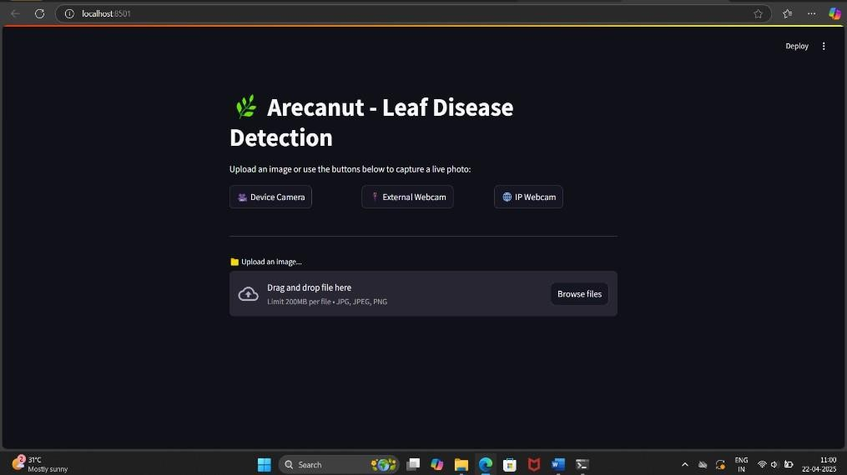
Figure 6.1 GUI Window for Arecanut-leaf disease detection

Figure 6.1 shows the Graphical User Interface (GUI) of the Arecanut Leaf Disease Detection application. The interface is designed with a dark theme, featuring a sleek and modern layout that enhances user experience. At the top, the title “Arecanut - Leaf Disease Detection” is prominently displayed with a green leaf icon, indicating the purpose of the application. Beneath it, three interactive buttons Device Camera, External Webcam, and IP Webcam allow users to capture real-time images using various camera sources. This feature makes the application flexible for both mobile and desktop use cases. Below the camera capture options, an image upload section is provided, enabling users to drag and drop or browse for image files (JPEG, JPG, PNG) with a maximum size of 200MB. This GUI is intuitive and ensures seamless interaction for farmers, researchers, or users seeking to detect

arecanut leaf diseases quickly and efficiently.

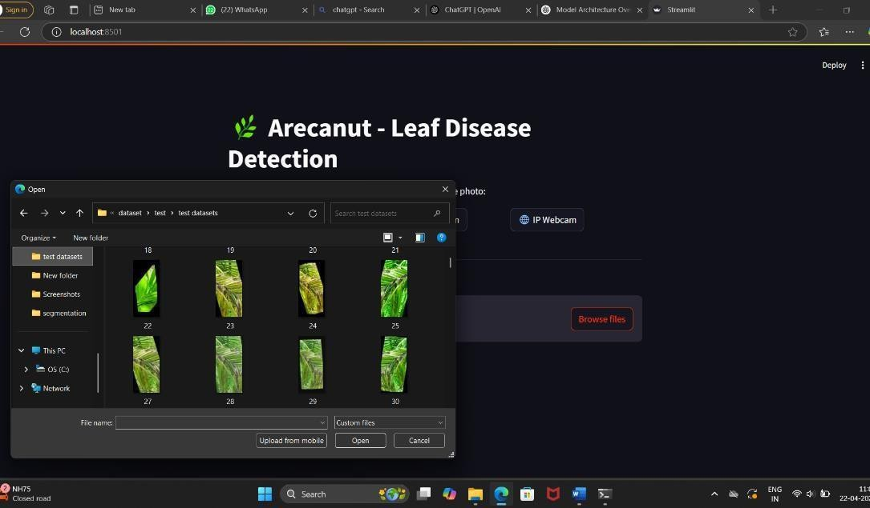
Figure 6.2 Displays a File Explore for Image upload option

Figure 6.2 shows the user-friendly file upload interface of the Arecanut Leaf Disease Detection system, which facilitates easy selection of leaf images for disease prediction. Upon clicking the “Browse files” button, a native file explorer window opens, allowing users to navigate their local storage and choose relevant images from datasets. In the screenshot, the user is accessing a folder labeled “test datasets” that contains various arecanut leaf images, each visually representing different conditions such as healthy, yellowing, or spot-affected leaves. The image thumbnails provide a quick visual reference, simplifying the selection process without the need to recall specific file names. Once an image is selected and opened, the system automatically processes it using a pre-trained deep learning model and displays the predicted disease classification on the web interface. This feature enables real-time validation of the model’s accuracy and performance using actual sample data. Additionally, the interface includes an “Upload from mobile” option, offering greater flexibility by allowing image uploads directly from mobile devices. This streamlined workflow enhances user experience, particularly for farmers or field workers who may rely on mobile-captured images. Overall, the integration of this upload feature bridges AI technology with practical usability, supporting efficient and accessible disease detection for arecanut cultivation.

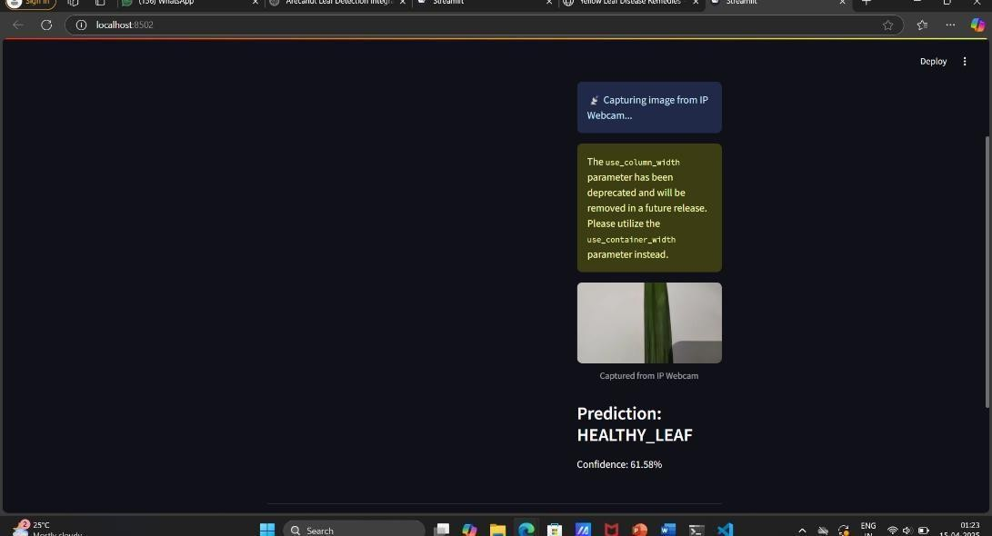

Figure 6.3 Capturing Image from IP Webcam and Prediction Display

Figure 6.3 illustrates the real-time prediction functionality of the Arecanut Leaf Disease Detection system using an IP webcam. In the screenshot, the application is actively capturing a live image feed from an external camera source, allowing users to analyze freshly captured images rather than uploading pre-stored files. Once the leaf image is captured, it is displayed below the message panel with a tag indicating it was obtained from the IP webcam. This feature adds a layer of convenience and practicality, particularly useful for field deployment where immediate diagnosis is required without the hassle of saving and uploading files. Alongside the image, the prediction result is clearly presented stating Prediction healthy leaf with a confidence score of 61.58%, signifying the model’s certainty about the classification. This transparent feedback helps users understand how confident the system is in its diagnosis. Additionally, a warning message appears on the interface regarding the deprecation of the use_column_width parameter in the underlying codebase, hinting that the application is built using the Streamlit framework. This ensures developers are aware of future compatibility changes. Overall, the integration of webcam-based input along with instant prediction and confidence display greatly enhances the application’s usability, making it a powerful tool for quick, on-site disease detection in arecanut plantations.

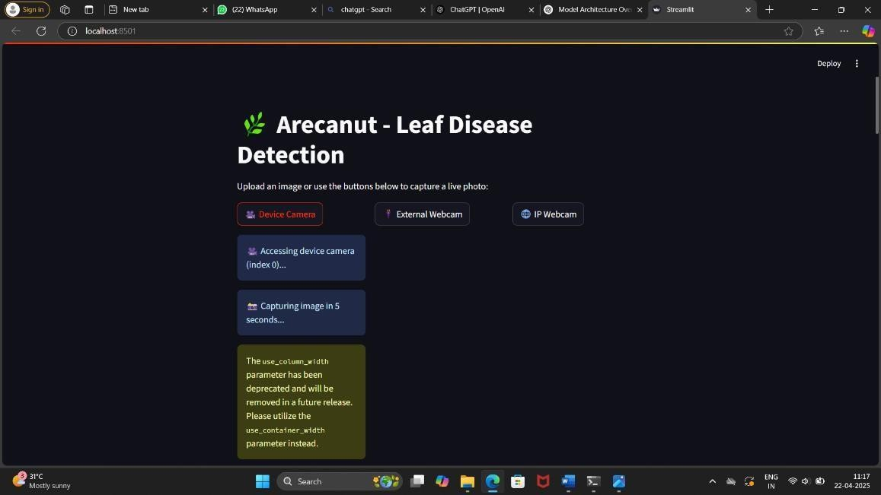
Figure 6.4 Capturing Image from IP Webcam and Prediction Display

Figure 6.4 shows the live capture functionality of the Arecanut Leaf Disease Detection application, demonstrating its ability to interface with multiple camera sources. The user interface offers three distinct options device camera, external Webcam, and IP Webcam to accommodate different hardware configurations, making the application adaptable for use in various environments. In the screenshot, the system is shown accessing the device's internal camera and initiating a five-second countdown to capture an image, providing users with a brief window to adjust the leaf placement for optimal image quality. This automated countdown improves usability, especially when operating hands-free or in field conditions. A caution message is also displayed, indicating that the use_column_width parameter in the code is deprecated and recommending the use of use_container_width instead, which is a helpful alert for developers maintaining the application. The clean and dark-themed UI ensures clarity and focus, with well-labeled buttons and informative status updates, enhancing the user experience. This functionality bridges AI with practical deployment by allowing direct image acquisition without manual uploads, making it ideal for on-the-go diagnosis. Farmers, agronomists, or researchers can capture real-time data, receive instant analysis, and make informed decisions regarding leaf health, ultimately contributing to improved arecanut crop management and disease control.

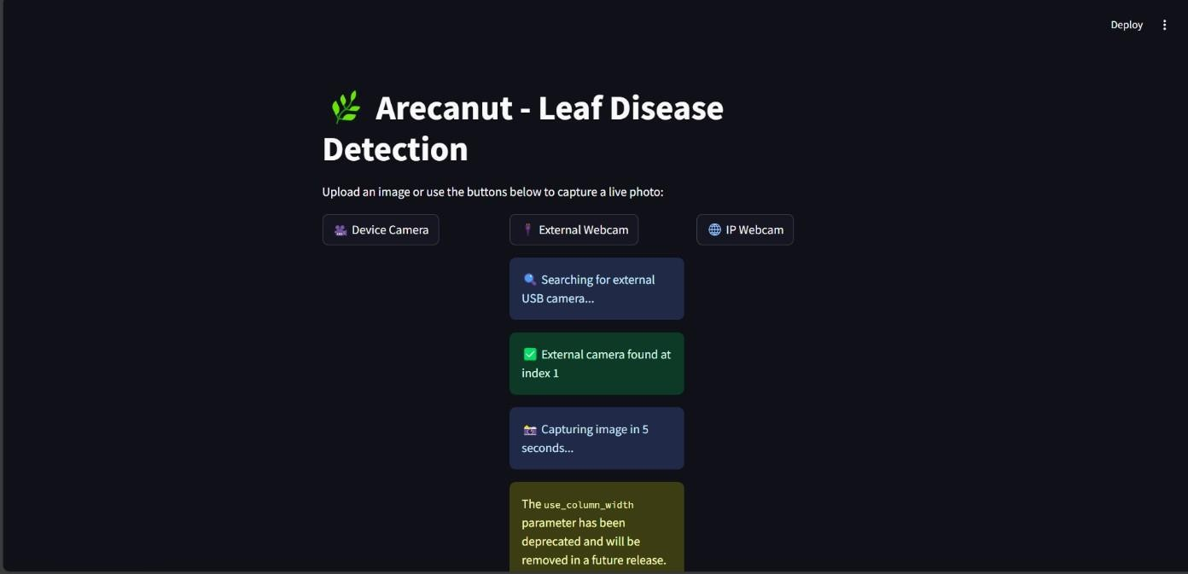
Figure 6.5 Capturing Image from External Camera and Disease Prediction

Figure 6.5 presents the seamless external webcam integration within the Arecanut Leaf Disease Detection application, showcasing its capability to interact with a variety of video input sources for real-time image capture. In the screenshot, the user has selected the external Webcam option, prompting the system to search for connected USB camera devices. Upon successful detection, the system identifies an available external camera at index 1 and prepares to capture an image, initiating a five-second countdown to allow for proper leaf positioning. This intuitive interaction ensures that users, particularly those working in agricultural fields or remote areas, can effortlessly operate the system with minimal technical expertise. Furthermore, the interface retains its consistent aesthetic, using dark backgrounds and clearly labeled interactive buttons for a visually appealing and user- friendly experience. A developer warning regarding the deprecation of the use_column_width parameter is also visible, indicating the system is built using Streamlit, and encouraging future-proofing by transitioning to the updated use_container_width. This functionality supports practical deployment in real-world scenarios, enabling users to perform disease detection directly from live camera feeds without manual uploads, enhancing efficiency and responsiveness in managing arecanut leaf health.

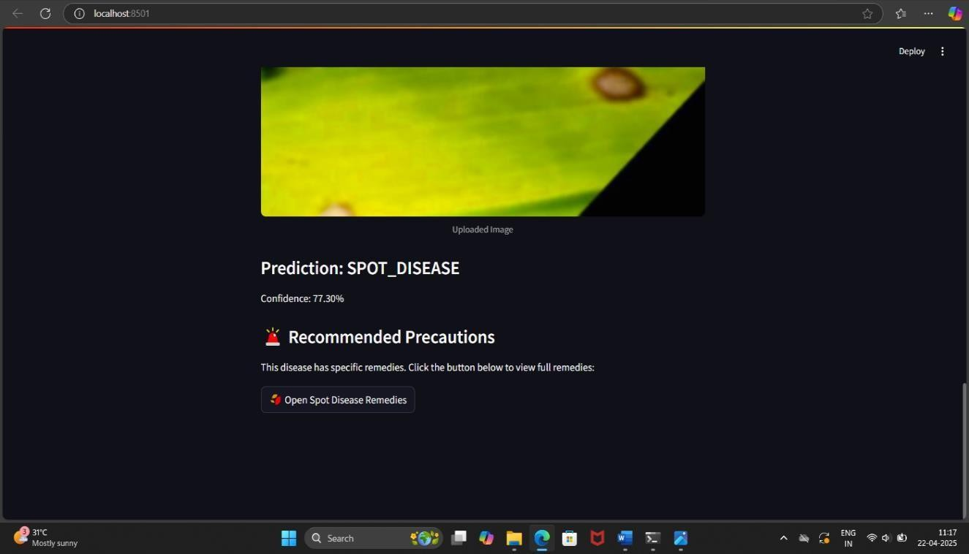
Figure 6.6 Result of Uploaded Image with Spot Disease Prediction and Remedies

Figure 6.6 illustrates the output screen of the Arecanut Leaf Disease Detection system after processing an uploaded image and identifying the presence of Spot Disease. The interface presents a clear and concise prediction result, stating “Prediction: SPOT_DISEASE” along with a confidence level of 77.30%, helping users understand the model’s certainty. Just below the prediction, the system provides valuable recommendations in the form of “Recommended Precautions,” acknowledging the seriousness of the diagnosis and guiding users toward the next steps. A prominently displayed button labeled “Open Spot Disease Remedies” encourages users to explore disease-specific treatment options, offering actionable advice to mitigate the impact. This feature significantly enhances the application's usability, transforming it from a mere diagnostic tool into a practical agricultural support system. The clean and visually engaging UI ensures that even users with limited technical knowledge can understand the results and follow through with appropriate action. The inclusion of such functionality is particularly beneficial for farmers and agricultural workers who rely on timely, accurate information to maintain crop health. By integrating both disease prediction and remedy suggestions, the system promotes a proactive approach to plant care, empowering users to make informed decisions that could improve yield and reduce losses caused by untreated leaf infections.

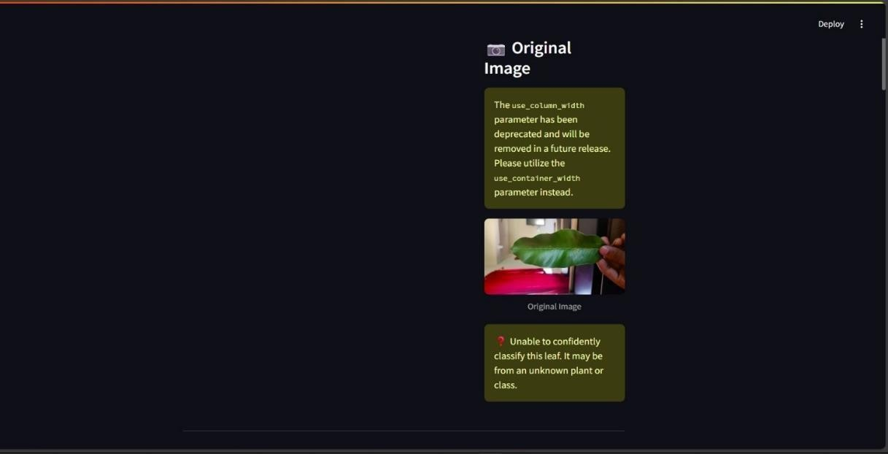
Figure 6.7 Detection of Non Arecanut Leaf

Figure 6.7 illustrates a scenario where the Arecanut Leaf Disease Detection system encounters difficulty in classifying the uploaded image. The interface presents the original image of a green leaf held by a user, alongside a clear message that reads, “Unable to confidently classify this leaf. It may be from an unknown plant or class.” This indicates that the model's training data likely did not include this specific type of leaf or the visual features were not distinct enough for reliable identification. Such feedback is essential as it maintains transparency and prevents misclassification, ensuring users do not rely on incorrect predictions. The warning is visually emphasized with a red caution icon to draw attention and suggest careful action. Additionally, a deprecated parameter warning is shown, reminding developers to update their Streamlit code for future compatibility by replacing use_column_width with use_container_width. This screen not only highlights the AI model’s current limitations but also reflects thoughtful UI design, offering clarity without overwhelming the user. It reinforces the importance of a well-trained dataset and also promotes user trust by admitting uncertainty instead of forcing a potentially incorrect result. The platform remains intuitive and user-friendly, even when outcomes are inconclusive, which adds credibility to the system's performance and reliability.

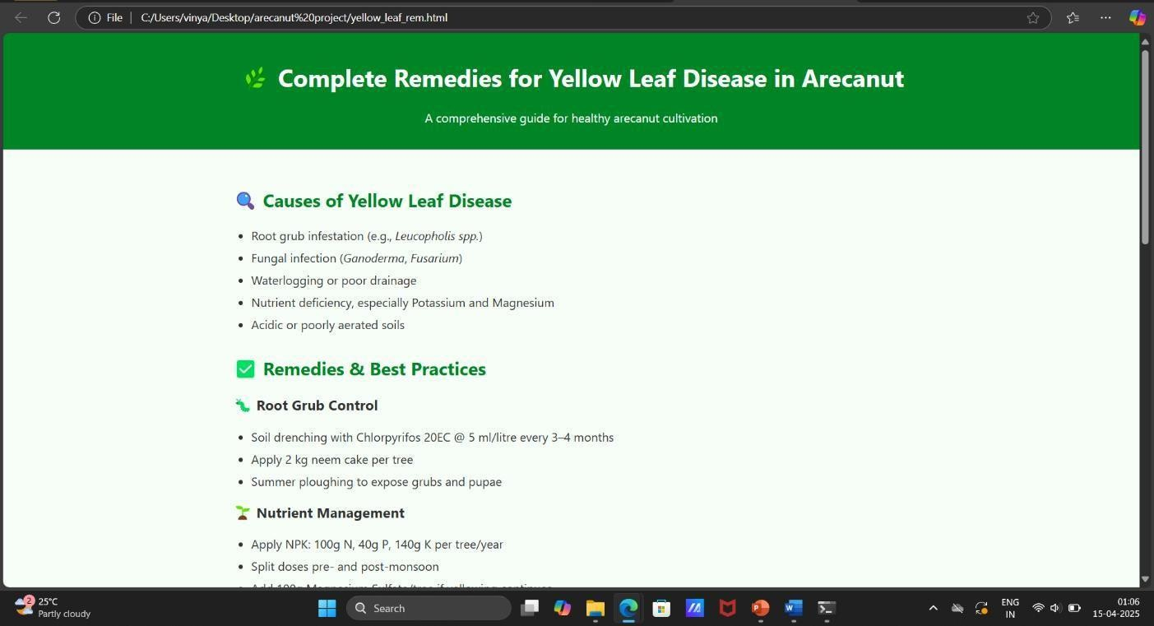
Figure 6.8 Remedies Page for Yellow Leaf Disease

Figure 6.8 presents the detailed and practical guide for managing Yellow Leaf Disease in arecanut plants, offering both causes and actionable remedies. This informative page begins by identifying the root causes such as root grub infestation (e.g., Leucopholis spp.), fungal infections like Ganoderma and Fusarium, waterlogging or inadequate drainage, and imbalanced soil nutrition, particularly deficiencies in potassium and magnesium. Additionally, it highlights that acidic or poorly aerated soils also contribute to this disease. The guide doesn’t stop at problem identification it provides clear, research-based best practices for managing the condition. Under root grub control, it recommends regular soil drenching using Chlorpyrifos 20EC every 3–4 months, applying neem cake around each tree, and conducting summer ploughing to destroy pests at the pupal stage. Nutrient management is emphasized as well, with specific instructions on applying NPK in precise quantities 100g Nitrogen, 40g Phosphorus, and 140g Potassium per tree annually, ideally in split doses around the monsoon seasons. The guidance is methodical and user-oriented, ideal for farmers seeking easy-to-follow, practical interventions. With a clean layout and accessible language, the page empowers cultivators to proactively address yellow leaf disease and maintain the growth and productivity of their arecanut plantations with confidence and clarity.

Table 6.1 Feature Values of Healthy Leaf

Feature Name | Feature Value
Low-level Feature 1 (Color) | 0.0000
Low-level Feature 2 (Texture) | 0.0353
Low-level Feature 3 (Edge Detection) | 0.0000
High-level Feature 1 (Shape) | 0.8503
High-level Feature 2 (Pattern) | 0.0022
High-level Feature 3 (Details) | 2.1922
Shape Feature 1 | 0.0000
Shape Feature 2 | 0.6531
Texture Feature 1 | 0.4471
Color Feature 1 | 0.2982

Table 6.1, the system accurately predicted the leaf to be healthy with a high confidence score of 92.56%. The feature vector shows strong values for shape (0.8503) and fine details (2.1922), while color and edge-related features remained minimal, indicating uniformity and structural integrity typical of a healthy leaf.

Table 6.2 Feature Values of Yellow Diseased Leaf
Index | Feature Name | Feature Value
0 | Low-level Feature 1 (Color) | 0.0000
1 | Low-level Feature 2 (Texture) | 0.7826
2 | Low-level Feature 3 (Edge Detection) | 0.1444
3 | High-level Feature 1 (Shape) | 0.6243
4 | High-level Feature 2 (Pattern) | 0.0000
5 | High-level Feature 3 (Details) | 0.8677
6 | Shape Feature 1 | 0.2505
7 | Shape Feature 2 | 0.5360
8 | Texture Feature 1 | 0.3982
9 | Color Feature 1 | 0.0015

Table 6.2 corresponds to a leaf exhibiting yellowing symptoms, reflected in elevated values for texture (0.7826) and detail (0.8677), though with lower edge detection (0.1444), indicating diffuse surface changes rather than defined lesions. The high texture and detail values in this case suggest early stress markers, potentially due to nutrient deficiencies. These results demonstrate the model’s ability to differentiate leaf conditions by interpreting variations in key visual features such as shape, texture, detail, and edge patterns, thereby supporting automated and accurate plant health assessment.

Table 6.3 Feature Values of Spot Diseased Leaf
Index | Feature Name | Feature Value
0 | Low-level Feature 1 (Color) | 0.0000
1 | Low-level Feature 2 (Texture) | 0.0000
2 | Low-level Feature 3 (Edge Detection) | 0.8013
3 | High-level Feature 1 (Shape) | 0.7967
4 | High-level Feature 2 (Pattern) | 0.0727
5 | High-level Feature 3 (Details) | 0.5835
6 | Shape Feature 1 | 0.0402
7 | Shape Feature 2 | 0.4907
8 | Texture Feature 1 | 1.5271
9 | Color Feature 1 | 0.0000

Table 6.3 presents a case of spot disease, where the system identified significant edge detection (0.8013) and moderate detail (0.5835), suggesting irregular patterns and localized damage on the leaf surface common characteristics of spot infections.

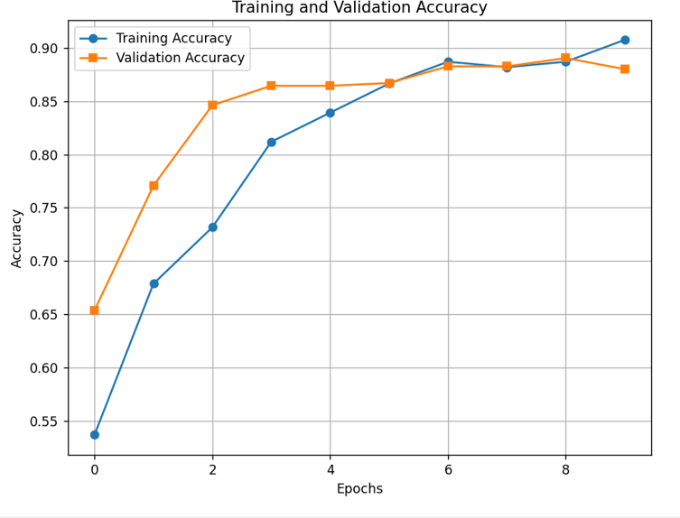
Figure 6.9 Training and Validation Accuracy Across Epochs

Figure 6.9 illustrates the progression of both training and validation accuracy for a Convolutional Neural Network (CNN) model across 10 epochs, showcasing how well the model learns and generalizes. From the graph, it is evident that training accuracy increases consistently over the epochs, starting around 54% and gradually reaching over 90% by the

end of the training cycle. Validation accuracy, on the other hand, shows a sharp rise in the early epochs, jumping from approximately 66% to around 85% within just three epochs, after which it levels off and fluctuates slightly, maintaining values close to the training accuracy. Notably, from epoch 5 onward, both training and validation accuracies remain closely aligned, suggesting the model is not overfitting and is able to generalize effectively to unseen data. The convergence of both accuracies near the 90% mark by the final epoch reflects a balanced and well-trained model. The early rapid gain in validation accuracy indicates the model quickly learned useful representations, while the later steady improvements in training accuracy suggest it continued to refine its internal parameters without compromising its ability to perform on the validation set. Overall, this performance trend reflects a healthy learning process, highlighting the robustness and reliability of the CNN architecture used.
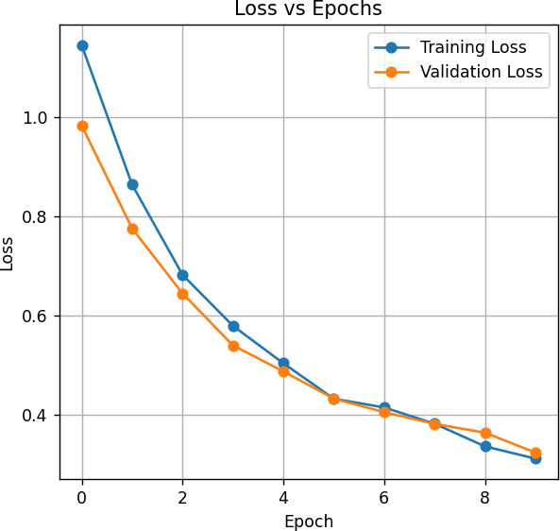

Figure 6.10 Loss VS Epochs

The Figure 6.10 illustrates the training and validation loss values over the course of 10 epochs, providing insight into the learning behavior of the CNN model. From the beginning, both losses start at relatively high levels above 1.0 for training loss and just below 1.0 for

validation loss indicating that the model initially made larger prediction errors. However, as the epochs progress, both curves exhibit a smooth and consistent downward trend, demonstrating that the model is effectively minimizing its errors during training. By epoch 5, both losses converge around 0.45, and from that point on, they continue to decline in near-parallel fashion, ending just above 0.3 by epoch 9. This close alignment between training and validation loss curves signifies a well-generalized model, as there is no significant divergence that would indicate overfitting. Steady rate of improvement across epochs suggests that the learning rate and optimization strategy were well-tuned, enabling the model to extract meaningful patterns from the data without memorizing it. Overall, the graph reflects a stable and healthy training process, reinforcing the reliability of the CNN in accurately classifying leaf diseases. The consistently low loss values towards the end also affirm that the model has achieved a strong fit on both training and validation datasets.

CHAPTER 7

CONCLUSION AND SCOPE FOR FUTURE ENHANCEMENT

Conclusion
The Arecanut Leaf Disease Detection system, built using deep learning techniques, demonstrates significant potential in accurately identifying diseases affecting arecanut leaves. By utilizing a systematic approach involving image preprocessing, feature extraction, model training and integration into a user-friendly Streamlit interface, the system effectively classifies diseases such as yellow disease. The inclusion of a dedicated arecanut leaf classifier and the ongoing integration of segmentation further enhances its performance and accuracy. However, to achieve even higher accuracy and robustness, continuous refinement and optimization are necessary, particularly in handling real-world variations in leaf images. With further advancements in the model, the system can be essential in helping farmers identify and manage diseases, thus improving crop health and yield. The project holds great promise for enhancing agricultural practices and ensuring better crop management through automated disease detection.

Scope of Future Advancement
The future advancements of the Arecanut Leaf Disease Detection system could focus on several key areas to improve its accuracy, scalability, and usability:
    - Enhanced Model Accuracy: Further improvements in the deep learning model by incorporating more advanced architectures like CNN-LSTM or attention- based models could enhance the system's accuracy in detecting diseases, even in challenging environmental conditions and diverse leaf variations.
    - Integration of Multi-Disease Detection: Expanding the system's capabilities to identify a broader range of diseases affecting arecanut leaves will increase its utility for farmers. This would involve training the model on more diverse and extensive datasets, including various stages of disease progression.

    - Real-Time Disease Detection: Implementing a real-time detection system, leveraging high-speed image processing and inference, would allow farmers to use mobile or webcam-based applications for immediate disease diagnosis in the field. This could be integrated into a mobile app for accessibility.
    - Cross-Platform Support: Developing the system to be cross-platform (web, desktop, mobile) would enable wider adoption, making the technology accessible to a larger community of farmers, researchers, and agricultural experts.
    - Segmentation and Localization: Further optimization of the segmentation module could help in accurately locating affected regions on the leaf, providing better insight for targeted treatment. Additionally, incorporating automated treatment suggestions based on the detected disease could be an essential enhancement.
    - Integration with IoT and Precision Agriculture: By integrating the system with IoT sensors or drones, real-time monitoring of the field conditions and detecting disease outbreaks in large plantations can be automated, improving the overall efficiency of disease management.
    - Improved Dataset and Real-World Adaptability: The system could be trained on more diverse datasets from various geographical regions, helping it to adapt to different environmental conditions and leaf types, thus enhancing its robustness in real-world scenarios.
By continuing to evolve these areas, the system could be essential to precision agriculture, offering an efficient, automated, and scalable method for early disease detection and management in arecanut farming.

REFERENCES

- J. G. A. Barbedo, “A review on the use of machine learning algorithms in plant disease detection,” Computers and Electronics in Agriculture, vol. 123, pp. 172–183, May 2016.
- K. P. Ferentinos, “Deep learning models for plant disease detection and diagnosis,” Computers and Electronics in Agriculture, vol. 145, pp. 311–318, Feb. 2018.
- J. Amara, B. Bouaziz, and A. Algergawy, “A deep learning-based approach for banana leaf diseases classification,” in Proceedings of the BTW Workshops, pp. 79– 88, March 2017.
- S. Sladojevic, M. Arsenovic, A. Anderla, D. Culibrk, and D. Stefanovic, “Deep neural networks based recognition of plant diseases by leaf image classification,” Computational Intelligence and Neuroscience, vol. 2016, pp. 1–11, Jan. 2016.
- S. P. Mohanty, D. P. Hughes, and M. Salathé, “Using deep learning for image-based plant disease detection,” Frontiers in Plant Science, vol. 7, art. no. 1419, Sept. 2016.
- S. S. Chouhan, A. Kaul, U. P. Singh, and S. Jain, “A novel approach for plant leaf disease classification using deep learning,” Information Processing in Agriculture, vol. 7, no. 4, pp. 535–545, Dec. 2020.
- M. Brahimi, K. Boukhalfa, and A. Moussaoui, “Deep learning for tomato diseases: Classification and symptoms visualization,” Applied Artificial Intelligence, vol. 31, no. 4, pp. 299–315, Apr. 2017.
- C. Szegedy et al., “Going deeper with convolutions,” in Proceedings of the IEEE Conference on Computer Vision and Pattern Recognition, pp. 1–9, June 2015.
- D. Ravi et al., “Deep learning for health informatics,” IEEE Journal of Biomedical and Health Informatics, vol. 21, no. 1, pp. 4–17, Jan. 2017.
- N. Pathak and R. Mathur, “A hybrid approach for plant disease detection using CNN and Decision Trees,” Journal of Ambient Intelligence and Humanized Computing, vol. 12, no. 6, pp. 6535–6545, June 2021.
- S. Ghosal et al., “An explainable deep machine vision framework for plant stress phenotyping,” Proceedings of the National Academy of Sciences, vol. 115, no. 18,
pp. 4613–4618, May 2018.

- C. Nicolas, L. Tissot, and S. Dupont, “A convolutional neural network-based approach for real-time plant disease detection,” Procedia Computer Science, vol. 159,
pp. 2145–2152, Dec. 2019.
- S. Sankaran, A. Mishra, R. Ehsani, and C. Davis, “A review of advanced techniques for detecting plant diseases,” Computers and Electronics in Agriculture, vol. 72, no. 1, pp. 1–13, Mar. 2010.
- M. Shoaib, M. J. Khan, S. Khan, and A. Shaukat, “A comprehensive review of deep learning in plant disease detection,” Artificial Intelligence Review, vol. 55, no. 3, pp. 2691–2738, Mar. 2022.
- K. SandhyaRani and M. Shyamala, “Deep learning applications in Indian agriculture: A survey,” International Journal of Computer Applications, vol. 183, no. 47, pp. 15– 20, Nov. 2021.
- A. Rehana and K. Ashok, “Leaf disease detection using region-based convolutional neural networks,” Journal of Agricultural Informatics, vol. 11, no. 2, pp. 23–31, Dec. 2020.
- A. Mustofa and S. Nandhini, “CNN-based plant leaf disease classification: A review,” Materials Today: Proceedings, vol. 45, pp. 6670–6676, May 2021.
- M. Karuna and S. Lavanya, “GUI-based tomato leaf disease classification using deep learning,” International Journal of Scientific Research in Computer Science, Engineering and Information Technology, vol. 8, no. 2, pp. 12–19, Feb. 2022.
- R. Gohil, D. Shah, and A. Patel, “Real-time plant leaf disease detection using CNN and YOLOv5,” Procedia Computer Science, vol. 218, pp. 451–458, Dec. 2023.
- M. Ramesh and K. Suresh, “A mobile-based plant disease detection system using CNN,” Journal of Mobile Computing and Application, vol. 8, no. 1, pp. 34–41, Jan. 2022.
- M. Zhang, Q. Wu, Z. Li, and Y. Wang, “Transfer learning for automatic detection of crop diseases,” IEEE Access, vol. 12, pp. 35601–35610, Apr. 2024.
- O. Terrada, F. B. Hmida, and D. Bouslimi, “Classification and prediction of atherosclerosis diseases using machine learning algorithms,” Healthcare Analytics, vol. 3, art. no. 100164, Jan. 2023.

- I. Pacal, E. Karaman, and A. Uçar, “Plant leaf disease classification using EfficientNet and Vision Transformers,” Computers and Electronics in Agriculture, vol. 191, art. no. 106553, Oct. 2021.
- S. Selim, A. El-Sayed, and A. Salem, “Explainable AI for plant disease classification using saliency maps,” Journal of Computer Science and Technology, vol. 36, no. 5,
pp. 905–918, Sept. 2021.
- M. H. Saleem, J. Potgieter, and K. M. Arif, “Plant disease detection and classification by deep learning: A review,” Plant Methods, vol. 17, no. 1, art. no. 22, Jan. 2021

