Student Performance Analytics System
Project Report | Python with AI | EWB Courses
Submitted by: Poorvi Sharma | Trainer: Ms. Chandni

1. Project Title
Student Performance Analytics System
Field | Details
Student Name | Poorvi Sharma
Email | poorvisharma2907@gmail.com
Contact | 6006836861
Course | Python with AI, EWB Courses
Trainer | Ms. Chandni
Submission Deadline | 15 October 2026

2. Objective
Educational institutions record marks and attendance for many students, but reading raw numbers makes it hard to answer simple questions: who is performing best, which subject is weakest, how many students passed, and which department needs attention.
The objective of this project is to build a Python program that reads student data from a CSV file, processes it using NumPy and Pandas, and produces clear, meaningful results: totals, averages, grades, pass/fail status, subject-wise analysis and a list of top performers. It also demonstrates the core concepts learned in the course: variables, data types, loops, functions, NumPy and Pandas.

3. Technologies Used
Tool | Purpose
Python 3 | Main programming language (functions, loops, conditions)
NumPy | Numerical calculations: sum, mean, max, min, argmax, where, all
Pandas | Reading the CSV, DataFrame handling, filtering, sorting, groupby
CSV file | Storage of student records
VS Code | Development and testing

No machine learning libraries were used, as per the assignment guidelines.

4. Dataset Description
The dataset is stored in students.csv and contains 20 student records with realistic values.
Column | Description
Student_ID | Unique ID of the student (101 to 120)
Name | Student name
Department | CSE, ECE, IT or ME
Maths, Physics, Chemistry, English, Computer | Marks out of 100 in each subject
Attendance | Attendance percentage

The data includes strong, average and weak performers so that every grade and the pass/fail condition are exercised.

5. Implementation
The project is written in a single file, main.py, organised into reusable functions and a main() function that runs the complete analysis.
Step 1: Loading the data. load_data() uses pd.read_csv() to load students.csv into a Pandas DataFrame. The program then prints the number of records, the column names and the first few rows.
Step 2: Total and average. calculate_total_and_average() converts the five subject columns into a NumPy array using to_numpy(). np.sum(marks, axis=1) gives each student's total and np.mean(marks, axis=1) gives the average. axis=1 means the calculation is done row-wise, i.e. per student.
Step 3: Grading. get_grade() applies the grading rule below, and assign_grades() uses a for loop to apply it to every student's average.
Average Marks | Grade
90 and above | A+
80 to 89.99 | A
70 to 79.99 | B
60 to 69.99 | C
40 to 59.99 | D
Below 40 | F

Step 4: Pass/Fail. assign_result() uses the condition: a student passes only if they score 40 or more in every subject. This is implemented with np.all(marks >= 40, axis=1) and np.where(), which works like a vectorised if-else. A student with a good average can still fail if one subject is below 40.
Step 5: Class analysis. Using NumPy (np.mean, np.argmax, np.argmin) the program finds the overall class average, the student with the highest and lowest average, the number of passed and failed students, the pass percentage and the average attendance.
Step 6: Subject-wise analysis. subject_analysis() loops through each subject and calculates the average, highest and lowest marks, then identifies the best and weakest subject.
Step 7: Department-wise analysis and top performers. Pandas groupby() gives the average per department. The top 5 students are found with sort_values() and printed with ranks using a loop.
Step 8: Saving results. The final processed DataFrame (with Total, Average, Grade and Result columns) is saved to results.csv.

6. Key Features
- Loads and organises data using a Pandas DataFrame
- Calculates total and average marks for every student using NumPy
- Assigns grades using a clearly defined grading rule
- Identifies pass/fail students using a clear condition (40+ in every subject)
- Finds the highest, lowest and overall class average
- Subject-wise analysis (average, highest, lowest) with best and weakest subject
- Grade distribution and department-wise average
- Top 5 performers with ranks
- List of failed students
- Reusable functions: load_data, calculate_total_and_average, get_grade, assign_grades, assign_result, subject_analysis, print_heading
- Exports the final results to results.csv

7. Output / Screenshots
The program was run with python main.py and produced the following output.
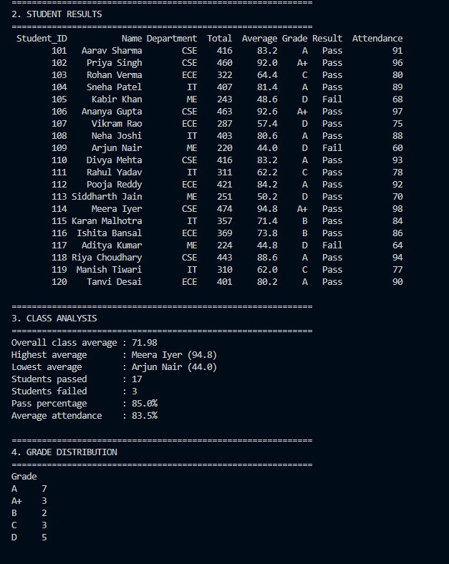
Screenshot 1: Student results, class analysis and grade distribution
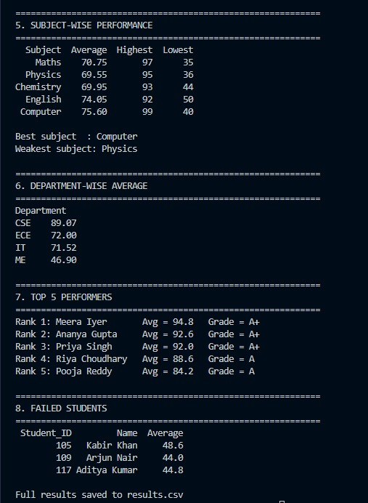
Screenshot 2: Subject-wise performance, department-wise average, top 5 performers and failed students
Class analysis
Measure | Result
Number of records | 20
Overall class average | 71.98
Highest average | Meera Iyer (94.8)
Lowest average | Arjun Nair (44.0)
Students passed | 17
Students failed | 3
Pass percentage | 85.0%
Average attendance | 83.5%

Grade distribution
Grade | A+ | A | B | C | D | F
Students | 3 | 7 | 2 | 3 | 5 | 0

Subject-wise performance
Subject | Average | Highest | Lowest
Maths | 70.75 | 97 | 35
Physics | 69.55 | 95 | 36
Chemistry | 69.95 | 93 | 44
English | 74.05 | 92 | 50
Computer | 75.60 | 99 | 40

Best subject: Computer. Weakest subject: Physics.
Department-wise average
Department | Average
CSE | 89.07
ECE | 72.00
IT | 71.52
ME | 46.90

Top 5 performers
Rank | Name | Average | Grade
1 | Meera Iyer | 94.8 | A+
2 | Ananya Gupta | 92.6 | A+
3 | Priya Singh | 92.0 | A+
4 | Riya Choudhary | 88.6 | A
5 | Pooja Reddy | 84.2 | A

Failed students: Kabir Khan (48.6), Arjun Nair (44.0) and Aditya Kumar (44.8), each scoring below 40 in at least one subject.

8. Final Outcome
The project successfully reads student data, processes it with NumPy and Pandas, and presents the results in a clear, readable format without the reader needing to look at the code. It answers the practical questions set in the assignment:
- Which student has the highest average? Meera Iyer (94.8)
- Which subject has the best average? Computer (75.60)
- How many students passed? 17 out of 20
- What is the overall class average? 71.98
The analysis also showed that the CSE department performs best on average, while the ME department has the lowest average and all three failed students. The program ran without errors and uses functions, loops, NumPy and Pandas as required.

9. Challenges & Learning
- Understanding axis in NumPy. At first it was confusing whether to sum across rows or columns. Learning that axis=1 works across each row (one student) and axis=0 down each column (one subject) solved this.
- Pass/fail logic. A student can have a decent average and still fail because of one weak subject. Using np.all() with the condition >= 40 handled this correctly.
- Combining NumPy and Pandas. Converting DataFrame columns with to_numpy() and putting results back as new columns showed how the two libraries work together.
- Presenting output clearly. Using headings, formatted strings and to_string(index=False) made the output easy to read.
What I learned: writing reusable functions, applying loops and conditions to real data, doing fast numerical work with NumPy, filtering, sorting and grouping with Pandas, and organising a project so that another person can understand it.

10. GitHub Repository
Repository link: https://github.com/poorvisharma29/student-performance-analytics
Repository contents: main.py, students.csv, results.csv, README.md, screenshots and this project documentation.

