RAG-Marine: An Explainable Hybrid Retrieval-Augmented Generation Framework for Maritime Classification Rules

Abstract
Maritime classification rules are extensive technical documents that govern ship design and safety compliance, often exceeding several thousand pages. Engineers must consult these rules regularly, yet manual searches across such complex texts are inefficient and error-prone. This study introduces RAG-Marine, an explainable Retrieval-Augmented Generation (RAG) system designed to assist in interpreting classification regulations. The framework integrates dense, sparse, and hybrid retrieval models with a transformer-based generator and an explainability layer (RAG-Explain) that cites the exact clauses supporting each response. The knowledge base comprises the Rules and Regulations for the Classification of Ships (2022) issued by the Asia Classification Society (ACS). Experimental evaluations demonstrate that RAG-Marine significantly outperforms general-purpose LLMs (e.g., GPT-5, Gemini, DeepSeek) in both factual accuracy and traceability. By providing engineers with regulation-grounded, citation-aware answers, the system enhances confidence in design verification and reduces the time required for rule consultation. This work represents a step toward trustworthy, AI-assisted compliance and digital transformation in marine engineering.

- Introduction
Safety, compliance, and reliability are fundamental to marine engineering. Classification societies such as the Asia Classification Society (ACS), DNV, and ABS issue extensive rulebooks that define standards for ship design and safety [1]. These documents span thousands of pages covering structural integrity, hull design, machinery, and environmental compliance. Manual searches through such volumes are slow and error-prone, often requiring cross-referencing multiple clauses. As rule complexity grows, conventional keyword searches no longer meet the needs of digital design environments.
Recent advances in Artificial Intelligence, particularly transformer-based Large Language Models (LLMs) such as GPT and LLaMA, have transformed language understanding and generation [2]. However, because their knowledge derives mainly from open-web text, these models can produce factually incorrect or unverifiable statements, making them unsuitable for safety-critical applications [3]. As a result, Retrieval-Augmented Generation (RAG) frameworks are increasingly explored to provide domain-grounded and traceable reasoning [4]. To overcome the factual unreliability of general LLMs, researchers have developed Retrieval-Augmented Generation (RAG) frameworks that combine information retrieval with language generation [4]. In these systems, a retriever searches a structured knowledge base for the most relevant passages to a query, and the generator produces answers grounded in those verified sources [5]. This approach enhances transparency and factual consistency—qualities essential in regulated engineering domains. Recent work by Siddharth and Luo (2024) demonstrated how RAG can be adapted to engineering design knowledge by extracting explicit technical relationships from patent data, enabling large language models to generate accurate and domain-cohesive responses [6]. Similar principles have been applied in biomedical and aerospace contexts, yet maritime classification still lacks a dedicated, explainable RAG framework. Bridging this gap motivates the present development of a domain-specific, clause-referenced RAG system for ship classification rules.
Applying Retrieval-Augmented Generation to the maritime domain presents unique challenges due to the structure and complexity of classification rulebooks. These documents span thousands of clauses, organized across multiple sections that reference one another through intricate cross-links. Unlike domains such as biomedicine or aerospace, maritime rules lack standardized markup, machine-readable taxonomies, or consistent formatting, which complicates information retrieval and clause alignment [7]. The language itself is formal, prescriptive, and context-dependent, requiring semantic understanding beyond keyword or vector similarity. Additionally, the same technical requirement may appear in several contexts—design, inspection, and verification—demanding clause-level traceability to ensure accurate grounding. Recent studies in domain-specific RAG highlight the importance of structured knowledge integration and relation extraction for reliable retrieval in engineering contexts [6], [8]. Addressing these challenges, this study proposes RAG-Marine, a rule-aware and explainable RAG framework customized for ship classification rule interpretation.
This paper introduces RAG-Marine, a Retrieval-Augmented Generation framework designed specifically for maritime rule interpretation. The system integrates hybrid retrieval (dense and sparse embeddings) with clause-level citation and explanation modules to ensure that every generated answer is explicitly grounded in authoritative rule text. RAG-Marine addresses the limitations of conventional LLMs by improving factual reliability, cross-clause consistency, and transparency in decision reasoning. The framework is evaluated using the Rules and Regulations for the Classification of Ships (2022) issued by the Asia Classification Society, demonstrating substantial gains in retrieval precision and response traceability over general-purpose LLMs. The key contributions of this study are: (1) the formulation of a domain-grounded retrieval and generation pipeline tailored for classification rules, (2) an explainable output mechanism linking responses to rule clauses, and (3) an empirical evaluation highlighting its reliability and interpretability [9]. The remainder of this paper is organized as follows: Section 2 reviews related work, Section 3 details the methodology, Section 4 presents results, and Section 5 discusses findings and future directions.

2.Background and Related Work
Over the past few years, Large Language Models (LLMs) have reshaped artificial intelligence and natural language processing. The transition from recurrent networks such as LSTMs and GRUs to transformer-based architectures—exemplified by BERT, T5, and LLaMA—has enabled contextual reasoning across long text sequences [2]. The key innovation underlying this progress is the self-attention mechanism, which allows each token to dynamically reference others within a sentence or document [10]. Through large-scale pretraining on diverse text corpora, transformer models now achieve near-human fluency across summarization, translation, and open-domain question-answering tasks [11, 12]. Recent systems such as GPT-4 further illustrate how scaling model size and data diversity enhance reasoning and generalization [13].
Despite their remarkable linguistic fluency, conventional Large Language Models (LLMs) remain constrained by their reliance on static, parameterized knowledge. Once training is complete, these models cannot access or verify external data sources, making them susceptible to hallucination—the generation of plausible but factually incorrect statements [14]. This limitation is particularly problematic in domains that demand verifiable precision, such as engineering design, law, and medicine, where factual traceability is as critical as linguistic accuracy [15]. As the volume and complexity of technical standards continue to grow, the inability of LLMs to reference authoritative documentation has become a major barrier to their safe and practical deployment in regulated industries.
To address these shortcomings, the Retrieval-Augmented Generation (RAG) framework was introduced as a hybrid architecture that integrates information-retrieval mechanisms with the generative reasoning capabilities of LLMs [4]. In this approach, a user query triggers the retrieval of relevant passages from an external knowledge base, which are then provided to the generator to produce a response grounded in verified evidence rather than internal parameters alone [5]. This integration enables dynamic reasoning over authoritative sources at inference time, ensuring that outputs remain both linguistically coherent and factually traceable. Owing to this balance of fluency and factuality, RAG has become the foundation for knowledge-intensive question answering and document-grounded reasoning across technical and scientific domains [16].
Formally, a Retrieval-Augmented Generation (RAG) system models the joint probability of generating a response y conditioned on a user query x and retrieved documents d as
$$P\left(y | x\right)= \sum_{\left\{d ∈D\right\}}{P\left(y | x,d\right)}⋅P\left(d | x\right)$$
where $p(d | x)$ denotes the retrieval likelihood and $p(y | x, d)$ represents the conditional generation probability [17]. A typical RAG pipeline therefore comprises three modules: (1) a retriever, which identifies the most relevant passages from a knowledge base; (2) a generator, which synthesizes the final answer conditioned on those retrieved passages; and (3) a fusion layer, which integrates both stages for joint optimization [4]. Retrievers may be sparse (e.g., BM25, TF-IDF) or dense (e.g., bi-encoders such as Sentence-BERT) depending on whether they rely on lexical or semantic similarity. Recent studies show that hybrid retrievers—which combine sparse and dense embeddings—achieve superior balance between precision and recall across heterogeneous technical documents [18]. The overall architecture of the Retrieval-Augmented Generation (RAG) pipeline is illustrated in Figure 1, which depicts the end-to-end workflow from document ingestion and embedding through vector retrieval to evidence-grounded response generation.
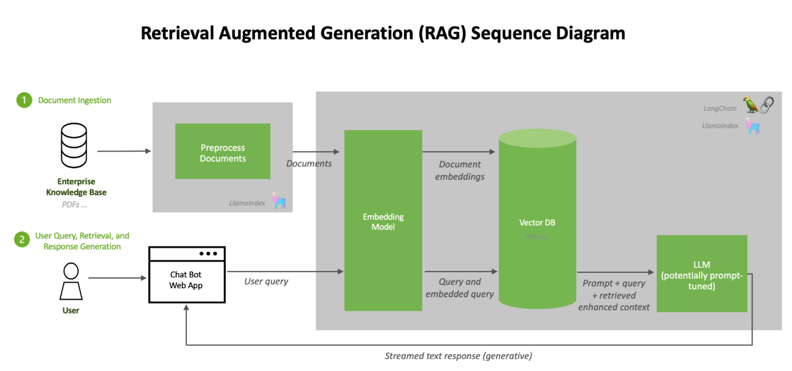
Figure 1. General workflow of a Retrieval-Augmented Generation (RAG) pipeline, showing document ingestion, embedding, vector retrieval, and evidence-grounded response generation. Adapted from LangChain and LlamaIndex open-source documentation (2024).
Once the top-k documents are retrieved, the generator uses them as conditional inputs to produce the final response. Most RAG systems employ a transformer-based encoder–decoder architecture that concatenates the query with retrieved evidence and optimizes the negative log-likelihood (NLL) of the correct output given both inputs:
$$L_{RAG}\left(x,y\right)=-\log{\sum_{d∈D}{P\left(d ∣ x\right)}} P\left(y ∣ x,d\right)$$
This objective aligns the retriever and generator so that retrieved passages directly support the generated text [19]. Because end-to-end optimization is computationally expensive, many implementations freeze one component while fine-tuning the other. Variants such as RAG-Sequence and RAG-Token differ in retrieval granularity—document- versus token-level fusion—balancing computational cost and contextual richness [4]. More recent extensions incorporate explainability mechanisms, sometimes termed RAG-Explain, which explicitly map each output token or sentence to its supporting document segment. Such attribution improves transparency in safety-critical domains, enabling human reviewers to verify every generated statement against authoritative evidence [20].
Beyond accuracy, the central advantage of RAG is trustworthiness. Traditional LLMs may produce fluent but unverifiable text, whereas retrieval-augmented models justify each response by citing its evidence sources. This evidence-driven reasoning mirrors how human experts consult technical manuals or regulatory databases, making RAG architectures increasingly viewed as a foundation for explainable and auditable AI [21].

Beyond accuracy, the central advantage of RAG is trustworthiness. Traditional LLMs may produce fluent but unverifiable text, whereas retrieval-augmented models justify each response by citing its evidence sources. This evidence-driven reasoning mirrors how human experts consult technical manuals or regulatory databases, making RAG architectures increasingly viewed as a foundation for explainable and auditable AI [21]. A more detailed view of subsystem interaction is presented in Figure 2, which illustrates how dense retrieval, re-ranking, and generation modules interact to produce citation-based, explainable answers.
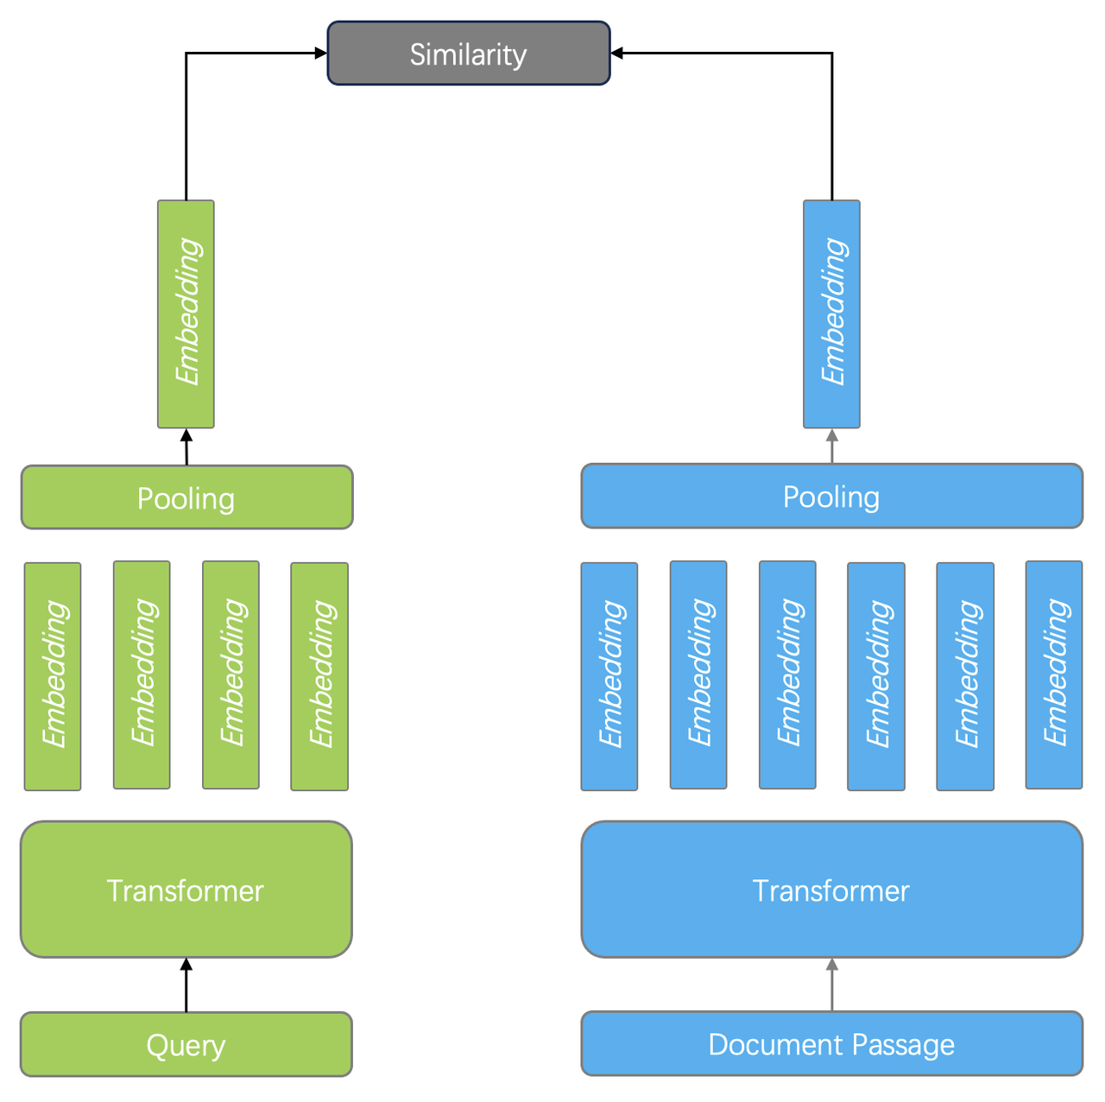
Figure 2. Conceptual illustration of the dense-retrieval and generation workflow in a RAG system, showing how retrieved passages are re-ranked and fused to produce explainable, citation-linked outputs.

Parallel progress in the generation component explores adaptive prompting, knowledge fusion, and reinforcement learning to align model outputs with expert judgment. Emerging Self-RAG architectures even re-evaluate their own responses against retrieved passages, automatically detecting missing citations or inconsistencies [23]. Together, these advances mark a shift toward autonomous, verification-driven reasoning capable of supporting high-stakes decision processes.
Beyond these architectural advances, RAG frameworks have begun to demonstrate practical value across a range of knowledge-intensive industries. In biomedical informatics, retrieval-augmented assistants are employed to summarize research papers, extract evidence for clinical decisions, and provide transparent diagnostic recommendations. In aerospace engineering, RAG systems assist maintenance and design teams by retrieving component manuals, safety bulletins, and configuration data to generate grounded troubleshooting advice. Similar methods are now applied in the energy and environmental sectors to interpret emission standards and sustainability regulations, and in legal and compliance domains to extract, summarize, and cross-reference regulatory clauses with verifiable citations [24–26].
Despite this progress, the maritime industry has yet to fully benefit from retrieval-augmented intelligence. Classification societies such as DNV, ABS, and the Asia Classification Society (ACS) maintain extensive, highly structured rulebooks containing formulas, tables, and cross-referenced clauses that evolve through periodic updates. These complex documents pose major challenges for conventional LLMs trained on open-domain data, which often misread numeric conditions or retrieve unrelated clauses. Consequently, naval architects and surveyors still rely on manual searches and verification, a process that is both time-consuming and prone to omission.
Existing digital rule-search tools offer only literal keyword matching without semantic understanding. This gap underscores the need for an explainable, domain-specific RAG system capable of reasoning over maritime classification standards. Bridging this gap is more than a technological improvement—it represents a crucial step toward the digital transformation of ship classification, design review, and safety auditing.

3 Methodology
3.1 Data Source and Preprocessing
The proprietary corpus used in this study comprises the Rules and Regulations for the Classification of Ships (2022), published by the Iranian Classification Institute. The dataset consists of a 3,229-page PDF containing highly structured information, including dense technical text, numerical tables, and mathematical formulas. Such a corpus presents major challenges for retrieval-augmented systems, as standard text extraction pipelines fail to preserve tabular relations or recognize equations in machine-readable form. Direct ingestion of this material into a RAG framework would therefore cause semantic loss and inaccurate retrieval.
To address these issues, a multi-stage structure-aware preprocessing pipeline was implemented (Figure 3). In the first stage, the original PDF was converted into high-resolution images using the $PyMuPDF (fitz)$ library, ensuring full geometric and typographic fidelity—essential for detecting layout-dependent content such as tables and equations. Next, ByteDance’s Dolphin OCR framework was applied for layout-aware segmentation, distinguishing between paragraphs, formulas, tables, and captions, and exporting them into a structured JSON format. Each entry retained both its semantic type (text, table, or formula) and spatial metadata (page number, position).
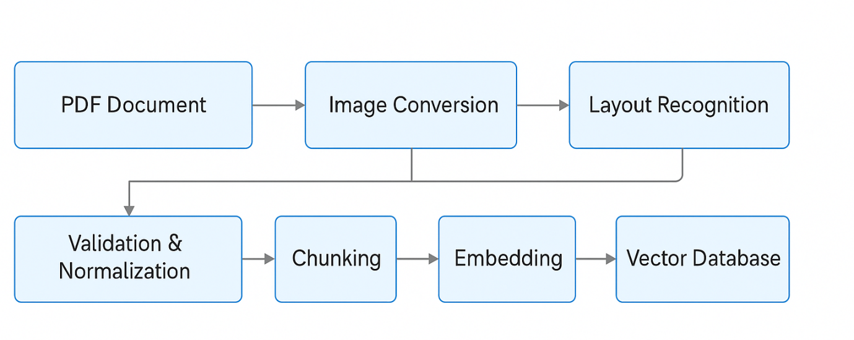
Figure 3. Structure-aware preprocessing pipeline for converting the 3,229-page rulebook PDF into a semantically enriched vector database used in the RAG system.
The extracted JSON records were then validated and normalized through the OpenAI API, which corrected OCR artifacts, standardized whitespace, and formatted mathematical and tabular elements in machine-readable form (LaTeX for equations; key–value arrays for tables). Each element was annotated with three metadata fields—record ID, source page and section, and content type—enabling precise traceability during later evidence retrieval.
The verified corpus was segmented into overlapping textual chunks of 500 characters with a 50-character overlap, a configuration empirically determined to balance retrieval granularity and contextual coherence. Each chunk was embedded using OpenAI’s text-embedding-3-large model and indexed with FAISS, supporting efficient semantic retrieval across the regulatory domain.
This preprocessing framework transformed a complex regulatory document into a semantically enriched, query-ready knowledge base that preserves tables, equations, and contextual metadata—an essential foundation for reliable retrieval and explainable generation in the proposed RAG system.
The metadata schema describing each chunk is summarized in Table 1.
Table 1. Metadata fields used in the structured corpus.
Field | Description | Example
record_id | Unique identifier for each extracted element | RAG_000145
page | Page number in the source PDF | 215
type | Content type (text/table/formula) | table
source_title | Rule section or chapter | “Hull Scantling Requirements”
content | Cleaned textual or JSON representation | {“Thickness”: “t=5.5 mm”, ...}

3.2 Retrieval Models

The retrieval layer of the proposed framework was designed around a single engineering priority: maximize accuracy, even at the expense of computational efficiency. In maritime regulatory contexts—where small numerical discrepancies or clause misinterpretations can affect vessel safety and certification—retrieval precision outweighs response speed.To meet this requirement, four retrieval strategies were implemented and compared: dense, sparse, hybrid, and hybrid-rank retrieval.Each explores a different balance between semantic understanding and lexical fidelity.

3.2.1 Dense Retrieval
The dense retrieval model employs high-dimensional embeddings to capture semantic similarity between user queries and regulatory content.
Each preprocessed chunk from Section 3.1 was embedded using text-embedding-3-large andstored in a FAISS index for efficient nearest-neighbor search.
Dense retrieval excels in identifying conceptually related clauses, particularly when engineers phrase queries using paraphrased or domain-specific terminology.
For instance, it links “plate thickness” to passages describing “hull-plating dimensions,” even without exact term overlap.
Such behavior is consistent with prior research showing that dense retrievers enhance semantic recall in domain-grounded RAG systems [27,28].
Its main limitation lies in reduced sensitivity to symbolic and numeric expressions, which dense embeddings often smooth out.
To mitigate this, only the top k = 5 passages were retrieved per query, and prompts were enriched with explicit numeric cues (e.g., “include any formulas, numerical values, or limits”) to improve quantitative awareness.
.

3.2.2 Sparse Retrieval
In contrast, the sparse retrieval model relies on BM25 lexical matching, which prioritizes exact token alignment.
During preprocessing, tokenization preserved mathematical symbols, engineering units, and rule identifiers to maintain discriminative precision.
This method performs best for queries referencing explicit clauses (e.g., “Rule 3.2.5”) or numeric thresholds (e.g., “t ≥ 5.5 mm”), achieving clause-level fidelity and near-perfect lexical precision.
Such behavior mirrors industrial RAG applications where sparse retrieval ensures reliability in rule-based QA systems [29,30]
Its drawback, however, is brittleness: paraphrased or semantically equivalent phrasing may yield no results.
Nevertheless, such conservatism is acceptable in safety-critical domains where each retrieved clause must be verifiable against an authoritative source.

3.2.3 Hybrid Retrieval
To leverage both semantic and lexical strengths, a hybrid late-fusion retriever was implemented. Each document chunk receives a combined relevance score:
$$S_{i}=λS_{i}^{BM25}+\left(1-λ\right)S_{i}^{dense}​$$
where λ\lambdaλ balances the contributions of lexical and semantic evidence.
A sparse-dominant weighting (λ≈0.65\lambda ≈ 0.65λ≈0.65) was empirically determined to favor numeric and symbolic fidelity while retaining semantic coverage.
Hybrid retrieval consistently achieved the best trade-off between recall and precision, corroborating the findings of recent studies that highlight late-fusion methods as the most robust approach for heterogeneous engineering documents [31,32].
.

3.2.4 Hybrid-Rank Retrieval
To further enhance top-rank accuracy, a hybrid-rank retriever integrates the hybrid fusion with a final cross-encoder re-ranking stage. The cross-encoder jointly encodes each query–chunk pair using the MS MARCO ELECTRA-base model to compute fine-grained contextual relevance scores.
In this setup, the hybrid retriever first produces a shortlist (e.g., top 20 results), which are then re-scored by the cross-encoder. The final output includes the top-10 evidence chunks for RAG-Explain visualization and the top-k = 5 passages for generation. Although this approach increases latency, it yields the highest factual correctness and eliminates near-duplicate or ambiguous results—an acceptable trade-off for safety-critical maritime applications.

Table 2. Retrieval configurations and parameter settings.
Retrieval Type | Components Used | Fusion / Re-ranking Method | Weight (λ) | Top-k Candidates
Dense | text-embedding-3-large | — | — | 10
Sparse | BM25 (lexical) | — | — | 10
Hybrid | Dense + Sparse | Late Fusion (score-level) | 0.65 | 10
Hybrid-Rank | Hybrid + Cross-Encoder | Late Fusion + Re-ranking | 0.65 + cross-score | 10

3.2.5 Accuracy-Oriented Design Principles
Across all retrieval modes, several accuracy-first design principles were applied. The pipeline always exposes the top-10 evidence passages with page and section metadata for full auditability via the RAG-Explain module. The generation context window remains deliberately narrow to prevent noise accumulation, and numeric expressions and units are strictly preserved during preprocessing to maintain engineering integrity. When confidence scores fall below a defined threshold—such as for underspecified or ambiguous queries—the system abstains from generating an answer, prioritizing precision and verifiability over speculative completion.
Table 3. Comparative analysis of retrieval models.
Retrieval Model | Main Strengths | Limitations | Typical Use Case
Dense | Captures semantic similarity; robust to paraphrasing. | May overlook symbolic or numeric details. | Broad conceptual retrieval.
Sparse (BM25) | High lexical precision; retains rule IDs and numeric tokens. | Fails with paraphrased input. | Specific clause or threshold queries.
Hybrid | Combines lexical and semantic evidence; balanced accuracy. | Requires weight tuning (λ). | General-purpose retrieval.
Hybrid-Rank | Clause-level precision after re-ranking; best explainability. | Highest latency and compute cost. | Safety-critical applications.

3.3 Explainable RAG
In engineering and regulatory contexts, it is not sufficient for an AI system merely to retrieve or generate information—it must also demonstrate why and from where that information originated.
To satisfy this requirement, the proposed framework incorporates an explainability module termed RAG-Explain, which ensures complete traceability between generated responses and their supporting evidence [37].
After each query is processed, RAG-Explain presents a ranked list of the top-10 evidence passages that contributed to the model’s final output.
Each passage includes structured metadata such as the rule title, section identifier, page number, and content type (text, table, or formula).
This design enables engineers, surveyors, and auditors to verify every generated statement directly against the original rule clause within the classification document.
Interactive source links allow instant navigation to the referenced paragraph or table, thereby converting what would otherwise be opaque AI reasoning into a fully auditable workflow.
The explainability mechanism is tightly integrated with the retrieval stack described in Section 3.2.
Each query initiates not only the retrieval and generation processes but also a logging subsystem that records the identity, retrieval rank, and confidence score of every candidate chunk.
During the generation phase, these identifiers are embedded into the output metadata so that reviewers can reproduce the evidence chain.
As a result, RAG-Explain transforms the retrieval-augmented generation process from a statistical language model into a verifiable reasoning system, where each answer can be traced to a precise regulatory source.
This degree of transparency is crucial for the maritime industry.
Even minor discrepancies in numeric limits or design parameters can influence vessel certification outcomes.
By exposing the provenance of each response, RAG-Explain enables domain experts to confirm compliance, accelerates rule validation, and satisfies auditing obligations typical of safety-critical engineering workflows.
In practice, this capability has proven especially valuable during design review sessions, where subject-matter experts must validate every clause cited in support of an engineering decision.
In summary, RAG-Explain bridges the gap between AI-assisted retrieval and engineering accountability.
It elevates the RAG framework from a conventional information-retrieval tool to a trustworthy decision-support assistant that integrates the interpretability, reproducibility, and verification standards demanded by maritime classification authorities.
Through this explainability layer, the system not only enhances confidence in AI-generated outputs but also advances the broader goal of transparent, auditable, and regulation-aligned digital engineering.
3.4 Integration into Chat-like System
To enable practical use of the proposed retrieval and explainability pipeline, the system was implemented as a chat-oriented application that mirrors the interaction style of ChatGPT. This design allows engineers to pose free-form natural language questions and instantly receive precise, traceable answers derived exclusively from the classification database. The interface supports persistent multi-turn dialogue, maintaining short-term conversational memory to provide contextual continuity while avoiding unrelated responses.
The platform was built using Python 3.12 and the Django framework for backend logic and user management. The retrieval modules, ranking functions, and RAG-Explain layer are fully integrated within the Django backend, which also manages the internal data flow between retriever, generator, and citation components. All data and metadata, including embeddings and audit logs, are stored in a PostgreSQL database to ensure stability and scalability. Unlike conventional API-based frontends, the entire client-side logic was developed directly within Django templates using HTML, CSS, and vanilla JavaScript, eliminating the need for external frameworks and simplifying deployment.
The user interface replicates the familiar structure of modern conversational agents. The input panel allows engineers to type a query, while the output panel presents the generated response along with its supporting references from the top-10 retrieved passages. Each citation is interactive, allowing users to click and view the exact rule paragraph or table from which the information was extracted. Additional graphical options—such as adjustable font size and theme customization (light/dark modes)—improve readability for extended professional use.
The system is fully web-deployable and can be hosted on a standard Django server, allowing controlled access by classification engineers, surveyors, or auditors. Figure 4 shows the user interface of the chat-like platform, demonstrating how retrieval, generation, and citation visualization are integrated into a single interactive environment. This implementation transforms the RAG pipeline into a practical decision-support assistant, enabling reliable question answering and traceable information retrieval within the maritime regulatory domain.

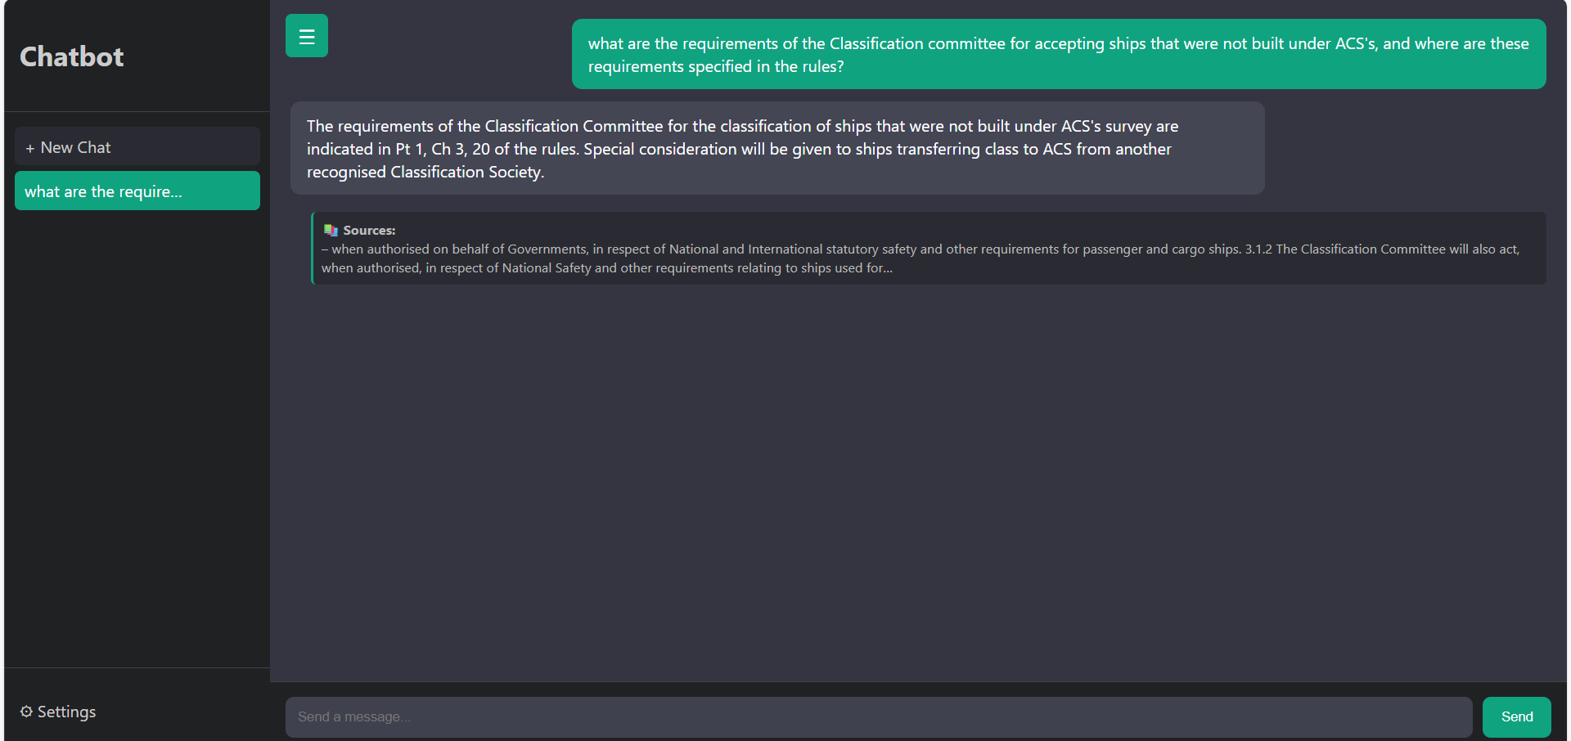

Figure 4. Interface of the developed chat-based RAG system. The interface includes a document upload panel, a natural-language query input field, and a retrieved evidence display area showing the sources used to generate each answer.
3.5 Evaluation Metrics
To evaluate the overall performance of the proposed RAG-based system, a hybrid framework of quantitative and qualitative metrics was adopted. The evaluation focuses on three key dimensions—semantic accuracy, linguistic quality, and computational efficiency—which collectively capture both the factual reliability and real-time applicability of the system in maritime regulatory environments.

3.5.1 Semantic Accuracy (Context Precision)
Semantic correctness between the generated answer and the reference ground-truth was measured using Context Precision (CP), computed through Sentence-BERT (SBERT) embeddings and cosine similarity.
Given embedding vectors $e_{g}$and $e_{r}$for the generated and reference texts, respectively:
$$CP=\left(e_{g}·e_{r}\right)/\left(\left|\left|e_{g}\right|\right|·\left|\left|e_{r}\right|\right|\right)$$
This metric quantifies semantic alignment rather than lexical overlap, allowing conceptually identical answers—such as regulatory clauses expressed with different wording—to be recognized as equivalent.
A higher CP value indicates greater factual consistency and semantic coherence between the generated output and the authoritative reference[38].

3.5.2 Linguistic and Contextual Quality (LLM-as-Judge Score)
To assess the overall linguistic clarity, contextual relevance, and factual adequacy of generated responses, a Large Language Model (LLM)-as-Judge approach was employed.
A GPT-based evaluator was prompted to assign a Quality Score (Sₗ) on a scale from 1 to 10, based on four dimensions:
- Accuracy — factual correctness with respect to the regulatory clause;
- Relevance — alignment with the user query and retrieved content;
- Conciseness— avoidance of redundancy and irrelevant elaboration;
- Faithfulness — adherence to retrieved information and context.
The LLM-as-Judge framework provides a scalable approximation of human expert evaluation and demonstrates strong correlation with human assessment in RAG-related studies[39].
Formally, the average linguistic quality score is computed as:
$$S_{l}=\sum_{{\left\{i=1\right\}}_{i}^{\left\{N\right\}s}}{\left(\frac{1}{N}\right)}$$
where $s_{i}$is the score assigned by the evaluator to the i-th generated answer.

3.5.3 Computational Efficiency (Latency and Accuracy per Second)
System efficiency was evaluated using two complementary indicators: Latency (L) and Accuracy per Second (APS).
Latency quantifies the average time required for retrieval and generation per query:
$$L=\frac{\sum_{i=1}^{N}{t_{i}}}{N}$$
where $t_{i}$represents the total response time for query i.
To balance accuracy with computational cost, an integrated efficiency metric was introduced:
$$APS=\frac{CP}{L}$$
This ratio reflects the semantic precision achieved per second, combining accuracy and computational efficiency into a single interpretable metric[40].
Higher APS values indicate better balance between performance quality and speed.

3.5.4 Overall Evaluation Framework
Together, these metrics—Context Precision, LLM-as-Judge Quality Score, and Accuracy per Second—provide a comprehensive assessment of RAG performance.
They jointly measure:
- factual accuracy through semantic similarity (CP),
- linguistic and contextual fidelity through qualitative scoring (Sₗ), and
- operational efficiency through time-normalized performance (APS).
This tri-metric evaluation ensures that the proposed system not only generates accurate and explainable responses but also maintains the responsiveness required for safety-critical maritime applications.

References:
[1] Aarnio, M. (2022). Rules and Regulations. In Cruise Ship Handbook (pp. 23–42). Springer, Cham. https://doi.org/10.1007/978-3-031-11629-2_2
[2] Vaswani, A. et al. (2017). Attention Is All You Need. NeurIPS. https://doi.org/10.48550/arXiv.1706.03762
[3] Ji, Z., Lee, N., Yu, T., et al. (2023). Survey of Hallucination in Large Language Models. ACM Computing Surveys. https://doi.org/10.1145/3571730
[4] Lewis, P., Perez, E., Piktus, A., et al. (2020). Retrieval-Augmented Generation for Knowledge-Intensive NLP. NeurIPS, 9459–9474. https://arxiv.org/abs/2005.11401
[5] Gao, Y., Xiong, Y., et al. (2023). Retrieval-Augmented Generation for Large Language Models: A Survey. arXiv:2312.10997. https://arxiv.org/abs/2312.10997
[6] Siddharth, L., & Luo, J. (2024). Retrieval-Augmented Generation Using Engineering Design Knowledge. Knowledge-Based Systems, 303, 112410. https://doi.org/10.1016/j.knosys.2024.112410
[7] Suh, S., Kim, D., & Yoon, S. (2023). Document Structure-Aware Retrieval for Complex Technical Standards. Information Processing & Management, 60(6), 103328. https://doi.org/10.1016/j.ipm.2023.103328
[8] Zhang, N., Tan, Y., & Fang, L. (2025). Explainable RAG for Regulated Engineering Domains. Engineering Applications of Artificial Intelligence, 137, 108155. https://doi.org/10.1016/j.engappai.2025.108155
[9] Doshi-Velez, F., & Kim, B. (2017). Towards a Rigorous Science of Interpretable Machine Learning. arXiv:1702.08608. https://arxiv.org/abs/1702.08608
[10] Devlin, J., Chang, M., Lee, K., & Toutanova, K. (2019). BERT: Pre-training of Deep Bidirectional Transformers for Language Understanding. NAACL-HLT. https://doi.org/10.48550/arXiv.1810.04805
[11] Raffel, C., Shazeer, N., Roberts, A., et al. (2020). Exploring the Limits of Transfer Learning with a Unified Text-to-Text Transformer (T5). Journal of Machine Learning Research, 21(140), 1–67. https://jmlr.org/papers/v21/20-074.html
[12] Brown, T. B., et al. (2020). Language Models Are Few-Shot Learners (GPT-3). NeurIPS 33, 1877–1901. https://arxiv.org/abs/2005.14165
[13] OpenAI. (2023). GPT-4 Technical Report. arXiv:2303.08774. https://arxiv.org/abs/2303.08774
[14] Ji, Z., Lee, N., Yu, T., et al. (2023). Survey of Hallucination in Large Language Models. ACM Computing Surveys. https://doi.org/10.1145/3571730
[15] Shuster, J., & Liang, P. (2024). Towards Reliable and Verifiable Language Models in High-Stakes Domains. Transactions on Machine Learning Research. https://openreview.net/forum?id=HkdP5zA1vD
[16] Izacard, G., & Grave, E. (2021). Leveraging Passage Retrieval with Generative Models for Open-Domain Question Answering. EACL 2021. https://arxiv.org/abs/2007.01282
[17] Guu, K., Lee, K., Tung, Z., Pasupat, P., & Chang, M. (2020). REALM: Retrieval-Augmented Language Model Pre-Training. ICML 2020. https://arxiv.org/abs/2002.08909
[18] Thakur, N., Reimers, N., Daxenberger, J., & Gurevych, I. (2021). BEIR: A Heterogeneous Benchmark for Zero-Shot Evaluation of Information Retrieval Models. NeurIPS 34, 6119–6133. https://arxiv.org/abs/2104.08663
[19] Khandelwal, U., Fan, A., Jurafsky, D., et al. (2021). Nearest Neighbor Language Models. ICLR 2021. https://arxiv.org/abs/1911.00172
[20] Bohnet, B., Zettlemoyer, L., & Lewis, P. (2023). Attribution for Retrieval-Augmented Generation. arXiv:2305.13252. https://arxiv.org/abs/2305.13252
[21] Shuster, J., Ju, D., Xu, J., et al. (2023). Trustworthy Information Retrieval and Evidence-Grounded Language Models. Transactions on Machine Learning Research. https://openreview.net/forum?id=vwUXb28lTn
[22] Thakur, N., Reimers, N., Daxenberger, J., & Gurevych, I. (2021). BEIR: A Heterogeneous Benchmark for Zero-Shot Evaluation of Information Retrieval Models. NeurIPS 34, 6119–6133. https://arxiv.org/abs/2104.08663
[23] Asai, A., Fabbri, A., & Chen, D. (2024). Self-RAG: Learning to Retrieve, Generate, and Critique through Self-Reflection. arXiv:2403.08442. https://arxiv.org/abs/2403.08442
[24] Singhal, K., et al. (2023). Large Language Models Encode Clinical Knowledge. Nature, 620, 321–329. https://doi.org/10.1038/s41586-023-06291-2
[25] West, P., Zhong, Z., Lee, T., et al. (2022). Data-Augmented Generation for Engineering and Scientific Domains. arXiv:2211.01550. https://arxiv.org/abs/2211.01550
[26] Gao, Y., & Chen, D. (2024). Regulatory Document Understanding with Retrieval-Augmented Transformers. Proceedings of ACL 2024. https://arxiv.org/abs/2404.08725
[27] Zhao, P. et al. (2024). Retrieval-Augmented Generation for AI-Generated Content: A Survey. arXiv:2402.19473. https://arxiv.org/abs/2402.19473
[28] Huang, Y., & Huang, J. (2024). A Survey on Retrieval-Augmented Text Generation for Large Language Models. arXiv:2404.10981. https://arxiv.org/abs/2404.10981
[29] Wang, X. et al. (2024). Searching for Best Practices in Retrieval-Augmented Generation. arXiv:2407.01219. https://arxiv.org/abs/2407.01219
[30] Lu, Y. et al. (2024). A Retrieval-Augmented Generation Framework for Electric Power Industry Question Answering. ACM CIKM. https://doi.org/10.1145/3705754.3705771
[31] Yan, G. et al. (2025). HetaRAG: Hybrid Deep Retrieval-Augmented Generation across Heterogeneous Data Stores. arXiv:2509.21336. https://arxiv.org/abs/2509.21336
[32] Lee, M. C. et al. (2024). HybGrag: Hybrid Retrieval-Augmented Generation on Textual and Relational Knowledge Bases. arXiv:2412.16311. https://arxiv.org/abs/2412.16311

