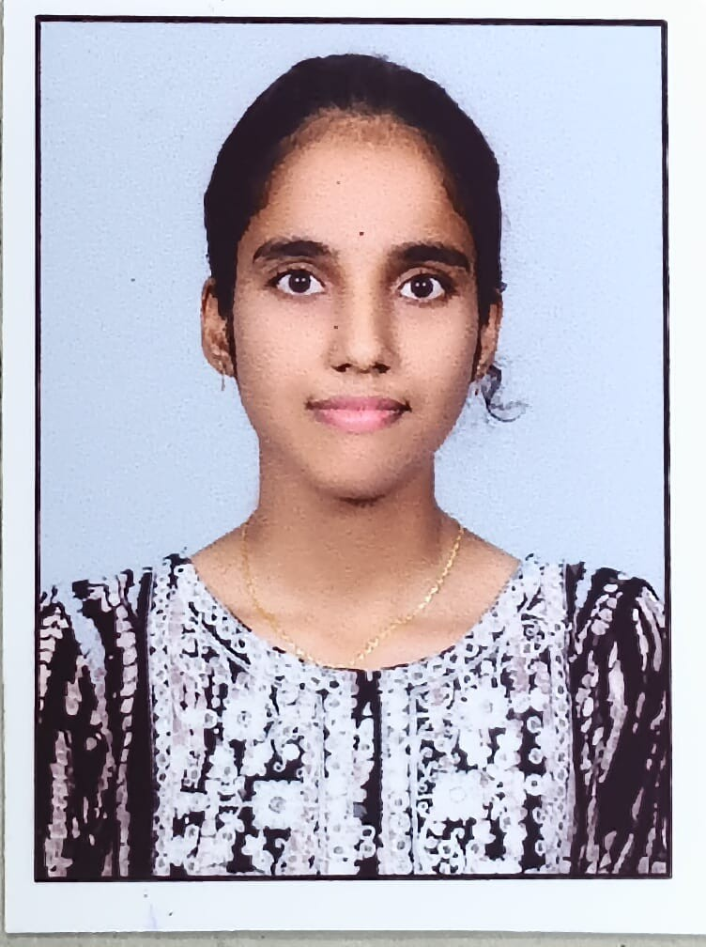Priya Poosaala

[priyapoosaala@gmail.com](mailto:priyapoosaala@gmail.com) — +91-9573495592 — Warangal, Telangana [LinkedIn](https://www.linkedin.com/in/priya-poosaala/) — [GitHub](https://github.com/poosaalapriya1012) — [LeetCode](https://leetcode.com/u/priyapoosaala/)

# EDUCATION

## SR University, Warangal Oct 2022 – May 2026

**B.Tech – Computer Science Engineering — CGPA: 9.5/10.0 Warangal, Telangana**

* **Relevant Courses:** Data Structures, Algorithms, DBMS, Operating Systems, Computer Networks, Software Engineering

# Technical Skills

**Languages:** Python, Java, C, JavaScript, SQL

**Frontend Development:** HTML, CSS, React.js, REST APIs

**Backend Development:** Node.js, Express.js

**Databases:** MySQL, MongoDB

**Tools:** Git, GitHub, Visual Studio Code

**Core Concepts:** Object-Oriented Programming, Software Engineering, Data Structures

# PROJECTS

## Real-Time File Sharing Chat Application React, Node.js, Socket.IO

[GitHub Repository](https://github.com/poosaalapriya1012/Real-Time-File-Sharing-Chat-Application)

* Developed a real-time chat application using React for frontend and Node.js with Express for backend API services supporting 50+ concurrent users
* Implemented bidirectional, event-driven communication using Socket.IO reducing message latency to under 100ms
* Designed modular architecture with 15+ reusable components separating client-side UI, server-side routing, and WebSocket handlers
* Integrated 5 key features including private messaging, online user status tracking, and real-time typing indicators
* Achieved near-instant message and file delivery with over 98% delivery success rate across 200+ text messages

## SecureChatGUI Python, Encryption, Socket Programming

[GitHub Repository](https://github.com/poosaalapriya1012/securechat_project)

* Built secure messaging application with 256-bit encryption supporting 10+ concurrent users
* Designed user interface with real-time messaging and authentication system, reducing login time by 40%
* Applied socket programming achieving 99% message delivery success rate

## Employee Management System Python, JSON, Authentication

[GitHub Repository](https://github.com/poosaalapriya1012/employee-management-system)

* Developed console-based employee management application with role-based authentication for admin/user access levels
* Implemented full CRUD operations with JSON file storage, auto-generated unique employee IDs, and data persistence
* Built modular architecture with separate classes for employee data handling, file operations, and CLI interface
* Integrated input validation and confirmation prompts for critical operations ensuring data integrity and user experience

# ACHIEVEMENTS

* **”Indoor Air Quality and Environment Management System” – Published, May 2025** — Contributed as part of the patent team [Verify](https://drive.google.com/file/d/1P9zLFv76-inUEpkShaw8nMIZsLZ_0_BD/view)
* Maintained consistent 8+ CGPA demonstrating strong academic performance in computer science fundamentals

# CERTIFICATIONS

* NPTEL – Theory of Computation (Algorithms, Automata Theory, Computational Complexity) [Verify](https://drive.google.com/file/d/1fLtLV_ZDCIRtSf5Whl9bGxZu_41wNXmR/view)
* Python Essentials 1 — Cisco Networking Academy (Issued June 20, 2025) [Verify](https://drive.google.com/file/d/1nScUfB4yvXK0Q3U-m1NKEVaAIW4wcC7I/view)
* Microsoft Certified Azure AI Fundamentals (AI-900) [Verify](https://drive.google.com/file/d/1G-Biwam5sUQUMILzw4ywDfVNl1-QbVDD/view)