Two-wire transmission lines.
Basic study of parameter dependencies.

Aleksei Ponomarenko-Timofeev
State University of Aerospace Instrumentation
Tampere University of Technology
Russia, St. Petersburg
alexeyponomarenko92@gmail.com
Gianfranco Scordino
Università degli Studi Roma Tre
Tampere University of Technology
Bari, Italy
g.scordino.alice.it

This study aims to provide information how different analysis methods can be used with two-wire transmission lines. It is shown how accurately main parameters of transmission lines can be estimated, on which intervals these methods prove to be useful. Graphs, obtained by simulation of the line and theoretical ones, are also provided throughout the document. In the end of this paper summary information about the results is provided.
Two-wire transmission line, analysis, accuracy, comparison

Introduction
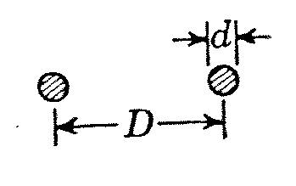
This paper shows the results of different analysis methods for two-wire transmission lines. It shows how accurate these methods are depending on the parameters of the line and its type. First of all, lets define what two wire transmission line is. Basically two conductors spaced by an insulator can be called a transmission line. What parameters do matter for that kind of structure? First of all, impedance or characteristic resistance. There are two ways of obtaining this value. Analytical formula can be used or it can be calculated using capacitance and inductance of the line. However, the second option requires us to know both capacitance and inductance, they can be obtained using the simulation software (COMSOL 4.3b in this particular case). The first option can not be used without any restrictions though, for instance, two-wire open transmission line impedance can only be calculated if space between conductors is significantly bigger than the diameter of the conductors. This and other aspects of evaluating parameters of transmission lines are reviewed in more detail below. The graphs, provided in the plots section, demonstrate from which point we can consider approximation accurate enough.

Analytical formulas for two-wire lines.

Two-wire open transmission line.
First, the open transmission line. This line consists of two parallel conductors with diameter d, separated by air gap of widht D. The cross section of the line is provided below:
The analytical formula for calculating the impedance of this line is available below:
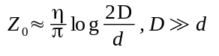, where
D – distance between centers of the conductors
d – diameter of the conductors
Below is a plot of this function:
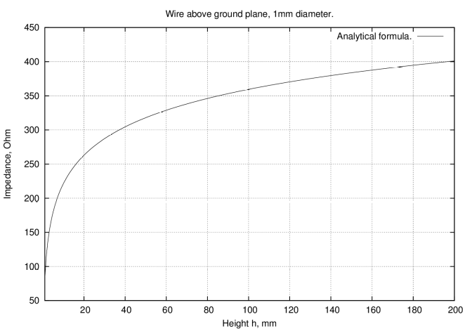
Fig. 1: Dependency of the impedance on the distance between conductors, diameter of the conductor is 1mm.

Wire above the ground plane.
This line is almost same as previous one, instead of one of the conductors there is a charged plane. The cross section of this transmission line can be seen below:
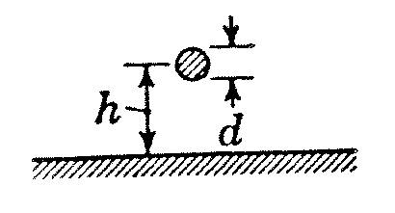

The impedance for the following line is:
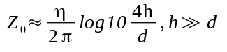, where,
d – diameter of the conductor
h – height above the ground plane

The plot of impedance function is provided below:
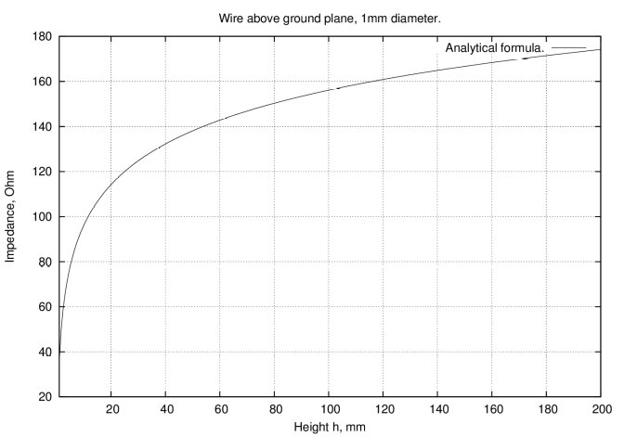
Fig. 2: Dependency of the impedance on the distance between conductor and plane, diameter of the conductor is 1mm.

Parallel plate line
This type of line consists of two conductive plates of width w separated from each-other with air spacing b:
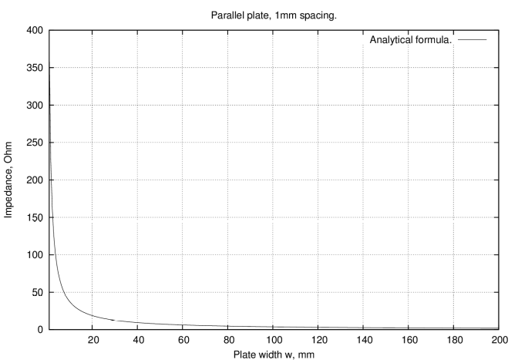
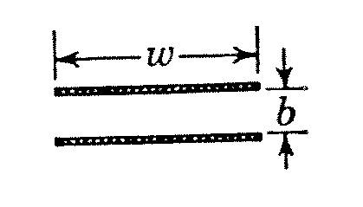
The dependency plot is below:
Fig. 3: Dependency of the impedance on the width of the planes, air spacing is 1mm.

Simulation results processing
Since COMSOL does not have an option to provide required values by means of standard tools, we have to calculate them somehow. It is known that the energy in the magnetic field is determined by this formula:
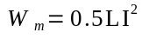, where,
I – surface current, A
L – inductance, H
And energy of the electric field is:
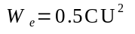, where,
C – capacitance, F
U – voltage, V
The I and U parameters in COMSOL can be set, so we know these values, and COMSOL can calculate energy for each of the fields. Voltage was set to 1 volt, surface current was set to 1 ampere. In COMSOL the electric and magnetic energies were measured. The capacitance and inductance can then be acquired using the formulas below:
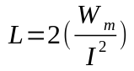,where
I is the current in the conductor
W_{m} is the energy stored in the magnetic field
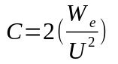, where
U is the voltage applied to conductors
W_{e} is the energy stored in the electric field
Since current and voltage were set to 1 ampere and 1 volt , we can simplify these equations to this form:
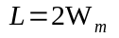
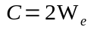
To impedance can finally be calculated using the following formula:
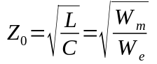

IV. COMSOL Results

Two plane transmission line
Below are the plots with simulation data and analytical formula results:
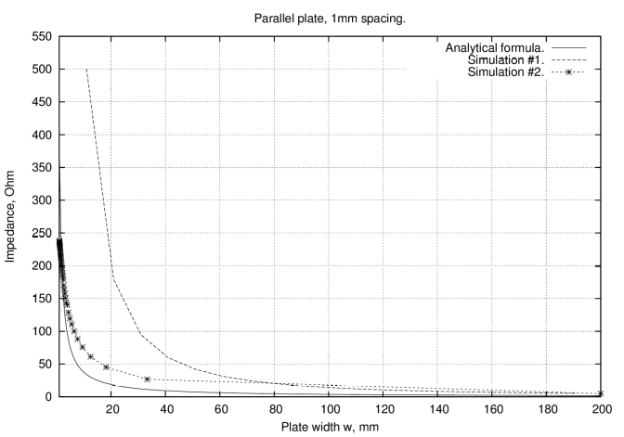
Fig. 4: Comparison of data obtained by simulation and analytical formula for parallel plate case
Two types of simulation were performed for this line. Simulation #1 involved changing the spacing between the conductive plates. In the second simulation the width of the plates was varied. Generally speaking, because the analytical formula states that impedance depends solely on the ratio of the spacing and plate width, we want to see how close it is to reality for different ratios.
By looking at the plot it can be noticed, that two simulations provided different results. This actually shows that the impedance depends on the ratio of the spacing and diameter. But this dependency can not be always considered being the same for both simulations.
However, as it can be clearly seen, the accuracy of analytical formula increases with the width of the conductive plates. Approximately after the width of the plates exceeds 180 millimeters, all plots descend to the same value.

B. Wire above ground plane line.
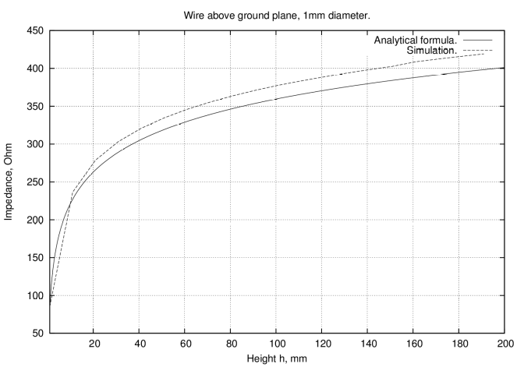
Fig. 5: Comparison of data obtained by simulation and analytical formula for wire above the plane case
The simulation results and analytical formula data turned out to be significantly different. The difference is so big, that it can either be an incorrect simulation parameters, or the plot of the function is done in the wrong way.
Multiple attempts have been taken to figure our what was actually done wrong, but none of them succeeded. The surface current value setting was checked in simulation.
However, speaking of relative values, we might say that the error value is not growing fast, as it can be seen from the plot. So most probably, at some point, it will become relatively small.
C. Two-wire transmission line.
The two wire wire transmission line is the most troublesome line to simulate right now. The simulation in COMSOL shows strange decline of impedance with the increase of distance between wires. Unfortunately, the simulation does not correlate with analytical formula in any way. The simulation will be revised until the data gets more or less correct. Plot of the simulation data and analytical function is shown on the next page:
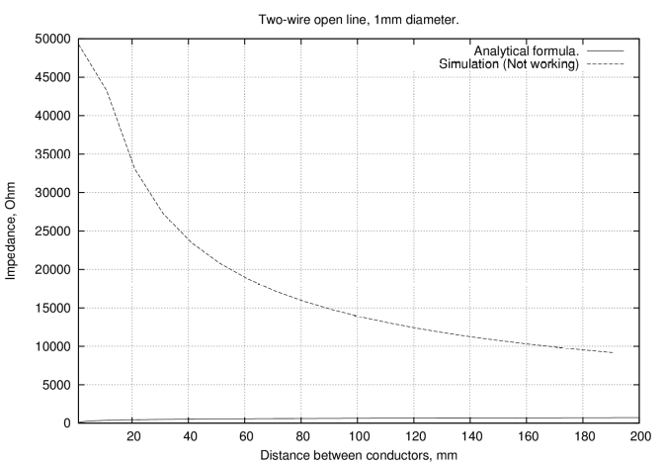
Fig. 6: 5: Comparison of data obtained by simulation and analytical formula for two-wire open line case

V Conclusions
This paper reviews some of the basic transmission lines and methods of their analysis. While completing this task, some aspects of the line analysis were reviewed. Such as, when analytical formula is no longer accurate enough. Still, no actual limits for each case were calculated, because of hardware limitations of my simulation machine. However, generating such tables can be considered as a future direction, as well as improving the simulations for different cases (e.g. two-wire line). The paper might also be updated soon, if there is a need for that.

