Compiled by
Nolan Mortenson
Mitchell Burkhardt
Ariana Askey

Exterminate

Last updated: October 25, 2020

Overview - Executive summary

Elevator Pitch / High Concept
<Game Pitch>
The game Exterminate is about an exterminator that has been called to clear out a bug problem, but there is one problem there is no one in the house, or the town? Desperate for his next pay check the exterminator pushes on to investigate the problem. According to a note and a quick glimpse of what he is up against, he quickly realizes that his equipment won’t be enough. He’ll have to investigate the house for resources in order to fill the ventilation with poison in order to get rid of his threat.

Genre
Horror

Key/Exotic Features
- Puzzle solving
In order to collect key items, the player must solve various puzzles before being caught by the monster.
- Hiding Mechanic/repelling mechanic
Hide from the monster to prevent from losing the game. You can also spray the monster with raid to repel it.

Target Audience
Primary:
Fans of Horror games/movies/tv shows
Secondary:
People who enjoy solving puzzles and solo play

Play Action and Cadence
<Cadence description>
The experience of the game is a slow steady pace that is meant to keep the player in constant suspense, the fun aspect of the game will revolve trying to avoid the monsters at all costs, until they have collected the weapon to defeat the queen.

Win Condition / Player Goal
<Win Condition>
The win condition in this game is to collect all of the parts to assemble the flamethrower and then defeat the monster with it.

Loss Condition / Continuation
<Loss condition>
The player loses if the monsters deal enough damage to the player without a repelling item (the raid can) then player will lose/die. When the player dies the scene will change to a startling screech and animation of the monster attacking. The player will understand that if they are caught by any of the monster without any defensive equipment they will get dealt damage and possibly lose the game. After the player loses they will be taken back to the menu and given the option to play again or exit the game.

Comparable products

<Product Name>
SlenderMan
<Picture of compara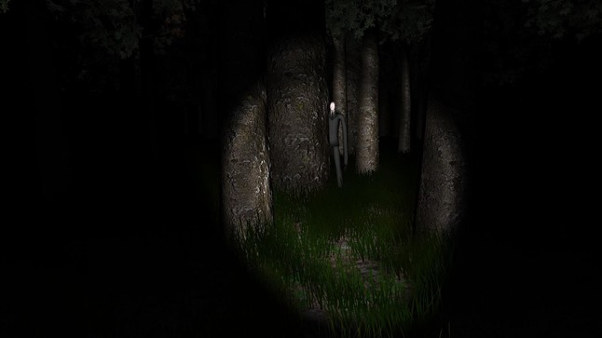ble portion>
Source:
https://www.syfy.com/syfywire/5-terrifying-slender-man-games-get-spooked

<Description of comparable portion>
Slender man is Focused on trying to avoid slender man at all cost, we plan to implement a similar feature to where the goal of the player is to avoid contact with the monsters as much as possible, making the game more stealth based.

<Product Name>
Pacify
<Picture of comparable portion>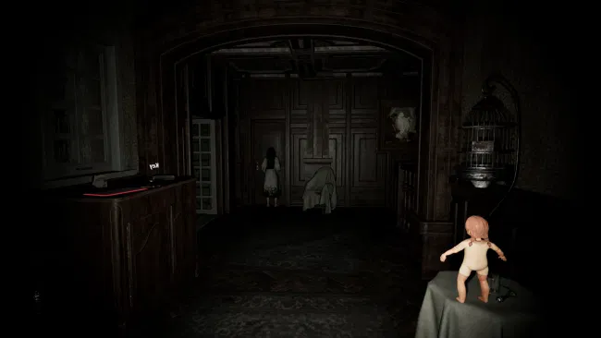
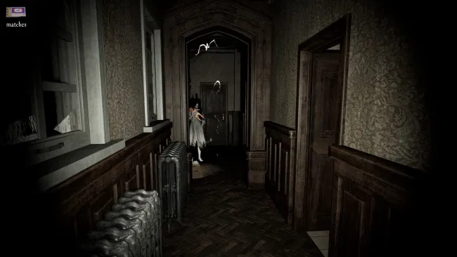

Source:
https://www.rapidreviewsuk.com/pacify/

<Description of comparable portion>
When you collect certain items (keys) it allows the player access to locked areas of the map, and if the player if holding a doll and are caught by the ghost, the ghost gets distracted and the player is able to escape. We are planning to implement a similar system with having keys to unlock areas of the map, and raid cans to deter the monster.

<Product Name>
SirenHead
<Picture of comparable portion>
<Description of comparable portion>
In SirenHead you have to collect items in order to fix a radio tower. We are using a similar approach to where you have to collect parts of a weapon to repair/craft.

<Product Name>
OutLast
<Picture of comparable portion>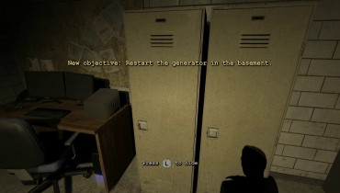
Source:
https://www.hxchector.com/outlast-guide/2/

<Description of comparable portion>
In OutLast the player can hide from enemies when needed by hiding in lockers or under a bed. We are planning to implement a hiding system as well so if the player does not have a raid can to deter the monster they can hide.

<Product Name>
State of Decay
<Picture of comparable portion>
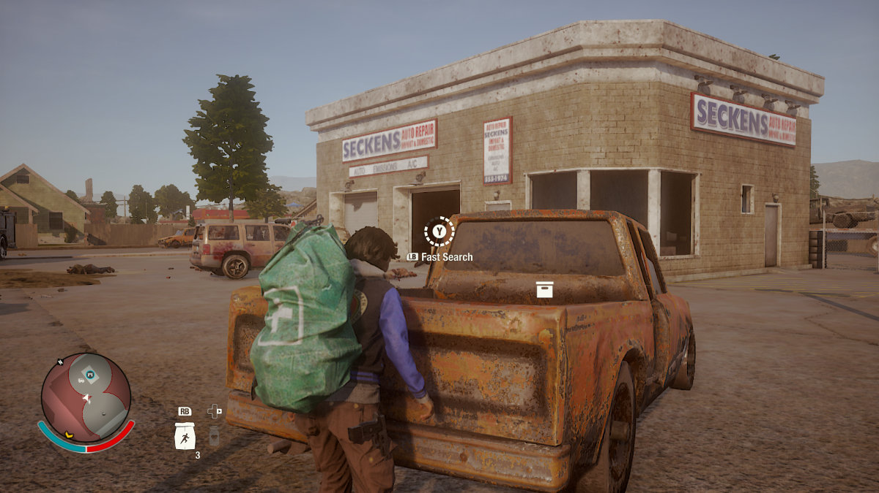
Source:
https://nexushub.co.za/nexus/state-of-decay-2.html

<Description of comparable portion>
When a player is scavenging for items they have the option to go faster with the added risk of attracting enemies by making more noise. We were thinking of adding a similar mechanic where the player has to control how much sound they are making.

<Product Name>
<Picture of comparable portion>
<Description of comparable portion>

Art and Production Design

Colors
<Description of intended color scheme>
Dark, gloomy, spooky color scheme.
<Image showing intended colors>

Source: https://www.freepik.com/premium-photo/haunted-house-creepy-night-forest_2251467.htm
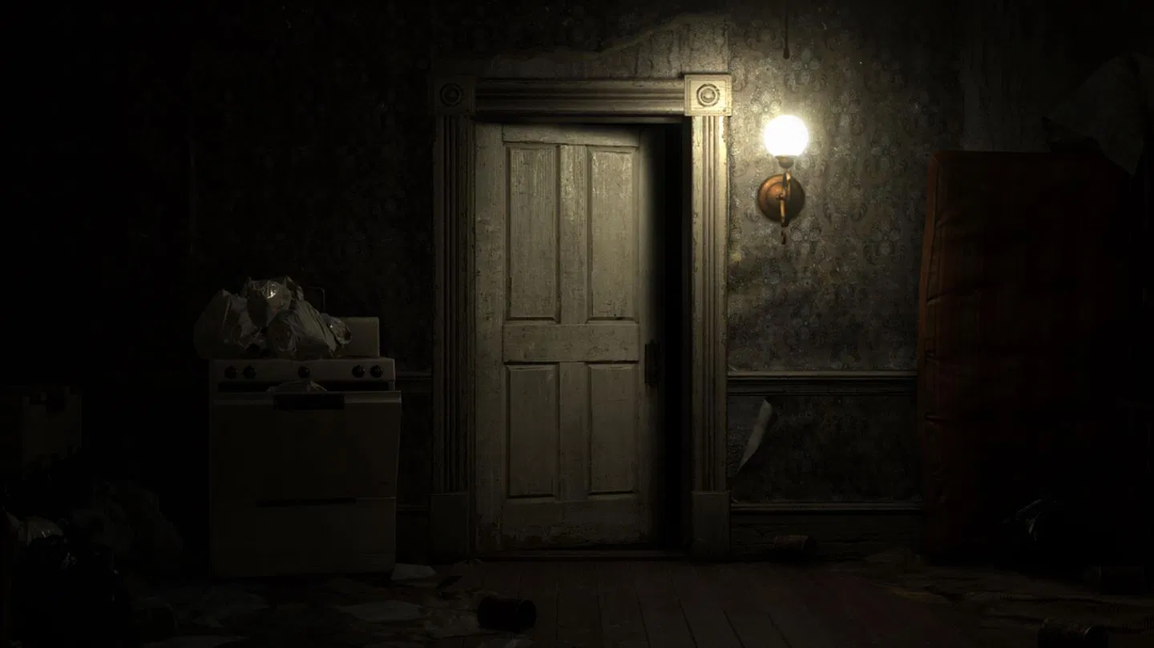
Source: https://news.xbox.com/en-us/2018/10/31/scary-xbox-one-games-halloween/

Art / visual Style
<Description of intended visuals>
3D art style
<Image showing intended visuals>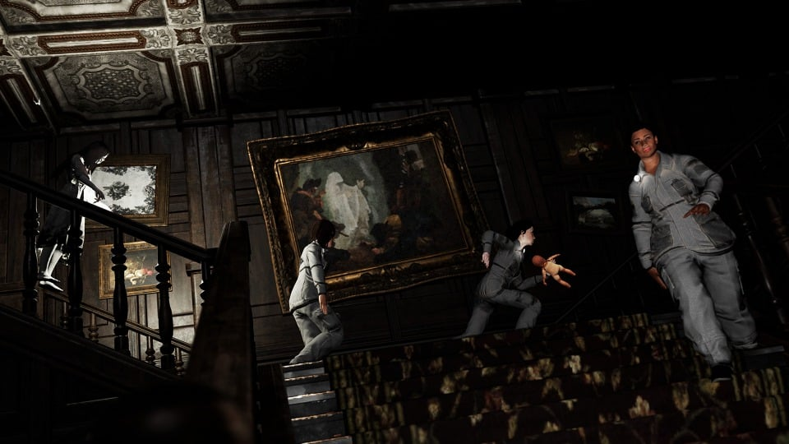
Source: https://www.guideoui.com/pacify-all-achievements-guide/

Music Style
<Description of intended music style>
Music focused on monster audio, and ominous background music.
<Link to example of intended style>
Storm - https://www.youtube.com/watch?v=Gz-jBbuqHZg
Monster - https://www.youtube.com/watch?v=Z-sSy8urj-c
Monster - https://www.youtube.com/watch?v=-JZSOILPi24
Monster - https://www.youtube.com/watch?v=Wki80BvSDRk
Monster Footrsteps - https://www.youtube.com/watch?v=-oEkmzXVeaE
Suspenseful background - https://www.youtube.com/watch?v=ljbrKDwXYt8
Suspenseful background - https://www.youtube.com/watch?v=QTFLYCMkyiM
Chase music - https://www.youtube.com/watch?v=ta7PPkwLZsg
Footsteps - https://www.youtube.com/watch?v=Xi1NxS0HP2M
Footsteps - https://www.youtube.com/watch?v=U3frQdGaJiY
GrandFather Clock - https://www.youtube.com/watch?v=uSFAlk3Yh_k
Door Opening/Creaking - https://www.youtube.com/watch?v=2paJB1s4XAo
Door unlocking - https://www.youtube.com/watch?v=cQ1jXK9BGcg
Safe Unlocking - https://www.youtube.com/watch?v=08z1fWAboU4

SFX Style
<Description of intended SFX style>
Realistic(somewhat)
<Link to example of intended style>
https://store.steampowered.com/app/967050/Pacify/

Helpful article - https://www.gamasutra.com/blogs/DarrenMcKettrick/20130909/199865/An_Investigation_into_the_Effects_of_Horror_Games.php

Interactivity

Camera Logic
<Camera Description>
First person angle
The camera will always face where the player is facing and follow the mouse
<Quick camera mockup below>
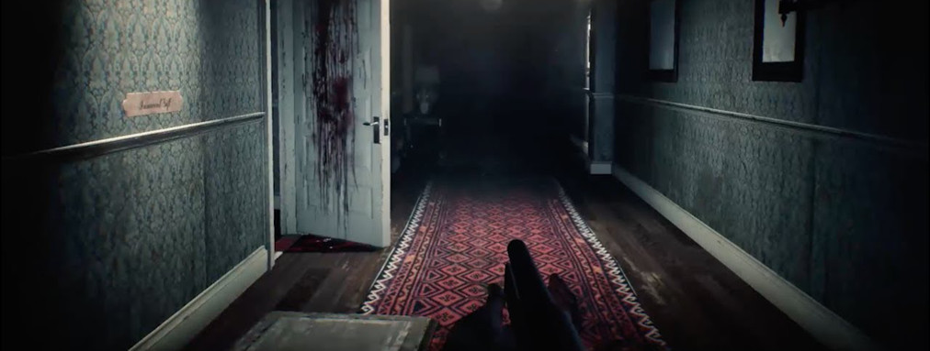
Source: https://www.game-debate.com/news/24551/get-a-fresh-perspective-on-horror-with-the-evil-within-2s-new-first-person-mode

<Scale of objects on screen>
Realistic scaling (maybe use the Horizontal plus method)
<Update and follow logic>
Follows the character forward direction dictated by the movement of the mouse
<Additional considerations>

Controls

PC Controls

- <Control>
- WASD - movement
- Mouse – look around
- Shift – to run
- Ctrl - crouch
- E - interaction
- Left mouse – Fire Weapon
- F – Turn Flashlight on/off
- R- reload flashlight
- numPad - inventory
- esc – pull up options scene

WebPlayer Controls

- <Control>
- Esc – pull up options scene
- WASD - movement
- Mouse – look around
- Shift – to run
- Ctrl - crouch
- E - interaction
- Left mouse – Fire Weapon
- F – Turn Flashlight on/off
- R- reload flashlight
- numPad - inventory

Tablet

- <Control>
- <Control>
- <Control>
- <Control>
- <Control>
- <Control>
- <Control>
- <Control>
- <Control>
- <Control>

Scope

Game Progress – Player Milestones
- <Player Milestone> Tutorial – tells the player the basic movement and inputs of the game
- <Player Milestone> Core Item Pickup – states the monster will start to move faster
- <Player Milestone> Key Item Pickup – States new area available
- <Player Milestone> Monster Noise – States the monster is nearby the first time heard
- <Player Milestone> Defeat Monster – guides the player to leave map to then win

Worlds/Levels
<Break down of the various environments of the game>’
One level - Abandoned building with 3 – 4 floors and various rooms with items
<Expected play times>
At least 15 – 30 mins per attempt
<Rough estimate of total play time>
4 attempts = 1 hour – 1 ½ hours

Mechanics
<List out and describe in complete detail the game mechanics here>
Avoiding Monster: hiding somewhere or repelling with raid can
Puzzles: solving puzzles to collect core items
Consumable Items: spawning raid cans

Player abilities

Ability
Item – raid can/poison – deters monster

Ability
Item – flashlight – Produces light for the player to be able to see their surroundings.

Enemy architypes
Arachnid Monster – AI that searches for player based on sound drop

Enemy mechanics

Mechanic
Patrols a designated area making the player to decide to either, try to sneak through, or go around.

Mechanic
Can hear the player if too much noise is made – noise attracts monster

Mechanic

Obstacle types

Obstacle
Locked doors – without a corresponding key parts of the map are blocked off

Obstacle
Avoiding monsters – may have to reroute path if monster is in the way

Unlockables
Unlock doors – finding keys to unlock critical areas of the map

Resources
Raid can(poison), core items, keys

Puzzles
Tower of Hanoi, wall safe, fuse connection, keycode to unlock safe, etc.

…

