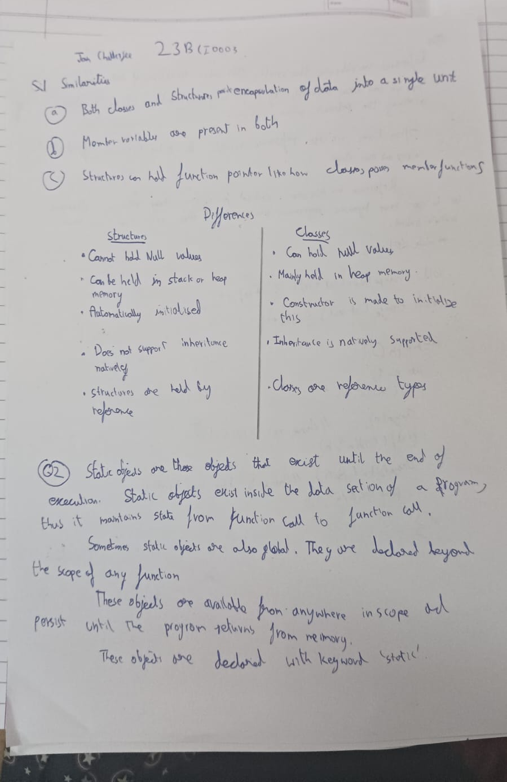
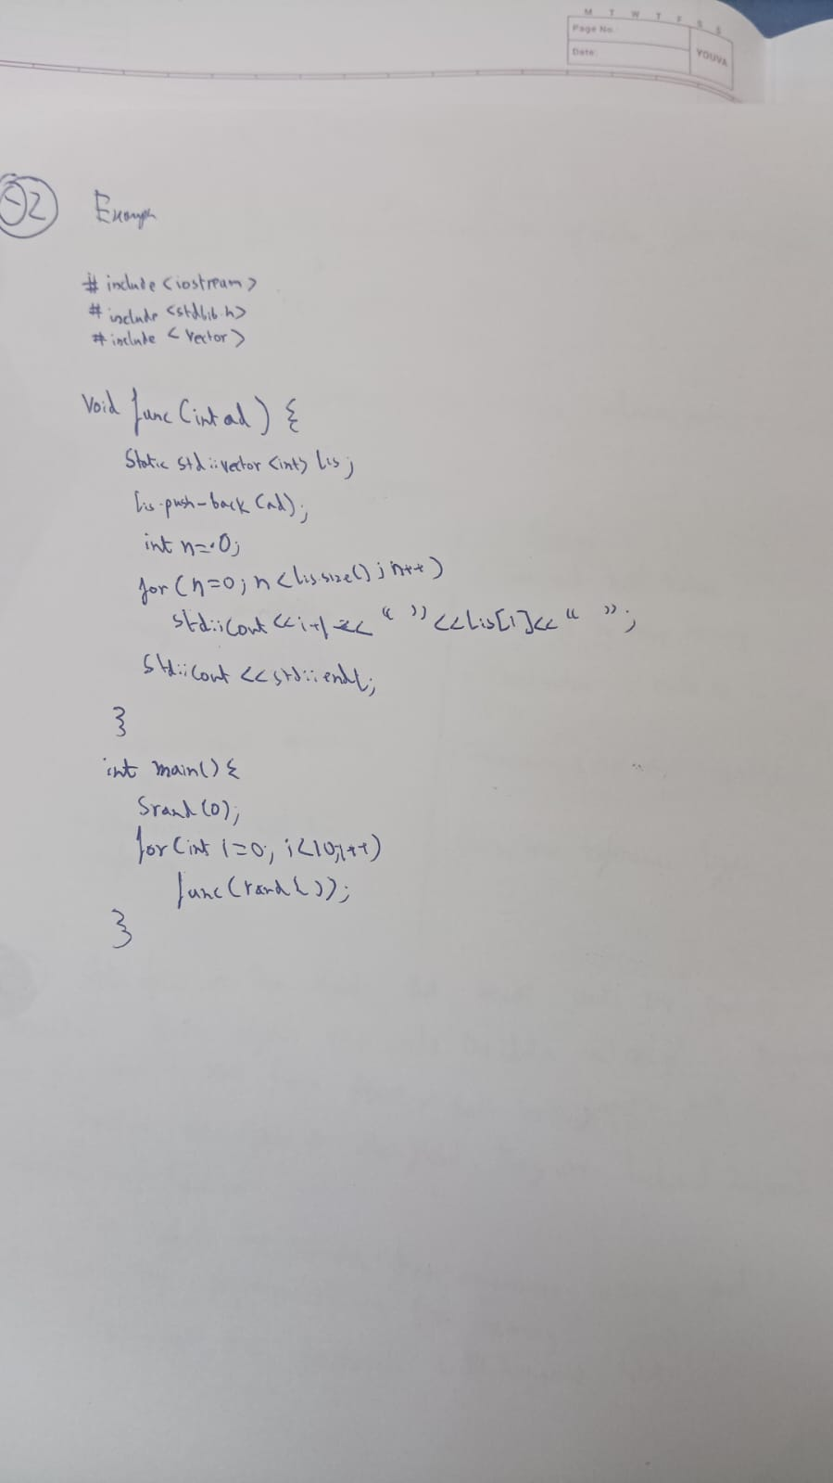
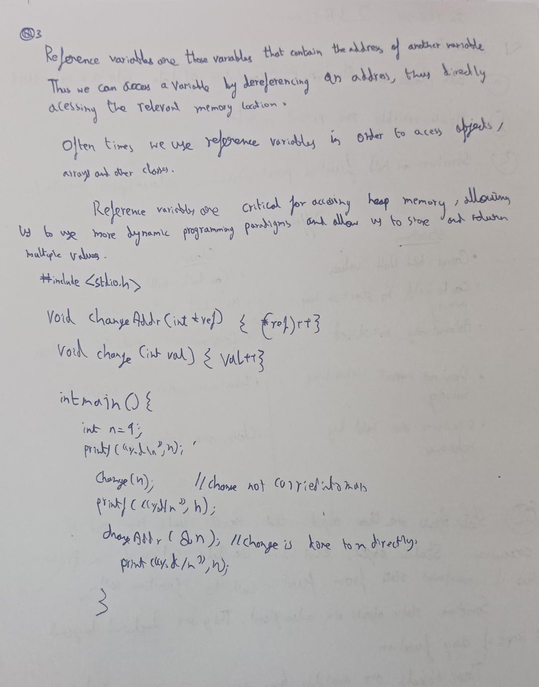
Q4
#include <corecrt.h>
#include <iostream>
#include <stdint.h>
#include <stdio.h>
#include <stdlib.h>
#include <string.h>
#include <time.h>
using namespace std;

typedef struct {
char name[5000];
} chio;

class Stack {
private:
uint8_t *data;
size_t len;
size_t filled;

inline int BoundCheck(size_t n) { return (len - filled) < n; }

public:
Stack(size_t ln = 1024) {
len = ln;
data = (uint8_t *)malloc(len);
for (int i = 0; i < len; i++)
data[i] = 0;
filled = 0;
}

void StackExpand() {
len *= 1.5;
data = (uint8_t *)realloc((void *)data, len);
cout << "Stack Expanded to: " << len << endl;
}
void int8Push(int8_t siz) {
if (BoundCheck(sizeof(int8_t)))
StackExpand();
data[filled] = siz;
filled++;
}
template <typename T> void push(T t) {
if (BoundCheck(sizeof(T))) {
StackExpand();
push(t);
return;
}

size_t temp = filled;
for (filled; filled - temp < sizeof(T); filled++) {
data[filled] = (uint64_t)t & 0xff;
t = (T)((uint64_t)t >> 8);
}
int8Push(sizeof(T));
}
int8_t int8Pop() {
filled--;
return data[filled];
}

template <typename T> void pop(T *t) {
if (filled == 0) {
cout << "STACK IS EMPTY" << endl;
return;
}

int8_t siz = int8Pop();
if (siz > sizeof(T)) {
cout << "POINTER MISMATCH" << endl;
int8Push(siz);
return;
}

*t = 0;
size_t temp = filled;
for (filled; temp - filled < siz; filled--) {
*t = (T)(((uint64_t)*t << 8) | data[filled - 1]);
}
*t = *t;
}
};

class Student {
private:
char name[50];
int Uid;

public:
Student(int i = 0) {
name[0] = 0;
Uid = i;
}
void input() {
cout << "Name? ";
cin >> name;
}
void out() { cout << "Uid: " << Uid << "\tName: " << name << endl; }
};

int main() {
Stack a = Stack();

int letteri = 0;
cout << "How Many Characters?: ";
cin >> letteri;
for (int i = 0; i < letteri; i++) {
char ti;
cin >> ti;
a.push(ti);
}

int Numi = 0;
cout << "How Many Numbers?: ";
cin >> Numi;
for (int i = 0; i < Numi; i++) {
int ti;
cin >> ti;
a.push(ti);
}

int Obji = 0;
cout << "How Many Objects?: ";
cin >> Obji;
for (int i = 0; i < Obji; i++) {
Student *ti = new Student(i + 1);
ti->input();
a.push(ti);
}

// POPIN
for (int i = 0; i < Obji; i++) {
Student *ti;
a.pop(&ti);
ti->out();
}

for (int i = 0; i < Numi; i++) {
int ti;
a.pop(&ti);
cout << ti << endl;
}

for (int i = 0; i < letteri; i++) {
char ti;
a.pop(&ti);
cout << ti << endl;
}

return 0;
}

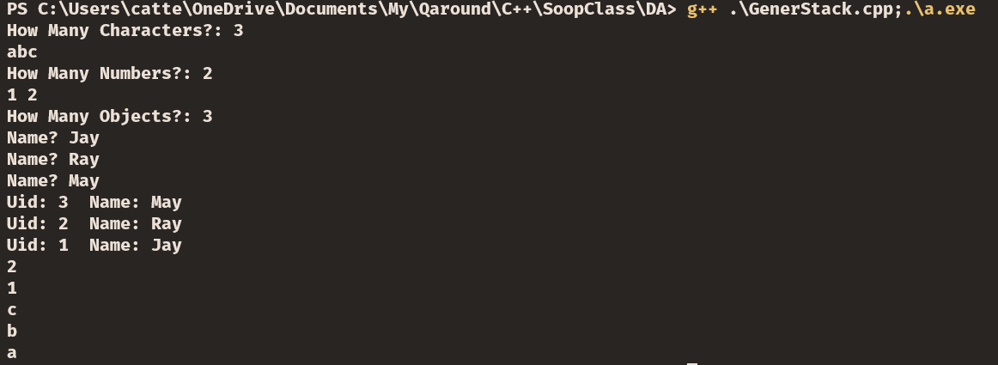

Q5

#include <cstddef>
#include <cstdio>
#include <iostream>
#include <locale.h>
#include <stdint.h>
#include <stdlib.h>
#include <time.h>
#include <vector>

int max(int a, int b) {
if (a > b)
return a;
else
return b;
}

template <typename T> class Vec {
private:
T *lis;
size_t at;
size_t len;

public:
Vec(int64_t len = 2) {
at = -1;
this->len = len;
lis = (T *)malloc(this->len * sizeof(T));
}

void VecExp(int Se = 0) {
len *= 1.5;
len = max(Se, len);
this->lis = (T *)realloc(lis, len * sizeof(T));
for (int i = at + 1; i < len; i++)
lis[i] = 0;
}

void push(T a) {
at++;
if (at >= len)
VecExp(at + 1);
lis[at] = a;
}

void prin() {
for (int i = 0; i <= at; ++i) {
std::cout << lis[i] << " ";
}
std::cout << std::endl;
}

T pop() { return lis[at--]; }

T &operator[](const size_t ind) {
if (ind >= len)
VecExp(ind + 1);
return lis[ind];
}
~Vec() { free(lis); }
};

int absol(int X) {
if (X > 0)
return X;
return -1 * X;
}

#define GUESSLIM 10
int main() {
srand(time(NULL));

uint32_t p = rand();
Vec<int> lis(2);

int num = 1;

for (int i = 0; i < GUESSLIM; i += 1) {
lis.push(num);
num *= 10;
num += rand() % 10;
}
int gues = 0;
printf("GUESS [1-%d] ", GUESSLIM);
std::cin >> gues;
gues--;
/* lis.prin(); */
p *= gues;
p %= GUESSLIM;
/* std::cout << p << std::endl; */
int dis = GUESSLIM - absol(p - gues) - 1;
printf("You win Rs %d\n", lis[dis]);
return 0;
}

