23BCI0003
JOSH CHATTERJEE

OS LAB DA 4: DISK SCHEDULING

FFCS:

ALGORITHM:

STEP 1: Start.
STEP 2: Find the first valid element of the list of requests.
STEP 3: Fulfill request and move read write head to specified location.
STEP 4: Remove element from the list. If list if empty go to step 5 else go to step 2.
STEP 5: Stop.

CODE:

int FIFOInit(ReqQue *req, rwHead *head) {
int index = -1;
for (int i = 0; i < req->len; i++) {
if (req->list[i] == -1)
continue;
head->targ = req->list[i];
index = i;
}
return index;
}

int FCFS(ReqQue *req, rwHead *head) {
int ind = FIFOInit(req, head);
if (ind != -1)
req->list[ind] = -1;
// printReq(req);
return ind;
}

OUTPUT:

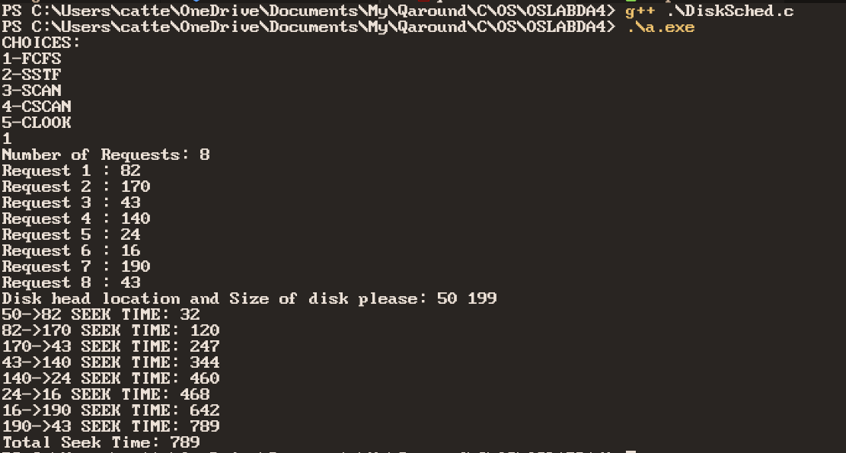
SSTF:

ALGORITHM:

STEP 1: Start.
STEP 2: Find a valid element of the list of requests that has minimum difference between itself and the current location.
STEP 3: Fulfill request and move read write head to specified location.
STEP 4: Remove element from the list. If list if empty go to step 5 else go to step 2.
STEP 5: Stop.

CODE:

int SSTF(ReqQue *req, rwHead *head) {
int min = FIFOInit(req, head);

for (int i = 0; i < req->len; i++) {
if (req->list[i] == -1)
continue;
if (abs(head->curr - req->list[i]) < abs(head->curr - head->targ)) {
head->targ = req->list[i];
min = i;
}
}
req->list[min] = -1;
return head->targ == -1;
}

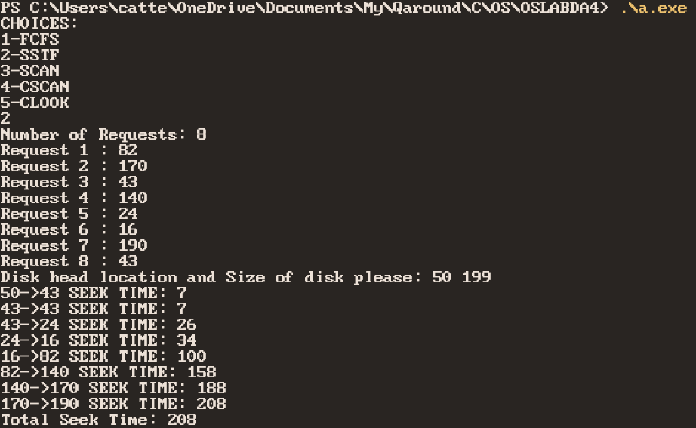
OUTPUT:
SCAN:

ALGORITHM:

STEP 1: Start
STEP 2: Start moving read write head from current location to maximum location
STEP 3: Fulfill all requests that occur as head moves.
STEP 4: If maximum location is reached got to location 0 else repeat STEP 3.
STEP 5: Stop

CODE:

int SCAN(ReqQue *req, rwHead *head) {

head->targ = head->max;

if (head->curr == head->max) {
head->targ = 0;
return 0;
}

for (int i = 0; i < req->len; i++) {
if ((req->list[i] < head->curr))
continue;
int delet = req->list[i];
req->list[i] = -1;
if (isEmpty(req)) {
head->targ = delet;
return 0;
}
}

return 0;
}

OUTPUT:
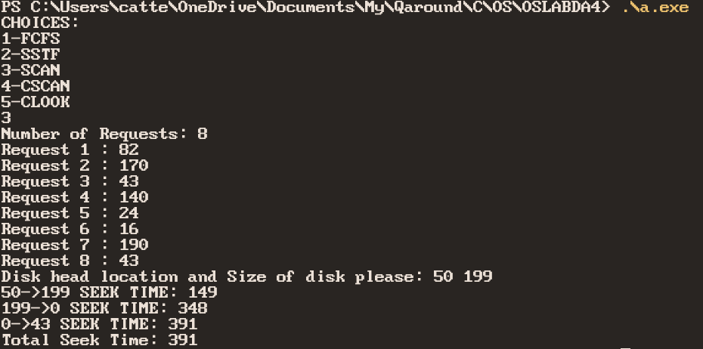
CSCAN:

ALGORITHM:

STEP 1: Start
STEP 2: Set target to maximum address of disk.
STEP 3: Start moving read write head from current location to target location
STEP 4: Fulfill all requests that occur as head moves.
STEP 5: If maximum location is reached got to STEP 6 else repeat STEP 4.
STEP 6: If target is 0 set target to maximum address else set target to 0
STEP 7: If request list is empty go to step 8 else go to step 3
STEP 8: Stop

CODE:

int CSCAN(ReqQue *req, rwHead *head) {
static int dir = 1;

head->targ = head->max * dir;

for (int i = 0; i < req->len; i++) {
if (dir != (req->list[i] > head->curr))
continue;

int delet = req->list[i];
req->list[i] = -1;
if (isEmpty(req)) {
head->targ = delet;
return i;
}
}
dir = !dir;

return head->targ;
}

OUTPUT:

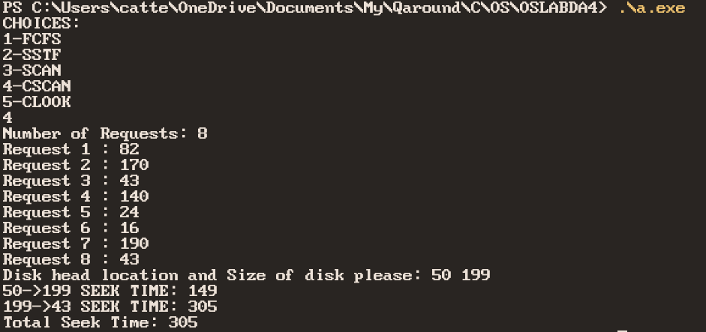
CLOOK:

ALGORITHM:

STEP 1: Start
STEP 2: Find the maximum request in the request list and set target to that
STEP 3: If target is to the left of current position go to STEP 4 else go to STEP 5.
STEP 4: Find minimum request in the request list and set target to that.
STEP 5: Go to target and fulfill all requests that are reached.
STEP 6: If request list is empty go to STEP 7 else go to STEP 2.
STEP 7: Stop

int CLOOK(ReqQue *req, rwHead *head) {
head->targ = max(req, head);
if (head->targ < head->curr) {
head->targ = min(req, head);
return 0;
}

for (int i = 0; i < req->len; i++) {
if (req->list[i] >= head->curr)
req->list[i] = -1;
}
return 0;
}

OUTPUT:
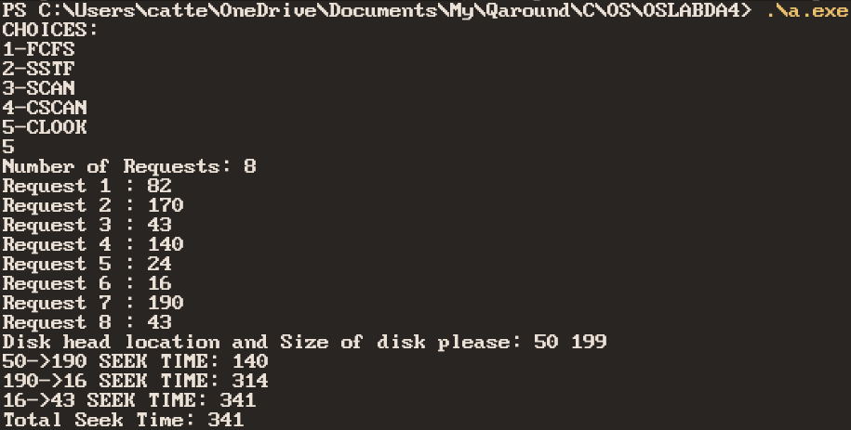
FULL CODE

#include <corecrt.h>
#include <stdio.h>
#include <stdlib.h>

typedef struct {
int *list;
size_t len;
} ReqQue;

typedef struct {
int curr;
int max;
int targ;
} rwHead;

int isEmpty(ReqQue *req);

ReqQue *ReqInit() {
ReqQue *Out = (ReqQue *)malloc(sizeof(ReqQue));

Out->len = 0;
printf("Number of Requests: ");
scanf("%llu", &Out->len);

Out->list = (int *)malloc(Out->len * sizeof(int));

for (int i = (int)Out->len - 1; i >= 0; i--) {
Out->list[i] = 0;
printf("Request %llu : ", Out->len - i);
scanf("%d", &Out->list[i]);
}

return Out;
}

void printReq(ReqQue *req) {
for (int i = 0; i < req->len; i++) {
if (req->list[i] == -1)
continue;
printf("%d ", req->list[i]);
}
printf("\n");
return;
}

void ReqFree(ReqQue *in) {
free(in->list);
in->list = NULL;
in->len = 0;
free(in);
}

int FIFOInit(ReqQue *req, rwHead *head) {
int index = -1;
for (int i = 0; i < req->len; i++) {
if (req->list[i] == -1)
continue;
head->targ = req->list[i];
index = i;
}
return index;
}

int FCFS(ReqQue *req, rwHead *head) {
int ind = FIFOInit(req, head);
if (ind != -1)
req->list[ind] = -1;
// printReq(req);
return ind;
}

int SSTF(ReqQue *req, rwHead *head) {
int min = FIFOInit(req, head);

for (int i = 0; i < req->len; i++) {
if (req->list[i] == -1)
continue;
if (abs(head->curr - req->list[i]) < abs(head->curr - head->targ)) {
head->targ = req->list[i];
min = i;
}
}
req->list[min] = -1;
return head->targ == -1;
}

int CSCAN(ReqQue *req, rwHead *head) {
static int dir = 1;

head->targ = head->max * dir;

for (int i = 0; i < req->len; i++) {
if (dir != (req->list[i] > head->curr))
continue;

int delet = req->list[i];
req->list[i] = -1;
if (isEmpty(req)) {
head->targ = delet;
return i;
}
}
dir = !dir;

return head->targ;
}

int SCAN(ReqQue *req, rwHead *head) {

head->targ = head->max;

if (head->curr == head->max) {
head->targ = 0;
return 0;
}

for (int i = 0; i < req->len; i++) {
if ((req->list[i] < head->curr))
continue;
int delet = req->list[i];
req->list[i] = -1;
if (isEmpty(req)) {
head->targ = delet;
return 0;
}
}

return 0;
}

int max(ReqQue *req, rwHead *head) {
int max = req->list[FIFOInit(req, head)];
for (int i = 0; i < req->len; i++) {
if (req->list[i] == -1)
continue;
if (req->list[i] > max)
max = req->list[i];
}
return max;
}

int min(ReqQue *req, rwHead *head) {
int min = req->list[FIFOInit(req, head)];
for (int i = 0; i < req->len; i++) {
if (req->list[i] == -1)
continue;
if (req->list[i] < min)
min = req->list[i];
}
return min;
}

int CLOOK(ReqQue *req, rwHead *head) {
head->targ = max(req, head);
if (head->targ < head->curr) {
head->targ = min(req, head);
return 0;
}

for (int i = 0; i < req->len; i++) {
if (req->list[i] >= head->curr)
req->list[i] = -1;
}
return 0;
}

int isEmpty(ReqQue *req) {
int cou = 0;
for (int i = 0; i < req->len; i++)
cou += req->list[i] == -1;
return cou == req->len;
}

int EvalAlgo(int (*Alg)(ReqQue *, rwHead *), ReqQue *req, rwHead *head) {
int seek = 0;
for (int i = 0; !isEmpty(req) && i < req->len; i++) {
Alg(req, head);
seek += abs(head->targ - head->curr);
printf("%d->%d SEEK TIME: %d\n", head->curr, head->targ, seek);
head->curr = head->targ;
}
printf("Total Seek Time: %d\n", seek);
return seek;
}

int main(int argc, char *argv[]) {

int n = 0;
printf("CHOICES:\n1-FCFS\n2-SSTF\n3-SCAN\n4-CSCAN\n5-CLOOK\n");
scanf("%d", &n);

ReqQue *Req = ReqInit();
printf("Disk head location and Size of disk please: ");
rwHead temp = {0, 199}; // curr max
scanf("%d %d", &temp.curr, &temp.max);

switch (n) {
case 1:
EvalAlgo(&FCFS, Req, &temp);
break;
case 2:
EvalAlgo(&SSTF, Req, &temp);
break;
case 3:
EvalAlgo(&SCAN, Req, &temp);
break;
case 4:
EvalAlgo(&CSCAN, Req, &temp);
break;
case 5:
EvalAlgo(&CLOOK, Req, &temp);
break;
}

ReqFree(Req);

return EXIT_SUCCESS;
}

