Functional Specification

For

G-Arc

SRCM Global Archival System

# Revision History

|  |  |  |  |  |
| --- | --- | --- | --- | --- |
| Revision Number | Change Descriptions | Author | Date Modified | Changes Made |
| 1.0 | Initial draft | Sujatha | 10th April 2015 | Draft |

Table of Contents

I. Revision History 2

**1.** **Project Objective** 5

**2.** **Business Case** 5

**3.** **Existing System Scope** 5

**4.** **Targeted Audience** 6

**5.** **Existing Process** 6

**6.** **Requirements** 6

**6.1** **Artefacts** 6

**6.2** **Attributes** 8

**6.3** **Check-in and Check-Out** 9

**6.1** **Maintenance Schedules** 9

**6.2** **Authentication & Authorization** 10

**6.3** **Dashboard** 13

**6.4** **Search/View Artifacts** 13

**6.5** **Reports** 14

# **Project Objective**

The primary objective is to maintain all the Artefacts across various Archive locations. This will be a global system to,

* + view the Artefacts that are available in each location
  + define periodic maintenance or do sporadic maintenance on the Artefacts
  + maintain conditional reports for each of the Artefact
  + maintain Presidential Archives with higher security level
  + preview the Artefact in Image or picture or Video or photo format
  + provide alerts for pending tasks, related to the maintenance of the Artefacts
  + define various attributes of the Artefacts

# **Business Case**

* + Currently there are various types of Artefacts in the Archives.
  + Duplicates of Artefacts are stored in multiple locations which include Video materials, books, Magazines, original letters and other personal belongings of Hierarchy of Masters.
  + Some of the Artefacts need to be replicated and sent to other locations.
  + There is a need for a system to globally manage the Archives and the Artefacts across the globe.
  + Scheduled maintenance is not in place
  + No visibility of what artefacts are in which location
  + No single repository where one can view the condition of the Artefact.
  + There are multiple teams working in Silos

# **Existing System Scope**

* + There are multiple teams working on various types of Artefacts. For instance there is a team for Audio and Video, separate team for Photographs, and separate team for books based on the expertise level of the teams.
  + Each team maintains the attributes, condition report of the Artefact in their own custom built or off the shelf products or in Excel.

# **Targeted Audience**

* + The President
  + Global Administrator
  + Local Archive Centre Administrators
  + Users who maintain the Artefacts

# **Existing Process**

Audio/Video materials are maintained using a bespoke application. Books are maintained in excel, photographs are maintained using off the shelf products.

# **Requirements**

# **Artefacts**

1. Capture various Artefact types. System should allow the Archive administrator to define a new Artefact type.

For instance one can define “Book”, “Magazine” as Artefact Type. This is meant for high level classification of all the items in the Archives.

2. Define all the child items that may exist for an item that can have an independent entity. The child item is to be defined only if it has its own attributes and can have its own maintenance schedules.

For Instance Artefact Type “Magazine” may have multiple “Topics”. The Parent Artefact magazine will have its own set of attributes such as Published Date, Magazine ID etc. The “Topic” which is a child item in a Magazine can have its own set of attributes such as “Author”, “Talk Date” etc.

|  |  |
| --- | --- |
| Artefact Type : Magazine | |
| Artefact Type : Magazine | Artefact Type : Topics *(inside the Magazine)* |
| **Item and its Attribute List** | **All Child Items and its Attribute List** |
| * **ID: MAG-CR-1995-Jan** | * **Topic id 1 : MAG-CR-1995-Jan_01** * **Topic id 2 : MAG-CR-1995-Jan_02** * **……** |

* **CR** 
  + **MAG-CR-1995-Jan** 
    - **Topic id 1 : MAG-CR-1995-Jan_01**
    - **Topic id 2 : MAG-CR-1995-Jan_02**
  + **MAG-CR-1995-Apr** 
    - **Topic id 1 : MAG-CR-1995-Apr_01**
    - **Topic id 2 : MAG-CR-1995-Apr_02**

|  |  |
| --- | --- |
| Artefact Type : Book | |
| Artefact Type : Book | Artefact Type : Chapter |
| **Item and its Attribute List** | **All chapters and its Attribute List** |
| * **ID: Bok-PSM-001** | * **Chap id : PSM-01-01-SURR** |
| * Name: Principles of SM | * Name : S |
| * Release Date : 02-Jan-1990 | * Chapter No : 1 |
| * Edition: Special Edition | * Gist : On Surrender |
| * Author : Compendium | * Author : Br. Xxyyzz |
| * ……… | * ……… |
|  | * **Chap id : PSM-01-02-Faith** |
|  | * Name : S |
|  | * Chapter No : 2 |
|  | * Gist : On Faith |
|  | * Author : Br. ZZppkkk |
|  | * ……… |

|  |  |
| --- | --- |
| Artefact Type : Video | |
| Artefact Type : Video | Artefact Type : Tracks |
| **Item and its Attribute List** | **All Child Items and its Attribute List** |
| * **ID: NVHS-1995-034-1** | * **Track1 : NVHS-1995-034-1_01** * **Track2 : NVHS-1995-034-1_02** * **…….** |

# **Attributes**

Upon defining the Artefact type, the attributes should also be defined. For instance if we define Artefact type called “Photo” then the Attributes for this type such as “Size”, “Place”, “Date”, “Color” will be defined.

Some of these attributes will have restricted values. i.e allow users to pick from the list rather than allowing to enter any value. For instance – user can only select language from the predefined list of language codes. Similarly for authors and allow the users to pick from the list rather than entering. Thereby not allowing data entry errors and more importantly due to which these may not appear in search results.

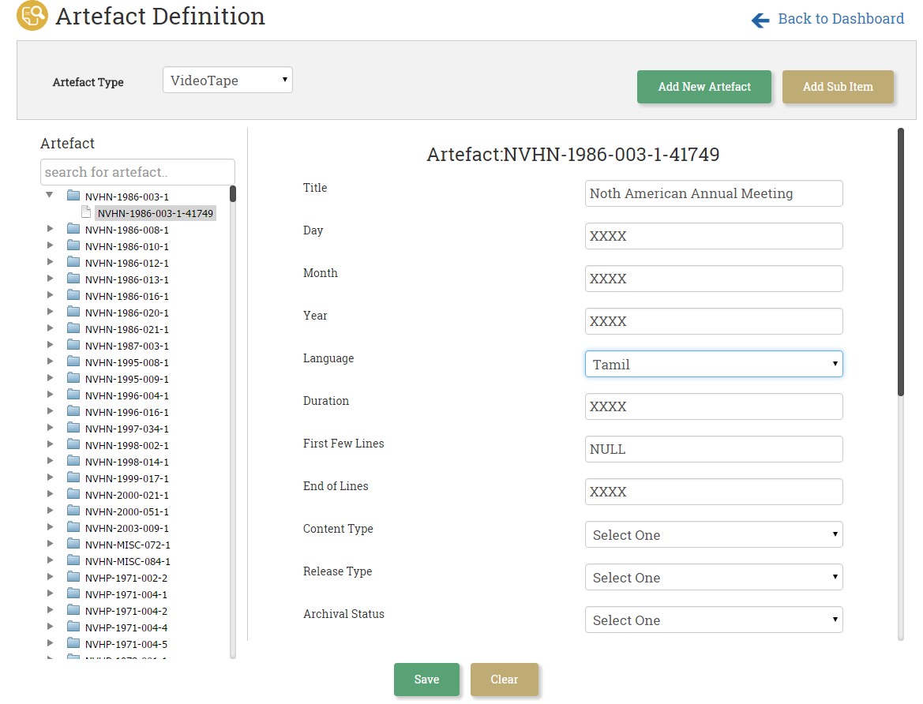

Artefact definition screen can be accessed based on the access permission configured in the system.

Each artefact type (ex- Book, VHS, Audio Tape) will be associated with predefined attributes which are defined by the system administrator.

Artefact parent and child will have the same attributes. (Book (parent), Chapter (child))

Artefacts can be defined at the artefact parent level and at the child level (sub item), after defining the artefact, user can key in the attribute values for the newly created artefact.

# **Check-in and Check-Out**

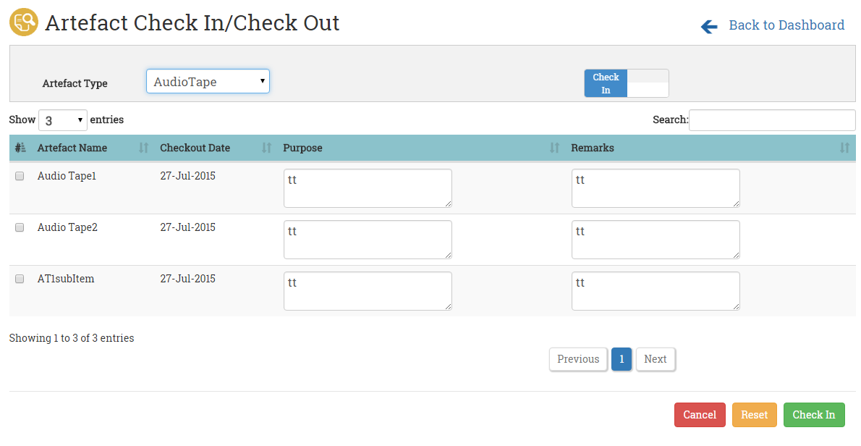

This module allows user to check out and check in items from the archives. This is location based and helps the local archive department head to track all the artefacts. A report can be generated from the system to track all outstanding artefacts.

# **Maintenance Schedules**

For each Artefact in every location it is mandatory to have a maintenance schedule, which will be enforced on all the artefacts. The maintenance date can be defined sporadically or defined on a periodic basis. When the user checks-out an artefact for maintenance, the user will be forced to specify the next maintenance dates while checking-in the artefact back into archives. The system based on the maintenance schedule provides alerts and posts messages as daily tasks/pending tasks on the dashboard.

# 

# **Authentication & Authorization**

Users/ Roles/ Locations/ Privileges- system allows one to define users, roles, locations and the appropriate privileges.

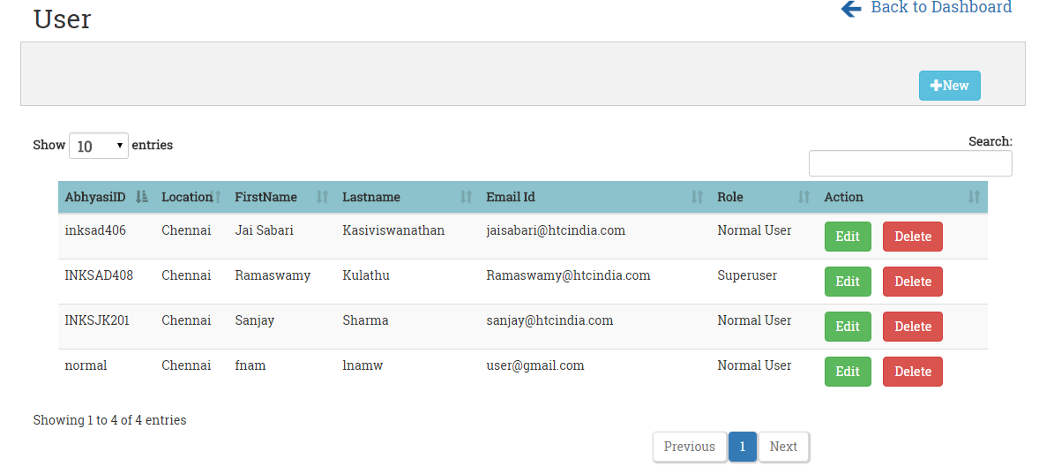

The Abhyasi Id can be used as a login id. A role is mapped to the user and based on the role definition the user will have access to the various pages.

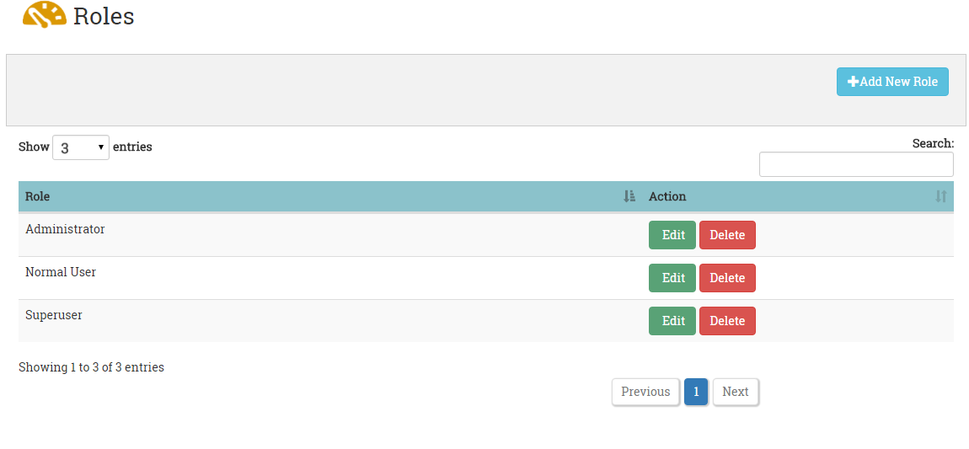

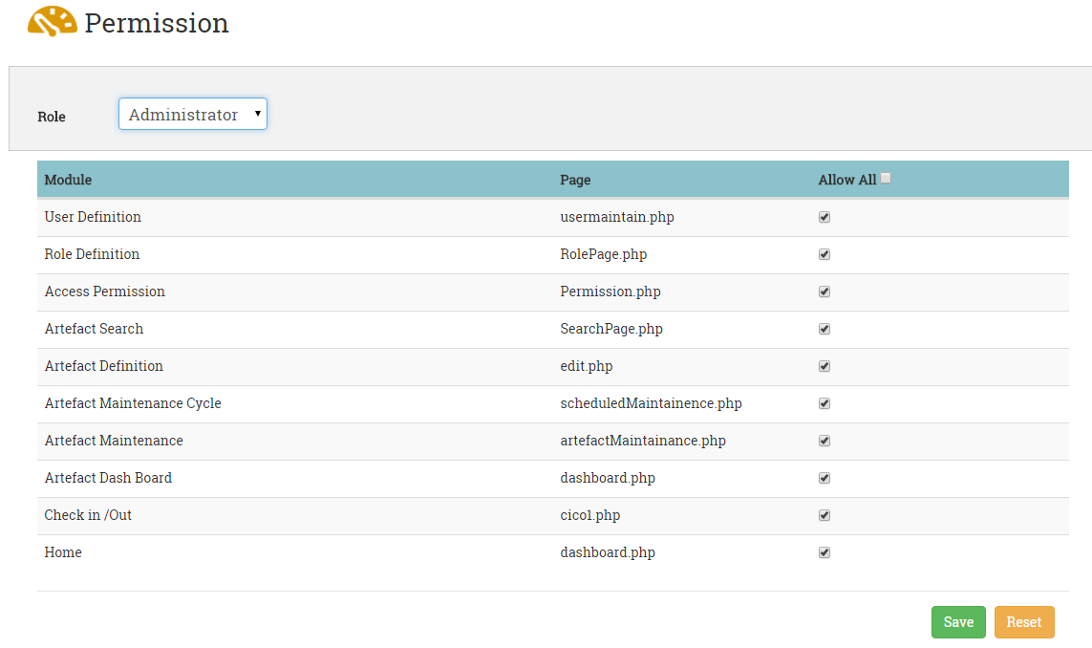

# **Dashboard**

When the user successfully logs-in, the landing page will be the Dashboard. This page gives a quick snapshot view of all the Artefact types in each location. From the pending task section, navigation is provided to maintenance screens.

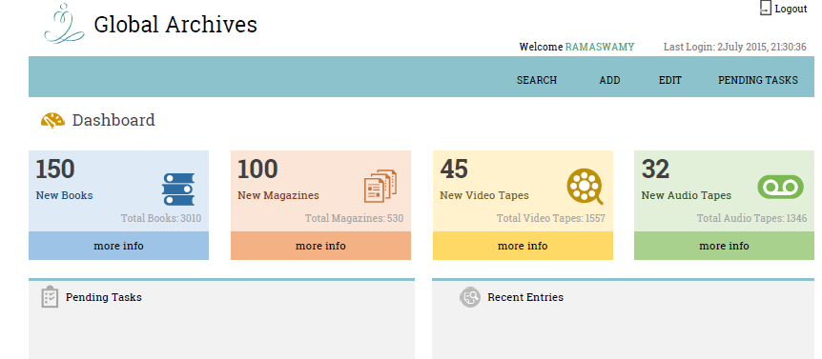

# **Search/View Artifacts**

The Artefact Search screen will have default location loaded based on the user sign- in credentials. The user will select the Artefact type from the drop down menu and based on that the attributes will be dynamically loaded. Each artefact type will have different attributes and so depending on the user’s selection the attributes will change.

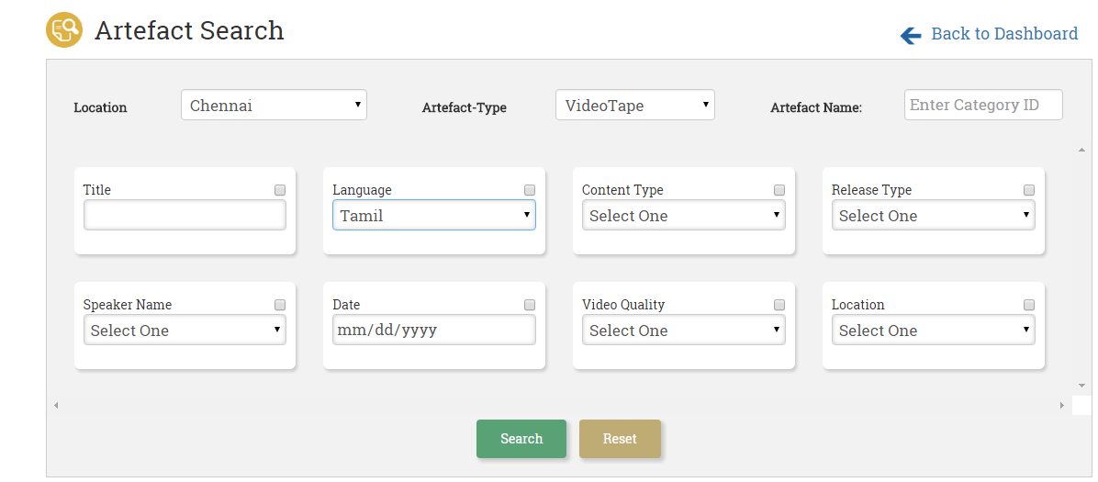

The search results are displayed in a grid. It is not mandatory to fill all the criteria fields for searching; any one will fetch the result. User can select all or specific attributes that should appear in the result grid. Free text search option is available for all the attributes that are available for the artefacts.

* system allows the users to search based on locations, type and various other attributes
* search results can be further refined
* user can preview the artefacts

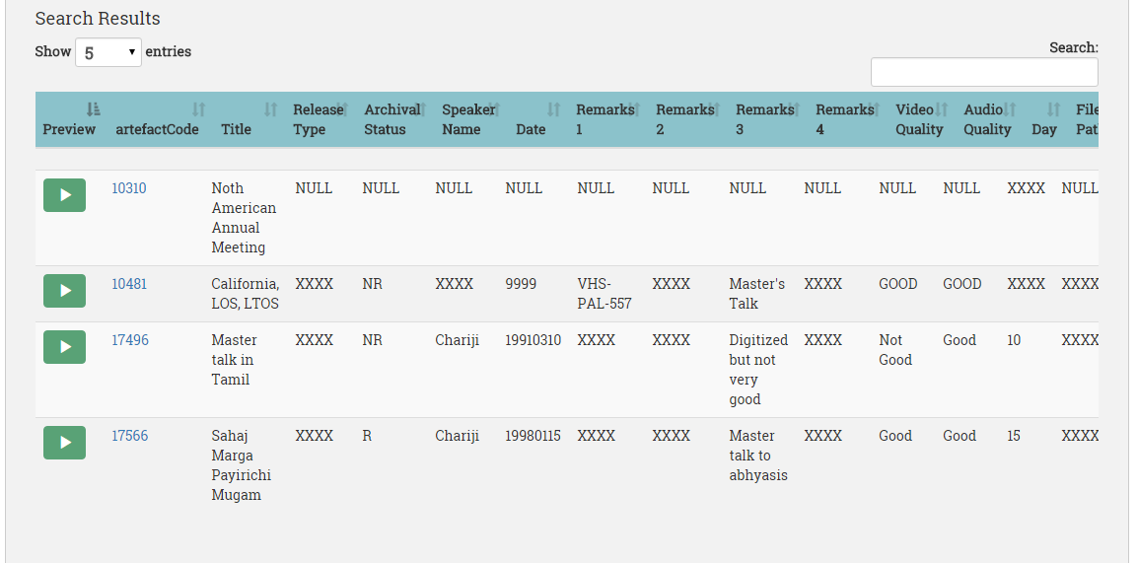

# **Reports**

1. Task list report – pending tasks by location.
2. Search Results should be exported to excel file format.
3. Maintenance schedule for the given period ( from date and to date)
4. Report based on the artefact condition – for instance, user can generate reports for all the fungal infected artefacts or artefacts that require treatment.
5. Condition report - The maintenance checklists that are available for a particular artefact type will have the list of tasks to be executed along with the status. Once the user executes and updates the status, the same should be available in the print format (which is the condition report for that artefact). For instance while performing the maintenance for a book one of the checklist item could be “check for the physical condition” and the various status.