Business Requirements Document
Project Details:
Project Name: Healthfirst Care Initiative
Project Start dte:17-03-2026
Prepared by: Poovarsha
Version:1.0
Introduction:
The HealthFirst Care initiative aims to improve patient experience and operational efficiency by addressing key issues such as long wait times, inefficient resource allocation, and communication gaps across departments. This document outlines the business requirements, stakeholders, and data-driven insights to guide the implementation of an improved healthcare management system.
Problem Statement:
HealthFirst Care currently faces several operational challenges:
- Long patient wait times leading to dissatisfaction
- Frequent appointment scheduling conflicts and double bookings
- Inefficient utilization of medical staff and resources
- Lack of effective communication between departments
- Limited integration of digital systems for scheduling and record management
Scope:
In Scope
- Appointment scheduling system improvements
- Resource allocation optimization
- Communication workflow enhancements
- Data-driven reporting and monitoring
Requirement ID | Title | Description | Priority | Stakeholders | Functional requirements
BR-01 | Automated appointment scheduling system | Implementing n automated scheduling system for patients | High | Patients | Setting up n scheduling system nd database for patients to book appointments
BR-02 | Conflict detection | To prevent double bookings, implement conflict detection | High | Patients, Administrative Staff | Implementing conflict detection to avoid double booking
BR-03 | Real-time notifications for patients and staff | Implementing communication system to provide updates | Medium | Patients, Administrative Staff, Doctors & Nurses | Setting up n communication system to provide notifications
BR-04 | Dashboard for monitoring appointments and resources | Creating Dashboards for monitoring, appointments | Medium | Administrative Staff, Doctors & Nurses, IT Staff | Fetching data in order to make Dashboards for monitoring appointments and resources
BR-05 | Centralized communication platform | Implementing communication channel | High | Patients, Administrative Staff, Doctors & Nurses, IT staff | Setting up n pltform for effective communication

Key Requirements
- Automate appointment scheduling
- Reduce double bookings
- Optimize staff and resource allocation
- Improve communication across departments
Acceptance Criteria
- Patient wait times reduced by at least 20%
- Appointment conflicts reduced significantly
- Increase in patient satisfaction scores
Improved staff utilization efficiency
Non-Functional Requirements
- System should be user-friendly
- High system availability (≥ 99%)
- Secure handling of patient data
- Scalable to support future growth
Assumptions
- Staff will be trained on the new system
- Patients will adopt digital communication methods
- Data provided is accurate and representative
Constraints
- Limited budget for system upgrades
- Existing legacy systems must be partially retained
- Limited IT resources for implementation
Risk Management:
- Training on new systems usage
- Monitoring and providing services for starting 3-months
- Securing the data in the systems

Supporting Data Insights
appointment_data.csv
The appointment data analysis identified 32 instances of scheduling conflicts where multiple appointments were assigned to the same doctor at the same time. These conflicts were most frequent during peak evening hours (5 PM–6:30 PM). Additionally, missing data in key fields indicates data quality issues. These findings emphasize the need for an automated scheduling system with conflict detection and validation features.
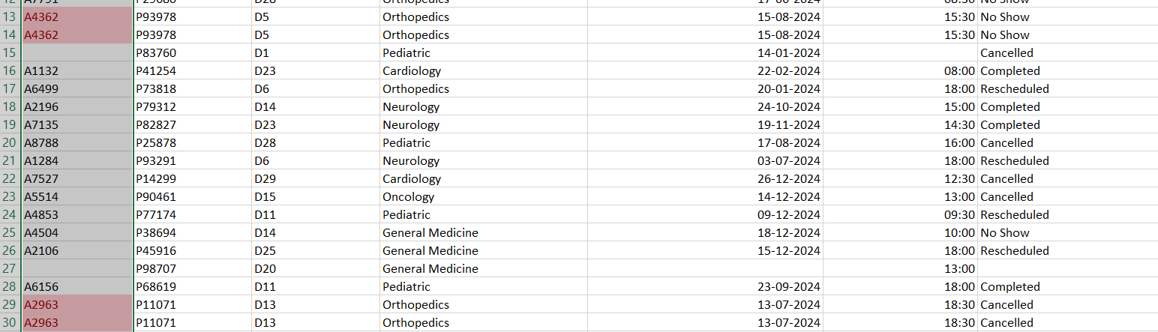
Fig_01: Highlighted Conflicting rows
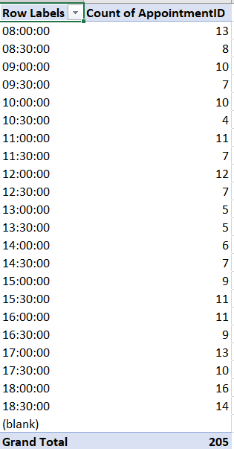
Fig_02: Peak Appointment Times

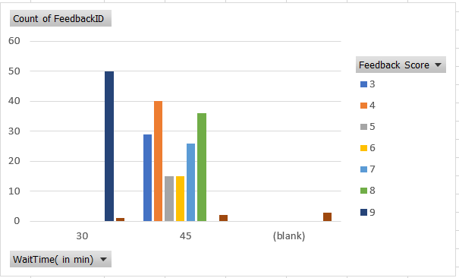
Fig_03 : Feedbck trends

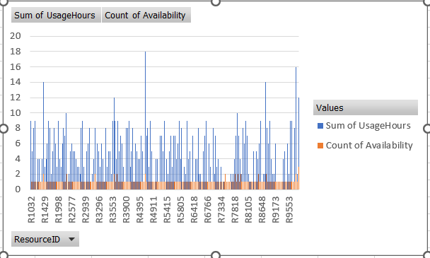
Fig_04 : resource utilization

