1. Introduction
- Purpose: Improve hospital efficiency
2. Current Challenges (AS-IS)
- Manual scheduling → errors
- Long wait times
- Poor communication
- System limitations

3. Proposed Solutions (TO-BE)
- Automated scheduling
- Self-service check-in
- Task management system

4. Expected Benefits
- Reduced wait time
- Improved patient satisfaction
- Better resource utilization
- Fewer errors

Analysis of Current Processes (As-Is)
Using your stakeholder file , here are the key pain points:
1. Appointment Scheduling Issues
- Manual booking by admin
- Double booking errors (Maria Carter)
- No real-time availability visibility
- Patients must call instead of using system
- No timely notifications (Sarah Ayvazyan)
Impact:
- Overbooked doctors
- Patient dissatisfaction
- Billing errors

2. Patient Check-in Issues
- Manual paperwork
- Long waiting times (30–60 mins)
- No real-time updates
- Difficult record retrieval
Impact:
- Delays in consultation
- Poor patient experience

3. Interdepartmental Communication Issues
- Manual communication between admin & IT
- Delays in lab/radiology results
- Miscommunication during patient transfers
- No centralized system
Impact:
- Treatment delays
- Duplicate work
- Resource inefficiency
- Task management system

4. Expected Benefits
- Reduced wait time
- Improved patient satisfaction
- Better resource utilization
- Fewer errors

Appointment Scheduling (AS-IS) Flowchart
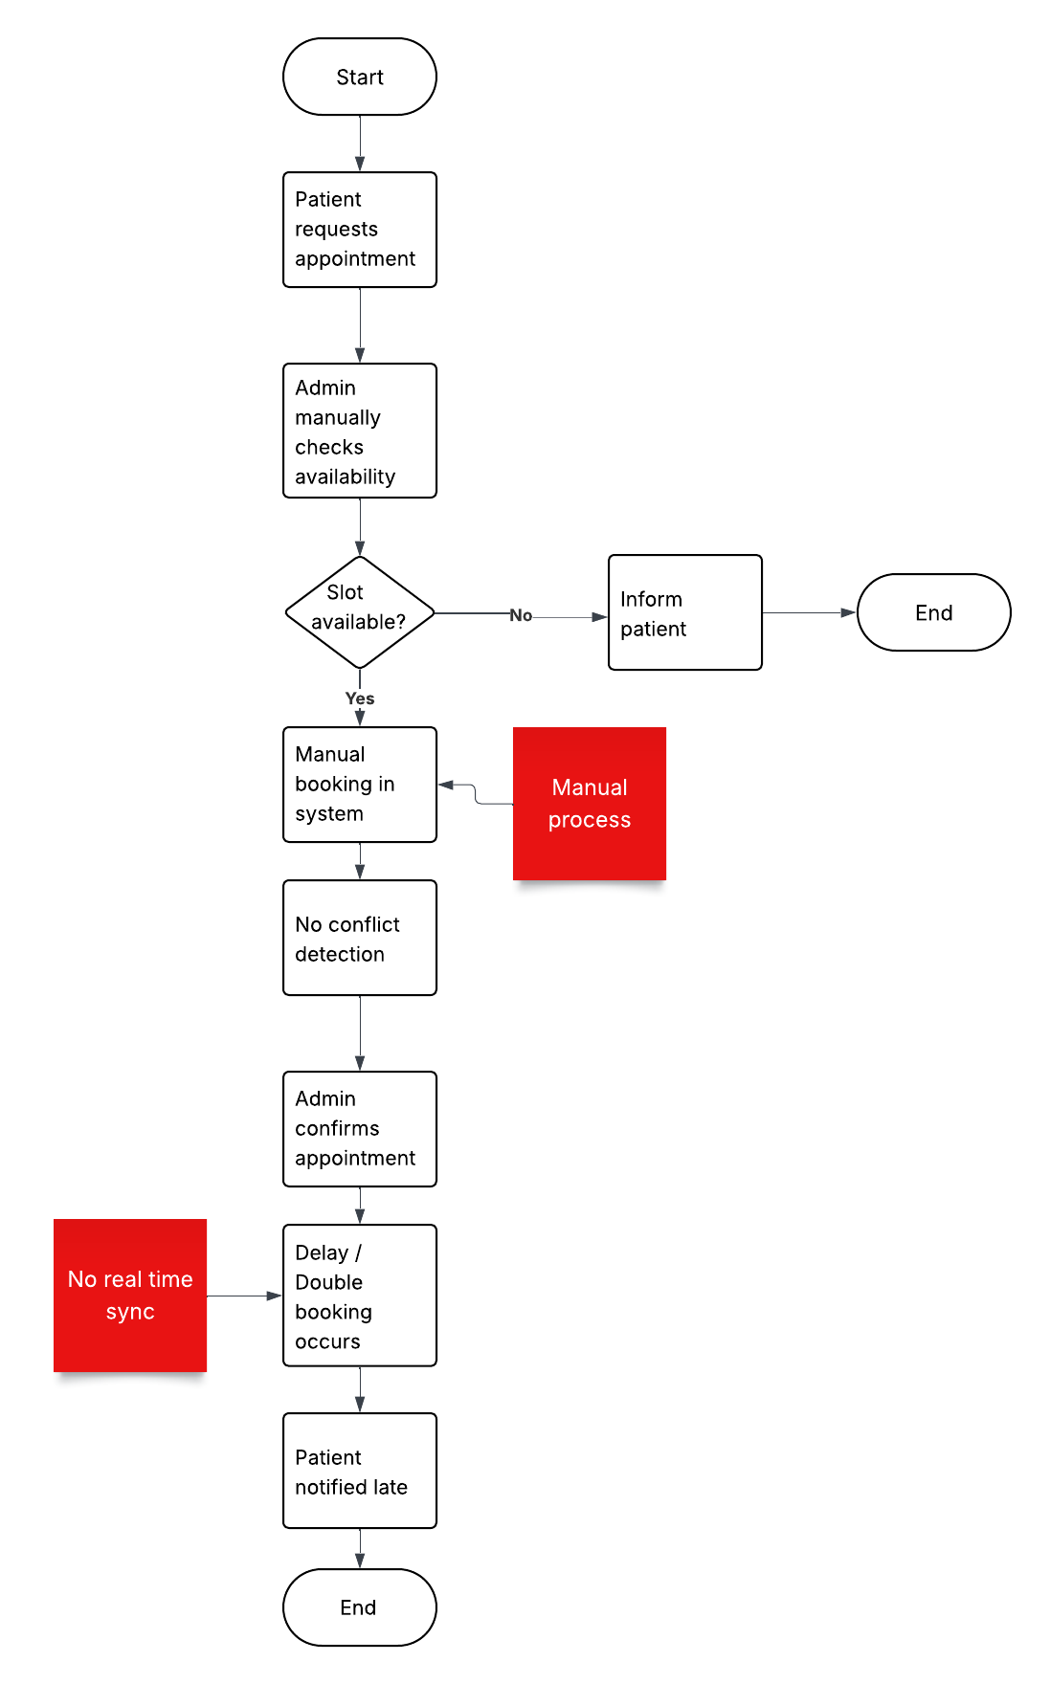
Patient Check-In (AS-IS) Flowchart

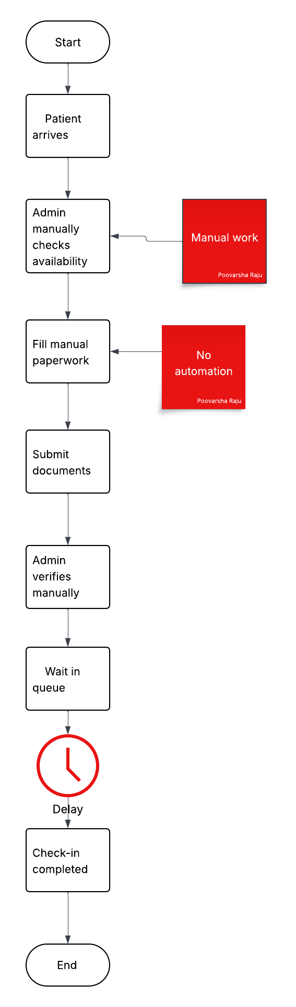

Interdepartment Communication (AS-IS) Flowchart
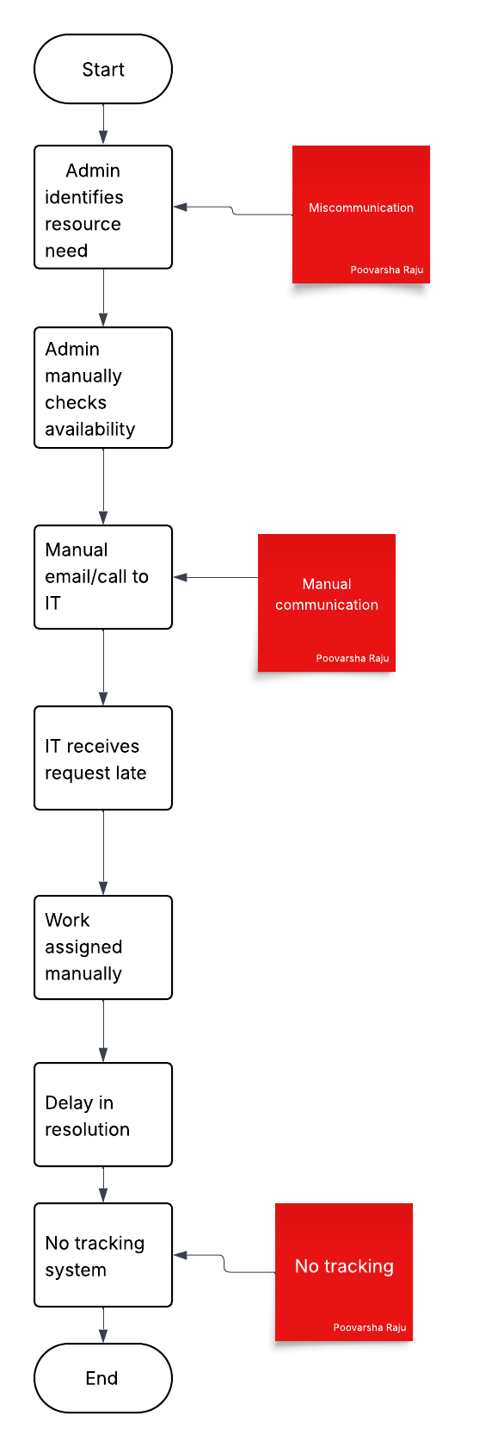

Appointment Scheduling (TO-BE) Flowchart

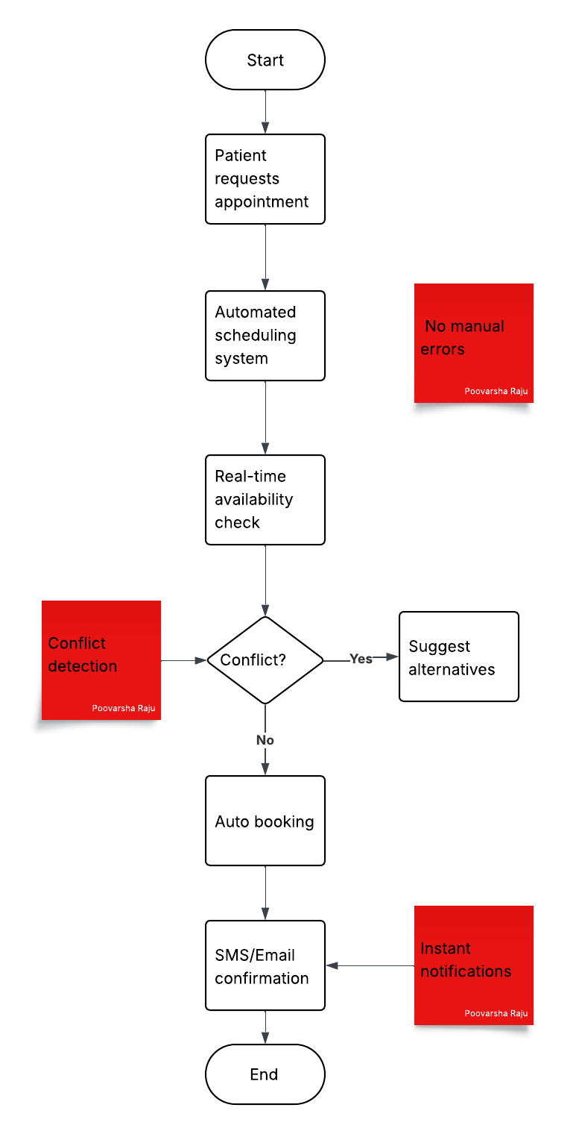
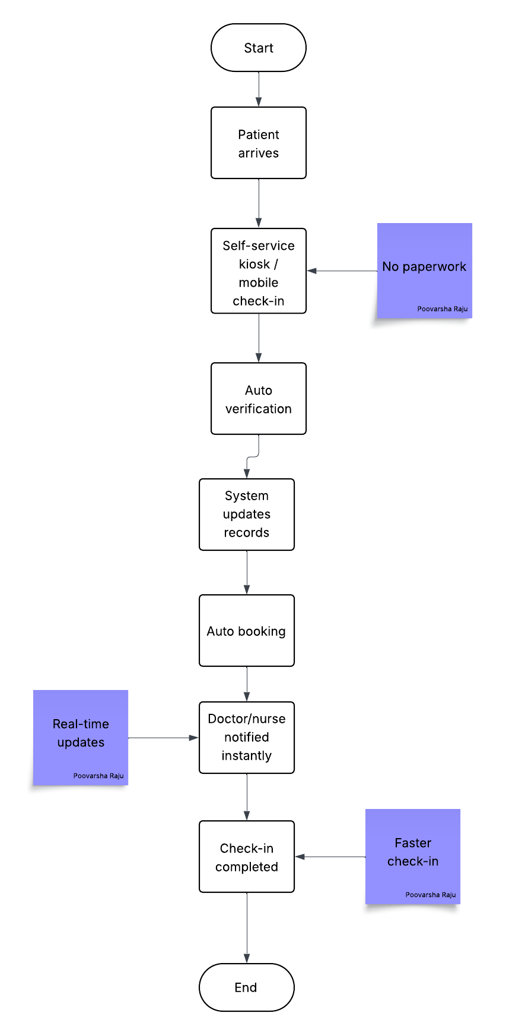
Patient Check-In (TO-BE) Flowchart

Interdepartment Communication TO-BE Flowchart 