Healthcare Workflow Analysis & BPMN Report
1. Introduction
This report analyses key healthcare workflows involving multiple stakeholders and maps them using advanced BPMN and swim lane diagrams. The objective is to identify inefficiencies, improve role clarity, and enhance process efficiency.

2. Workflow Analysis
2.1 Appointment Scheduling & Confirmation
Stakeholders: Patient, Admin Staff, IT Team
Critical Touchpoints:
- Patient → Admin (appointment request)
- Admin → IT system (availability check)
- Admin → Patient (confirmation)
Identified Issues:
- Manual availability checks cause delays
- Dependency on IT system without fallback
- Miscommunication in confirmation updates
Bottlenecks:
- System downtime
- Admin workload during peak hours

2.2 Patient Check-in & Resource Allocation
Stakeholders: Front Desk, Doctors, Nurses
Critical Touchpoints:
- Front Desk → Nurse (patient info handoff)
- Nurse → Doctor (case readiness)
Identified Issues:
- Repetitive data entry
- Lack of real-time updates
Bottlenecks:
- Queue management at front desk
- Delay in doctor availability

2.3 Discharge Planning Process
Stakeholders: Doctors, Nurses, Billing Department, Admin Staff, Patient
Critical Touchpoints:
- Doctor → Nurse (discharge approval)
- Nurse → Billing (documentation)
- Billing → Patient (payment)
- Admin → Patient (final clearance)
Identified Issues:
- Delays in billing clearance
- Manual document preparation
- Lack of coordination between departments
Bottlenecks:
- Payment processing delays
- Waiting for doctor approval

3. BPMN Diagram Summary
3.1 Appointment Scheduling Workflow
Start Event: Appointment Request Initiated
Tasks:
- Receive appointment request
- Check availability
- Schedule appointment
- Send confirmation
Gateway:
- Is preferred slot available?
  - Yes → Confirm booking
  - No → Suggest alternative slot
End Event: Appointment Confirmed

3.2 Discharge Process Workflow
Start Event: Discharge Request Initiated
Tasks:
- Doctor reviews patient
- Approve discharge
- Generate discharge summary (subprocess)
- Billing clearance
- Provide feedback
Gateways:
- Patient fit for discharge?
- Payment completed?
End Event: Patient Discharged

4. Swimlane Diagram Summary
4.1 Appointment Scheduling Swimlane
- Patient: Request appointment, receive confirmation
- Admin Staff: Check availability, schedule appointment
- IT Team: Maintain system, resolve issues
Delay Areas:
- Manual scheduling
- System downtime

4.2 Discharge Process Swimlane
- Patient: Initiate discharge, make payment, give feedback
- Doctor: Review and approve discharge
- Nursing Staff: Prepare summary and documents
- Billing Department: Generate bill and confirm payment
- Admin/System: Final clearance
Delay Areas:
- Billing clearance delays
- Inter-department handoffs

5. Key Findings
5.1 Current Challenges
- Unclear ownership across departments
- Manual processes causing delays
- Inefficient communication between stakeholders
- Redundant data entry

5.2 Proposed Improvements
- Implement automated scheduling systems
- Use centralized digital records
- Introduce real-time status tracking
- Define clear role ownership in workflows

5.3 Impact on Efficiency
- Reduced patient waits times
- Improved coordination between departments
- Faster discharge processing
- Enhanced patient satisfaction

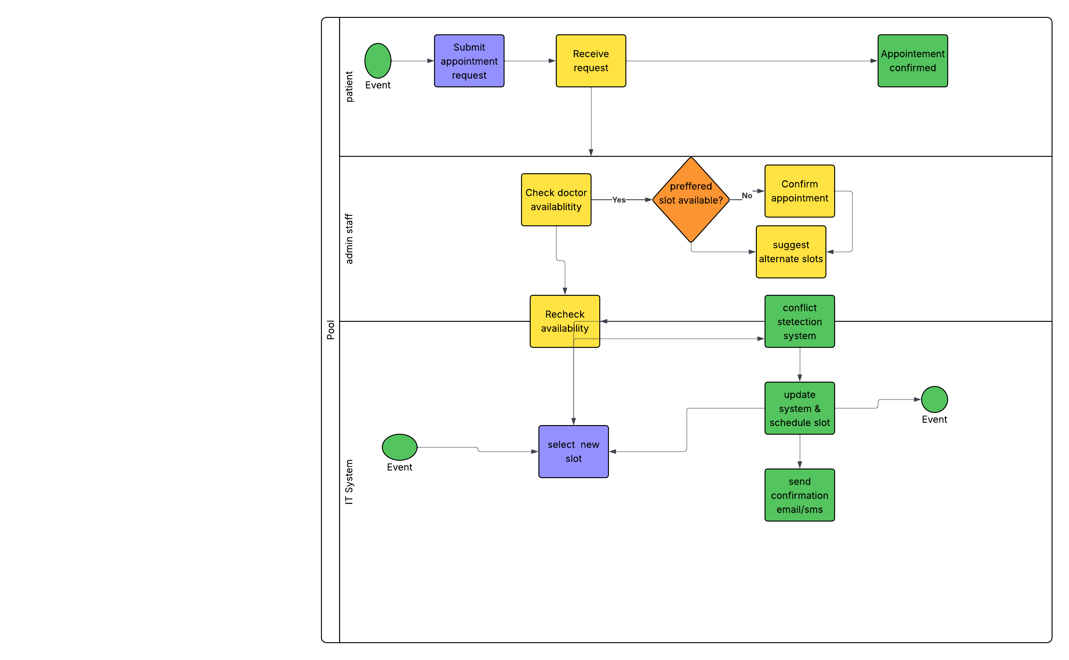
Fig_01: Appointment scheduling BPMN model

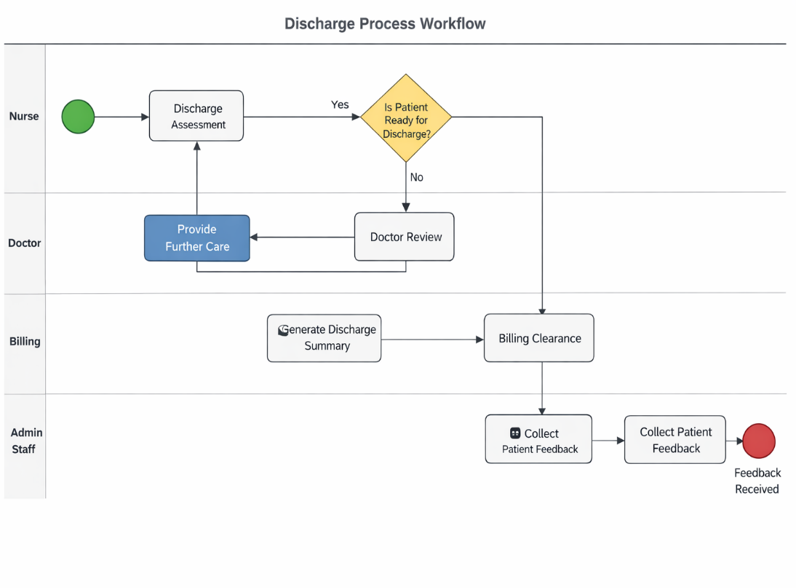
Fig_02: Discharge BPMN model
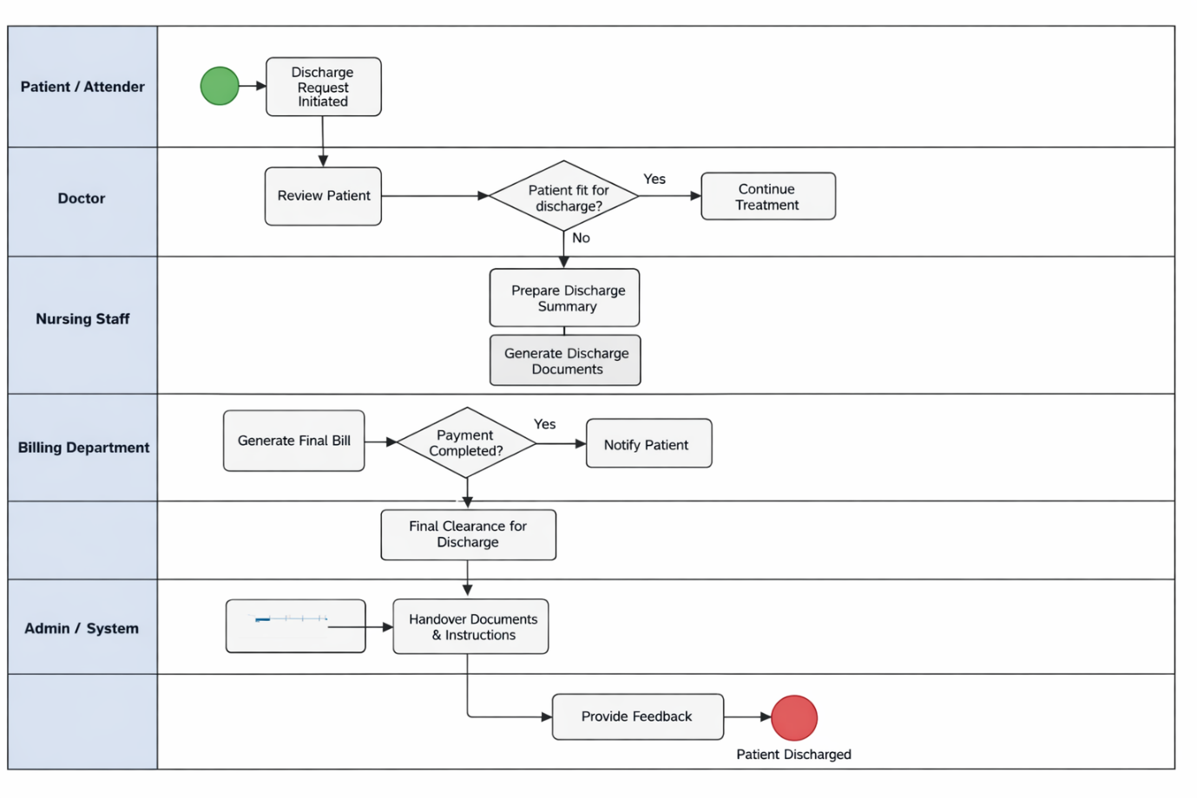
Fig_03: Discharge swim lane diagram
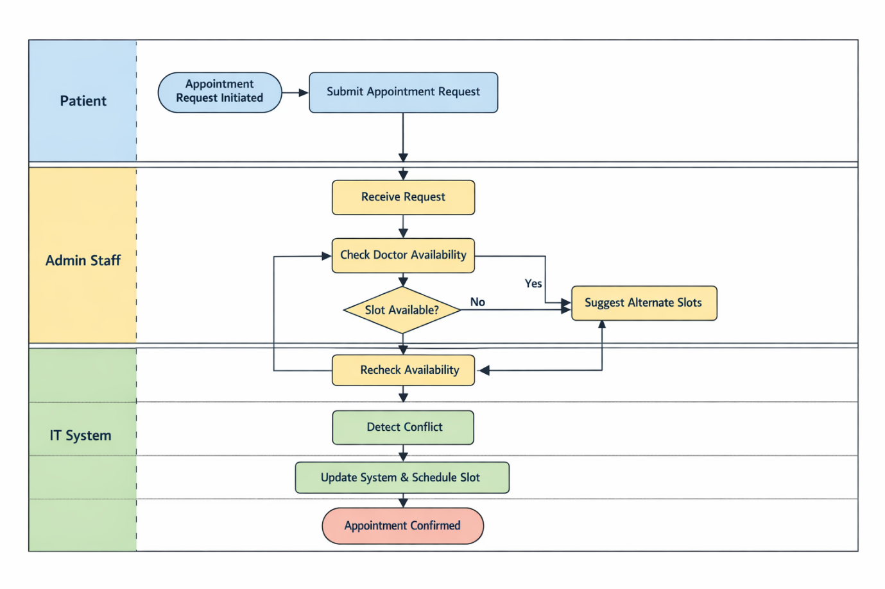

Fig_04: Appointment scheduling swim lane diagram
6. Conclusion
This analysis demonstrates how BPMN and swim lane diagrams can effectively model complex healthcare workflows. By addressing bottlenecks and improving role clarity, healthcare organizations can significantly enhance operational efficiency

