Name : Poovizhi S
Register no : 732924CSR117
Course Name : Database Management ……………………… System
Assignment Title: SQL Query Practice

Queries:
CREATE TABLE Employee (EmpID INT PRIMARY KEY, Name VARCHAR(50), Department VARCHAR(50),Salary INT,City VARCHAR(50));
insert into Employee values(101,'Ravi','IT',50000,'chennai');
insert into Employee values(102,'Meena','HR',45000,'chennai');
insert into Employee (EmpID,Name,Department,Salary) values(103,'Arun','IT',60000);
insert into Employee values(104,'Kavya','Finance',55000,'chennai');
insert into Employee values(105,'John','HR',40000,'coimbatore');

- select * from Employee;
Output:
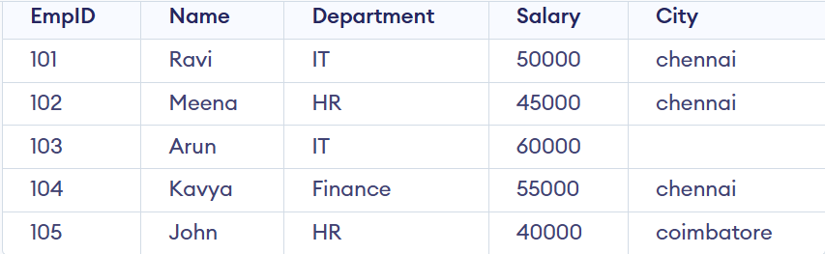

- SELECT Name, Salary FROM Employee;
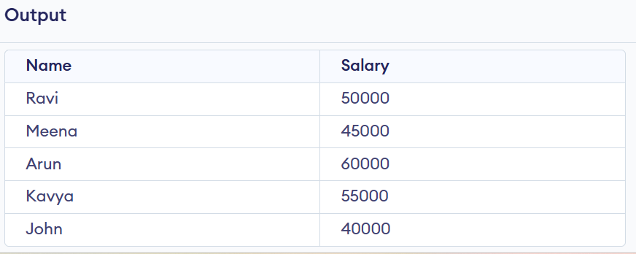

3. SELECT * FROM Employee WHERE Salary > 50000; 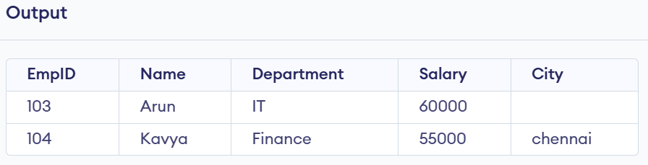
4. SELECT * FROM Employee WHERE Department = 'IT';
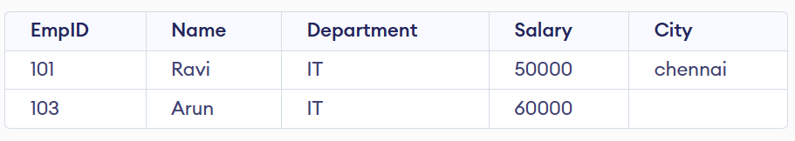
5. SELECT * FROM Employee WHERE City = 'chennai';
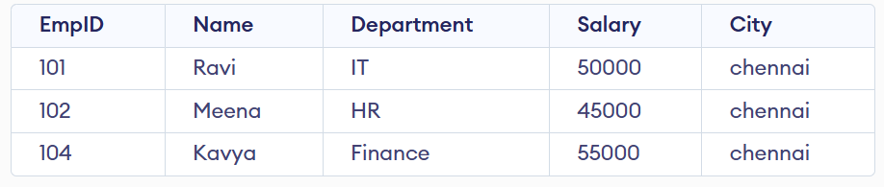 6. SELECT * FROM Employee WHERE Salary BETWEEN 40000 AND 60000;
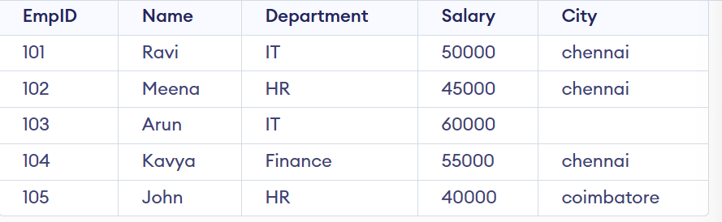
7. SELECT Name FROM Employee WHERE Name LIKE 'A%';


8. SELECT DISTINCT Department FROM Employee;

9. SELECT * FROM Employee WHERE City IS NULL;
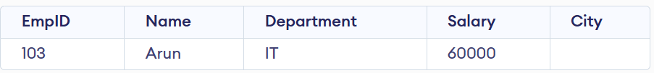
10.SELECT SUM(Salary) AS Total_Salary FROM Employee;

11. SELECT AVG(Salary) AS Average_Salary FROM Employee
WHERE Department = 'IT';

12. SELECT Department, COUNT(*) AS Employee_Count FROM Employee GROUP BY Department;

13. SELECT * FROM Employee WHERE Salary > (SELECT AVG(Salary) FROM Employee);
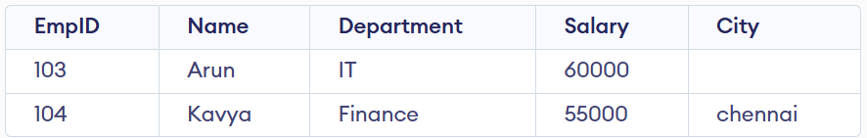
14. INSERT INTO Employee (EmpID, Name, Department, Salary, City)
VALUES (105, 'Priya', 'IT', 48000, 'Chennai');
select *from Employee;
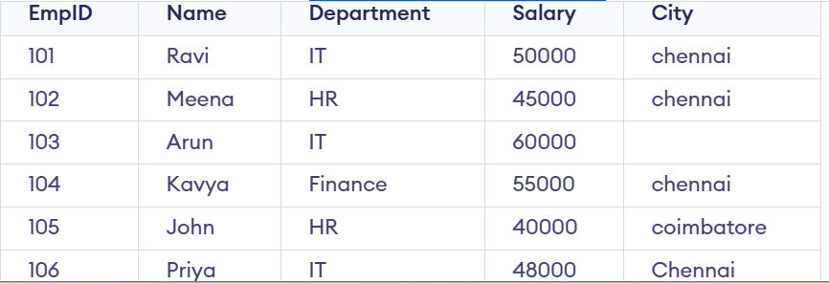
15. UPDATE Employee SET Salary = 48000 WHERE EmpID = 105;
select *from Employee;
