Kianoush Arshi 810198438 MohammadTaha Fakharian 810198449 CA2

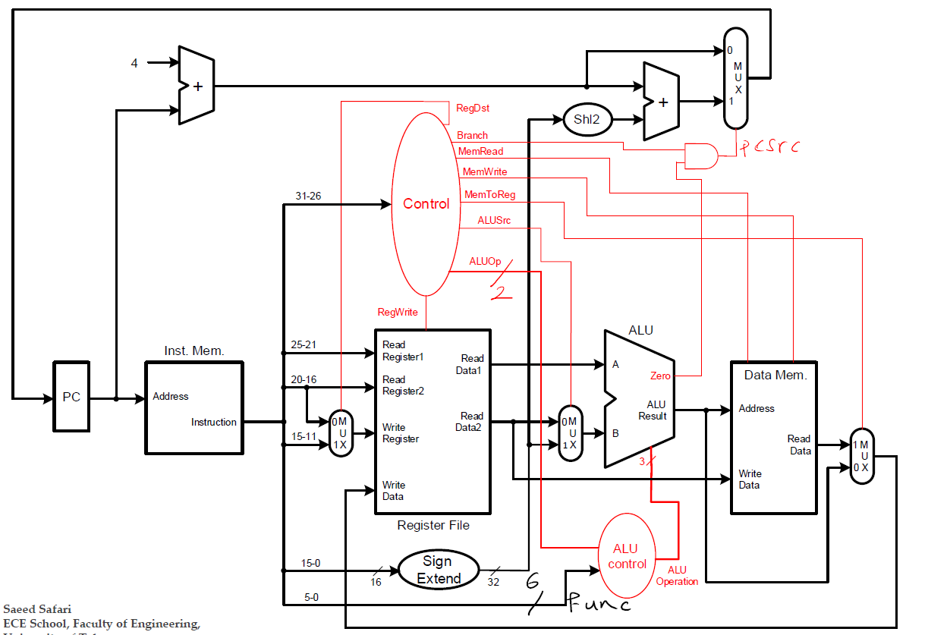

5’d31

RegDst

2

1

0

2

DataWrite

1

0

jmp

0

1

jr

**Shl2**

**31-28**

**25-0**

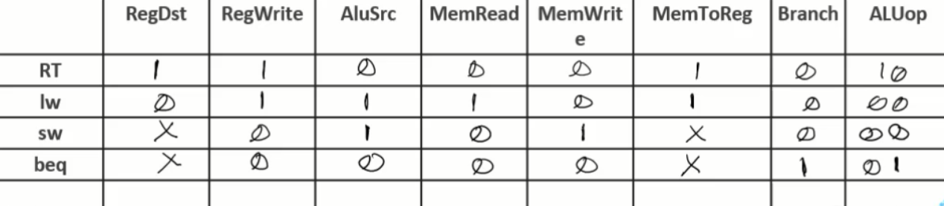

0

Jmp

0

0

0

0

0

1

1

1

0

0

**slti 00 1 1 0 0 0 0 11**

**jr (jr = 1) 00 0 0 0 0 0 0 00**

**jal 10 1 0 0 0 0 0 00**

**j 00 0 0 0 0 0 0 00**

**slt 01 1 0 0 0 0 0 10**

**addi 00 1 1 0 0 0 0 00**

For jal and (slt & slti), new signal data_to_write is added and is set at 1 and 2 respectively.