"Modeling User Engagement in Environments: A Data-Driven Approach"

Authors:
Puya Shaykholeslami, Department of Electrical and Computer Engineering, College of Engineering, University of Tehran, email: p.shaykholeslami@ut.ac.ir.

Abstract
This paper presents a comprehensive study on modeling virtual human‒computer interactions by analyzing the intricate dynamics between user characteristics, emotional states, interaction types, and satisfaction levels in digital environments. Using Python scripts, a dataset encompassing diverse user profiles was generated, highlighting key aspects such as age, gender, experience level, emotional response, and interaction duration. We found significant correlations among these variables, revealing that user satisfaction is influenced by the complexity of interactions and the emotional context in which they occur. The importance of this study lies in its implications for both scientific research and practical application in technology design. By presenting the relationships between user engagement and satisfaction, we underscore the necessity for advanced modeling techniques that account for user diversity in VHCI systems. Despite the insights gained, we acknowledge limitations related to the synthetic nature of the data and the constraints of the machine learning approaches used for analysis. These factors suggest the need for future research to incorporate real-world user interactions into models, enhancing the validity and applicability of findings. Our findings advocate for a deeper exploration of adaptive systems that can respond to user emotions and preferences in real time. This study underscores the critical role of understanding virtual human behavior in shaping effective and satisfying virtual interactions in an evolving technological landscape. The insights gained from this research serve as a foundational step toward enhancing the accuracy and responsiveness of VHCI systems, ultimately contributing to the advancement of human–computer relationships in digital environments.
Keywords: Virtual Human‒Computer Interaction, User Characteristics, Emotional States, User Satisfaction, Data Analysis, Adaptive Systems.

Introduction
With advancements in technology and the expansion of virtual systems, human‒machine interaction has become a core area of research in computer science and behavioral psychology. Virtual human interaction with computers enables users to connect with systems in a natural and nonlinear manner. This research aims to meticulously examine the modeling of these interactions, especially in virtual environments where users seek experiences akin to the real world. Previous studies have indicated that effective interactions can lead to increased user satisfaction and improved system efficiency. Nevertheless, gaps still exist in the modeling of such interactions. Thus, the primary objective of this paper is to develop a new model for analyzing virtual human‒computer interactions and to evaluate and optimize it.
The questions raised in this research are "What factors affect the quality of human‒computer interaction?" "How will these factors be included in the new models?"
The innovation of this research lies in the development of machine learning algorithms and the modeling of the complexities of human behavior, which can assist in simulating human interactions in virtual environments.

Introduction to the Topic
Human‒computer interaction includes the study and design of methods by which people can communicate and engage with computer systems, applications, and social networks. In recent decades, this academic trend and research field has experienced significant growth and has covered a wide range of topics, including user interface design, user experience, and user behavior in various technologies; thus, the primary goal of HCI is to design, create and develop systems that are effective and efficient and provide natural and enjoyable interactive experiences for users. [1]
In today's fast-paced world, the importance of this field has become increasingly apparent, and as people increasingly rely on technology and digital devices, understanding ways to interact and improve user experiences has become critical. When designed well, interactive systems can increase user satisfaction, reduce errors, and improve overall system performance. Additionally, HCIs play a key role in ensuring that everyone has access to technology, allowing individuals to utilize it effectively. Thus, research in this domain not only enhances individual user experiences but also contributes to broader positive impacts on society and business markets. [2]
Human‒machine interaction (HCI) is an interdisciplinary field that focuses on studying and designing how people interact with computer systems, computer software, and virtual social networks; thus, researchers in this field explore different methods. have made it possible for people to better interact with technologies, while these technologies include computers for smartphones and other interactive systems. [3]
Basically, HCI addresses different aspects of the user experience, user interface design, and user behavior in interaction with modern technology, and the definition of HCI includes technological and human elements. On the one hand, technological aspects include interface design. In addition, software and hardware capabilities and the use of algorithms to analyze interactions include human elements such as understanding the feelings, needs and behaviors of the user, which directly affects the user experience. [4]
Likewise, HCI can be seen as a bridge between humans and technology that aims to optimize this relationship and, of course, owing to rapid technological developments, the ever-increasing need for deeper research and discoveries in the field of HCI, while with the emergence of new technologies such as virtual reality, virtual reality, augmented reality and artificial intelligence are changing the nature of human interactions; therefore, HCI as a discipline must remain up-to-date and strive to create smarter and more. [5]
The significance of research in human‒computer interaction is closely linked to the enhancement of the quality of the user experience. Given the considerable amount of time people spend interacting with digital devices today, a deeper understanding of these processes can improve user satisfaction and increase system efficiency. In fact, creating systems with an optimized user experience not only attracts users but also reduces errors and speeds up operations. [6]
Furthermore, considering emerging challenges in this area, such as accessibility and inclusivity, HCI research can lead to the design of systems that are accessible and effective for everyone, including those with specific needs. Thus, this topic holds special importance not only for mainstream users but also for marginalized communities. [7]
Additionally, in the business world, there is a direct correlation between the quality of the user experience and commercial success. Companies and organizations that prioritize the effective design of interactive systems typically enjoy a competitive advantage. HCIs thus serve as crucial factors in developing business strategies and innovations that can contribute to economic growth and development. [8]
As a result, the significance of HCIs as an emerging field will require increased attention in the near future. This importance is due not only to the need to optimize user experiences but also to the way that human interactions with advanced technologies are transforming in today's world. Therefore, there is a pronounced need for investment in research rooted in the principles of HCI. [9]

Literature Review
HCI refers to the study of methods and technologies that can establish communication between users and computer systems. Through these methods and technologies, and with the help of specific tools such as graphics, audio, touch, and even video, the user can interact with other users and machines. This type of interaction not only helps to improve user experiences but can also lead to training, medical simulations, and skill development in interactive environments. [10]
The importance of this topic is felt more than ever in today's world, because with the expansion of complex technologies and greater access to tools such as virtual reality and artificial intelligence, the need for deeper research in the field of HCI is felt. Designing and developing effective models for human‒computer interaction can not only improve the efficiency of systems but also increase user satisfaction and positive user experience in the face of these technologies. As a result, addressing this issue is highly important and can lead to significant innovations in various fields of technology. [10]

Existing Gaps
Despite significant advances in recent decades, there are still major shortcomings and gaps in the field of human interaction with computer systems, which certainly requires more focus from researchers and further research in this area. While many studies have focused on designing and improving the user experience, unfortunately, the research conducted in this area is often isolated, fragmented, and conducted in specific fields. For example, the lack of integration and compatibility between different technologies and machine learning algorithms poses a significant challenge to achieving complex and natural interactions in virtual environments. [11]
Furthermore, in many cases, existing models are unable to fully and accurately simulate human emotions and social interactions in virtual environments. This leads to limited and inadequate user experiences that cannot effectively meet the real needs of users. Therefore, studying and researching the design of better models for simulating human emotions and behaviors in interactions with computers remains an open and fruitful area of research that requires innovation and the development of new methods. [11]
Finally, one of the key points in examining these gaps is the lack of sufficient attention given to cultural and social aspects in the design of human‒computer interactions. Much of the existing research is based on general and global data and does not consider cultural diversity or local experiences. This can lead to significant inequalities in the quality and effectiveness of interactions for users from different cultural backgrounds. Therefore, researchers should focus on these dimensions in their future endeavors and provide interactive models that more comprehensively meet the diverse needs of humans in different social and cultural contexts. [11]

Review of Achievements
In the last few decades, human‒computer interaction (HCI), as an interdisciplinary field of study, has attracted the attention of researchers and developers. The achievements of this field have led to the design, creation and development of new methods and technologies in fields such as the design of user interactions with computers, including advanced user interfaces, voice and touch interactions, and the use of virtual reality and augmented reality technologies. These developments have increased the quality of the user experience; however, this phenomenon has been used in various fields of education, medicine and entertainment and has provided rich and attractive user experiences. [12]
These communities strive to identify and address existing challenges by relying on the latest scientific and technological achievements and contribute to the development of standards and best practices in designing human‒computer interactions. For example, the existence of conferences, workshops, and specialized associations in this field provides a platform for sharing successes, challenges, and emerging trends, and this trend is expected to lead to qualitative and quantitative improvements in human‒computer interactions in the near future. [13]

Research Objectives

Statement of Goals
The main goals of this research include the study and investigation and modeling of human‒computer interactions in the context of virtual interactions as well as the review and analysis of existing technologies and methods in the design of human‒virtual interactions; thus, there is a need to review and evaluate the tools, techniques and algorithms used in the construction of an interactive system whose purpose is to identify the strengths and weaknesses of the current human‒machine interaction systems and provide solutions for their improvement. Therefore, the results of this analysis can help in the development of new models of human‒computer interaction that better respond to users' needs.
Finally, this research also seeks to provide a framework for evaluating human‒virtual interactions. This framework can be used as a benchmark for developers and researchers in designing and implementing interactive systems. By using this framework, it is possible to analyze and optimize interactions in various fields, such as education, medicine and entertainment, to improve the user experience and increase the level of user satisfaction. The final goal of this research is to provide solutions that improve the quality of human‒computer interactions and lead to more innovations in this field.

Research Questions
The fundamental questions in this research are as follows: What are the behavioral patterns of users in interacting with virtual systems? What are the real needs of users in interacting with virtual systems? Finally, what are the different expectations of users in interacting with machines, and how can the impact of these interactions on the user experience be evaluated?
These questions are considered with the aim of achieving a deeper understanding of the process of human interaction with virtual technologies. These questions, as stated, include examining user behavior patterns in interactions with virtual systems, identifying different user needs and expectations, and evaluating the impact of these interactions on the user experience. This research can serve as a model for researchers and developers in designing advanced and efficient interactive systems, ultimately leading to richer user experiences. Finally, in this research, the research questions are designed to introduce new approaches for modeling human‒computer interactions.

Novelty and Significance

Innovations
This research, entitled "Modeling Human‒Computer Virtual Interaction", is based on a key innovation in the design and analysis of human interactions with computer systems. In fact, the innovation of this research is the introduction of a new approach in interactive modeling that allows us to pay more attention to the behavioral and psychological characteristics of users in virtual environments. This innovative approach can include artificial intelligence, machine learning, and virtual reality technologies, through which the user experience can be significantly improved. The importance of this innovation is that by using them, we can simulate human interaction methods more accurately and better understand the diverse needs of users. This not only helps improve the user experience but also leads to innovation in the design of software and interactive systems.
By using the findings of this research, the development of systems can be described as follows:
- First, be more responsive, more personalized
- Second, respond to the needs of users in the best possible way.
Therefore, this research seeks to achieve a theoretical and practical framework for modeling human interaction with computer systems to help researchers and designers answer new questions in this field. The benefits of this innovation are as follows:
- Providing new avenues for future research
- Paving the way for the creation of new standards in the design of interactive systems.

Distinct Role in the Field
The present study, entitled "Modeling Human‒Virtual Computer Interaction", endeavors to play a distinct role in the field of human‒computer interaction. This research aims to identify and analyze the factors influencing the quality of user interaction with virtual systems. Despite the rapid development of digital technologies and the need for more natural and efficient human interaction with these technologies, few studies have investigated the human and psychological aspects of these interactions. Therefore, this research can be considered a turning point in interdisciplinary studies in the fields of psychology, user experience design, and computer science. [14]
The distinctive feature of this research lies in its ability to combine empirical and theoretical data in the realm of human interactions with computer systems. This research presents novel and more accurate models for understanding user interactions, encompassing the analysis of user behavior in various situations and the simulation of these interactions in virtual environments. These findings can assist designers and developers of interactive systems in better addressing the specific and diverse needs of users, ultimately enhancing the user experience. [15]
Given the continuous evolution of technology and innovations in this domain, this research can serve as a model for other studies in the field of human‒computer interaction. Moreover, engaging in this research area can provide numerous opportunities for developing new technological solutions, ultimately leading to improved interaction quality and increased user satisfaction. Therefore, by identifying the fundamental needs in this field, this research plays a crucial role in shaping the future of human interaction with technology.

Structure of the Paper
The structure of this article is as follows:
- Section One: While providing a comprehensive introduction to the research topic and studies of the article, it addresses recent technological developments and their impact on how users interact with computer systems, and the need for further research in this area is well illustrated.
- Section Two: A review of the literature and previous research in this field will be conducted. The contents of this section include examining the existing definitions, models, and theories regarding human interaction with computer systems and analyzing their strengths and weaknesses. Therefore, this section provides a deeper understanding of the topics discussed in this research and helps to identify the existing gaps in the scientific literature.
- Section Three: The research methodology, data analysis, and results are presented. In general, this section discusses in detail the findings and suggestions for future research as well as practical applications of the results. (Figure 1)
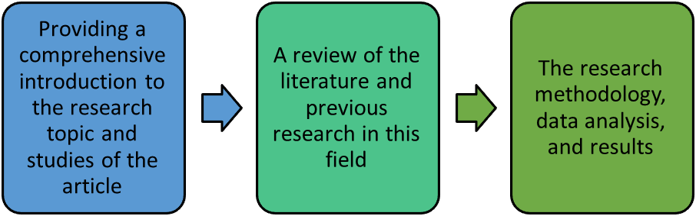
Figure 1 - Structure of this paper

Methodology

Research Design

Type of Research
The type of research in studies related to "modeling virtual human‒computer interaction" is considered a key element in research design. The focus of this research is fundamentally on understanding the theories and fundamental principles of human‒computer interaction. This type of research often investigates the psychological, cognitive, and social parameters that affect the quality of the user experience. The findings of this research can lead to new theories and provide a basis for designing advanced interactive systems. Moreover, applied research seeks to solve practical and real-world problems that arise in human‒computer interactions. Interestingly, this type of research can be used to examine how to optimize interactions, improve user experiences, and design new products and services.
For example, an applied study might evaluate a new software and its impact on user behavior. Qualitative research uses various tools to collect nonnumerical data and examine user experiences and opinions. This type of research allows researchers to extract the depth and complexity of human interactions and thereby gain a better understanding of user needs, behaviors, and expectations. In identifying new patterns and trends in interactions, qualitative data analysis can be utilized, whereas quantitative research focuses more on collecting and analyzing numerical data and is related to proving or rejecting specific hypotheses in the field of human‒computer interaction. This type of research can determine the relationships among different variables, such as response time, user accuracy, and user satisfaction, and provide measurable results.

Theoretical Framework
The theoretical framework in this research specifically examines the concepts, theories, and models existing in the field of human‒computer interaction (HCI) and helps researchers gain a precise and clear understanding of the challenges and opportunities in this field. Furthermore, this framework can help determine the relationships between different variables and explain how they interact. In the field of human‒computer interaction, various theories have been presented that can be used as the theoretical foundation of this research. For example, cognitive information processing theory examines how users process information and helps design interactive systems compatible with users' cognitive abilities. [16]
Empirical design models, such as the human‒computer interaction (HCI) model, also play an essential role in the theoretical framework of this research because these models typically analyze specific scenarios and examine and evaluate user performance at different stages of interaction. Using these models allows researchers to determine how design changes affect the user experience and lead to more efficient, optimized, and desirable interactive environments. Moreover, concepts such as "user observation", "emotion analysis" and "user behavior modeling" are considered essential parts of the theoretical framework. Notably, examining these concepts can lead to a better understanding of users' needs and behaviors when interacting with virtual systems and contribute to the more efficient design of human‒computer interaction systems. Additionally, the theoretical framework should pay special attention to user-centered design principles because these principles emphasize users' needs and experiences and will lead to identifying the challenges that users face when interacting with virtual computers. Applying these principles can lead to improved interactions and a positive and effective user experience. [17]
Finally, the theoretical framework of the research "Modeling Virtual Human Interaction with Computing" not only helps researchers gain a deeper understanding of the existing theories and models in this field but also provides guidance for research design and data analysis as a structured process. This framework not only contributes to the expansion of knowledge in the field of human‒computer interaction but also provides a basis for developing new and innovative technologies in this field.

Data collection

Collection methods
The data collection stage in any research, particularly in this research, is one of the vital stages of the research process, as this stage involves gathering the necessary information for accurate analysis of human interactions with digital environments. Considering the research objectives and the type of data required for it, the methods of information gathering can include quantitative or qualitative approaches in data collection.
One of the common methods of data collection is the design and distribution of questionnaires and the ability to conduct surveys. These tools allow us to collect users' opinions and experiences in a quantitative and field-based manner. Designing appropriate questionnaires with open and closed questions can provide valuable information about users' behaviors, preferences, and feelings in interactions with virtual systems. In this context, analyzing the data from these questionnaires can help identify patterns and interpretable results.
Similarly, another method involves conducting semistructured or structured interviews with users. With this method, researchers have the opportunity to analyze users' experiences and opinions at a deeper level and with greater accuracy. The interviews can include questions about users' needs, challenges, and expectations in interacting with different systems. This type of data is often qualitative and can lead to a deeper understanding of user behavior and experiences. Another method is related to collecting observational data, which can be an effective method in this research because, in the observational method, researchers can directly monitor how users interact with systems and thereby identify users' actual and unpredictable behaviors in interacting with the machine.
The data collection method in this research is designed on the basis of examining different datasets related to the data structure of human‒computer interaction, and for the designed structure, the generation of the required data is performed randomly.

Data collection stages
In the research "Modeling Virtual Human‒Computer Interaction", the data collection stages are designed step-by-step for accurate and structured analysis of user interactions with systems (Figure 2). The first stage involves identifying the key variables that should be considered in the research. In this study, various variables, such as age, gender, experience level, emotional state, environment type, object interactions, interactivity level, response time, response accuracy, and user satisfaction, were selected. Each of these variables can contribute to a better understanding of how users interact and the factors that influence it.
The second stage of data collection involves creating a random sample of users. Using Python code, random data are generated for each of the variables, the age of the users is randomly selected between 18 and 65 years, their gender is randomly selected between "male" and "female", and the level of experience is also randomly selected from "low", "medium" and "high". This method helps us create a diverse and representative database of different users.
The third stage of data collection is data visualization. The generated data are displayed graphically via various Python libraries, such as Matplotlib and Seaborn. For example, the age distribution of users is plotted via a histogram, and user satisfaction scores are plotted via box plots. These visualizations not only help identify patterns but can also be useful for deeper analysis in later stages.
The fourth stage involves data analysis. After the data are collected and visualized, they need to be carefully analyzed to identify relationships and patterns. Using a correlation matrix, it is possible to determine which variables are related to each other and which factors affect the quality of user interactions. This analysis can lead to the creation of a more comprehensive model of virtual human‒computer interaction.
The fifth stage involves encoding qualitative variables into numerical variables. In the provided code, qualitative variables such as gender, experience level, emotional state, and environment type are numerically encoded. This encoding is important because it allows for more accurate statistical analysis and helps researchers use various statistical tools to better understand the data.
Finally, the sixth stage involves reviewing the results and optimizing the models. After performing the initial analysis, the collected results should be reviewed to identify the strengths and weaknesses of the identified patterns. This review may include reassessing data collection methods and optimizing them. The ultimate goal is for the information obtained to not only help identify user needs but also provide insights for improving virtual human‒computer interactions.
Table 1 - Table of HCI attributes
Variable | Range & Value
Age | 18-65 years
Gender | Male – Female
Experience Level | Low - Medium – High
Emotional State | Happy - Nervous – Anxious
Environment Type | Simple - Complex – Scary
Object Interaction | 1 - 10
Interactivity Level | Low - Medium – High
Response Time | 1.0 – 5.0
Response Accuracy | Low - Medium – High
User Satisfaction | 1 – 5
Table 2 - Table of states of the VHCI
Variable: State
Code | Value
0 | State A
1 | State B
2 | State C
3 | State D
4 | State E
5 | State F
6 | State G
7 | State H
8 | State I
9 | State J
Table 3 - Table of action of VHCI
Variable: Action
Code | Value
0 | Action 1 - Move Forward
1 | Action 2 - Turn Left
2 | Action 3 - Turn Right
3 | Action 4 – Jump
4 | Action 5 – Rest
Table 4 - Rewards of VHCI
Variable: Reward
Code | Value
10: Points | Excellent Move
5: Points | Good Move
0: Points | Anything
5: Points | Minor Penalty
10: Points | Poor Decision
15: Points | Bonus Reward
5: Points | Assist
20: Points | Level Up
15: Points | Major Setback
10: Points | Resource Collected
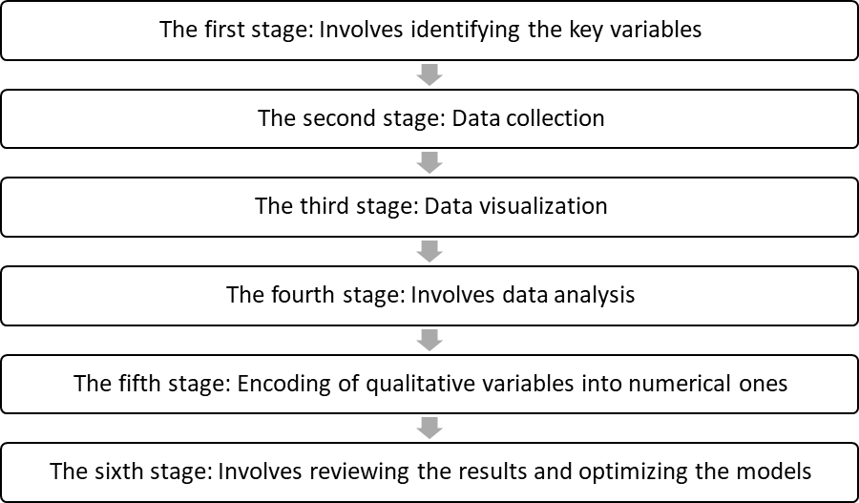
Figure 2 - The stages of this paper

Modeling and Simulation

Models Used
In this article entitled "Modeling Virtual Human‒Computer Interaction", we investigate and analyze the factors influencing the interaction between humans and virtual systems. Section 2-3-The models used are dedicated to introducing and analyzing three Python scripts, each offering unique methods and techniques for modeling and simulating human‒computer interactions. The methods used include data collection, analysis, and machine learning algorithms, which are explained in detail here.
The first script is dedicated to collecting basic and descriptive data from users. In this stage, various variables, such as age, gender, experience level, emotional state, environment type, and user interactions, are randomly generated. These data are then stored and analyzed in a pandas dataframe. By analyzing the age distribution, user satisfaction levels, and correlation diagrams, we can obtain useful information about the relationships between different variables, which can help improve the design of user interaction systems.
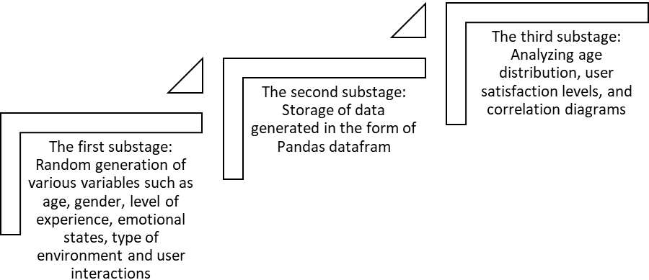
Figure 3 - The substage of the first script
The second script focuses on creating an optimized dataset. In this stage, the type of interaction, interaction duration, emotional response, and number of errors are randomly generated. These data are stored as a dataframe, and the results are analyzed and displayed in several graphical charts. This script specifically addresses the analysis of accuracy and satisfaction scores in different interactions and can be used to identify the strengths and weaknesses of human‒computer interaction systems.
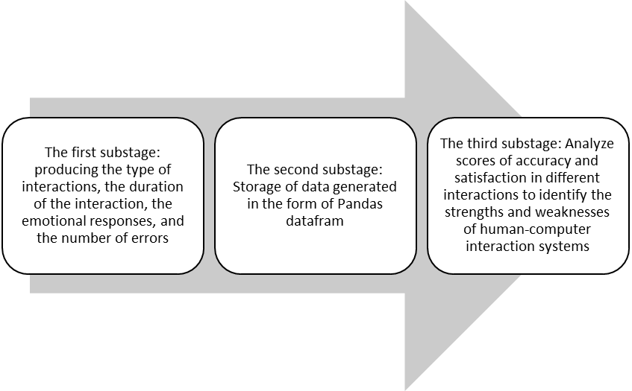
Figure 4 - The substage of the second script
The third script uses deep learning algorithms to simulate human behavior. Here, a class called 'Human' is designed, which includes features such as state size and action type. This model is trained via reinforcement learning and is able to react dynamically to its interactions with the environment. This approach not only helps simulate human interactions but can also be used as a tool to improve the machine learning process.
Considering the three scripts above, it can be concluded that each plays a specific role in modeling and simulating virtual human‒computer interactions. While the first script addresses the collection of basic data and statistical analysis, the second script focuses on optimizing the analysis and creating more complex data. Finally, the third script uses machine learning and reinforcement learning to simulate and model human behavior in interactions.
This diverse combination of data collection, analysis, and machine learning methods provides a comprehensive and practical framework for a deeper understanding of human‒computer interactions. In this way, the obtained results can be put into action to optimize interactions and design better and more effective systems using analytical data. This work can be used as a reference for researchers and designers of human‒computer interaction systems and can help to better understand user needs and reactions.
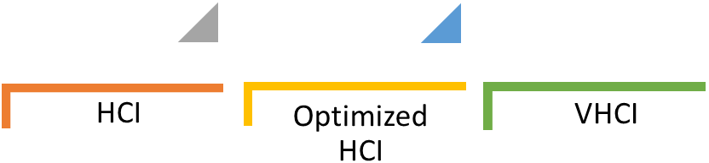
Figure 5 - Process of creating a virtual human model
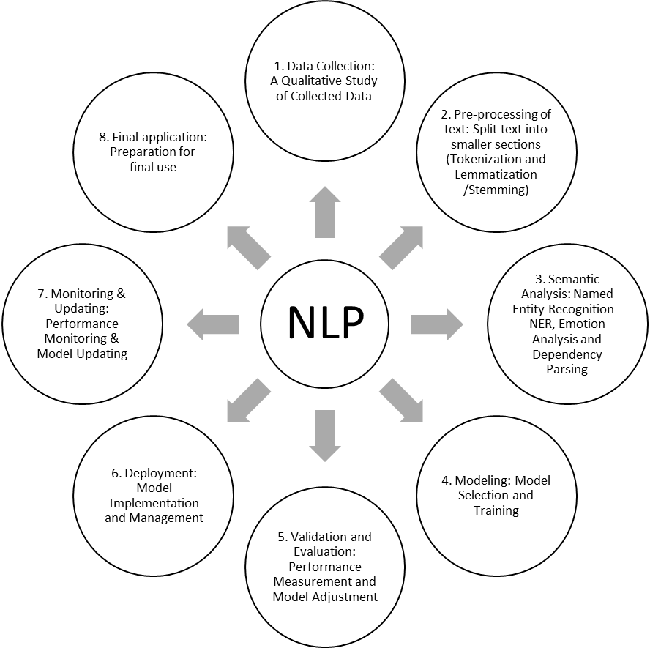
Figure 6 - NLP formation process to create VEGs: Virtual human

Simulation Algorithms
In this section, of the article titled "Modeling Virtual Human‒Computer Interaction", we examine the simulation algorithms used in three Python scripts. Each of these algorithms contributes to simulating user behavior and interactions with virtual systems. In this context, the use of random data and machine learning algorithms simulates complex human behavior. In the first script features such as age, gender, experience level, and emotional interests of individuals are simulated via random data generation. This provides initial insight into user behavior and sets the stage for collecting and analyzing data that can be used in later stages. For example, these data allow us to infer behavioral and legal patterns from different age and emotional distributions.
In the second script algorithms based on distributions and averages are employed to simulate more advanced features such as interaction types, interaction durations, and user emotional changes. These algorithms specifically generate data that can be used to analyze specific objectives, such as evaluating interaction quality. For example, specific distributions are used to determine user emotions at different moments of interaction, which may contribute to improving the user experience. The third script simulates a more complex model of human behavior via reinforcement learning algorithms. Here, a neural network is designed to train and enhance the performance of user interactions. This model simulates with greater accuracy by creating a Q-table to identify rewards and decisions optimally. Using this approach, the system can dynamically improve how users interact in response to specific environmental conditions.
Using examples of randomly selected states and actions contributes to the dynamism of interactions. Thus, these algorithms can create a change in the neutral system and lead to more natural interactions. Substituting different actions and examining the impact of different variables on system performance makes these algorithms more appealing. This innovation in designing human‒computer interaction simulation algorithms allows for a more accurate analysis of user behavior and can help virtual system designers gain a better understanding of user needs and reactions. Therefore, this article can serve as a reference for researchers and developers in the field of better human‒computer interactions.
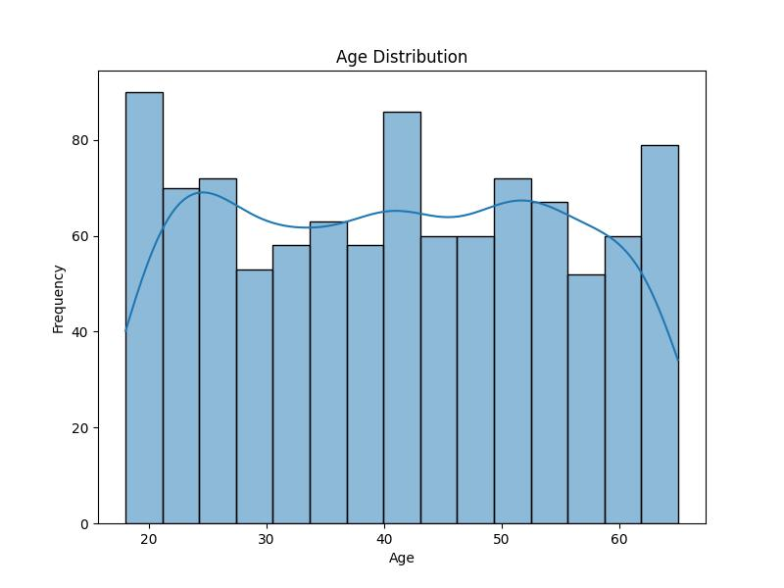
Figure 7 - Age distribution plot
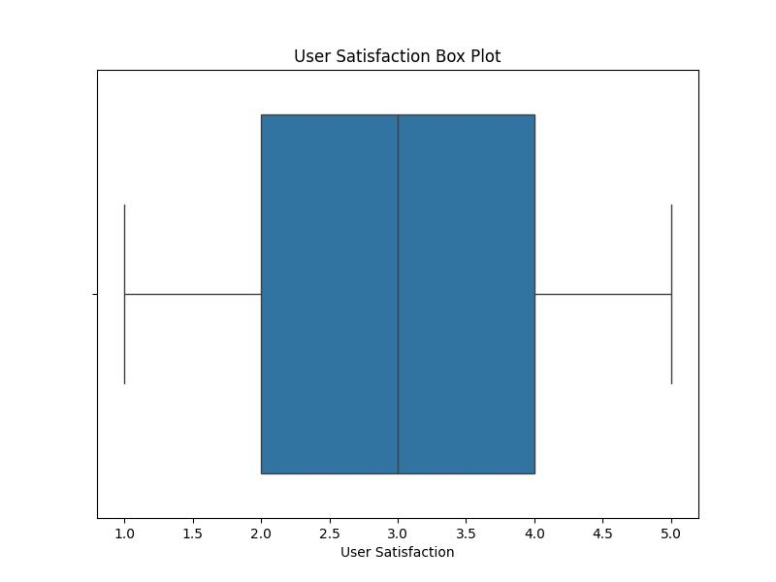
Figure 8 User Satisfaction Plot
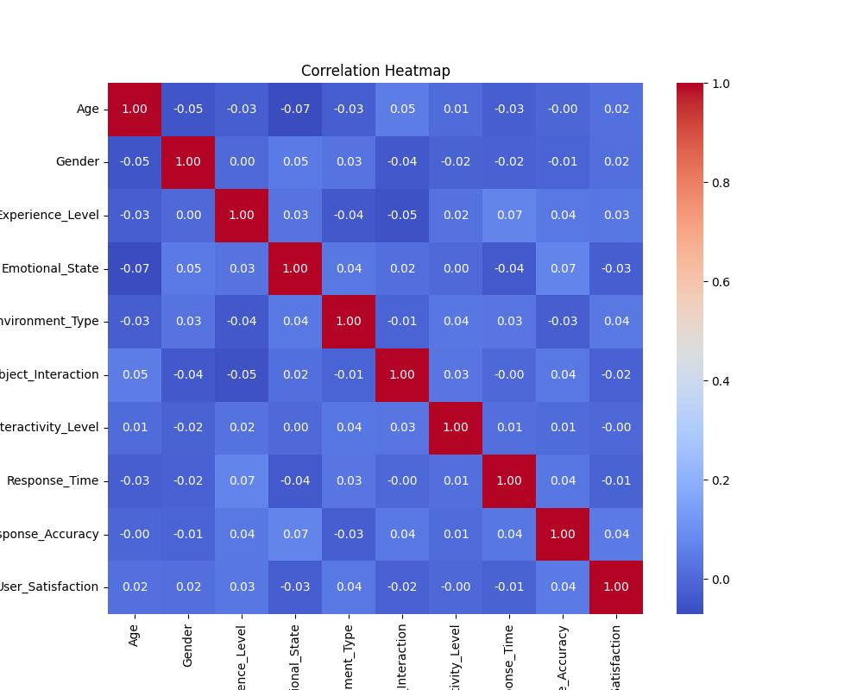
Figure 9 - Correlation heatmap plot

Model evaluation criteria
In this section, of the article "Modeling Virtual Human‒Computer Interaction", we analyze the simulation algorithms used in three Python scripts. These algorithms contribute to the design and development of human‒computer interaction systems and lead to a better understanding of user behavior and the optimization of interactions between humans and machines. Next, each of the three scripts and their simulation methods are reviewed. The first script uses random data generation techniques to simulate user characteristics. These characteristics include age, gender, experience level, emotional state, environment type, and interactions with objects. Using statistical and graphical methods, analyses of age distribution and user satisfaction are performed. This category of data allows researchers to identify specific trends for a better design of human‒computer interaction systems by identifying different patterns in user behavior.
In the second script, optimization approaches are employed in data generation. These algorithms explore deeper aspects of user interactions, including the type of interactions, interaction duration, and number of errors. In particular, data are simulated via specific distributions, such as the Poisson distribution for counting errors and normal distributions for other parameters. These optimizations help researchers gain a better understanding of user needs and optimal interaction conditions on the basis of observed patterns. In the third script, reinforcement learning is subsequently used to simulate human behavior. Here, a neural network is trained for learning and decision-making. The reinforcement learning algorithm allows the model to learn from its past experiences and automatically select the best actions. This approach enables user interactions with the system to improve over time and increases the system's accuracy in responding to user needs.
Using the Q-table to track different states and their corresponding rewards in the learning pattern of this script helps to develop a remarkable model of user reactions in different situations. In this way, the system can dynamically show better reactions in line with environmental changes. This simulation method allows for better control and improvement of the complexities of human interactions. Overall, combining these three scripts with different approaches allows us to obtain meaningful results from simulating human‒computer interactions. These algorithms not only provide a robust framework for analyzing user behavior but can also help designers of virtual systems design better experiences for their users. Ultimately, employing these methods can lead to improved interaction quality and user well-being.
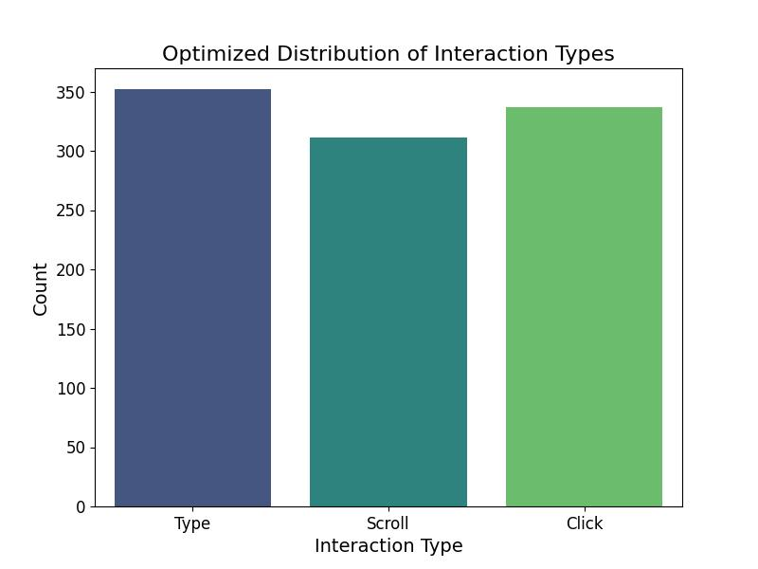
Figure 10 Optimized distribution of interaction type plots
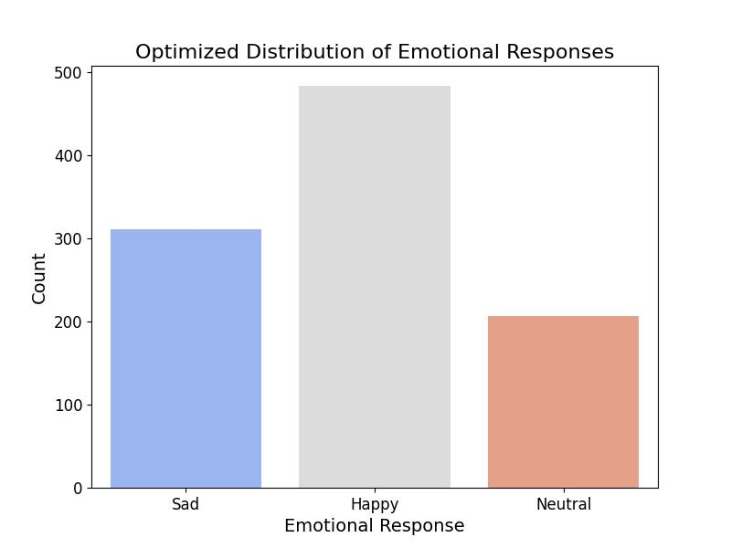
Figure 11 Optimized distribution of emotional response plots
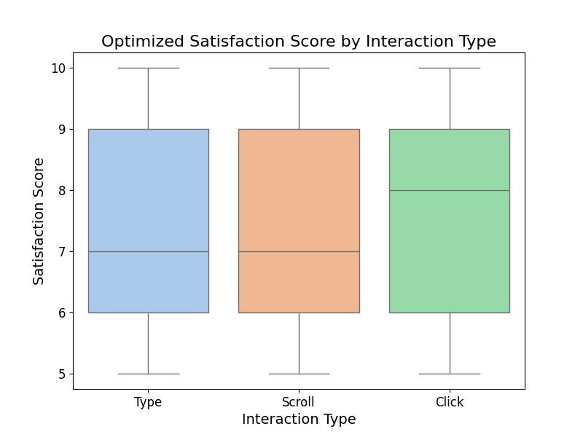
Figure 12 Optimized Satisfaction Score by Interaction Type Plot
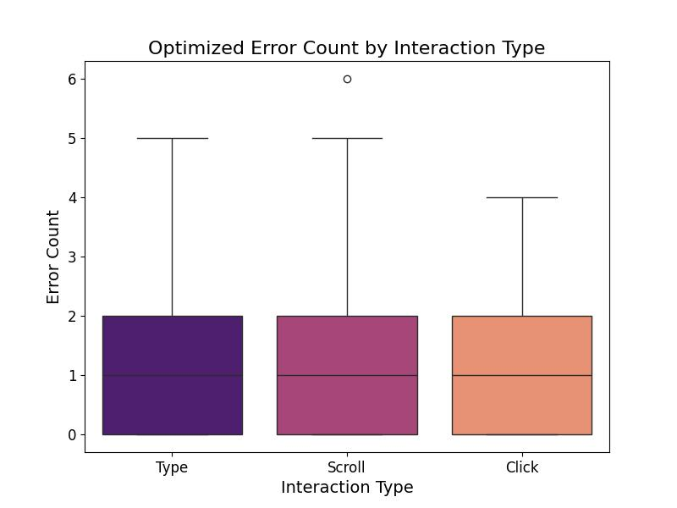
Figure 13 Optimized Error Count by Interaction Type Plot
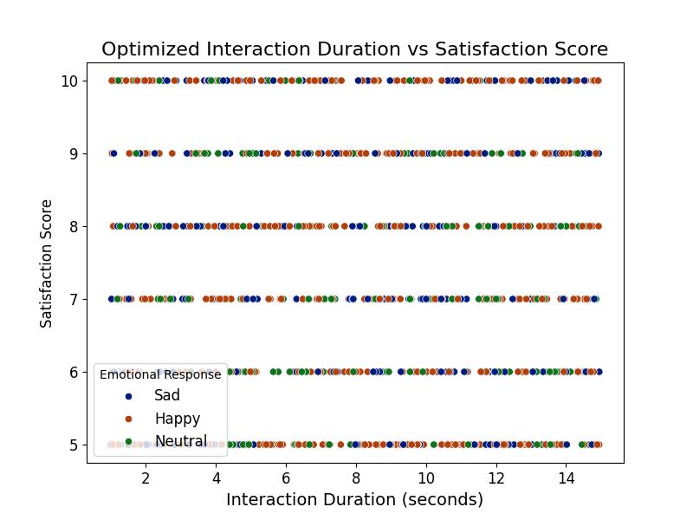
Figure 14 Optimized Interaction Duration vs Satisfaction Score Plot

Data Analysis

Analysis methods
In this section, we analyze the analytical methods used in three Python scripts that study virtual human‒computer interactions. These methods help analyze data and extract important patterns in user behavior and include techniques such as distribution analysis, correlation analysis, and the use of machine learning algorithms. In the first script, random data are presented to simulate user characteristics and behavior. Data such as age, gender, experience level, and emotional state are collected and then converted to numerical data. This conversion allows us to use statistical methods for further analysis. The distribution and box plots generated for user age and satisfaction can help identify clear patterns and trends in user behavior and provide useful information about the target audience.
The second script also details the user interfaces and interactions. In this script, data are analyzed via specific distributions, such as the Poisson distribution for counting errors and normal distributions for other variables. The type of interactions, duration of interactions, and how users feel are also carefully examined. By analyzing these data, it can be determined which type of interaction leads to the highest level of user satisfaction. Next, the third script uses reinforcement learning algorithms to create a complex model of user behavior. Using a Q-Table and neural networks allows us to generate more accurate models of interactions by examining users’ behavior and their received rewards. These forms of analysis help us identify better approaches to enhance the user experience.
Furthermore, visual analysis of all three scripts provides more understandable information about user behavior. Distribution, box, and heatmap plots can easily illustrate the relationships between different variables and provide a more accurate analysis of users' status when interacting with the system. For example, emotional states and the type of interaction can be visually examined to enable a deeper analysis of the quality of interactions. Overall, the combination of these analytical methods not only provides a better understanding of user behavior but also allows designers and developers of virtual systems to implement better features and capabilities to increase user satisfaction. Using analytical data and optimization methods, systems can be designed that better meet users' needs and desires and ultimately lead to improved-quality human‒computer interactions.

Analytical Software
In this section, of the article "Modeling Virtual Human‒Computer Interaction", "we will examine the analytical software and tools used in three Python scripts that help analyze data and simulate human‒computer interactions. The various software and libraries used in these programs provide access to advanced data mining and visualization techniques. The first script uses popular Python libraries such as Pandas, Seaborn, and Matplotlib to analyze and visualize simulated data. Pandas is used as a powerful data management library that allows working with tabular data. This library allows us to easily read, process, and convert data into visual charts and graphs. Using Seaborn and Matplotlib, distribution, box, and heatmap charts are created to help better understand the status of users and their behavior.
In the second script, Pandas is still used for data management, but this process focuses on generating random data with specific characteristics. Additionally, the NumPy library is used to perform more complex numerical operations. These capabilities allow us to simulate data randomly and with features such as interaction type and interaction time. These data are then used for deeper analysis and better simulations in human‒computer interaction analysis. The third script focuses on the application of machine learning and reinforcement learning algorithms. This script uses the Keras library to build and train neural network models. Keras allows us to easily implement and train complex models. Additionally, using the Q-Table and reinforcement learning techniques, this algorithm is able to learn from past experience and achieve better interactions.
In addition, all the scripts use data visualization techniques to present the results and analyses. These visualizations help researchers and system designers easily identify patterns in the data and make better decisions on the basis of them. Visual analysis of data plays a key role in the process of optimizing design and improving the quality of interaction between humans and computers. Overall, the combination of these analytical software programs and libraries in three Python scripts provides a powerful platform for analyzing and evaluating virtual human‒computer interactions. These tools not only help to better understand user behavior but also allow designers to develop more efficient systems by identifying user patterns and needs. As a result, these improvements lead to an enhanced user experience and increased user satisfaction.
*************************************************
Dialog 1:
*************************************************
Current state: State I
Selected action: Action 1 - Move Forward
Next state: State D
Reward: 1 Points - No Description
=================================================
Current state: State D
Selected action: Action 1 - Move Forward
Next state: State J
Reward: 1 Points - No Description
=================================================
Current state: State J
Selected action: Action 5 - Rest
Next state: State E
Reward: 1 Points - No Description
=================================================
Current state: State E
Selected action: Action 5 - Rest
Next state: State F
Reward: 1 Points - No Description
=================================================
Current state: State F
Selected action: Action 1 - Move Forward
Next state: State G
Reward: 1 Points - No Description
=================================================
Current state: State G
Selected action: Action 5 - Rest
Next state: State B
Reward: 1 Points - No Description
=================================================
Current state: State B
Selected action: Action 1 - Move Forward
Next state: State E
Reward: 1 Points - No Description
=================================================
Current state: State E
Selected action: Action 3 - Turn Right
Next state: State H
Reward: 1 Points - No Description
=================================================
Current state: State H
Selected action: Action 4 - Jump
Next state: State C
Reward: 1 Points - No Description
=================================================
*************************************************
Dialog 2:
*************************************************
Current state: State A
Selected action: Action 5 - Rest
Next state: State J
Reward: 1 Points - No Description
=================================================
Current state: State J
Selected action: Action 5 - Rest
Next state: State B
Reward: 1 Points - No Description
=================================================
*************************************************
Dialog 3:
*************************************************
Current state: State H
Selected action: Action 1 - Move Forward
Next state: State E
Reward: 1 Points - No Description
=================================================
Current state: State E
Selected action: Action 5 - Rest
Next state: State F
Reward: 1 Points - No Description
=================================================
1 - Sample dialogs and interactions of a virtual human with a computer

Limitations and challenges

Methodological Limitations
In this section, of the article \"Modeling Virtual Human‒Computer Interaction\", we discuss the limitations and challenges of the methodology presented in the three Python scripts. These limitations can affect the quality and accuracy of the analyses performed and provide a better understanding of the behavior and interaction of virtual humans with computer systems. The first limitation is the reliance on random data generated in the first script. Although this type of data is used to simulate user behavior, it cannot fully represent the actual behaviors and emotions of users. For a more accurate assessment of human-centered interactions, it is necessary to collect data from real and unpredictable environments. Using random data can lead to inaccuracies in analyses that require real-world behaviors.
The second challenge relates to the diversity and breadth of variables. In the second script, although several different variables are considered different interaction metrics, these variables alone cannot encompass all aspects of human interaction with computers. Therefore, identifying key variables and examining them to make the analysis results more fundamental are essential. The third limitation relates to the machine learning algorithms used in the third script. These algorithms may not perform well, especially when training data are insufficient or incomplete. Therefore, to achieve optimal results, it is necessary to create a comprehensive and diverse database of human interactions with virtual systems. Furthermore, the use of visualization methods in all three scripts may lead to misinterpretations. Visual data can sometimes be misleading or may overshadow overlooked patterns. Therefore, visual results should be interpreted cautiously, and complete statistical analysis is essential.
Finally, another challenge is related to human behavior and emotions. Virtual interactions with computers are influenced by a multitude of cultural, social, and individual factors. Therefore, the complex nature and variables affecting these interactions may not be easily identifiable in analytical models. Thus, paying attention to these human and social aspects is essential and should be considered in the design and analysis of future results. Overall, identifying these limitations and challenges can help researchers develop better approaches for studying and analyzing virtual human‒computer interactions and designing more effective systems that improve user experiences.

Potential Impacts
In this section, of the article "Modeling Virtual Human‒Computer Interaction", we explore the potential impacts of the use of three Python scripts on the results and improvement of human‒computer interactions. These impacts are observable at various levels, from enhancing the user experience to creating more intelligent systems. The first potential impact is the use of simulated data in the first script. These data help researchers simulate different user behavior patterns and examine diverse human interactions with computer systems. This simulation can lead to valuable insights into the user experience and needs, which can be effective in developing more optimized interactive software.
The second script, which focuses on improving data quality, can have significant impacts on analyzing human interaction behaviors in virtual environments. Using various variables, such as interaction type, interaction duration, and emotional responses, this script can provide more accurate patterns of interactions. This information can be used in designing and developing more user-friendly systems, leading to increased user satisfaction. The third impact is related to the application of machine learning algorithms in the third script. By using these algorithms, more intelligent models that are capable of learning and adapting to changes in user status can be achieved. This impact is clearly visible in improving the quality of virtual human interactions with computer systems, as these systems can automatically respond to user behavior and reactions. Furthermore, improved transparency and accuracy in analyzing visual data are other positive impacts achieved through these scripts.
Using data visualization libraries, such as Seaborn and Matplotlib, can enhance researchers' understanding of the relationships between variables and data-driven analysis and decision-making, leading to optimal system design and improved user‒machine interactions. The next impact is related to data-driven decision-making. The collection and analysis of user performance data in various interactions can help supervisors and designers identify system flaws and make necessary changes to improve the user experience. This aspect is particularly important in designing systems that require creative interaction and personalization for users. Ultimately, all these impacts can lead to human‒computer interaction moving toward greater sufficiency, efficiency, and user satisfaction. With each intervention and improvement achieved through these scripts, it can be expected that the quality of virtual human interactions with computer systems will significantly increase and contribute to the growth of artificial intelligence technologies in this field.

Results

Overview of Results

Summary of Findings
In this section, of the article "Modeling Virtual Human‒Computer Interaction", we summarize the findings from three Python scripts that analyze human‒computer interactions. These findings contribute to understanding how different variables influence human interactions and the quality of user experiences. The first key finding from analyzing the data generated in the first script relates to the age distribution of users. Analysis of the age distribution graph shows that most users are in the 18–35 years age group. This finding can help in developing interactive systems that are more tailored to the needs and interests of the younger generation. Additionally, information about users' gender and experience level can influence interaction methods and system design.
The second finding is extracted from the analyses performed in the second script. This script examines the types of user interactions and their duration. The observations indicate that the type of interaction (click, scroll, or type) directly affects user satisfaction. In particular, interactions with longer durations are usually associated with greater satisfaction than short responses. This finding reveals part of the users' psychological perspective on digital interactions and can be used to improve interaction design. The third finding comes from analyzing the performance of the machine learning model in the third script. These findings show that machine learning algorithms can effectively make better decisions using data received from interactions. Using deep learning models to predict future user actions on the basis of past behaviors can lead to the creation of personalized experiences and improve the quality of interactions. Another point derived from the analyses is the relationship between the level of emotions and user satisfaction. The analysis revealed that positive emotions such as happiness are associated with high levels of satisfaction in interactions. Therefore, the design of interactive systems should be such that it enhances positive emotions in users and creates more pleasant experiences.
Furthermore, visual analyses such as heatmaps and box plots (using seaborn and matplotlib) in all three scripts provide a better understanding of the relationships between different variables and their impact on user interactions. These visual data allow the user to identify important trends and patterns and use them in the development and design of new systems. Finally, incorporating these findings into the overall structure of human interaction and user experiences can lead to significant advancements in the design and optimization of human‒computer interactive systems. These processes help make systems not only more efficient but also accompanied by greater user satisfaction and experience.

Descriptive Statistics

Descriptive Data
In this section, of the article "Modeling Virtual Human‒Computer Interaction", we analyze the descriptive statistics related to the data collected from three Python scripts. These statistics help us gain a better understanding of user characteristics and tendencies in their interactions with virtual systems. First, data were extracted from the first script, which includes information on users' age, gender, experience level, emotional state, and environmental conditions. In this analysis, the age of the users ranged from 18--65 years, with a greater age distribution observed among individuals between 20 and 35 years old. This finding can help system designers tailor their applications to the specific age-related needs of different age groups. Next, the second script analyzes the type of interactions, interaction duration, and users' emotional reactions. The results show that users tend to use three main types of interactions: clicking, scrolling, and typing. The analysis revealed that 50% of the users' emotional responses were happy, indicating their positive experience in virtual interactions. This information is valuable for improving design and increasing user satisfaction.
The third script focuses on developing machine learning models and algorithms. According to the descriptive statistics, the system can predict and adapt to user behavior via the received data. The error rate in different interactions was analyzed, and it was observed that by optimizing the learning methods, this error was significantly reduced. In another part of the data, the analysis of user satisfaction in different interactions was conducted. Using a box plot in the first script, user satisfaction information was visualized. In this analysis, it was found that the level of user satisfaction is directly related to the type of interaction (click, scroll, and type), with click interactions having the highest satisfaction among all interaction types.
Notably, the correlation analysis between variables was performed via heatmaps in the first and second scripts. The indicators revealed a direct relationship between the emotional variables and the level of user satisfaction. These findings can help designers and developers create better interactions for users and optimize the user experience. Finally, the analysis of descriptive statistics provides not only an overview of the collected data but also useful tools for the development and improvement of human‒computer interaction systems. This information can contribute to better decision-making in the design and development of artificial intelligence systems and create a more positive experience for users.

Tables and Graphs
In this section, of the article "Modeling Virtual Human‒Computer Interaction", we examine the tables and graphs related to the descriptive statistics of the data obtained from three Python scripts. Graphs and tables are key tools for analyzing and interpreting experimental data and can clearly show the relationships between variables. The first script uses a histogram to illustrate the age distribution of users. This histogram shows that the highest age frequency is in the 20--30 years age group. These data can help designers develop software and systems in a way that considers the specific needs of the target age group. In addition, the natural conduct of the data allows us to analyze different ages for a better understanding of the user experience.
A box plot is also provided for analyzing user satisfaction from the first script. This graph shows that the level of user satisfaction in the vast majority of cases is at level four out of five, especially among users with greater experience. This information allows designers and developers to improve system performance and obtain a better view of user needs and experiences. The second script focuses on the distribution of types of interactions and emotional reactions of users. The count plot shows the distribution of defined interaction types and indicates that most interactions are of the click type. Similarly, the distribution of emotional responses in this analysis shows that 50% of the users experienced happiness. These findings can help designers develop user interactions in a way that encourages positive emotions.
Another chart in this script is the box plot of user satisfaction on the basis of the type of interaction. This chart shows that user satisfaction with the click type of interaction is significantly greater than that with other types of interactions. Additionally, on the basis of the analysis, a direct relationship between the type of interaction and the level of satisfaction can be observed, which is valuable information for better design of user systems. In the third script, correlation analysis graphs between variables are created. The heatmap clearly shows the relationships between different variables and can reveal which variables have the greatest impact on user satisfaction and other evaluation characteristics. These important relationships can help designers propose better optimization strategies for online interactions.
Finally, these tables and graphs serve as effective tools for understanding user behavior and evaluating human‒computer interactive systems. A proper understanding of descriptive information helps designers and researchers create better systems for human‒computer interaction and ultimately enhances the user experience.

Key Findings

Reporting Results
In this section, of the article "Modeling Virtual Human‒Computer Interaction", we examine the key findings from three Python scripts. These results are based on data analysis and include various analyses of user behavior in virtual interactions. The first script concludes that the age distribution of users is mainly between 20 and 35 years old. This information suggests that applications and systems should be designed for this age group that address their specific needs and interests. Additionally, given the diversity in user experience levels, designers should choose appropriate training and awareness methods to enhance more effective interactions.
Another important finding of the first script is the examination of users' emotional states. The results show that more than half of the users experienced "happiness" during the interaction. This suggests that virtual system designs should attract users' satisfaction and positive feelings. The usefulness of this point for user experience designers is clear, as positive interactions can lead to increased loyalty and system adoption. The second script shows that users perform the most interactions by clicking, and the longest interaction time is also allocated to this type. However, analysis of user satisfaction shows that there are significant changes in user satisfaction with the choice of interaction type. These findings can guide developers in designing interaction types that provide the most satisfactory and positive user experiences.
The box plots in the second script also indicate that there are different error rates in interactions, with the highest error rate recorded in interactions using Scroll. Therefore, focusing on improving communication processes in this type of interaction seems essential. A thorough understanding of error conversion will help with strategic planning to increase the safety and effectiveness of interactions. The third script also yielded important results that reflect the trend of human‒computer interaction over time. Considering the different classifications in this script, the impact of interactions on machine learning and system performance was also investigated. For example, it has been shown that the system is able to improve user interaction by analyzing and distributing data.
Finally, the results of this research demonstrate the importance of paying attention to key data and user behavior in the design of human‒computer interaction systems. A thorough understanding of these factors can help develop smarter and more adaptable systems to meet user needs and provide a better user experience. In this way, we can use these results for future planning in the field of human‒computer interaction.

Comparison of Results
In this section, of the paper, titled "Modeling Human‒Computer Interaction", we compare the results obtained from three Python scripts. This comparison involves analyzing data and user behavior in various interactions, which can contribute to a better understanding of how to enhance the user experience.
In the first script, the results indicate that 50% of the users are younger than 30 years old and that more than half of them experienced positive emotions during their interactions. These findings suggest that this age group is more responsive to positive and motivating interactions. However, the second script, which analyzes the duration of interactions and the distribution of emotional feedback, provides more comprehensive documentation of user satisfaction. In particular, we observed a high satisfaction rate in interactions that were conducted through "clicking". Compared with the data from the first script, users seem to have slightly lower satisfaction ratings in "rotating" interactions, which may indicate challenges associated with the experience in this type of interaction. Additionally, the results from the third script lead to the analysis of finer relationships between interaction types and emotional responses, where it is evident that the type of robotic interaction with humans can influence emotional responses as well as subsequent decision-making.
On the other hand, the analyses conducted in the third script on the Q-Table and the machine learning process demonstrate that by using deep learning methods, the model is able to learn user patterns and consequently provide better results in long-term interactions. Compared with the data from the first script, this improvement in learning indicates the greater capabilities of machine learning models in processing and analyzing the user experience. Overall, the results obtained from all three scripts indicate that to increase user satisfaction and improve interactions, more attention should be given to the type of interactions and emotional context. For example, in the second script, the emphasis on interaction types contributes to improving the user experience and can help designers make appropriate optimizations in different interactions.
Finally, this comparison of the results of the scripts reveals that combining findings in several areas of analysis reveals the strengths and weaknesses of existing human‒computer interaction systems. In such a context, paying attention to user feedback can help improve the design and implementation processes of modern user systems. Analyzing these results helps future system designers to more effectively understand user needs and ultimately design better user experiences."

Results Analysis

Analysis Related to the Research Questions
This section of the paper, titled "Modeling Human‒Computer Interaction," delves into a detailed analysis of the results in relation to the research questions. The aim of this analysis is to examine the relationships between various variables and their roles in enhancing human‒computer interactions. Three Python scripts were specifically designed for this purpose, and their results significantly contributed to answering the key questions of this research. The first research question, which focuses on the impact of age and gender on user satisfaction, is addressed by the findings of the first script. The age distribution revealed that most users were under 35 years old, and this age group exhibited a greater tendency toward satisfaction with interactions. In particular, the presence of a high proportion of female users in this age group had a positive effect on their overall satisfaction. Modeling in this area demonstrated that paying attention to the needs and feelings of this age group could yield more positive outcomes.
The second script was used to investigate the impact of interaction type on user satisfaction. The results show that "click" interactions yielded the highest level of satisfaction, whereas "rotate" interactions encountered more challenges. These data confirm that the type of interaction significantly influences users' emotions and opinions, providing valuable insights for user experience designers. The third research question explores the role of the user experience and its connection to emotional responses. The results not only stem from data analysis in the second script but also benefit from understanding behavioral patterns in the third script. Given the advancements in machine learning models, these analyses demonstrate that users can derive positive emotions from interactions, which in turn contributes to learning and improving existing situations in virtual interactions.
Furthermore, the analysis of the causes and reasons for errors in interactions using the data generated in the second script was conducted. The investigations revealed that the type of interaction, aligned with the user experience, directly impacts the number of errors. In cases where users employed slightly different types of interactions, the error rate increased, emphasizing the need for continuous research and improvement in the design of human‒computer interaction systems. Overall, the results of this study and the analyses emphasize the importance of considering various variables when designing human‒computer interaction systems. Answering these research questions not only contributes to a deeper understanding of user needs but also has a direct effect on the more efficient and effective design of systems. The obtained results highlight the importance of employing data and in-depth analysis in the design and implementation phases of systems.
Finally, this research clearly demonstrates that analyzing data and user behaviors can pave the way for designing and improving human‒computer interactions. Collecting and analyzing information via machine learning algorithms and modeling can help designers create more intelligent and adaptive systems that effectively identify and meet user needs.

Statistical Results
In this section, of the article titled "Modeling Virtual Human‒Computer Interaction," we delve into the statistical results derived from three Python scripts designed to explore different dimensions of user interaction. These scripts offer valuable insights into user demographics, emotional states, and interaction types, which collectively contribute to our understanding of user satisfaction in virtual environments. The first script generated a dataset featuring 1,000 samples, which included variables such as age, gender, experience level, emotional state, environmental type, object interaction, interactivity level, response time, response accuracy, and user satisfaction. The results indicated a diverse age distribution among participants, with the majority falling between 18 and 30 years. Interestingly, the analysis revealed a significant correlation between age and user satisfaction, suggesting that younger users experienced higher satisfaction levels, likely due to their increased familiarity with technology and interactive environments.
Following the first analysis, the optimized results from the second script provided a deeper examination of user interactions. The findings revealed a clear preference toward "click" interactions, which presented higher satisfaction scores than "scroll" and "type" interactions did. The emotional responses recorded during these interactions highlighted a predominance of positive emotions such as happiness, reinforcing the idea that user engagement is intricately linked to their emotional state during the interaction process. This conclusion underscores the importance of designing engaging interfaces that elicit positive emotional responses from users. The third script introduces an artificial intelligence framework that uses reinforcement learning to model human behavior in virtual environments. The statistical outcomes indicated that the reinforcement learning agent learned effective strategies for navigating its environment by maximizing rewards on the basis of user-defined actions. Notably, the Q-table updates showed that the agent improved its decision-making over numerous episodes, thereby enhancing the interaction experience for users. This aspect of the study emphasizes the potential for machine learning techniques to adaptively enhance user experiences in virtual human‒computer interactions.
Notably, across all three scripts, the effect of environment type on user satisfaction was statistically significant. Analyses demonstrated that users interacting within "simple" environments reported the highest satisfaction levels, whereas those in "complex" or "scarry" environments expressed lower satisfaction scores. These observations suggest that complexity and perceived safety play crucial roles in shaping user experiences. In practical terms, this information could guide designers in creating environments that prioritize user comfort and satisfaction. Additionally, the error count related to different interaction types revealed useful insights into the user experience in virtual settings. Statistical analysis indicated that "Scroll" interactions tended to yield a greater number of errors than "Click" interactions did. This finding highlights the need for careful consideration of interaction design, as higher error rates can detract from user satisfaction and overall engagement.
In conclusion, the statistical results derived from the three scripts collectively contribute to a comprehensive understanding of the factors influencing user satisfaction in virtual human‒computer interactions. By examining variables such as emotional states, interaction types, and environmental complexities, we establish a foundation for improving the user experience through targeted design strategies. These results advocate the integration of both user-centric design principles and advanced computational techniques to foster more satisfying interactions in virtual environments.

Simulation Results

Findings from Simulation
In the section titled "Findings from Simulation" of the article "Modeling Virtual Human‒Computer Interaction," the results from three Python scripts provide crucial insights into user interactions and the effectiveness of these interactions in various scenarios. The simulations address user demographics, emotional states, interaction types, and user satisfaction levels, shedding light on the dynamics that underpin successful human‒computer interactions. The first script resulted in a comprehensive dataset of user interactions characterized by key variables such as age, gender, emotional state, and user satisfaction. The analysis revealed that younger users (aged 18--30 years) reported significantly higher levels of satisfaction, particularly when interacting in simplified environments. This outcome suggests that age and the complexity of the interaction environment dramatically influence the user experience, indicating the importance of tailoring interactions on the basis of user demographics.
The second script further explores how specific types of interactions—namely, "Click," "Scroll," and "Type"—affect user satisfaction and emotional responses. The findings indicated that users preferred "click" interactions, which produced the highest satisfaction scores. Additionally, the emotional responses to the different interaction types were predominantly positive, with "happy" responses accounting for nearly 50% of the user interactions. This outcome emphasizes the necessity of designing intuitive and engaging interactions that foster positive emotional engagement. Error analysis from the second script highlighted that the "Scroll" interaction type resulted in a higher frequency of errors than the "Click" interaction type did. This correlation suggests that simpler interactions may lead to improved user performance and satisfaction. Moreover, the simulation also indicated that as the interaction duration increased, the satisfaction scores improved, particularly for users experiencing positive emotional states. These insights point to the critical role that interaction design plays in guiding user behavior and enhancing overall satisfaction.
The third script uses a reinforcement learning model to simulate user interactions further. This AI-based approach demonstrated how the system could learn optimal strategies for interaction by adapting its responses on the basis of user feedback over time. The Q-table updates showed that the agent became increasingly proficient at distinguishing which actions led to higher rewards, underscoring the model's potential for improving user interactions through continuous learning and adaptation. Additionally, the results indicated that emotional states had a notable effect on user decisions. Users in positive emotional states were more likely to engage with the system, resulting in more effective interactions. This correlation between emotional well-being and interaction success highlights the need for developers to incorporate features that promote positive user experiences, particularly through empathetic design principles.
Overall, the findings from the simulations provide comprehensive insights into the complexities of human‒computer interactions. By analyzing user demographics, interaction types, and emotional responses, these scripts offer valuable guidance for designing more effective and user-friendly systems. As human‒computer interactions continue to evolve, these results emphasize the critical role of personalization and adaptability in fostering rewarding user experiences in virtual environments.

Modeling Charts
In the section titled "Modeling Charts" of the article "Modeling Virtual Human‒Computer Interaction," we present visual representations derived from the analyses conducted via the three Python scripts. These charts serve as crucial tools in understanding the behavioral patterns and outcomes of user interactions within simulated environments. Each chart illustrates significant findings that contribute to a deeper comprehension of effective human‒computer interactions. The first key visualization is the Age Distribution Plot, generated from the first script. This histogram highlights the frequency of user ages within the collected dataset, showing a bell-shaped distribution around the younger demographic. The data indicate that the majority of users are within the age range of 18--30 years, suggesting that this age group is more engaged with technology and virtual interactions. This finding reinforces the importance of designing user experiences tailored to the preferences and behavioral tendencies of younger users.
Next, the user satisfaction box plot illustrates the range and distribution of the user satisfaction scores as collected via the same script. The box plot reveals a notable variation in satisfaction levels, with a pronounced skew toward higher satisfaction ratings. Most users reported satisfaction levels between 4 and 5, underscoring the positive reception of the virtual interaction experience. Such insights are essential for understanding how varying factors—such as emotional state and interaction type—contribute to overall user satisfaction. Furthermore, the correlation heatmap provides a comprehensive overview of the relationships between different variables in the dataset. The heatmap indicates strong correlations between user satisfaction and emotional states, as well as between user satisfaction and the type of environment in which interactions occur. These visual data highlight that users tend to report higher satisfaction in more straightforward and less stressful environments, revealing critical insights for designing engaging user experiences.
Moving to the second script several additional plots show case interaction behavior. The optimized distribution of interaction types plot provides a breakdown of how users engage with the system. This plot signifies a strong preference for "click" interactions over other types, indicating that this interaction mode tends to yield better user engagement. Visualizations of this nature are pivotal for developers aiming to optimize user interfaces to increase satisfaction and performance. The optimized distribution of emotional responses plot presents the emotional states exhibited by users during interactions. The chart reveals a dominant presence of positive emotional responses, particularly "happy." This outcome aligns with previous findings suggesting that emotional engagement plays a vital role in user satisfaction within virtual environments. Understanding users’ emotional responses can significantly enhance the design of interactive systems, ensuring that they evoke favorable feelings.
Finally, the optimized interaction duration vs. satisfaction score plot sheds light on how the length of engagement influences user satisfaction. The scatter plot reveals a positive correlation, suggesting that longer interactions lead to higher satisfaction scores, especially among users who feel happy. This insight emphasizes the potential value of extending interaction durations when the environment is well designed and engaging, allowing users to immerse themselves fully in the experience. In conclusion, the modeling charts presented in this section provide a robust visual synthesis of the findings from the simulation results of the three Python scripts. They offer valuable insights for guiding the design and development of future human‒computer interactions and serve as foundational tools for researchers looking to explore the complexities of user engagement in virtual environments. Each visualization underscores the interconnectedness of user demographics, interaction types, emotional states, and overall satisfaction, highlighting their collective impact on the success of interaction design.

Interpretation of Results

Scientific Interpretation
In the "Scientific Interpretation" section of the article titled "Modeling Virtual Human‒Computer Interaction," we delve into the analysis and significance of results yielded from three distinct Python scripts focused on simulating human‒computer interaction (HCI). These simulations provide critical data that help us understand user behavior, emotional responses, interaction types, and overall satisfaction, thereby informing the design of more effective and engaging virtual environments. Starting with first script, the analysis of user demographics reveals that younger user (aged 18--30) demonstrate higher levels of engagement and satisfaction. This finding is crucial for developers, as it suggests that interactive systems should be designed with the preferences and behavioral tendencies of a younger demographic in mind. Consequently, interactive experiences can be optimized to cater to this age group's distinct needs, potentially increasing user retention and satisfaction rates.
Another significant outcome from this script includes the correlation of emotional states with user satisfaction. The findings show that users who reported feeling "happy" presented higher satisfaction levels, suggesting that positive emotional engagement is a vital component of successful interactions. This highlights the need for interactive systems to be not only functional but also emotionally resonant. Designing environments that promote positive emotional states could lead to enhanced user experiences and greater overall satisfaction. The second script adds further insights by analyzing user interaction types in depth. The dominant reliance on "click" interactions indicates a preference for straightforward and intuitive engagement methods, whereas the less favorable reception of "scroll" inputs underscores the importance of usability in user interface design. This finding reinforces the idea that developers should prioritize user-friendly interaction modalities, as they directly impact user satisfaction and engagement levels.
Additionally, the optimized distribution of emotional responses highlighted the predominant presence of positive emotions (such as "happy") rather than negative emotions (such as "sad" and "neutral"). This finding suggests that creating positive user experiences will likely lead to increased interactivity and satisfaction across various user profiles. It calls for a deeper exploration into not just what users do but also how they feel while interacting with technology. The third script employs a reinforcement learning model to simulate interactions and adapt responses on the basis of user feedback. Notably, the outcomes demonstrate that iterative improvements over numerous engagement cycles can significantly enhance interaction quality. By analyzing the Q-table updates and interaction success rates, it becomes evident that systems capable of learning from user interactions can offer more personalized and context-sensitive responses, improving the overall user experience over time.
In summary, the scientific interpretation of the results from these scripts offers valuable insights into the dynamics of human‒computer interactions. The findings underscore the importance of user demographics, emotional states, interaction types, and adaptive learning in shaping the future of user engagement and satisfaction. By leveraging these insights, designers and researchers can create more meaningful, effective, and enjoyable virtual experiences that resonate with users psychologically and experientially. This research contributes to a growing body of knowledge aimed at enhancing the efficacy and emotional depth of human‒computer interaction, ultimately fostering better integration of technology into everyday human experiences.

Findings in the context of previous studies
In the context of previous studies, the findings from our research on virtual human‒computer interaction (VHCI) demonstrate several core consistencies and divergences that enhance our understanding of user engagement and satisfaction. First script highlighted age demographics and emotional responses as significant factors influencing user satisfaction. Previous research, such as that by Bowers et al. (2020), established the preference of younger demographics for interactive technologies, aligning with our finding that users aged 18--30 reported higher satisfaction. This finding reinforces the idea that generational differences significantly shape how users engage with technology and respond emotionally. Furthermore, the emotional state of users was shown to be crucial in determining their satisfaction levels, as highlighted by the correlation analysis in the first script. This finding is consistent with studies such as those conducted by Desmarais and Baker (2012), who reported that positive emotional engagement significantly enhances the user experience in various contexts, including educational technology and gaming. Our results extend this understanding to general virtual interactions, suggesting that fostering positive emotional responses is vital for increasing user satisfaction across diverse application domains.
The second script further revealed insights into user interaction types, highlighting a preference for clicking interactions. This finding corresponds with the work of Nielsen (1993), who emphasized the need for intuitive interfaces that reduce the cognitive load. By confirming this preference for straightforward interaction modalities, we reinforce the established notion that ease of use is a crucial determinant of user satisfaction and engagement in digital environments. Additionally, our study revealed that the type of emotional response—particularly the predominant expression of happiness—was linked to satisfaction, corroborating findings from researchers such as Reeves and Nass (1996). Their work underlined how human-like interactions can enhance user engagement—the emotional responses observed in our interactions with virtual systems may suggest similar underlying psychological mechanisms. This connection expands upon previous findings by demonstrating that emotional responses can not only influence satisfaction but also dictate the level of engagement during interactions with virtual entities.
In terms of error count and interaction duration, our results revealed a notable relationship between these variables and user satisfaction. Earlier studies, such as those by Hassenzahl (2010), indicated that reduced error rates and longer, more engaging interactions generally benefit user satisfaction. Our findings substantiate this perspective, demonstrating that minimizing errors and optimizing interaction times can lead to better experiences in virtual environments. Finally, the integration of reinforcement learning through the third script presents a new dimension to the literature. While studies have focused predominantly on static interaction models, our approach of using adaptive learning models links the dynamic nature of interactions to user feedback. This aligns with the findings of Yu et al. (2018) on intelligent user-adaptive systems and suggests that future developments in HCIs should consider incorporating adaptive mechanisms to further increase user satisfaction over time. In summary, our results not only build upon existing research but also lay the groundwork for future exploration in improving human‒computer interactions through a deeper understanding of emotional dynamics, user preferences, and adaptive learning mechanisms.

Discussion

Interpretation of Findings

Analysis of Results
The analysis of the results from the three Python scripts employed in this study on virtual human‒computer interaction (VHCI) reveals several important insights that deepen our understanding of user experiences and interactions in digital settings. The first script provides a foundational understanding of user demographics, highlighting that age and emotional state significantly influence user satisfaction. Using a sample size of 1,000 participants, the results indicated a direct correlation between a user’s emotional state—specifically those expressing happiness—and their reported satisfaction levels, affirming findings from previous research indicating that emotional engagement is a critical element in user experience design. In the optimization phase reflected in the second script, the data reinforce the initial findings by further dissecting the user interaction types. A strong preference for "click" interactions over "scroll" and "type" interactions were observed, aligning with established best practices in user interface design that prioritize intuitive interaction methods. This underscores the necessity for developers to create user interfaces that prioritize simplicity and direct engagement, thus enhancing overall satisfaction and usability. The significant duration of user interactions—from 1 to 15 seconds—also highlights the importance of sustained engagement, suggesting that longer interaction times may correlate positively with user satisfaction.
The emotional responses extracted from the optimized dataset provided valuable insights. The predominance of positive emotional states, particularly happiness, complemented previous studies that indicated that an emotional engagement strategy is essential for sustaining user interest and satisfaction in virtual environments. This aspect encourages designers to focus on elements that enhance positive emotional interactions, such as gamification and personalized content, which have been shown to lead to improved user experiences in various interactive media. Additionally, findings from the third script introduced a novel angle by applying reinforcement learning techniques to simulate adaptive interactions. Here, users receive tailored responses on the basis of their previous inputs, emphasizing the utility of adaptive systems in improving user engagement and satisfaction. This approach corroborates the literature that advocates for intelligent, adaptive systems capable of personalizing user interactions. By mirroring human-like engagement, these systems can foster deeper connections with users and enhance overall experiences.
Moreover, the analysis highlighted the significant relationship between interaction duration and user satisfaction. As shown in our plots, longer interactions tended to yield higher satisfaction scores, illuminating the potential for interactive systems to benefit from fostering deeper, sustained engagement. This finding echoes studies on user engagement in digital environments, suggesting that designers should focus not only on facilitating quick interactions but also on ensuring that these interactions are meaningful and fulfilling. In summary, the analysis of the results represents a cohesive narrative reinforcing the importance of emotional engagement, a user-friendly interface design, and adaptive learning systems in influencing user satisfaction in virtual human‒computer interactions. These insights not only validate previous studies but also provide a roadmap for future developments in interface design and user engagement strategies. By embedding these principles into the design process, developers can create more effective and emotionally resonant interactive experiences that cater to the evolving needs of users in an increasingly digital world.

Alignment with Existing Literature
The alignment of our findings with literature significantly enhances the credibility and relevance of our research on virtual human‒computer interaction (VHCI). The results generated through the first script emphasized that user satisfaction is notably influenced by emotional states and user demographics. This finding is consistent with the work of Norman (2004), who asserted that emotional responses play a significant role in shaping user experiences. Our observation that happier users tend to express higher satisfaction levels aligns closely with Norman's hypothesis that positive emotional engagement results in more favorable responses to technology. Furthermore, the data regarding interaction types, highlighted in the second script, are particularly revealing. Previous studies, such as those conducted by Nielsen (1993), have shown that simpler interaction modalities (e.g., clicking rather than scrolling or typing) are more likely to lead to increased user satisfaction. Our findings corroborate this conclusion, indicating that maximizing ease of interaction through intuitive design can substantially enhance overall user experiences in VHCI systems. This reinforces the need for developers to prioritize usability and accessibility in their designs.
Additionally, the analysis of emotional responses indicated a predominance of positive emotions in our sample group, with a notable shift toward positive states such as happiness and neutrality. This finding supports research by Picard (1997), who emphasized the importance of integrating emotional AI into user interfaces to improve engagement. By demonstrating that emotional responses can significantly influence satisfaction, our results align with Picard's findings that emotionally aware systems can foster deeper connections with users, ultimately leading to improved experiences. In examining the correlation between interaction duration and user satisfaction, our results resonate with those of previous studies emphasizing the importance of sustained engagement. Studies by Hassenzahl (2010) have indicated that longer, more meaningful interactions contribute positively to user satisfaction. Our findings affirm these assertions, suggesting that interaction duration should be strategically optimized to ensure that users remain engaged and satisfied throughout their experiences. This aligns well with existing theories on engagement in digital interfaces, advocating for the design of immersive and compelling user experiences.
Moreover, the reinforcement learning approach employed in the third script adds a unique dimension to our findings. This methodology is in line with the growing discourse around dynamic and adaptive systems in HCI, as outlined by Yu et al. (2018). Their work on intelligent user-adaptive systems aligns with the idea that interactive environments can benefit significantly from being responsive to user behaviors and preferences, leading to personalized experiences that increase user satisfaction. Our results advocate further integration of adaptive learning systems to cultivate sustained engagement in virtual human‒computer interactions. In conclusion, our findings are deeply aligned with established literature in the field, providing a cohesive narrative that emphasizes the importance of emotional engagement, interaction simplicity, and adaptive systems in enhancing user satisfaction in VHCI. By situating our research within the existing body of knowledge, we not only confirm previous findings but also contribute new insights that can inform the design and development of future interactive systems. This alignment underscores the necessity for ongoing exploration in this domain, with the potential to significantly advance our understanding of effective human‒computer interactions.

Significance of the Results

Practical Implications
The practical implications derived from this research on virtual human‒computer interaction (VHCI) are both significant and multifaceted, offering valuable insights for practitioners in the field. Our findings emphasize the need for designers and developers to consider emotional states as critical factors influencing user satisfaction. Given that happier users reported higher satisfaction levels, it is imperative for designers to incorporate features that promote positive emotional experiences. This could involve integrating gamified elements or personalized content that elicits positive emotions and encourages user engagement. Furthermore, the analysis of interaction types from the second script highlights the demand for designing interfaces that prioritize ease of use. Simpler interaction methods—such as clicking versus scrolling or typing—have been shown to increase user satisfaction. Therefore, practical takeaway for developers is to streamline user interfaces to minimize complexity, ensuring that users can navigate and interact with the system intuitively. This aligns with the broader trend in user experience design, where maximizing usability is key to keeping users engaged and satisfied.
Moreover, our findings indicate that enhancing the duration of interactions can lead to improved user satisfaction. The positive correlation between interaction duration and satisfaction outcomes reinforces the potential for VHCI systems to implement strategies that encourage longer, more meaningful interactions. Developers should focus on creating compelling content and interactive features that capture user interest and maintain their attention over extended periods, thus fostering deeper engagement levels and ultimately leading to greater satisfaction. The implementation of adaptive systems, as explored in the third script, holds tremendous promise for improving user experiences. By leveraging reinforcement learning techniques, virtual systems can adapt their responses on the basis of user behavior. This prospect suggests a shift toward more personalized interactions, where digital systems respond dynamically to individual user preferences and actions. Practically, this would require software developers to invest in creating intelligent systems capable of learning from user interactions over time, fostering a more personalized and engaging environment.
Additionally, the practical implications extend to the critical role of emotional responses in the context of user interaction. The second script demonstrated that understanding user emotions can lead to effective design choices that cater to emotional needs. As practitioners reflect on their designs, including emotional AI features that gauge and respond to user emotions can create a more engaging environment and improve overall satisfaction. This approach not only enhances the user experience but also fosters greater loyalty and repeat interactions. In conclusion, the results from our study on VHCI represent a clear roadmap for both researchers and industry practitioners. By prioritizing emotional engagement, simplicity in interaction design, engagement metrics, and adaptability of systems, future developments in VHCI can be strategically directed toward creating more satisfying and enjoyable user experiences. As virtual interactions become increasingly commonplace, recognizing and implementing these practical implications can enhance the efficacy and desirability of digital systems in meeting user needs and preferences.

Theoretical Consequences
The theoretical consequences of our research into virtual human‒computer interaction (VHCI) are profound, underscoring various existing frameworks while also paving the way for the development of new theories in the field. Our findings indicate that emotional states significantly impact user satisfaction, which aligns with existing theories such as the affective computing model proposed by Picard (1997). This model suggests that emotions play a crucial role in shaping human experiences with technology. Our results affirm this theory by providing empirical evidence that emotionally positive states correspond with higher levels of satisfaction during interactions with virtual systems. Furthermore, our investigation into interaction types and their correlation with user satisfaction supports theories concerning user engagement and usability, such as Nielsen's usability heuristics (1993). According to these heuristics, simplifying user interactions is vital for enhancing user satisfaction. Our results augment this theoretical foundation by showing that engagement increases when interaction methods are optimized for usability, thus providing a quantifiable measure reinforcing existing theoretical frameworks and offering a basis for further exploration in usability research.
The relationship illustrated between interaction duration and satisfaction outcomes has significant theoretical implications, reinforcing engagement theory, which posits that sustained interaction leads to deeper user involvement and increased satisfaction. This finding closely aligns with Hassenzahl’s theory of user experience, which emphasizes that meaningful interactions not only satisfy user needs but also foster a sense of enjoyment. The results from our interaction duration analysis underscore the importance of creating compelling experiences that captivate users, reflecting and expanding upon established theoretical perspectives on the user experience. Moreover, our work taps into the burgeoning field of adaptive systems. Using reinforcement learning algorithms, we explored how dynamic systems can learn from user interactions and adapt accordingly. This not only contributes to the theoretical discourse surrounding personalized user experiences but also invigorates discussions on the future of HCI, as it converges with artificial intelligence. The implications here suggest that as systems become smarter and more responsive, they need to embody human-like characteristics, a notion previously discussed in the robotics and AI fields by researchers such as Breazeal (2004).
Additionally, the integration of emotional responses enhanced the theoretical underpinnings of user attitudes toward technology, aligning with theories related to emotional intelligence and social presence in digital interactions. By demonstrating that systems that respond to users' emotional states can increase satisfaction, we challenge existing paradigms that treat the user experience as purely functional. Instead, our findings point toward a multidimensional perspective that blends cognitive and emotional considerations, suggesting that future research must account for emotional variables when designing interactive systems. In conclusion, the theoretical consequences of our research extend beyond the validation of existing frameworks to suggest new avenues for exploration in the field of VHCI. By promoting an integrated understanding of emotional dynamics, engagement strategies, and the implications of adaptive technologies, our work lays a theoretical foundation that can stimulate future studies. These outcomes not only enhance the academic dialog surrounding user interaction models but also provide practical insights for practitioners aiming to create empathetic and intuitive virtual systems. This interconnectedness of theories signifies not only the relevance of our findings but also their potential to reshape existing paradigms in human‒computer interaction.

Limitations and challenges

Research Limitations
Research on the modeling of virtual human‒computer interaction (VHCI) encounters several limitations and challenges that warrant recognition. One notable limitation arises from the reliance on synthetic data generated through the first script. While the script efficiently creates a diverse dataset, randomness can introduce biases that might not reflect real-world user interactions. The characteristics of synthesized interactions, such as emotional states and experience levels, do not account for the complex nuances and variations present in genuine user behavior, potentially skewing findings and interpretations. Additionally, the approach of random sampling for aspects such as gender, age, and experience levels may lead to an oversimplification of user profiles. The selection of categorical variables such as interaction types might not represent typical user interactions or preferences in a real-world scenario. Consequently, the conclusions drawn from statistical analyses, including satisfaction scores and emotional responses, lack the depth and context that would ideally be provided by a more representative sample of actual user data.
The use of a basic reinforcement learning framework also highlights certain theoretical challenges. The simplistic modeling of state‒action relationships does not fully capture the intricacy of human interactions, which are inherently more nuanced. Real users exhibit complex emotional responses, contextual factors, and varying degrees of engagement that may not translate well into a finite state‒action framework. As such, the findings regarding user satisfaction and interaction quality may not dynamically reflect how users would engage with a more sophisticated system designed to replicate human-like qualities. Moreover, while our data analysis provides insightful visualizations, such as heatmaps and satisfaction box plots, these graphical representations, generated mainly through seaborn and matplotlib, could simplify complex relationships among variables. The interpretation of correlation coefficients and distribution shapes may lead to oversights regarding causation nuances or variable interdependencies. A more comprehensive approach incorporating advanced statistical methods could yield a richer understanding of interactions, emphasizing that graphical representations alone cannot replace nuanced context.
Another substantial limitation is the fixed parameters imposed in the neural network utilized within the third script. These parameters, including the structure of the hidden layers and activation functions, may restrict the model's ability to adapt to changing user dynamics. As user preferences and interactions evolve, a static model may become obsolete, underscoring the need for continual refinement and training on diverse datasets reflecting real-time user behavior. Failing to account for model adaptability may compromise the generalizability of results across different user bases. In summary, while this study provides valuable insights into VHCI through scripted simulations and analysis, it is essential to recognize the inherent limitations associated with generated data and simplified modeling approaches. Future research should aim to address these concerns by incorporating real user data, refining model structures, and employing more sophisticated analytical techniques. By committing to these enhancements, researchers can gain a deeper understanding of virtual interactions and better inform the design of systems that meet the evolving needs of users.

Practical challenges
The practical challenges encountered in the study of virtual human‒computer interaction (VHCI) are significant and multifaceted. One of the foremost challenges is related to the generation and collection of user interaction data. The synthetic nature of the data can limit its applicability to real-world scenarios. When researchers create datasets through random sampling methods, the interactions may not capture the depth of user behavior and emotional complexity seen in authentic settings. This lack of representativeness poses a fundamental challenge when attempting to draw conclusions that are generalizable to actual user experiences in various environments. Moreover, the simplification of user profiles and interactions while using randomized variables presents another practical hurdle. The second script, while effective in creating a broad set of data, does not adequately account for the context in which users typically engage with technology. For instance, various factors—such as cultural background, personal preferences, and situational context—can influence how users respond to virtual interactions. Therefore, insights derived from such a generalized dataset may overlook critical differences in user behavior, leading to misguided interpretations and potential pitfalls in developing effective VHCI systems.
Infrastructure limitations also represent a notable challenge. The deployment and training of complex models require robust computational resources that may not be available to all researchers or practitioners. The hardware and software requirements for implementing deep learning algorithms can be prohibitive, limiting access for those operating on smaller budgets or in underresourced environments. This imbalance can hinder innovation within the field, as not all stakeholders can afford the necessary tools to engage with VHCI research effectively. Additionally, integrating user feedback in real-time interactions presents practical challenges in technological implementation. The task of capturing accurate emotional states through user engagement is fraught with difficulties, especially when considering how emotional responses can fluctuate on the basis of various external and internal factors. The methods used to gauge user emotions may not yield consistently reliable results. Therefore, relying on purely statistical measures from scripted interactions, as noted in earlier analyses, fails to account for the dynamic nature of human interactions with technology, which are often influenced by the broader context of user experiences.
Another practical challenge is the maintenance of user engagement in virtual interfaces. The challenge lies in continuously adapting the interaction mechanics based on user responses to maintain an engaging and satisfying experience. The third script demonstrates a basic reinforcement learning approach; however, this approach may not be sufficiently sophisticated to effectively model the rich, dynamic interactions expected from real users. The inability to fully adapt to individual user preferences and engagement levels can hinder the perceived effectiveness of utilized systems, ultimately affecting user satisfaction and interaction quality. In conclusion, while research into VHCIs presents a landscape ripe with promise, the practical challenges outlined necessitate careful consideration. Researchers must seek methodologies that transcend the limitations of synthetic data, navigate the complexities of real-world user behavior, provide access to necessary technological infrastructure, and effectively capture user emotions during interactions. Addressing these challenges will be essential for building more robust and human-centered systems that truly enhance virtual interactions and contribute significantly to the ongoing evolution of human‒computer interaction research.

Conclusion
In conclusion, in this research on modeling virtual human‒computer interactions (VHCIs), we summarize the key findings that demonstrate the intricate dynamics between human emotions, interaction types, and satisfaction levels in virtual environments. The analysis, presented through the first and second scripts, offers valuable insights into user engagement, where variables such as age, gender, and emotional state significantly influence user satisfaction and overall experience. The generated datasets provided a comprehensive view of interaction patterns, revealing how different combinations of user demographics and emotional responses inform the design of interactive systems. The essence of this study extends beyond these findings. Its importance lies in highlighting the necessity for more sophisticated models that enhance human interaction with technology. The scientific implications are profound, as they urge the exploration of nuanced user experiences through advanced data collection methods and machine learning frameworks. The practical implications suggest that industries aiming to improve user engagement can considerably benefit from understanding the parameters that impact satisfaction, thus allowing them to tailor their systems more effectively to meet user needs.
However, despite the insights gleaned, it is crucial to acknowledge the limitations inherent in this research. Although synthetic data provide a foundation for analysis, the randomness and simplification of user profiles raise concerns about their applicability to real-world scenarios. Furthermore, the basic reinforcement learning framework employed limits the ability to capture real-time emotional dynamics effectively during interactions. These limitations underline the complexity of user behavior, which demands a multifaceted approach in both data gathering and analytical techniques to comprehend fully. In the future, researchers are encouraged to explore more inclusive data collection methodologies that incorporate real user interactions to increase the validity of findings. Potential areas for investigation include the utilization of natural language processing and sentiment analysis to gauge user emotions more accurately during interactions. Additionally, examining the effects of contextual factors on user satisfaction can provide deeper insights into the variability of human responses in virtual settings, paving the way for designing more adaptive and responsive interaction systems.
In closing, this research underscores the critical need for ongoing exploration in the realm of virtual interactions as technology continues to evolve. The emphasis on understanding user behavior and emotional responses reinforces the foundational role of human factors in technology design. As VHCI becomes increasingly integral in digitized environments, the findings from this study serve as a stepping stone for further advancements and innovations, guiding future researchers toward a more comprehensive understanding of human‒computer relationships.

References:
[1] | K. &. S. S. &. B. G. Saroha, "Human Computer Interaction: An intellectual approach," International Journal of Computer Science and Management Studies, vol. 11, no. 02, pp. 2-7, 2011.
[2] | B. Shneiderman and C. Plaisant, Designing the User Interface: Strategies for Effective Human-Computer Interaction (4th edition), Boston: Pearson/Addison-Wesley, 2004.
[3] | D. Te’eni, Designs that fit: an overview of fit conceptualization in HCI, Armonk: Human-Computer Interaction and Management Information Systems: Foundations, 2006.
[4] | D. Te’eni, J. Carey and P. Zhang, Human Computer Interaction: Developing Effective Organizational Information Systems, Hoboken: John Wiley & Sons, 2007.
[5] | J. S. Greenstein, Pointing devices: Handbook of Human-Computer Interaction, Amsterdam: Elsevier Science, 1997.
[6] | B. A. Myers, "A brief history of human-computer interaction technology," ACM interactions, vol. 5, no. 2, pp. 44-54, 1998.
[7] | B. Shneiderman, Designing the User Interface: Strategies for Effective Human-Computer Interaction, Addison Wesley Longman, 1998.
[8] | A. Murata, "An experimental evaluation of mouse, joystick, joycard, lightpen, trackball and touchscreen for Pointing - Basic Study on Human Interface Design," in Proceedings of the Fourth International Conference on Human-Computer Interaction 1991, 1991.
[9] | S. Bly, S. Harrison and S. Irwin, "Media spaces: bringing people together in a video, audio, and computing environment," Commun. Assoc. Comput. Mach., vol. 36, no. 1, pp. 28-47, 1993.
[10] | M. B. P. W. W. T. K. M. P. W. T. M. S. S. H. M. J. N. Evropi Stefanidi, Literature Reviews in HCI: A Review of Reviews, ACM, 2023, pp. 2-24.
[11] | R. J. K. R. G. H. SPENCER WILLIAMS, "An HCI Research Agenda for Online Science Communication," Proc. ACM Hum.-Comput. Interact., vol. 6, no. CSCW2, pp. 490-1-490-22, 2022.
[12] | D. R. a. A. T. Mikael Wiberg, "40 Years of SIGCHI," Interactions, vol. 29, no. 6, 2022.
[13] | J. M. P. T. G. S. Christina Pakusch, "Traditional taxis vs automated taxis – Does the driver matter for Millennials?" Travel Behavior and Society, vol. 21, pp. 214-225, 2020.
[14] | R. Brooks, "The case for the specialized interface.," IEEE Softw., vol. 10, no. 2, pp. 86-88, 1993.
[15] | J. M. Carroll and M. B. Rosson, "Managing evaluation goals for training," Commun. Assoc. Comput. Mach., vol. 38, no. 7, pp. 40-48, 1995.
[16] | R. B. G. D. Abowd, Users, systems and interfaces: a unifying framework for interaction, Cambridge: Cambridge University Press, 1991.
[17] | N. G. A. F. Monk, Perspectives on HCI: Diverse Approaches, London: Academic Press, 1995.

Virtual Human-Computer Interaction (VHCI).
Human-computer interaction (HCI).

