Bank Management System with File Handling

1Prof. Pankaj Kunekar, 2Pooja Jadhavrao, 3Manas Patil, 4Vaibhav Pokale, 5Prathamesh Patil, 6Roshan Patil

*Abstract: The "Bank Management System with File Handling" project addresses the pressing need for a robust software solution in the banking industry. Managing customer accounts efficiently and this software system offers an extensive array of functionalities, including account creation, updating, display, removal, depositing, and withdrawing, all while incorporating sophisticated file handling for data storage and retrieval. In a complex financial landscape, this project simplifies the management of numerous customer accounts through an intuitive user interface, leveraging a binary search tree data structure for organized data storage. Rigorous testing has confirmed the software's efficacy in providing seamless and secure operations. In conclusion, this project serves as an indispensable tool for banks, promoting operational efficiency while ensuring data integrity and demonstrating the pivotal role of data structures and algorithms in addressing real-world challenges.*

*Keywords- BST, Linked-List, File handling, GUI, Java*

INTRODUCTION

The "Bank Management System with File Handling" project is a pivotal response to the intricacies of managing customer accounts within the dynamic and vital banking industry. In an era characterized by the relentless flow of financial transactions, the effective and secure management of customer data is paramount. This project provides a comprehensive solution that not only simplifies the complex web of banking operations but also ensures the efficient storage and retrieval of vital customer data, thanks to its robust file-handling capabilities. The contemporary banking landscape demands innovative and user-friendly software systems to streamline the diverse array of tasks involved in customer account management. The project's multifaceted approach offers an interface that caters to the core functionalities that banks rely on daily, including the creation of new accounts, the updating of existing account details, the seamless display of customer information, the secure removal of accounts, and crucially, the ability to handle deposit and withdrawal operations with precision. The software system incorporates a binary search tree, a widely acknowledged and efficient data structure, to store and manage customer account information. This structure ensures rapid access to customer accounts and maintains data in a sorted order based on account numbers, facilitating easy retrieval and manipulation of data. Additionally, the integration of file handling provides an effective means of data persistence and integrity. The software can efficiently save customer data to a file and retrieve it as required. This capability ensures that the painstakingly gathered customer information remains intact and can be accessed without any loss of data, even in the face of system interruptions or reinitializations.

METHODOLOGY

The methodology employed in the "Bank Management System with File Handling" project encompasses the design and development of robust algorithms to handle various banking operations. These algorithms are the fundamental building blocks of the system and ensure the smooth execution of essential tasks. The project's methodology consists of creating, updating, displaying, removing, depositing, and withdrawing funds from customer accounts.

1. Create Account Algorithm:

The "Create Account" algorithm initiates by accepting customer details, including the account number, name, and initial balance from the user. It performs data validation to ensure that all fields are filled correctly. After validation, it inserts the customer into a binary search tree to efficiently store customer accounts. This algorithm checks for account number uniqueness and valid ranges before creating an account, ensuring data integrity.

2. Update Account Algorithm:

The "Update Account" algorithm allows users to modify customer account details. It prompts the user to input the account number, new name, and new balance. The algorithm then traverses the binary search tree to locate the account based on the account number and updates the name and balance of the customer. It also records the transaction as an "Update" operation in the customer's transaction history.

3. Display Customers Algorithm:

The "Display Customers" algorithm provides a way to view the details of all customer accounts. It traverses the binary search tree in an in-order manner, ensuring that customer accounts are displayed in ascending order based on their account numbers. The algorithm lists account numbers, names, balances, and transaction history for each customer.

4. Remove Account Algorithm:

The "Remove Account" algorithm enables users to close an existing account by providing the account number. It searches for the account, removes it from the binary search tree, and records the removal transaction. The algorithm ensures that the account number exists before attempting to remove it.

5. Deposit Algorithm:

The "Deposit" algorithm allows customers to add funds to their accounts. Users input the account number and the deposit amount. The algorithm locates the account, updates the balance, and records the transaction as a "Deposit" operation in the customer's transaction history.

6. Withdraw Algorithm:

The "Withdraw" algorithm facilitates fund withdrawals from customer accounts. It verifies the availability of sufficient funds, updates the balance, and records the transaction as a "Withdrawal" operation in the transaction history.

These algorithms together form a comprehensive methodology for effective and secure management of customer accounts within the banking system.

Data Structure:

The project uses a binary search tree to efficiently store and manage customer accounts. It provides quick access to customer accounts and maintains data in sorted order based on account numbers.

RESULTS

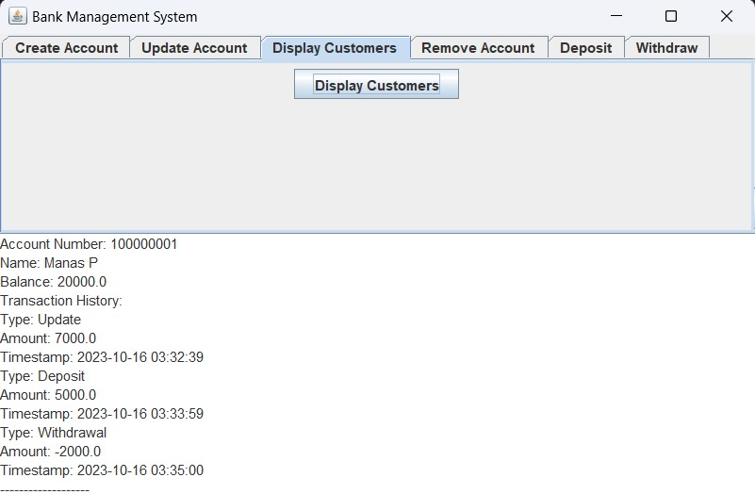

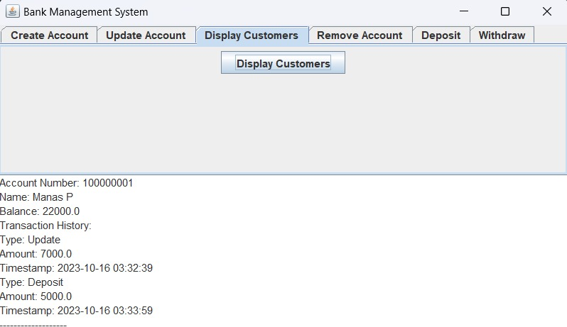

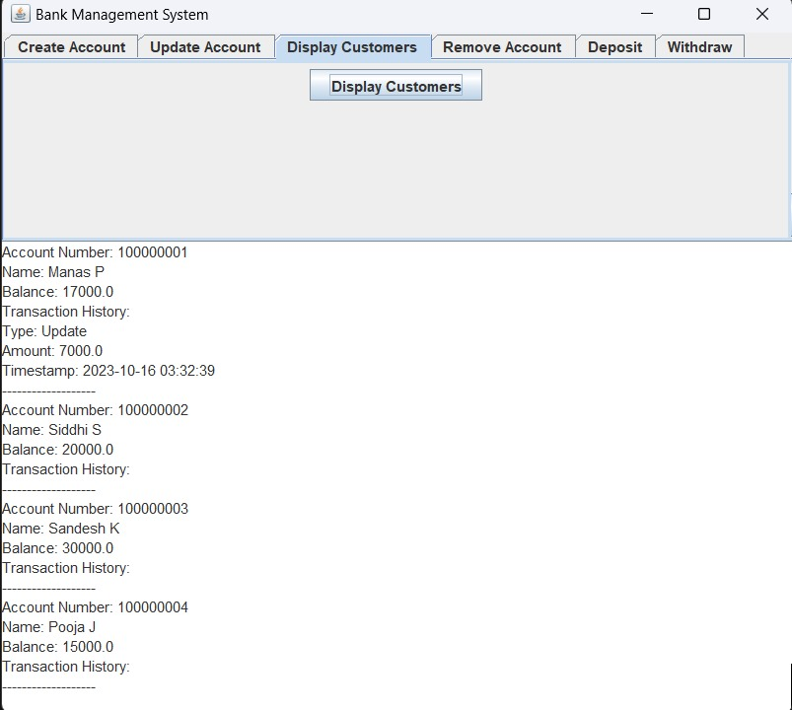

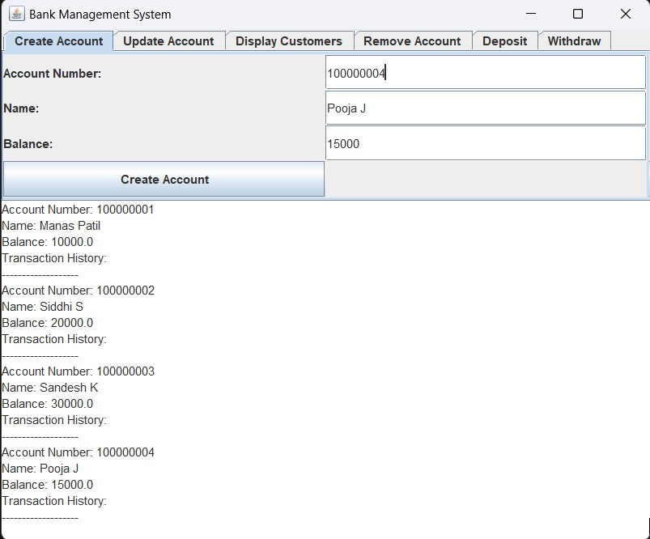

CONCLUSION

In conclusion, the "Bank Management System with File Handling" project has successfully addressed the intricate challenge of managing customer accounts within a bank, offering a comprehensive and user-friendly solution. Through the use of well-designed algorithms, data structures, and file-handling capabilities, the project streamlines account management processes while ensuring data integrity and persistence. The software's implementation of a binary search tree data structure allows for efficient storage and retrieval of customer account information while maintaining data in a sorted order based on account numbers. Moreover, the incorporation of file handling empowers the system to save and load customer data seamlessly, enhancing data security and persistence. This project demonstrates the practical application of Java programming, data structures, and algorithmic concepts to real-world scenarios. It underscores the importance of structured software engineering in addressing complex problems and provides a strong foundation for further enhancements and adaptations to meet evolving banking needs. By offering a powerful and reliable tool for managing customer accounts, the "Bank Management System with File Handling" project showcases the potential for technology to optimize banking operations and serve as a model for efficient and secure financial data management.

REFERENCES

[1] Liu Qinwen, "Analysis on the Application practice of management Accounting in commercial Banks under the Supply-side Reform", Time Financial, no. 26, pp. 127-128, 2018.

[2] Bao Lianlian, Research on the Profit Model Transformation of China's Commercial Banks in the Context of Internet Finance, China University of Mining and Technology, 2019.

[3] Zhao Yi, Enterprise Customer Information Management System Construction Project of Hengfeng Bank, Beijing:Hengfeng Bank Co., LTD., 01 2020.

[4] Zhang Hui, "Realization of QT-based Student Information Management System", Computer Knowledge and Technology, vol. 14, no. 36, pp. 46-48, 2012.

[5] Puling Li and Zhaoyang Yang, "Accounting Fraud and Prevention In Listed Companies In China", International Journal of Frontiers in Sociology, vol. 1, no. 1, pp. 23-31, 2019.

[6] B. Rong, Y. Qian, K. Lu, H. Chen and M. Guizani, "Call Admission Control Optimization in WiMAX Networks", IEEE Transactions on Vehicular Technology, vol. 57, no. 4, pp. 2509-2522, July 2008.

[7] R. O. Duda, P. E. Hart and D. G. Stork, Pattern classification, John Wiley & Sons, 2012.

[8] SHAFFER, C.A.: Data Structures and AlgorithmAnalysis. Edition 3.2 (Java Version). Dover Publi-cations. Mar. 2013. url: http://people.cs.vt.edu/~shaffer/Book/JAVA3elatest.pdf

[9] SHIPILEV, A.: (The Art of) (Java) Benchmarking.Talk given by Aleksey Shipilev for JavaOne SF 2011.Okt. 2011. url: https://shipilev.net/talks/j1-Oct2011-21682-benchmarking.pdfISSN 1335-8243

[10] EGOROV, D.: JMH - Great Java Benchmarking.dzone.com, Performance Zone, Tutorial. Okt. 2017.url: <https://dzone.com/articles/jmh-great-java-benchmarking>.

[11] COSTA, D.: Benchmark-driven Software Perfor-mance Optimization. PhD. Thesis. July 2019,url:https://www.researchgate.net/publication/335014121_Benchmark-driven_Software_Performance_Optimization.

[12] SESTOFT, P.: Microbenchmarks in Java and C#.IT University of Copenhagen, Denmark. Sep. 2015.url: <https://www.itu.dk/people/sestoft/papers/benchmarking.pdf>.