Report: Modelling Human Travel Behavior with GPS Tracking Data
Group: 3
Member names: Puja Khadka, Linn Bellskog, Madelene Stenberg
Submission Date: 21/05/2025
Contents
Introduction 1
Methodology 1
Task 1: Data Processing 1
Task 2: Layer Creation in QGIS 1
Task 3: Network Analysis 1
Task 4: Pattern Analysis 2
Task 5: Speed Variation Mapping 2
Task 6: Gender-Based Heatmap 2
Task 7: Independent Analysis 2
Results 2
Analysis 6
Conclusion 6

Introduction
The endeavor’s main aim was to utilize GPS tracking data to examine the mobility patterns of human for comprehending everyday travel habits. The data gathered from 21 volunteers was analyzed through GIS tools, which contains the information regarding time, longitude, latitude, and speed. The final objective is to use GIS technologies, especially QGIS, to extract, process, and interpret this data in order to show mobility patterns, spot transportation trends, and predict future movements.

Methodology

Task 1: Data Processing
Data Preprocessing was the initial step for GPS tracking data for spatial analysis. It encompasses calculating distance, time difference, speed, and acceleration between points, filtering out data with speeds greater than 200 km/h, and creating unique trip and point ids based on time intervals across records. Calculations were made for summary statistics such as trip time, total distance travelled, average speed, acceleration and so on. After cleaning, the dataset is saved as a CSV file which was later used with a GIS.

Task 2: Layer Creation in QGIS
With the appropriate coordinate referencing, the pre-processed GPS data is loaded into QGIS (WGS84). (Jim Clifford et al., 2013)Then the data was furthered stored as a permanent layer called "Positional Recordings" once non-Swedish points are eliminated. To facilitate additional study, other layers are included, such as the Falun municipality (extracted from Kommuner_Sverige) and Sweden's road network.

Task 3: Network Analysis
For the task 3 "Point to Path" function in QGIS is utilized to represent the volunteers' travel routes as line layers, or "Tracks." To find trends, tracks are grouped by Driver_ID.(Hervé Pella & Ose, 2018) Using Sweden_Road_Networks or ISA_in_Dalarna dataset, a chosen route is examined for the shortest path computation. Lastly, the real GPS tracks is compared with and Google Maps recommendations in order to comprehend routing behavior.

Task 4: Pattern Analysis
In task 4 we analysed the spatial density of GPS points utilizing clustering algorithms and heatmaps. Borlänge's data concentration is shown on a heatmap.(A. Folini et al., 2022) Data overlap and dispersion are also analyzed at using point cluster and point displacement methods. To represent different perspectives into patterns of travel, an integrated figure compares the three visualization techniques.

Task 5: Speed Variation Mapping
For the task5, we generate a themed map that represents the traffic movement, GPS locations are divided into seven speed bands. Speed distribution is facilitated by this map. To draw focus at certain speed behaviour, a detailed map is generated for a chosen road or region.

Task 6: Gender-Based Heatmap
Two different heatmaps was generated in the task 6 by splitting the data in gender ('M' for males and 'F' for females)(Rostislav Nétek & Pour, 2018). These maps show that male and female participants travelled at different speeds and frequencies. A written comparison and maps are included in the result.

Task 7: Independent Analysis
Our main objectives was to discover the most frequently used route from Falun to Borlange with the help of GPS movement data for the task7. We used trips that are originated within the falun municipality and end in Borlange. Then we visualized these filtered tracks and develop a heatmap highlighting the areas with highest movement concentration. The visualized map enables us to observe spatial patterns and discover the most travelled route among the focused two locations.

Results
GPS data processing involve elimination of invalid speed records over 200 km/h and negative value from the data, and every trip was precisely split using a 180-second time gap criterion. As a result, the data was cleaned and contained data that can be used for analysis. We were able to contextualize volunteer mobility spatially by merging the Falun municipality boundaries and Sweden's road network with the positional recordings, which were successfully depecting as point layers in QGIS.
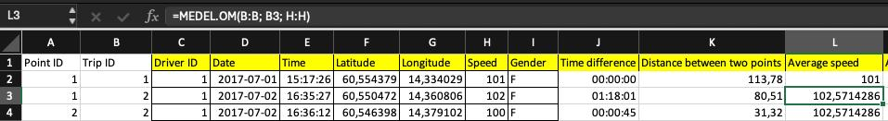
Figure 1 figure of excel data preprocessing
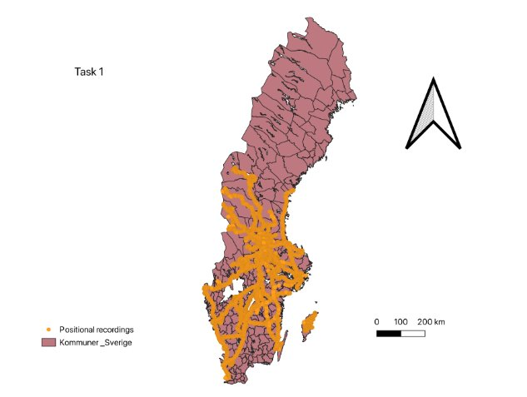
Figure 2 Positional Recordings Layer with Sweden Road Network and Falun Municipality
Track lines was created from the location data showing distinct patterns of motion, and grouping them according to Driver_ID exposed individual differences in travel habits. We were able to compare the algorithmically recommended route and actual travel utilizing the shortest path analysis which was further compared with the Google Maps.
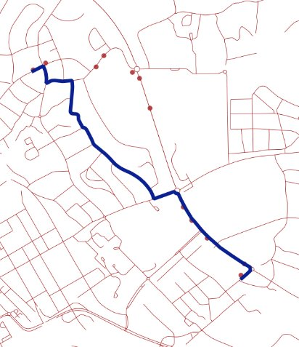  Figure 3comparison of shortest part using GIS data | 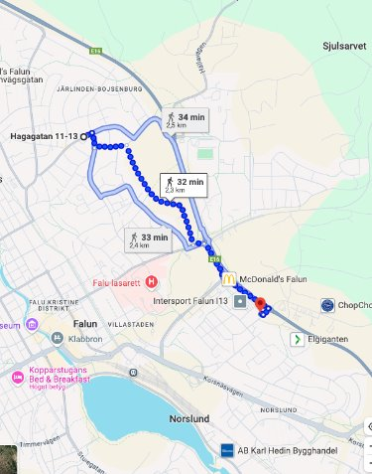  Figure 4comaprison of shortest parth in google

Utilizing the heatmap analysis, areas with significant traffic were identified within Borlänge, especially in the core zones and along important road corridors. While point displacement maps shows clarity in busy areas, point clustering efficiently compressed overlapping data. We analyzed that the comparison of different approaches facilitate different comprehension on the dispersion and concentration of data.
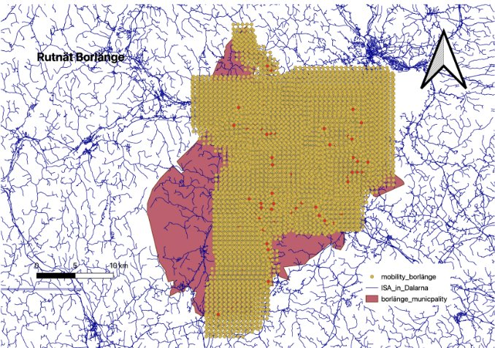  Figure 5Point displacement | 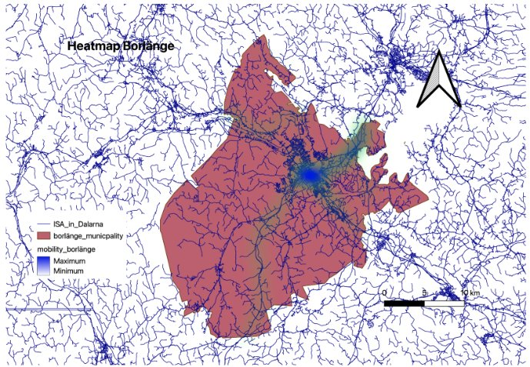  Figure 6 Heatmap of GPS point in Borlange | 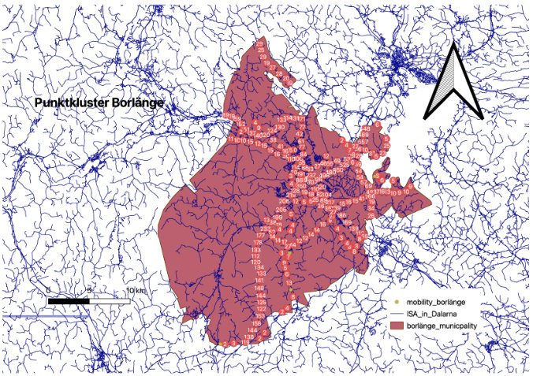  Figure 7 point Cluster
With the help of by speed mapping, we were able to show a typical urban routes with most speeds falling between 10 and 50 km/h, specially in crowded city centers, and greater speeds in more outlying locations. Slower speeds in congested areas were verified by a thorough zoom-in. Male and female participants exhibited different patterns, as per the gender-specific heatmaps; males specially tends to utilize longer and faster journeys, while females' seemed more concentrated and slower.
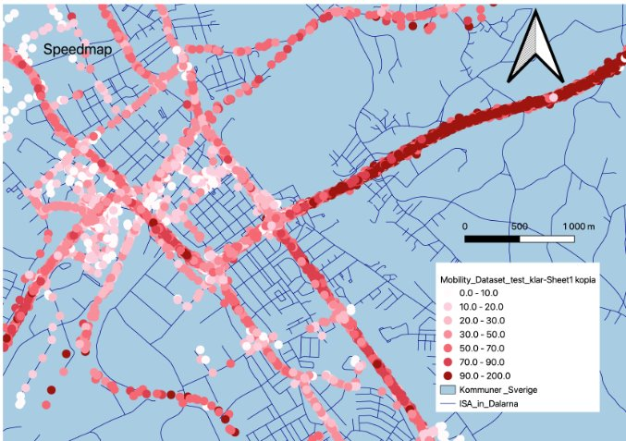
Figure 8routes with most speeds falling between 10 and 50 km/h
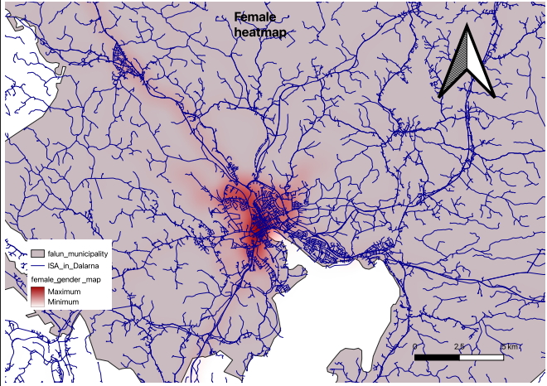  Figure 9 female-specific heatmap | 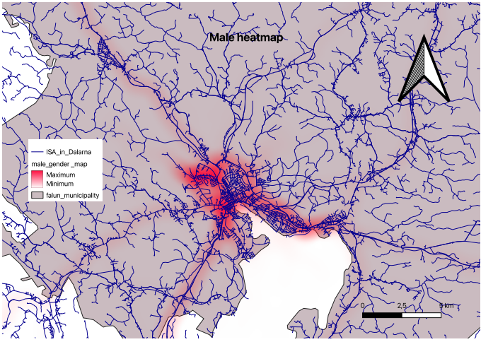  Figure 10 Male based heatmap

lastly, a custom study further demonstrated a particular pattern of travel habits (such as the road that is frequently used from Falun to Borlange), highlighting the vital of spatial analysis of data in grasping human mobility.

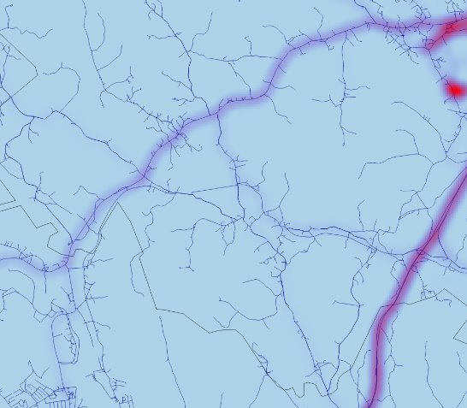
Figure 11 old road from Falun to Borlange
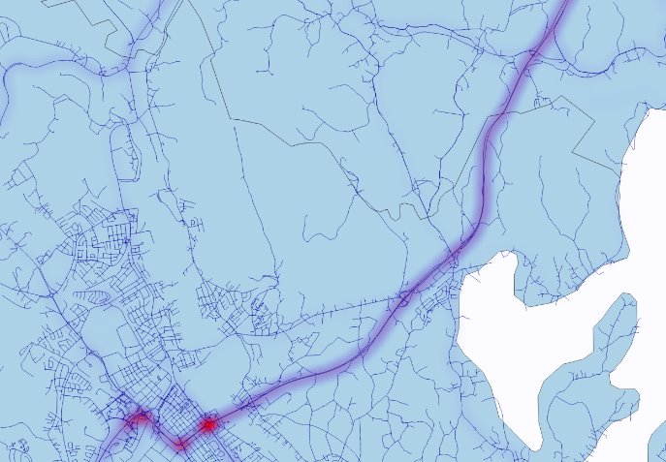
Figure 12 new road from Falun to Borlange

Analysis
Some useful trends were comprehending regarding the human mobility pattern using the GPS monitoring data. While the majority of travel are brief and limited to urban areas. Utilization of clustering and heatmap approaches aids in discovering Travel hotspots effectively. Gender-based analysis aids to uncover the Subtle mobility variations in frequency of travel and area coverage. The origin-destination analysis uncovers vital information for transportation strategy, including high-traffic areas and corridors that are frequently utilized.
The GIS technic such as QGIS can be useful in large-scale mobility processing of data, visualization, and interpretation. These spatial analytic techniques can be modified for more general uses like smart city organizing, customized transportation services, and traffic flow optimization.

Conclusion
The proposed endeavor represents the way spatial data analysis can be utilized to understand human mobility pattern. The method varying from network analysis to heatmaps and generate meaningful insight which can be useful for both practically and intellectually. For the further study, ML technic can be utilized which can generate even more focused information regarding the mobility pattern and aids to up-surge the urban transit system.

References
A. Folini, , E. L., & , C. A. B. (2022). XLVIII-4/W1-2022. https://isprs-archives.copernicus.org/articles/XLVIII-4-W1-2022/151/2022/isprs-archives-XLVIII-4-W1-2022-151-2022.pdf
Hervé Pella, & Ose, K. (2018). Network Analysis and Routing with QGIS. https://doi.org/10.1002/9781119476726.ch4
Jim Clifford, Josh MacFadyen, & Macfarlane, D. (2013). Creating New Vector Layers in QGIS 2.0. https://doi.org/10.46430/phen0034
Rostislav Nétek, & Pour, T. (2018). Implementation of Heat Maps in Geographical Information System – Exploratory Study on Traffic Accident Data. 10(1). https://doi.org/10.1515/geo-2018-0029

