Parallel Object Programming C++
Installation manual for
the Cygwin™ version



version POP-C++ : 1.1.1
version documentation : 1.0

Nicolas Brasey
Pierre Kuonen
Jean-François Roche

Grid and Ubiquitous Computing Group

http://www.eif.ch/gridgroup/popc

 | University of Applied Sciences  of Western Switzerland, Fribourg

1. Introduction

Cygwin™ (http://www.cygwin.com) is a Linux-like environment for Windows. It ports for Windows the main popular GNU software tools. This chapter is a guide to how install and configure Cygwin™ to run POP-C++ ont top of it.

Contents of the distribution

The POP-C++ distribution for Cygwin™ contains 3 directories and 3 files :

- include
This directory contains the SUN-XDR include file fitted for POP-C++

- src
This directory contains the source files of POP-C++

- cygwin_packages
This directory contains the required packages for POP-C++. You will use it if you don't want to download these packages from the internet

- setup_cygwin.exe
This application is the setup to install Cygwin™. You will use it if you don't want do download it from the internet

- Installation_manual_POPC_Cygwin.pdf
This is the installation manual for Cygwin™ and POP-C++

- README.TXT
This file contains some late informations

WARNING :
- POP-C++ uses à special manufactured xdr.h file. The original one from Cygwin™ will be replaced during the installation of POP-C++. After the installation of Cygwin™ or if Cygwin was already installed, we strongly recommand to save the original xdr.h file before you begin with the installation of POP-C++ in order to be able to reverse this operation.

Known limitations :
- Actually Cygwin™ ist not able to deal with the use of space character in the directory name. You should be sure that you install and run POP-C++ in a directory which have no space in his name

This installation guide is part of the official documentation « Parallel Object Programming C++ User and Installation Manual (version 1.1.1) » . The copyright and licences term for the Cygwin™ version of POP-C++ are the same as for the standard Linux version. Cygwin™ has his own copyright and licences terms, so please see the official documentation of Cygwin™ to know about this.

2. Installing Cygwin

First of all, you need to download the Cygwin™ installer. It can be found at this address: http://www.cygwin.com/setup.exe

Execute the installer and follow the instructions. Here are the required packages you need to install in order to install POP-C++ later:

devel/autoconf
devel/automake
devel/flex
devel/gcc
devel/make
editors/vim
libs/sunrpc
net/openssh
utils/diffutils
web/wget

Of course, you can select more packages if you need editors or some other stuff.

To simplify the life of people which are not familiar with Cygwin™, you will find here an example of the installation

- Just after launching the setup you will have an « Welcome » window with some explanation (fig.1.1). Just click « Next »

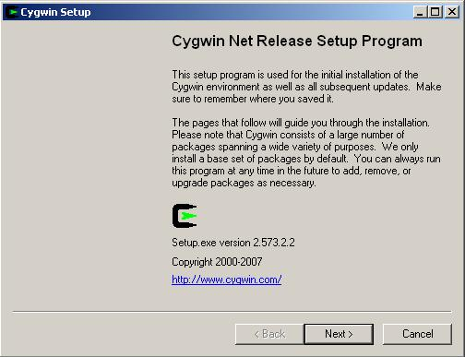
fig 1.1

- Because the setup needs a lot more files, it ask where do you want take the necessary files. In our example the files were not stored locally so they will be installed from internet
(fig.1.2). Choose the installation method and then click « Next »

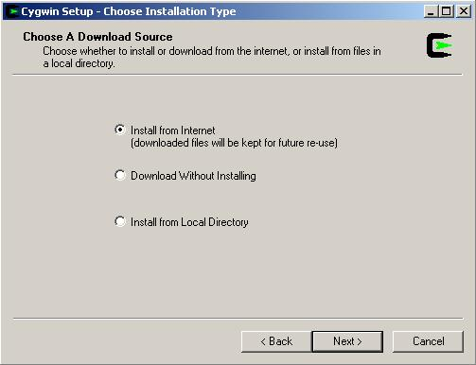
fig 1.2

If you already downloaded the files or download them without installing, you will be of course able to install from local directory without download it again.

- The setup will now ask where do you want have the root directory. If you don't have special requirement, let all to the default (fig. 1.3). When you have give the suitable informations click « Next »

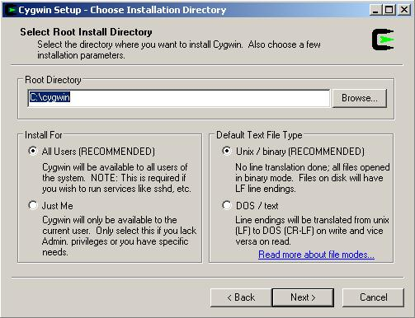
fig 1.3

- If you are installing from the internet or just download the files you need to inform the setup where it must store the needed files for the installation (fig. 1.4). In this example, the files will be downloaded to the directory c:\cygwin_packages. You can choose the directory you want but should not be the same as the root directory.

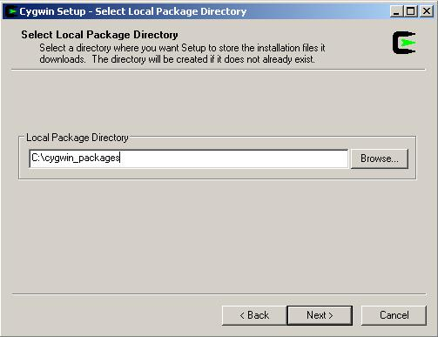
fig 1.4

- In case of downloading (just downloading or with installation) the setup will ask you how you are connected to the internet (fig. 1.5) Select the correct connection and confirm with a click on « Next »

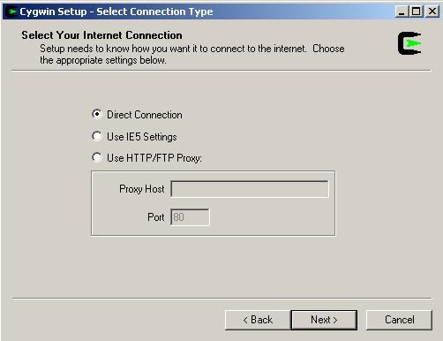
fig 1.5

- To avoid the use of unnecessary router around the world, select a mirror in your region from where the setup will download the necessary files (fig 1.6) and click « Next »

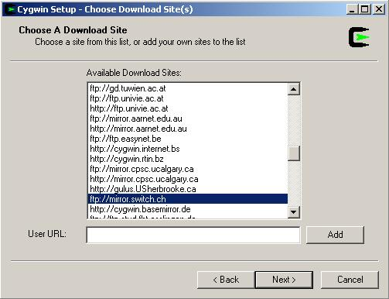
fig 1.6

- To avoid unnecessary traffic due to transfert from unnecessary files, you will be asked now to select the packages you need (fig 1.7). If you don't know exactly which is the purpose of the option on the top, just let « Curr » (current) active and let the obsoleted package hided (at the bottom of the window)

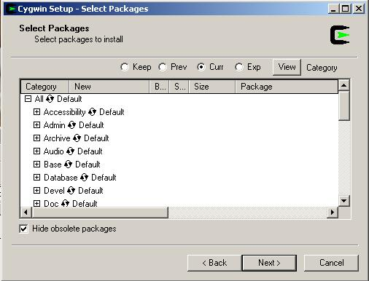
fig 1.7

The following operations are the most complicated part of the installation of Cygwin™.

- When you will install a package from a group, you need to click on the cross on the left of the package group to expand the group.

- To select a package, click once on « Skip » on the left of the package you will install (fig. 1.8)

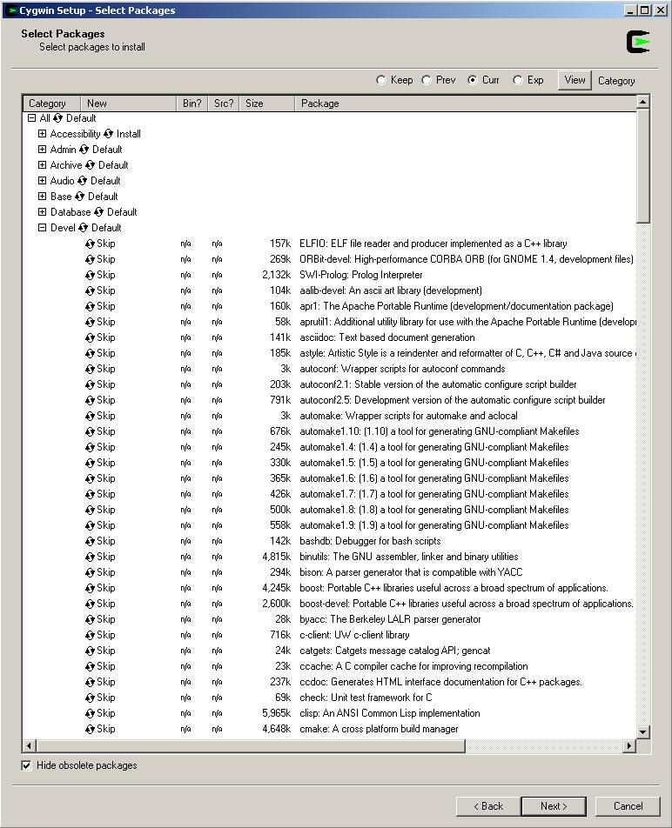
fig 1.8

You will see that a number will replace « skip » and that also some other lines are changed. The number indicate the version number of the package and the other lines which are also changed are packages which are required from your selected package. You will also see that under the column « Bin? » the « n/a » ist replaced by a square with a cross. This indicate that the binary of the package will be installed. If you don't really need the source, let the square under « Src? » empty.

So, as indicated above, you will need to install the package « autoconf » from the group « devel » and you will become a window like this bellow (fig 1.9). You can ignore all lines which contain no required for the installation of POP-C++. You will also see that some packages are installed by default. These packages are needed from Cygwin™ itself so that it can provide the basic services. Of course, depending when you download the packages, the number of the version can change but the principle leave the same.

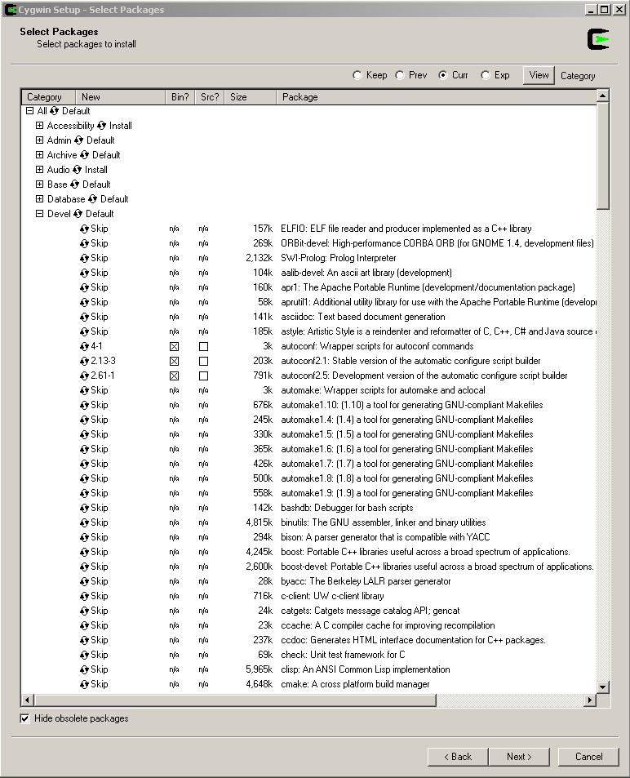
fig 1.9

Once the last required package is selected, click on « next » to continue the installation which is the downloading from the packages (fig. 1.10)

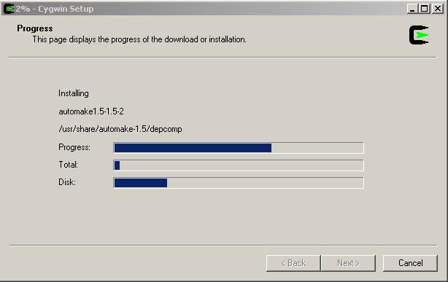
fig 1.10

When the packages are downloaded and installed the setup ask if you want to create some shorcuts. Select both options and click « Finish » to complete the installation of Cygwin™ (fig. 1.11)

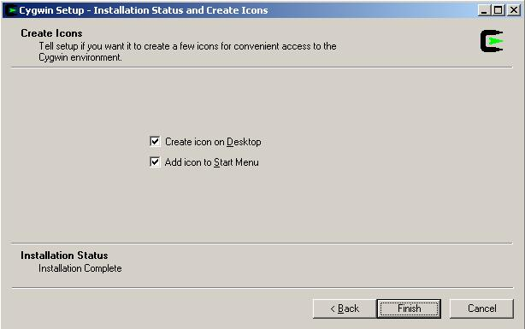
fig 1.11

3. Configuration of Cygwin™

3.1 Changing Windows variables
Before continuing the configuration of Cygwin™, you need to changes some Windows variables.

To do this, click with the right button on « My Computer » and left click on « properties » (fig 3.1)

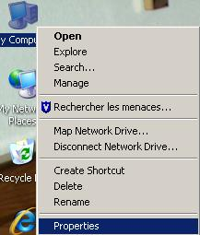
fig 3.1

then click on the « Advanced » (fig 3.2) tab.

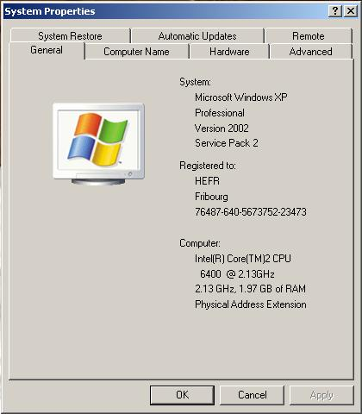
Fig 3.2

To acces the Windows variables just click on « Environment Variables » (fig 3.3)

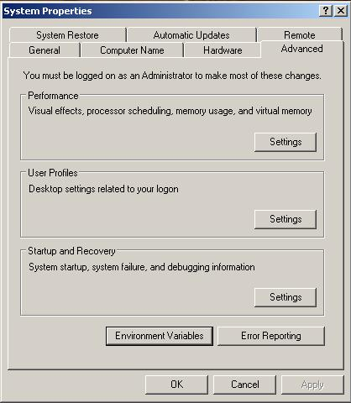
fig 3.3

We can now make the necessary changes. First we add a new system variable called « CYGWIN » which have the value « ntsec tty ». To do this, we click on the « new » button in the System variable area. A new window will apear and you can fill both areas as displayed on fig. 3.4 Accept the modification with a click on the « Ok » button.

You also have to add the path of the binary of Cygwin™. Select the variable named « Path » in the system variables area (fig 3.5) and click on the « edit » button. A new window will appear. Go to the end of the variable value and append « ;c:\cygwin\bin » to the existing variable string. Accept the modification with a click on the « Ok » button

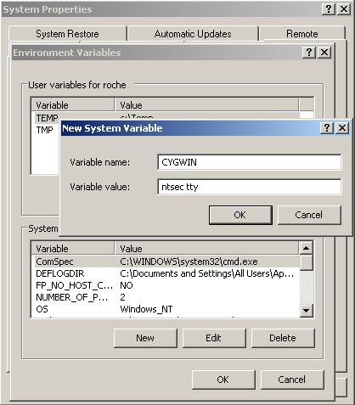
fig 3.4

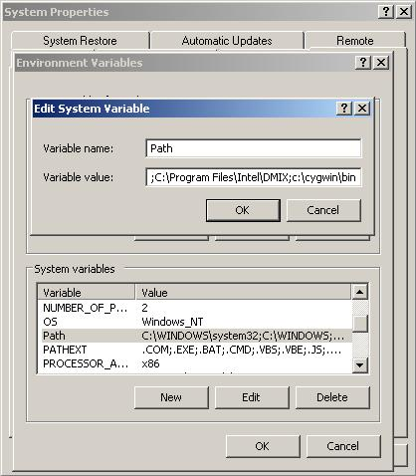
fig 3.5

3.2 Configuring Cygwin™

3.2.1 Configuring users

You need to synchronize users defined in Windows with Cygwin™. Open a Cygwin™ window with a double-click on the Cygwin™ icon (fig 3.6)

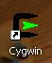 fig 3.6

and run the following commands

mkpasswd -cl > /etc/passwd
mkgroup -l > /etc/group

as shown on fig 3.7

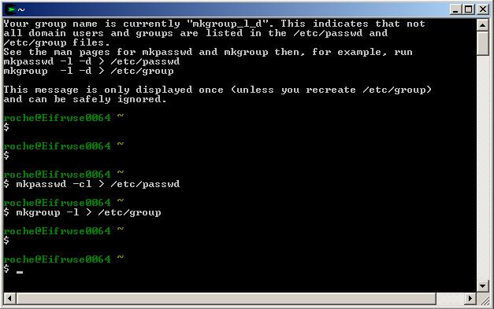
fig 3.7

3.2.2 Configuring SSH server

To run properly a POP-C++ applicatin, you need to have a SSH server running on your machine. You must open a Cygwin™ window in order to configure the SSH server. When you are at the prompt, type the following command:

ssh-host-config

This program will ask you several questions:

to « privilege separation », answer yes
to « create local user sshd », answer yes
to « install sshd as service », answer yes
to « CYGWIN = », your answer must be ntsec tty

As shown on fig. 3.8

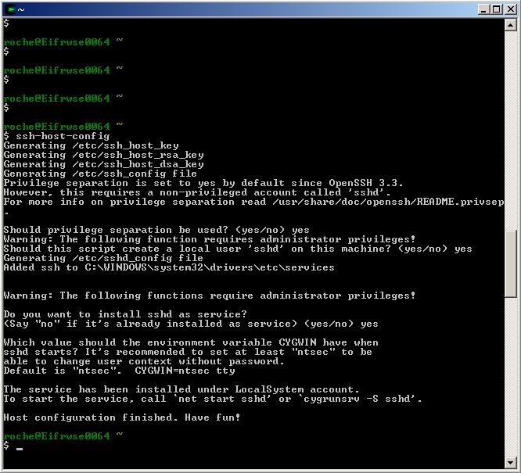
fig 3.8

SSH is now configured and it should be possible to start the server using the following command:

net start sshd

as shown on fig. 3.9

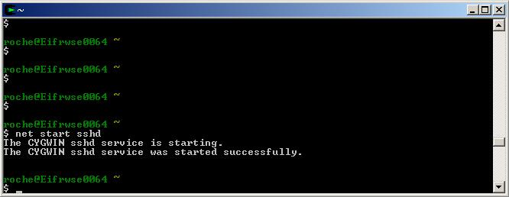
fig. 3.9

4. Standard installation of POP-C++ for Cygwin™

The installation of POP-C++ on Cygwin™ is done with very few differences than the POP-C++ installation on traditional Linux machine as described in the standard POP-C++ documentation available at http://www.eif.ch/gridgroup/popc.

To install POP-C++ on Cygwin™ you can follow the procedure below :

Go to the directory where you have copied and decompress the sources of POP-C++.

The new xdr.h file is a special manufacturing for POP-C++ and could cause problem if you use other applications which use the standard one ! We strongly recommend to save the original xdf.h file in order to be able to reverse this operation

Before we begin with the compilation you have to copy the file xdr.h located in the directory /distrib_1.1.1/include in the directory /usr/include/rpc to replace the original one.

Enter the command

./configure

Once this command is terminated, go to the directory parser by entering the command

cd parser

now we start the make command with the parameter LDFLAGS="-lfl"

make LDFLAG="-lfl"

This will make the compilation of the parser. When this is finished we go back to the source directory with the command

cd ..

now we make the compilation of the rest of POP-C++ with the command

make

followed by the

make install

Once this is finished, POP-C++ for the Cygwin™ is ready to work.

