

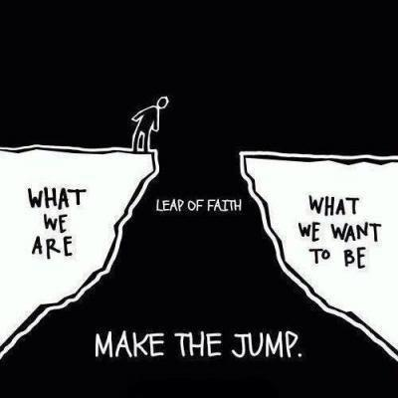

Regarding: Personal development plan #1

Student name: Peter Kapsiar

Student number: 5486866

Course: Professional Skills

Phase: Year 1

Study coach Miguel Ranchor



1. What competences will I develop during this period?

**Professional workmanship**

| **Profession-specific competencies** | **What requires special attention?** |
| --- | --- |
| 1. Managing | Staying focused during longer tasks |
| 1. Analysing |  |
| 1. Advising | Formulating my explanations into a more easy to understand format |
| 1. Designing |  |
| 1. Executing | Avoiding delaying tasks no matter what. Staying in flow. |
|  | |

**Professionalisation**

| **Study career competences** | **What requires special attention?** |
| --- | --- |
| 1. Ability to pursue one’s own competence development independently | I could be paying more attention to planning and organising my tasks. |
| 1. Ability to take responsibility for one's own study progress | I am well aware of any consequences that my actions can lead to. |
| 1. Ability to make the right study and career choices |  |
| 1. Ability to build up a supportive social network | I want to get better at getting to know people. |
|  | |

**Professionalisation**

| **Study competencies** | **What requires special attention?** |
| --- | --- |
| 1. To learn how to learn |  |
| 1. Planning |  |
| 1. Time management |  |
| 1. Project-based working | I want to learn how to keep things more under control and create/follow a project structure. |
|  | |

**Social and communicative competencies**

| **Social and communicative competences** | **What requires special attention?** |
| --- | --- |
| 1. Ability to correct in an appropriate way |  |
| 1. Interview techniques | I need to improve my agenda preparation and following the agenda. |
| 1. Personal feedback |  |
| 1. Presentation skills | I need to improve my confidence while presenting. |
| 1. Reporting in writing |  |
| 1. Techniques in meeting | Same as in interview techniques - preparing and following the agenda. |
| 1. Writing a formal or business letter |  |
|  | |

2. What are my personal development goals?

Action plan: which activities will I undertake to realise my developmental goals?

| **Development goal**  **(SMART)** | **Activity**  **(SMART)** | **Measurable result**  **(SMART)** | **Time completed** |
| --- | --- | --- | --- |
| 1.  I want to improve my sleeping habits so I can start my day with more energy and discipline. Therefore, I will train myself to wake up immediately when my alarm rings without using the snooze button. | Whenever I have to wake up at a specific time using an alarm I will wake up immediately after I hear the alarm ringing.  After I wake up I will track my success and feelings in a Google Docs sheet. | During the period 12.May - 11.June I will wake up without snoozing my alarm and my progress on this will be tracked in my Google Docs sheet. | 11-06-2025 |
| 2.  I want to improve my Dutch vocabulary so I can navigate the Netherlands more easily. To help with this I will keep learning Dutch every day using Duolingo. | Complete at least one Duolingo Dutch lesson every day. | In the in-app calendar I will have a perfect uninterrupted learning streak from the starting day until the end day (7.May - 11.June) and I will have learned new words from all the lessons. | 11-06-2025 |
| 3.  I want to improve my physical appearance so I will start exercising at least 3 times per week. | Do at least a 30 min workout 3 times per week. | During the period 12.May - 11.June I will have done at least 12 workouts which i will have kept track of in a journal list. | 11-06-2025 |
|  | |  |  |

For approval study coach: 

For approval student: 