**“LUCIAN BLAGA” UNIVERSITY OF SIBIU  
ENGINEERING FACULTY**

**DEPARTMENT OF COMPUTER SCIENCE, ELECTRICAL**

**AND ELECTRONICS ENGINEERING**

**DISSERTATION**

SCIENTIFIC ADVISOR: Univ. prof. dr. eng. Remus BRAD

COORDINATOR: Univ. prof. dr. eng. Remus BRAD

GRADUATE:

Carmen POPA

Embedded Systems

* Sibiu, 2020 –

**“LUCIAN BLAGA” UNIVERSITY OF SIBIU  
ENGINEERING FACULTY**

**DEPARTMENT OF COMPUTER SCIENCE, ELECTRICAL**

**AND ELECTRONICS ENGINEERING**

**Localization and mapping with autonomous robot, based on LIDAR sensor**

SCIENTIFIC ADVISOR: Univ. prof. dr. eng. Remus BRAD

COORDINATOR: Univ. prof. dr. eng. Remus BRAD

GRADUATE:

Carmen POPA

Embedded Systems

**"LUCIAN BLAGA" UNIVERSITY OF SIBIU APPROVED (date)**

**FACULTY OF ENGINEERING __________________**

**Department of Computer Science, Head of Computer Science, Electrical**

**Electrical and Electronics Engineering and Electronics Engineering**

**_____________**

**THEMATIC PLAN FOR DISSERTATION**

Student’s name and surname *Popa Carmen*.

Study program *Embedded Systems*.

1. Subject ***Localization and mapping with autonomous robot, based on lidar sensor.***

2. Deadline ***01.07.2020***

3. Basic elements for the project

***Science articles, books;***

***Development tool: Arduino IDE and MATLAB.***

***Hardware: Arduino, chassis (wheels, motors, motor driver), lidar sensor, wireless connector***

4. Problems to be solved

***Creating a robot that will be able to construct and use a map of the environment, based on the lidar sensor, and localize itself within it. The map will be in 2D and 3D formats.***

***Based on this map, the robot will automatically detect the obstacle in front of it and avoid it by turning itself in another direction.***

6. Advices schedule (every week)

***Twice a week.***

7. Theme released on **10.03.2020**.

**Theme received by student:** SCIENTIFIC ADVISOR**,**

**Date _________ _____________________**

**Student's signature ________________ (name and signature)**

Content

Abstract

1. **INTRODUCTION IN MAPPING AND LOCALIZATION**
2. **Mapping**

Robotic mapping is a discipline related to computer vision and cartography. Mapping robots can now be found in several areas like industry, military, home appliances, exploration, and self-driving cars[1]. In most cases, these robots are used where humans cannot reach, or it is very hard for a human to reach those areas.

The goal of this robot is to be able to construct and use a map (indoor or outdoor) and to localize its position in this map [2].

“*Robotic mapping is that branch which deals with the study and application of the ability to localize itself in a map/plan and sometimes to construct the map or floor plan by the autonomous robot*” [2].

In order to create the map, the robot must be equipped with several types of sensors, like Sonar sensor, laser, radar, infrared, touch sensor, GPS, camera, and so on [22]. Of course, sensors have at least a small error, and also the sensors have a limited operating range. These limitations and errors will not lead to a 100% accurate map. To improve map accuracy, there are used several algorithms and methods [22].

1. **Map categories**

These maps can be categorized into four categories: the metric map, topological map, conceptual map, and cognitive map [22], as shown in figure 1.

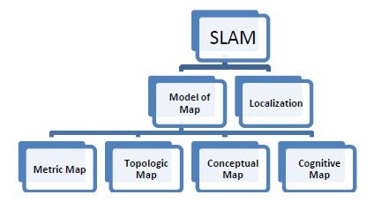

Fig. 1. Map categories [22]

1. Metric Map

The environment coordinates are being scaled accordingly using the metric map. One example of the metric map is the occupancy grid, which shows the environment as a “discrete network of cells” [23]. This map is most used when the robot is equipped with a distance measurement sensor, like sonar or lidar. Of course, this method has its weakness, more precisely the usage of high memory for saving all the information.

The basic idea of this map is to “represent a map of the environment as an evenly spaced field of binary random variables each representing the presence of an obstacle at that location in the environment” [23]. In more simple words, each cell that is occupied will have a specific value, for example, “1”, and each free cell will have another value, for example, “0”. This kind of map is a non-parametric model because it does not use environment parameters to create the map.

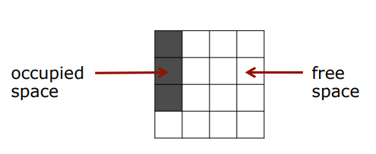

Fig. 2. Occupancy grid example

1. Topological Map

This map uses the characteristic of the environment that are effective in robot localization, and avoid characteristic like geometric measurements. In most cases, this map “is a graph of nodes and links” [22]. Here, the nodes represent the important obstacles or places on the map and the links between nodes represent the connection between two places.

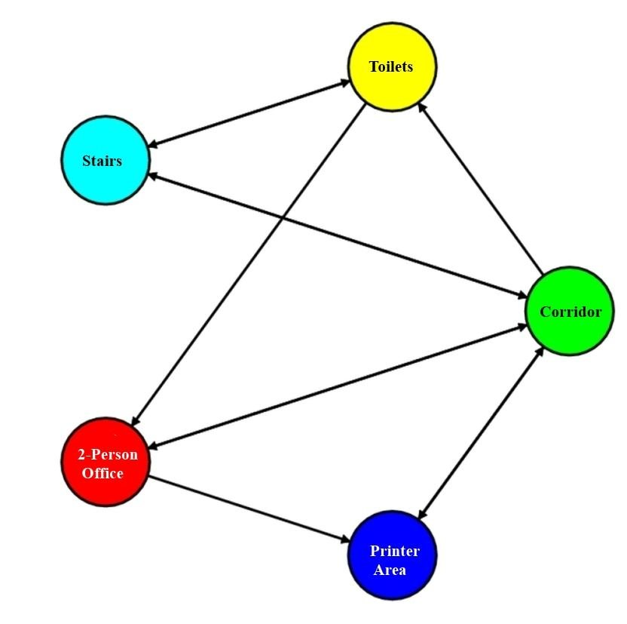

Fig.3 Topological map [24]

1. Conceptual Map

“A concept map is a diagram that depicts suggested relationships between concepts” [25]. The concept uses, in this case, organizing and representing knowledge. An example of this map can be seen in the following picture:

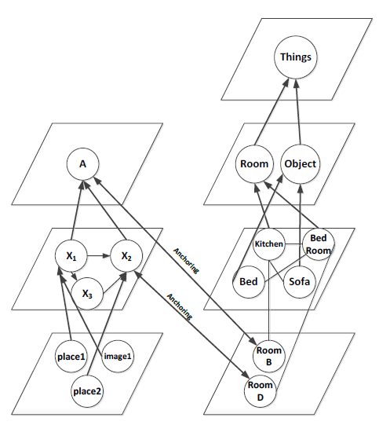

Fig. 4 Conceptual map [25]

1. Cognitive Map

This map will be used for robots with artificial intelligence, which “understand the environment map like humans” [22]. This map will be presented “based on anatomy and function of the human brain” [22]. Using this map, the robot will be able to act and take action like humans.

* 1. **Localization**

The problem of robot mapping is to acquire information about the robot environment based on a set of data received from a set of sensors. To acquire a map, robots must use a set of multiple sensors, which will allow them to perceive the outside world. Most of the sensors used in this task are cameras, distance sensors (using sonar, laser, and infrared technology), radar, compasses, and GPS. However, all these sensors are subject to errors, like measurement errors or noises, but also some limitations (range limitation, sensor position limitation). [3]

When creating a map, it is very important, the robot localization on the map. “Localization is the problem of using sensor measurements to estimate the robot’s pose relative to some map” [4].

Localization is essential to decide on future actions, to avoid dangerous situations (collisions or unsafe conditions – temperature, radiation, exposure to weather).

“Robot navigation means the robot’s ability to determine its position in its frame of reference and then plan a path toward some goal location” [5].

1.2.1 Coordinates calculation

In order to establish the robot localization, it is necessary to know the coordinates of the robot. For this, there are multiple methods, like: …….

The problem with localization and mapping is that each process is based on having data and information from the robot sensor and actuators. The sensor information isn’t 100% accurate, so in order to avoid measurement errors, it will be needed complex algorithms and calculations.

To create an accurate map of the environment, we need information about the robot pose; this means that in order to create the mapping, we need localization. But to determine the robot pose, we need to have information about the environment, like a map. This problem is known as the “chicken and egg” problem [6].

**1.3 SLAM**

There exists a technique which overcomes this problem, which is called: Simultaneous Localization and Mapping (SLAM) [6].

The main principle of SLAM is to detect the outside environment using sensors on the robot and construct the map of the environment while estimating the pose – localization, and orientation – of the robot.

SLAM uses a set of algorithms in order to solve the localization problem and also the mapping problem. “SLAM is more like a concept than a single algorithm” [20].

Some examples of SLAM techniques are the following: EFK SLAM, FastSLAM, Graph-based SLAM, Lidar-SLAM, and so on, but in all techniques, the problem is the same: we need a map for localization and we need the position estimation for creating the map. So both problems are unknown, and the purpose of SLAM needs to solve them.

The most used SLAM techniques algorithms include Kalman filters and particle filters (Monte Carlo methods). Those algorithms use an estimation of the probability function for robot pose and map parameters [20]. Most of SLAM algorithms are implemented on ROS – robot operating systems, which is an open-source library, which is used together with Point Cloud Library for creating the 3D map or with visual features from OpenCV.

SLAM application can be found in automatic car piloting or unrehearsed off-road terrains, rescue tasks for the high-risk or difficult-navigation environment, planetary, aerial, terrestrial, oceanic exploration, medicine, and many more.

The most important parameters in the investigation of the SLAM problem are [22]:

* Sensor uncertainty
* Correspondence
* Loop closing
* Time complexity
* Dynamic environment

1. Sensor uncertainty can be explained by the accumulation of small errors. This uncertainty can be described by:
   1. Restriction of incoming – this is related to sensor limitations; most of the sensors have small distances limitation, which will lead to errors when trying to read further distances.
   2. Sensor fault – this is caused by noises read by the sensors.
   3. Mistake/Slip – this is caused by robot movement errors; a small slip can cause problems.
2. Correspondence issue which is also called data relation. This problem will determine if “sensor measurements at different times relate to the same physical object or not” [22].
3. Loop closing performs after the previous issue. When the robot is in a loop, it has to decide its position on the map. “It is therefore difficult because during the closing loop may accumulate error be too high”. [22]
4. The time complexity issue is related to robot performance. This means that the robot must perform in real-time, in order to be faster.
5. Dynamic environment – this issue is related to changes in the environment. “This issue can make two hypotheses for the robot: first, the environment has changed. Second, the robot has entered in a new place” [22].

**1.5 Obstacle detection**

“Obstacle detection is the process of using sensors, data structures, and algorithms to detect objects or terrain types that impede motion” [26].

In order to detect the obstacles, there are several methods, based on the equipment or sensor used [27], most of them based on distance measurement. So, we can have the following categories of sensors:

* Ultrasonic sensors – which uses ultrasonic waves to measure the distance to an object.
* Infrared sensors – which uses a light source to measure the distance to an object.
* Proximity sensors – which uses an electromagnetic field to measure the distance to an object.
* Push sensors – uses physical contact to detect the distance to the object.
* Accelerometer – uses the orientation of the robot. “When robot hit an object, the accelerometer mark a motion in the opposite direction according to Newton’s third law” [27].
* Gyroscope – is constantly monitoring the changes in the orientation. “When the robot hit by an obstacle the large variation is marked as detection of obstacles” [27].

Obstacle avoidance methods can be classified into two categories: Direct detection and avoidance and Indirect detection and avoidance [27].

1. Direct detection and avoidance – DDA – this method allow the robot to touch the obstacle and react according to the collision. This means that after the collision, the robot will move away from the obstacle.

In this case, the most common uses sensors include push sensors, accelerometer, and gyroscope, which permit the robot to touch the obstacle and react.

One example of a robot using a push sensor for obstacle avoidance can be seen in the following image:

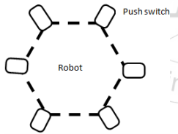

Fig. 5. Direct detection and avoidance robot [27]

1. Indirect Detection and Avoidance – IDA – this method does not allow the robot to reach the obstacle and react according to sensor information.

In this case, the most uses sensor are ultrasonic, infrared or proximity sensors which read the distance to the object, send the information to the robot, on which the path calculation will take place, in order to avoid the obstacle.

One example of a robot using an infrared sensor for obstacle avoidance can be seen in the following image:

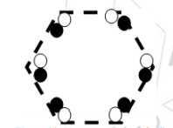

Fig. 6 Indirect detection and avoidance robot [27]

**1.6 Lidar technology**

Lidar technology, also known as ‘Light Detection and Ranging’ technology, uses light technology to detect the distance to an object. The basic principle of the lidar sensor is based on laser light and measures the reflection of it. “Lidar is a [remote sensing](https://oceanservice.noaa.gov/facts/remotesensing.html) method that uses light in the form of a pulsed laser to measure ranges (variable distances) to the Earth” [7].

A lidar device or sensor sends laser lights and measure how long does it take for the light to come back. The basic principle is known as “time of flight” measurement, where light beams are emitted by the device or sensor toward an obstacle or object, and then reflected and collected in the device. The returned light beam contains information regarding distance to the obstacles and sometimes optical characteristic, like reflexivity [28].

The main goal of a lidar sensor is supporting an autonomous car to navigate in an environment, but the sensors have also many additional applications, across various industries and fields.

Lidar technology is similar to radar or sonar technology, but still has some improvements like the precision of sensing [28]. The lidar precision can create a map, also known as “point cloud” [28], which represent a dense map of measurements, which can be seen on a display like physical objects.

A basic lidar sensor combines three technologies: a transmitter, a receiver, and a detector technology.

Lidar technology can be used in several modes, from autonomous vehicles to agriculture or image processing.

According to [8], which found “100 Uses for LIDAR 3D sensing technology”, the most used application can be found in digital elevation models, agriculture, astronomy, biology and conservation, image recognition, and so on.

Further on will be presented some examples of lidar sensors used in different areas.

1. Autonomous vehicle

In this case, Lidar is popular as guidance systems for autonomous vehicles and has some particular usage like collision avoidance, thanks to its speed and accuracy, autonomous cruise control and obstacle detection. “Lidar enables a self-driving car” [8].

1. Digital elevation models(DEMs)

These models are used to create 3D models or representations of a surface. In this case, Lidar made huge progress in this domain, based on its speed and easiness to use; before lidar, the map was created using photogrammetry or ground surveys.

1. Agriculture

In agriculture, LIDAR sensors are used to take precise measurements, which can be used for topographic analysis and prediction of soil properties. Also, with LIDAR technology, it is easier to categorize crops based on their characteristics. “A crop may thrive in one area of the farm, but may not do well in another area” [8].

1. Image recognition

This area includes gesture recognition, motion analysis, and lip-reading. In the first case, a lidar sensor can be used to take very fast measurements, in order to keep up with the person's gestures. These measurements can be used in automotive, in order to detect driver gestures or also can be used in game industries. For the leap reading, it is still much to do. After all, it is hard to read someone's lips, because it depends on the speaker's lips, or spoken language and pronunciation.

1. Biology and conservation

Lidar technology can be used from biodiversity, to flood modeling or earthquake damage. A lidar was also used to create a map, which shows flooding extension in New Orleans after Hurricane Katrina.

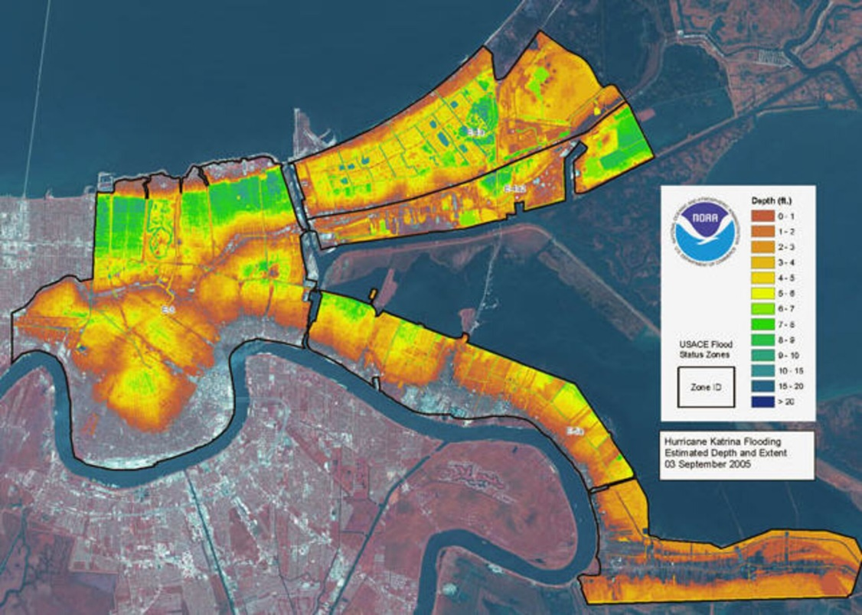

Fig. 7 Lidar map after the Katrina hurricane [29]

1. **SCIENCE ACCOMPLISHMENTS USING LIDAR SENSOR**

**2.1 Combination of low-cost LIDAR sensor and vision sensor**

A method of SLAM is developed by Guolai Jiang, Lei Yin, Shaokun Jin, Chaoran Tian, Xinbo Ma, and Yongsheng OU at the Chinese Academy of Sciences and University of Chinese Academy of Science, which uses light detection and ranging sensor, adopted for robot navigation. [18]. Their paper proposes a “new graph optimization-based SLAM framework through the combination of low-cost LIDAR sensor and vision sensor” [18]. The project will create a 2.5D map, which will include obstacles and vision features and also a fast relocation method with the map.

The experimental robot will be equipped with 360° low-cost LiDar and a front-view RGB-D camera and will be used in a real indoor scene. Their purpose is to demonstrate that the method has better results than using only Lidar or camera.

The SLAM framework based on graph optimization is divided into 2 parts: front-end and back-end, as shown in the following picture: [18]

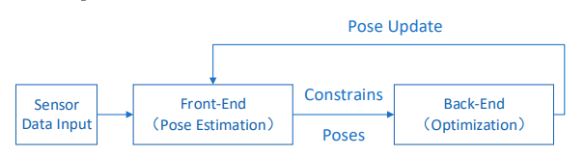

Fig. 8 SLAM framework [18]

The front-end estimates the position of the robot, using information from the sensor, however, this data contains noises (both image and laser data). The noises present in data will lead to cumulative errors in pose estimation, error which will increase with time. The back-end part is responsible to eliminate the errors and improve the positioning of the robot. Also in the back-end, graph optimization will be used, and the error is “minimized by the descending gradient through nonlinear optimization” [18]. This graph optimization describes the problem of optimization in the “form of a graph” [18]. Each node of the graph represents the position and the attitude, and each edge represents the relationship between the position and the attitude [18].

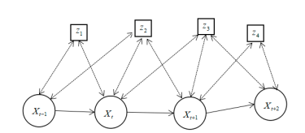

Fig. 9 Graph representation [18]

In this figure, X values represent the position and pose of the robot and Z represents the observation (Z will be a combination between camera and obstacles detected by Lidar).

The SLAM framework of Lidar and vision fusion has a new united error function, which combines visual data-matching error and laser data-matching error. Also, it is used as a loop detection method, to solve the problem of loop detection of tradition Lidar-SLAM.

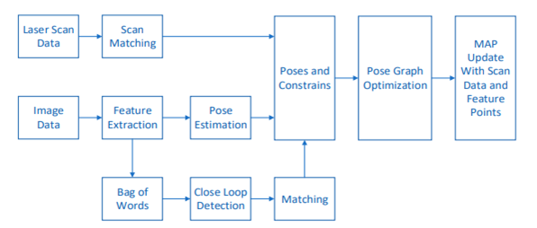

Fig. 10 SLAM framework

2.5D map

In this project, the authors introduces a new concept of 2.5D map, which is based on visual collected data and scan data.

The difference between the traditional grid map and 2.5D map, is that the traditional grid is a simply 2D map that will present the obstacles on the LiDar plane, while the 2.5D map combines obstacle representation on 2D map with other backup features, called feature list, all respresented in 3D space.

The experiment developed is divided into three parts:

* The first part uses a “comparative experiment of fixed-point positioning accuracy” in a small range of scenes. [18]
* The second part uses a large loop experiment to verify the efficiency of the proposed method.
* The third part is used to load the builed map for the relocalization experiment.

As hardware parts, the authors uses a platform based on Turtlebot 2, which will contain the following parts: a notebook, a Lidar( model RPLIDAR-A2) and a RGB-D camera ( model Xtion-pro).

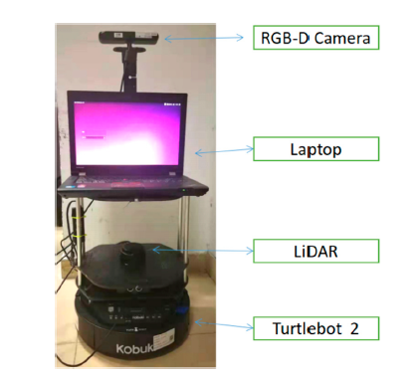

Robot platform

For a better evaluation of the result, the authors used 6 positions: the start point position which is represented with (0,0), the first position represented with (3,0), the second position represented with (6,0), the third position represented with (6,-8), the forth position represented with (6,-16) and the last position represented with (3,-16).

The following table will represent a comparation between the real position, Karto-SLAM and their method.

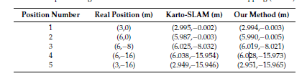

After several experiments, they created the 2.5D map, by comparing the Adaptive Monte Carlo Localization method, orb-SLAM localization method and their proposed method.

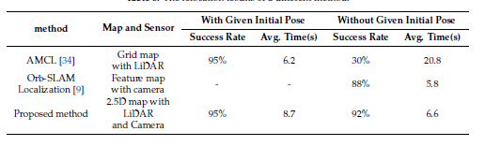

The AMCL method has a success rate of 95%, when the initial pose is given, but has a very small success rate when the initial pose is missing. The orb-SLAM method is capable of fast global relocation, with a fast response time. The method proposed by the authors is faster and has a higher success rate, without the initial pose, in comparation with the above methods.

The second project is developed by I.Maulana, A. Rusdinar and R.A. Priramadhi at School of Electrical Engineering, Indonesia. [1] Their project propose the creation of the LIDAR sensor, using one laser sensor, which will be rotated by a servo-motor. The information read by the sensor will be transformed in Cartesian axes, which will be later used to create the local map and to localize the position.

In order to create the map, several stage of data collection are used:

* Rotation of the sensor using the stepper motor
* Information read by Arduino from LIDAR
* Sending data from Arduino to Matlab, using Bluetooth device.
* Data processing by Matlab and map creation.
* Sending command from Matlab to robot, in order to control the robot.

The flowchart of the project follows the above stages and is presented in the following picture.

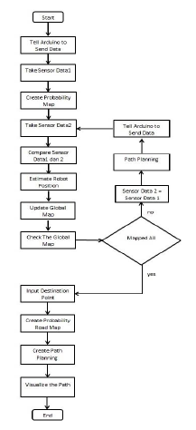

Flowchart[1]

The occupancy grid is represented in tow formats: binary occupancy grid and probability occupancy grid. The binary occupancy grid uaed Boolean values: True values to represent the occupied environment – obstacles and False values represents the free environment – non obstacles. In the probability ocuupancy grid, there are used probability values to create a more presentative map. “This representation is the preferred method for using the Residential grid” [1]. The Residential grid uses cells, and each cell has a value representing the probability of the cell occupancy. If the cell contains an obstacle, the probability value will be close to 1, and if the cell is not occupied, the probability value will be close to 0.

“Probability road map (PRM) is a network graph of paths that may be present in a map determined by a free and unimpeded space.” [1] This map takes random samples from the map and each sample is verified if it’s in an empty cell or occupied cell. After the samples are taken, the local planning is made, and after that each plan will be connected to each other, based on the nearest.

The probability road map has two stages: the construction stage and the second stage determine the shortest path using Dijkstra Algorithm.

Hardware design

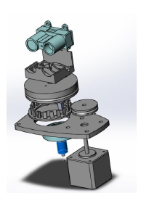

Hardware design [1]

The lidar used in the project is the LIDAR-Lite V3, from Garmin. The conversion from distance and angle data in Cartesian form is made with the following formula: \

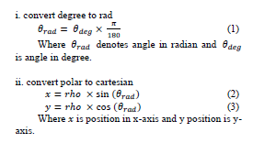

Inside the project, several test are made, in order to show the efficiency of the lidar sensor.

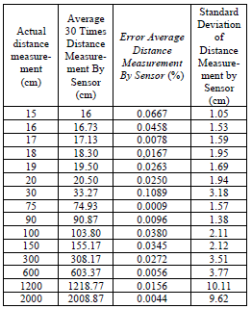

As shown in the above table, the deviation value is increasing same time with the distance value; if the measured distance is smaller, the deviation is small, but if the measure distance has a higer value, the deviation is quite big ( for example for 2000 cm, the deviation is 9.6 cm).

The second test determine the result of reading at a certain angle range.



According to the previous image, the reading of the lidar sensor is close to the actual distance.

The next two tests are made on measuring distance on different surface color, respectively on different surface material.

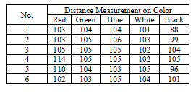

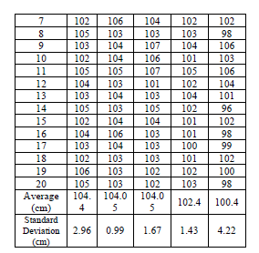

On the color test, it can be seen that each different measurement color har different deviation values, so the color can influence the mapping process. On the other hand, the surface material also influence the measured values.

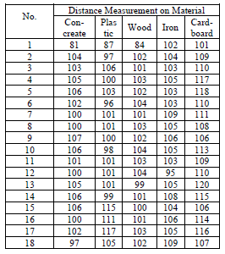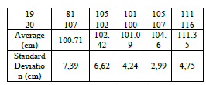

The next test is the visualization of lidar sensor scan result values. The purpose of this test is to see a comparation between the real environment and the result of lidar values.

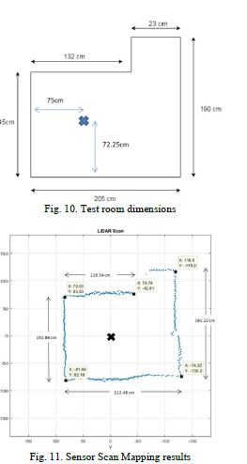

The result is very close to the original map, but also present some “variation of sensor readout error” (where the line is not straight).

The last test represent mapping navigation data from sensor spinner.

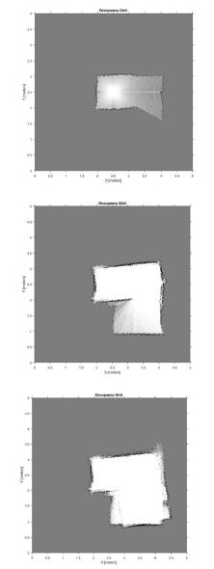

In this test can be seen the error on the visualization of the map, caused by the reading the orientation of the robot. “Because the position and orientation estimation based on current and previous scan data, the resulting error is getting bigger and cause the mapping result the less good can be seen from the visualization result which is getting away from the actual shape at every step of mapping step.” [1]

The tests result shown that Lidar Lite V3 has different standard deviation values, depending on the distance, color, material and angle, deviation which will lead to mapping errors.[1]

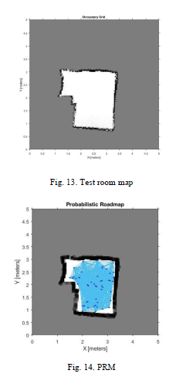 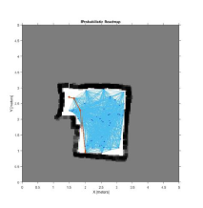

Another interesting project in this field is called "Mobile Robotics Mapping using RP Lidar Scanner"[19] which was done by 4 students from the Perlis University of Malaysia. The project consist of using a low cost LIDAR sensor to track the objects in an indoor environment. After retrieving the distance information from the sensor, 2 algorithms are being used to get rid of eronated values and also to successfully map the environment data (such as fixed objects, etc.).

The LIDAR sensor is called RP LIDAR, and is a low cost LIDAR sensor developed by the Robopeak company. The sensor can scan the environment at a distance of about 6 meters with 360 degrees. Each round of scanning consists of 360 sampling data. The sensor is visible on fig x.y.z



The phisical part consists of a chassis, tires, a motor, a driver, computer(for data processing), a power supply and a wireless transmitter. An image of the robot is displayed in fix x.y.z



Since the project does not have a really big complexity, the scenarios of the program consists of the following:

1) The robot starts at the initial point(have 0,0 values in the x-y coordinate system).

2) The robot starts moving and after the sensor detects an object it stops moving.

3) The robot does a 360 degree scan and save the data received.

4) Depending on the area, the robot moved to a specific direction(forward, to the right, to the left, backwards).

These steps are being repeated untill all the points in the room are being calculated, so that, by the end of the repetition process, we will have all the information regarding the environment.

In order to get rid of the un-necesarry data, 2 algorithms are being used: the raw filter algorithm and smooth method.

Raw filter is an algorithm that removed invalid data."This is not the best solution for image pre-processing, but, it gives simple computation, fast and very practical to a simple mapping application".Since the maximum value is 6m, then all data is mapped to be from 0-6m, discarding all the other data which is above/below this interval.

Another algorithm that is being used is the smooth algorithm.This will ensure that some patterns will be captured from the existing data. "In this study, the smooth filter performs the small correction using the moving average method where the angle results become the input." A graphical comparison of the row data and the data after the smoothing process is being displayed

in FIG x.y.z



"Based on the results, this study shows that the use of the RP Lidar is impressive in terms of its accuracy of scanning.

Most of the trials get 90% above of the scanning accuracy. "

The lidar sensor used in the project is a low cost unidirectional ranging lidar sensor, especially created for Arduino boards, called “Benewake TF Mini micro lidar”. The sensor range varies from 30 centimeters to 12 meters, with long range and high-precision of 1 cm and a very low power consumption.

This sensor principale is based on TOF, namely, Time of Flight principle. [9] This principle is a method for measuring the distance between an object and a sensor, based on the time difference between the emission of a signal and its return to the signal, after being reflected by an object. [10], as shown in the following picture.

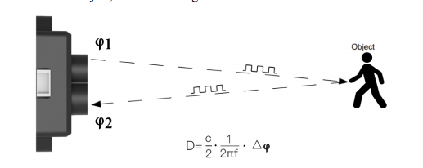

Fig. TOF principle [9]

Characteristic parameters:

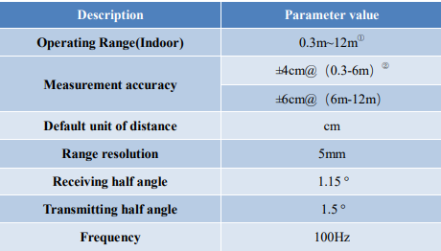

Measurement range of the sensor is affected by the environment illumination intensity and the reflectivity of detection object. [9]. Accordint to TF mini product manual, there are 5 areas of measurement ranges, as follow: [9]

1. The first area is the blind area of the sensor, between 0 cm and 30 cm, in which the data read by the sensor are unreliable.
2. The second range is represented by the extreme condition, which is between 0.3 m and 3m. Extreme condition relate to the outdoor open field, where illumination intensity is aroung 100klux, and detection of black target, where reflectivity is 10%.
3. The third range represent the range for white target under normal sunshine condition, with approximatively 70klux illumination intensity, which includes also the seconde range and is between 0.3 m and 7 m.
4. The forth range is represented by indoor environment, or the range where the ambient light is very low, and consist between 0.3 m to 12m.
5. The last range represent the “minimum side length of effective detection for TFmini at a different distances” [9]. In order for the data to be reliable, the side length of the detection object must be equal or more than the minimum side length. This minimum side length depends on FOV of sensor – FOV refers to the smaller value between the receiving angle and the transmitting angle, and has the following formula:

d = 2*D*tan(beta), where d is the minimum side length of effective detection, D is detection range and beta is the half of the value of the receiving angle of the sensor, 1.15°.

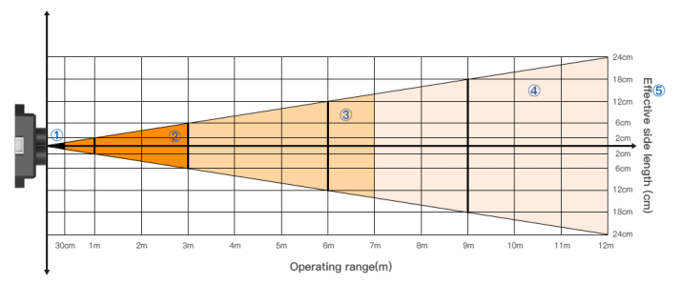

Fig. Schematic of range of distance measurement

Electrical characteristic:

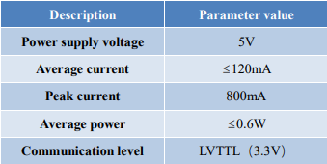

Data communication protocol

The sensor used the serial port communication protocol, as shown in the following picture:

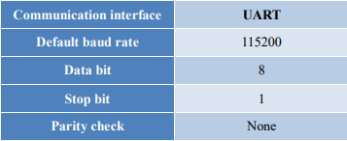

The sensor output came in two format: the standar data output format and Pixhawk data format.

The first one has each data package in 9 byte, which include the header of the package, distance information, signal strength information, distance mode and data check byte (CRC). The format of this data is hexadecimal, and is detailed in the following picture:



Fig. Data format

Data code explanation:

* Byte 0: 0x59 represent the frame header, same for each frame
* Byte 1: 0x59 represent the frame header, same for each frame
* Byte 2: Dist_L represent the lower value of the distance – 8 bits
* Byte 3: Dist_H represent the higher value of the distance – 8 bits
* Byte 4: Strength_L represent the lower value of the strength – 8 bits
* Byte 5: Strength_H represent the higher value of the strength – 8 bits
* Byte 6: Mode represent the distance mode and can be 02 for short distances and 07 for long distances, which is automatically switchable by default.
* Byte 7: Not used, 00 by default
* Byte 8: Checksum represent the cumulative sum of the numbers of the first 8 bytes – 8 bits.

Description of default Output data

* Dist – distance value outputted by the TFmini sensor, with the unit in cm. The value of distance is interpreted into decimal value, in the range of 0-1200 (0 cm-1200 cm). Distance value is influenced by Strength value: if strength is smaller than 20, the value of distance will be consider as unreliable, and the output of distance will be FFFF; if strength is bigger than and the actual value is bigger than 12 meters, the output of distance will be 1200(cm).
* Strength – signal strength with default value in range of 0-3000. Signal strength is influenced by the distances measured but also by the reflectivity, as follows: if the measured distance has a higher value, the signal strength will be smaller; if the value of reflectivity is small, signal strength value will small.
* Mode – it is used to indicate distance mode of the product. The sensor has two modes, namely, 02 and 07, which represent short-distance operating mode and long-distance operating mode. The switch between these mode is made automatically based on the value of the distance; this will also influence signal strength value.

Pixhawk data format is the format of character string and its unit in meters. For example, if the measured distance is 2.74m, the ouput string will be 2.74, followed by the escape character.

Functional overview

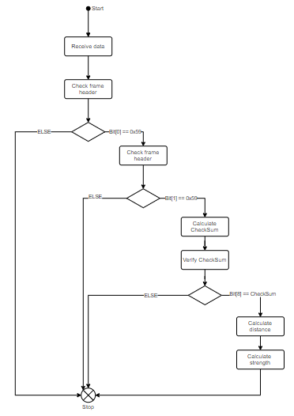

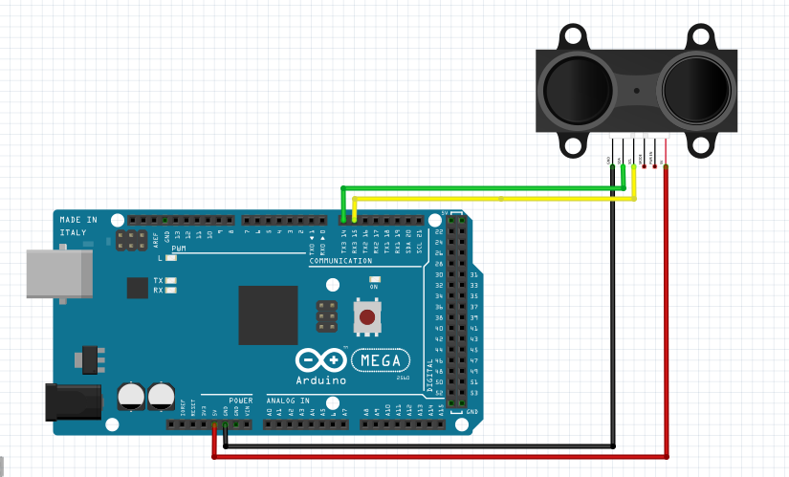

HC-05 Bluetooth Module

Bluetooth technology is a high speed low powered wireless technology link, which is used to connect multiple devices like phones or other portable equipments. [11]. Bluetooth uses UHF radio waves, from 2.402 GHz to 2.480 GHz. [12] The IEEE standardizez Bluetooth as IEEE 802.15.1. [12]

Bluetooth technology is used for short distances, typically up to 10 meters. It allows connection of 8 devices simulatenously, and for each device, it will offer a unique 48 address (according with IEEE 802 standard).

Bluetooth network consist of a Personal Area Network which containing 2 deviced (minimum), usually a master and up to 7 slaves.[11] The operation mode is defined by the following scenario: the master device will sends a radio a message asking for response from one particular slave (using slave addresses); then the slave respond and synchronize their frequency with the master device. [11]

As every communication method, Bluetooth has some specification, defined by “Bluetooth Core Specification working Group – CSWG) [13], which can be splitted in two categories: core specification and profile specification.[11]

* Core specification – this includes the Bluetooth protocol stack and requirements – used for testing Bluetooth based product. This specification can be devide in 5 layers: [11]
  + Radio – include frequency, modulation and power specification
  + Baseband layer – include the definition of channel used: pyshical or logical; link types; definition of packet format; transmit and receive timing; it defined channel control and device addressing.
  + LMP – Link Manager Protocol (LMP) – this establish the procedure for link set up
  + Logical Link Control and Adaptation Protocol (L2CAP) – this layer adapts upper-layer to be baseband layer.
  + Service Discovery Protocol (SDP) – layer used to allow quering Bluetooth devices.

Bluetooth architecture

Bluetooth architecture is mentioned as scattered ad-hoc topology. This topology uses a small cell called Piconet, which include a collection of devices connected in an ad-hoc manner. [14]

Bluetooth devices can be devided in four types[14]:

* Master(M)
* Slave(S)
* Stand By(SB) – Stand by device is waiting to join the bluetooth network meanwhile it saves its MAC address in the network.
* Parked/hold(P) Parked device is waiting to join the bluetooth network later meanwhile and after that release its MAC address.

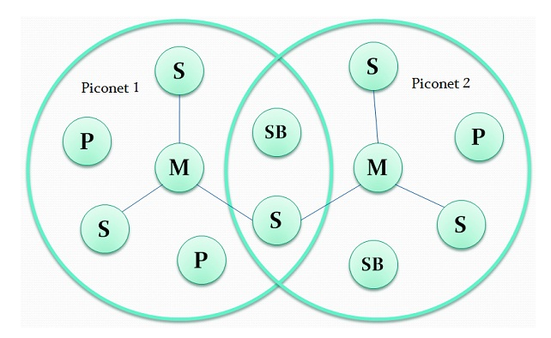

Bluetooth states [14]

Physical connection

The physical connection between a Bluetooth device and a nominal antenna power is realized via FHSS – frequency hopping spread spectrum modem. The power of the nominal antenna establishe the coverage of the Bluetooth signal: if the power is 0 dB the coverage will be 10 meters and if the power is 20dB the coverage will be 100 meters.

Security

The Bluetooth security is devided in[14]:

* 128 bit long random number
* 48-bit MAC address of devices
* Two keys – authentication (128 bits) and encryption (8 to 128 bits).

Bluetooth vs wireless technology

The main differences between Bluetooth network and wireless network is defined in the following table[14]:

|  |  |  |
| --- | --- | --- |
|  | BLUETOOTH | WIFI |
| Bandwitdh | Low | High |
| Range | 10 meters | 100 meters |
| Security | Less secure | Security features are better |
| Power consumption | Low | High |
| Frequency range | 2.4 GHz and 2.483 GHz | 2.4 GHz and 5 GHz |
| Flexibility | Limited number of users | Large number of users |
| Modulation techniques | GFSK (Gaussian frequency shift keying) | OFDM (Orthogonal frequency division multiplexing) and QAM (Quadrature Amplitude Modulation) |

Bluetooth HC-05 is a Serial Port Protocol Bluetooth module, which use serial communication (UART) which allows a very easy interface with the controller or with a PC. [15] This module has two modes: order response work and automatic connection work mode [16].

In the automatic connection work mode it will use the default way to transmit data automatically. In the order-response work mode, the command AT can be sent by the user to the module to set the control parameters. The switch between those modes can be dove by controlling the module PIN – PIO11 input level.

This module can be used in multiple applications, like wireless communication between two microcontroller, communication with PCs, data logging application, wireless robot or home automation. [17]

The default baud rate is 9600, with the default communication as “slave” and the default mode as automatic connection mode.

The typical sensitivity is -80dBm and the transmit power is up to +4dBm.

As hardware specification, the HC-05 module has a power operation voltage between 4V and 6V, operating current of 30mA, with an integrated antenna and edge connector. The module is follwos IEEE 802.15.1 standardized protocol, using FHSS (Frequency-Hopping Spread Spectrum) The module security is based on a password, which has the default value as “1234” or “0000”.

Pin description

The HC-05 bluetooth module is equipped with 6 pins: ENABLE, VCC, GND, TXD&RDX, STATE and button switch, one led and one buttons.

* Enable pin is used to toggle between automatic connection mode and order response mode (AT). To enter connection mode, the pin value should be set to low. The default value of the pin is low.
* VCC pin is used to supply the module. This pin should be connected to +5V voltage.
* GND pin is used to connect the module to the system ground.
* TX transmitter pin is used to transmit serial data outputted by the Bluetooth module.
* RX receiver pin is used to receive serial data broadcasted via Bluetooth module.\
* State pin is connected to on board LED and is regularry used to check if Bluetooth is working properly.
* LED indicates the Bluetooth status and has 3 possible functionalities:
  + Blink once in 2 seconds which means that the module is in “command mode”.
  + Repetead blinking which means that the module Is waiting for connection in “connection mode”.
  + Blink twice in 1 seconds which means that the module is connected successful in “connection mode”.
* Button it controls the enable pin, to switch from “connection mode” to “AT mode”. [17]

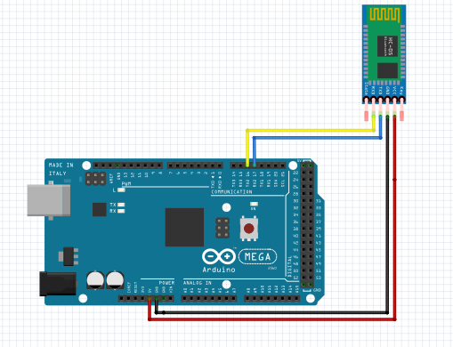

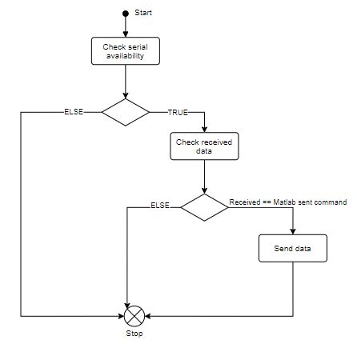

ARDUINO MEGA

Arduino MEGA is a microcontroller from ATmega family, based on ATmega2560 microchip, with a lot of pins and functionalities [30], who is one of the most popular development board, including small project but also big project, all due to its high capabilities.

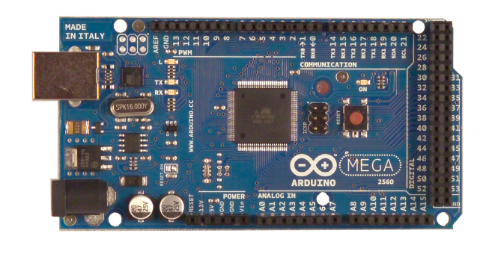

Fig. [30]

Arduino Mega has a lot of features to offer, which include a lot of pins (analog and digital), multiple hardware serial ports and a 16 MHz crystal oscillator. To all this features is added a flash memory of 256 KB for storing the code, from which 8 KB are used by the bootloader, a SRAM of 8KB and an EEPROM of 4 KB.

Arduino Mega inputs and outputs can be categorized in the following pins: [30]

* 54 Digital pins – which can be used to read/write digital signals.
* 16 Analog pins – which can be used to read/write analog signals.
* AREF – which can be used to change the reference voltage for the analog pins.
* Reset – which can be used to reset the microcontroller.

Some of the digital pins can have some extra functions:

* 14 PWM pins - which can be used to generate PWM signals.
* 4 Hardware serial ports – which can be used to receive and transmit TTL serial data. Serial0 of the microcontroller it is also connected to the corresponding pins of the ATmega USB-to-TTL Serial chip.
* External interrupts – which can be used to trigger an interrupt on a rising or falling edge, a low value or a change in value on the corresponding pin.
* SPI – which can be used for SPI communication.
* LED – which can be used to trigger the build-in led on the controller.
* I2C – which can be used for I2C communication.

Analog pins provides a 10 bits of resolution and by default the pins measure 5V. As an exception, this value can be changes using AREF pin and analogReference() function. [30]

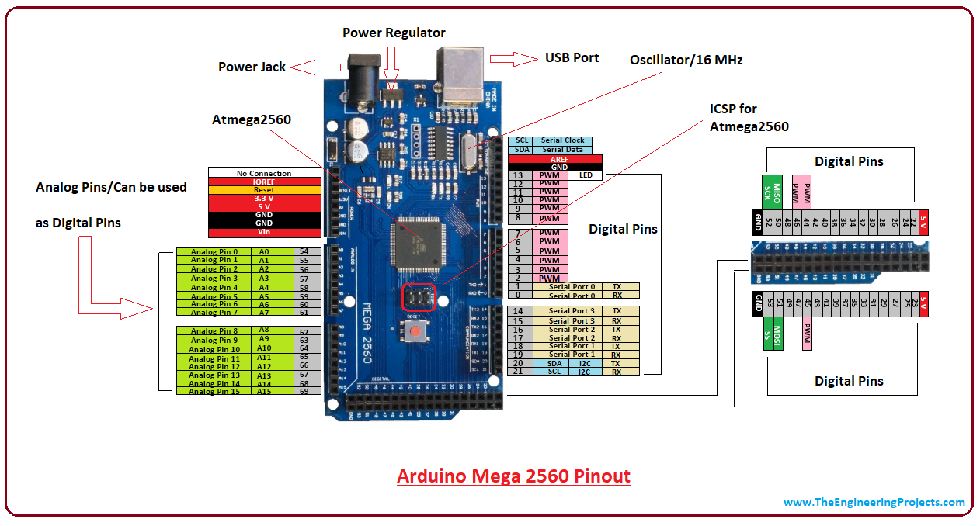

Fig. [31]

Arduino Mega specification:

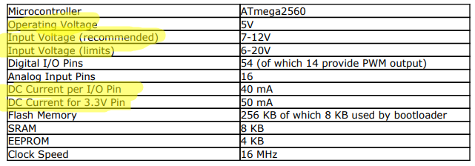

Arduino Mega programming

Arduino Mega can be programmed using Arduino IDE(Integrated Development Environment) software. The chip on Arduino Mega came with a preburned booloader, which will allow the user to upload the software on the board without using an external hardware programmer. The communication uses original STK500 protocol. [30]

Arduino IDE is a cross-platform application, writted in Java and which has its own origins in development tool called “Procesing” and project “Wiring”. This application uses a simplified version of C++ language, which increase the easiness of programming, but still kipping the possibility to develop large and complex applications.

This IDE uses the concept of “Sketches”, being a standard place to save software code. The basic structure of an application includes two parts: the setup part, which is called only once, in the inisialization phase, where all pins and communication must be initialized, and the second part which is executed repeatedly, until Arduino board voltage is disabled.   
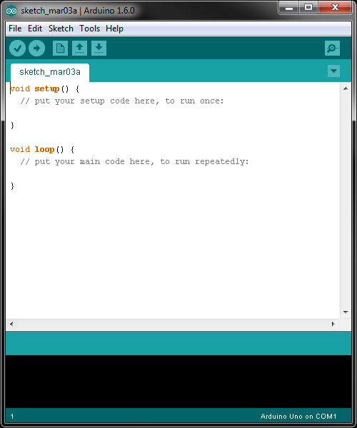

Matlab

Matlab is a high-level language programming environment, with an interactive view and which can be used for numerical computation visualization and programming. [32] MATLAB, short from MATrix LABoratory [33] is design for quick and easy calculation, data analisis, develop algorithms and creates models and applications. Matlab was originally writted have a easy access to matrices and arrays, developed by the LINPACK – linear system package and EISPACK – eigen system package projects. Still, Matlab has become a very used programming tool, because of its modern environment, which includes sophisticate data structures, debugging tools and build-in editing and also support OOP – object oriented programming.

The big advantage of MATLAB, in comparison with C language or other convetional computer language, is the ability to solve technical problems. The basic element which makes Matlab better than the convetional language is the ability to use an array without specifying its dimension.

The matlab system can be divided in five main parts[34]:

* *Development environment* – this is the graphical user interfaces, which is divided in multiple sub-windows:
  + The command windows
  + The workspace
  + The current directory
  + The editor windows
  + Browser – is used for viewing help

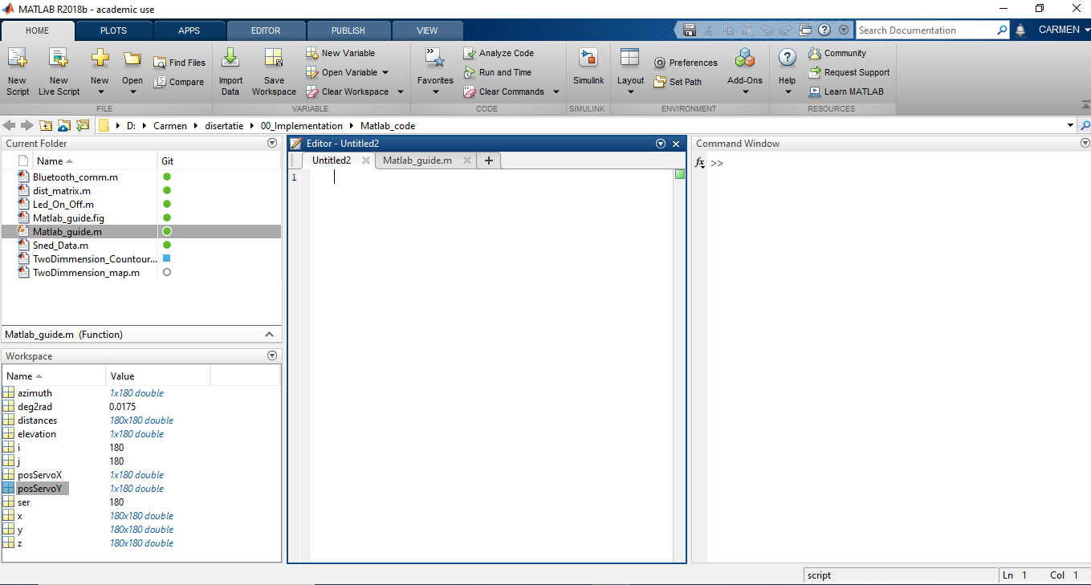

* Matlab Mathematical function library – this includes elementary mathematic functions, like sum, sine, cosine but also contains complex arithmetic, like matrix inverse, Bessel functions, Fourier transforms and so on.
* Matlab language – this includes the matrix/array language, input/output features, functions, data structures and obiect-oriented programming features.
* Graphics – this is used for displaying vectors and matrices as graphs, as well as other operation with graphs, like annotating and printing.
* Matlab external interfaces/API – this is a library which allows the user to combine C programs with Matlab programs. This facilities the interaction between Matlab and C, by calling routine from Matlab.

**APPLICATION**

In order to apply all information and techniques presented earlier, I develop an autonomous robot, which uses a low cost lidar, in order to create a 2D and 3D map, and also avoid obstacles.

This paper is divided in two part: hardware part and software part.

1. Hardware part

This part will present all hardware components used at robot creation, and will also include explanation of functionalities and methods used.

The following components were used:

1. Robot chassis
2. Motor shield
3. Lidar sensor
4. Batteries
5. Arduino

[1] - LIDAR Application for Mapping and Robot Navigation on Closed Environment – PDF

[2] - <https://en.wikipedia.org/wiki/Robotic_mapping>

[3] - <http://robots.stanford.edu/papers/thrun.mapping-tr.pdf>

[4] - <https://ri.cmu.edu/pub_files/2009/1/thesis_revision_2009_02_13.pdf>

[5] - <https://en.wikipedia.org/wiki/Robot_navigation>

[6] - master_thesis_benjamin_mader%20(3).pdf

[7] - <https://oceanservice.noaa.gov/facts/lidar.html>

[8] - <https://levelfivesupplies.com/100-real-world-applications-of-lidar-technology/>

[9] - <https://cdn-shop.adafruit.com/product-files/3978/3978_manual_SJ-PM-TFmini-T-01_A03ProductManual_EN.pdf>

[10] - <https://www.terabee.com/time-of-flight-principle/#:~:text=Time%2Dof%2DFlight%20Principle,being%20reflected%20by%20an%20object.>

[11] - <https://www.elprocus.com/how-does-bluetooth-work/#:~:text=A%20Bluetooth%20technology%20is%20a,over%20short%20distance%20without%20wires.>

[12] - <https://en.wikipedia.org/wiki/Bluetooth>

<https://learn.sparkfun.com/tutorials/tfmini---micro-lidar-module-hookup-guide/all>

[13] - <https://en.wikipedia.org/wiki/Bluetooth#Specifications_and_features>

[14] - <https://techdifferences.com/difference-between-bluetooth-and-wifi.html>

[15] - <https://www.gme.cz/data/attachments/dsh.772-148.1.pdf>

[16] - <http://www.linotux.ch/arduino/HC-0305_serial_module_AT_commamd_set_201104_revised.pdf>

[17] - <https://components101.com/wireless/hc-05-bluetooth-module>

[18] - file:///D:/Carmen/disertatie/02_Researches/applsci-09-02105.pdf

[19] - 04_paperiris-rplidarscannerformappingapplications

[20] - <http://www.arreverie.com/blogs/introduction-simultaneous-localisation-and-mapping/>

[21] - <https://en.wikipedia.org/wiki/Simultaneous_localization_and_mapping>

[22] – p1_4_7.pdf

[23] - <https://www.cs.cmu.edu/~16831-f14/notes/F14/16831_lecture06_agiri_dmcconac_kumarsha_nbhakta.pdf>

[24] - <https://www.researchgate.net/figure/Topological-Mapping-a-Building-map-of-sections-A-with-robot-following-two-different_fig22_269573252>

[25] - <https://en.wikipedia.org/wiki/Concept_map>

[26] - <https://link.springer.com/referenceworkentry/10.1007%2F978-0-387-31439-6_52>

[27] - file:///C:/Users/Alin/Downloads/NOV152937.pdf

[28] - <https://www.lumitex.com/blog/lidar-technology>

[29] - <http://www.esa.int/ESA_Multimedia/Images/2012/01/LIDAR_map_of_New_Orleans_flooding_caused_by_Hurricane_Katrina_3_September_2005>

[30] - <https://www.robotshop.com/media/files/pdf/arduinomega2560datasheet.pdf>

[31] - <https://www.theengineeringprojects.com/2018/06/introduction-to-arduino-mega-2560.html>

[32] - <https://www.bu.edu/tech/files/2017/01/intro_matlab_2017Spring.pdf>

[33] - <https://web.stanford.edu/class/cme001/handouts/matlab.pdf>

[34] - <https://www.mn.uio.no/astro/english/services/it/help/mathematics/matlab/getstart.pdf>