TFMini – micro Lidar Module

<https://learn.sparkfun.com/tutorials/bi-directional-logic-level-converter-hookup-guide/all>

The [TFMini](https://www.sparkfun.com/products/14588) is a ToF (Time of Flight) LiDAR sensor capable of measuring the distance to an object as close as 30 cm and as far as 12 meters!

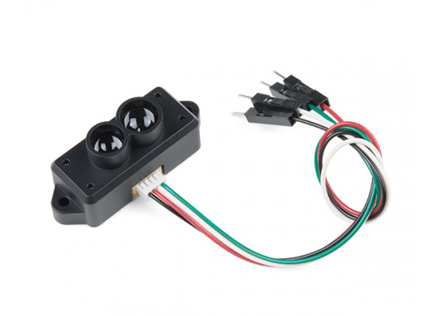

The sensor works by sending a modulated near-infrared light out. The light that is reflected from the object returns to the sensor's receiver. The distance between the two can be converted using the sensor by calculating the time and phase difference. The distance measured may vary depending on the environment and the reflectivity of object.

While the sensor can be powered at 5V, the serial UART pins are only **3.3V logic**. Make sure to use a logic level converter when reading the sensor with a 5V microcontroller.

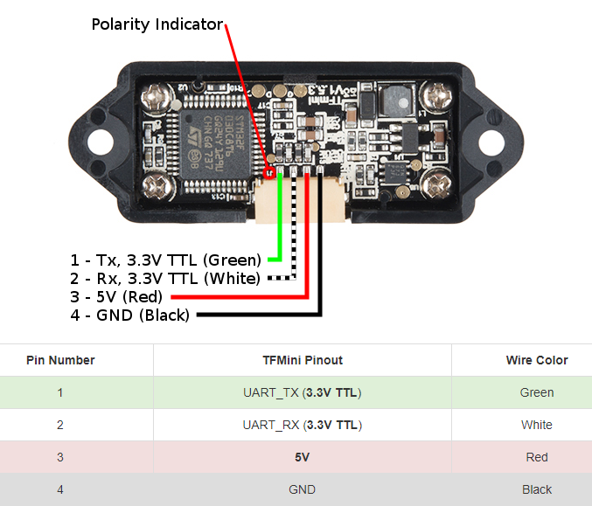

For the purpose of this tutorial, we will be using a 5V Arduino. A microcontroller and logic level converter is required in order to read the sensor values through the serial UART pins. Make sure to [solder](https://learn.sparkfun.com/tutorials/how-to-solder-through-hole-soldering) the [male header pins](https://www.sparkfun.com/products/116) to the converter before making the connections on a breadboard. Begin by making a connection from an Arduino's high side and following the connection to the TFMini. Then continue to make the rest of the connections by following the hookup table listed below.

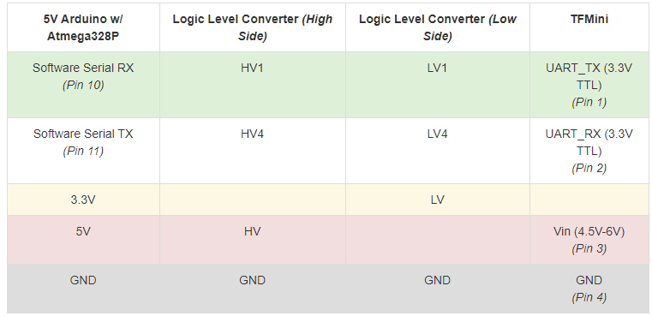

Download and install Peter Jansen's **Arduino TFMini library** using the library manager. You can also manually install it from the [GitHub Repository](https://github.com/opensensinglab/tfmini) by downloading the library from the button below.

Grab a mini-USB cable and connect the Arduino to your computer. Upload the **BasicReading.ino** that was included in the library's examples to your Arduino. Make sure to use the correct COM port and board selection.

Once uploaded, try moving an object in front of the sensor to test. In the example below, a third hand was used to hold the TFMini when detecting an object at a certain distance away from the sensor. Since the sensor is not able to detect an object when less than 11.8 inches (or 30cm = 0.3m) away, the object under test was placed at 20 inches and 30 inches.

Opening the [serial monitor](https://learn.sparkfun.com/tutorials/terminal-basics/arduino-serial-monitor-windows-mac-linux) at **115200**