transceiver nrf24l01

 It uses the 2.4 GHz band and it can operate with baud rates from 250 kbps up to 2 Mbps. If used in open space and with lower baud rate its range can reach up to 100 meters.

The module can use 125 different channels which gives a possibility to have a network of 125 independently working modems in one place. Each channel can have up to 6 addresses, or each unit can [communicate with up to 6 other units at the same time](https://howtomechatronics.com/tutorials/arduino/how-to-build-an-arduino-wireless-network-with-multiple-nrf24l01-modules/).

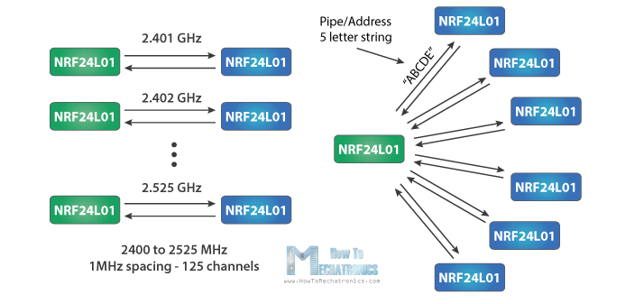

**The operating voltage of the module is from 1.9 to 3.6V**, but the good thing is that the other pins tolerate 5V logic, so we can easily connect it to an Arduino without using any logic level converters.

**Three of these pins are for the SPI communication and they need to be connected to the SPI pins of the Arduino, but note that each Arduino board have different SPI pins. The pins CSN and CE can be connected to any digital pin of the Arduino board and they are used for setting the module in standby or active mode, as well as for switching between transmit or command mode. The last pin is an interrupt pin which doesn’t have to be used.**

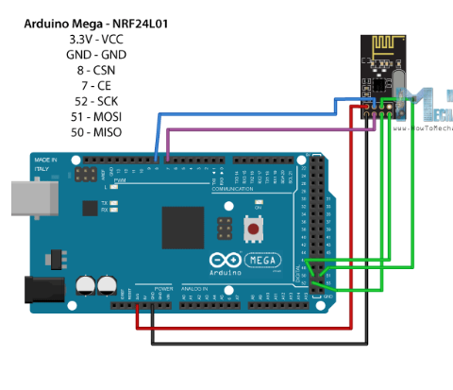

<https://howtomechatronics.com/tutorials/arduino/arduino-wireless-communication-nrf24l01-tutorial/>