Lab 5 – Homework

Deadline – week 11

No. | Assignment
1. | We have a file that contains the first N natural numbers ordered. Let Pi a process that eliminates all multiples of i from the interval 2 to N given. Using a suitable number of Pi processes, write a program that determines all prime numbers between 1 and N given.
2. | A natural number is perfect if it is equal with the sum of all its divisors not including the number itself. Write a program that uses an adequate number of processes to determine all the perfect numbers smaller than N given.
3. | We have a file that contains N integer numbers. Using two types of processes (one for determining the minimum and the other to determine the maximum value from an array), write a program that determines the kth element in increasing order of the integer array, without sorting the array.
4. | Given Pi a process that checks if i is a divisor of a number N given, and determines the multiplicity order of this divisor. Launch a suitable structure of such processes to decompose the number N given in prime factors.
5. | Given P a process that calculates the greatest common divisor (gcd) of two numbers. Using a suitable structure of such processes, write a program that determines the gcd of N given numbers.
6. | Given Pi the process that determines the frequency of occurrences of letter i in a given text. Write a program that uses such processes to print a statistic of frequency for each letter occurrence.
7. | An array of numbers is given. Calculate the sum of the cubes of these numbers such that the cube of each number is calculated by a separate process.
8. | The following arithmetic expression is given (a+b*c) / (a-b+d-c) + a*b*c*d. Write a program that determines the value of this expression, such that each arithmetical operation is executed by a separate process.
9. | An array of numbers is given x1, x2, ..., xn. Compute the partial sums x1, x1+x2, x1+x2+x3, ..., x1+x2+...+xn, using a separate process for each partial sum.
10. | An array of letters is given. Using a separate process for each vowel, delete all vowels from the array.
11. | Given the Polynomic A=(a0, a1, ...,an). Compute the value of A for an x, using Horner formula and several processes. For example: a0+a1*x+a2*x² can be computed:  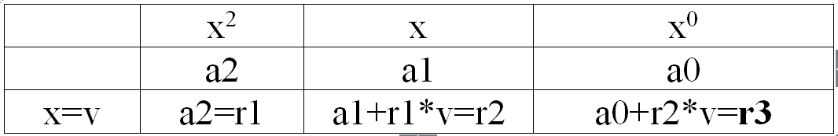
12. | Compute the sum of an array of numbers using divide et impera method: a process splits the array in two sub-arrays and gives them to two other chid processes to compute their sums, then adds the results obtained. The child processes use the same technique (split, etc. …).
13. | Calculate the product of an array n of numbers using divide et impera method: a process splits the array in two sub-arrays and gives them to two other chid processes to compute their product, then multiplies the results obtained from the two. The two child processes apply the same technique (split, etc…).

