SheDrive – Business requirement document
By Arcorp Team

May-2026

Contents
1. Document Control 4
1.1 Document Purpose 4
1.2 Intended Audience 4
1.3 Document Conventions 4
1.4 Version History 5
1.5 Authors & Reviewers 5
1.6 Approval & Sign-off 5
2. Executive Summary 6
2.1 Background 6
2.2 Business Problem Statement 7
2.3 Proposed Solution Overview 7
2.4 Expected Benefits 8
2.4.1 Benefits for Riders 8
2.4.2 Benefits for Drivers 8
2.4.3 Benefits for Operations & Administration 8
2.4.4 Benefits for Management & Decision-Makers 8
2.4.5 Business & Market Benefits 9
2.5 High-Level Out-of-Scope 9
3. Glossary & Definitions 10
3.1 Business Terms 10
3.2 Acronyms & Abbreviations 12
3.3 Actor Definitions 14
4. Project Overview 15
4.1 Project Vision 15
4.2 Project Objectives 15
4.3 Stakeholders & Actors 16
4.3.1 Internal Stakeholders 16
4.3.2 Primary Users 16
4.3.3 External Service Providers 16
4.4 Project Assumptions 17
4.4.1 Business & Market 17
4.4.2 Users & Identity 17
4.4.3 Payments & Financial 17
4.4.4 Language & Localization 17
4.4.5 Operations & Reporting 18
4.4.6 Integrations & Dependencies 18
4.5 Project Constraints 18
4.5.1 Scope & Delivery 18
4.5.2 Market & Geographic 18
4.5.3 User & Eligibility 18
4.5.4 Payment & Financial 18
4.5.5 Operational & Reporting 18
4.5.6 Regulatory & Compliance 19
4.5.7 Time & Resource 19
4.5.8 Operating Hours 19
4.6 Dependencies 19
4.6.1 External Services 19
4.6.2 Regulatory & Compliance 19
4.6.3 Business & Operational 19
4.6.4 Stakeholder & Decision 19
4.6.5 External Readiness 20
5. Business Scope 20
5.1 In-Scope for MVP 20
5.1.1 Rider App 20
5.1.2 Driver App 20
5.1.3 Admin & Operations Portal 20
5.1.4 Identity & Verification 21
5.1.5 Payments (Cash + Digital) 21
5.1.6 Trip & Dispatch Engine 21
5.1.7 Pricing & Neighborhood Zones 21
5.1.8 Safety & SOS 21
5.1.9 Notifications 21
5.1.10 Reporting & Analytics 21
5.2 Out-of-Scope for MVP 22
5.2.1 Service & Ride Variations 22
5.2.2 Payment & Financial Capabilities 22
5.2.3 Advanced User & Account Features 22
5.2.4 Advanced Safety & Intelligence 22
5.2.5 Analytics & BI 22
5.2.6 Operations & Platform Extensions 22
5.2.7 Technical & Implementation 23
5.3 Target Users 23
5.3.1 Female Riders 23
5.3.2 Female Drivers 23
5.3.3 Operations & Administration Users 23
5.3.4 Management & Decision-Making Users 23
5.3.5 External Service Actors 23
6. Solution Overview (Module Architecture) 24
6.1 Module Map 24
6.2 Module Summaries 25
6.2.1 Rider App 25
6.2.2 Driver App 25
6.2.3 Admin & Operations Portal 26
6.2.4 Identity & Verification 26
6.2.5 Payments (Cash + Digital) 26
6.2.6 Trip & Dispatch Engine 26
6.2.7 Pricing & Neighborhood Zones 27
6.2.8 Safety & SOS 27
6.2.9 Notifications 27
6.2.10 Reporting & Analytics 27
6.3 Module Interaction Overview 28
7. Functional Requirements (MVP) 28
7.0 Reading Guide 28
Priority Definitions 28
Priority Distribution 29
7.1 Rider App 30
7.2 Driver App 34
7.3 Admin & Operations Portal 38
7.4 Identity & Verification 42
7.5 Payments (Cash + Digital) 44
7.6 Trip & Dispatch Engine 46
7.7 Pricing & Neighborhood Zones 47
7.8 Safety & SOS 48
7.9 Notifications 50
7.10 Reporting & Analytics 51

1. Document Control

1.1 Document Purpose
This Business Requirements Document (BRD) defines the business context, objectives, scope, stakeholders, and high-level functional expectations for the SheDrive platform — a women-only ride-hailing service designed for the Egyptian market. The document serves as the authoritative reference for stakeholders, decision-makers, and project teams to ensure shared understanding and alignment on business needs prior to High-Level Design (HLD), Low-Level Design (LLD), and implementation.
The BRD establishes:
- A common understanding of the business problem and proposed solution.
- The agreed scope, boundaries, and target users for the MVP.
- The business rules, scenarios, and process flows that the system must support.
- A foundation for downstream technical design, estimation, and delivery planning.
- A reference point for evaluating change requests and scope variations during execution.
This document is non-technical in nature. It does not specify system architecture, technology stack, integration mechanisms, or implementation details. These are addressed in the High-Level Design document.

1.2 Intended Audience
This BRD is intended for the following audiences:
- Business Sponsor & Executive Leadership — for approval, strategic alignment, and investment decisions.
- Product & Business Stakeholders — to validate the business problem, scope, and expected outcomes.
- Operations & Compliance Teams — to confirm operational and regulatory expectations are reflected.
- Project Management — for planning, scheduling, and stakeholder coordination.
- Engineering & Solution Architects — as input for High-Level Design and technical decision-making.
- Quality Assurance & Acceptance Teams — as the basis for acceptance criteria and validation activities.
- External Reviewers — for legal, financial, or regulatory review where applicable.

1.3 Document Conventions
The following conventions are used throughout this document:
- Shall / Must — denotes a mandatory business requirement.
- Should — denotes a recommended requirement that may be negotiated.
- May / Could — denotes an optional or future-phase requirement.
- MVP — refers exclusively to the scope defined in 5.1.
- Out-of-Scope — refers to items explicitly excluded from MVP delivery (5.2).
- Section references use the format X.Y (e.g., 5.1).
- Actor names (Rider, Driver, Administrator, etc.) are capitalized when referring to defined system roles.
- All monetary values are expressed in Egyptian Pounds (EGP) unless otherwise stated.
- All times are expressed in local Egyptian time (EET / EEST).

1.4 Version History
Version | Date | Author | Description
1.0 | 22/01/2026 | Mohamed Talaat – Senior Head of Engineering | Initial BRD
1.1 | 22/04/2026 | Abdelrahman Mamdouh | Updated Scope
1.2 | 06/05/2026 | Abdelrahman Mamdouh | Added section 9, 10 and 11.
1.3 | 22/06/2026 | Abdelrahman Mamdouh | Scope update: added scheduled rides; replaced automated identity verification with manual Administrator review and Driver visual verification; reduced Safety & Live Trip Sharing to live trip sharing with trusted contacts; single Administrator role; list-driven dispatch; global-only commission; revised child-ride and in-trip-communication rules; rider 18 / driver 21.

1.5 Authors & Reviewers
Authors
- Abdelrahman Mamdouh, Senior Product Owner, ARCorp
Reviewers
Name | Role | Organization | Review Scope
[TBD] | [TBD] | [TBD] | [TBD]

1.6 Approval & Sign-off
This document requires formal approval before transitioning to High-Level Design. By signing below, approvers confirm that the business requirements, scope, rules, and scenarios described herein are accurate and complete to the best of their knowledge, and that delivery may proceed on this basis.
Approver Name | Role | Date | Signature
[TBD] | Business Sponsor
[TBD] | Product Owner
[TBD] | Head of Engineering
Subsequent material changes to the approved baseline are managed through a formal change request process and require re-approval by the original approvers or their delegates.

2. Executive Summary

2.1 Background
Urban mobility services have become essential in Egypt's major cities, with ride-hailing platforms serving millions of trips each month. Despite the maturity of this market, existing platforms are designed as general-purpose mobility services and are not specialized for the safety, trust, and cultural needs of women and families.
A meaningful segment of female passengers in Egypt expresses hesitation about using mixed-gender ride-hailing services — particularly during late hours, in unfamiliar areas, or when accompanied by children. These concerns are amplified by:
- Limited gender-specific eligibility controls.
- Inconsistent identity verification standards.
- Absence of dedicated child-friendly ride policies.
- Lack of transparent emergency handling procedures.
In parallel, many qualified Egyptian women are willing to participate in the ride-hailing economy as drivers but face the same gender-related concerns as riders, limiting supply on the driver side.
This combination — under-served female demand and constrained female supply — creates a clear and addressable market gap.
SheDrive is conceived as a women-only ride-hailing platform that addresses this gap directly. Both riders and drivers are women, children under the age of 12 are explicitly permitted under defined safety rules, and the platform supports both Arabic and English from launch.
The initial release is structured as a Minimum Viable Product (MVP) with full ride-cycle capabilities — sufficient to validate market demand, prove operational viability, and inform a phased growth plan. The MVP is targeted at a defined neighborhood-based footprint within Greater Cairo (Cairo and Giza) and supports both cash and digital payments to align with local market behavior. The platform launches with daytime-only operating hours; expansion to 24/7 operation is planned for a subsequent phase, contingent on safety performance and operational readiness.

2.2 Business Problem Statement
Existing ride-hailing platforms in Egypt do not adequately serve the safety, trust, and comfort expectations of women and families. The resulting gaps create both a user experience deficit and an underserved commercial opportunity.
For female riders:
- Personal safety concerns when riding alone, particularly outside daylight hours.
- Limited assurance regarding driver identity, eligibility, and conduct.
- No purpose-built support for traveling with young children.
- Lack of clear, immediate emergency mechanisms during trips.
For female drivers:
- Reluctance to operate within mixed-gender platforms.
- Concerns about rider conduct and safety incidents.
- Limited platforms that align with cultural and family expectations.
For the business and the market:
- Significant unmet demand among female passengers and families.
- Underutilized supply potential of qualified female drivers.
- Absence of standardized safety, identity, and child-ride policies in the local market.
- Limited operational visibility into trips, cancellations, and safety events on existing platforms.
A purpose-built, women-only mobility platform — with strict eligibility, identity assurance, child-ride support, dual payment rails, and operational accountability — addresses these gaps in a focused and commercially viable way.

2.3 Proposed Solution Overview
SheDrive is a women-only ride-hailing platform serving female riders and female drivers in Greater Cairo (Cairo and Giza), with explicit support for children under the age of 12 under defined safety and eligibility rules.
The MVP is structured around ten business modules covering the full ride cycle:
- Rider App — registration, booking, ride scheduling, tracking, payment, safety, and feedback.
- Driver App — onboarding, availability, ride handling, navigation, earnings, and safety.
- Admin & Operations Portal — back-office for ops, support, finance, and compliance.
- Verification & Onboarding — driver document submission and Administrator review.
- Payments (Cash + Digital) — dual payment rails with cash reconciliation.
- Trip & Dispatch Engine — matching, lifecycle, and real-time location.
- Pricing & Neighborhood Zones — polygon-based zone configuration and per-zone fare rules.
- Safety & Live Trip Sharing — trusted contacts and live trip sharing.
- Notifications — SMS, push, in-app, and email communications.
- Reporting & Analytics — operational dashboards and management reporting.
The platform is delivered on three primary surfaces:
- A native Rider mobile application.
- A native Driver mobile application.
- A web-based Administration & Operations portal.
The MVP is positioned as a market-validation release: full enough to support real daily operations, intentionally constrained enough to deliver and learn. Drivers operate their own vehicles (the platform does not provide a fleet), and the platform runs within a daytime-only operating window at launch. More advanced capabilities — including extended ride types, automated payouts, advanced analytics, 24/7 operation, and broader geographic expansion — are deferred to subsequent phases.

2.4 Expected Benefits

2.4.1 Benefits for Riders
- A dedicated, women-only environment that addresses cultural and safety expectations.
- Clear, enforceable identity and eligibility rules for drivers.
- Purpose-built support for traveling with children under 12.
- Transparent ride status, fare breakdown, and emergency mechanisms.
- Choice of payment method (cash or digital) aligned with local preferences.

2.4.2 Benefits for Drivers
- A trusted, female-only working environment with reduced exposure to mixed-gender risks.
- Clearly defined onboarding, eligibility, and ride rules.
- Transparent earnings, commission, and cash settlement processes.
- Tools and protocols that prioritize driver safety on equal footing with rider safety.
- A practical participation path for women who would otherwise stay outside the ride-hailing economy.

2.4.3 Benefits for Operations & Administration
- Centralized visibility into riders, drivers, active trips, and incidents.
- Standardized handling of cancellations, safety events, and disputes.
- Configurable pricing and cancellation rules at the neighborhood level.
- Reduced operational ambiguity through clearly defined business rules.
- Faster, auditable response to incidents and exceptions.

2.4.4 Benefits for Management & Decision-Makers
- Foundational reporting to monitor operational health and safety performance.
- Insight into demand patterns by neighborhood and time of day.
- Clear basis for evaluating MVP success and planning subsequent phases.
- A controlled environment to test business model assumptions before broader investment.

2.4.5 Business & Market Benefits
- Differentiated positioning in a crowded ride-hailing market.
- Access to underserved demand and supply segments.
- Brand trust as a structural advantage rather than a marketing claim.
- A controlled, measurable MVP launch with manageable risk.
- A platform foundation that scales to broader geographies and capabilities.

2.5 High-Level Out-of-Scope
To preserve focus and a deliverable timeline, the following items are explicitly excluded from the MVP and may be considered in subsequent phases:
- Ride pooling, shared rides, and recurring rides.
- Intercity, long-distance, hourly, and rental ride models.
- Multiple service tiers (e.g., economy, premium, family-plus).
- In-app rider or driver wallets.
- Automated driver payouts and settlement.
- Promotional codes, discounts, referrals, and loyalty programs.
- Corporate, enterprise, and family / multi-user accounts.
- Subscription pricing models.
- AI-driven safety scoring, behavioral analytics, and predictive modeling.
- In-trip audio or video recording.
- Full Business Intelligence (BI) platform and ad-hoc analytical dashboards.
- Marketing campaign management tools.
- Dispatcher / call-center based booking.
- Multi-country or multi-currency operation.
- 24/7 operation (deferred to a subsequent phase).
- Platform-supplied or platform-leased driver vehicles.
A more detailed in-scope and out-of-scope breakdown is provided in 5.

3. Glossary & Definitions

3.1 Business Terms
Term | Definition
Active Ride | A ride that has been requested and is in any state prior to completion or cancellation.
Booking | The act of submitting a ride request through the Rider App.
Cancellation | Termination of a ride before completion, initiated by either Rider or Driver.
Cancellation Fee | A charge applied to the cancelling party based on configured cancellation rules.
Cash Trip | A trip where the rider has selected cash as the payment method.
Child-Accompanied Ride | A ride during which one or more children under 12 travel with the rider.
Commission | The percentage of trip fare retained by the platform from the driver's earnings.
Digital Trip | A trip where the rider has selected digital (card) as the payment method.
Driver Settlement | The process by which drivers transfer cash owed to the platform from cash trips.
Eligibility | The conditions a user must meet to register and operate as a Rider or Driver.
Fare | The total amount charged to the rider for a completed trip.
Greater Cairo | The combined metropolitan area of Cairo and Giza, comprising the MVP launch geography.
Identity Verification | Administrator review of a Driver's submitted documents and photo to confirm identity and eligibility.
Incident | A logged event requiring operational review (gender-mismatch report, dispute, complaint, etc.).
MVP | Minimum Viable Product — the initial release scope defined in 5.1.
Neighborhood / Zone | A defined geographic polygon used for driver eligibility and pricing configuration.
Onboarding | The end-to-end process from driver registration through approval and activation.
Operating Hours | The defined daily window during which the platform accepts ride requests; daytime-only at MVP launch.
Ride | A single end-to-end transaction from request to completion or cancellation.
Ride Request | A submission by a rider seeking driver assignment.
Trip | A ride that has progressed to or beyond the "Trip Started" lifecycle state.
Trusted Contact | A person nominated by a Rider to receive trip-sharing updates during an active trip.
Vehicle Eligibility | The platform-defined criteria a driver-owned vehicle must satisfy to be approved for use on the platform.
Scheduled Ride | A ride booked in advance for a future time within operating hours, automatically dispatched as the scheduled time approaches.

3.2 Acronyms & Abbreviations
Acronym | Definition
API | Application Programming Interface
APNS | Apple Push Notification Service
AR / EN | Arabic / English
BRD | Business Requirements Document
EGP | Egyptian Pound
ETA | Estimated Time of Arrival
FCM | Firebase Cloud Messaging
GPS | Global Positioning System
HLD | High-Level Design
ID | Identification (specifically National ID in this document)
MVP | Minimum Viable Product
OTP | One-Time Password
PSP | Payment Service Provider
RBAC | Role-Based Access Control
RTL | Right-to-Left (text direction, applicable to Arabic)
SLA | Service Level Agreement
SMS | Short Message Service
T&Cs | Terms & Conditions
UI / UX | User Interface / User Experience
2FA | Two-Factor Authentication

3.3 Actor Definitions
Actor | Definition
Rider | A verified female user who requests and consumes rides via the Rider App. May travel alone or with children under 12.
Driver | A verified, approved female user who provides rides via the Driver App using her own vehicle. Has completed identity, license, vehicle, and background verification.
Administrator | An authorized back-office user who manages riders, drivers, rides, and configurations through the Admin Portal. In the MVP a single Administrator role holds all back-office privileges; the specialized roles below are planned for a future phase.
Operations Supervisor | A senior operational role responsible for incident handling, escalation oversight, and service quality.
Customer Support Agent | A back-office user who handles user inquiries, disputes, and incident follow-ups.
Finance User | A back-office user responsible for payment reconciliation, settlement tracking, and financial reporting.
Compliance User | A back-office user responsible for verification audits, regulatory adherence, and policy enforcement.
Management User | A stakeholder with read-only access to operational and decision-support reports.
Trusted Contact | An external individual nominated by a Rider to receive trip-sharing links during an active trip.
Payment Service Provider (PSP) | An external party that processes digital payment transactions.
Maps & Location Provider | An external party providing mapping, geocoding, and routing services.
Notification Provider | An external party delivering SMS, push, and email messages.

4. Project Overview

4.1 Project Vision
To establish the most trusted mobility platform for women and families in Egypt by combining a women-only ecosystem, rigorous safety standards, and culturally aligned service design — and to use the Greater Cairo MVP as the foundation for a sustainable, multi-city presence over time.

4.2 Project Objectives
The MVP is structured to deliver against the following objectives:
- Establish a women-only mobility platform with enforceable eligibility and identity rules for both riders and drivers.
- Enable a complete ride cycle from request to payment, supporting both cash and digital methods to align with local market behavior.
- Operationalize safety as a core capability — including verification, live trip sharing, and women-only enforcement — as first-class features rather than add-ons.
- Support child-accompanied rides under defined safety and eligibility rules, addressing a clear underserved use case.
- Support female driver participation through a trusted onboarding process, transparent earnings, and protective in-trip features.
- Deliver operational visibility and control to ops, support, finance, and compliance teams via a unified back-office portal.
- Validate business assumptions about demand, supply, pricing, and cancellation behavior in a controlled neighborhood-based footprint within Greater Cairo.
- Lay a foundation for phased growth — including 24/7 operation and additional cities — without re-engineering core capabilities.

4.3 Stakeholders & Actors

4.3.1 Internal Stakeholders
- Business Sponsor / Executive Leadership — accountable for funding, strategic alignment, and final approvals.
- Product Owner — accountable for scope, priorities, and ongoing requirement decisions.
- Operations Management — accountable for daily platform operations, incident handling, and service continuity.
- Customer Support Team — handles user inquiries, complaints, and follow-ups on incidents and disputes.
- Finance & Accounting — responsible for payment reconciliation, cash settlement oversight, and financial reporting.
- Compliance & Legal — responsible for regulatory adherence, data protection, and policy review.
- Engineering & Delivery Team — responsible for design, build, test, and deployment of the platform.
- Marketing & Growth — responsible for user acquisition, brand positioning, and launch communications.

4.3.2 Primary Users
- Female Riders — registered female users using the Rider App. May travel alone or accompanied by children under 12. Subject to identity verification before first trip.
- Female Drivers — registered, verified, and admin-approved female users providing rides through the Driver App using their own vehicles. Subject to identity, license, vehicle, and background verification.
- Administrators & Operations Users — back-office users managing platform activities through the Admin Portal, with role-based permissions.
- Management Users — stakeholders with read-only access to operational dashboards and management reports.

4.3.3 External Service Providers
- Payment Service Provider (PSP) — processes digital card payments, returns transaction status, and supports manual refunds.
- Maps & Location Provider — provides mapping, geocoding, routing, distance, and ETA calculations.
- Notification Provider — delivers SMS messages, push notifications, and emails.
- Regulatory Authorities (Indirect) — Egyptian governmental and regulatory bodies whose rules govern transportation, data protection, and digital services.

4.4 Project Assumptions
The following assumptions form the basis of MVP planning and scope. Any change to these assumptions may require formal scope reassessment.

4.4.1 Business & Market
- The platform launches in Egypt as a single-country deployment.
- Initial geographic footprint is constrained to a defined set of neighborhoods within Greater Cairo (Cairo and Giza), not a full city, governorate, or country rollout.
- The business model is per-ride transaction-based with platform commission on each trip; subscription and B2B models are out of scope for MVP.
- Demand exists in the targeted neighborhoods to support meaningful market validation within the MVP horizon.
- The platform launches with daytime-only operating hours. Expansion to 24/7 operation is planned for a subsequent phase, contingent on safety performance, operational maturity, and management approval.

4.4.2 Users & Identity
- All Riders and Drivers must be female. Riders must be at least 18 years old; Drivers must be at least 21 years old.
- Riders register via mobile OTP and accept the women-only eligibility terms; a rider is confirmed to be a woman by the Driver's visual verification on the rider's first trip.
- Drivers additionally submit a national ID, driving license, vehicle documents, and a profile photo, which an Administrator reviews and approves before activation.
- Drivers own and operate their own vehicles. The platform does not own, supply, lease, or maintain vehicles for drivers in the MVP. Each vehicle must satisfy platform-defined vehicle eligibility criteria.
- User-provided identity information is assumed to be accurate and is subject to validation, manual review, and audit.
- Children under 12 may travel accompanied by an adult Rider with no declaration; a child traveling unaccompanied must be declared at booking and is the only exception to the women-only rule.

4.4.3 Payments & Financial
- Both cash and digital payment methods are supported from MVP launch.
- A single PSP integration is sufficient for MVP digital payments.
- Driver settlement (transfer of cash owed to platform) is an operational process; in-app automated payouts are out of scope for MVP.
- Pricing is configured centrally per neighborhood and applies prospectively.

4.4.4 Language & Localization
- The platform supports Arabic and English from launch.
- Arabic is the default language for end users, with full RTL support in both apps.
- Localization includes UI language, notification templates, and date/number formats.

4.4.5 Operations & Reporting
- Daily operations require live operational dashboards, queue management, and incident handling capabilities at MVP.
- Foundational management reporting is in scope; advanced analytics, BI, and predictive modeling are out of scope.
- Customer support operates through defined operational workflows rather than self-service automation.

4.4.6 Integrations & Dependencies
- External providers (PSP, maps, notifications) are available and contractually engaged for the MVP timeline.
- External provider interfaces are stable and suitable for integration during the MVP.
- Regulatory requirements relevant to MVP (transportation, data protection, payments) remain stable during delivery.

4.5 Project Constraints

4.5.1 Scope & Delivery
- MVP scope is bounded by 5.1; any additions require formal change control.
- Implementation details (architecture, technology stack, deployment) are addressed in HLD, not in this document.

4.5.2 Market & Geographic
- Initial launch is constrained to Egypt only.
- Initial coverage is limited to a defined set of neighborhoods within Greater Cairo (Cairo and Giza), with expansion to additional governorates or cities deferred to post-MVP phases.

4.5.3 User & Eligibility
- Access is restricted to female users meeting the minimum age (Riders 18 or older, Drivers 21 or older).
- Children under 12 may travel accompanied by an adult with no declaration, or unaccompanied when declared.
- Unverified users cannot complete trips.
- Drivers must own and operate a vehicle that satisfies platform-defined vehicle eligibility criteria; the platform does not provide vehicles in the MVP.

4.5.4 Payment & Financial
- A single PSP is supported in the MVP.
- Wallets, automated payouts, and complex refund automation are out of scope.
- Driver cash settlement is operationally supported but not automated end-to-end.

4.5.5 Operational & Reporting
- Operational dashboards are limited to MVP-defined views.
- Advanced analytics and BI are excluded from MVP delivery.

4.5.6 Regulatory & Compliance
- Platform operations must comply with applicable Egyptian transportation, data protection, and payment regulations.
- Material regulatory changes during delivery may impact scope or timeline.

4.5.7 Time & Resource
- Delivery is constrained by the agreed schedule and the resources committed to the project.
- External provider readiness directly affects integration and launch milestones.

4.5.8 Operating Hours
- The platform operates within a defined daytime-only window at launch (specific start and end hours to be confirmed by Operations and reflected in 8 Business Rules).
- 24/7 operation is out of scope for the MVP and is planned for a subsequent phase.
- New ride requests are not accepted outside the operating window. Behavior of trips spanning the end-of-day cutoff is governed by Business Rules in 8.

4.6 Dependencies

4.6.1 External Services
- PSP availability for digital payment processing, transaction confirmations, and refunds.
- Maps & location provider for mapping, routing, and ETA.
- Notification provider for SMS, push, and email delivery.

4.6.2 Regulatory & Compliance
- Continued alignment with applicable Egyptian transportation, payment, and data protection regulations during delivery.

4.6.3 Business & Operational
- Timely approval of business rules — pricing, cancellation, eligibility, vehicle eligibility, operating hours, and safety procedures.
- Availability of operations resources for driver onboarding, incident handling, and customer support during pilot operations.
- Defined cash settlement process between drivers and the platform.

4.6.4 Stakeholder & Decision
- Timely approvals from business sponsor and product owner on scope, rules, and reporting.
- Alignment between business, operations, finance, and compliance functions on shared definitions and policies.

4.6.5 External Readiness
- App store review and publication readiness for both Rider and Driver apps.
- Executed legal agreements with all external service providers prior to integration milestones.

5. Business Scope

5.1 In-Scope for MVP
The following capabilities, organized by module, are included in the MVP delivery. Detailed feature definitions are provided in 7. The MVP operates within Greater Cairo (Cairo and Giza) and within a daytime-only operating window.

5.1.1 Rider App
Registration via mobile OTP, booking with map-based pickup and destination, fare estimate, ride scheduling, unaccompanied-child declaration, payment method selection (cash/digital), real-time driver tracking, in-app communication, ride cancellation, fare display and payment, rating and feedback, trip history, language switching, live trip sharing, and trusted contacts.

5.1.2 Driver App
Registration, document submission (national ID, driving license, vehicle registration, insurance, vehicle and profile photos), background-check consent, onboarding status tracking, online/offline toggle, ride request handling, navigation deep-linking, trip lifecycle management, ride cancellation, cash collection confirmation, digital payment status, earnings dashboard, cash balance tracking, rating, in-app communication, and language switching.

5.1.3 Admin & Operations Portal
2FA login, single administrator role, live operational dashboard, driver onboarding queue and document review, rider and driver account management, live ride monitoring, ride detail and history, cancellation and incident management, gender-mismatch report review, neighborhood / zone management, pricing and cancellation rule configuration, commission configuration, cash reconciliation, manual refund processing, dispute management, audit logs, notification template management, and static content management.

5.1.4 Verification & Onboarding
Driver document submission (national ID, driving license, vehicle registration, insurance), driver profile photo and vehicle photo capture, Administrator manual review with approve or reject, and women-only eligibility enforcement through the Driver's visual verification of the rider on her first trip plus a gender-mismatch reporting and review workflow.

5.1.5 Payments (Cash + Digital)
PSP integration, card tokenization and saved cards, payment authorization and capture, cash recording, driver cash balance ledger, commission calculation, cash settlement workflow, payment failure handling, manual refunds, receipt generation, cancellation fee calculation, and unresolved-failure ride blocking.

5.1.6 Trip & Dispatch Engine
Driver-rider matching, zone-aware eligibility filtering, ride broadcasting, acceptance handling, decline / timeout reassignment, scheduled-ride dispatch, ETA calculation, lifecycle state machine, real-time location streaming, geofence detection, list-driven dispatch with no-driver-available handling, and operating-hours enforcement on new ride requests.

5.1.7 Pricing & Neighborhood Zones
Polygon-based zone definition, per-zone base fare, per-km and per-minute rates, minimum fare, zone-to-zone pricing rules, cancellation fee rules per zone, and pricing rule versioning.

5.1.8 Safety & Live Trip Sharing
Live trip sharing, trusted contacts, women-only and age policy enforcement, and a Driver-raised gender-mismatch report routed to Administrator review.

5.1.9 Notifications
SMS, push, in-app, and email channels with template management in Arabic and English, delivery tracking and retry, user preferences, and critical-alert priority handling.

5.1.10 Reporting & Analytics
Live operational dashboard, daily/weekly ride summaries, driver performance, cancellation analytics, payment reconciliation, safety incident reporting, zone performance, management KPI dashboard, and CSV/Excel export.

5.2 Out-of-Scope for MVP
The following are explicitly excluded from MVP delivery. Each item may be considered for subsequent phases subject to formal prioritization.

5.2.1 Service & Ride Variations
- Ride pooling or shared rides.
- Scheduled or recurring rides.
- Intercity, hourly, or rental ride models.
- Multiple service tiers (premium, family-plus, etc.).
- 24/7 operation.

5.2.2 Payment & Financial Capabilities
- In-app rider or driver wallets.
- Automated driver payouts and end-to-end settlement automation.
- Promotional codes, discounts, referrals, and loyalty programs.
- Multiple PSPs and advanced payment routing.
- Subscription pricing models.

5.2.3 Advanced User & Account Features
- Corporate, enterprise, or institutional accounts.
- Family or multi-user account management.
- Guardian dashboards and parental control panels.
- Subscription or membership tiers.

5.2.4 Advanced Safety & Intelligence
- AI-driven behavior monitoring and risk scoring.
- Predictive safety analytics.
- In-trip audio or video recording.
- Automated fraud detection beyond basic controls.

5.2.5 Analytics & BI
- Full Business Intelligence platform.
- Predictive analytics and demand forecasting.
- Custom or ad-hoc analytical dashboards.
- Cross-platform data warehousing.

5.2.6 Operations & Platform Extensions
- Dispatcher / call-center booking.
- Manual ride creation by administrators.
- Marketing campaign management tools.
- White-label or multi-brand support.
- Third-party marketplace integrations beyond core services.
- Platform-supplied or platform-leased driver vehicles.
- Vehicle fleet management.

5.2.7 Technical & Implementation
- System architecture, infrastructure design, technology stack selection.
- API design and integration mechanisms (covered in HLD).
- Deployment environments and DevOps processes.
- Performance optimization and scaling strategy.
Note: Any capability not explicitly included in 5.1 is considered out of scope. Changes to scope are subject to formal change control and re-approval.

5.3 Target Users

5.3.1 Female Riders
- Female individuals aged 18 or above, eligible to use the Rider App.
- May travel alone or accompanied by children under 12 (declared at booking).
- Subject to identity verification before first trip.

5.3.2 Female Drivers
- Licensed female individuals aged 18 or above (or higher minimum age if defined by business policy).
- Subject to identity verification, driving license validation, vehicle document verification, and background check.
- Own and operate their own vehicle, which must satisfy platform-defined vehicle eligibility criteria.
- Operate under defined availability, safety, and service policies, including the platform's defined operating hours.
- Activated only after administrative approval.

5.3.3 Operations & Administration Users
- Authorized back-office staff with permissions assigned via RBAC.
- Includes Administrators, Operations Supervisors, Customer Support, Finance, and Compliance roles.

5.3.4 Management & Decision-Making Users
- Internal stakeholders with read-only access to operational and management reports.
- Responsible for performance monitoring and strategic oversight.

5.3.5 External Service Actors
- Third-party providers supporting payments, identity verification, mapping, notifications, and background checks.
- Engage with the platform through defined business interfaces and contractual agreements.

6. Solution Overview (Module Architecture)

6.1 Module Map
The SheDrive platform is structured around ten business modules organised into three logical layers:
User-Facing Surfaces — applications that platform users interact with directly:
- Rider App
- Driver App
- Admin & Operations Portal
Domain Capabilities — the business and operational engines that power user actions:
- Verification & Onboarding
- Payments (Cash + Digital)
- Trip & Dispatch Engine
- Pricing & Neighborhood Zones
- Safety & Live Trip Sharing
Cross-Cutting Capabilities — services that support all modules:
- Notifications
- Reporting & Analytics
# | Module | Layer | Primary Users
1 | Rider App | User-Facing Surface | Female Riders
2 | Driver App | User-Facing Surface | Female Drivers
3 | Admin & Operations Portal | User-Facing Surface | Administrators, Operations, Support, Finance, Compliance
4 | Verification & Onboarding | Domain Capability | Riders, Drivers (during onboarding)
5 | Payments (Cash + Digital) | Domain Capability | Riders, Drivers, Finance
6 | Trip & Dispatch Engine | Domain Capability | Riders, Drivers (system-driven)
7 | Pricing & Neighborhood Zones | Domain Capability | Administrators (configuration)
8 | Safety & Live Trip Sharing | Domain Capability | Riders, Drivers, Operations
9 | Notifications | Cross-Cutting Capability | All users
10 | Reporting & Analytics | Cross-Cutting Capability | Operations, Management

6.2 Module Summaries

6.2.1 Rider App
The Rider App is the primary touchpoint for female riders, providing a complete journey from account registration through ride booking, real-time tracking, in-trip communication, payment, feedback, and access to safety features. The app supports ride scheduling, trusted contacts setup, and live trip sharing — all positioned around the platform's safety-first promise.
The Rider App interacts with the Trip & Dispatch Engine during the ride lifecycle, with Payments during fare settlement, with Safety & Live Trip Sharing for trusted-contact updates, and with Notifications throughout for real-time updates.

6.2.2 Driver App
The Driver App enables verified female drivers to manage their availability, accept and execute rides using their own vehicles, navigate to pickups and destinations, confirm cash collection, view earnings, and access safety features. The app guides drivers through a structured onboarding process — national ID submission, driving license and vehicle document upload, vehicle and profile photo capture, and background-check consent — before Administrator approval and activation.
The Driver App interacts with the Trip & Dispatch Engine for ride lifecycle, with Payments for commission and cash balance tracking, with Safety & Live Trip Sharing during active trips, and with Notifications for ride and operational alerts.

6.2.3 Admin & Operations Portal
The Admin & Operations Portal is the back-office hub for managing the platform's daily operations. It is operated by a single Administrator role with full privileges in the MVP. The portal supports driver onboarding approvals, rider and driver account management, live ride monitoring, cancellation and incident handling, gender-mismatch report review, pricing and zone configuration, cash reconciliation, refunds, and audit oversight.
The Admin & Operations Portal depends on every other module for the data and operations it surfaces, and is the primary control surface for enforcing platform-wide business rules.

6.2.4 Verification & Onboarding
The Verification & Onboarding module is the platform's gatekeeper. Drivers submit their national ID, driving license, vehicle documents, a profile photo, and vehicle photos, which an Administrator reviews before approving the account. The module enforces the platform's women-only and age-eligibility rules — Drivers through Administrator review of the profile photo, and Riders through the Driver's visual verification on the rider's first trip, backed by a gender-mismatch report and review workflow.
The Verification & Onboarding module supports Driver onboarding and is governed by the Admin & Operations Portal for review and approval workflows.

6.2.5 Payments (Cash + Digital)
The Payments module handles all financial flows on the platform, supporting both cash and digital rails from launch. It integrates with a single Payment Service Provider for digital card transactions, manages card tokenisation and saved cards, authorises and captures fares, and records cash payments through dual rider/driver confirmation. It maintains driver cash ledgers, calculates commission, supports cash settlement workflows, processes manual refunds, and generates receipts.
The Payments module interacts closely with the Trip & Dispatch Engine for fare triggers and with the Admin & Operations Portal for reconciliation and dispute handling.

6.2.6 Trip & Dispatch Engine
The Trip & Dispatch Engine is the matching and lifecycle core of the platform. It receives ride requests from the Rider App, filters candidate drivers based on availability and the pickup's service zone, ranks them by estimated time of arrival, dispatches sequentially with a defined timeout, handles acceptance with atomic locking, and reassigns on decline or timeout. The engine maintains the trip state machine, streams driver location during active trips, calculates ETAs, and detects pickup and drop-off geofences.
The Trip & Dispatch Engine is central to the platform — every active ride flows through this module — and connects to Pricing for fare logic, to Payments for trigger events, to Notifications for status updates, and to Safety & Live Trip Sharing during active trips.

6.2.7 Pricing & Neighborhood Zones
The Pricing & Neighborhood Zones module enables the platform to configure pricing at the granularity of individual neighborhoods within Greater Cairo. Administrators define zones as map polygons and configure base fare, per-kilometre and per-minute rates, minimum fare, zone-to-zone rules, and cancellation fees per zone. The module supports versioning of pricing rule changes for audit and rollback, and provides hooks for future peak-hour multipliers.
The Pricing & Neighborhood Zones module is consumed by the Trip & Dispatch Engine during fare estimation and by Payments during fare calculation.

6.2.8 Safety & Live Trip Sharing
The Safety & Live Trip Sharing module operationalises the platform's safety-first positioning. It lets a Rider share her live trip location with saved trusted contacts during an active trip, and it enforces the platform's women-only and age policies — including the Driver-raised gender-mismatch report that routes a suspected violation to Administrator review.
The Safety & Live Trip Sharing module integrates with the Admin & Operations Portal for gender-mismatch report review.

6.2.9 Notifications
The Notifications module delivers all platform communications across SMS, push, in-app, and email channels. It supports template management in Arabic and English, delivery tracking with retry, user-level preferences for non-critical messages, and a critical-alert priority mode that bypasses quiet hours for safety messages.
Every other module produces notifications via this module, and SMS in particular is foundational from launch for OTP delivery during registration.

6.2.10 Reporting & Analytics
The Reporting & Analytics module provides foundational visibility for both daily operations and management decision-making. It includes a live operational dashboard, daily and weekly summaries, driver performance reports, cancellation analytics, payment reconciliation, safety incident reports, zone performance reports, and a management KPI view. It also supports CSV and Excel export.
The Reporting & Analytics module reads from every other module and outputs primarily to Operations and Management users via the Admin Portal.

6.3 Module Interaction Overview
At a high level, the modules interact as follows during a typical ride:
- A Rider registers via the Rider App using mobile OTP. The Notifications module delivers OTP messages. The rider is confirmed to be a woman by the Driver's visual verification on her first trip.
- A Driver completes a similar onboarding flow with additional license and vehicle document submission and background-check consent. The Admin & Operations Portal reviews and approves her account. Notifications keep her informed of progress.
- The Rider submits a ride request through the Rider App. The Pricing & Neighborhood Zones module supplies the fare estimate based on the originating zone. The Trip & Dispatch Engine matches her with an eligible Driver, who accepts via her app.
- The trip executes. The Trip & Dispatch Engine streams location to the Rider App and the Admin & Operations Portal. Notifications inform both parties of lifecycle events.
- During an active trip a Rider may share her live location with her trusted contacts. If a Driver finds the rider is not female, she raises a gender-mismatch report that routes the case to Administrator review.
- On trip completion, the Payments module triggers fare capture via the PSP for digital trips, or records cash payment via dual confirmation. Commission is calculated. The Driver's cash balance ledger updates.
- All interactions feed into Reporting & Analytics for operational and management visibility.
The Admin & Operations Portal supervises the entire process, providing a unified view across modules and the controls needed to manage rides, drivers, riders, incidents, finances, and configuration.

7. Functional Requirements (MVP)

7.0 Reading Guide
Each functional requirement in this section is expressed as a single "shall" statement. Requirements are grouped by module and tagged with a unique identifier (e.g., RA-001) and a development priority from P1 to P4.

Priority Definitions
Priority | Meaning | Description
P1 | Foundation | Foundational capabilities every other feature depends on (auth, identity core, RBAC, core data models, platform-wide policies). Built first.
P2 | Core Ride Cycle | Minimum end-to-end ride loop: registration → onboarding → booking → matching → trip lifecycle → basic payment → live trip sharing. Built second.
P3 | Operational Completeness | Everything required to run real operations: full payment flows, cancellations, full admin tools, notifications, basic reporting. Built third.
P4 | Polish | Nice-to-haves and edge cases: advanced reports, optional features, peak pricing, post-incident workflows. Built last.

Priority Distribution
Priority | Count | % of Total
P1 | 28 | 18%
P2 | 56 | 37%
P3 | 53 | 35%
P4 | 15 | 10%
Total | 152 | 100%

7.1 Rider App
The Rider App provides female riders with the complete journey from registration through trip completion, including safety and payment features.
ID | Feature | Requirement | Priority
RA-001 | Registration with mobile OTP | The system shall allow Riders to register using an Egyptian mobile number, verified via a one-time SMS password. | P1
RA-002 | Login, logout & session management | The system shall provide Riders with secure login, logout, and persistent session management with defined session expiry. | P1
RA-003 | Profile management | The system shall allow Riders to view and edit their name, profile photo, email, and language preference. | P1
RA-004 | Emergency contacts management | The system shall allow Riders to add, edit, and remove up to three trusted contacts, used for live trip sharing. | P3
RA-006 | Map-based home screen | The system shall present Riders with a map-based home screen showing current location, recent destinations, and a primary call-to-action to request a ride. | P1
RA-007 | Pickup location selection | The system shall allow Riders to set the pickup location via GPS auto-detection, manual map pin placement, or selection from saved places. | P2
RA-008 | Destination selection | The system shall allow Riders to set the destination by searching by name or address, placing a manual map pin, or selecting from saved places. | P2
RA-009 | Fare estimate before booking | The system shall display an estimated fare and trip duration to the Rider before request submission, calculated using configured zone-based pricing rules. | P2
RA-010 | Unaccompanied-child declaration | The system shall require a declaration only when a child under 12 travels unaccompanied; a child accompanied by an adult Rider requires no declaration. A declared unaccompanied child of any gender is the only exception to the women-only rule. | P2
RA-011 | Payment method selection | The system shall allow Riders to select between cash and digital (saved or new card) as the payment method for each ride. | P2
RA-012 | Submit ride request | The system shall allow Riders to submit a ride request after confirming pickup, destination, payment method, and child accompaniment information. | P2
RA-013 | Driver matching status & wait screen | The system shall display a "searching for driver" status to Riders during driver matching, with the option to cancel before driver assignment. | P2
RA-014 | Driver info card | The system shall display the assigned Driver's photo, name, vehicle make/model/colour, plate number, and average rating to the Rider upon assignment. | P2
RA-015 | Real-time driver tracking on map | The system shall provide Riders with real-time map tracking of the assigned Driver, with continuously updated estimated time of arrival. | P2
RA-016 | Trip status timeline | The system shall present Riders with a visual timeline showing trip progress through the states: assigned, driver arrived, trip started, and trip completed. | P2
RA-017 | In-app text chat with driver | The system shall provide Riders with limited in-app text messaging to the assigned Driver during the active ride, with messaging disabled after trip completion. | P3
RA-019 | Live trip sharing with trusted contacts | The system shall allow Riders to share a live trip status link with trusted contacts via SMS, displaying real-time location, ETA, and Driver information. | P3
RA-021 | Cancel ride with reason | The system shall allow Riders to cancel a ride before trip Starting, requiring selection of a reason from a predefined list, and shall display any applicable cancellation fee before confirmation. | P3
RA-022 | Trip completion & fare breakdown | The system shall display the final fare with itemised breakdown (base, distance, time, fees) to the Rider upon trip completion. | P2
RA-023 | Cash payment confirmation flow | The system shall require both Rider and Driver confirmation of cash payment for cash trips, closing the trip only upon dual confirmation. | P2
RA-024 | Digital payment processing flow | The system shall capture authorised digital payment from the Rider's selected card upon trip completion and display the payment outcome to the Rider. | P2
RA-025 | Rate driver + feedback | The system shall allow Riders to rate the Driver on a 1-to-5 scale and submit categorical tags and free-text feedback after trip completion. | P3
RA-026 | Trip history & receipts | The system shall provide Riders with a chronological list of past trips, including date, route, fare, payment method, and access to trip receipts. | P3
RA-027 | Saved places | The system shall allow Riders to save home, work, and custom locations for quick selection during booking. | P4
RA-028 | Language switcher (AR/EN, RTL) | The system shall allow Riders to switch the application language between Arabic (with full right-to-left support) and English, with the selection persisting across sessions. | P1
RA-029 | Help & support contact | The system shall provide Riders with access to in-app FAQs, a contact form, and direct contact channels to customer support. | P4
RA-030 | Schedule a ride in advance | The system shall allow Riders to schedule a ride for a future time within operating hours (at least 30 minutes and at most 7 days ahead) and shall automatically dispatch it as the scheduled time approaches. | P3

7.2 Driver App
The Driver App enables verified female drivers to onboard, manage availability, execute trips using their own vehicles, and access safety features.
ID | Feature | Requirement | Priority
DA-001 | Registration with mobile OTP | The system shall allow Drivers to register using an Egyptian mobile number, verified via a one-time SMS password. | P1
DA-002 | Login & session management | The system shall provide Drivers with secure login, logout, and persistent session management with defined session expiry. | P1
DA-003 | Profile management | The system shall allow Drivers to view and edit their name, profile photo, contact information, and language preference. | P1
DA-004 | Identity verification (ID) | The system shall require Drivers to complete identity verification (national ID front and back) as part of onboarding. | P1
DA-005 | Driving license upload & validation | The system shall require Drivers to upload front and back images of a valid Egyptian driving license, and shall validate format, expiry, and category as part of onboarding. | P1
DA-006 | Vehicle documents upload | The system shall require Drivers to upload current vehicle registration and valid insurance documents as part of onboarding. | P1
DA-007 | Vehicle photo upload | The system shall require Drivers to upload exterior photographs of their vehicle so that Riders can visually identify the assigned vehicle. | P2
DA-008 | Background check consent flow | The system shall require Drivers to acknowledge and consent to a background check before document review proceeds. | P2
DA-009 | Onboarding status tracking | The system shall display the current onboarding status to Drivers across each stage (documents submitted, under review, approved, or rejected). | P2
DA-010 | Online / offline toggle | The system shall provide Drivers with a single-tap toggle to switch between online (available) and offline (unavailable) status. | P2
DA-012 | Incoming request popup with timer ( 10 seconds ) | The system shall present incoming ride requests to available Drivers as a popup containing rider, route, and fare information, automatically dismissing after a defined timeout. | P2
DA-013 | Accept / decline ride request | The system shall allow Drivers to accept or decline incoming ride requests within the timeout window, triggering reassignment upon decline or timeout. | P2
DA-014 | Pickup navigation | The system shall provide Drivers with a deep link to a default mapping application for turn-by-turn navigation to the Rider's pickup location. | P2
DA-015 | Arrived at pickup confirmation | The system shall allow Drivers to confirm arrival at the pickup location, triggering rider notification and starting the pickup wait window. | P2
DA-016 | Start trip | The system shall allow Drivers to start the trip after pickup, transitioning the trip lifecycle to "in progress" and initiating real-time location streaming. | P2
DA-017 | In-trip navigation | The system shall provide Drivers with a deep link to a default mapping application for navigation to the destination during an active trip. | P2
DA-018 | Complete trip | The system shall allow Drivers to complete the trip upon reaching the destination, triggering fare calculation and payment processing. | P2
DA-019 | Cancel ride with reason | The system shall allow Drivers to cancel an assigned ride before trip completion, requiring a reason from a predefined list, with repeated cancellations flagged for review. | P3
DA-020 | Cash collection confirmation | The system shall allow Drivers to confirm cash payment receipt for cash trips, matched against the Rider's confirmation to close the trip. | P2
DA-021 | Digital payment status visibility | The system shall display the digital payment outcome to the Driver after trip completion. | P2
DA-022 | Trip history list | The system shall provide Drivers with a chronological list of completed trips, including route, fare, and rider rating. | P3
DA-023 | Earnings dashboard | The system shall provide Drivers with a daily, weekly, and per-trip earnings dashboard, including platform commission breakdown. | P3
DA-024 | Cash owed to platform balance | The system shall display a live balance of platform commission owed by the Driver from cash trips, with settlement reminders. | P3
DA-025 | Rate rider + feedback | The system shall allow Drivers to rate the Rider on a 1-to-5 scale and submit categorical tags after trip completion. | P3
DA-027 | In-app chat with rider | The system shall provide Drivers with limited in-app text messaging to the assigned Rider during the active ride, with messaging disabled after trip completion. | P3
DA-029 | Help & support contact | The system shall provide Drivers with access to in-app FAQs, a support form, and direct contact channels to customer support. | P4
DA-030 | Language switcher (AR/EN) | The system shall allow Drivers to switch the application language between Arabic and English, with the selection persisting across sessions. | P1

7.3 Admin & Operations Portal
The Admin & Operations Portal supports the Operations, Customer Support, Finance, and Compliance teams in running daily platform operations.
ID | Feature | Requirement | Priority
AP-001 | Admin authentication with 2FA | The system shall require Administrators to authenticate using credentials and a second factor (TOTP or SMS), with enforced session timeout. | P1
AP-002 | Administrator access | The system shall provide a single Administrator role with full portal privileges in the MVP. Finer-grained roles (Operations, Support, Finance, Compliance) are a planned future addition. | P1
AP-003 | Live operational dashboard | The system shall provide Administrators with a live dashboard displaying key operational indicators, including active rides, online drivers, open safety reports, and payment failures. | P3
AP-004 | Driver onboarding queue | The system shall present Administrators with a queue of Drivers awaiting review, with filtering by status and submission date. | P2
AP-005 | Driver document review | The system shall allow Administrators to inspect submitted Driver identity, license, and vehicle documents and to approve or reject onboarding with a captured reason. | P2
AP-006 | Driver account management | The system shall allow Administrators to activate, suspend, or deactivate Driver accounts, with each action recorded in the audit trail. | P2
AP-007 | Rider account management | The system shall allow Administrators to search, view, suspend, or block Rider accounts, including viewing trip history. | P3
AP-008 | Live ride monitoring map | The system shall provide Administrators with a real-time map of all active rides, with filtering by zone, status, or driver. | P3
AP-009 | Active rides list with filters | The system shall provide Administrators with a tabular view of active rides, with filters for zone, status, payment method, and child ride. | P3
AP-010 | Ride detail view | The system shall provide Administrators with a complete trip-detail view, including event timeline, location trail, payment, and communication log. | P3
AP-011 | Cancellation review queue | The system shall provide Administrators with a list of recent cancellations and their reasons. | P3
AP-012 | Incident management workflow | The system shall allow Administrators to log incidents linked to specific rides or users, assign owners, track resolution, and close incidents with notes. | P3
AP-015 | Neighborhood / zone management | The system shall allow Administrators to define neighborhood polygons on a map and to activate, deactivate, or edit zone boundaries. | P1
AP-016 | Pricing configuration per zone | The system shall allow Administrators to configure base fare, per-kilometre and per-minute rates, minimum fare, and zone-pair pricing rules per zone. | P2
AP-017 | Cancellation rule configuration | The system shall allow Administrators to configure cancellation time windows and applicable fees, globally or per zone. | P3
AP-018 | Commission rate configuration | The system shall allow Administrators to configure the global platform commission percentage. | P2
AP-019 | Cash reconciliation dashboard | The system shall provide Administrators with an aggregate view of cash owed by Drivers versus cash settled, including identification of overdue settlements. | P3
AP-020 | Driver cash balance tracking | The system shall provide a per-Driver ledger of cash trips, commission accrued, and settlement history. | P3
AP-021 | Manual refund processing | The system shall allow Administrators to issue manual refunds for digital trips, with reason captured for audit. | P4
AP-022 | Dispute management workflow | The system shall allow Administrators to log payment-related disputes, track status through resolution, and attach supporting evidence. | P4
AP-023 | Audit logs viewer | The system shall provide a searchable log of all administrative actions, including approvals, suspensions, configuration changes, and refunds. | P3
AP-024 | Notification template management | The system shall allow authorised Administrators to edit SMS, push, email, and in-app notification templates per language without code deployment. | P4
AP-025 | Static content management | The system shall allow Administrators to manage Terms & Conditions, privacy policy, and FAQ content shown in the apps without code deployment. | P3

7.3.1 System Parameters Management
The System Parameters Management capability enables authorised Administrators to maintain platform-wide operational thresholds, timeouts, and policy values without code deployment. This capability addresses configurable values that are referenced throughout the BRD as "defined," "configured," or "platform-defined" but are not owned by Pricing & Neighborhood Zones (7.7) or the business-rule configuration items already listed in 7.3 (AP-015 through AP-018, AP-024, AP-025).
All parameter changes are subject to role-based access control, are recorded in the audit log (AP-023), and apply prospectively from a defined effective date. Parameters are grouped into logical categories to simplify operational ownership.
ID | Feature | Requirement | Priority
AP-026 | Operating hours configuration | The system shall allow authorised Administrators to configure the platform's daily operating window (start time and end time, in local Egyptian time), with changes applying prospectively and recorded in the audit log. | P1
AP-027 | Dispatch & matching parameters | The system shall allow authorised Administrators to configure dispatch-related parameters, including the Driver request response timeout and the pickup wait window duration. | P2
AP-030 | Eligibility policy parameters | The system shall allow authorised Administrators to maintain eligibility policy parameters, including the minimum Rider and Driver age and the platform-defined vehicle eligibility criteria (vehicle age limit, accepted categories, and required documents). | P2

7.5 Payments (Cash + Digital)
The Payments module handles all financial flows for both cash and digital rails.
ID | Feature | Requirement | Priority
PY-001 | PSP integration | The system shall integrate with the configured Payment Service Provider for processing card payments, tokenisation, and refunds. | P1
PY-002 | Card tokenization & saved cards | The system shall securely tokenise Rider card details via the PSP and allow Riders to save cards for use in future trips. | P1
PY-003 | Payment authorization on trip start | The system shall pre-authorise the estimated fare amount on the Rider's payment method when the trip starts. | P2
PY-004 | Payment capture on trip completion | The system shall capture the final fare amount after trip completion, supporting partial-capture scenarios. | P2
PY-005 | Cash payment recording | The system shall record cash trip payments based on dual confirmation from the Rider and Driver. | P2
PY-006 | Driver cash balance ledger | The system shall maintain a per-Driver ledger of cash trips, commission accrued, and amounts owed to the platform. | P3
PY-007 | Commission calculation & deduction | The system shall calculate platform commission for each completed trip and apply it to Driver earnings or cash balance. | P2
PY-008 | Cash settlement workflow | The system shall support a defined workflow for Drivers to settle outstanding cash owed to the platform, including settlement events and confirmation. | P3
PY-009 | Payment failure handling & retry | The system shall detect payment failures, notify the Rider, and allow retry using the same or an alternative payment method. | P3
PY-010 | Manual refund processing | The system shall provide back-office capability to issue manual refunds for digital trips, with audit trail and PSP reconciliation. | P4
PY-011 | Digital + cash receipt generation | The system shall generate trip receipts for both cash and digital trips, viewable in-app and exportable. | P3
PY-012 | Cancellation fee calculation | The system shall calculate cancellation fees based on configured zone-level rules and timing, and shall charge them via the active payment method. | P3
PY-013 | Block new rides on unresolved failure | The system shall prevent Riders from booking new rides while a previous payment failure remains unresolved. | P3

7.6 Trip & Dispatch Engine
The Trip & Dispatch Engine governs matching, lifecycle, and real-time location.
ID | Feature | Requirement | Priority
TD-001 | Driver-rider matching algorithm | The system shall match each ride request to the most suitable eligible Driver based on proximity and the pickup's service zone, ranked by estimated time of arrival. | P2
TD-003 | Ride request broadcasting | The system shall broadcast ride requests to candidate Drivers, sequentially , within a defined timeout window ( 10 seconds ). | P2
TD-004 | Driver acceptance handling | The system shall process Driver acceptance with an atomic lock to prevent multiple Drivers from being assigned to the same ride. | P2
TD-005 | Decline / timeout reassignment logic | The system shall re-broadcast a ride request to the next eligible Driver upon decline or response timeout. | P2
TD-006 | ETA calculation | The system shall calculate the Estimated Time of Arrival using the configured maps service and recalculate it as the Driver's location updates. | P2
TD-007 | Trip lifecycle state machine | The system shall enforce valid state transitions across the trip lifecycle: requested, assigned, arrived, started, completed, and cancelled. | P1
TD-008 | Real-time location streaming | The system shall stream the Driver's location during an active trip to the Rider App and the Operations portal. | P2
TD-009 | Geofence detection (pickup & drop-off) | The system shall detect Driver entry into pickup and drop-off zones and trigger relevant lifecycle events. | P2
TD-010 | List-driven dispatch & no-driver handling | The system shall dispatch a ride request sequentially through a ranked candidate list and shall mark the request expired — notifying the Rider — when the list is exhausted or no eligible Driver is available; dispatch is list-driven with no time-based retry or backoff. | P3
TD-011 | Scheduled-ride dispatch | The system shall automatically begin matching a scheduled ride shortly before its scheduled time (target approximately 15 minutes prior) using the standard dispatch flow. | P3

7.7 Pricing & Neighborhood Zones
The Pricing & Neighborhood Zones module enables polygon-based zone configuration and per-zone fare rules.
ID | Feature | Requirement | Priority
PZ-001 | Polygon-based neighborhood definition | The system shall allow Administrators to define neighborhood boundaries as map polygons, persisted as geo-fences. | P1
PZ-002 | Per-zone base fare configuration | The system shall allow Administrators to set a base fare per zone, applied to trips originating in that zone. | P2
PZ-003 | Per-km & per-minute rate configuration | The system shall allow Administrators to set distance-based and duration-based rates per zone. | P2
PZ-004 | Minimum fare per zone | The system shall allow Administrators to define a minimum fare per zone to ensure short trips remain commercially viable. | P2
PZ-006 | Cancellation fee rules per zone | The system shall allow Administrators to configure cancellation timing windows and fee amounts per zone. | P3
PZ-007 | Pricing rule versioning & history | The system shall maintain a history of pricing rule changes with effective dates for audit and rollback purposes. | P4
PZ-008 | Peak-hour multiplier ( Surge ). | The system shall optionally apply a configured multiplier to base pricing during defined peak hours per zone. | P4

7.8 Safety & Live Trip Sharing
The Safety & Live Trip Sharing module operationalises the platform's safety-first positioning.
ID | Feature | Requirement | Priority
SS-006 | Live trip sharing (rider) | The system shall provide a shareable live link to a Rider's trip status, delivered to her Trusted Contacts during an active trip. | P3
SS-007 | Trusted contacts management | The system shall allow Riders to maintain a list of up to three Trusted Contacts to be notified during live trip sharing. | P3
SS-010 | Women-only & age policy enforcement | The system shall enforce that all Riders (18 or older) and Drivers (21 or older) are female across all platform interactions, with the sole exception of a declared unaccompanied child of any gender. | P1

7.9 Notifications
The Notifications module delivers all platform communications across channels.
ID | Feature | Requirement | Priority
NT-001 | SMS gateway integration | The system shall integrate with the configured SMS gateway for delivery of one-time passwords and critical alerts. | P1
NT-002 | Push notification service (FCM / APNS) | The system shall integrate with Firebase Cloud Messaging (Android) and Apple Push Notification Service (iOS) for push delivery, with managed device-token storage. | P2
NT-003 | In-app notification center | The system shall provide a persistent in-app inbox of recent notifications in the Rider, Driver, and Administrator applications. | P3
NT-004 | Email notifications (admin / finance) | The system shall support email delivery for administrative and finance notifications, including reconciliation summaries. | P3
NT-005 | Notification template management (AR + EN) | The system shall provide editable notification templates per channel and language, supporting variable substitution. | P4
NT-006 | Delivery tracking & retry | The system shall track delivery status per notification and shall retry failed deliveries with backoff. | P3
NT-008 | Critical alert priority | The system shall ensure that safety-related alerts bypass quiet hours and Do Not Disturb settings on user devices. | P3

7.10 Reporting & Analytics
The Reporting & Analytics module provides operational and management visibility.
ID | Feature | Requirement | Priority
RP-001 | Live operational dashboard | The system shall provide a live operational dashboard showing active rides, online drivers, payment success rate, open safety reports, and cancellation rate. | P3
RP-002 | Daily / weekly ride summary | The system shall produce daily and weekly summary reports of trips, gross merchandise value, completion rate, and average fare, grouped by day, week, and zone. | P3
RP-003 | Driver performance report | The system shall produce per-Driver performance reports including trips completed, earnings, cancellation rate, average rating, and hours online. | P3
RP-004 | Cancellation analytics report | The system shall produce reports on cancellation reasons, timing patterns, and correlation with zones, Drivers, and Riders. | P3
RP-005 | Payment reconciliation report | The system shall produce a payment reconciliation report covering cash and digital splits, success and failure rates, and outstanding cash balances. | P3
RP-006 | Safety incident report | The system shall produce safety reports including women-only and gender-mismatch reports, live-trip-share usage, and accounts with repeat incidents. | P3
RP-007 | Zone performance report | The system shall produce per-zone performance reports including trips, gross merchandise value, supply versus demand balance, and cancellation rate. | P4
RP-008 | Management KPI dashboard | The system shall provide an executive-level KPI dashboard covering gross merchandise value, active users, retention, safety, and financial health. | P4
RP-009 | CSV / Excel export | The system shall support exporting filtered data from any report to CSV or Microsoft Excel formats. | P4

8. Business Rules
This section consolidates the platform's enforceable business rules. Each rule is expressed as a single, testable statement and is assigned a unique identifier (e.g., BR-EL-01) for cross-reference and traceability.
Rules marked [TBD — Operations to confirm] require explicit decision and approval by the relevant stakeholder before the document can be baselined as v1.0.

8.1 Eligibility & Identity Rules
ID | Rule | Status
BR-EL-01 | Only female users are permitted to register and operate as Riders or Drivers on the platform. | Approved
BR-EL-02 | Riders must be at least 18 years of age and Drivers at least 21. The system rejects registrations below the applicable minimum age. | Approved
BR-EL-03 | A Rider's status as a woman is confirmed by the Driver's visual verification on her first trip. A suspected violation is reported for Administrator review. | Approved
BR-EL-04 | Drivers must submit a national ID, valid driving license, vehicle documents, and a profile photo, all reviewed and approved by an Administrator before activation. | Approved
BR-EL-05 | The platform enforces the women-only rule through Administrator review of the Driver's profile photo and the Driver's visual verification of the Rider on her first trip. | Approved
BR-EL-06 | A national ID number may be associated with only one active platform account. Duplicate registrations are blocked. | Approved
BR-EL-07 | A mobile phone number may be associated with only one active platform account at a time. | Approved
BR-EL-08 | A user whose identity verification is rejected may resubmit verification a maximum of [TBD — Operations to confirm: e.g., 3] times before account suspension. | TBD
BR-EL-11 | A verification decision is permanently recorded against the user account and is not changed without re-submission and Administrator re-review. | Approved

8.2 Child Ride Rules
ID | Rule | Status
BR-CH-01 | Children under 12 may travel accompanied by an adult Rider with no declaration. A child traveling unaccompanied is permitted only when declared at booking. | Approved
BR-CH-02 | Declaration is required only when a child travels unaccompanied; an accompanied child requires no declaration. A declared unaccompanied child of any gender is the only exception to the women-only rule. | Approved
BR-CH-03 | The maximum number of children per trip is [TBD — Operations to confirm, e.g., 2]. | TBD
BR-CH-04 | Total passengers per trip (Rider plus declared children) shall not exceed the seating capacity declared for the assigned vehicle, less the Driver. | Approved
BR-CH-05 | Driver acceptance of a ride with a declared unaccompanied child implies acceptance of carrying that child. A Driver may decline based on the declared child information at the request stage. | Approved
BR-CH-06 | An unaccompanied child must match the booking declaration. Discrepancies are subject to operational review and possible policy enforcement. | Approved
BR-CH-07 | The platform recommends but does not enforce the use of child safety seats. The Rider is responsible for compliance with applicable Egyptian regulations. | Approved

8.3 Pricing Rules
ID | Rule | Status
BR-PR-01 | Trip fare is calculated as: base fare + (distance × per-km rate) + (duration × per-minute rate), subject to a minimum fare floor. | Approved
BR-PR-02 | All fare components (base, per-km, per-minute, minimum fare) are configured per neighborhood zone of trip origin. | Approved
BR-PR-03 | If a trip starts in Zone A and ends in Zone B, the system shall apply the rules configured for the zone of origin (Zone A), unless a Zone-A-to-Zone-B specific rule exists. | Approved
BR-PR-04 | The estimated fare displayed to the Rider before booking is non-binding. The final fare is calculated on trip completion based on actual distance and duration. | Approved
BR-PR-05 | The final fare shall not exceed the estimated fare by more than [TBD — Operations to confirm, e.g., 25%] without operational notification, except in cases of route deviation requested by the Rider. | TBD
BR-PR-06 | Pricing rule changes are applied prospectively only. Trips already in progress at the time of a pricing change use the rules in effect at the time of trip start. | Approved
BR-PR-07 | All pricing rule changes are versioned with effective date and the identity of the Administrator making the change. | Approved
BR-PR-08 | Peak-hour multipliers, where configured, are applied transparently and shown in the fare estimate before the Rider confirms the ride request. | Approved

8.4 Cancellation Rules
ID | Rule | Status
BR-CA-01 | A ride may be cancelled by either party at any point prior to trip completion. | Approved
BR-CA-02 | A cancellation reason is mandatory and must be selected from a predefined list configured by Administrators. | Approved
BR-CA-03 | A free cancellation window of [TBD — Operations to confirm, e.g., 2 minutes] applies after Driver assignment, during which no cancellation fee is charged. | TBD
BR-CA-04 | Cancellation by a Rider after the free window incurs a cancellation fee of [TBD — Operations to confirm, e.g., 15 EGP] charged via the active payment method. | TBD
BR-CA-05 | Cancellation by a Driver after the free window does not result in a fee to the Rider but is recorded against the Driver's performance metrics. | Approved
BR-CA-06 | If a Driver fails to arrive at the pickup location within [TBD — Operations to confirm, e.g., 10 minutes] of confirming the assignment, the Rider may cancel without a fee. | TBD
BR-CA-07 | A Driver who exceeds [TBD — Operations to confirm, e.g., 3] cancellations within a 24-hour period is flagged for operational review. | TBD
BR-CA-08 | A Rider who exceeds [TBD — Operations to confirm, e.g., 5] cancellations within a 7-day period is flagged for operational review and may be temporarily restricted. | TBD
BR-CA-09 | All cancellation events are logged with reason, timestamp, initiating party, and trip stage. | Approved
BR-CA-10 | Cancellation fees applied to digital trips are processed automatically through the PSP. Cancellation fees applied to cash trips accumulate to the Rider's account and must be settled before the next ride. | Approved

8.5 Payment & Refund Rules
ID | Rule | Status
BR-PY-01 | The platform supports two payment methods: cash and digital (card via the configured PSP). Wallets and other methods are out of scope for the MVP. | Approved
BR-PY-02 | The Rider selects the payment method at the time of ride request. Mid-trip change of payment method is not supported. | Approved
BR-PY-03 | For digital payments, the system pre-authorises the estimated fare on trip start and captures the actual fare on trip completion. | Approved
BR-PY-04 | If digital payment authorisation fails at trip start, the trip cannot start. The Rider is prompted to retry or change payment method. | Approved
BR-PY-05 | If digital payment capture fails at trip completion, the trip is marked with a failed payment status and the Rider is restricted from booking further trips until resolved. | Approved
BR-PY-06 | A failed digital payment may be retried up to [TBD — Operations to confirm, e.g., 3] times by the Rider before requiring operational intervention. | TBD
BR-PY-07 | Cash payments are recorded based on dual confirmation by both Rider and Driver. Discrepancies in confirmation are routed to operational review. | Approved
BR-PY-08 | Refunds, where applicable, are processed manually by authorised back-office users. Automated refunds are out of scope for the MVP. | Approved
BR-PY-09 | All refunds are recorded with reason, amount, initiating Administrator, and PSP transaction reference (where applicable). | Approved
BR-PY-10 | Receipts are generated and made available in-app for every completed trip, regardless of payment method. | Approved

8.6 Cash Handling & Settlement Rules
ID | Rule | Status
BR-CS-01 | For each cash trip, the Driver collects the full fare from the Rider in cash. | Approved
BR-CS-02 | The platform's commission portion of every cash trip accrues to the Driver's "cash owed to platform" balance. | Approved
BR-CS-03 | Drivers must settle their outstanding cash owed to the platform when the balance reaches [TBD — Operations to confirm, e.g., 500 EGP] or after [TBD — e.g., 7] days, whichever occurs first. | TBD
BR-CS-04 | A Driver whose outstanding cash balance exceeds the threshold and remains unsettled beyond a defined grace period is automatically restricted from accepting new rides until settlement. | Approved
BR-CS-05 | Cash settlement methods are operationally managed (bank deposit, in-person collection, etc.) and the platform records each settlement event with date, amount, and confirmation. | Approved
BR-CS-06 | Discrepancies between the Driver's recorded cash balance and the settlement amount received are flagged for finance review. | Approved
BR-CS-07 | The Driver's earnings dashboard always reflects net earnings after platform commission, regardless of payment method. | Approved

8.7 Driver Onboarding & Approval Rules
ID | Rule | Status
BR-DO-01 | A Driver application progresses through the stages: registration → documents submitted → under review → approved or rejected. | Approved
BR-DO-02 | A Driver may begin using the Driver App for non-trip functions immediately after registration but cannot accept ride requests until the application is approved. | Approved
BR-DO-03 | All required documents (national ID, driving license, vehicle registration, valid insurance, vehicle photos) must be submitted before the application enters review. | Approved
BR-DO-04 | Driver approval requires Administrator review and approval of the submitted national ID, driving license, vehicle documents, vehicle eligibility, and profile photo. | Approved
BR-DO-05 | A Driver application may be rejected with a documented reason. The Driver is informed of the reason and may resubmit corrected documents. | Approved
BR-DO-06 | Vehicle eligibility criteria are: maximum vehicle age of [TBD — Operations to confirm, e.g., 8 years]; accepted vehicle types include [TBD — Operations to confirm, e.g., 4-door sedans and SUVs]; vehicle must be in roadworthy condition with current registration and valid insurance. | TBD
BR-DO-07 | A Driver's driving license must be currently valid and not expired at the time of approval. The system tracks license expiry and alerts the Driver before expiry. | Approved
BR-DO-08 | A Driver's insurance must be currently valid throughout the period of platform participation. Lapsed insurance results in automatic Driver suspension until renewal evidence is provided. | Approved
BR-DO-09 | Drivers consent to a background check during onboarding. Where such a check is performed, acceptance criteria are agreed with Compliance. | Approved
BR-DO-10 | A Driver may operate only the vehicle whose documents are on file. Use of an unregistered vehicle is a policy violation. | Approved
BR-DO-11 | A Driver may register an additional vehicle by submitting full vehicle documents for that vehicle. Each registered vehicle is subject to independent eligibility verification. | Approved

8.8 Commission Rules
ID | Rule | Status
BR-CM-01 | The platform retains a commission of [TBD — Operations / Finance to confirm, e.g., 20%] of the trip fare for every completed trip. | TBD
BR-CM-02 | Commission is calculated on the final trip fare exclusive of any cancellation fees. | Approved
BR-CM-03 | Commission is configured as a single global percentage that applies uniformly across all zones in the MVP. Per-zone commission overrides are a future consideration. | Approved
BR-CM-04 | Commission rate changes are applied prospectively only. Trips already started use the commission rate in effect at the time of trip start. | Approved
BR-CM-05 | For digital trips, the Driver receives the trip fare net of platform commission via the operational settlement process (out of scope for MVP system automation). | Approved
BR-CM-06 | For cash trips, the Driver retains the full fare collected from the Rider, and the platform's commission accrues to the Driver's "cash owed to platform" balance. | Approved
BR-CM-07 | All commission calculations are recorded against each trip and made available for finance reconciliation. | Approved

8.9 Safety & Live Trip Sharing Rules
ID | Rule | Status
BR-SF-09 | Riders may share their live trip status with Trusted Contacts at any time during an active trip. | Approved
BR-SF-10 | The platform retains the right to suspend or remove any user whose account is associated with a substantiated safety incident, in accordance with the platform's safety policy. | Approved

8.10 Notification Rules
ID | Rule | Status
BR-NT-01 | One-time passwords (OTPs) and authentication-related notifications are delivered via SMS only. | Approved
BR-NT-02 | Ride lifecycle notifications (Driver assigned, Driver arrived, trip started, trip completed) are delivered via push notification, with SMS fallback when push delivery fails. | Approved
BR-NT-03 | Payment-related notifications (success, failure, refund) are delivered via push and in-app notification. | Approved
BR-NT-04 | Safety-related notifications, including live trip share alerts, are treated as critical and bypass user-level notification preferences and device Do Not Disturb settings. | Approved
BR-NT-05 | Administrative notifications (driver onboarding pending, payment failure alerts, daily summaries) are delivered via email to authorised back-office recipients. | Approved
BR-NT-06 | Notifications are delivered in the user's selected application language (Arabic or English). | Approved
BR-NT-07 | OTP messages are valid for [TBD — Operations to confirm, e.g., 5 minutes] from the time of issuance and may be requested up to [TBD — e.g., 3] times within a defined window before account-level rate limits apply. | TBD
BR-NT-08 | All outbound notifications are recorded with channel, delivery status, and timestamp for operational and audit review. | Approved
BR-NT-09 | Users may, at their discretion, opt out of non-critical notifications (e.g., promotional, summary) but cannot opt out of safety, ride lifecycle, or payment notifications. | Approved

8.11 Operating Hours Rules
ID | Rule | Status
BR-OH-01 | The platform operates within a defined daytime-only window during the MVP. Specific operating hours are [TBD — Operations to confirm, e.g., 06:00 to 22:00 local Egyptian time]. | TBD
BR-OH-02 | New ride requests are not accepted outside the operating window. The Rider App displays a clear notification indicating that booking is unavailable. | Approved
BR-OH-03 | Trips already in progress at the end of the operating window proceed to completion. The Trip & Dispatch Engine does not interrupt active trips on cutoff. | Approved
BR-OH-04 | Drivers may set themselves online only within the operating window. Drivers attempting to go online outside the window are presented with an informational message. | Approved
BR-OH-05 | Operating hours apply uniformly across all neighborhood zones during the MVP. Zone-specific operating hours are not supported in the MVP. | Approved
BR-OH-06 | A defined "wind-down" period before end-of-window during which new ride requests may be restricted to short-range trips is [TBD — Operations to confirm whether this is required]. | TBD

9. Diagrams
This section provides visual representations of the platform's architecture, primary user journeys, key business processes, and operational workflows. Each diagram complements — and does not replace — the textual specifications provided in earlier sections of this document. Where a diagram and the surrounding text appear to differ, the textual specifications and functional requirements (Section 7) take precedence.
The diagrams are organised as follows:
- 9.1 Module Interaction Diagram — High-level view of the ten platform modules and how they relate across layers.
- 9.2 Use Case Diagram — Primary actors and their core use cases, grouped by user type.
- 9.3 Rider Journey Flow — End-to-end Rider experience from registration through trip completion.
- 9.4 Driver Onboarding Flow — Driver journey from registration through approval and activation.
- 9.5 Trip Lifecycle State Diagram — Valid trip states and transitions.
- 9.6 Dispatch & Matching Sequence — Sequence of interactions during ride matching.
- 9.7 Payment Flow (Cash + Digital) — Side-by-side handling of cash and digital payment rails.

9.1 Module Interaction Diagram
This diagram presents the SheDrive platform as three logical layers: User-Facing Surfaces (the apps and portal), Domain Capabilities (the business engines), and Cross-Cutting Capabilities (services that support all modules). User-facing surfaces consume the domain capabilities; domain capabilities emit events and data into the cross-cutting layer; and notifications also flow directly back to the user-facing surfaces.
This view aligns with the module structure defined in Section 6.1 and the interaction narrative in Section 6.3.
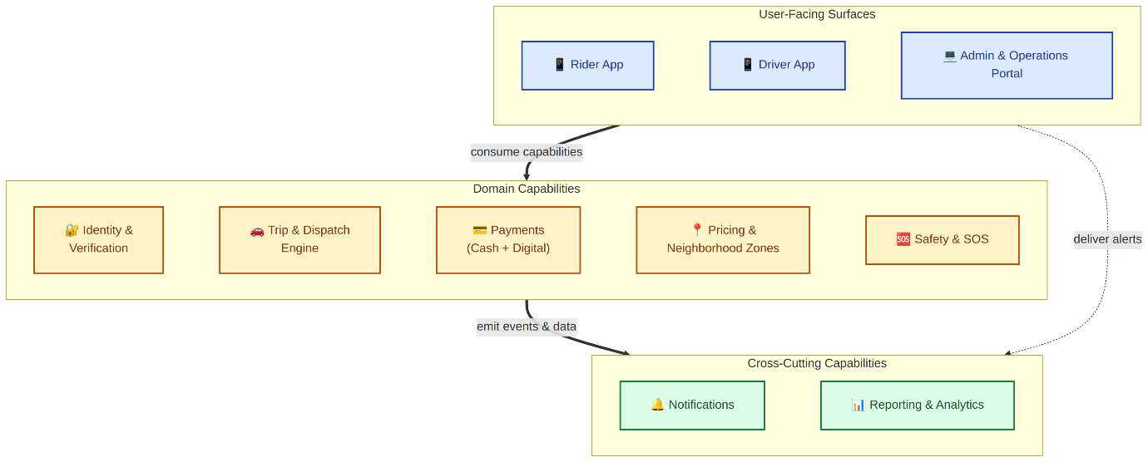

9.2 Use Case Diagram
This diagram organises the primary use cases of the SheDrive platform around three actor groups: Rider, Driver, and Back-Office users. Each use case is associated with the actor or actors who initiate it. External actors — Trusted Contacts and the Payment Service Provider — are shown with dashed connections to indicate that they participate in but do not initiate the corresponding use cases.
The use cases shown are illustrative of the platform's primary functional surface and are detailed exhaustively in Section 7. Some use cases (e.g., Register, Share Live Trip) are reachable by both Rider and Driver actors and are shown in both swim-lanes.
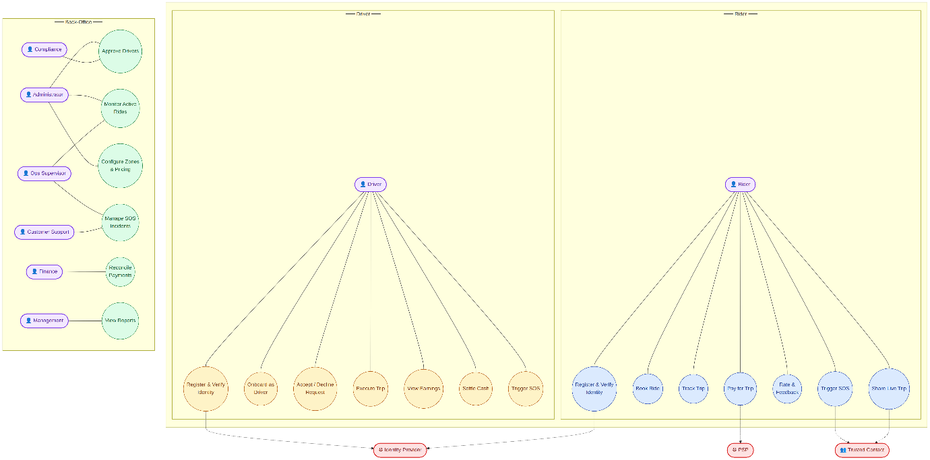

9.3 Rider Journey Flow
This diagram presents the end-to-end experience of a Rider from initial registration through trip completion. It covers the three logical phases of the Rider experience: account creation and identity verification, booking and matching, and trip execution and settlement. Diamond-shaped nodes mark decision points (identity verification outcome, driver availability, payment method); rectangular nodes represent process steps.
The flow assumes a Rider operating within the platform's defined operating hours and within a configured neighborhood zone. Edge cases — payment failure and no driver available — are visualised.
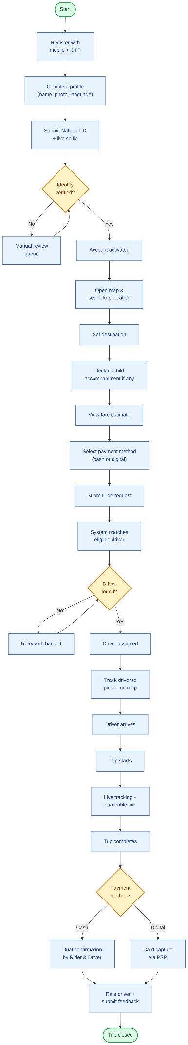

9.4 Driver Onboarding Flow
This diagram covers the multi-stage Driver onboarding sequence: mobile registration, national ID and document submission, driving license and vehicle document upload, vehicle and profile photo capture, background-check consent, and final Administrator review. Any failed gate routes the Driver to onboarding rejection with a captured reason; only approved Drivers are activated and become matchable.
This flow reflects the requirements in Section 7.2 (Driver App) and the administrative review behaviours defined in Section 7.3.
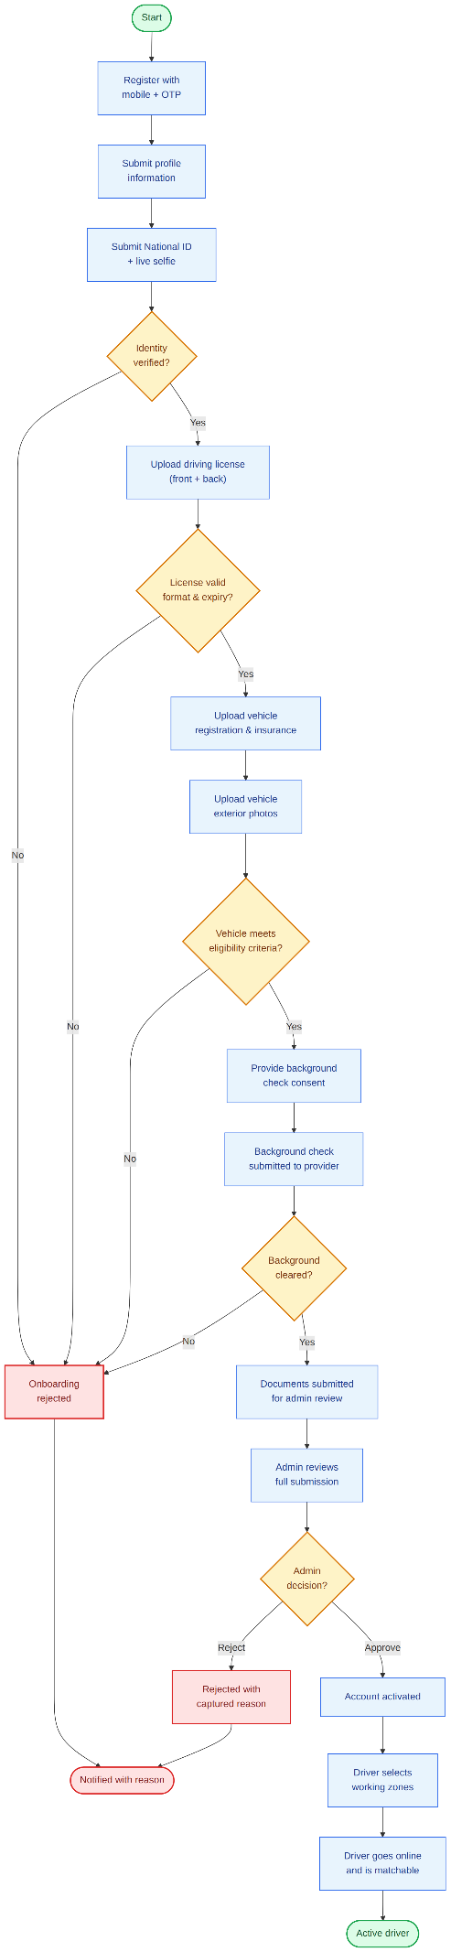

9.5 Trip Lifecycle State Diagram
This diagram captures the valid trip states enforced by the Trip & Dispatch Engine (TD-007) and the legal transitions between them. A trip enters the "Requested" state when the Rider submits a ride request, progresses through matching, assignment, arrival, in-progress, and completion, or terminates in one of three cancellation states (cancelled by Rider, cancelled by Driver, or cancelled because no Driver was available).
Cancellation policy and applicable fees vary by zone configuration (Section 7.7) and trip state at the time of cancellation. Real-time location streaming and live trip sharing apply during the In-Progress state. Trip completion triggers fare capture (digital) or dual cash confirmation (cash) and the rating flow.
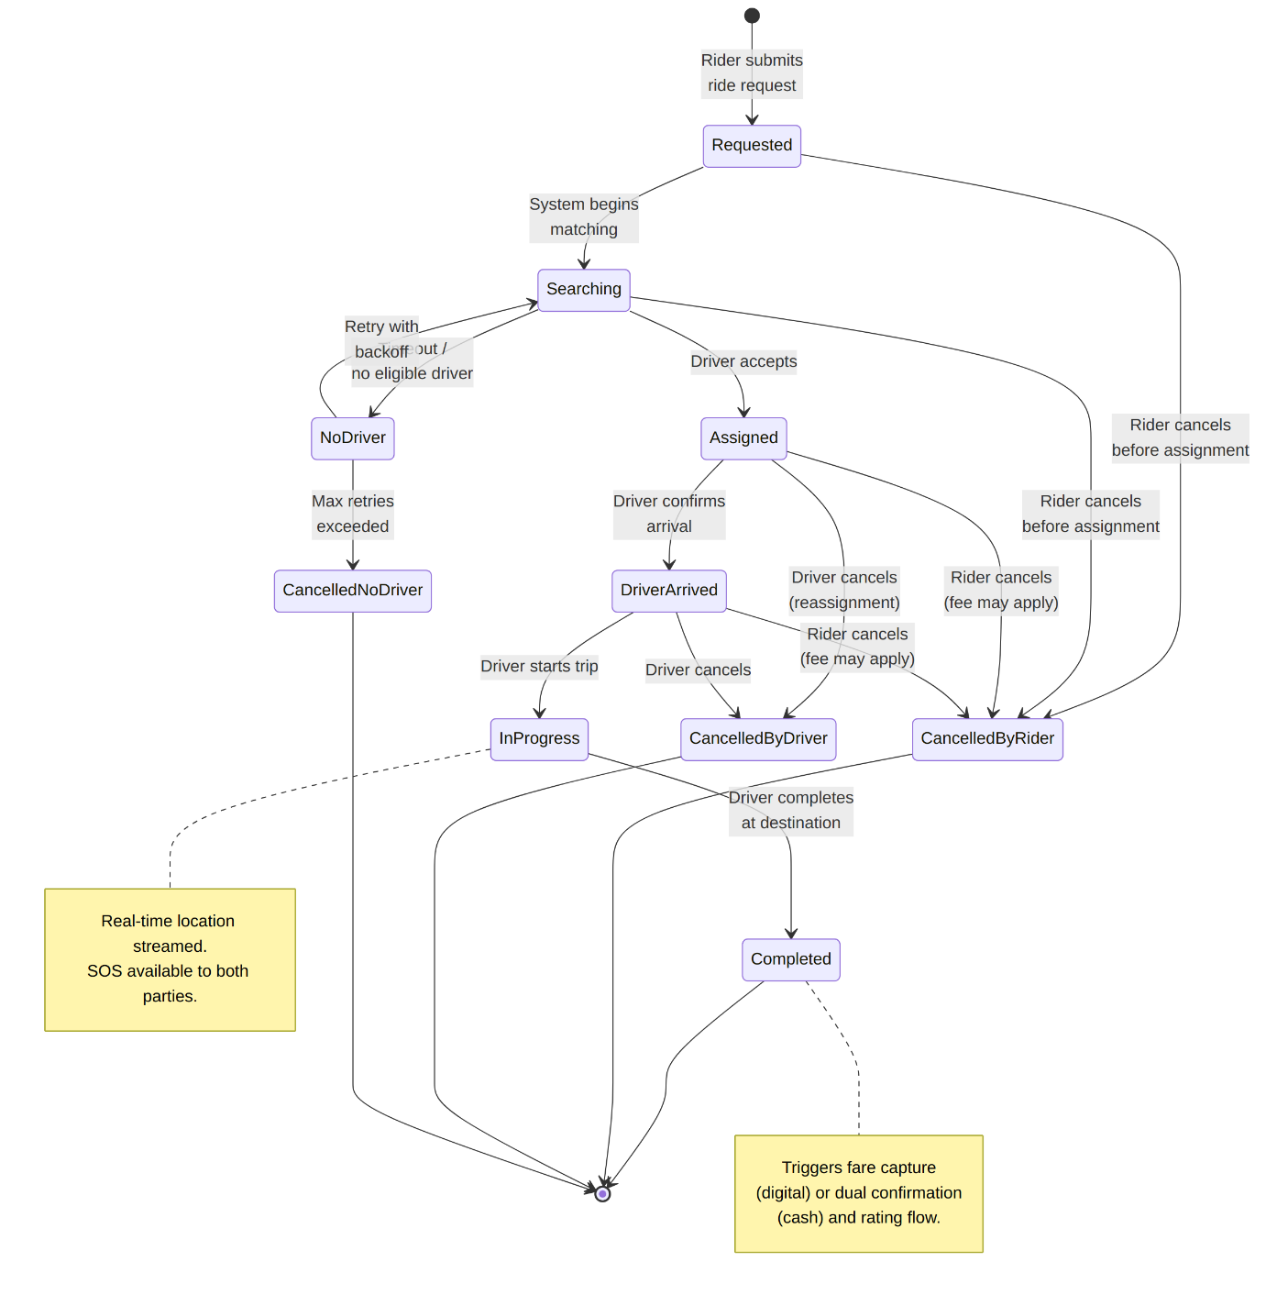

9.6 Dispatch & Matching Sequence
This diagram presents the sequence of interactions during ride matching, from the Rider's initial request submission through Driver assignment (or the no-driver-available case). It is intentionally aligned with the requirements in Section 7.6 (Trip & Dispatch Engine), including the broadcast-with-timeout pattern (TD-003), atomic acceptance (TD-004), decline/timeout reassignment (TD-005), and list-driven expiry when the candidate list is exhausted (TD-010).
The Pricing & Neighborhood Zones module is consulted at fare-estimate time. The Notifications module is invoked at lifecycle transitions to keep both parties informed.
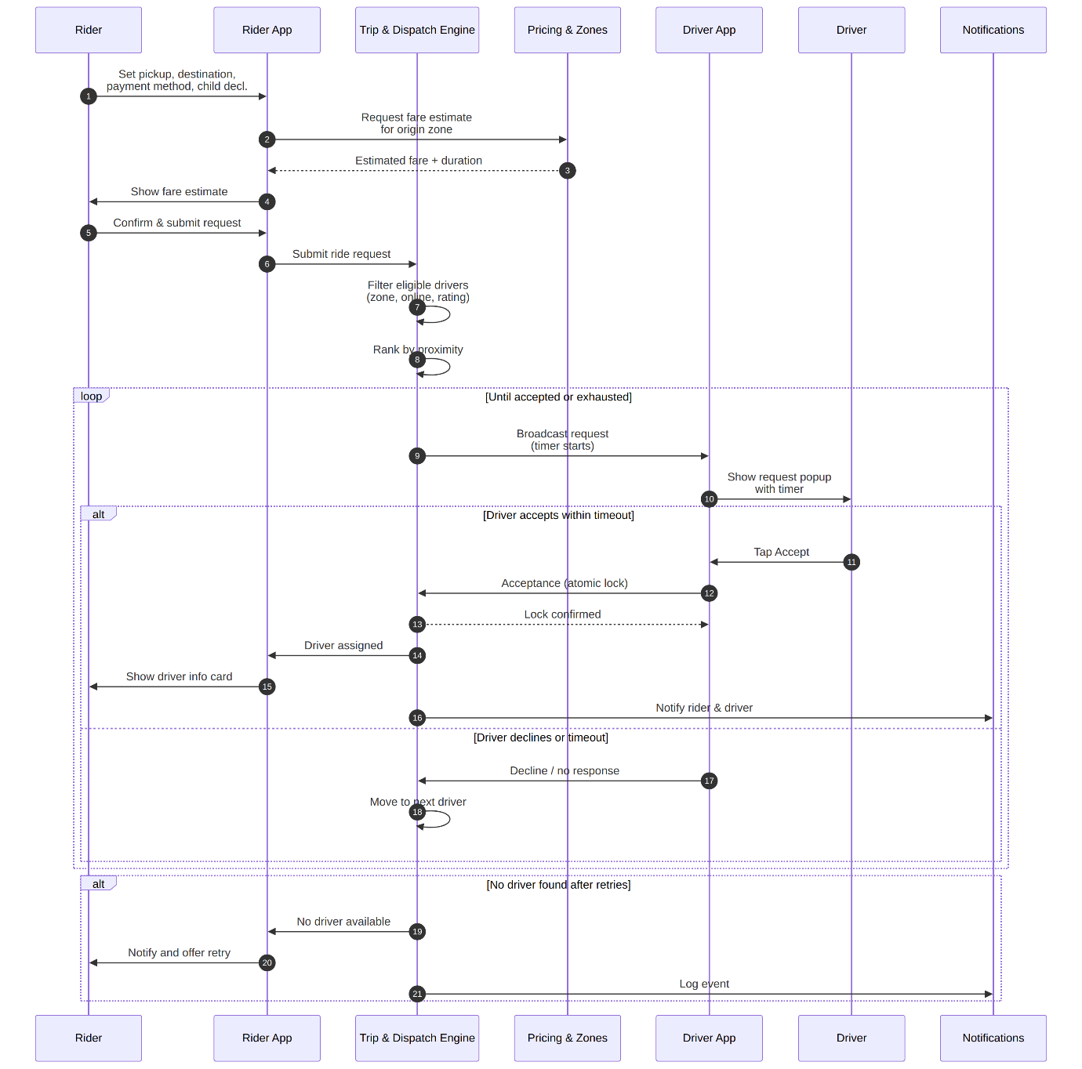

9.7 Payment Flow (Cash + Digital)
This diagram presents the two payment rails side-by-side. The Digital path uses pre-authorisation at trip start and capture at trip completion via the configured PSP, with explicit handling for capture failure (rider notified, future bookings blocked until resolved). The Cash path requires dual confirmation from both Rider and Driver at trip completion; mismatched confirmation routes the trip to the Operations dispute workflow. Both rails culminate in commission calculation and trip settlement.
This flow reflects the requirements in Section 7.5 (Payments). Refund handling and reconciliation views are managed through the Admin & Operations Portal (Section 7.3).
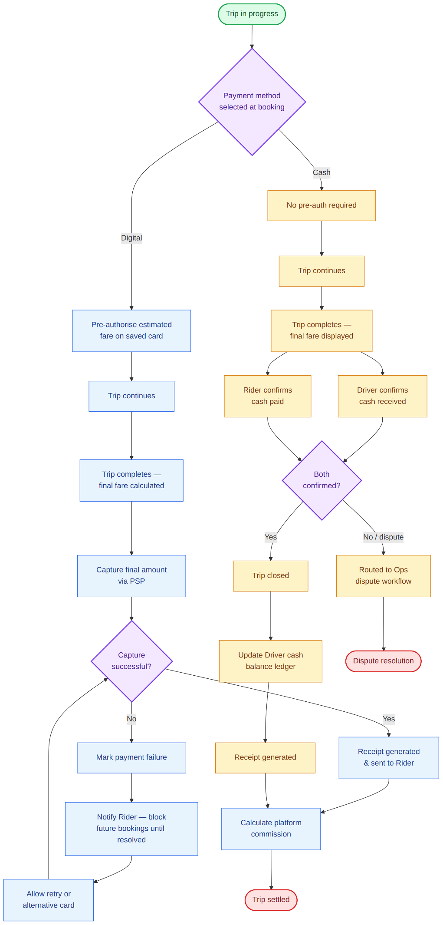

9.8 (Removed in v1.3) — SOS Escalation Flow
The multi-tier SOS escalation workflow has been removed from scope in v1.3. Safety in this release is limited to live trip sharing with trusted contacts (Section 7.8). The diagram image below is retained for reference only and is scheduled for removal.
The SLA durations themselves are platform parameters configured via the System Parameters Management capability described in Section 7.3.1.
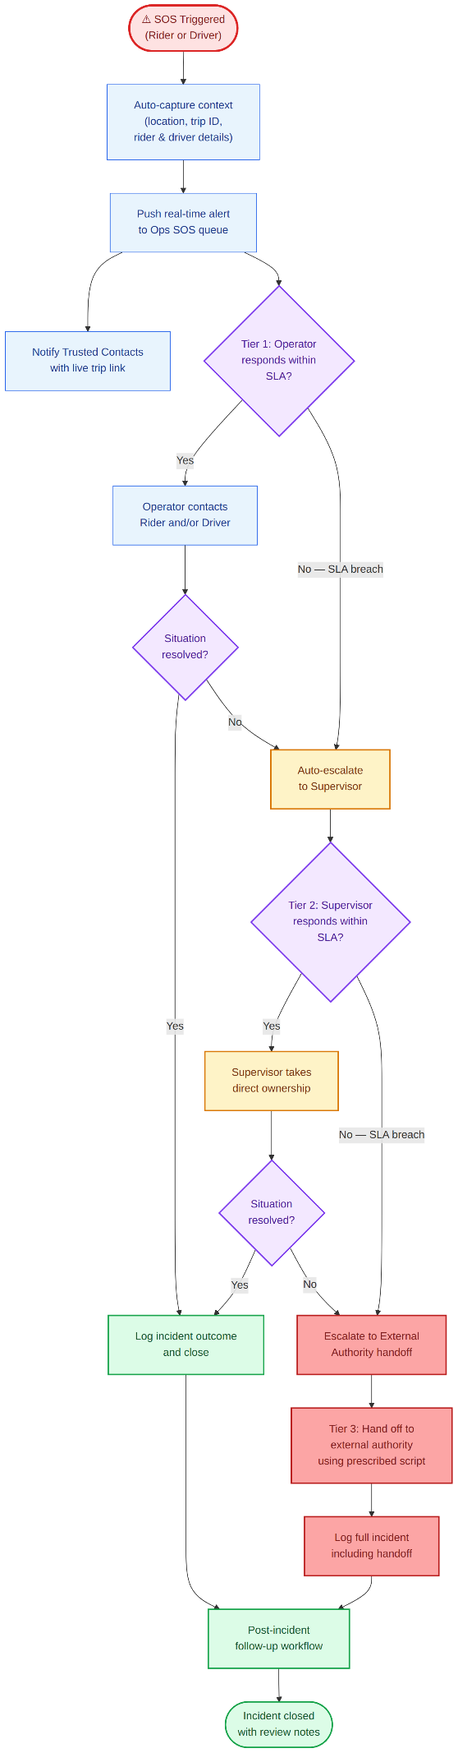

10. Non-Functional Business Requirements
This section defines non-functional expectations expressed at a business level. Technical realisation, including specific architectural and infrastructure approaches, is addressed in the High-Level Design document.

10.1 Availability Expectations
ID | Requirement
NF-AV-01 | The platform shall be available during 100% of the configured operating hours, targeting a service availability of [TBD — Operations to confirm, e.g., 99.5%] measured monthly during the operating window.
NF-AV-02 | Planned maintenance shall be scheduled outside the operating window wherever possible, with advance notice to users.
NF-AV-03 | Unplanned outages affecting safety features (live trip sharing) shall be treated as severity-1 incidents with the highest operational priority for resolution.
NF-AV-04 | The Admin & Operations Portal shall be available 24/7 to support back-office work outside the public operating window.
NF-AV-05 | External provider unavailability (PSP, maps, notifications) shall not bring down core platform functions; degraded operation modes shall be defined for each.

10.2 Performance Expectations
ID | Requirement
NF-PF-01 | The Rider App shall display the fare estimate and present available drivers within a duration that feels immediate to a typical user (target: under [TBD — e.g., 3 seconds] under normal load).
NF-PF-02 | Driver matching shall complete within a duration that does not noticeably degrade the user experience (target: under [TBD — e.g., 30 seconds] under normal load).
NF-PF-04 | Real-time location updates shall be delivered to the Rider App with a perceived latency consistent with industry-standard ride-hailing experiences.
NF-PF-05 | The platform shall support concurrent active rides and online drivers consistent with the projected MVP load envelope, defined in HLD.
NF-PF-06 | Payment processing latency (digital) shall not visibly delay the trip completion experience under normal PSP performance conditions.

10.3 Localization (Arabic / English, RTL)
ID | Requirement
NF-LO-01 | The platform shall support Arabic and English as user-facing languages from launch.
NF-LO-02 | Arabic shall be the default language for end users in Egypt, with full right-to-left layout, typography, and component mirroring across the Rider and Driver apps.
NF-LO-03 | All user-facing copy, including notifications, error messages, button labels, and static content, shall be available in both languages.
NF-LO-04 | Date formats, time formats, currency formatting (Egyptian Pound), and number formatting shall reflect locale conventions.
NF-LO-05 | The Admin & Operations Portal shall support English as its primary language. Arabic support for the portal is out of scope for the MVP.
NF-LO-06 | Language switching within the apps shall be available without requiring re-login or app restart.
NF-LO-07 | Notification templates shall be maintained in both languages, with the appropriate language selected based on the user's app preference.

10.4 Accessibility
ID | Requirement
NF-AC-01 | The Rider App and Driver App shall meet a baseline of accessible design, targeting compliance with WCAG 2.1 Level AA where applicable to mobile applications.
NF-AC-02 | Visual elements shall provide sufficient colour contrast, font sizing, and tap-target sizing to support users with mild visual or motor impairments.
NF-AC-03 | Critical user flows (registration, booking, live trip sharing) shall be operable without reliance on colour alone.
NF-AC-04 | The apps shall be usable with the device's native screen reader (VoiceOver / TalkBack) for primary flows, including ride request, ride status, and live trip sharing.
NF-AC-05 | The platform shall support standard system-level accessibility features available on iOS and Android (text resizing, dynamic type, high contrast modes).

10.5 Security Expectations (Business Level)
ID | Requirement
NF-SE-01 | Personal and identity data shall be protected against unauthorised access in storage and in transit, in accordance with applicable Egyptian data protection requirements.
NF-SE-02 | Card data shall not be stored by the platform. Card information shall be tokenised by the PSP, with the platform retaining only the resulting tokens.
NF-SE-03 | Administrator access to sensitive data and actions shall require two-factor authentication and role-based access control.
NF-SE-04 | All sensitive administrative actions (account approvals, suspensions, refunds, configuration changes) shall be recorded in an immutable audit log.
NF-SE-05 | User passwords, where applicable, shall be stored using industry-standard one-way hashing methods.
NF-SE-06 | The platform shall implement reasonable rate limiting and abuse prevention on registration, OTP requests, login, and payment retry endpoints.
NF-SE-07 | Personal mobile phone numbers of Riders and Drivers shall not be exposed to the other party. In-trip communication shall be mediated via in-app chat; masked voice calling is not provided in the MVP.
NF-SE-08 | The platform shall support a defined process for users to request account deletion, with deletion handled in accordance with applicable retention obligations.
NF-SE-10 | All third-party providers (PSP, maps, notifications) shall be engaged under contractual terms that include data protection obligations consistent with the platform's standards.

