SheDrive – Business requirement document
By Arcorp Team
User
JAN-2026

Contents
1. Document Control 7
1.1 Purpose of the Document 7
1.2 Document Version History 7
1.3 Authors & Reviewers 7
Author 7
Reviewers 7
2. Executive Summary 7
2.1 Background 7
2.2 Business Need / Problem Statement 8
2.3 Proposed Solution Overview 9
2.4 Expected Benefits 10
2.4.1 Benefits for Riders 10
2.4.2 Benefits for Drivers 10
2.4.3 Benefits for Operations & Administration 10
2.4.4 Benefits for Management & Decision-Makers 11
2.4.5 Business & Market Benefits 11
2.5 Out of Scope (High-Level) 11
2.5.1 Service & Ride Types 11
2.5.2 Payments & Financial Features 11
2.5.3 Advanced User & Account Features 12
2.5.4 Advanced Analytics & Business Intelligence 12
3. Project Overview 12
3.1 Project Objectives 12
3.2 Stakeholders & Actors 13
3.2.1 Key Stakeholders 13
3.2.2 System Actors 13
3.2.3 External Actors 14
3.2.4 Actor Interaction Overview 14
3.3 Project Assumptions 15
3.3.1 Business & Market Assumptions 15
3.3.2 User & Identity Assumptions (Revised) 15
3.3.3 Payment & Financial Assumptions 15
3.3.4 Language & Localization Assumptions 15
3.3.5 Operations & Reporting Assumptions 16
3.3.6 Integration & Dependency Assumptions 16
3.4 Project Constraints 16
3.4.1 Scope & Delivery Constraints 16
3.4.2 Market & Geographic Constraints 16
3.4.3 User & Eligibility Constraints 16
3.4.4 Payment & Financial Constraints 17
3.4.5 Operational & Reporting Constraints 17
3.4.6 Regulatory & Compliance Constraints 17
3.4.7 Time & Resource Constraints 17
3.5 Dependencies 17
3.5.1 External Service Dependencies 17
3.5.2 Regulatory & Compliance Dependencies 18
3.5.3 Business & Operational Dependencies 18
3.5.4 Stakeholder & Decision Dependencies 18
3.5.5 External Readiness Dependencies 18
4. Business Scope 18
4.1 In-Scope 18
4.1.1 Rider Application (MVP) 18
4.1.2 Driver Application (MVP) 19
4.1.3 Administration & Operations Portal (MVP) 19
4.1.4 Payments & Financial Processing (MVP) 19
4.1.5 Notifications & Communication (MVP) 20
4.1.6 Safety, Trust & Compliance (MVP) 20
4.1.7 Operational Monitoring & Reporting (MVP) 20
4.2 Out-of-Scope 21
4.2.1 Ride Types & Service Variations 21
4.2.2 Payments & Financial Capabilities 21
4.2.3 Advanced User & Account Features 21
4.2.4 Advanced Safety & Intelligence Features 21
4.2.5 Analytics, Reporting & BI 21
4.2.6 Operations & Platform Extensions 22
4.2.7 Technical & Implementation-Related Items 22
4.3 Target Users 22
5. Functional Requirements (MVP) 23
5.1 Rider Application (MVP) 23
5.1.1 Registration & Account Access 23
5.1.2 Identity Verification (Before First Trip) 23
5.1.3 Rider Profile Management 23
5.1.4 Ride Request & Booking 23
5.1.5 Ride Tracking & Status 24
5.1.6 Communication with Driver 24
5.1.7 Ride Cancellation (Rider-Initiated) 24
5.1.8 Trip Completion & Feedback 24
5.1.9 Payments 24
5.1.10 Safety & Emergency Features 24
5.1.11 Notifications 24
5.2 Driver Application (MVP) 25
5.2.1 Registration & Account Access 25
5.2.2 Identity Verification & Onboarding 25
5.2.3 Availability Management 25
5.2.4 Ride Request Handling 25
5.2.5 Trip Execution 26
5.2.6 Ride Cancellation (Driver-Initiated) 26
5.2.7 Earnings & Trip History 26
5.2.8 Safety & Emergency Features 26
5.2.9 Notifications 26
5.3 Administration & Operations Portal (MVP) 26
5.3.1 Access Control & Roles 26
5.3.2 Rider Management 27
5.3.3 Driver Management & Onboarding Approval 27
5.3.4 Ride Monitoring & Operations 27
5.3.5 Cancellation & Incident Management 27
5.3.6 Safety & SOS Handling 27
5.3.7 Pricing & Business Rules Configuration 27
5.3.8 Operational Reporting (MVP) 27
5.4 Payments & Financial Rules (MVP) 28
5.4.1 Supported Payment Method 28
5.4.2 Payment Trigger & Flow 28
5.4.3 Payment Success Handling 28
5.4.4 Payment Failure Handling 28
5.4.5 Pricing Rules 28
5.4.6 Cancellations & Financial Impact 29
5.4.7 Driver Settlement (MVP Assumptions) 29
5.4.8 Financial Visibility & Reporting 29
5.5 Notifications & Communication (MVP) 29
5.5.1 Notification Channels (Conceptual) 29
5.5.2 Rider Notifications 29
5.5.3 Driver Notifications 30
5.5.4 Administrative Notifications 30
5.5.5 Notification Rules & Management 30
5.6 Safety, Trust & Compliance (MVP) 30
5.6.1 Women-Only Platform Enforcement 30
5.6.2 Identity & Eligibility Enforcement 30
5.6.3 Child Ride Eligibility 31
5.6.4 Real-Time Trip Monitoring 31
5.6.5 SOS & Emergency Handling 31
5.6.6 Incident Reporting & Management 31
5.6.7 Data Privacy & Trust 31
5.6.8 Compliance & Auditability 31
6. Business Scenarios (MVP) 32
6.1 Rider Scenarios 32
6.1.1 Rider Account Registration 32
6.1.2 Rider Identity Verification (Before First Trip) 32
6.1.3 Rider Requests a Ride 33
6.1.4 Rider Cancels a Ride 33
6.1.5 Trip Completion & Payment 34
6.1.6 Rider Triggers SOS During Trip 34
6.2 Driver Scenarios 34
6.2.1 Driver Account Registration 34
6.2.2 Driver Identity Verification & Onboarding 35
6.2.3 Driver Goes Online (Availability Management) 35
6.2.4 Driver Accepts a Ride Request 36
6.2.5 Driver Cancels a Ride 36
6.2.6 Driver Completes a Trip 36
6.2.7 Driver Triggers SOS During Trip 37
6.3 Admin & Operations Scenarios 37
6.3.1 Approve Driver Onboarding 37
6.3.2 Monitor Active Rides 37
6.3.3 Handle Ride Cancellation Review 38
6.3.4 Handle SOS Incident 38
6.3.5 Configure Pricing Rules 38
6.3.6 View Operational Reports 39
6.4 Payment & Financial Scenarios 39
6.4.1 Successful Trip Payment 39
6.4.2 Payment Failure Handling 40
6.4.3 Cancellation Fee Application 40
6.4.4 Payment Dispute Handling (MVP) 40
6.4.5 Driver Earnings Visibility 41
7. Business Process Diagrams (MVP) 41
7.1 Rider Journey Diagram 41
7.2 Driver Journey Diagram 43
7.3 Ride Lifecycle Diagram 45
7.4 Ride Cancellation Flow Diagram 45
7.5 SOS & Safety Escalation Diagram 46
7.6 Payment High-Level Flow Diagram 48
7.7 Rider Account Registration Diagram 49
7.8 Rider Identity Verification Diagram 49
7.9 Driver Identity Verification and Approval Diagram 51
7.10 Ride Request and Assignment Diagram 52
7.11 Payment Failure Resolution Diagram 53
7.12 Admin SOS Handling Diagram 54
7.13 Cancellation Comparison Diagram (Rider vs Driver) 55
7.14 Reporting Overview Diagram (Operational + Decision-Making) 56

1. Document Control

1.1 Purpose of the Document
This Business Requirements Document (BRD) defines the business context, objectives, scope, and high-level requirements for the SheDrive solution.
It serves as a reference for stakeholders, decision-makers, and project teams to ensure alignment on business needs prior to detailed design and implementation.

1.2 Document Version History
Version | Date | Author | Description
0.1 | 19-JAN-2026 | Mohamed Talaat – Senior Head of Engineering | Initial draft of BRD document
1.0 | 22-JAN-2026 | Mohamed Talaat – Senior Head of Engineering | Final BRD

1.3 Authors & Reviewers

Author
- Mohamed Talaat, Senior Head of Engineering

Reviewers
Version | Date | Author | Description

2. Executive Summary

2.1 Background
Urban mobility services have become an essential part of daily life, providing convenient transportation options for millions of users. However, in many markets, including Egypt, existing ride-hailing platforms do not fully address the safety, trust, and cultural concerns faced by women and families, particularly when it comes to transporting women and children.
A significant segment of female users express discomfort or hesitation when using mixed-gender ride-hailing services, especially during late hours or when traveling with children. These concerns are amplified by the lack of specialized controls around driver eligibility, identity verification, and child-friendly ride policies. As a result, there is a clear gap in the market for a transportation solution that prioritizes women’s safety, privacy, and confidence, while still offering the convenience and efficiency expected from modern mobility platforms.
SheDrive is conceived as a women-only ride-hailing platform, where both riders and drivers are female, and where children under the age of 12 are explicitly permitted to ride under defined safety and eligibility rules. The platform is intended to launch initially in Egypt, supporting both Arabic and English, and operating under a safety-first business model.
The initial focus of SheDrive is to deliver a Minimum Viable Product (MVP) that validates the core business concept, enables safe and reliable daily operations, and establishes trust with users and stakeholders. The MVP will concentrate on essential ride-hailing capabilities, strong identity verification, integrated digital payments, real-time notifications, and foundational operational and decision-support reporting. More advanced capabilities will be introduced progressively in future phases based on adoption, feedback, and business priorities.
This Business Requirements Document (BRD) captures the business context and functional expectations for the SheDrive MVP, serving as a foundation for estimation, stakeholder alignment, and subsequent technical design.

2.2 Business Need / Problem Statement
Despite the widespread adoption of ride-hailing services, a significant gap remains in addressing the specific safety, trust, and comfort needs of women and families, particularly in urban environments such as Egypt. Existing platforms are primarily designed as general-purpose mobility services, with limited specialization for vulnerable or sensitive user segments.
Many female riders experience concerns related to:
- Personal safety when riding alone
- Trust in driver identity and background
- Traveling with children, especially those under the age of 12
- Lack of transparent emergency handling and accountability mechanisms
These concerns often result in reduced usage, reliance on informal transportation alternatives, or complete avoidance of ride-hailing services in certain situations, such as late hours or child-accompanied trips. At the same time, many qualified female drivers face barriers to participation in the ride-hailing economy due to safety concerns or discomfort operating within mixed-gender platforms.
From a business perspective, this creates:
- An underserved and high-demand market segment
- Missed revenue opportunities due to low adoption and trust barriers
- Increased reputational and operational risks when safety incidents are not clearly managed
- Limited visibility for operators and decision-makers into real-time operations and safety performance
Additionally, existing solutions often lack clear, enforceable business rules around identity verification, age eligibility, and safety compliance, making it difficult to consistently guarantee a safe experience for women and children. Reporting and analytics capabilities are frequently either too limited for operational control or too complex to adapt to evolving business needs.
There is a clear business need for a purpose-built, women-only mobility platform that:
- Enforces strict eligibility and identity verification policies
- Explicitly supports child-friendly ride scenarios
- Integrates digital payments and real-time notifications as standard capabilities
- Provides foundational operational monitoring and management-level reporting
- Establishes trust as a core value rather than an optional feature
SheDrive is intended to address this gap by delivering a focused, safety-first ride-hailing solution that aligns with cultural expectations, regulatory considerations, and the practical mobility needs of women and families in Egypt, starting with a clearly defined MVP and evolving through controlled, phased growth.

2.3 Proposed Solution Overview
The proposed SheDrive solution is a women-only ride-hailing platform designed to provide a safe, trusted, and culturally aligned transportation service for women and children under the age of 12 in Egypt. The solution focuses on enforcing safety, identity assurance, and operational transparency as core business principles, rather than optional features.
From a business perspective, the SheDrive solution comprises the following key functional capabilities:
- Rider Mobile Application
A mobile application that enables female riders to register, verify their identity, request and track rides, communicate with drivers, complete trip payments, manage ride cancellations, and access built-in safety features. The application explicitly supports child-accompanied rides under defined eligibility and safety rules.
- Driver Mobile Application
A mobile application dedicated to female drivers, allowing them to onboard, complete identity verification, manage availability, receive and handle ride requests, execute trips, view earnings summaries, manage trip cancellations, and use safety and emergency features.
- Administration & Operations Portal
An operational portal that enables authorized staff to manage riders and drivers, review and approve driver onboarding, monitor active and completed trips, handle cancellations and incidents, configure pricing rules, and oversee day-to-day platform operations.
- Payment Processing Capability
An integrated digital payment capability that allows riders to complete trip payments electronically through a supported payment service provider, with payment status tracking and business-defined settlement rules.
- Notifications & User Communication
A unified notification and communication capability that provides real-time updates to riders, drivers, and administrators, including ride status changes, payment confirmations, cancellation notifications, and safety-related alerts.
- Operational Monitoring & Reporting (MVP)
Built-in operational dashboards that provide real-time visibility into active rides, driver availability, incidents, cancellations, and key operational indicators required for daily management and service continuity.
- Decision Support & Analytics (MVP – Foundational Level)
Foundational reporting views intended to support management and decision-making, providing aggregated insights into platform usage, safety trends, and operational performance, with a clear roadmap to evolve into a more advanced Business Intelligence (BI) capability in future phases.
The SheDrive solution is designed to be delivered initially as a Minimum Viable Product (MVP), focusing on essential capabilities required for a safe and controlled market launch. More advanced features, analytics, and service extensions will be introduced progressively based on business priorities, regulatory considerations, and user adoption.
All technical architecture, integration mechanisms, and implementation details required to realize these capabilities will be defined separately in the High-Level Design (HLD) document.

2.4 Expected Benefits
The SheDrive platform is expected to deliver a range of business, operational, and user-centric benefits by addressing unmet safety and trust needs in the ride-hailing market. These benefits apply to riders, drivers, operators, and decision-makers, particularly during the MVP launch phase.

2.4.1 Benefits for Riders
- Enhanced personal safety and peace of mind through a women-only ecosystem.
- Increased confidence when traveling with children under the age of 12.
- Clear visibility into trip status, driver identity, and ride progress.
- Access to reliable emergency and safety mechanisms during trips.
- Improved overall ride experience through culturally aligned service design.

2.4.2 Benefits for Drivers
- A trusted and secure working environment dedicated to female drivers.
- Increased participation opportunities for women who prefer or require gender-segregated platforms.
- Reduced exposure to safety risks through defined eligibility and ride rules.
- Transparent trip handling, earnings visibility, and cancellation policies.
- Greater trust between drivers and riders, leading to smoother interactions.

2.4.3 Benefits for Operations & Administration
- Centralized visibility into daily platform operations, including active rides, driver availability, cancellations, and incidents.
- Improved control over driver onboarding and eligibility enforcement.
- Standardized handling of payments, cancellations, and safety events.
- Reduced manual intervention through clearly defined business rules.
- Faster response to operational issues and safety incidents.

2.4.4 Benefits for Management & Decision-Makers
- Access to foundational operational and decision-support reporting at MVP stage.
- Improved understanding of platform usage patterns and service demand.
- Visibility into safety-related trends and operational performance.
- Data-driven insights to guide future enhancements, expansion, and investment decisions.
- A scalable foundation for evolving analytics and Business Intelligence capabilities.

2.4.5 Business & Market Benefits
- Clear differentiation from existing ride-hailing platforms through a safety-first, women-only positioning.
- Increased adoption among underserved user segments.
- Strengthened brand trust and reputation.
- Controlled and measurable MVP launch with reduced risk.
- A solid foundation for phased growth and feature expansion.

2.5 Out of Scope (High-Level)
To ensure a focused and controlled delivery of the SheDrive Minimum Viable Product (MVP), the following items are explicitly excluded from the scope of this phase. These items may be considered in future phases based on business priorities, market feedback, and platform maturity.

2.5.1 Service & Ride Types
- Ride pooling or shared rides.
- Scheduled or recurring rides.
- Intercity or long-distance transportation.
- Vehicle categories or service tiers (e.g., premium, family, economy).
- Rental or hourly-based ride services.

2.5.2 Payments & Financial Features
- In-app wallets for riders or drivers.
- Automated driver payout or settlement mechanisms.
- Promotional codes, discounts, or loyalty programs.
- Multiple payment service providers or advanced payment routing.
- Refund automation and complex dispute handling.

2.5.3 Advanced User & Account Features
- Corporate or enterprise accounts.
- Family or multi-user account management.
- Guardian dashboards or parental control panels.
- User subscription models.

2.5.4 Advanced Analytics & Business Intelligence
- Full-scale Business Intelligence (BI) platform.
- Predictive analytics or demand forecasting.
- AI-driven behavioral or safety scoring.
- Custom or ad-hoc analytical dashboards.

3. Project Overview

3.1 Project Objectives
The primary objective of the SheDrive project is to design and deliver a safe, reliable, and trusted women-only ride-hailing platform that addresses the specific mobility needs of women and children under the age of 12 in Egypt, while enabling efficient daily operations and informed decision-making.
The key objectives of the SheDrive MVP are as follows:
- Establish a Safety-First Mobility Platform
Deliver a women-only ride-hailing service that enforces strict eligibility, identity verification, and safety policies for both riders and drivers.
- Enable Secure and Simple Ride Experience
Provide an intuitive booking, tracking, payment, and communication experience that meets user expectations while prioritizing safety and reliability.
- Support Child-Friendly Transportation
Explicitly support rides involving children under 12 through defined business rules and safety considerations.
- Enable Female Driver Participation
Create a trusted environment that encourages female drivers to participate in the platform by offering clear onboarding, verification, and operational workflows.
- Ensure Operational Visibility and Control
Equip operations teams with real-time monitoring capabilities to manage active rides, cancellations, incidents, and daily platform activities effectively.
- Provide Foundational Reporting for Decision-Making
Deliver essential operational and management-level reporting at MVP stage to support performance tracking and data-driven decisions.
- Deliver a Controlled MVP Launch
Limit initial scope to essential features to reduce risk, validate the business model, and gather market feedback for future expansion.
- Lay the Foundation for Scalable Growth
Establish a business framework that allows the platform to evolve in future phases without disrupting core operations or compromising safety.
These objectives guide the scope, prioritization, and delivery of the SheDrive MVP and serve as a reference point for evaluating project success and future enhancements.

3.2 Stakeholders & Actors
The SheDrive platform involves multiple stakeholders and user actors, each playing a distinct role in the delivery, operation, and governance of the service. Clear identification of these roles ensures alignment across business, operational, and decision-making functions.

3.2.1 Key Stakeholders
- Business Sponsor / Product Owner
Responsible for defining the business vision, approving scope and priorities, and ensuring alignment with market and strategic objectives.
- Operations Management
Oversees day-to-day platform operations, including service continuity, incident handling, and compliance with business rules and policies.
- Customer Support Team
Handles user inquiries, complaints, and incident follow-ups related to rides, cancellations, payments, or safety concerns.
- Finance & Accounting Team
Responsible for financial oversight, payment reconciliation, settlement monitoring, and revenue reporting.
- Compliance & Legal Stakeholders
Ensure that the platform adheres to applicable regulations, data privacy requirements, and safety-related policies.
- Data & Analytics Stakeholders
Consume operational and decision-support reports to analyze performance, trends, and growth opportunities.

3.2.2 System Actors
- Female Rider
A registered female user who uses the Rider Application to request rides, complete payments, travel with or without children under 12, communicate with drivers, and access safety features.
- Female Driver
A registered and verified female user who uses the Driver Application to manage availability, accept and complete trips, interact with riders, and access safety and emergency features.
- Administrator (Admin)
An authorized operational user responsible for managing riders and drivers, approving driver onboarding, monitoring trips, handling incidents, configuring pricing rules, and managing cancellations.
- Operations Supervisor
A senior operational role with visibility across platform activities, responsible for overseeing incidents, escalations, and service quality.
- Decision Maker / Management User
A stakeholder role with access to aggregated operational and management-level reporting to support strategic decisions.

3.2.3 External Actors
The SheDrive platform relies on several external actors that provide essential services required for business operations and user experience. These external actors interact with the platform through defined business interfaces and agreements.
- Payment Service Provider
An external entity responsible for processing electronic payments, handling transaction authorization, and providing payment status updates for completed and failed transactions.
- Notification Service Provider
An external service responsible for delivering system-generated communications, including SMS messages, push notifications, and critical alerts related to authentication, ride status, payments, and safety events.
- Maps & Location Service Provider
An external service responsible for providing map visualization, geolocation, routing, distance calculation, and estimated time of arrival (ETA) information used during ride booking, tracking, and navigation.
- Identity Verification Service Provider
An external service that supports automated identity and biometric verification, including validation of national ID documents, face matching between ID and live selfie, and age eligibility verification.
- Regulatory Authorities (Indirect)
External governmental or regulatory bodies that define legal, safety, and compliance requirements applicable to transportation services, data protection, and digital platforms.

3.2.4 Actor Interaction Overview
Each actor interacts with the SheDrive platform according to defined business rules and permissions, ensuring:
- Clear separation of responsibilities
- Controlled access to sensitive functions
- Traceability and accountability for critical actions
- Safe and compliant operation of the service

3.3 Project Assumptions
The following assumptions define the baseline conditions under which the SheDrive MVP will be planned, estimated, and delivered. These assumptions are intended to ensure alignment among stakeholders and to reduce ambiguity during execution.

3.3.1 Business & Market Assumptions
- The platform will initially launch in Egypt as a single-country deployment.
- The primary target users are female riders and female drivers, with no mixed-gender participation.
- Children under the age of 12 are permitted to ride under defined safety and eligibility rules.
- The MVP launch will focus on a limited geographic area (e.g., selected cities) before wider expansion.
- The business model is based on per-ride transactions rather than subscriptions at MVP stage.

3.3.2 User & Identity Assumptions (Revised)
- Both riders and drivers are required to complete identity verification before completing their first trip on the platform.
- Users may register and create accounts prior to completing identity verification; however, trip execution is restricted until verification requirements are fulfilled.
- Identity verification includes:
  - Submission of national ID (front and back)
  - Live selfie capture
  - Validation of age eligibility
- Driver accounts require administrative approval after successful identity verification and before becoming eligible to accept trips.
- The platform enforces verification checkpoints to prevent unverified users from participating in rides.
- User-provided identity information is assumed to be accurate and subject to validation and review.

3.3.3 Payment & Financial Assumptions
- Digital payments will be supported through a single payment service provider at MVP stage.
- Payment failures will prevent trip completion unless an alternative payment option is explicitly enabled.
- Driver settlements and payouts will be handled outside the platform during the MVP phase.
- Pricing rules will be centrally configured and managed by administrators.

3.3.4 Language & Localization Assumptions
- The platform will support Arabic and English from the initial launch.
- Arabic will be the default language for users in Egypt.
- Localization will include language, location formats, and communication templates.

3.3.5 Operations & Reporting Assumptions
- Operational monitoring dashboards will be available as part of the MVP to support daily operations.
- Foundational reporting will be available for management and decision-making at MVP stage.
- Advanced analytics and BI capabilities will be developed as a separate initiative in future phases.

3.3.6 Integration & Dependency Assumptions
- External service providers (payments, notifications, maps, identity verification) will be available and contractually supported during MVP development and launch.
- Required external services will expose stable interfaces suitable for integration.
- Regulatory requirements applicable to transportation, data privacy, and digital services are assumed to be stable during the MVP delivery period.

3.4 Project Constraints
The following constraints define the boundaries within which the SheDrive MVP will be delivered. These constraints are intended to ensure focus, manage risk, and support a controlled and achievable launch.

3.4.1 Scope & Delivery Constraints
- The project scope is limited to the Minimum Viable Product (MVP) features as defined in this BRD.
- Any functionality not explicitly included in the MVP scope is considered out of scope unless formally approved.
- Feature additions or scope changes during the MVP phase are subject to impact assessment and stakeholder approval.

3.4.2 Market & Geographic Constraints
- The initial launch is constrained to Egypt only.
- The MVP may be limited to specific cities or operational zones during early rollout.
- Expansion to additional regions or countries is outside the scope of the MVP.

3.4.3 User & Eligibility Constraints
- Only female riders and female drivers are eligible to use the platform.
- Rides involving children are limited to those under the age of 12, in accordance with defined business rules.
- Users who have not completed identity verification are restricted from completing trips.

3.4.4 Payment & Financial Constraints
- The MVP supports a single electronic payment service provider.
- Advanced financial features such as wallets, automated payouts, and refunds are excluded from this phase.
- Driver settlements are handled outside the platform during the MVP phase.

3.4.5 Operational & Reporting Constraints
- Operational dashboards are limited to core monitoring needs at MVP stage.
- Advanced analytics and Business Intelligence capabilities are excluded from the MVP and will evolve separately.
- Customer support processes are limited to defined operational workflows.

3.4.6 Regulatory & Compliance Constraints
- The platform must comply with applicable local regulations, data protection laws, and transportation-related requirements in Egypt.
- Any regulatory changes occurring during delivery may impact timelines or scope.

3.4.7 Time & Resource Constraints
- Delivery timelines are constrained by agreed project schedules and available resources.
- External dependency readiness (e.g., payment, identity, maps, notification services) may impact delivery milestones.

3.5 Dependencies
The successful delivery and operation of the SheDrive MVP depend on several internal and external factors. These dependencies influence planning, estimation, and risk management and must be considered throughout the project lifecycle.

3.5.1 External Service Dependencies
- Payment Service Provider Availability
Availability and readiness of the selected payment service provider to support electronic payments, transaction confirmations, and settlement reporting.
- Maps & Location Service Availability
Availability of reliable map, routing, distance calculation, and location services to support ride booking, tracking, and navigation.
- Notification Service Availability
Availability of SMS and push notification services for authentication, ride updates, payment notifications, and safety alerts.
- Identity Verification Service Availability
Availability of identity and biometric verification services to support national ID validation, face matching, and age eligibility checks before first trip execution.

3.5.2 Regulatory & Compliance Dependencies
- Approval and ongoing alignment with applicable local transportation, data protection, and digital service regulations in Egypt.
- Stability of regulatory requirements during the MVP delivery timeframe.

3.5.3 Business & Operational Dependencies
- Timely definition and approval of business rules, including pricing, cancellation policies, eligibility rules, and safety procedures.
- Availability of operational resources for:
  - Driver onboarding and approval
  - Incident handling and customer support
  - Daily platform monitoring

3.5.4 Stakeholder & Decision Dependencies
- Timely feedback and approvals from business stakeholders on:
  - MVP scope
  - Business rules
  - Reporting requirements
- Alignment between business, operations, finance, and compliance stakeholders.

3.5.5 External Readiness Dependencies
- Readiness of app distribution channels (e.g., mobile app stores) to support application review and release timelines.
- Availability of required legal agreements and contracts with third-party service providers.

4. Business Scope

4.1 In-Scope
The following features and capabilities are included within the scope of the SheDrive MVP. These items represent the minimum required functionality to enable a safe, reliable, and controlled launch of the platform in Egypt.

4.1.1 Rider Application (MVP)
The Rider Application will enable female users to request and complete rides in a safe and trusted environment.
In scope for the MVP:
- User registration and login using mobile number authentication.
- Progressive identity verification (required before first trip).
- Rider profile management.
- Ride request using map-based pickup and destination selection.
- Real-time trip tracking and ride status updates.
- In-app text communication with the assigned driver.
- Ride cancellation by rider according to defined business rules.
- Trip completion and ride rating / feedback submission.
- Digital payment for completed trips.
- Child-accompanied ride indication (children under 12).
- Safety features, including SOS and trip sharing.

4.1.2 Driver Application (MVP)
The Driver Application will enable verified female drivers to accept and complete ride requests.
In scope for the MVP:
- Driver registration and onboarding.
- Identity verification (national ID + selfie).
- Document submission and review.
- Administrative approval before activation.
- Online / offline availability management.
- Receiving, accepting, or declining ride requests.
- Navigation to pickup and drop-off locations.
- Trip lifecycle management (start, in-progress, end).
- Trip cancellation by driver with mandatory reason.
- View of completed trips and basic earnings summary.
- Safety features, including SOS.

4.1.3 Administration & Operations Portal (MVP)
The Administration Portal will support day-to-day operational control and governance.
In scope for the MVP:
- Admin authentication and role-based access.
- Rider management (view, suspend, block).
- Driver management and onboarding approval.
- Review of driver identity and documents.
- Monitoring of active and completed rides.
- Management of ride cancellations and incidents.
- Configuration of pricing rules.
- Handling of safety and SOS events.
- Basic operational reports.

4.1.4 Payments & Financial Processing (MVP)
The MVP will support basic digital payment capabilities.
In scope for the MVP:
- Electronic payment for rides through a supported payment service provider.
- Payment confirmation and failure handling.
- Visibility of trip payment status to riders and administrators.
- Manual driver settlement handled outside the platform.

4.1.5 Notifications & Communication (MVP)
The platform will provide essential user communications.
In scope for the MVP:
- SMS notifications for authentication and critical alerts.
- Push notifications for ride status updates.
- Notifications for payment confirmation and cancellation events.
- Safety-related notifications (SOS alerts).

4.1.6 Safety, Trust & Compliance (MVP)
Safety is a core element of the MVP.
In scope for the MVP:
- Women-only enforcement for riders and drivers.
- Identity verification before first trip execution.
- Age eligibility enforcement.
- Real-time GPS tracking during trips.
- SOS escalation workflow.
- Ride audit trail for accountability and review.

4.1.7 Operational Monitoring & Reporting (MVP)
Basic reporting to support daily operations and management.
In scope for the MVP:
- Real-time view of active rides.
- Driver availability overview.
- Ride completion and cancellation summaries.
- Incident and safety event tracking.
- Foundational management-level reporting.

4.2 Out-of-Scope
The following features, capabilities, and activities are explicitly excluded from the scope of the SheDrive MVP. These items may be considered for future phases subject to business prioritization, feasibility, and formal approval.

4.2.1 Ride Types & Service Variations
- Ride pooling or shared rides.
- Scheduled or recurring rides.
- Intercity or long-distance rides.
- Hourly, rental, or package-based rides.
- Multiple ride categories or vehicle classes (e.g., premium, family, economy).

4.2.2 Payments & Financial Capabilities
- In-app wallets for riders or drivers.
- Automated driver payouts or settlement processing.
- Refund automation and dispute management workflows.
- Promotional codes, discounts, or loyalty programs.
- Support for multiple payment service providers.
- Subscription-based pricing models.

4.2.3 Advanced User & Account Features
- Corporate, enterprise, or institutional accounts.
- Family or guardian dashboards.
- Multi-user or shared accounts.
- Subscription or membership tiers.
- User-to-user referrals and rewards.

4.2.4 Advanced Safety & Intelligence Features
- AI-based behavior monitoring or risk scoring.
- Predictive safety analytics.
- Video or audio recording during trips.
- Real-time third-party monitoring services.
- Automated fraud detection beyond basic controls.

4.2.5 Analytics, Reporting & BI
- Full-scale Business Intelligence (BI) platforms.
- Predictive analytics or demand forecasting.
- Custom or ad-hoc analytical dashboards.
- Data warehouse or advanced analytics pipelines.
- Cross-platform or multi-source analytics integration.

4.2.6 Operations & Platform Extensions
- Dispatcher-based or call-center ride booking.
- Manual ride creation by administrators.
- Marketing campaign management tools.
- White-label or multi-brand platform support.
- Integration with third-party marketplaces or partners beyond core services.

4.2.7 Technical & Implementation-Related Items
- System architecture and infrastructure design.
- Technology stack selection.
- API design and integration mechanisms.
- Deployment environments and DevOps processes.
- Performance optimization and scaling strategies.
Note:
Any feature or capability not explicitly included in Section 4.1 (In-Scope – MVP) is considered out of scope for the SheDrive MVP.
Changes to this scope require formal review, impact assessment, and written approval from authorized stakeholders.

4.3 Target Users
The SheDrive MVP is designed to serve the following target user groups:
- Female Riders
  - Female individuals eligible to use the SheDrive Rider Application
  - May travel alone or accompanied by children under the age of 12
  - Subject to identity verification and platform eligibility rules
- Female Drivers
  - Licensed female drivers eligible to provide transportation services through the SheDrive Driver Application
  - Subject to identity verification, document submission, and administrative approval
  - Operate under defined availability, safety, and service policies
- Operations & Administration Users
  - Authorized operational staff responsible for managing and overseeing platform activities
  - Includes administrators and operational supervisors with defined access permissions
- Management & Decision-Making Users
  - Business and management stakeholders with access to aggregated operational and performance reports
  - Responsible for strategic oversight and decision-making
- External Service Actors
  - Third-party service providers supporting core platform capabilities
  - Includes payment processing, notifications and messaging, maps and location services, and identity verification services

5. Functional Requirements (MVP)

5.1 Rider Application (MVP)
The Rider Application enables female users to request, track, and complete rides in a safe and trusted environment. The following requirements define the business capabilities that must be supported as part of the SheDrive MVP.

5.1.1 Registration & Account Access
- The system shall allow riders to create an account using mobile number authentication.
- The system shall support account login and logout.
- The system shall allow account creation prior to identity verification.
- The system shall restrict trip execution until identity verification is completed.

5.1.2 Identity Verification (Before First Trip)
- The system shall require riders to complete identity verification before completing their first trip.
- Identity verification shall include:
  - National ID submission (front and back)
  - Live selfie capture
  - Age eligibility validation
- The system shall prevent ride execution for unverified accounts.
- The system shall record verification status and make it visible to authorized administrators.

5.1.3 Rider Profile Management
- The system shall allow riders to view and update basic profile information.
- The system shall allow riders to indicate whether a ride includes a child under the age of 12.
- The system shall enforce platform eligibility rules based on profile and verification status.

5.1.4 Ride Request & Booking
- The system shall allow riders to request a ride using map-based pickup and destination selection.
- The system shall display estimated trip distance and duration prior to confirmation.
- The system shall submit the ride request to available eligible drivers.
- The system shall notify the rider when a driver is assigned.

5.1.5 Ride Tracking & Status
- The system shall provide real-time tracking of the assigned driver.
- The system shall display ride status throughout the trip lifecycle, including:
  - Driver assigned
  - Driver arrived
  - Trip started
  - Trip completed
- The system shall provide ride status notifications to the rider.

5.1.6 Communication with Driver
- The system shall allow in-app text communication between rider and assigned driver.
- Communication shall be limited to the duration of the active ride.
- The system shall restrict direct sharing of personal contact information.

5.1.7 Ride Cancellation (Rider-Initiated)
- The system shall allow riders to cancel a ride before trip completion.
- The system shall require the rider to select a cancellation reason.
- The system shall apply cancellation rules based on trip status.
- The system shall record cancellation events for operational review.

5.1.8 Trip Completion & Feedback
- The system shall notify the rider upon trip completion.
- The system shall allow riders to rate the completed trip.
- The system shall allow riders to submit feedback related to the trip experience.
- The system shall store ratings and feedback for operational and quality review.

5.1.9 Payments
- The system shall allow riders to complete digital payment for completed trips.
- The system shall display payment confirmation or failure status.
- The system shall associate payment status with the corresponding trip record.

5.1.10 Safety & Emergency Features
- The system shall provide an SOS feature accessible during an active trip.
- The system shall allow riders to share trip details with trusted contacts.
- The system shall record safety events and make them visible to authorized administrators.
- The system shall support escalation of safety incidents according to defined business rules.

5.1.11 Notifications
- The system shall notify riders of key events, including:
  - Ride request status
  - Driver assignment
  - Trip start and completion
  - Payment confirmation
  - Cancellation updates
  - Safety-related alerts

5.2 Driver Application (MVP)
The Driver Application enables verified female drivers to provide transportation services in a safe, controlled, and trusted environment. The following requirements define the business capabilities that must be supported as part of the SheDrive MVP.

5.2.1 Registration & Account Access
- The system shall allow drivers to register using mobile number authentication.
- The system shall allow drivers to log in and log out of the application.
- The system shall allow account creation prior to identity verification.
- The system shall restrict ride acceptance and trip execution until all required verification and approvals are completed.

5.2.2 Identity Verification & Onboarding
- The system shall require drivers to complete identity verification before accepting their first trip.
- Identity verification shall include:
  - National ID submission (front and back)
  - Live selfie capture
  - Age eligibility validation
- The system shall allow drivers to submit required personal and vehicle-related documents.
- The system shall require administrative review and approval before driver activation.
- The system shall record and display driver verification and approval status to authorized administrators.

5.2.3 Availability Management
- The system shall allow drivers to set their availability status (online / offline).
- The system shall restrict ride assignment to drivers marked as available.
- The system shall prevent drivers from accepting multiple simultaneous rides.

5.2.4 Ride Request Handling
- The system shall notify available drivers of incoming ride requests.
- The system shall allow drivers to accept or decline ride requests.
- The system shall apply defined business rules for ride assignment and reassignment.
- The system shall notify riders upon driver acceptance.

5.2.5 Trip Execution
- The system shall allow drivers to navigate to the rider’s pickup location.
- The system shall allow drivers to start a trip once the rider is picked up.
- The system shall track trip progress until completion.
- The system shall allow drivers to complete the trip upon reaching the destination.

5.2.6 Ride Cancellation (Driver-Initiated)
- The system shall allow drivers to cancel a ride before trip completion.
- The system shall require drivers to select a cancellation reason.
- The system shall apply defined cancellation rules and record cancellation events.
- The system shall make cancellation history visible to authorized administrators.

5.2.7 Earnings & Trip History
- The system shall allow drivers to view a list of completed trips.
- The system shall display basic earnings information per trip.
- The system shall provide summary views for completed trips and earnings.
- The system shall not support automated payouts or wallet functionality at MVP stage.

5.2.8 Safety & Emergency Features
- The system shall provide an SOS feature accessible during an active trip.
- The system shall allow drivers to trigger safety alerts during emergencies.
- The system shall record safety events and escalate them according to defined business rules.
- The system shall make safety events visible to authorized administrators.

5.2.9 Notifications
- The system shall notify drivers of key events, including:
  - Ride requests and assignment status
  - Trip start and completion
  - Ride cancellation updates
  - Safety-related alerts

5.3 Administration & Operations Portal (MVP)
The Administration & Operations Portal enables authorized staff to manage users, oversee day-to-day operations, enforce business rules, and respond to incidents. The following requirements define the business capabilities required for the SheDrive MVP.

5.3.1 Access Control & Roles
- The system shall allow administrators to authenticate securely to the portal.
- The system shall support role-based access to features and data.
- The system shall restrict sensitive actions to authorized roles only.

5.3.2 Rider Management
- The system shall allow administrators to view rider profiles and account status.
- The system shall allow administrators to suspend or block rider accounts based on defined rules.
- The system shall provide visibility into rider verification status and trip history (read-only).

5.3.3 Driver Management & Onboarding Approval
- The system shall allow administrators to review driver applications and submitted documents.
- The system shall allow administrators to approve or reject driver onboarding.
- The system shall allow administrators to activate, suspend, or deactivate driver accounts.
- The system shall provide visibility into driver verification, approval status, and activity history.

5.3.4 Ride Monitoring & Operations
- The system shall provide real-time visibility into active rides.
- The system shall allow administrators to view completed rides and ride statuses.
- The system shall allow administrators to monitor driver availability.
- The system shall provide basic filtering and search capabilities for rides.

5.3.5 Cancellation & Incident Management
- The system shall allow administrators to view ride cancellations initiated by riders or drivers.
- The system shall display cancellation reasons and related trip details.
- The system shall allow administrators to track and manage reported incidents.
- The system shall maintain an audit trail for cancellations and incidents.

5.3.6 Safety & SOS Handling
- The system shall provide visibility into active and historical SOS events.
- The system shall allow administrators to view SOS details associated with a ride.
- The system shall support escalation and resolution tracking for safety incidents.
- The system shall record all safety-related actions for accountability and review.

5.3.7 Pricing & Business Rules Configuration
- The system shall allow authorized administrators to configure pricing rules.
- The system shall allow administrators to manage cancellation policies.
- The system shall apply configured rules consistently across rides.
- The system shall record changes to pricing and business rules.

5.3.8 Operational Reporting (MVP)
- The system shall provide basic operational reports, including:
  - Active and completed rides
  - Driver availability
  - Ride cancellations
  - Safety and incident summaries
- Reports shall support operational monitoring and management review.

5.4 Payments & Financial Rules (MVP)
This section defines the business rules and functional expectations related to payment processing and financial handling within the SheDrive MVP. Technical implementation and integration details are addressed separately in the High-Level Design (HLD) document.

5.4.1 Supported Payment Method
- The system shall support electronic payment as the primary payment method for completed rides.
- The MVP shall support a single payment service provider.
- Cash payments are not supported in the MVP unless explicitly approved.

5.4.2 Payment Trigger & Flow
- The system shall initiate payment processing upon successful trip completion.
- The system shall associate each payment transaction with a specific ride.
- The system shall display payment status to the rider and administrators.

5.4.3 Payment Success Handling
- The system shall confirm successful payment to the rider.
- The system shall mark the trip as paid upon successful transaction confirmation.
- The system shall make successful payment records available for operational and financial review.

5.4.4 Payment Failure Handling
- The system shall notify the rider if payment fails.
- The system shall mark the trip with a failed payment status.
- The system shall restrict further ride requests until payment status is resolved, based on defined business rules.
- The system shall provide visibility of failed payments to administrators.

5.4.5 Pricing Rules
- Ride pricing shall be calculated based on configured business rules.
- Pricing rules may consider distance, duration, and other business-defined parameters.
- Pricing rules shall be configurable by authorized administrators.
- Pricing logic shall be applied consistently across all rides.

5.4.6 Cancellations & Financial Impact
- Cancellation fees, if applicable, shall be governed by configured business rules.
- The system shall apply cancellation-related charges based on trip status.
- The system shall record all cancellation-related financial events.

5.4.7 Driver Settlement (MVP Assumptions)
- Driver settlement and payout processes are handled outside the platform during the MVP phase.
- The system shall provide visibility into trip-level earnings for drivers.
- Automated payouts, wallets, and financial reconciliation are out of scope for the MVP.

5.4.8 Financial Visibility & Reporting
- The system shall provide basic visibility into:
  - Paid trips
  - Failed payments
  - Cancellation-related charges
- Financial data shall be accessible to authorized operational and finance users.

5.5 Notifications & Communication (MVP)
This section defines the business requirements related to notifications and user communication within the SheDrive MVP. Notifications are intended to keep users informed of key events, support operational awareness, and enhance safety.

5.5.1 Notification Channels (Conceptual)
- The system shall support user notifications through:
  - In-application notifications
  - SMS messages
  - Push notifications
- The selection and configuration of notification channels are managed as business rules.

5.5.2 Rider Notifications
- The system shall notify riders of key events, including:
  - Account registration and authentication events
  - Identity verification status updates
  - Ride request submission and confirmation
  - Driver assignment and arrival
  - Trip start and completion
  - Ride cancellation updates
  - Payment success or failure
  - Safety and SOS-related alerts

5.5.3 Driver Notifications
- The system shall notify drivers of key events, including:
  - Registration and onboarding status updates
  - Ride request availability
  - Ride assignment and acceptance confirmation
  - Trip start and completion
  - Ride cancellation updates
  - Safety and SOS-related alerts

5.5.4 Administrative Notifications
- The system shall notify administrators of key operational events, including:
  - New driver registration pending approval
  - Active ride monitoring alerts
  - Ride cancellations requiring review
  - Safety incidents and SOS triggers
  - Payment failure alerts

5.5.5 Notification Rules & Management
- Notification content shall be configurable by authorized administrators.
- Notification triggering events shall follow defined business rules.
- The system shall ensure notifications are delivered in the user’s selected language.
- The system shall record notification events for operational review.

5.6 Safety, Trust & Compliance (MVP)
Safety, trust, and compliance are core principles of the SheDrive platform. This section defines the business requirements and rules that ensure a secure, trusted, and compliant experience for all users during the MVP phase.

5.6.1 Women-Only Platform Enforcement
- The system shall enforce a women-only policy for both riders and drivers.
- Only verified female users shall be permitted to request or provide rides.
- The system shall restrict access to ride functionality for users who do not meet eligibility criteria.

5.6.2 Identity & Eligibility Enforcement
- The system shall require identity verification before the completion of a user’s first trip.
- Identity verification shall include:
  - National ID submission (front and back)
  - Live selfie capture
  - Age eligibility validation
- The system shall prevent trip execution for users with incomplete or rejected verification.
- Driver accounts shall require administrative approval before activation.

5.6.3 Child Ride Eligibility
- The system shall allow rides involving children under the age of 12.
- The system shall require riders to indicate child accompaniment during ride request.
- The system shall apply defined business rules related to child safety and eligibility.

5.6.4 Real-Time Trip Monitoring
- The system shall track trips in real time from pickup to drop-off.
- Trip status and location data shall be available for operational monitoring.
- The system shall maintain a complete trip audit trail.

5.6.5 SOS & Emergency Handling
- The system shall provide an SOS feature accessible to riders and drivers during active trips.
- SOS activation shall trigger immediate alerts to authorized operational users.
- The system shall support escalation and resolution tracking for safety incidents.
- All SOS events shall be logged for audit and review purposes.

5.6.6 Incident Reporting & Management
- The system shall allow incidents to be recorded and associated with specific trips.
- The system shall provide visibility into incident details for authorized administrators.
- Incident resolution status shall be tracked and auditable.

5.6.7 Data Privacy & Trust
- The system shall handle personal and identity data in accordance with applicable data protection regulations.
- Access to sensitive user information shall be restricted to authorized roles.
- The system shall ensure traceability and accountability for sensitive actions.

5.6.8 Compliance & Auditability
- The system shall maintain audit logs for:
  - Identity verification actions
  - Ride lifecycle events
  - Cancellations and incidents
  - Safety and SOS actions
- Audit records shall be accessible to authorized users for compliance and review purposes.

6. Business Scenarios (MVP)
This section describes illustrative business scenarios for the SheDrive MVP.
The purpose of these scenarios is to clarify end-to-end business flows, validate functional requirements, and align stakeholders on expected system behavior.
Important Note
The scenarios described in this section are not exhaustive and do not define technical design, system architecture, or implementation details.
Technical workflows, integrations, and system behavior will be detailed separately in the High-Level Design (HLD) document.

6.1 Rider Scenarios

6.1.1 Rider Account Registration
Element | Description
Scenario Title | Rider Account Registration
Actors | Female Rider
Trigger | Rider wants to use the SheDrive platform for the first time
Pre-Conditions | Rider does not have an existing account
Primary Flow | 1. Rider opens the Rider Application → 2. Selects “Create Account” → 3. Enters mobile number → 4. System sends OTP → 5. Rider enters OTP → 6. Account is created
Alternative Flow | A1: OTP expires → system allows requesting a new OTP; A2: Mobile number already registered → system prompts rider to log in
Post-Conditions | Rider account is created
Expected Outcome | Rider can access the application but cannot complete a trip until identity verification is completed
Notes | Identity verification is required before first trip, not before registration

6.1.2 Rider Identity Verification (Before First Trip)
Element | Description
Scenario Title | Rider Identity Verification
Actors | Female Rider
Trigger | Rider attempts to request a ride for the first time
Pre-Conditions | Rider account exists; identity verification not completed
Primary Flow | 1. Rider initiates ride request → 2. System prompts for identity verification → 3. Rider submits national ID (front & back) → 4. Rider captures live selfie → 5. System validates data → 6. Verification marked as completed
Alternative Flow | A1: Verification fails → system requests resubmission; A2: Verification pending → rider is informed of review status
Post-Conditions | Rider identity verification status updated
Expected Outcome | Rider becomes eligible to request and complete trips
Notes | Verification rules and approval thresholds are business-configurable

6.1.3 Rider Requests a Ride
Element | Description
Scenario Title | Request a Ride
Actors | Female Rider
Trigger | Rider wants to travel from pickup location to destination
Pre-Conditions | Rider account exists; identity verification completed
Primary Flow | 1. Rider selects pickup and destination → 2. System displays estimated trip details → 3. Rider confirms ride request → 4. System searches for eligible drivers → 5. Driver is assigned → 6. Rider receives confirmation
Alternative Flow | A1: No drivers available → system notifies rider; A2: Rider cancels request before driver assignment
Post-Conditions | Ride request created with assigned driver
Expected Outcome | Rider can track driver arrival in real time
Notes | Driver matching logic is handled as a business rule

6.1.4 Rider Cancels a Ride
Element | Description
Scenario Title | Cancel Ride (Rider-Initiated)
Actors | Female Rider
Trigger | Rider decides not to proceed with the ride
Pre-Conditions | Ride request exists
Primary Flow | 1. Rider selects “Cancel Ride” → 2. System requests cancellation reason → 3. Rider confirms cancellation
Alternative Flow | A1: Cancellation after driver arrival → system applies defined cancellation rules
Post-Conditions | Ride is cancelled
Expected Outcome | Ride is terminated and relevant parties are notified
Notes | Cancellation fees, if applicable, are governed by business rules

6.1.5 Trip Completion & Payment
Element | Description
Scenario Title | Complete Trip & Payment
Actors | Female Rider
Trigger | Trip reaches destination
Pre-Conditions | Trip is in progress
Primary Flow | 1. Driver completes trip → 2. System calculates final fare → 3. Payment is initiated → 4. Payment succeeds → 5. Rider receives confirmation
Alternative Flow | A1: Payment fails → system notifies rider and restricts new ride requests
Post-Conditions | Trip marked as completed
Expected Outcome | Payment status recorded and visible to rider and administrators
Notes | Settlement to drivers is handled outside the platform in MVP

6.1.6 Rider Triggers SOS During Trip
Element | Description
Scenario Title | SOS Trigger During Trip
Actors | Female Rider
Trigger | Rider feels unsafe during an active trip
Pre-Conditions | Trip is active
Primary Flow | 1. Rider activates SOS → 2. System sends alert to operations → 3. SOS is logged and tracked
Alternative Flow | A1: Rider cancels SOS → system records resolution
Post-Conditions | Safety incident recorded
Expected Outcome | Operations team can respond according to safety procedures
Notes | Escalation rules are defined by business policy

6.2 Driver Scenarios

6.2.1 Driver Account Registration
Element | Description
Scenario Title | Driver Account Registration
Actors | Female Driver
Trigger | Driver wants to join the SheDrive platform
Pre-Conditions | Driver does not have an existing account
Primary Flow | 1. Driver opens Driver Application → 2. Selects “Register” → 3. Enters mobile number → 4. System sends OTP → 5. Driver enters OTP → 6. Account is created
Alternative Flow | A1: OTP expires → system allows resending OTP; A2: Mobile number already registered → system prompts driver to log in
Post-Conditions | Driver account is created
Expected Outcome | Driver can access the application but cannot accept rides until verification and approval are completed
Notes | Identity verification and admin approval are required before first trip

6.2.2 Driver Identity Verification & Onboarding
Element | Description
Scenario Title | Driver Identity Verification & Onboarding
Actors | Female Driver
Trigger | Driver attempts to go online or accept a ride
Pre-Conditions | Driver account exists; verification not completed
Primary Flow | 1. System prompts for verification → 2. Driver submits national ID (front & back) → 3. Driver captures live selfie → 4. Driver submits required documents → 5. System records verification → 6. Admin reviews and approves
Alternative Flow | A1: Verification rejected → system requests resubmission; A2: Verification pending → driver is informed of review status
Post-Conditions | Driver verification and approval status updated
Expected Outcome | Driver becomes eligible to go online and accept trips
Notes | Approval thresholds and document requirements are business-configurable

6.2.3 Driver Goes Online (Availability Management)
Element | Description
Scenario Title | Driver Sets Availability
Actors | Female Driver
Trigger | Driver wants to start receiving ride requests
Pre-Conditions | Driver is verified and approved
Primary Flow | 1. Driver sets status to “Online” → 2. System marks driver as available
Alternative Flow | A1: Driver sets status to “Offline” → system stops assigning rides
Post-Conditions | Driver availability status updated
Expected Outcome | Driver becomes eligible for ride assignment
Notes | Availability rules are enforced by business policies

6.2.4 Driver Accepts a Ride Request
Element | Description
Scenario Title | Accept Ride Request
Actors | Female Driver
Trigger | System notifies driver of a new ride request
Pre-Conditions | Driver is online and available
Primary Flow | 1. System sends ride request → 2. Driver reviews request → 3. Driver accepts → 4. System assigns ride
Alternative Flow | A1: Driver declines request → system searches for another driver
Post-Conditions | Ride assigned to driver
Expected Outcome | Driver can navigate to pickup location
Notes | Assignment logic follows business rules

6.2.5 Driver Cancels a Ride
Element | Description
Scenario Title | Cancel Ride (Driver-Initiated)
Actors | Female Driver
Trigger | Driver cannot proceed with the assigned ride
Pre-Conditions | Ride assigned
Primary Flow | 1. Driver selects “Cancel Ride” → 2. System requests cancellation reason → 3. Driver confirms cancellation
Alternative Flow | A1: Cancellation close to pickup → system applies defined penalties
Post-Conditions | Ride is cancelled
Expected Outcome | Ride reassigned or terminated
Notes | Repeated cancellations may be flagged for review

6.2.6 Driver Completes a Trip
Element | Description
Scenario Title | Complete Trip
Actors | Female Driver
Trigger | Driver reaches destination
Pre-Conditions | Trip is in progress
Primary Flow | 1. Driver ends trip → 2. System records trip completion → 3. Trip status updated
Alternative Flow | A1: Trip interrupted → system records incident
Post-Conditions | Trip marked as completed
Expected Outcome | Trip data becomes available for payment and reporting
Notes | Fare calculation follows pricing rules

6.2.7 Driver Triggers SOS During Trip
Element | Description
Scenario Title | SOS Trigger (Driver)
Actors | Female Driver
Trigger | Driver feels unsafe during an active trip
Pre-Conditions | Trip is active
Primary Flow | 1. Driver activates SOS → 2. System sends alert to operations → 3. SOS event logged
Alternative Flow | A1: Driver cancels SOS → system records resolution
Post-Conditions | Safety incident recorded
Expected Outcome | Operations team can respond according to safety procedures
Notes | Escalation and response are governed by business policy

6.3 Admin & Operations Scenarios

6.3.1 Approve Driver Onboarding
Element | Description
Scenario Title | Approve Driver Onboarding
Actors | Administrator
Trigger | A new driver completes identity verification and document submission
Pre-Conditions | Driver account exists; verification data submitted
Primary Flow | 1. Admin logs into portal → 2. Views pending driver applications → 3. Reviews identity and documents → 4. Approves driver
Alternative Flow | A1: Documents incomplete or invalid → admin rejects application with reason
Post-Conditions | Driver status updated (approved or rejected)
Expected Outcome | Approved driver becomes eligible to go online and accept rides
Notes | Approval criteria are governed by business policy

6.3.2 Monitor Active Rides
Element | Description
Scenario Title | Monitor Active Rides
Actors | Administrator / Operations Supervisor
Trigger | Operations team needs real-time visibility of platform activity
Pre-Conditions | One or more rides are active
Primary Flow | 1. Admin opens ride monitoring view → 2. Views list of active rides → 3. Selects a ride to view details
Alternative Flow | A1: No active rides → system displays empty state
Post-Conditions | No data changes
Expected Outcome | Operations team maintains awareness of live platform activity
Notes | Monitoring is read-only at MVP stage

6.3.3 Handle Ride Cancellation Review
Element | Description
Scenario Title | Review Ride Cancellation
Actors | Administrator
Trigger | A ride is cancelled by rider or driver
Pre-Conditions | Cancellation event recorded
Primary Flow | 1. Admin views cancellation list → 2. Selects a cancellation record → 3. Reviews reason and trip details
Alternative Flow | A1: Repeated cancellations detected → admin flags account for further review
Post-Conditions | Cancellation review status updated
Expected Outcome | Cancellation patterns are monitored and controlled
Notes | Penalties and actions are defined by business rules

6.3.4 Handle SOS Incident
Element | Description
Scenario Title | Handle SOS Incident
Actors | Administrator / Operations Supervisor
Trigger | Rider or driver triggers SOS during an active trip
Pre-Conditions | SOS event generated
Primary Flow | 1. System alerts operations team → 2. Admin opens SOS incident → 3. Reviews ride and user details → 4. Tracks incident status
Alternative Flow | A1: SOS resolved by user → admin marks incident as resolved
Post-Conditions | Incident resolution status updated
Expected Outcome | Safety incident is recorded and tracked
Notes | Escalation actions follow safety procedures

6.3.5 Configure Pricing Rules
Element | Description
Scenario Title | Configure Pricing Rules
Actors | Authorized Administrator
Trigger | Business requires pricing adjustment
Pre-Conditions | Admin has pricing configuration privileges
Primary Flow | 1. Admin opens pricing configuration → 2. Updates pricing parameters → 3. Saves changes
Alternative Flow | A1: Invalid configuration → system rejects changes
Post-Conditions | Pricing rules updated
Expected Outcome | New pricing rules applied to subsequent rides
Notes | Pricing logic is applied prospectively, not retroactively

6.3.6 View Operational Reports
Element | Description
Scenario Title | View Operational Reports
Actors | Administrator / Management User
Trigger | Operations or management requires operational insight
Pre-Conditions | Operational data exists
Primary Flow | 1. User opens reports section → 2. Selects report type → 3. Views aggregated data
Alternative Flow | A1: No data available → system displays empty report
Post-Conditions | No data changes
Expected Outcome | Users gain visibility into platform operations
Notes | Reports are limited to MVP operational scope

6.4 Payment & Financial Scenarios

6.4.1 Successful Trip Payment
Element | Description
Scenario Title | Successful Trip Payment
Actors | Female Rider
Trigger | Trip is completed successfully
Pre-Conditions | Trip is active and reaches destination
Primary Flow | 1. Driver completes trip → 2. System calculates final fare → 3. System initiates payment → 4. Payment succeeds → 5. System confirms payment
Alternative Flow | None
Post-Conditions | Trip marked as paid
Expected Outcome | Rider receives payment confirmation and trip is closed
Notes | Fare calculation follows configured pricing rules

6.4.2 Payment Failure Handling
Element | Description
Scenario Title | Payment Failure
Actors | Female Rider
Trigger | Payment attempt fails
Pre-Conditions | Trip completed; payment initiated
Primary Flow | 1. Payment attempt fails → 2. System notifies rider → 3. Trip marked with failed payment status
Alternative Flow | A1: Rider retries payment → system reattempts payment
Post-Conditions | Payment remains unresolved or marked as successful
Expected Outcome | Payment issue is visible to rider and administrators
Notes | Further ride requests may be restricted until resolution

6.4.3 Cancellation Fee Application
Element | Description
Scenario Title | Cancellation Fee Application
Actors | Female Rider / Female Driver
Trigger | Ride is cancelled
Pre-Conditions | Ride request or trip exists
Primary Flow | 1. Ride is cancelled → 2. System evaluates cancellation timing → 3. Applicable fee calculated → 4. Fee recorded
Alternative Flow | A1: No fee applicable → system records zero charge
Post-Conditions | Cancellation charge recorded (if applicable)
Expected Outcome | Financial impact of cancellation is reflected
Notes | Cancellation fees are governed by business rules

6.4.4 Payment Dispute Handling (MVP)
Element | Description
Scenario Title | Payment Dispute Handling (MVP)
Actors | Administrator / Customer Support
Trigger | Rider reports an issue related to a completed trip payment
Pre-Conditions | Trip is completed; a payment record exists (successful or failed)
Primary Flow | 1. Support/Admin receives dispute request → 2. Admin searches the trip and payment record → 3. Admin reviews trip details and payment status → 4. Admin records dispute category and outcome → 5. Admin closes the dispute
Alternative Flow | A1: Payment status is “Failed” and rider requests retry → admin requests rider to retry payment; A2: Rider claims incorrect fare → admin reviews pricing rules applied and records outcome
Post-Conditions | Dispute is logged with status (e.g., Open / In Review / Resolved / Rejected)
Expected Outcome | Dispute is tracked for audit purposes and operational follow-up
Notes | Automated refunds and chargebacks processing are out of scope for MVP; resolution actions follow business policy and may be handled externally if required

6.4.5 Driver Earnings Visibility
Element | Description
Scenario Title | Driver Earnings Visibility
Actors | Female Driver
Trigger | Driver views completed trips
Pre-Conditions | One or more trips completed
Primary Flow | 1. Driver opens earnings view → 2. System displays trip-level earnings
Alternative Flow | None
Post-Conditions | No data changes
Expected Outcome | Driver can review earnings information
Notes

7. Business Process Diagrams (MVP)
This section provides high-level business process diagrams that illustrate the key journeys and flows of the SheDrive MVP.
The diagrams are intended to support understanding of business requirements and scenarios defined in Sections 5 and 6.
Note:
The diagrams in this section are conceptual and business-oriented.
They do not represent system architecture, technical integrations, or implementation details, which will be addressed in the High-Level Design (HLD) document.

7.1 Rider Journey Diagram
This diagram illustrates the end-to-end business journey of a female rider on the SheDrive platform, from account access through identity verification, ride booking, trip execution, payment, and feedback. It highlights the point at which identity verification becomes mandatory and where safety mechanisms may be triggered.
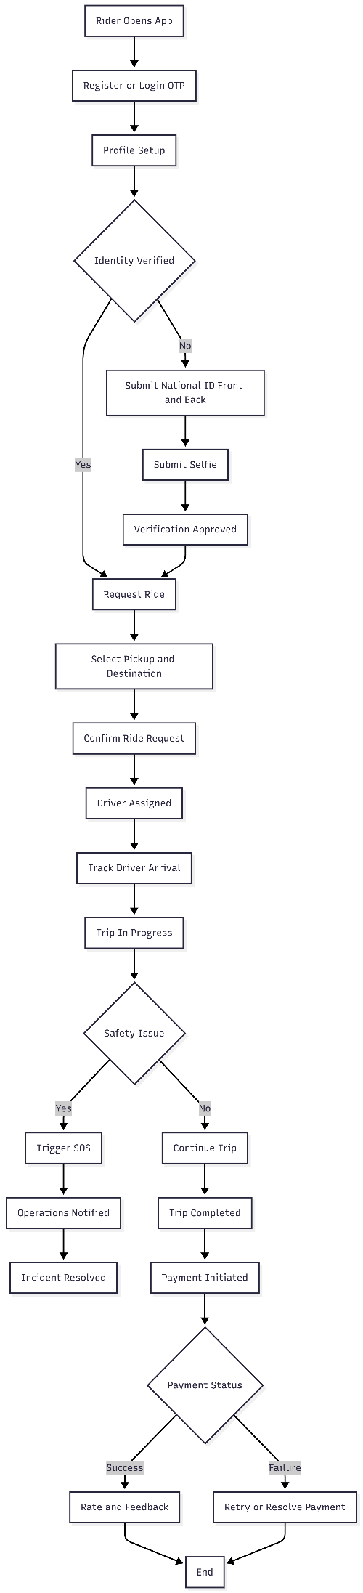

7.2 Driver Journey Diagram
This diagram shows the lifecycle of a female driver, starting from registration and identity verification, through administrative approval, availability management, ride handling, trip execution, and earnings visibility. It also highlights safety escalation during trips.
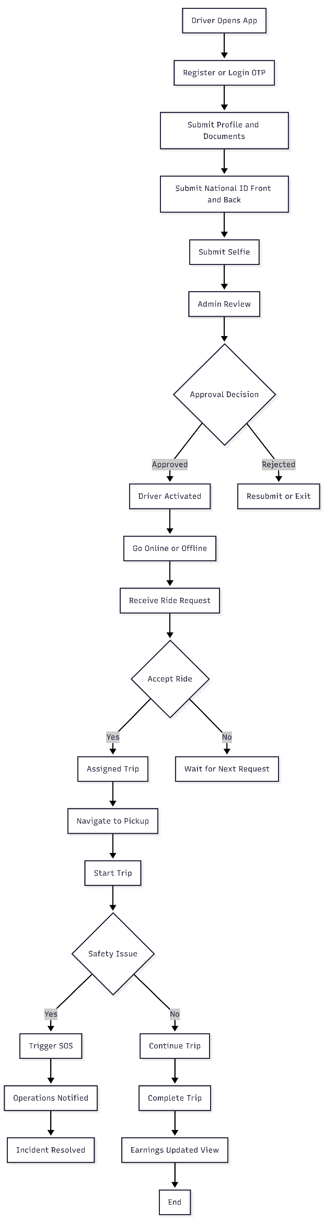

7.3 Ride Lifecycle Diagram
This diagram represents the business states of a ride from the moment it is requested until it is either completed or cancelled. It provides a unified view of valid ride transitions and termination points.
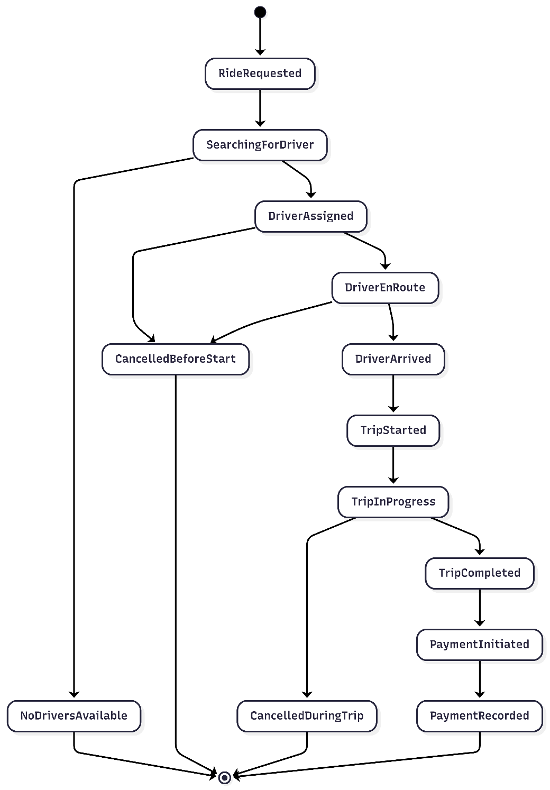

7.4 Ride Cancellation Flow Diagram
This diagram explains how ride cancellations are handled from a business perspective, distinguishing between rider-initiated and driver-initiated cancellations, and showing how timing affects applicable rules and financial impact.
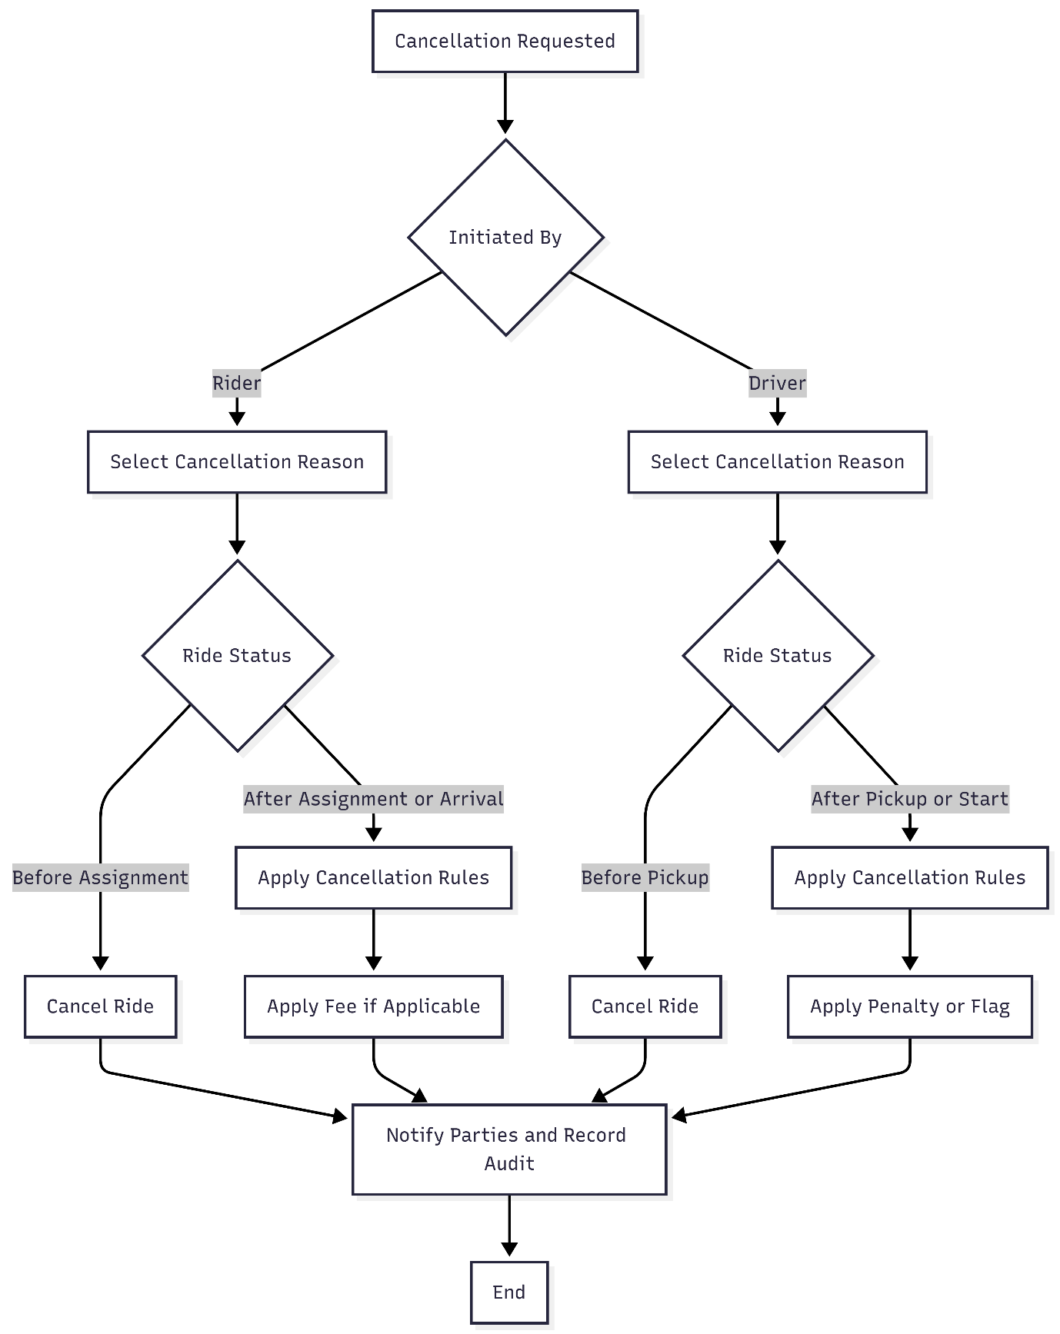

7.5 SOS & Safety Escalation Diagram
This diagram illustrates the safety escalation process when a rider or driver triggers an SOS during an active trip, including notification of operations, incident tracking, escalation, and closure.
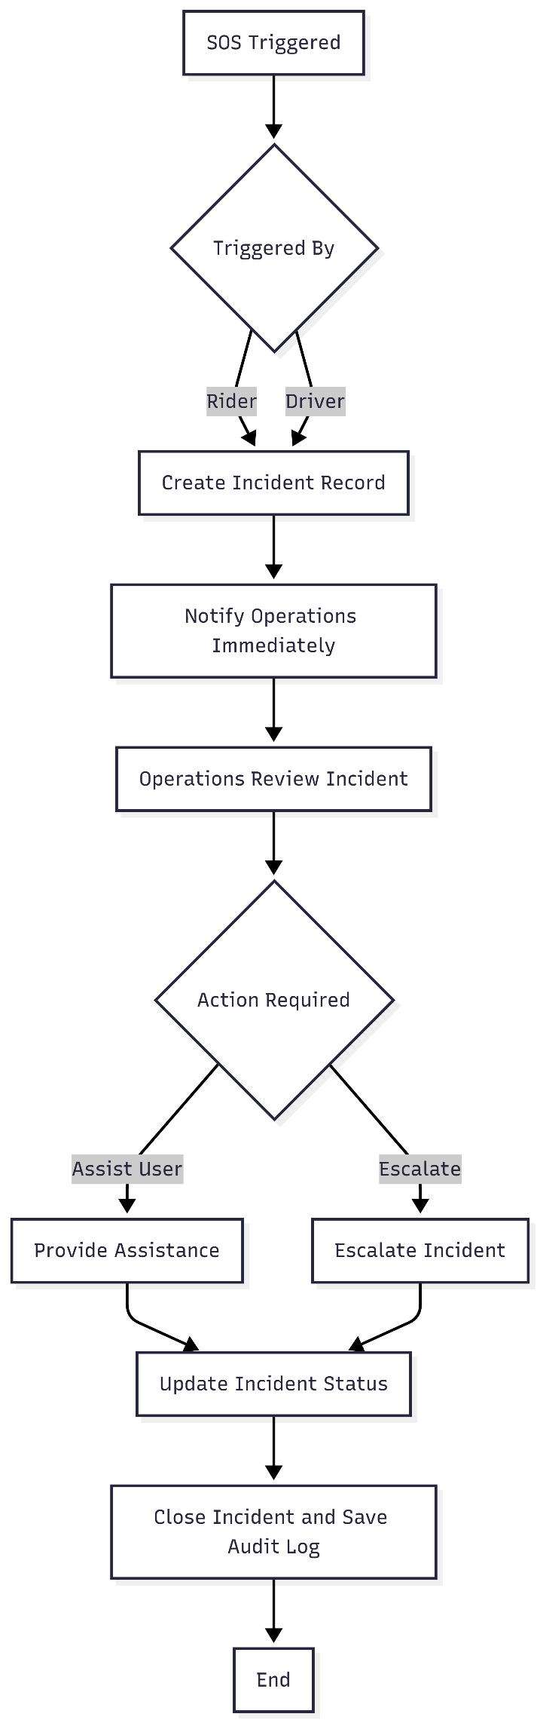

7.6 Payment High-Level Flow Diagram
This diagram shows the business flow of payment processing after trip completion, including fare calculation, payment initiation, success and failure handling, and rider notification.
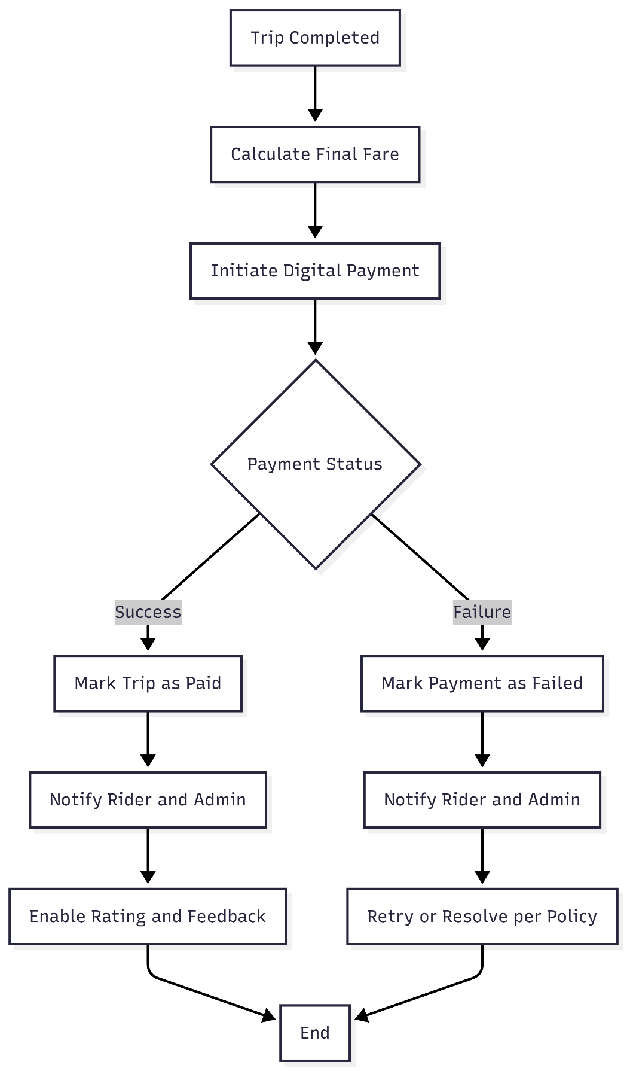

7.7 Rider Account Registration Diagram
This diagram shows how a rider creates an account using mobile OTP, including handling OTP expiry and the case where the mobile number is already registered.
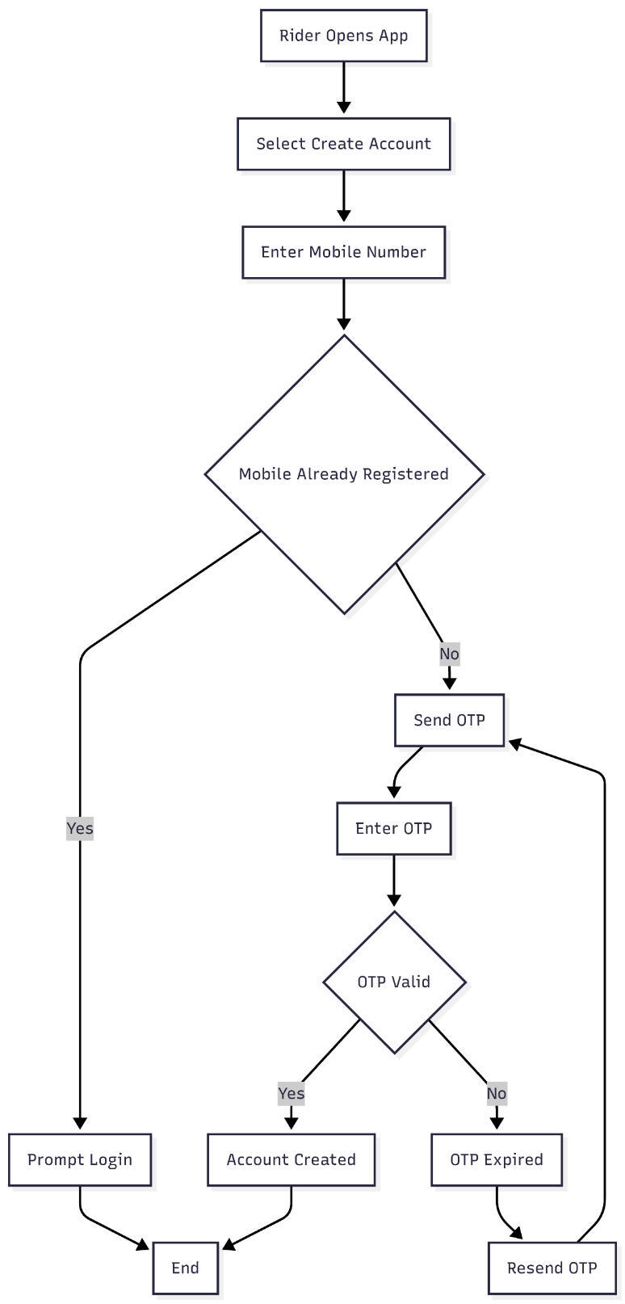

7.8 Rider Identity Verification Diagram
This diagram illustrates the rider identity verification flow required before completing the first trip, including approved, rejected, and pending outcomes.
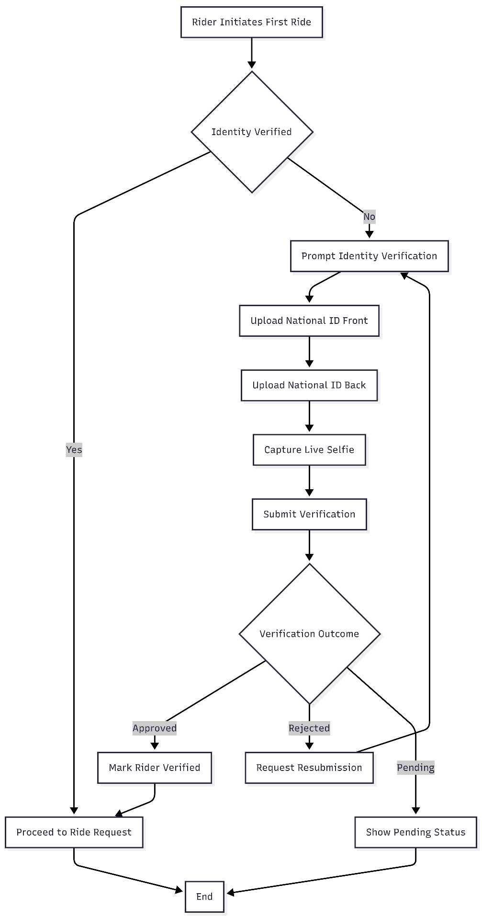

7.9 Driver Identity Verification and Approval Diagram
This diagram shows the driver onboarding verification process, followed by the admin approval step required before the driver can go online and accept rides.
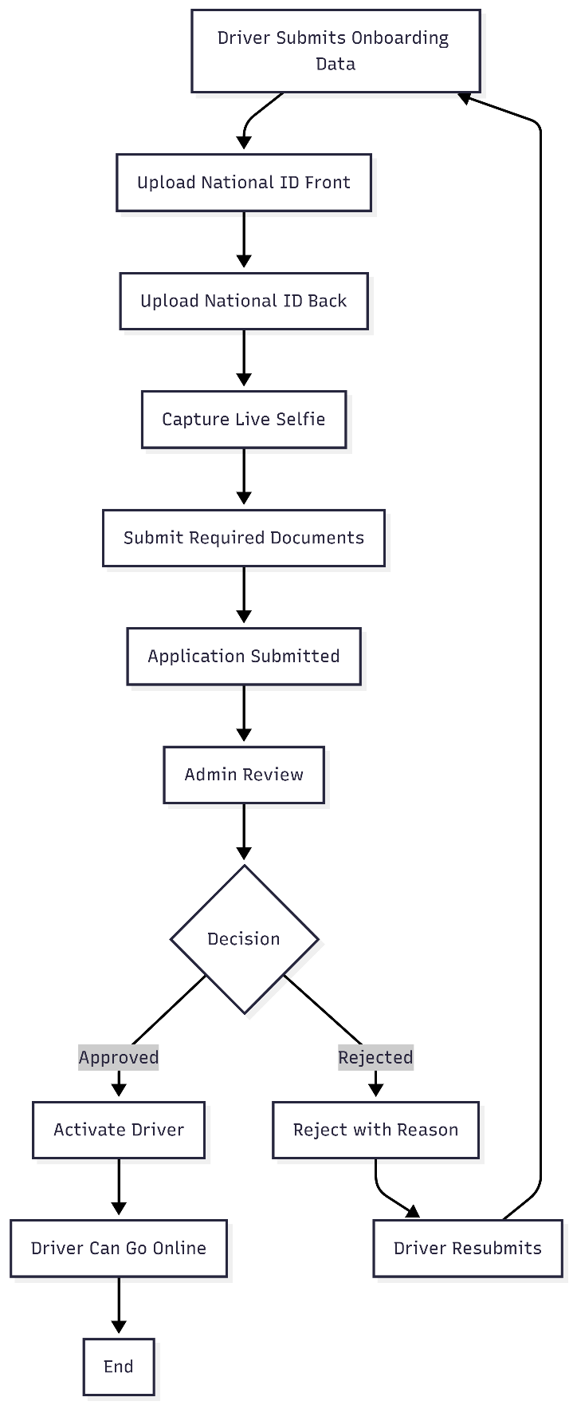

7.10 Ride Request and Assignment Diagram
This diagram describes how a ride request is created and assigned to an eligible driver, including driver acceptance/decline and the case of no available drivers.
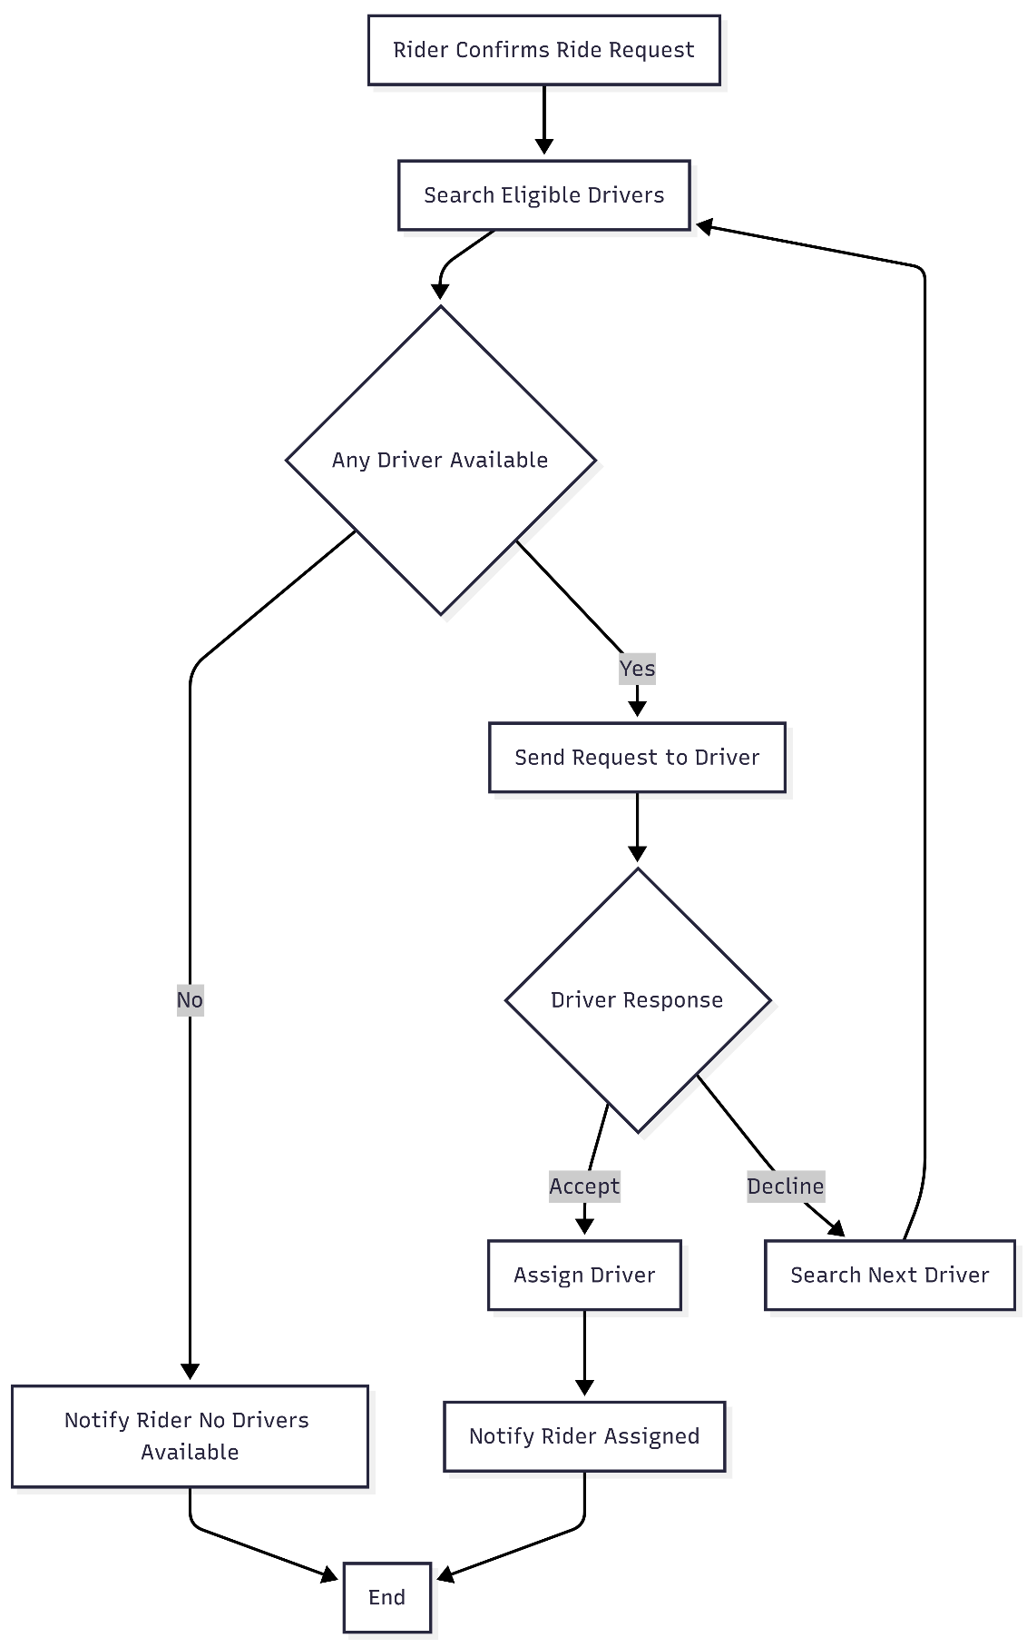

7.11 Payment Failure Resolution Diagram
This diagram explains the business flow when payment fails after trip completion, including retry and the policy-based restriction on requesting new rides until resolution.
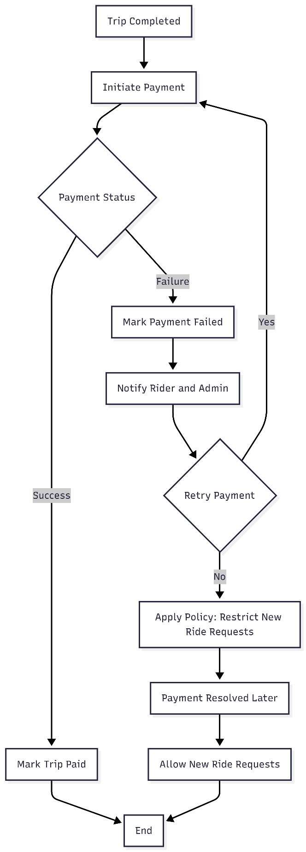

7.12 Admin SOS Handling Diagram
This diagram shows how operations handle an SOS incident from receiving the alert through review, action, and closure, including escalation per safety policy.
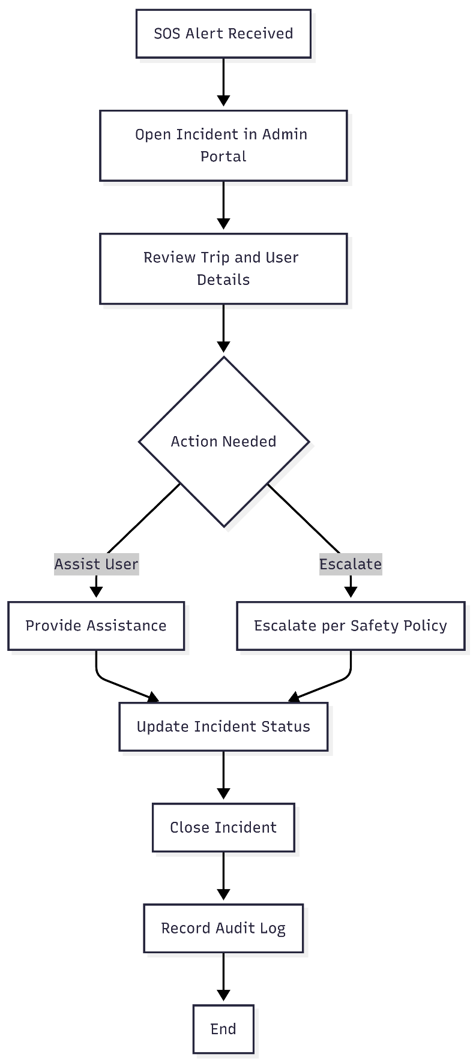

7.13 Cancellation Comparison Diagram (Rider vs Driver)
This diagram compares rider-initiated and driver-initiated cancellations, showing the shared steps (reason capture, rule evaluation, notifications, audit logging) and where business rules may apply fees, penalties, or flags based on timing.
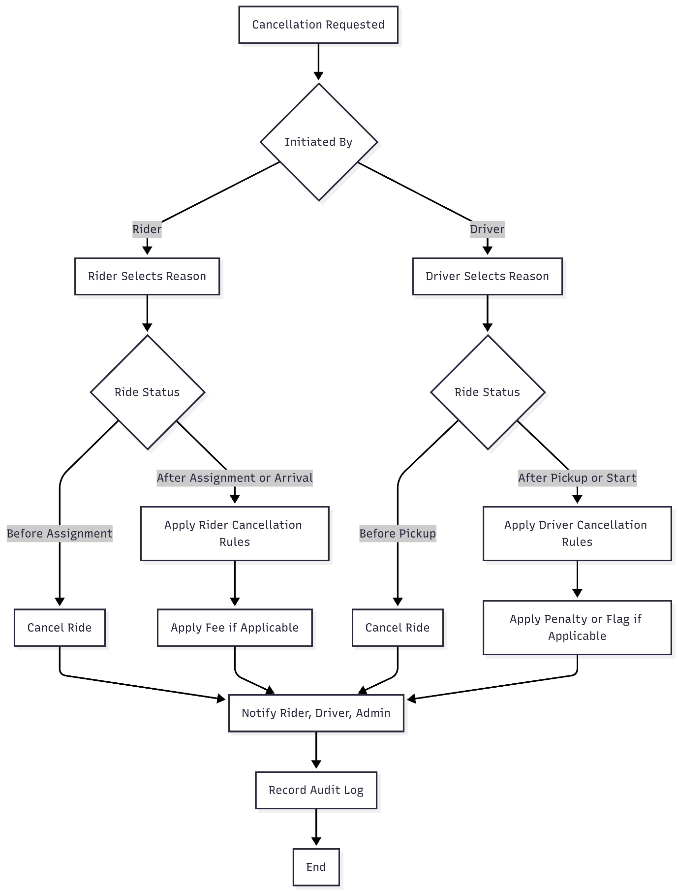

7.14 Reporting Overview Diagram (Operational + Decision-Making)
This diagram illustrates the MVP reporting concept at a business level, distinguishing between Operational Monitoring (day-to-day control) and Decision-Making Reporting (management insights). It shows how platform events feed reporting views without describing technical implementation.
