| Logo | **Australian Influenza**  **Surveillance Report**  **No. 8, 2016, REPORTING PERIOD:**  **3 - 16 September 2016** |
| --- | --- |

The Department of Health acknowledges the providers of the many sources of data used in this report and greatly appreciates their contribution.

# KEY MESSAGES

* In the fortnight ending 16 September 2016, influenza activity declined nationally; however, widespread activity continued to be reported in a number of regions.
* National indicators of influenza-like illness (ILI) declined in the last fortnight, further supporting that the season has peaked nationally. The proportion of patients presenting to sentinel general practitioners with ILI and testing positive for influenza declined this fortnight.
* Influenza A(H3N2) continued to be the dominant circulating influenza virus nationally.
* Notification rates this year to date have been highest in adults aged 75 years or older, with a secondary peak in the very young, aged less than 5 years. This is consistent with influenza A(H3N2) being typically more prevalent in older age groups.
* Clinical severity for the season to date, as measured through the proportion of patients admitted directly to ICU and deaths attributable to pneumonia or influenza, is low to moderate.
* To date, the seasonal influenza vaccines appear to be a good match for circulating virus strains.

# ANALYSIS

## 1. Geographic Spread of Influenza Activity in Australia

In the fortnight ending 16 September 2016 (week 37), influenza activity was reported by state and territory health departments as unchanged when compared with the previous fortnight in all regions of Queensland (QLD) and all regions of Western Australia (WA); as increased in South Australia (SA) and both regions of the Northern Territory (NT); and as decreased in Australian Capital Territory (ACT), New South Wales (NSW), Victoria (VIC) and Tasmania (TAS) (Figure 1).

The geographic spread of influenza activity was reported as regional in NSW, the Central Australia region of the NT, the Tropical region of QLD; and widespread in all other regions of Australia.

Influenza-like illness (ILI) activity reported from syndromic surveillance systems when compared with the previous fortnight was reported as increased in SA; decreased in ACT and NSW, unchanged in NT, TAS, VIC and WA.

Figure . Map of influenza activity by state and territory, Australia, 3 – 16 September 2016.

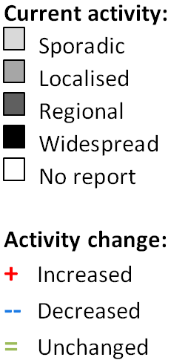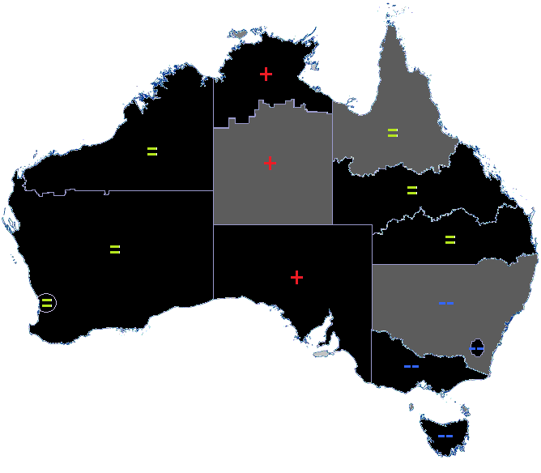

## 2. Laboratory Confirmed Influenza Activity

### Sentinel Laboratory Surveillance

Influenza was detected by sentinel laboratories at decreasing levels over the reporting fortnight. The percentage of tests positive for influenza across all sentinel laboratories was 17.6% in week 37, a decrease from 20.6% in week 36; continuing the decline from the peak in week 35 of 20.8% (Figure 2). Influenza A was the respiratory virus most commonly detected by sentinel laboratories in all reporting states this fortnight.

Figure . Proportion of sentinel laboratory tests positive for influenza, 21 May to 16 September 2016, by subtype and month and week.

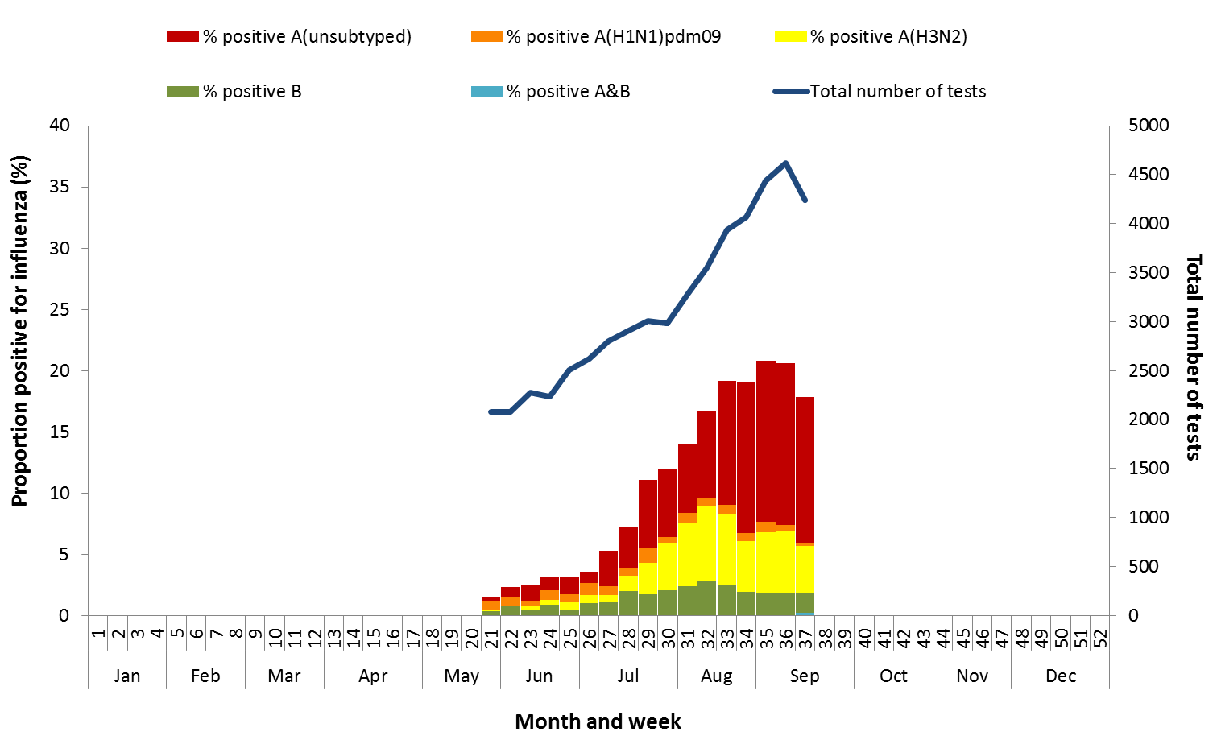

Participating sentinel laboratories: National Influenza Centres (NSW, VIC, WA) and TAS* and SA^ public laboratories.

*PCR testing only; ^Reporting period ends on a Sunday.

### Notifications of Influenza to Health Departments

Notifications of laboratory confirmed influenza to the National Notifiable Diseases Surveillance System (NNDSS) have decreased this reporting fortnight, continuing the decline from the peak in week 35 (Figure 3). For the year to 16 September, a total of 66,648 notifications of laboratory confirmed influenza were reported to the NNDSS: 28,768 in NSW; 17,430 in QLD; 8,417 in VIC; 5,923 in WA; 3,657 in SA; 1,374 in ACT; 733 in TAS and 346 in the NT (Figure 4).

For the year to 16 September, 90% of notifications of laboratory confirmed influenza to the NNDSS were influenza A (71% A(unsubtyped), 7% influenza A(H1N1)pdm09 and 11% influenza A (H3N2)), 10% were influenza B and less than 1% were influenza C, influenza A&B co-infections or untyped (Figure 5). In the most recent fortnight, 92% of notifications of laboratory confirmed influenza to the NNDSS were influenza A (83% influenza A(unsubtyped), 2% influenza A(H1N1)pdm09 and 8% influenza A (H3N2), 8% were influenza B and less than 1% were influenza C, influenza A&B co-infections or untyped.

While the number of influenza A(H3N2) notifications decreased over the reporting fortnight the number continued to exceed the number of influenza A(H1N1)pdm09 notifications, with almost five notifications of influenza A(H3N2) reported to the NNDSS for every one influenza A(H1N1)pdm09 in the reporting fortnight.

So far in 2016, notification rates have been highest in adults aged 75 years or older, with a secondary peak in the very young, aged less than 5 years (Figure 6). While influenza A(H3N2) is detected across all age groups, it accounts for a greater proportion of influenza A where subtyping is available in adults aged 65 years or older, than in any other age group (Figure 7).

Figure . Notifications of laboratory confirmed influenza, Australia, 1 January 2012 to 16 September 2016, by month and week of diagnosis.

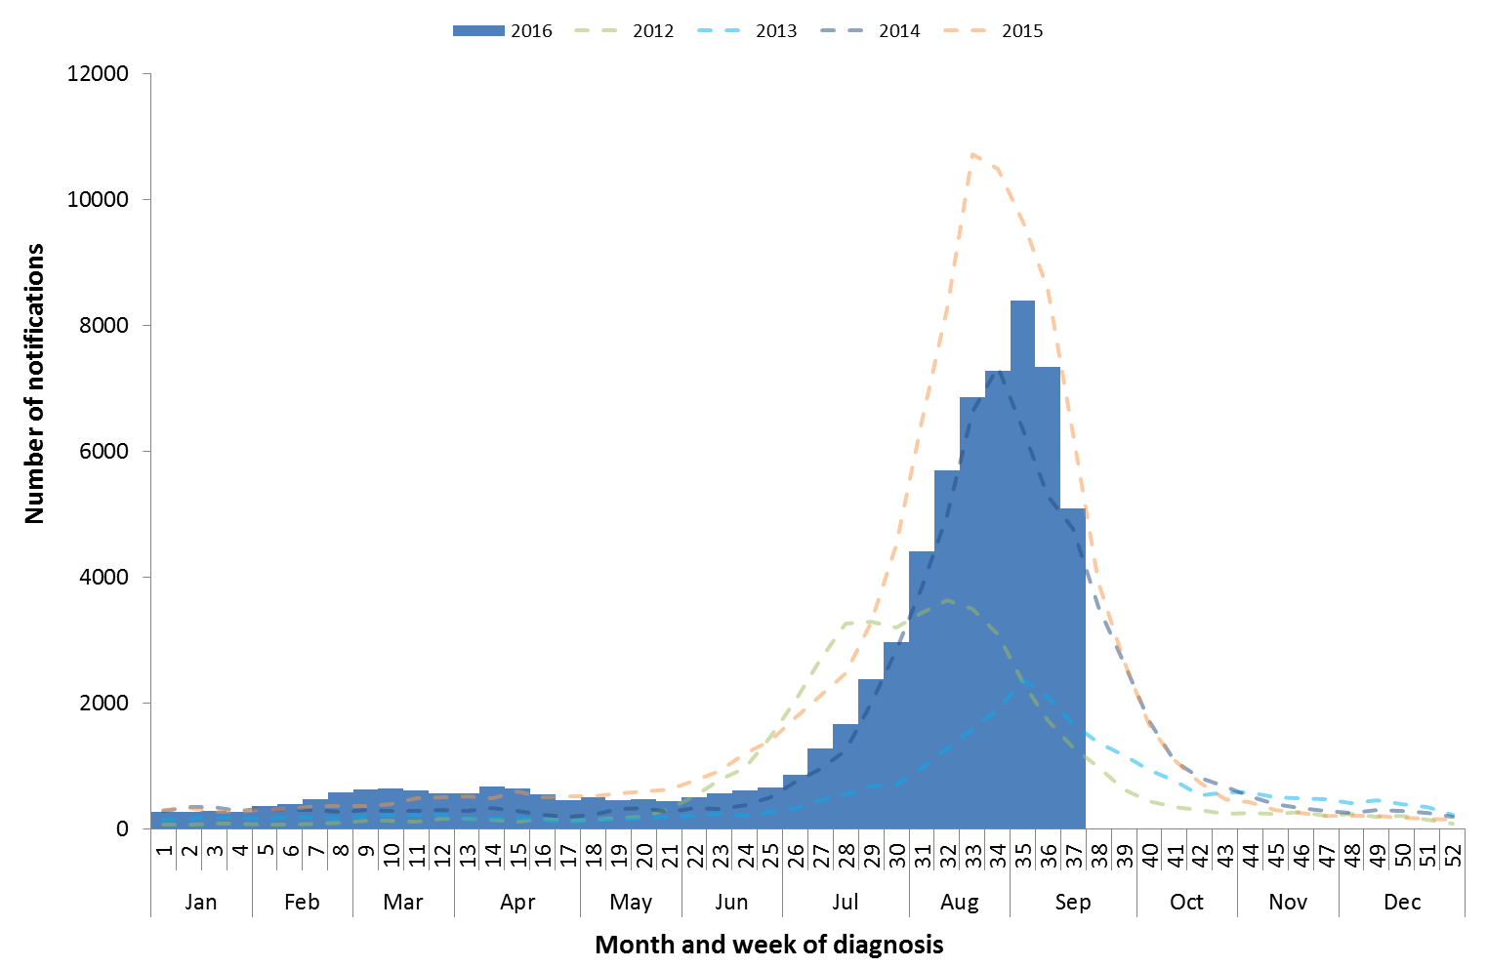

Source: NNDSS

Figure . Notifications of laboratory confirmed influenza, 2 January to 16 September 2016, by state or territory and week.

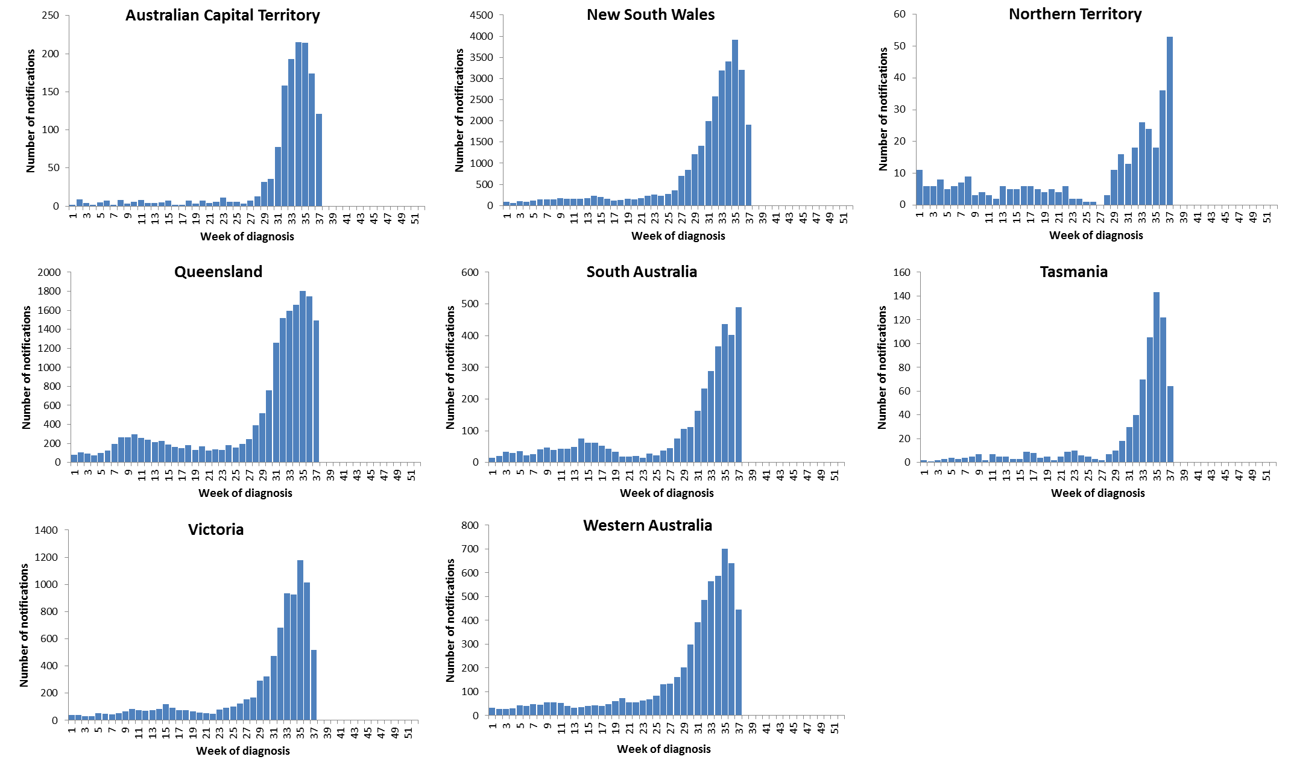

Source: NNDSS

Figure . Notifications of laboratory confirmed influenza, Australia, 2 January to 16 September 2016, by subtype and week.

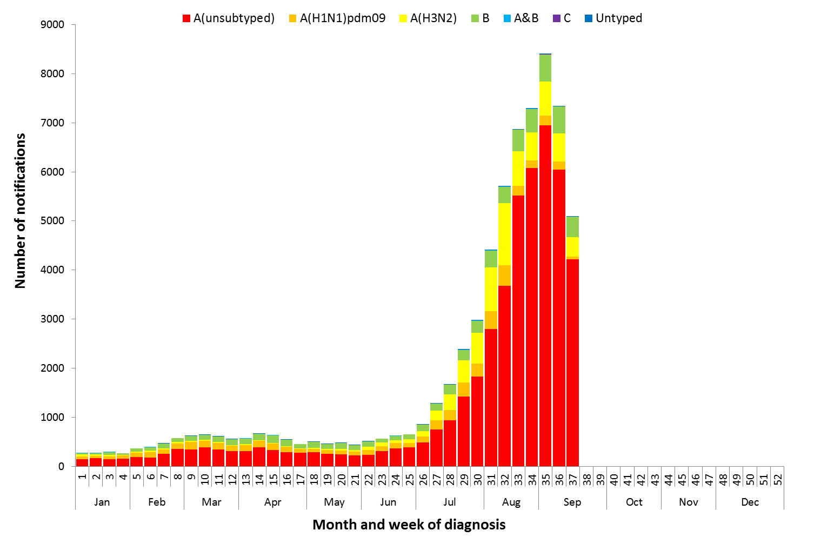

Source: NNDSS

Figure . Rate of notifications of laboratory confirmed influenza, Australia, 1 January to 16 September 2016, by age group and subtype.

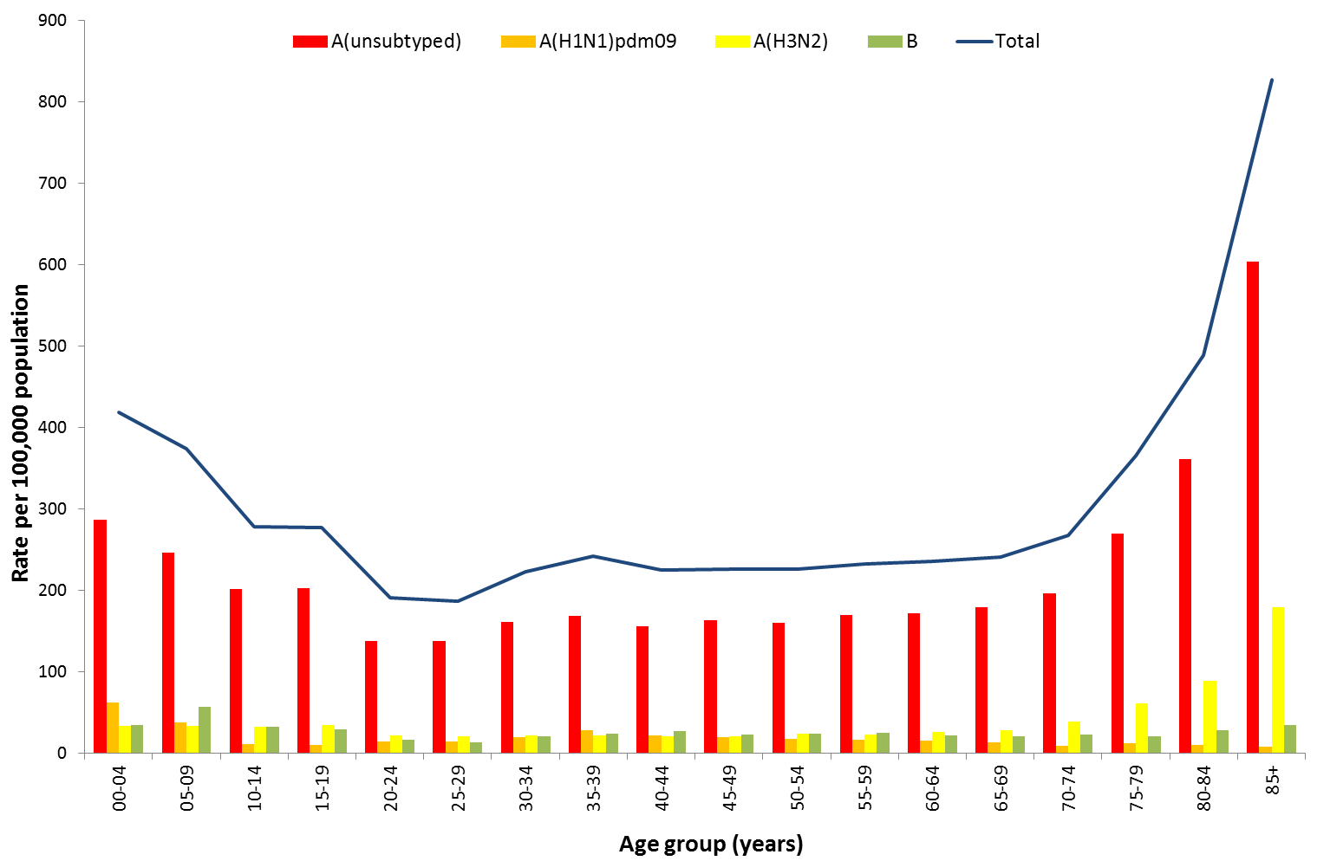

Source: NNDSS

Figure . Notifications of laboratory confirmed influenza by week of diagnosis and cumulative year to date, Australia, 2 January to 16 September 2016, by age group and subtype.

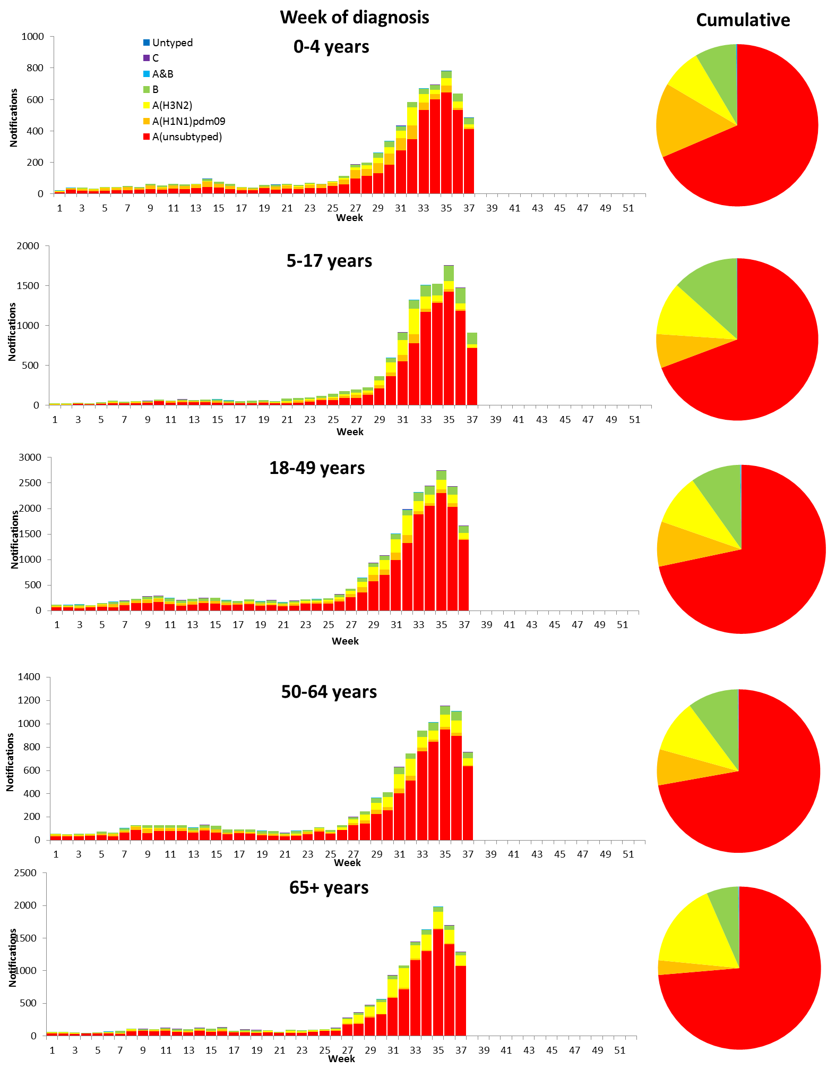

## 3. Influenza-like Illness Activity

### Community Level Surveillance

FluTracking, a national online system for collecting data on ILI in the community, indicated that rates of ILI among participants reached a plateau between weeks 32 and 36, rather than the sharper seasonal peaks reported in recent years. ILI activity among participants in weeks 36 and 37 declined; consistent with previous years. (Figure 8). The proportion of participants reporting fever and cough declined from week 36 (2.6%) to 37 (2.3%). The proportion of participants reporting fever, cough and absence from normal duties declined over the fortnight from 1.9% in week 36 to 1.7% in week 37. So far this year 61% of all participants and 81% of participants who identify as working face-to-face with patients reported receiving the seasonal influenza vaccine.[1]

Figure . Proportion of fever and cough among FluTracking participants, Australia, between May and October, 2012 to 2016, by month and week.

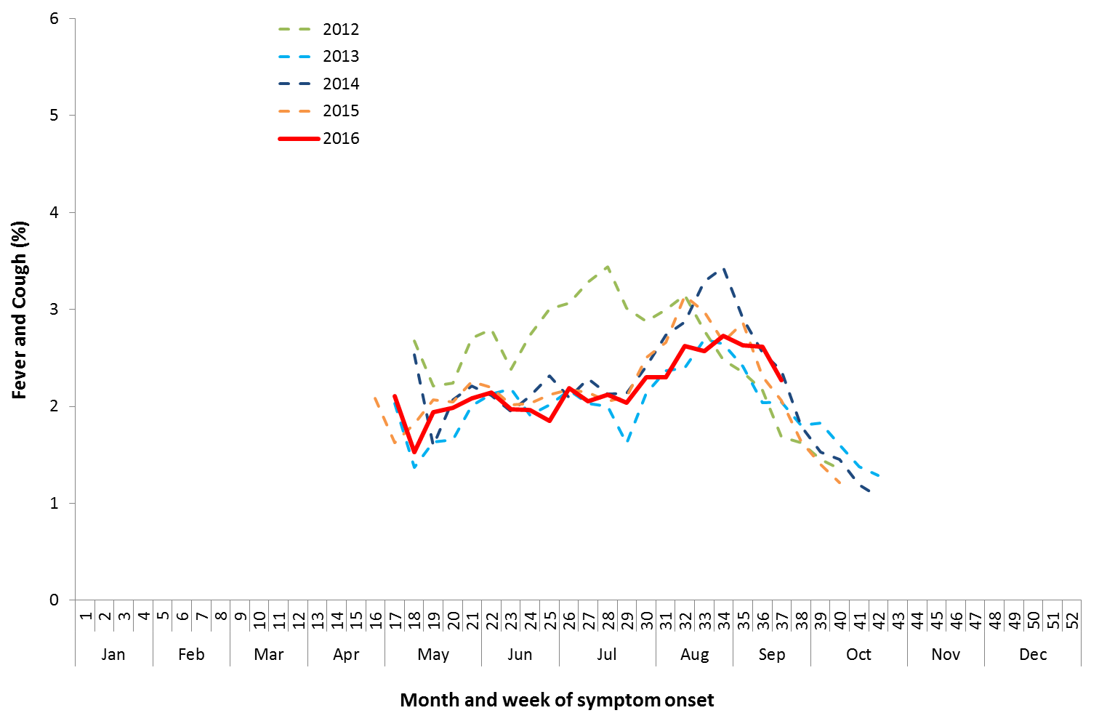

Source: FluTracking

### Sentinel General Practice Surveillance

Sentinel general practitioner ILI consultations were unchanged this fortnight with 11.9 per 1,000 consultations in week 37, and 11.9 per 1,000 consultations in week 36 (Figure 9). This continues a decline from the peak reached in week 33 of 15.1 ILI consultations per 1,000 consultations.

Of the 97 specimens taken from ILI patients seen by a sentinel practitioner during the current reporting fortnight, 40 (41%) were positive for influenza, with influenza A (H3N2) being the predominant influenza subtype identified (Figure 10).

Figure . Unweighted rate of ILI reported from sentinel GP surveillance systems, Australia, 1 January 2012 to 18 September 2016, by month and week.

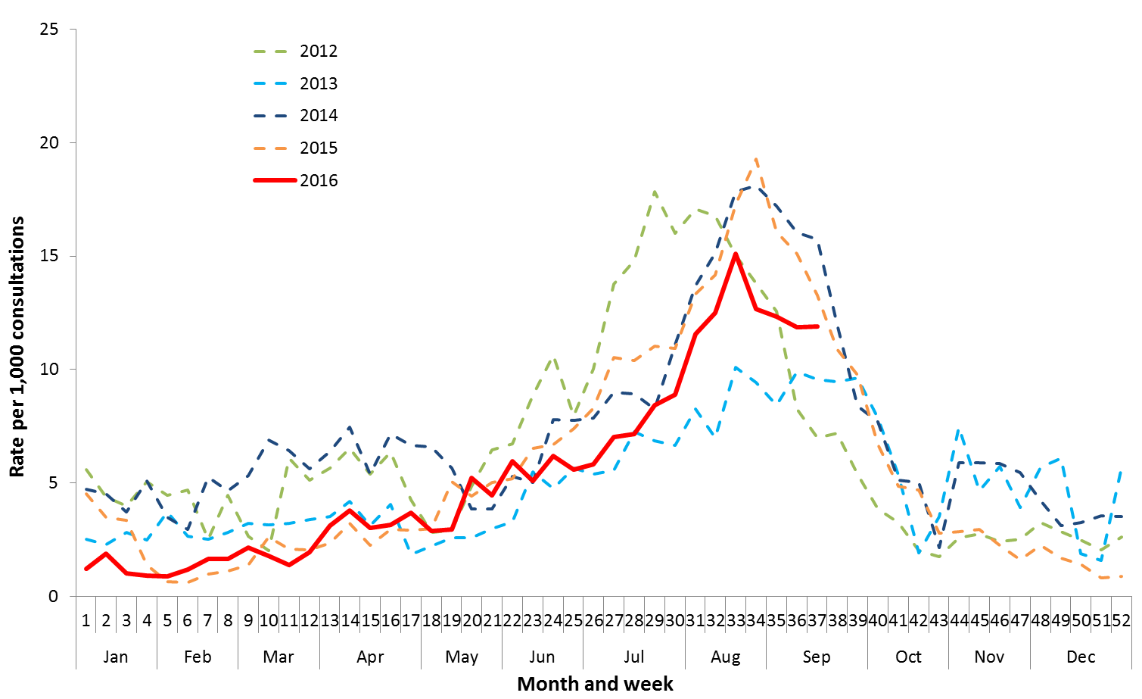

SOURCE: ASPREN and VicSPIN

Figure . Proportion of respiratory viral tests positive for influenza in ASPREN ILI patients and ASPREN ILI consultation rate, Australia, 4 January to 16 September 2016, by month and week.

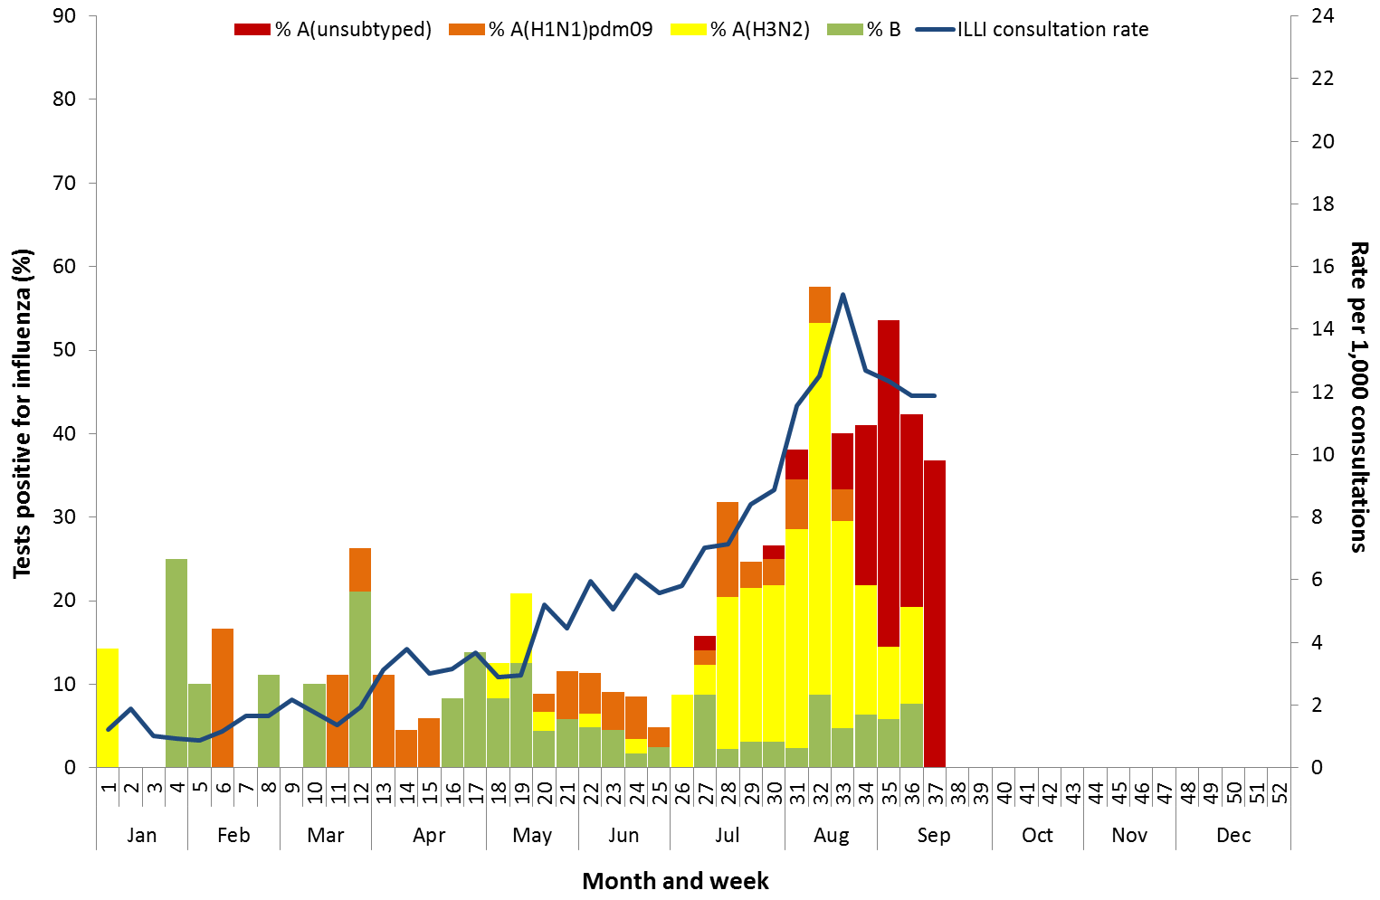

SOURCE: ASPREN

## 4. Hospitalisations

### Sentinel Hospital Surveillance

Admissions with confirmed influenza to sentinel hospitals declined from week 36 to 37; continuing the decline from the peak in week 35 (Figure 11). Since seasonal surveillance commenced through the Influenza Complications Alert Network (FluCAN) sentinel hospital surveillance system on 1 April 2016, a total of 1,407 people have been admitted with confirmed influenza, of which 273 (19%) were children aged less than 15 years and 619 (44%) were adults aged 65 years or older. Approximately 10% of influenza patients have been admitted directly to ICU; this indicator was higher for admissions due to influenza B (14.9%) than admissions due to influenza A (9.4%). Consistent with other systems, the majority of influenza admissions have been due to influenza A (94%). Overall, 72% of patients were reported with significant risk factors, with the presence of risk factors increasing with age.

Figure . Number of influenza hospitalisations at sentinel hospitals, 1 April to 16 September 2016, by month and week of and influenza subtype.

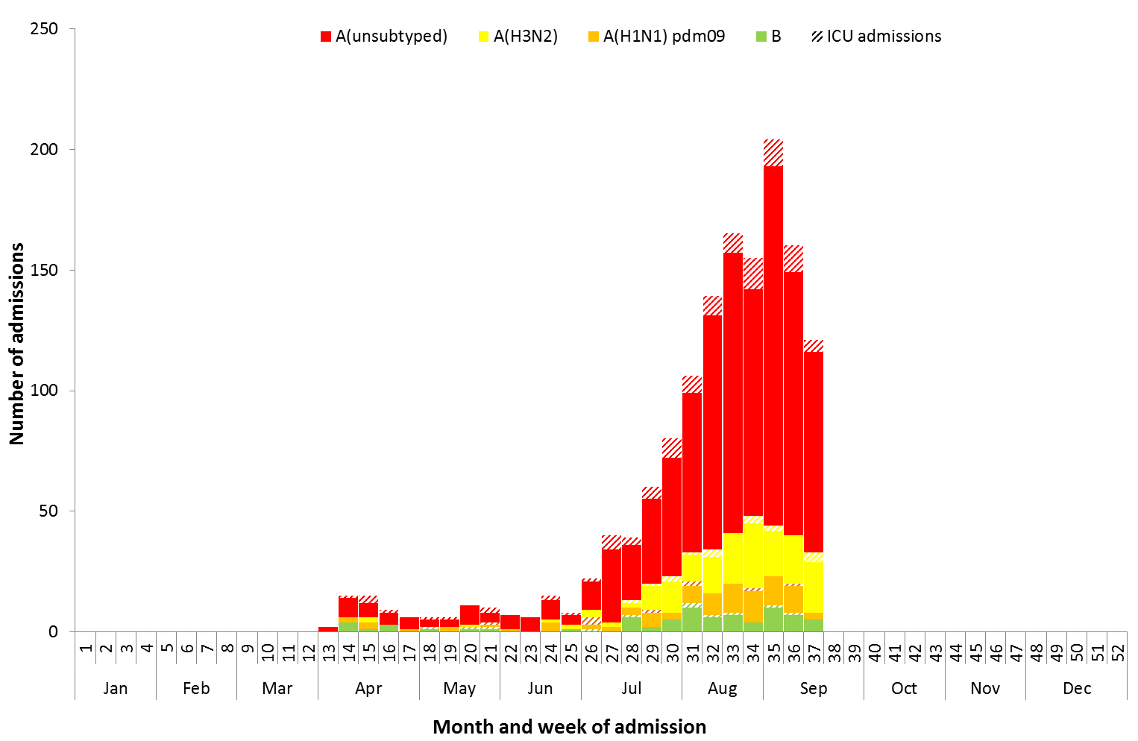

Source: FluCAN Sentinel Hospitals

### Paediatric Severe Complications of Influenza

The Australian Paediatric Surveillance Unit (APSU) conducts seasonal surveillance between July and October annually of children aged 15 years and under who are hospitalised with severe complications of influenza. Between 1 July 2016 and 18 September 2016, there were 10 hospitalisations associated with severe complications of influenza reported to APSU. The median age of the cases was 3.2 years. All cases were associated with influenza A infection. Two cases reported having an underlying chronic condition, seven cases were not vaccinated for influenza and three had an unknown vaccination status.

## 5. Deaths Associated with Influenza and Pneumonia

### Nationally Notified Influenza Associated Deaths

So far in 2016, 48 influenza associated deaths have been notified to the NNDSS. The median age of deaths notified was 79 years (range 0 to 96 years). The number of influenza associated deaths reported to the NNDSS is reliant on the follow up of cases to determine the outcome of their infection and most likely does not represent the true mortality associated with this disease.

### New South Wales Influenza and Pneumonia Death Registrations

Death registration data from NSW for 2016 up to the week ending 2 September 2016 shows deaths attributed to pneumonia or influenza remained low. (Figure 12).[2]

Figure . Rate of deaths classified as influenza and pneumonia from the NSW Registered Death Certificates, 2011 to 2 September 2016.

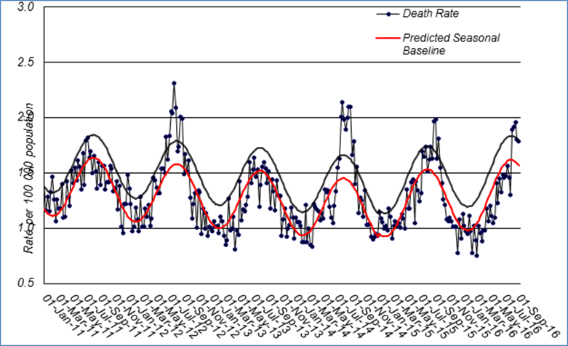

Source: NSW Registry of Births, Deaths and Marriages

## 6. Virological Surveillance

### Australian Influenza Vaccines Composition 2016

The influenza virus strains included in the 2016 seasonal influenza vaccines in Australia are:

* A/California/7/2009, (H1N1)pdm09-like virus;
* A/Hong Kong/4801/2014, (H3N2)-like virus;
* B/Brisbane/60/2008-like virus, Victoria lineage;
* B/Phuket/3073/2013-like virus, Yamagata lineage (Quadrivalent influenza vaccine only).

### Typing and Antigenic Characterisation

In 2016, up to 19 September the World Health Organization Collaborating Centre for Reference and Research on Influenza (WHOCC) characterised 759 influenza viruses (Table 1). When further characterised for similarity to the vaccine components, isolates appeared to be well matched. All the influenza B isolates were characterised as similar to the vaccine components. A small number of influenza A(H1N1)pdm09 isolates (n=29) and influenza A(H3N2) isolates (n=23) were characterised as low reactors.

Table . Australian influenza viruses typed by HI from the WHOCC, 1 January to 19 September 2016.

|  |  |  |  |  |  |  |  |  |  |
| --- | --- | --- | --- | --- | --- | --- | --- | --- | --- |
| **Type/Subtype** | **ACT** | **NSW** | **NT** | **QLD** | **SA** | **TAS** | **VIC** | **WA** | **TOTAL** |
| **A(H1N1) pdm09** | 10 | 157 | 14 | 166 | 32 | 39 | 62 | 19 | 499 |
| **A(H3N2)** | 5 | 63 | 0 | 16 | 14 | 7 | 45 | 12 | 162 |
| **B/Victoria lineage** | 3 | 12 | 1 | 14 | 6 | 0 | 5 | 5 | 46 |
| **B/Yamagata lineage** | 5 | 11 | 1 | 16 | 4 | 1 | 8 | 6 | 52 |
| **Total** | 23 | 243 | 16 | 212 | 56 | 47 | 120 | 42 | 759 |

SOURCE: WHO CC

Note: Viruses tested by the WHO CC are not necessarily a random sample of all those in the community.

State indicates the residential location for the individual tested, not the submitting laboratory.

There may be up to a month delay on reporting of samples.

### Antiviral Resistance

The WHOCC reported that from 1 January to 5 September 2016, of the 1,005 influenza viruses tested for neuraminidase inhibitor resistance, three influenza A(H1N1)pdm09 viruses have shown highly reduced inhibition to the antiviral drug Oseltamivir.

## 7. International Surveillance

The World Health Organization reported that influenza activity varied in countries of temperate South America and increased steadily in the last few weeks in Oceania.[3] Influenza activity in the temperate zone of the northern hemisphere was at inter-seasonal levels.

# DATA CONSIDERATIONS

***The information in this report is reliant on the surveillance sources available to the Department of Health. As access to sources vary throughout the season, this report will draw on available information.***

Detailed notes on interpreting the data presented in this report are available at the Department of Health’s [Australian Influenza Surveillance Report website](http://www.health.gov.au/flureport) (www.health.gov.au/flureport).

This report aims to increase awareness of influenza activity in Australia by providing an analysis of the various surveillance data sources throughout Australia. While every care has been taken in preparing this report, the Commonwealth does not accept liability for any injury or loss or damage arising from the use of, or reliance upon, the content of the report. Delays in the reporting of data may cause data to change retrospectively. For further details about information contained in this report please contact the [Influenza Surveillance Team](mailto:flu@health.gov.au) ([flu@health.gov.au](mailto:flu@health.gov.au)).

# REFERENCES

1. FluTracking, FluTracking Weekly Interim Report, Week ending 18 September 2016. Available from [FluTracking Reports](http://www.flutracking.net/Info/Reports) (http://www.flutracking.net/Info/Reports) [Accessed 22 September 2016].
2. Personal communication, Robin Gilmour, Health Protection NSW, NSW Ministry of Health, 21 September August 2016.
3. WHO, Influenza Update No. 272, 19 September 2016. Available from the [WHO website](http://www.who.int/influenza/surveillance_monitoring/updates/latest_update_GIP_surveillance/en/) (http://www.who.int/influenza/surveillance_monitoring/updates/latest_update_GIP_surveillance/en/) [Accessed 22 September 2016].