| Logo | **Australian Influenza**  **SURVEILLANCE REPORT**  **No. 1, 2017**  **Reporting period 13 - 26 May 2017** |
| --- | --- |

The Department of Health acknowledges the providers of the many sources of data used in this report and greatly appreciates their contribution.

# KEY MESSAGES

* Influenza activity has increased slightly in the last month, but remains at inter-seasonal levels across Australia.
* Detections of influenza B viruses have increased in recent weeks, consistent with the predominance of influenza B viruses worldwide currently.[1]
* Respiratory viruses other than influenza are more commonly causing influenza-like illness presentations to sentinel general practitioners, with rhinovirus and respiratory syncytial virus (RSV) detected most frequently.
* There is no indication of the potential severity of the 2017 season at this time.
* To date, the seasonal influenza vaccines appear to be a good match for circulating virus strains.

# ANALYSIS

## 1. Laboratory Confirmed Influenza Activity

### Notifications of Influenza to Health Departments

Notifications of laboratory confirmed influenza reported to the National Notifiable Diseases Surveillance System (NNDSS) were higher over the 2016-17 inter-seasonal period this year when compared to previous years. Notifications received from January to March this year were 64% higher than the same period in 2016 and 148% higher than the 5 year mean for the period. Notifications declined over April but increased over   
May (Figure 1). It is unlikely that the high number of notifications in the inter-seasonal period was entirely due to an increase in incidence of influenza in the community; however the influence of health seeking behaviours and testing practices is unable to be quantified and so notification data outside the context of the other National Influenza Surveillance Scheme surveillance systems must be interpreted with caution.

For the year-to-date (YTD) to 26 May, a total of 12,772 notifications of laboratory confirmed influenza were reported to the NNDSS: 4,306 in Queensland (Qld); 3,668 in NSW; 1,795 in Victoria (VIC); 1,557 in South Australia (SA); 637 in Western Australia (WA); 531 in the Northern Territory (NT); 169 in Tasmania (Tas) and 109 in the Australian Capital Territory (ACT).

Notifications in individual jurisdictions have largely increased in recent weeks, with the exception of the NT and WA, where notifications remained relatively stable in recent weeks (Figure 2).

For the YTD to 26 May, 82% of notifications of laboratory confirmed influenza to the NNDSS were influenza A (70% A(unsubtyped), 10% influenza A(H3N2) and 2% influenza A(H1N1)pdm09), 18% were influenza B and less than 1% were influenza A&B co-infections or untyped (Figure 3). The overall proportion of influenza A reported by jurisdictions so far this year has been generally consistent with the national proportion, ranging from 78% in NSW to 87% in Qld. However the ratio of influenza A(H1N1)pdm09 to influenza A(H3N2) has varied substantially across jurisdictions. Nationally, for every 1 notification of influenza A(H1N1)pdm09 reported to the NNDSS so far this year, 5.1 influenza A(H3N2) notifications were reported. This ranged from a ratio of 1:0.2 in Vic to 1:18.5 in NT.

In the last fortnight, 70% of notifications of laboratory confirmed influenza to the NNDSS were influenza A (61% A(unsubtyped), 5% influenza A(H3N2) and 4% influenza A(H1N1)pdm09), 30% were influenza B and less than 1% were influenza A&B co-infections. The number and proportion of notifications for infection with influenza B has been increasing since the first week of May (Figure 4). This increasing trend of influenza B has been reported in a number of jurisdictions, most notably in NSW where 44% of notifications in the last fortnight were influenza B.

Notification rates so far this year have generally increased with age (Figure 5). YTD to 26 May, the highest age-specific notification rate for all influenza notifications was in the elderly aged 85 years and older (151.6 notifications per 100,000 population). Influenza A(H1N1)pdm09 was highest in children aged less than 5 years (2.7 notifications per 100,000 population), influenza A(H3N2) was highest in the elderly aged 85 years and older (23.8 per 100,000 population) and influenza B was highest in children aged 5 to 9 years (15 notifications per 100,000 population). Increases in notifications in recent weeks have been across all age groups, most prominently in the 5 to 17 years age group (Figure 6).

Figure . Notifications of laboratory confirmed influenza, Australia, 1 January 2013 to 26 May 2017, by month and week of diagnosis.

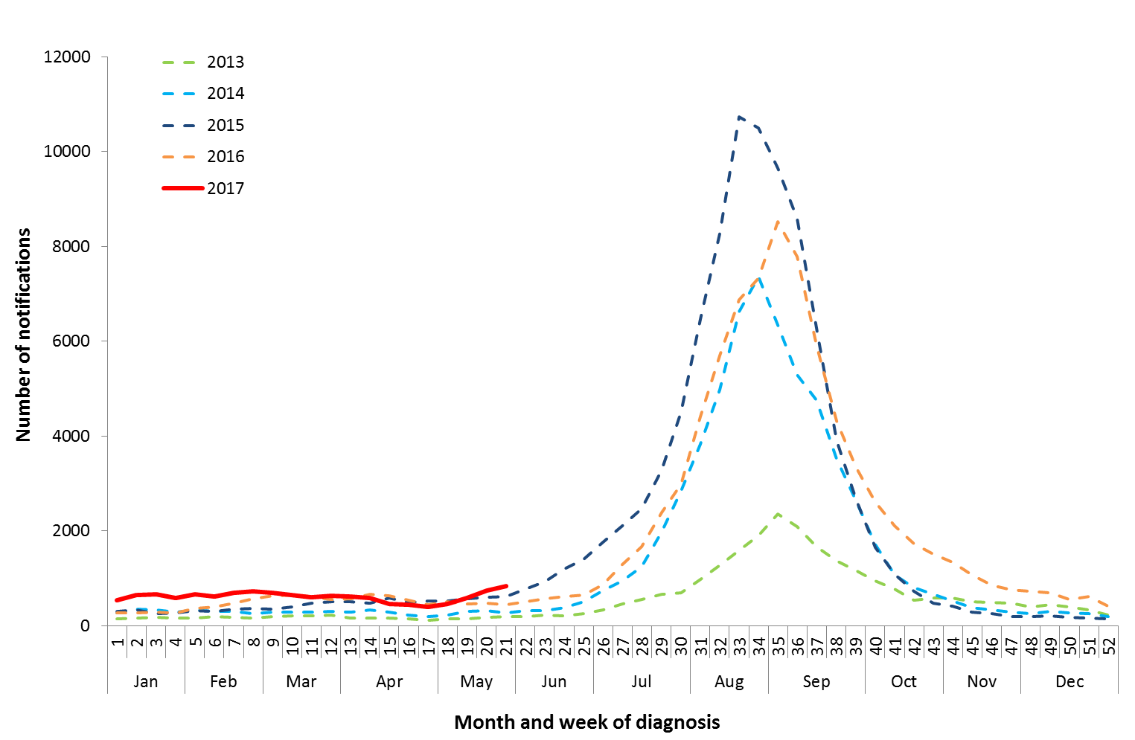

Source: NNDSS

Figure . Notifications of laboratory confirmed influenza, 1 January to 26 May 2017, by state or territory and week.

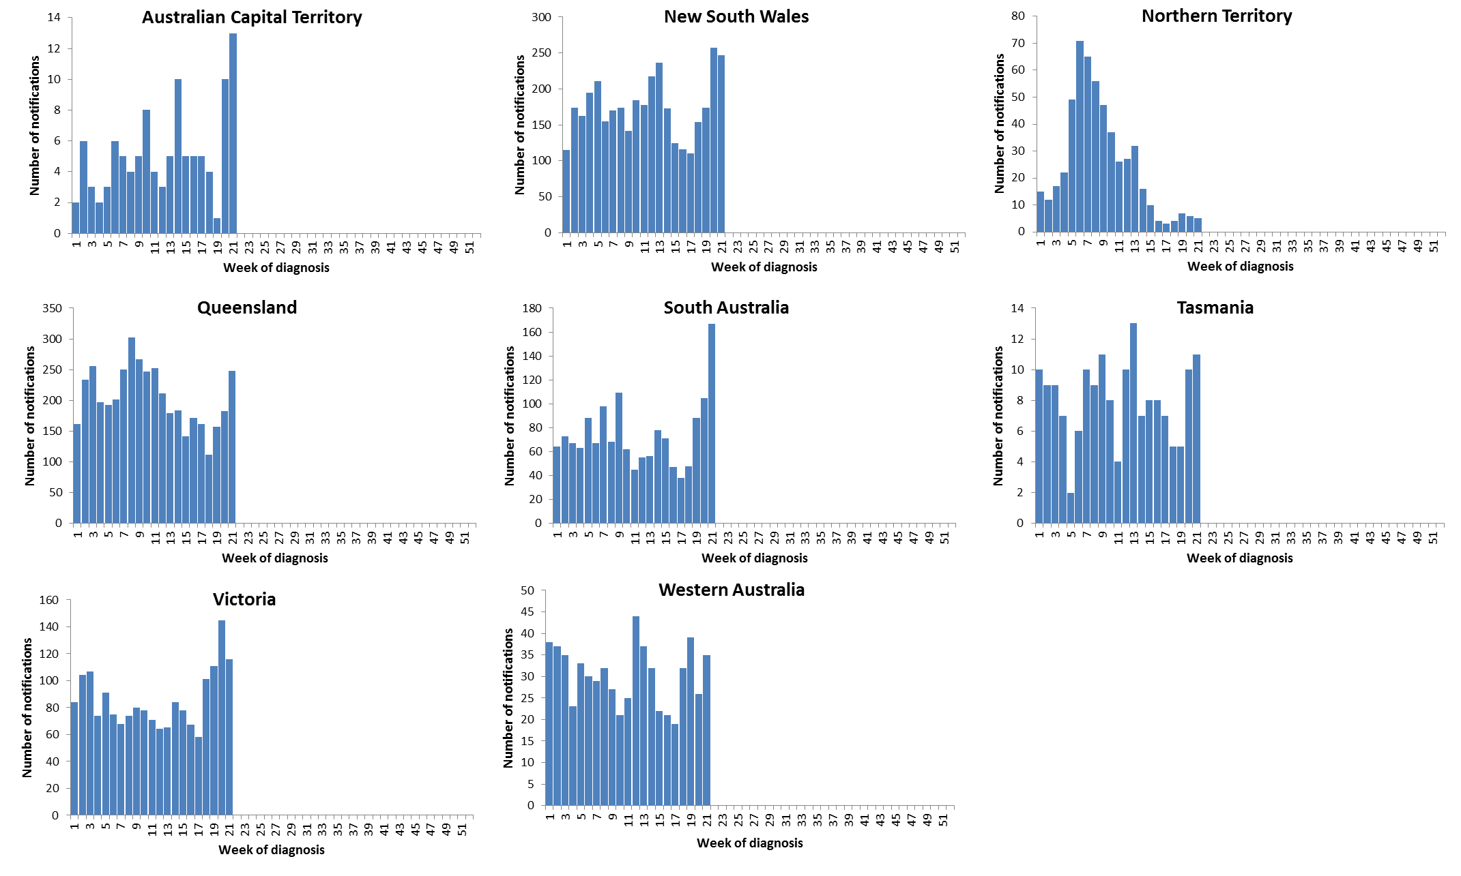

Source: NNDSS

Figure . Per cent of notifications of laboratory confirmed influenza, Australia, 1 January to 26 May 2017, by subtype and state or territory.

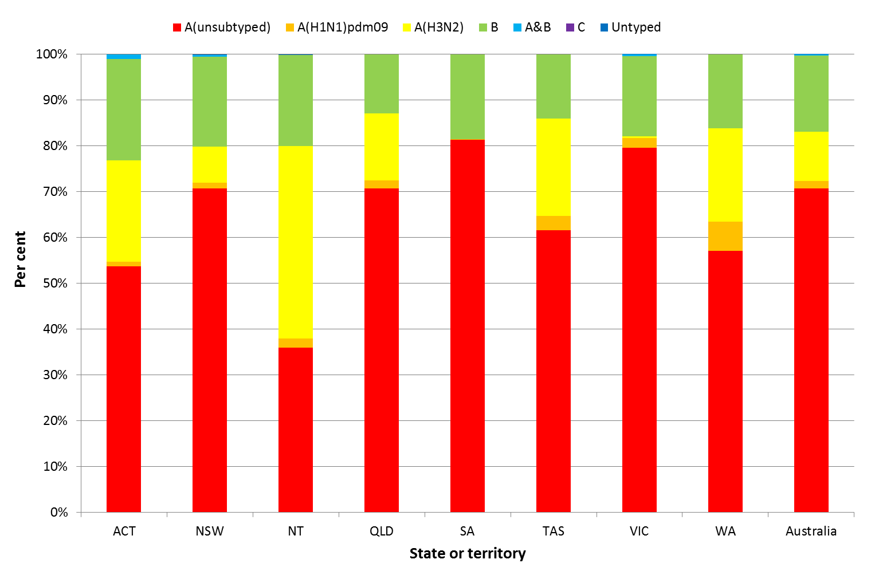

Source: NNDSS

Figure . Per cent of laboratory confirmed influenza, Australia, 1 January to 26 May 2017, by subtype and week.

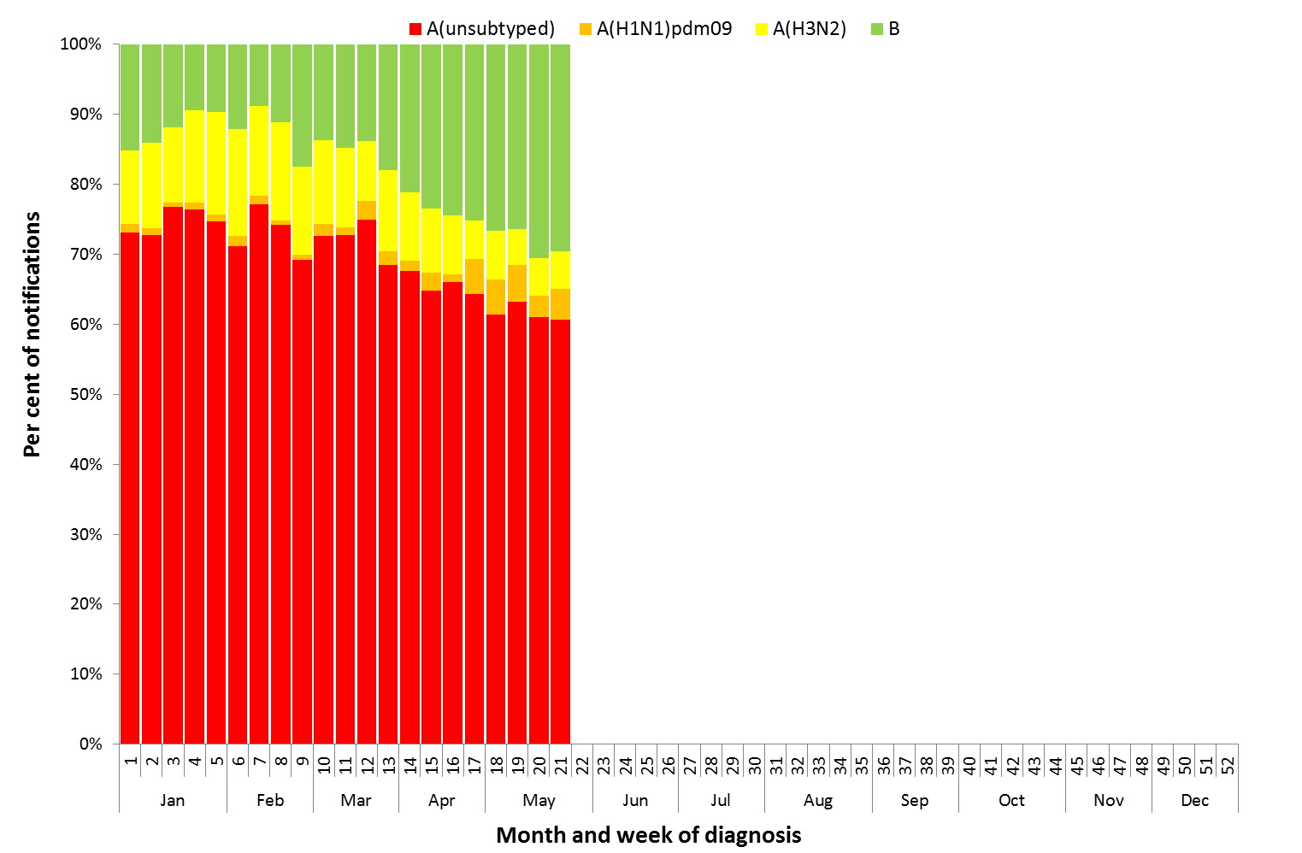

Source: NNDSS

Figure . Rate of notifications of laboratory confirmed influenza, Australia, 1 January to 26 May 2017, by age group and subtype.

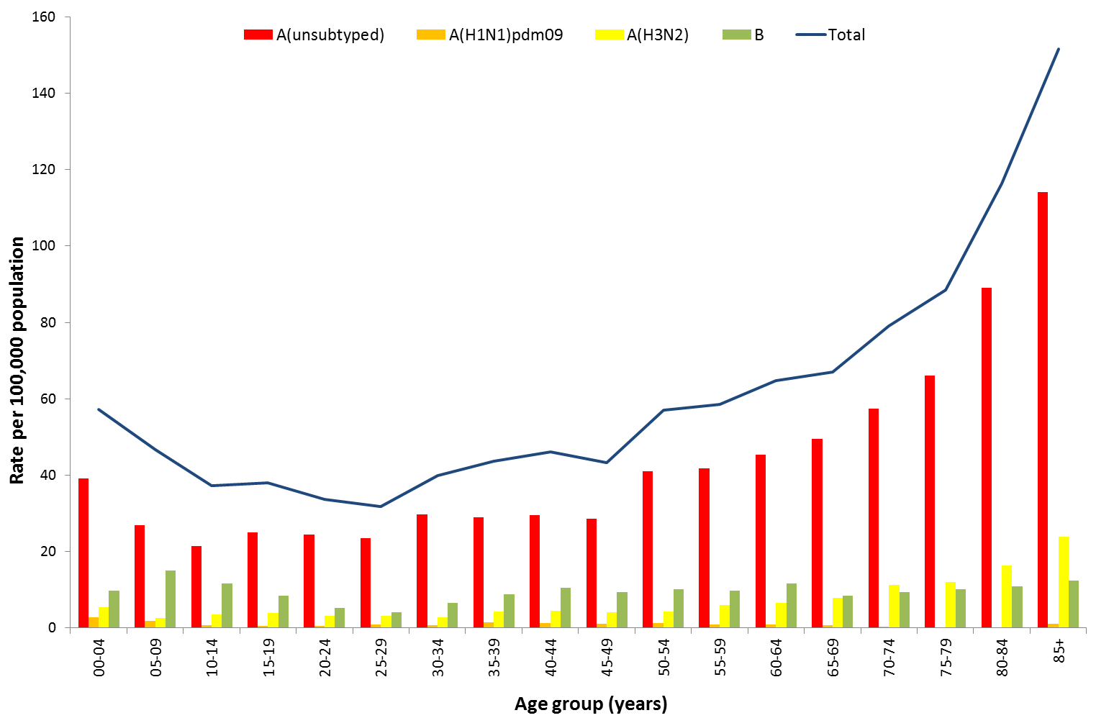

Source: NNDSS

Figure . Notifications of laboratory confirmed influenza by week of diagnosis and cumulative year-to-date, Australia, 1 January to 26 May 2017, by age group and subtype.

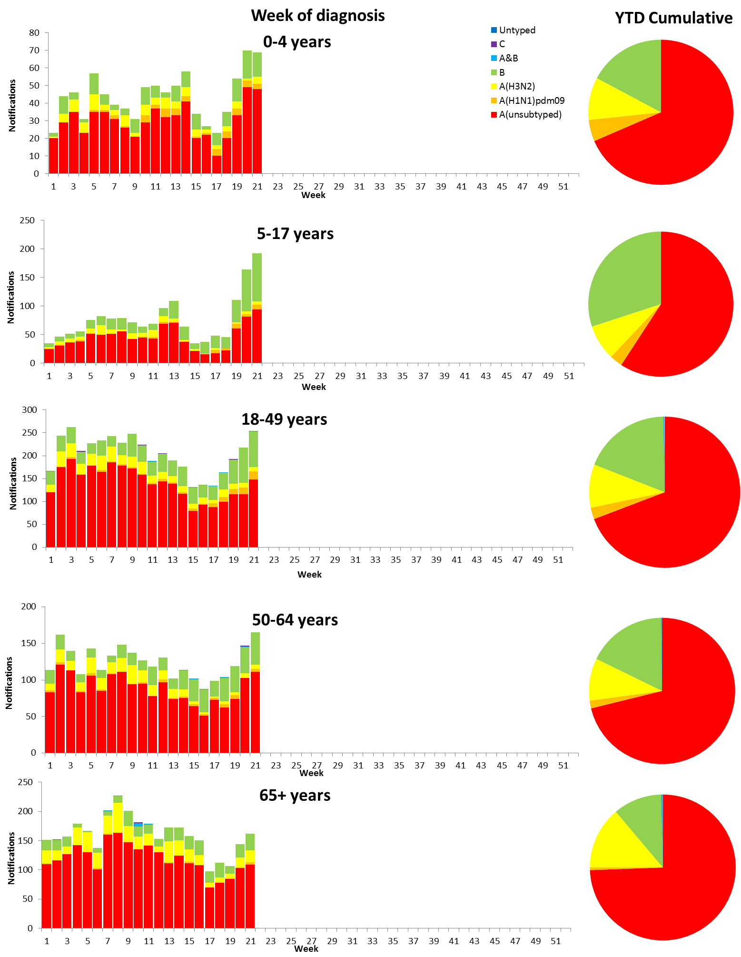

Source: NNDSS

## 2. Influenza-like Illness Activity

### Community Level Surveillance

FluTracking, a national online system for collecting data on ILI in the community, indicated that rates of ILI among participants so far this year have been on the lower range of recent seasons (Figure 7). The proportion of participants reporting fever and cough was recorded at 1.8% in week 17, decreasing from week 20 (2.0%) to week 21 (1.7%). The proportion of participants reporting fever, cough and absence from normal duties has steadily increased from 1.0% in week 17 to 1.2% in week 21. So far this year 57% of all participants and 75% of participants who identify as working face-to-face with patients reported receiving the seasonal influenza vaccine.[2]

Figure 7. Proportion of fever and cough among FluTracking participants, Australia, between May and October, 2013 to 2017, by month and week.

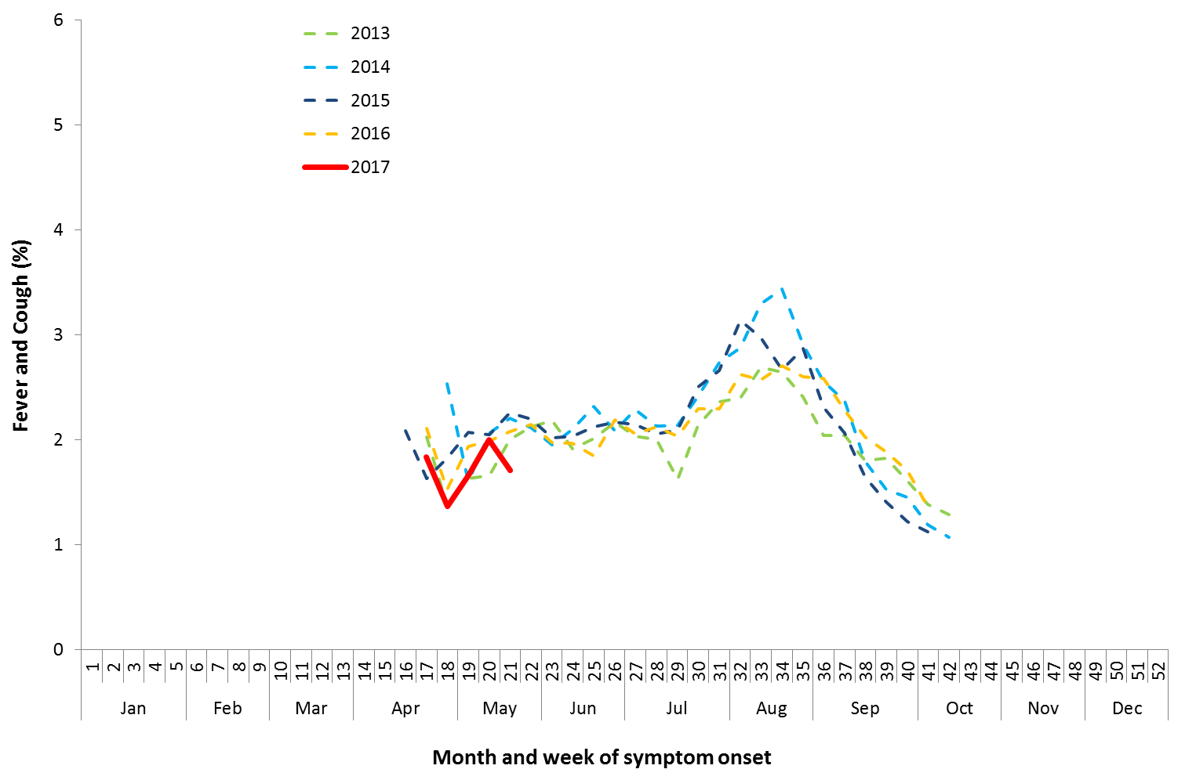

Source: FluTracking

### Sentinel General Practice Surveillance

The cumulative sentinel general practitioner (GP) influenza-like illness (ILI) consultation rate for the months January to March this year was 2.3 per 1,000 consultations. This is higher than the cumulative rate reported for the same period in 2016 (1.6 per 1,000 consultations) but within the range of recent seasons (Figure 8).

The ILI consultation rate plateaued over April and while showing an increasing trend, remained within the historical range during the weeks of May.

Of the 215 specimens collected YTD from ILI patients seen by a sentinel practitioner, 38 (18%) were positive for influenza, with influenza A(H3N2) most commonly detected (Figure 9). Rhinovirus was the most common non-influenza virus detected in the YTD, with 21% of patients swabbed testing positive.

In the last fortnight, of the 29 specimens collected from ILI patients, only 1 (3%) was positive for influenza. The most common non-influenza viruses detected in the last fortnight were RSV and rhinovirus, with 17% and 14%, respectively, of patients swabbed testing positive.

Figure . Unweighted rate of ILI reported from sentinel GP surveillance systems, Australia, 1 January 2013 to   
28 May 2017, by month and week.

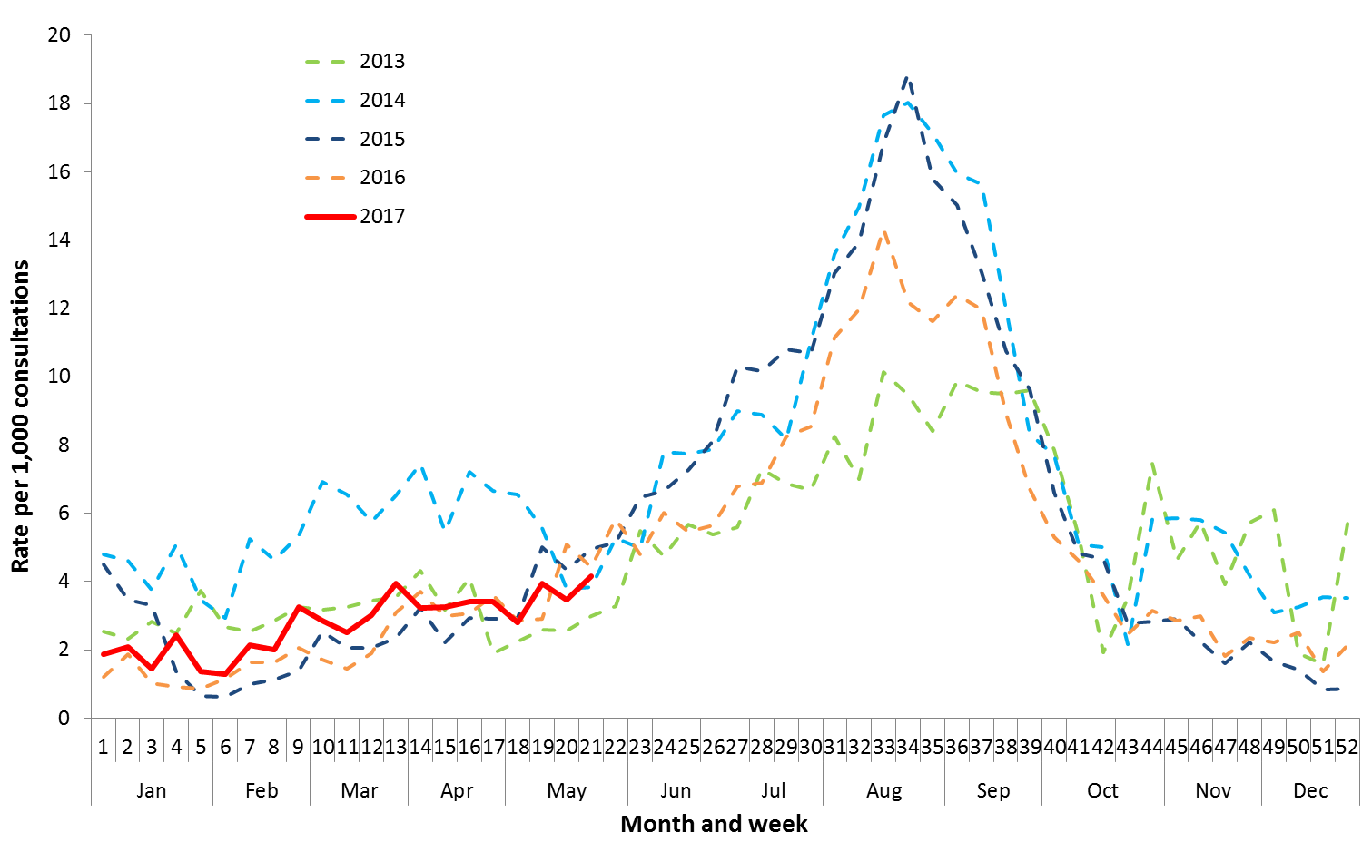

Source: ASPREN and VicSPIN

Figure . Proportion of respiratory viral tests positive for influenza in ASPREN ILI patients and ASPREN ILI consultation rate, Australia, 1 January to 28 May 2017, by month and week.

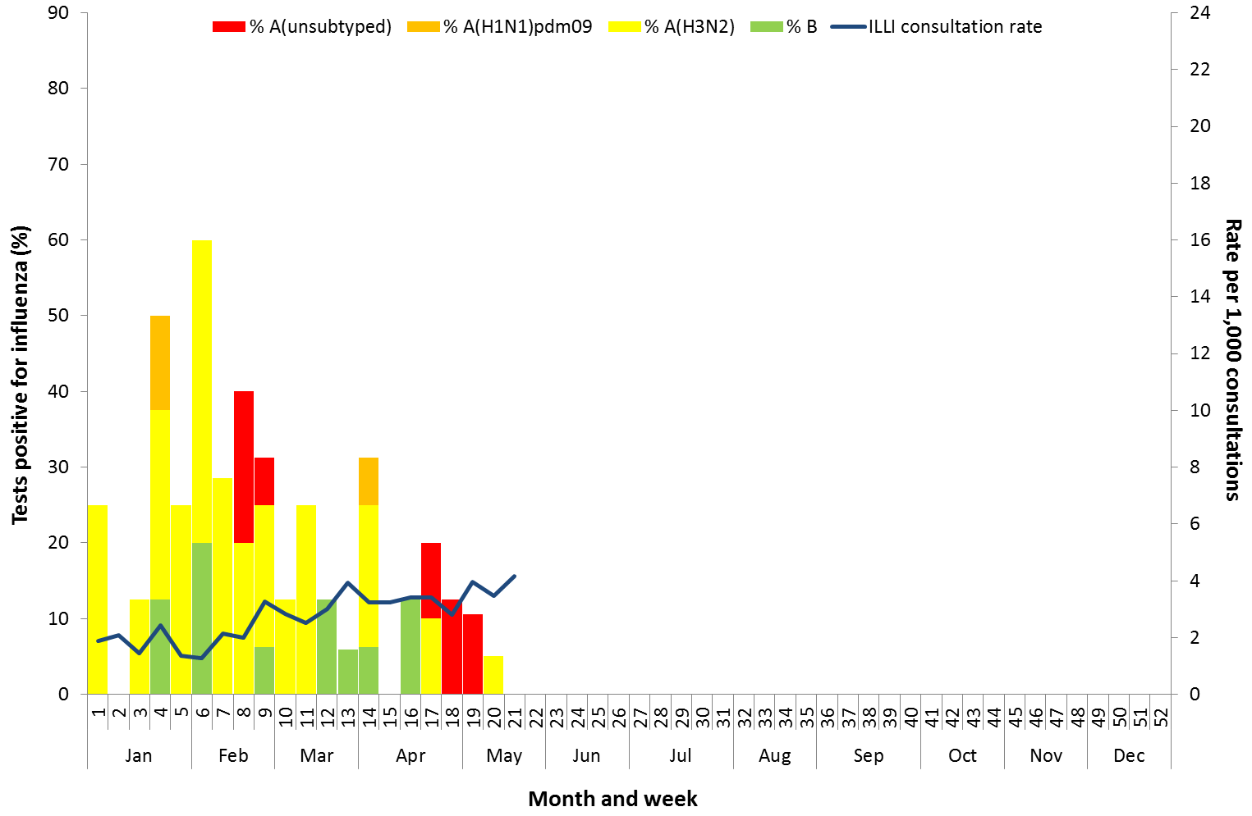

Source: ASPREN

## 3. Hospitalisations

### Sentinel Hospital Surveillance

Since seasonal surveillance commenced through the Influenza Complications Alert Network (FluCAN) sentinel hospital surveillance system on 3 April 2017, a total of 99 people have been admitted with confirmed influenza (Figure 10). Of all admissions, 21 (21%) were children aged less than 16 years and 46 (46%) were adults aged 65 years or older.

Approximately 5% of influenza patients have been admitted directly to the Intensive Care Unit (ICU); all due to infection with influenza A (Figure 11). Infection with influenza B accounted for 24% of all total admissions, which is consistent with the proportion of notifications for influenza B seen notifications to the NNDSS over the same period.

Overall, 76% of patients were reported with significant risk factors, with the presence of risk factors increasing with age.

Figure . Number of influenza hospitalisations at sentinel hospitals, between March and October, 2013 to 2017 by month and week .

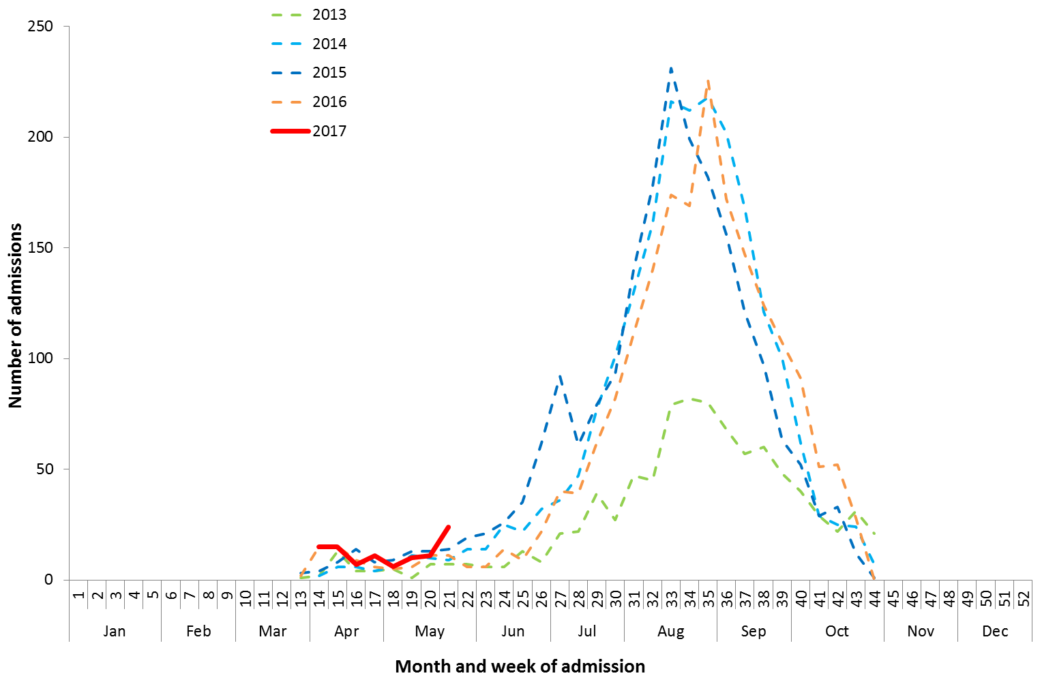

Source: FluCAN

Figure . Number of influenza hospitalisations at sentinel hospitals by subtype and ICU admission, 3 April to 26 May 2017, by month and week .

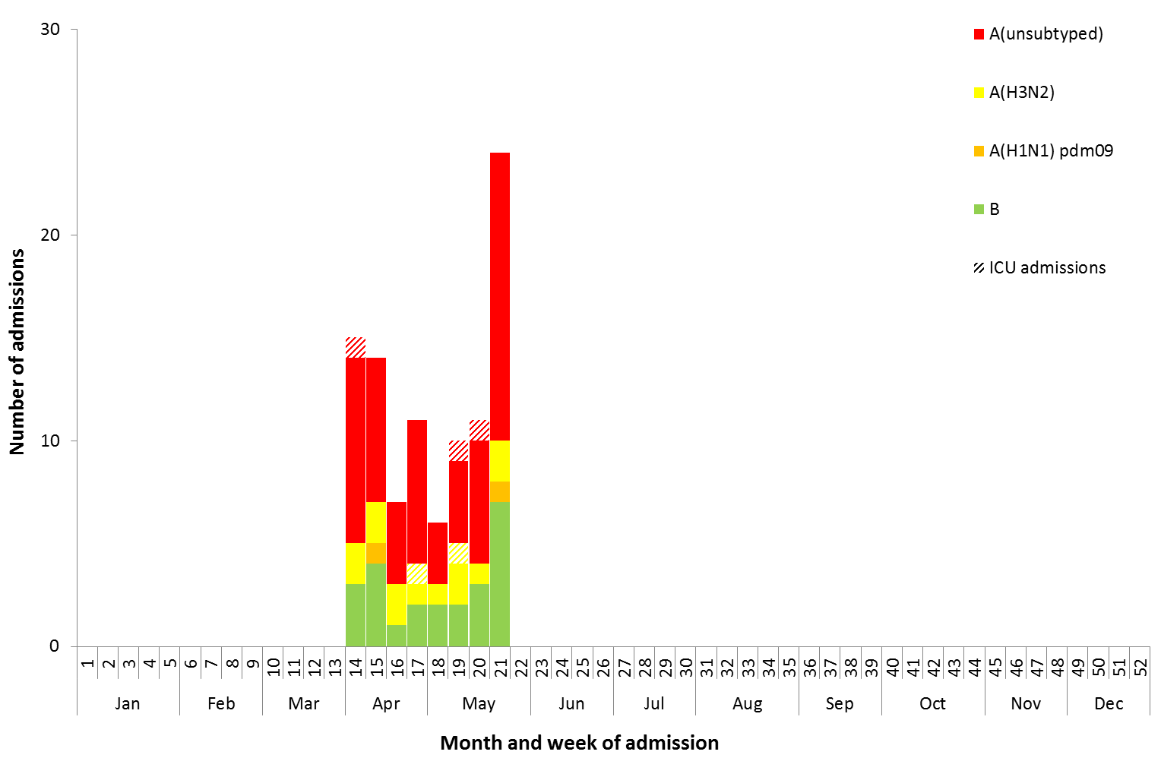

Source: FluCAN

## 4. Deaths Associated with Influenza and Pneumonia

### Nationally Notified Influenza Associated Deaths

So far in 2017, 19 influenza associated deaths have been notified to the NNDSS. The majority of deaths were due to influenza A (68%, n = 13). The median age of deaths notified was 78 years (range 50 to 97 years). The number of influenza associated deaths reported to the NNDSS is reliant on the follow up of cases to determine the outcome of their infection and most likely does not represent the true mortality associated with this disease.

### New South Wales Influenza and Pneumonia Death Registrations

Death registration data from NSW for the week ending 14 April 2017 show that there were 0.75 “pneumonia and influenza” deaths per 100,000 NSW population, which was below the epidemic threshold of 1.43 per 100,000 NSW population (Figure 11).[3]

Figure 11. Rate of deaths classified as influenza and pneumonia from the NSW Registered Death Certificates, 2012 to   
14 April 2017.

Please refer above for description and interpretation.

Source: NSW Registry of Births, Deaths and Marriages

## 5. Virological Surveillance

### Australian Influenza Vaccines Composition 2017

The influenza virus strains included in the 2016 seasonal influenza vaccines in Australia are:

* A/Michigan/45/2015, (H1N1)pdm09-like virus;
* A/Hong Kong/4801/2014, (H3N2)-like virus;
* B/Brisbane/60/2008-like virus, Victoria lineage;
* B/Phuket/3073/2013-like virus, Yamagata lineage.

### Typing and Antigenic Characterisation

From 1 January to 16 May, the World Health Organization Collaborating Centre for Reference and Research on Influenza (WHOCC) has characterised 188 influenza viruses (Table 1). When further characterised for similarity to the vaccine components, isolates appeared to be well matched. All the influenza B isolates were characterised as similar to the vaccine components. A small number of influenza A(H1N1)pdm09 isolates (n=1) and influenza A(H3N2) isolates (n=11) have been characterised as low reactors. From 1 January to 16 May, 71 influenza A(H3) isolates were unable to be characterised in the HI assay due to insufficient titre.

Table 1. Australian influenza viruses typed by HI from the WHOCC, 1 January to 16 May 2017.

|  |  |  |  |  |  |  |  |  |  |
| --- | --- | --- | --- | --- | --- | --- | --- | --- | --- |
| **Type/Subtype** | **ACT** | **NSW** | **NT** | **QLD** | **SA** | **TAS** | **VIC** | **WA** | **TOTAL** |
| **A(H1N1) pdm09** | 0 | 7 | 0 | 8 | 2 | 1 | 0 | 2 | 20 |
| **A(H3N2)** | 1 | 71 | 10 | 24 | 34 | 1 | 3 | 2 | 146 |
| **B/Victoria lineage** | 0 | 0 | 0 | 1 | 1 | 0 | 0 | 0 | 2 |
| **B/Yamagata lineage** | 0 | 9 | 2 | 8 | 1 | 0 | 0 | 0 | 20 |
| **Total** | 1 | 87 | 12 | 41 | 38 | 2 | 3 | 4 | 188 |

SOURCE: WHO CC

Note: Viruses tested by the WHO CC are not necessarily a random sample of all those in the community.

State indicates the residential location for the individual tested, not the submitting laboratory.

There may be up to a month delay on reporting of samples.

### Antiviral Resistance

The WHOCC reported that from 1 January to 16 May 2017, of the 253 influenza viruses tested for neuraminidase inhibitor resistance, none of the samples demonstrated reduced inhibition to the antiviral drugs Oseltamivir or Zanamivir.

## 6. International Surveillance

The World Health Organization reported that based on data up to 14 May influenza activity in temperate southern hemisphere countries had begun to increase slowly, but remains low generally. Influenza activity in the temperate zone of the northern hemisphere is decreasing. Worldwide, influenza B viruses were predominant.

# DATA CONSIDERATIONS

The NNDSS data provided were extracted on 26 May 2017. Due to the dynamic nature of the NNDSS, data in this report is subject to retrospective revision and may vary from data reported in published NNDSS reports and reports of notification data by states and territories. Detailed notes on interpreting the data presented in this report are available at the Department of Health’s [Australian Influenza Surveillance Report website](http://www.health.gov.au/flureport) (www.health.gov.au/flureport).

The Australian Influenza Surveillance Report and Activity Updates are compiled from a number of data sources, which are used to monitor influenza activity and severity in the community. These data sources include laboratory-confirmed notifications to the NNDSS; influenza associated hospitalisations; sentinel influenza-like illness (ILI) reporting from general practitioners and emergency departments; and community level surveys; and sentinel laboratory testing results. The information in this report is reliant on the surveillance sources available to the Department of Health at the time of production.

While every care has been taken in preparing this report, the Commonwealth does not accept liability for any injury or loss or damage arising from the use of, or reliance upon, the content of the report. Delays in the reporting of data may cause data to change retrospectively. For further details about information contained in this report please contact the [Influenza Surveillance Team](mailto:flu@health.gov.au) ([flu@health.gov.au](mailto:flu@health.gov.au)).

# REFERENCES

1. WHO, Influenza Update No. 290, 14 May 2017. Available from the [WHO website](http://www.who.int/influenza/surveillance_monitoring/updates/latest_update_GIP_surveillance/en/) (http://www.who.int/influenza/surveillance_monitoring/updates/latest_update_GIP_surveillance/en/) [Accessed 8 June 2017].
2. FluTracking, FluTracking Weekly Interim Report, Week ending 28 May 2017. Available from FluTracking Reports (http://www.flutracking.net/Info/Reports) [Accessed 8 June 2017].
3. NSW Health, Influenza Monthly Epidemiology Report, NSW, April 2017. Available from NSW Health Influenza Surveillance Reports (http://www.health.nsw.gov.au/Infectious/Influenza/Pages/reports.aspx)[Accessed 8 June 2017].