| Logo | **Australian Influenza**  **SURVEILLANCE REPORT**  **No. 2, 2017**  **Reporting period 27 May – 9 June 2017** |
| --- | --- |

The Department of Health acknowledges the providers of the many sources of data used in this report and greatly appreciates their contribution.

# KEY MESSAGES

* Influenza activity is variable across Australia; increasing in some regions, while low and stable in others.
* Respiratory viruses other than influenza are more commonly causing influenza-like illness presentations to sentinel general practitioners, with rhinovirus detected most frequently in the past fortnight.
* Detections of influenza B viruses have increased in recent weeks, consistent with the predominance of influenza B viruses worldwide currently.[1]
* To date, the seasonal influenza vaccines appear to be a good match for circulating virus strains.

# ANALYSIS

## 1. Geographic Spread of Influenza Activity in Australia

In the fortnight ending 9 June 2017 (week 23), influenza activity was reported by state and territory health departments as increased in New South Wales (NSW), South Australia (SA), Victoria (Vic) and the metro region of Western Australia (WA), and unchanged in all other jurisdictions, when compared to the previous fortnight (Figure 1).

The geographic spread of influenza activity was reported as sporadic in the Australian Capital Territory (ACT), the Top End and Central Australian regions of the Northern Territory (NT), Tasmania (Tas) and all regions of WA; localised in NSW and Vic and regional in SA.

Influenza-like illness (ILI) activity reported from syndromic surveillance systems when compared with the previous fortnight was reported as increased in all jurisdictions.

Figure . Map of influenza activity by state and territory, Australia, 27 May - 9 June 2017.

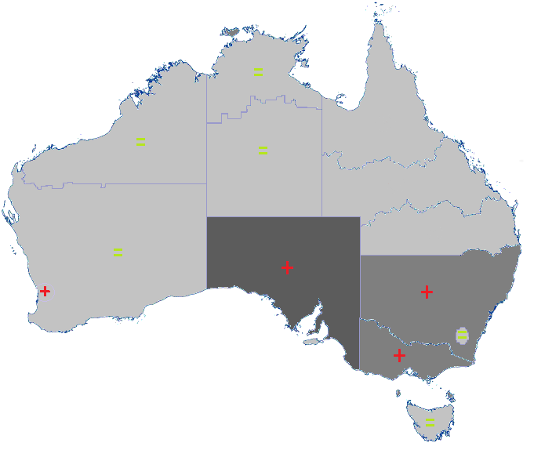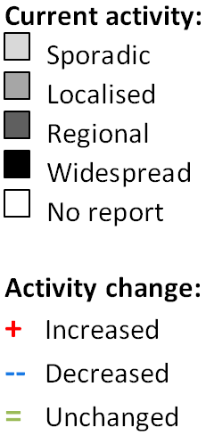

## 2. Laboratory Confirmed Influenza Activity

### Sentinel Laboratory Surveillance

### Notifications of Influenza to Health Departments

Notifications of laboratory confirmed influenza to the National Notifiable Diseases Surveillance System (NNDSS) have slightly increased this reporting fortnight (Figure 2). For the year to 9 June, a total of 14,568 notifications of laboratory confirmed influenza were reported to the NNDSS: 4,820 in QLD; 4,327 in NSW; 2,010 in VIC; 1,855 in SA; 709 in WA; 542 in the NT; 183 in TAS; and 122 in the ACT.

Notifications of laboratory confirmed influenza increased in NSW and SA, but remained steady or decreased across other jurisdictions (Figure 3).

For the year to 9 June, 80% of notifications of laboratory confirmed influenza to the NNDSS were influenza A (68% A(unsubtyped), 2% influenza A(H1N1)pdm09 and 10% influenza A (H3N2)), 20% were influenza B and less than 1% were influenza C, influenza A&B co-infections or untyped (Figure 4). In the most recent fortnight, 66% of notifications of laboratory confirmed influenza to the NNDSS were influenza A (58% influenza A(unsubtyped), 4% influenza A(H1N1)pdm09 and 4% influenza A (H3N2)), 34% were influenza B and less than 1% were influenza C, influenza A&B co-infections or untyped (Figure 5).

The number of influenza A(H3N2) notifications decreased over the reporting fortnight from 47 notifications in week 21 to 34 notifications in week 23. The number of influenza B notifications increased from 226 and 250 notifications in weeks 20 and 21 respectively to 283 and 317 notifications in weeks 22 and 23 respectively, consistent with WHO reporting on the predominance of influenza B worldwide currently.

So far in 2017, notification rates have been highest in adults aged 75 years or older (126 notifications per 100,000) (Figure 6). While influenza A(H3N2) is detected across all age groups, it accounts for a greater proportion of influenza A where subtyping is available in adults aged 65 years or older, than in any other age group (Figure 7). Influenza B was highest in children aged 5 to 9 years (23 notifications per 100,000 population). Increases in notifications in the last fortnight have occurred in individuals younger than 49 years of age, while notifications have remained steady in adults over the age of 50 years.

Figure . Notifications of laboratory confirmed influenza, Australia, 1 January 2013 to 9 June 2017, by month and week of diagnosis

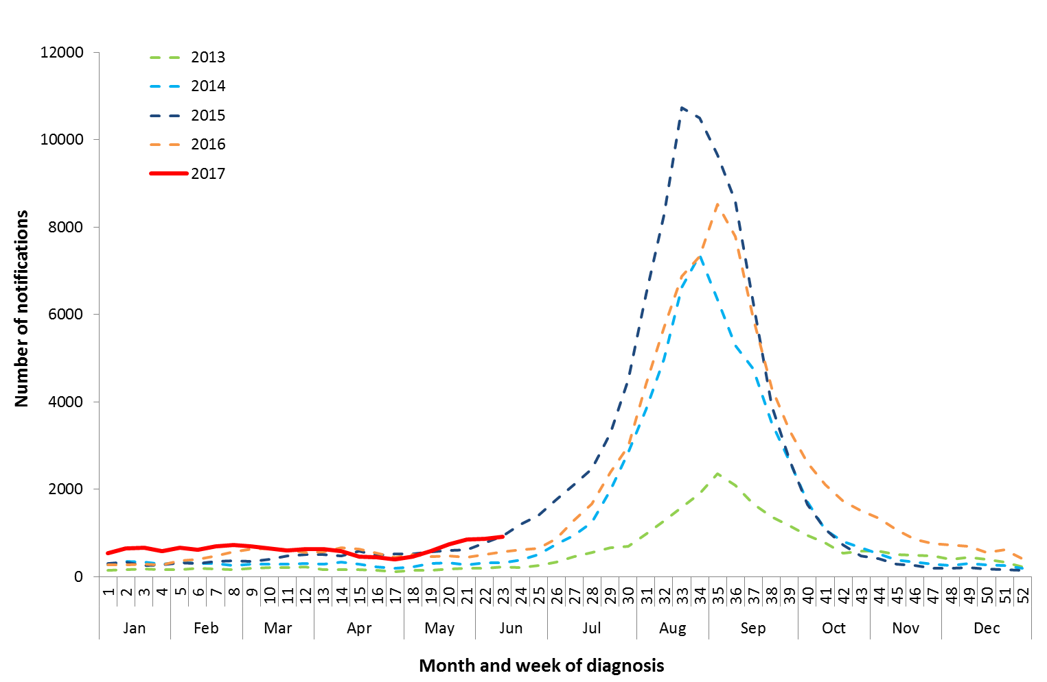

Source: NNDSS

Figure . Notifications of laboratory confirmed influenza, 1 January to 9 June 2017, by state or territory and week

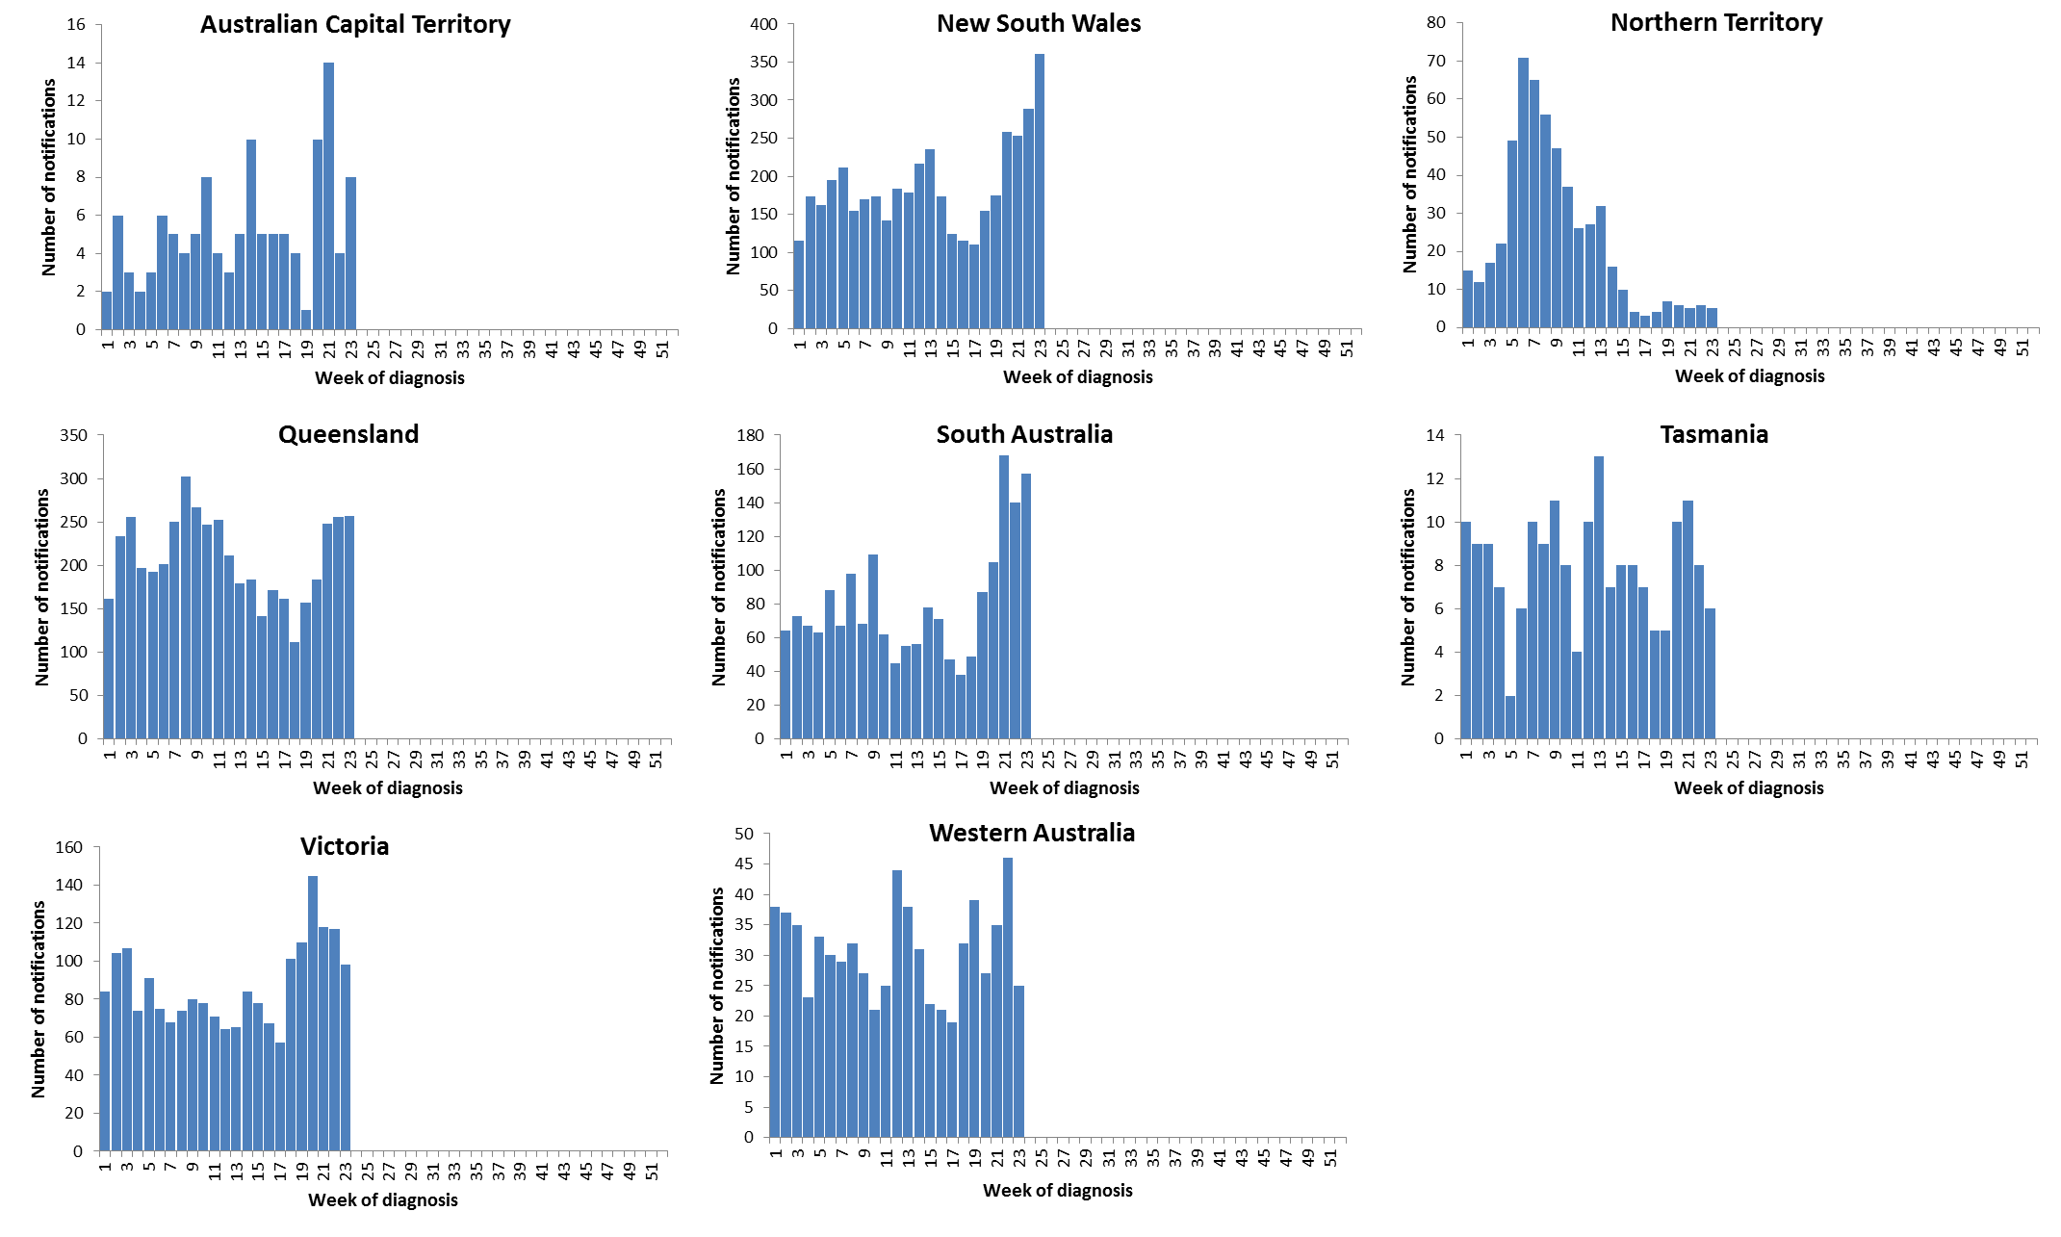

Source: NNDSS

Figure . Per cent of notifications of laboratory confirmed influenza, Australia, 1 January to 9 June 2017, by subtype and state or territory

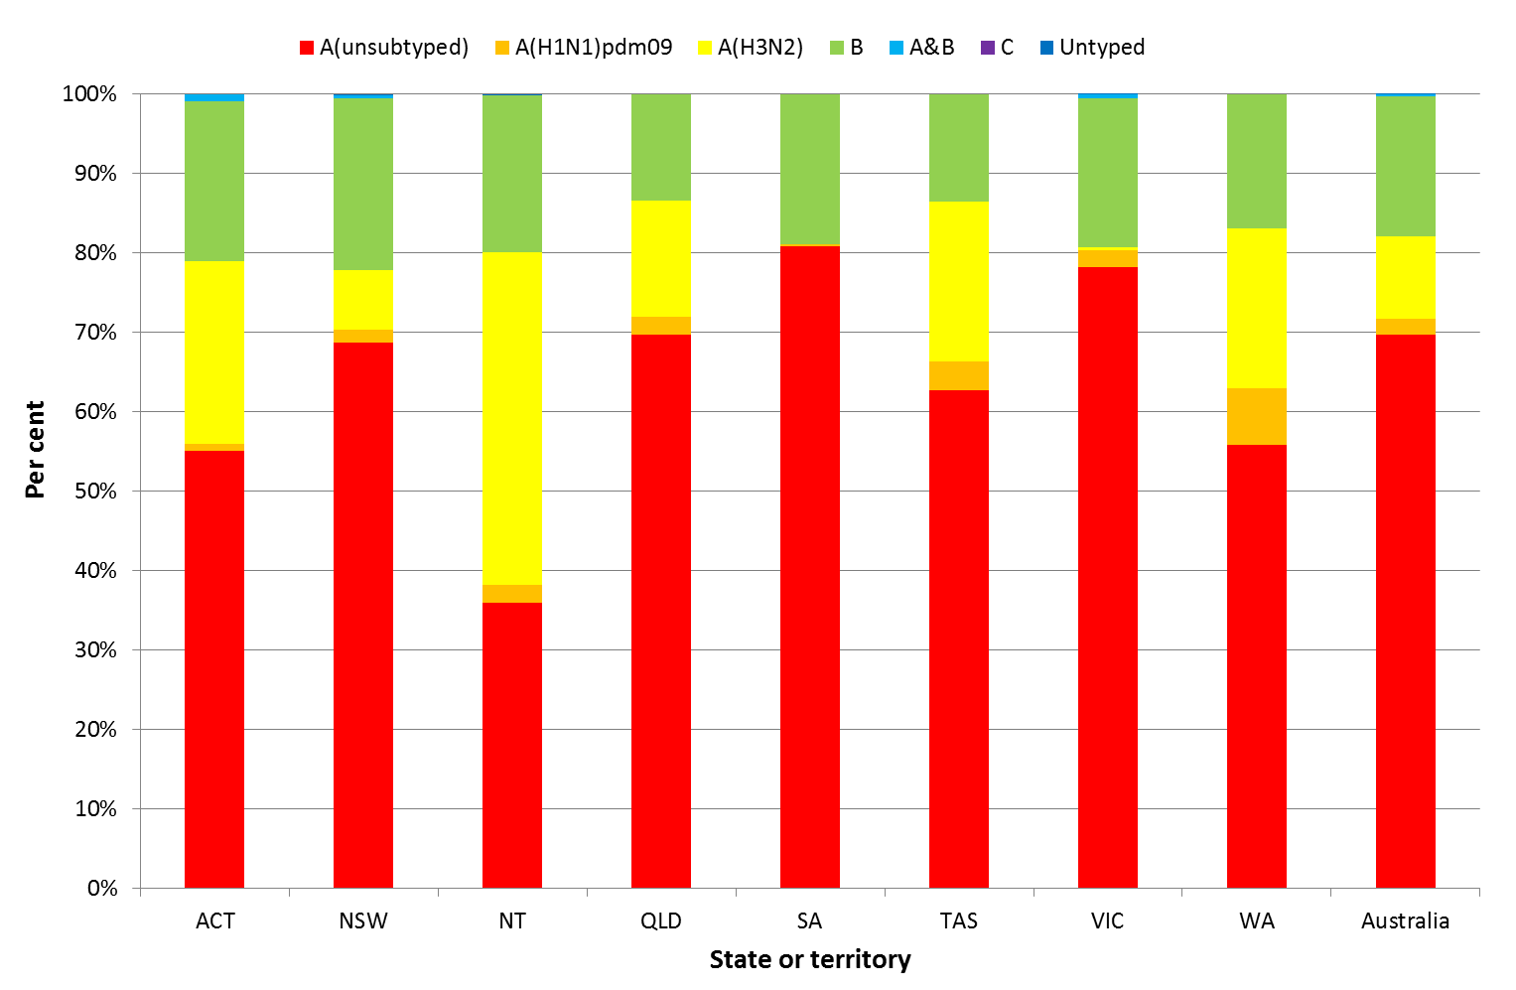

Source: NNDSS

Figure . Per cent of laboratory confirmed influenza, Australia, 1 January to 9 June 2017, by subtype and week

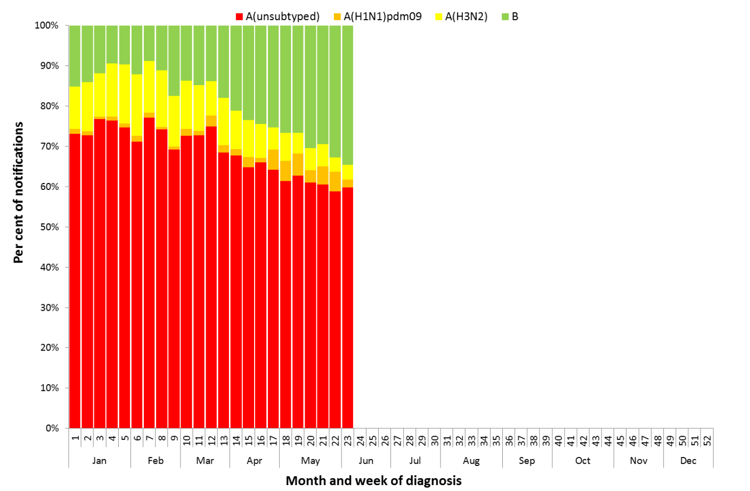

Source: NNDSS

Figure . Rate of notifications of laboratory confirmed influenza, Australia, 1 January to 9 June 2017, by age group and subtype

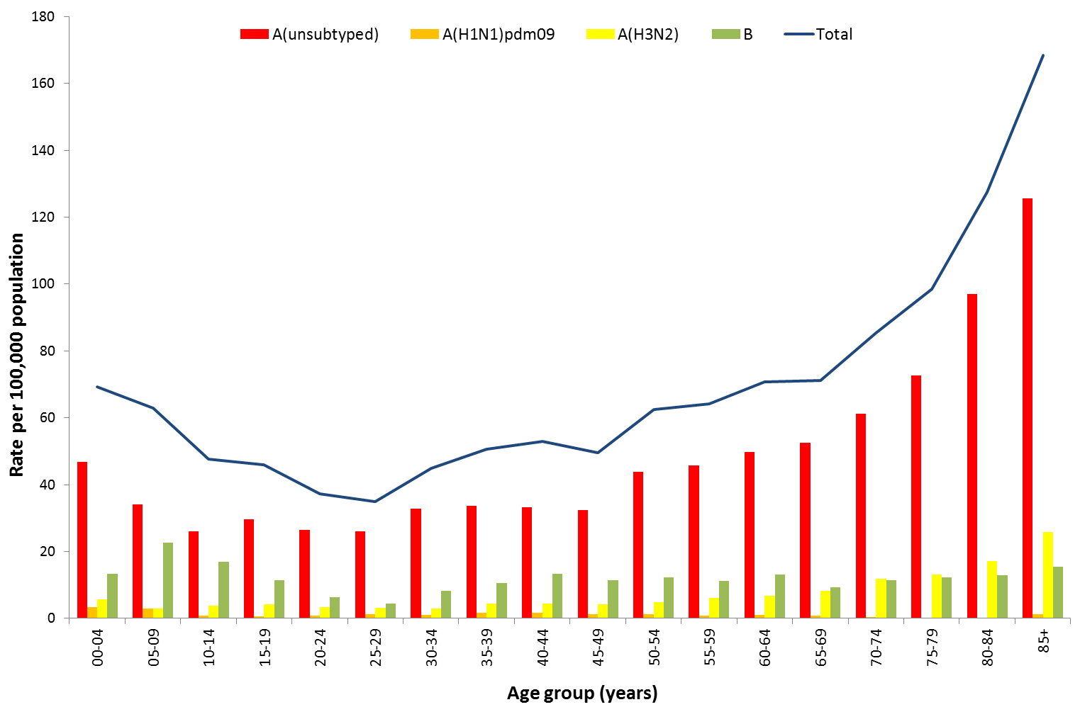

Source: NNDSS

Figure . Notifications of laboratory confirmed influenza by week of diagnosis and cumulative year-to-date, Australia, 1 January to 9 June 2017, by age group and subtype

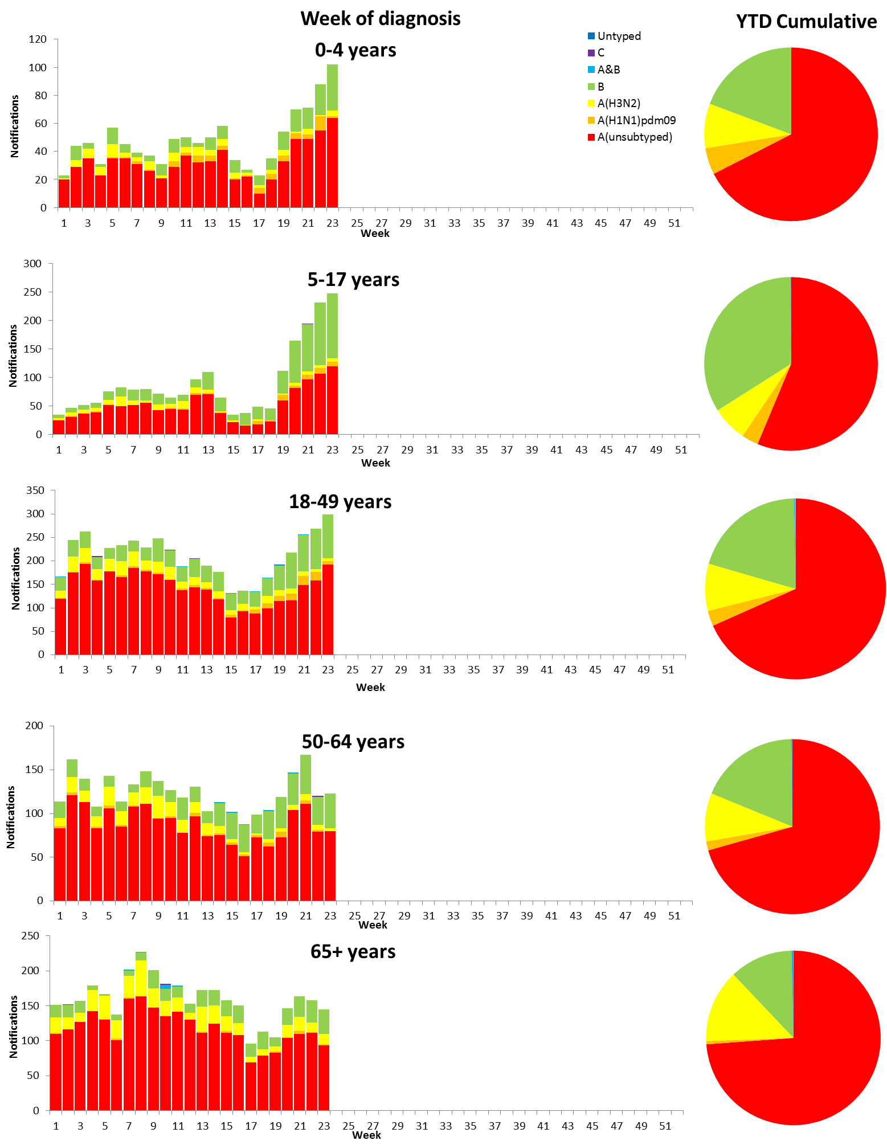

Source: NNDSS

## 2. Influenza-like Illness Activity

### Community Level Surveillance

FluTracking, a national online system for collecting data on ILI in the community, indicated that rates of ILI among participants remained low and steady between weeks 22 and 23 (Figure 8). ILI activity among participants, reported as fever and cough, declined from week 20 (2.0%) to 23 (1.7%). So far this year 59% of all participants and 78% of participants who identify as working face-to-face with patients reported receiving the seasonal influenza vaccine.[2]

Figure . Proportion of fever and cough among FluTracking participants, Australia, between May and October, 2013 to 2017, by month and week

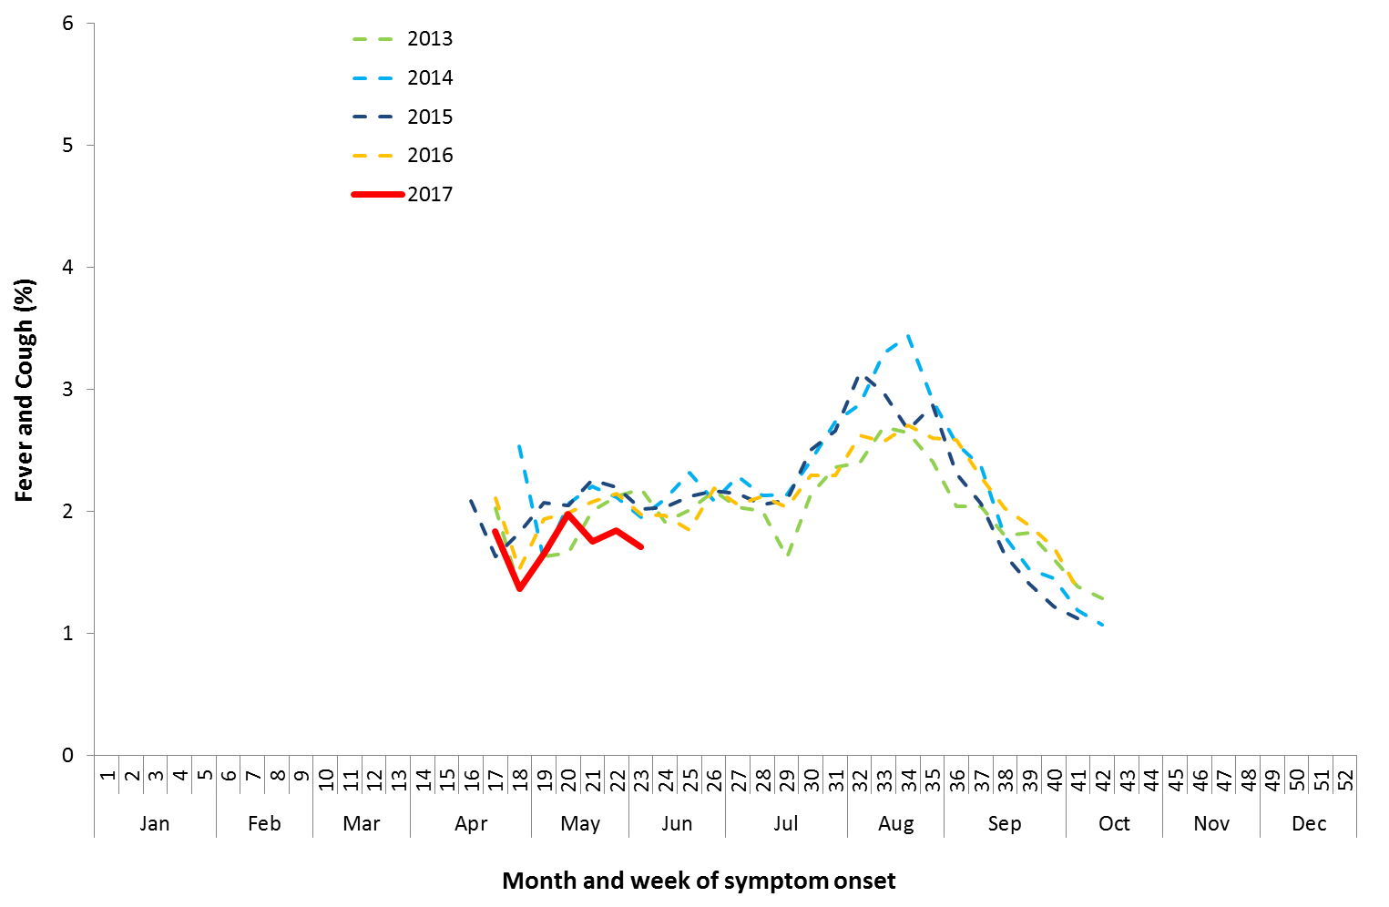

Source: FluTracking

### Sentinel General Practice Surveillance

Sentinel general practitioner ILI consultations have increased this fortnight with 4.7 per 1,000 consultations in week 22 and 5.0 per 1,000 consultations in week 23 (Figure 9).

Of the 81 specimens taken from ILI patients seen by a sentinel practitioner during the current reporting fortnight, 9 (11%) were positive for influenza, consisting of 5 samples if influenza A(H3N2), 2 influenza A(unsubtyped) and 2 influenza B (Figure 10). Parainfluenza 3 was the most common non-influenza virus detected this fortnight, representing 26% of tests processed.

Figure . Unweighted rate of ILI reported from sentinel GP surveillance systems, Australia, 1 January 2013 to 11 June 2017, by month and week

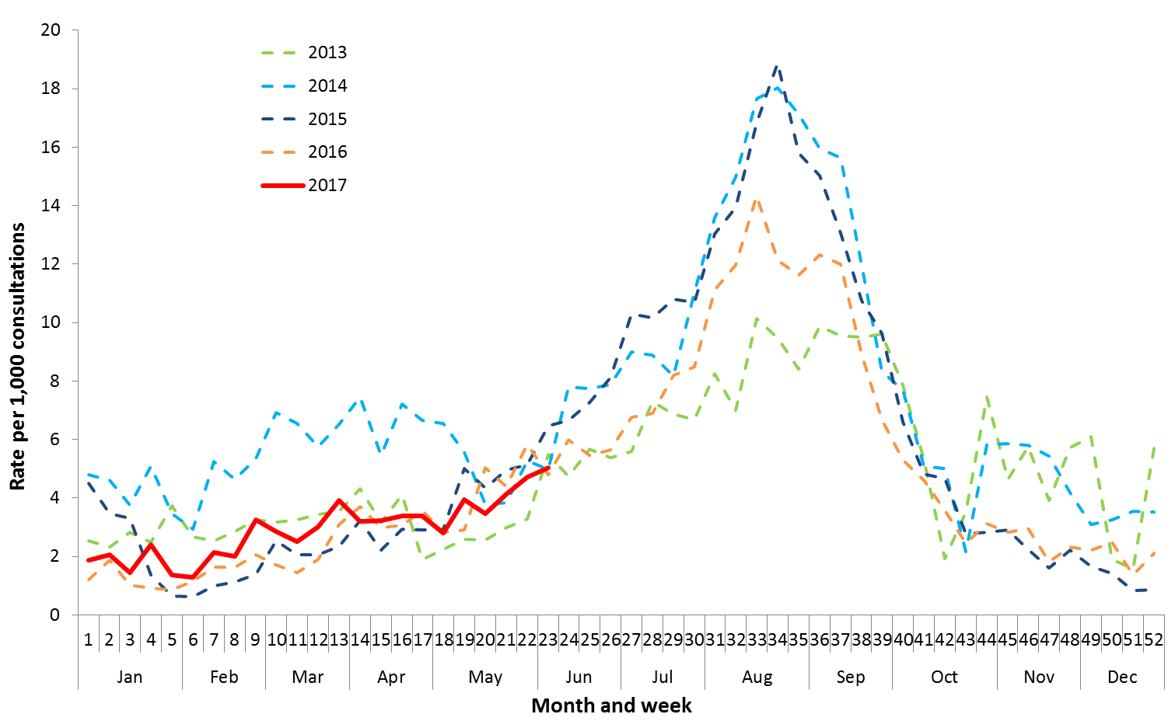

Source: ASPREN and VicSPIN

Figure . Proportion of respiratory viral tests positive for influenza in ASPREN ILI patients and ASPREN ILI consultation rate, Australia, 1 January to 11 June 2017, by month and week

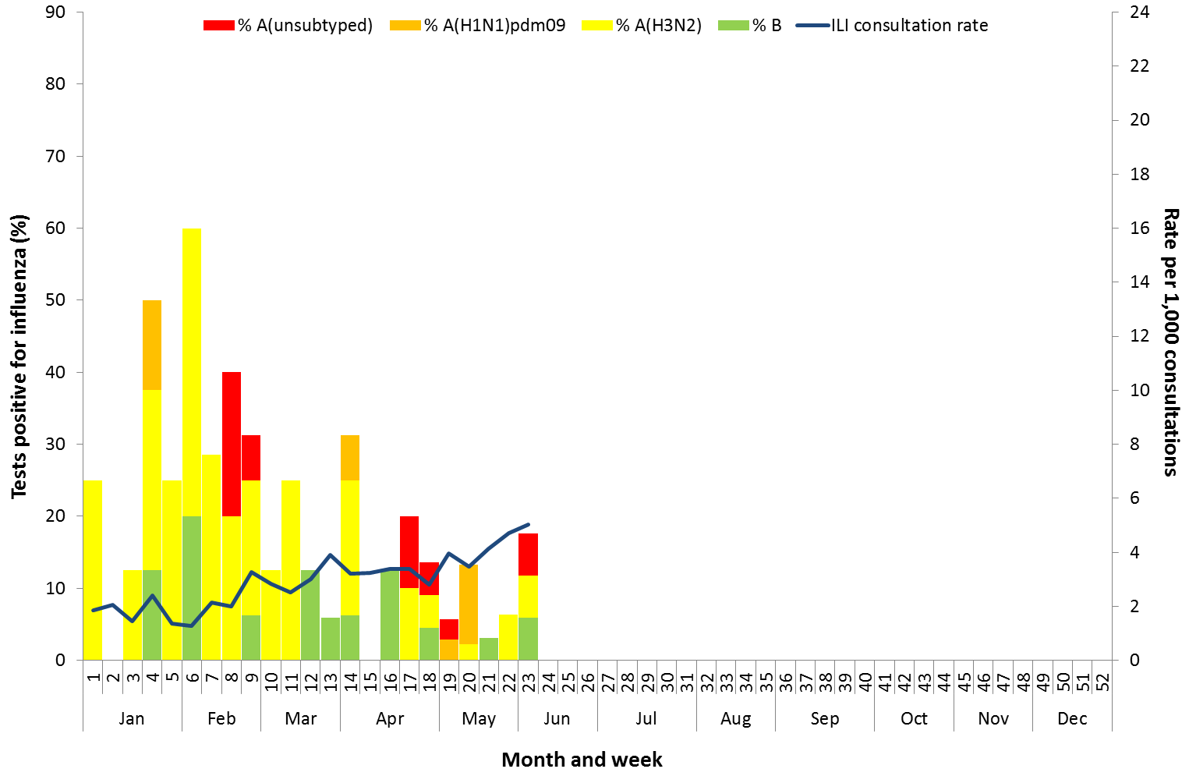

Source: ASPREN

## 3. Hospitalisations

### Sentinel Hospital Surveillance

Admissions with confirmed influenza to sentinel hospitals declined from week 21 to 23 (Figure 11), with 20 patients admitted in week 22 and 18 in week 23, compared to 29 in week 21. Since seasonal surveillance commenced through the Influenza Complications Alert Network (FluCAN) sentinel hospital surveillance system on 3 April 2017, a total of 131 people have been admitted with confirmed influenza, of which 28 (21%) were children aged less than 15 years and 61 (47%) were adults aged 65 years or older. Approximately 5% of influenza patients have been admitted directly to ICU; with all cases related to infection with influenza A (Figure 12). Consistent with other systems, the majority of influenza admissions have been due to influenza A (63%).

Figure . Number of influenza hospitalisations at sentinel hospitals, between March and October, 2013 to 2017 by month and week

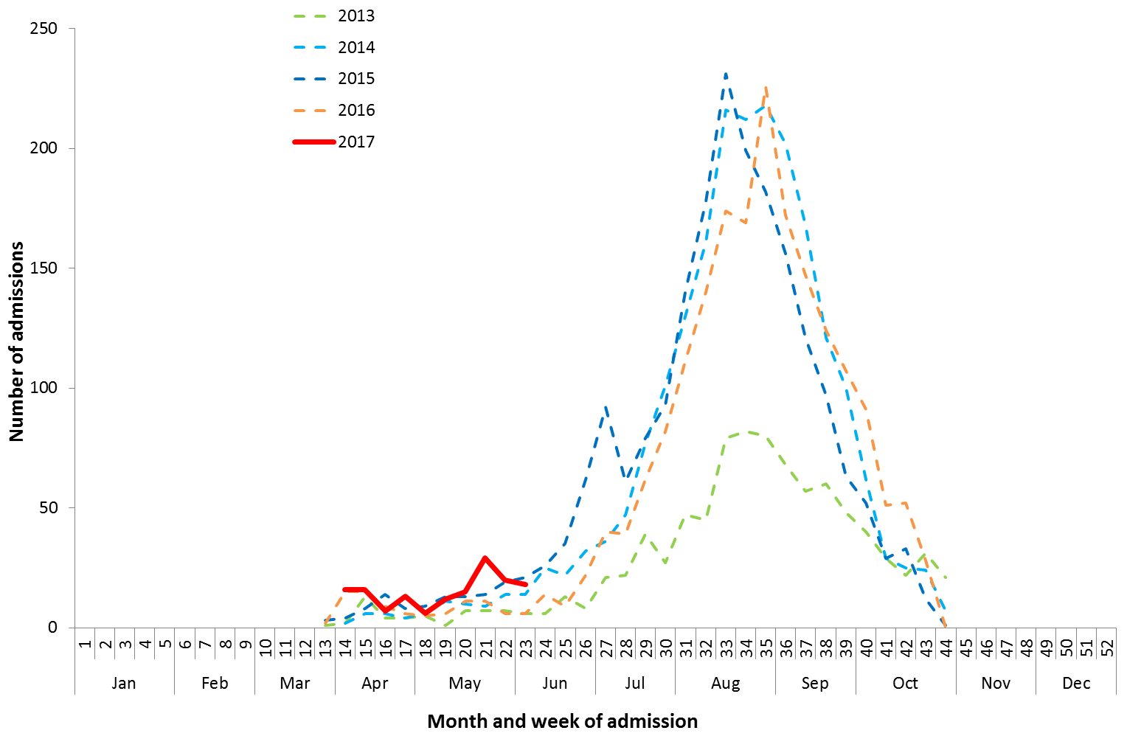

Source: FluCAN

Figure . Number of influenza hospitalisations at sentinel hospitals by subtype and ICU admission, 3 April to 9 June 2017, by month and week

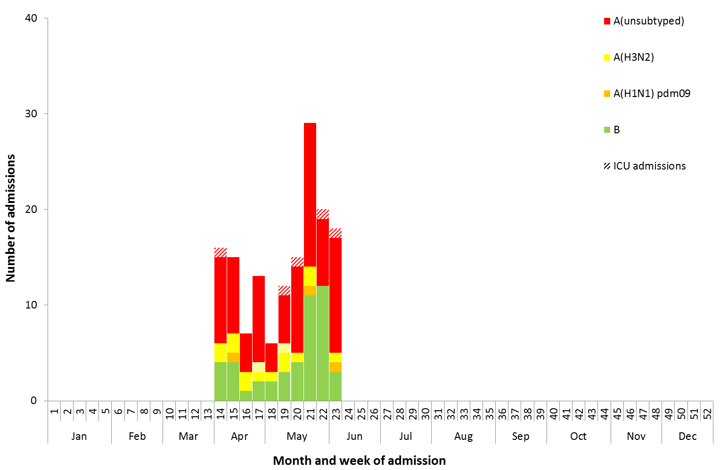

Source: FluCAN

### Paediatric Severe Complications of Influenza

The Australian Paediatric Surveillance Unit (APSU) conducts seasonal surveillance between June and September annually of children aged 15 years and under who are hospitalised with severe complications of influenza. Between 1 June 2017 and 11 June 2017, there was 1 hospitalisation associated with severe complications of influenza reported to APSU. This case was associated with influenza A infection, had no underlying chronic conditions, and was not vaccinated for influenza.

## 4. Deaths Associated with Influenza and Pneumonia

### Nationally Notified Influenza Associated Deaths

So far in 2017, 20 influenza associated deaths have been notified to the NNDSS. The majority of deaths were due to influenza A (70%, n = 14). The median age of deaths notified was 78 years (range 29 to 97 years). The number of influenza associated deaths reported to the NNDSS is reliant on the follow up of cases to determine the outcome of their infection and most likely does not represent the true mortality associated with this disease.

### New South Wales Influenza and Pneumonia Death Registrations

Death registration data from NSW for the week ending 12 May 2017 show that there were 1.07 “pneumonia and influenza” deaths per 100,000 NSW population, which was below the epidemic threshold of 1.61 per 100,000 NSW population (Figure 13).[3]

Figure . Rate of deaths classified as influenza and pneumonia from the NSW Registered Death Certificates, 2012 to 12 May 2017

Please refer above for description and interpretation.

Source: NSW Registry of Births, Deaths and Marriages

## 5. Virological Surveillance

### Australian Influenza Vaccines Composition 2017

The influenza virus strains included in the 2017 seasonal influenza vaccines in Australia are:

* A/Michigan/45/2015, (H1N1)pdm09-like virus;
* A/Hong Kong/4801/2014, (H3N2)-like virus;
* B/Brisbane/60/2008-like virus, Victoria lineage;
* B/Phuket/3073/2013-like virus, Yamagata lineage.

### Typing and Antigenic Characterisation

From 1 January to 13 June, the World Health Organization Collaborating Centre for Reference and Research on Influenza (WHOCC) has characterised 243 influenza viruses (Table 1). When further characterised for similarity to the vaccine components, isolates appeared to be well matched. All the influenza B isolates were characterised as similar to the vaccine components. A small number of influenza A(H1N1)pdm09 isolates (n=1) and influenza A(H3N2) isolates (n=21) have been characterised as low reactors. From 1 January to 13 June, 98 influenza A(H3) isolates were unable to be characterised in the HI assay due to insufficient titre.

Table . Australian influenza viruses typed by HI from the WHOCC, 1 January to 13 June 2017.

|  |  |  |  |  |  |  |  |  |  |
| --- | --- | --- | --- | --- | --- | --- | --- | --- | --- |
| **Type/Subtype** | **ACT** | **NSW** | **NT** | **QLD** | **SA** | **TAS** | **VIC** | **WA** | **TOTAL** |
| **A(H1N1) pdm09** | 0 | 7 | 0 | 8 | 2 | 1 | 0 | 2 | 20 |
| **A(H3N2)** | 4 | 75 | 16 | 24 | 51 | 1 | 3 | 7 | 181 |
| **B/Victoria lineage** | 0 | 0 | 0 | 1 | 1 | 0 | 0 | 0 | 2 |
| **B/Yamagata lineage** | 1 | 18 | 9 | 8 | 4 | 0 | 0 | 0 | 40 |
| Total | 1 | 87 | 12 | 41 | 38 | 2 | 3 | 4 | 243 |

SOURCE: WHO CC

Note: Viruses tested by the WHO CC are not necessarily a random sample of all those in the community.

State indicates the residential location for the individual tested, not the submitting laboratory.

There may be up to a month delay on reporting of samples.

### Antiviral Resistance

The WHOCC reported that from 1 January to 13 June 2017, of the 346 influenza viruses tested for neuraminidase inhibitor resistance, none of the samples demonstrated reduced inhibition to the antiviral drugs Oseltamivir or Zanamivir.

## 6. International Surveillance

The World Health Organization reported that based on data up to 28 May influenza activity in temperate southern hemisphere countries had begun to increase slowly, but remains low generally.1 Influenza activity in the temperate zone of the northern hemisphere decreased. Worldwide, influenza B viruses were predominant.

# DATA CONSIDERATIONS

The NNDSS data provided were extracted on 14 June 2017. Due to the dynamic nature of the NNDSS, data in this report is subject to retrospective revision and may vary from data reported in published NNDSS reports and reports of notification data by states and territories. Detailed notes on interpreting the data presented in this report are available at the Department of Health’s [Australian Influenza Surveillance Report website](http://www.health.gov.au/flureport) (www.health.gov.au/flureport).

The Australian Influenza Surveillance Report and Activity Updates are compiled from a number of data sources, which are used to monitor influenza activity and severity in the community. These data sources include laboratory-confirmed notifications to the NNDSS; influenza associated hospitalisations; sentinel influenza-like illness (ILI) reporting from general practitioners and emergency departments; and community level surveys; and sentinel laboratory testing results. The information in this report is reliant on the surveillance sources available to the Department of Health at the time of production.

While every care has been taken in preparing this report, the Commonwealth does not accept liability for any injury or loss or damage arising from the use of, or reliance upon, the content of the report. Delays in the reporting of data may cause data to change retrospectively. For further details about information contained in this report please contact the [Influenza Surveillance Team](mailto:flu@health.gov.au) ([flu@health.gov.au](mailto:flu@health.gov.au)).

# REFERENCES

1. WHO, Influenza Update No. 291, 12 June 2017. Available from the [WHO website](http://www.who.int/influenza/surveillance_monitoring/updates/latest_update_GIP_surveillance/en/) (http://www.who.int/influenza/surveillance_monitoring/updates/latest_update_GIP_surveillance/en/) [Accessed 16 June 2017].
2. FluTracking, FluTracking Weekly Interim Report, Week ending 11 June 2017. Available from [FluTracking Reports](http://www.flutracking.net/Info/Reports) (http://www.flutracking.net/Info/Reports) [Accessed 16 June 2017].
3. NSW Health, Influenza Monthly Epidemiology Report, NSW, April 2017. Available from NSW Health Influenza Surveillance Reports (http://www.health.nsw.gov.au/Infectious/Influenza/Pages/reports.aspx)[Accessed 8 June 2017].