| Logo | **Australian Influenza**  **SURVEILLANCE REPORT**  **No. 3, 2017**  **Reporting period 10 – 23 June 2017** |
| --- | --- |

The Department of Health acknowledges the providers of the many sources of data used in this report and greatly appreciates their contribution.

# KEY MESSAGES

* Influenza activity is increasing in most of the southern and central regions of Australia while sporadic and stable in the northern regions of the country.
* While testing for influenza has increased over the reporting fortnight, respiratory viruses other than influenza, in particular rhinovirus, were most commonly detected by sentinel laboratories.
* Nationally, notifications of laboratory confirmed influenza B viruses have continued to increase over the reporting fortnight, however influenza A(H1N1)pdm09 and influenza A(H3N2) are also co-circulating in some parts of the country.
* Influenza-like illness (ILI) in the community was low and relatively stable this reporting fortnight, while ILI presentations to sentinel GPs were also low, but increasing.
* To date, the seasonal influenza vaccines appear to be a good match for circulating virus strains.

# ANALYSIS

## 1. Geographic Spread of Influenza Activity in Australia

In the fortnight ending 23 June 2017 (week 25), influenza activity was reported by state and territory health departments as increased when compared to the previous fortnight in all southern regions of Australia except the Australian Capital Territory (ACT) where activity was unchanged. The Top End and Central Australia regions of the Northern Territory (NT), the Tropical region of Queensland (Qld) the Northwest region of Western Australia (WA) also reported that activity was unchanged compared to the previous fortnight (Figure 1). The geographic spread of influenza activity was reported as sporadic in the ACT, Tasmania (Tas) and those northern regions that reported unchanged activity; localised in New South Wales (NSW), Victoria (Vic) and the Perth metro and Rural south regions of WA and regional in the Central and Southern regions of Qld and South Australia (SA). Influenza-like illness (ILI) activity reported from syndromic surveillance systems when compared with the previous fortnight was reported as increased in NSW, decreased in SA and unchanged in all other states and territories.

Figure 1. Map of influenza activity by state and territory, Australia, 27 May - 23 June 2017.

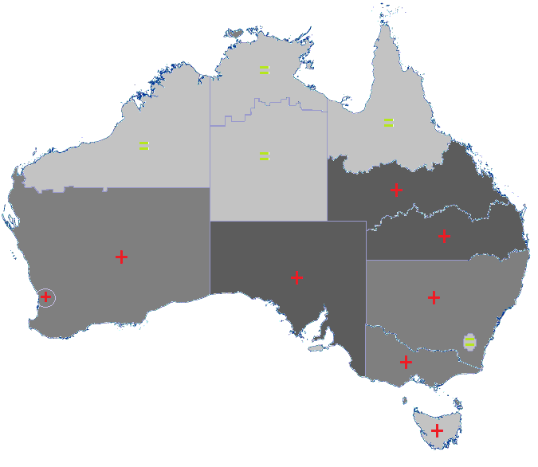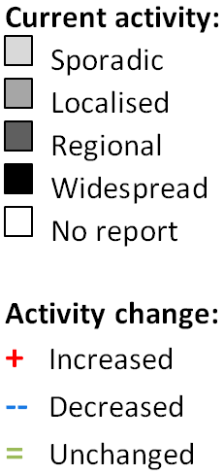

## 2. Laboratory Confirmed Influenza Activity

### Sentinel Laboratory Surveillance

Influenza was detected by sentinel laboratories at increasing levels over the reporting fortnight (Figure 2). The pooled percentage of tests positive for influenza across all sentinel laboratories increased from 5.7% in week 24 to 7.6% in week 25. The percentage of tests positive for influenza increased in all contributing laboratories and jurisdictions over the reporting fortnight.

Percentage of tests positive for influenza in the interseasonal period should be interpreted with caution due to small numbers of tests being undertaken in this time, resulting in high variability in the indicators.

Testing for influenza increased over the reporting fortnight (Figure 3). Respiratory viruses other than influenza, in particular rhinovirus, were most commonly detected by sentinel laboratories this fortnight.

Figure 2. Proportion of sentinel laboratory tests positive for influenza, 1 January to 23 June 2017, by contributing laboratory or jurisdiction and month and week.

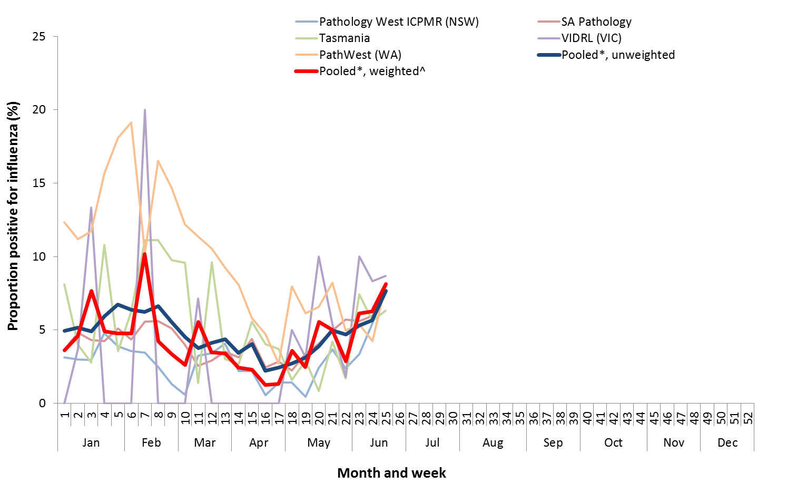

* Pooled percentage positive indicators should be interpreted with caution, noting that collectively pooled contributing laboratories are not representative of testing across Australia and individually contributing laboratories may not be representative of the jurisdiction in which they are located.

^ Weighted according to jurisdictional population in which laboratories are located.

Figure 3. Proportion of sentinel laboratory tests positive for influenza and total number of specimens tested, 1 January to 23 June 2017, by subtype and month and week.

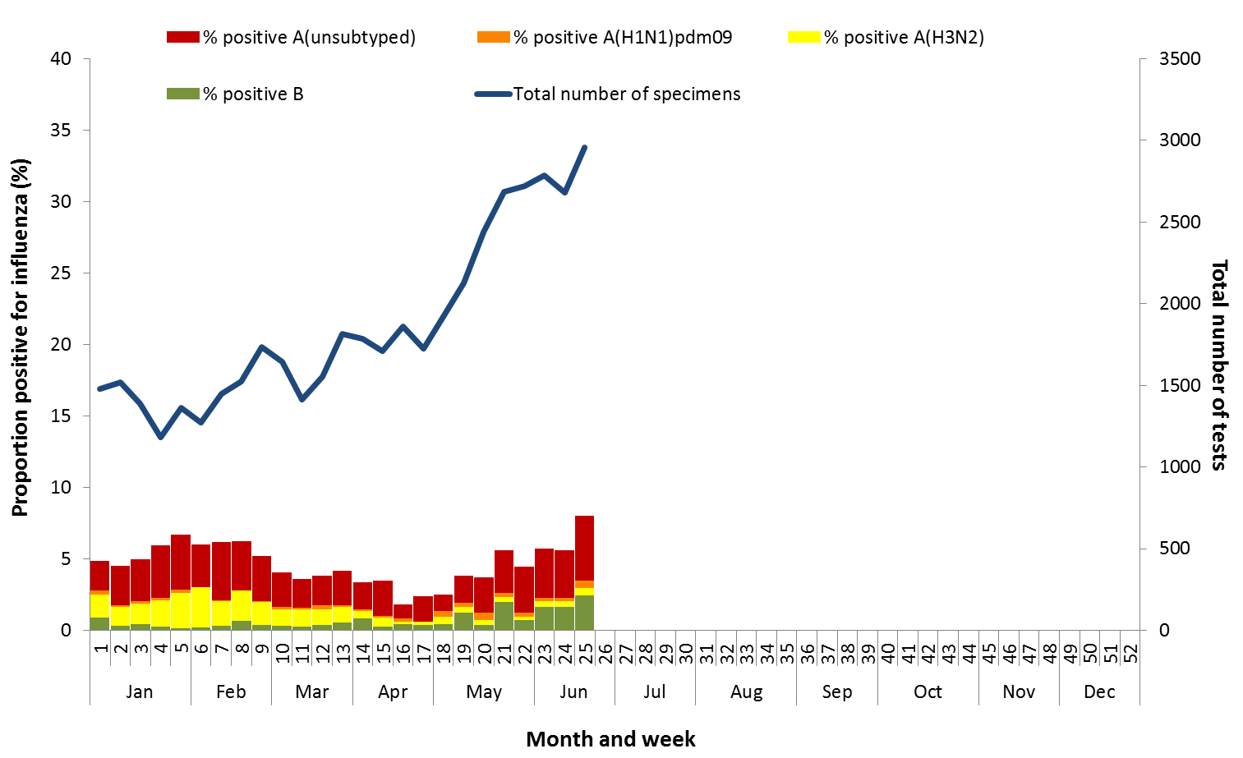

### Notifications of Influenza to Health Departments

Notifications of laboratory confirmed influenza to the National Notifiable Diseases Surveillance System (NNDSS) have continued to increase this reporting fortnight (Figure 4). For the year to 23 June, a total of 17,978 notifications of laboratory confirmed influenza were reported to the NNDSS: 5,718 in NSW; 5,641 in QLD; 2,556 in VIC; 2,314 in SA; 842 in WA; 553 in the NT; 216 in TAS and 138 in the ACT. Notifications of laboratory confirmed influenza increased in NSW, QLD, SA, VIC and WA over the reporting fortnight and remained relatively stable in the ACT, the NT and TAS (Figure 5).

For the year to 23 June, 77% of notifications of laboratory confirmed influenza to the NNDSS were influenza A (66% A(unsubtyped), 2% influenza A(H1N1)pdm09 and 8% influenza A (H3N2)), 23% were influenza B and less than 1% were influenza C, influenza A&B co-infections or untyped (Figure 6). The proportion of all notifications year to date reported as influenza A has ranged across jurisdictions from 67% in NSW to 83% in QLD and WA. Detections of influenza A subtypes have varied across jurisdictions also. Nationally, for every one notification of influenza A(H1N1)pdm09 reported to the NNDSS, 3.4 notifications of influenza A(H3N2) were received. This ratio has ranged from 1:0.1 in VIC to 1:34 in the ACT.

In the most recent fortnight, 62% of notifications of laboratory confirmed influenza to the NNDSS were influenza A (55% influenza A(unsubtyped), 3% influenza A(H1N1)pdm09 and 3% influenza A (H3N2)), 38% were influenza B and less than 1% were influenza A&B co-infections or untyped (Figure 7). The proportion of all notifications this reporting fortnight reported as influenza B ranged across jurisdictions from 21% in WA to 56% in NSW. The number of influenza B notifications continued to increase this fortnight, with the proportion of influenza B of all notifications declining slightly over the fortnight from 39% in week 24 to 38% in week 25 (Figure 7 and Figure 8).

So far in 2017, notification rates have tended to increase with increasing age. Age-specific notification rates of influenza overall have been highest in adults aged 75 years or older (144 notifications per 100,000), with a secondary smaller peak in children aged 5-9 years (97.6 per 100,000) (Figure 9). Influenza A(H1N1)pdm09 was highest in children aged less than 5 years, influenza (H3N2) was highest in the elderly aged 85 years and older and influenza B was highest in children aged 5 to 9 years (41 notifications per 100,000 population).

Increases in notifications have been seen across all broad age groups this reporting fortnight (Figure 10). The distribution of influenza types and subtypes differed across age groups, with 40% of 5-17 year olds notified with influenza being detected with influenza B, while only 14% of adults aged 65 years and older detected with influenza B. While influenza A(H3N2) is detected across all age groups, it accounted for a greater proportion of influenza A where subtyping is available in adults aged 65 years or older, than in any other age group.

Figure 4. Notifications of laboratory confirmed influenza, Australia, 1 January 2013 to 23 June 2017, by month and week of diagnosis

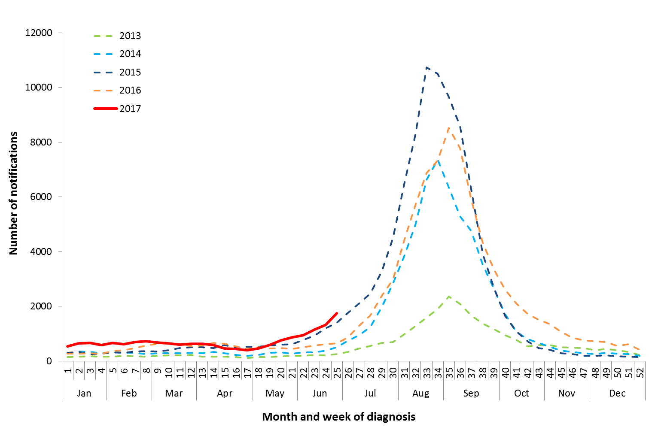

Source: NNDSS

Figure 5. Notifications of laboratory confirmed influenza, 1 January to 23 June 2017, by state or territory and week

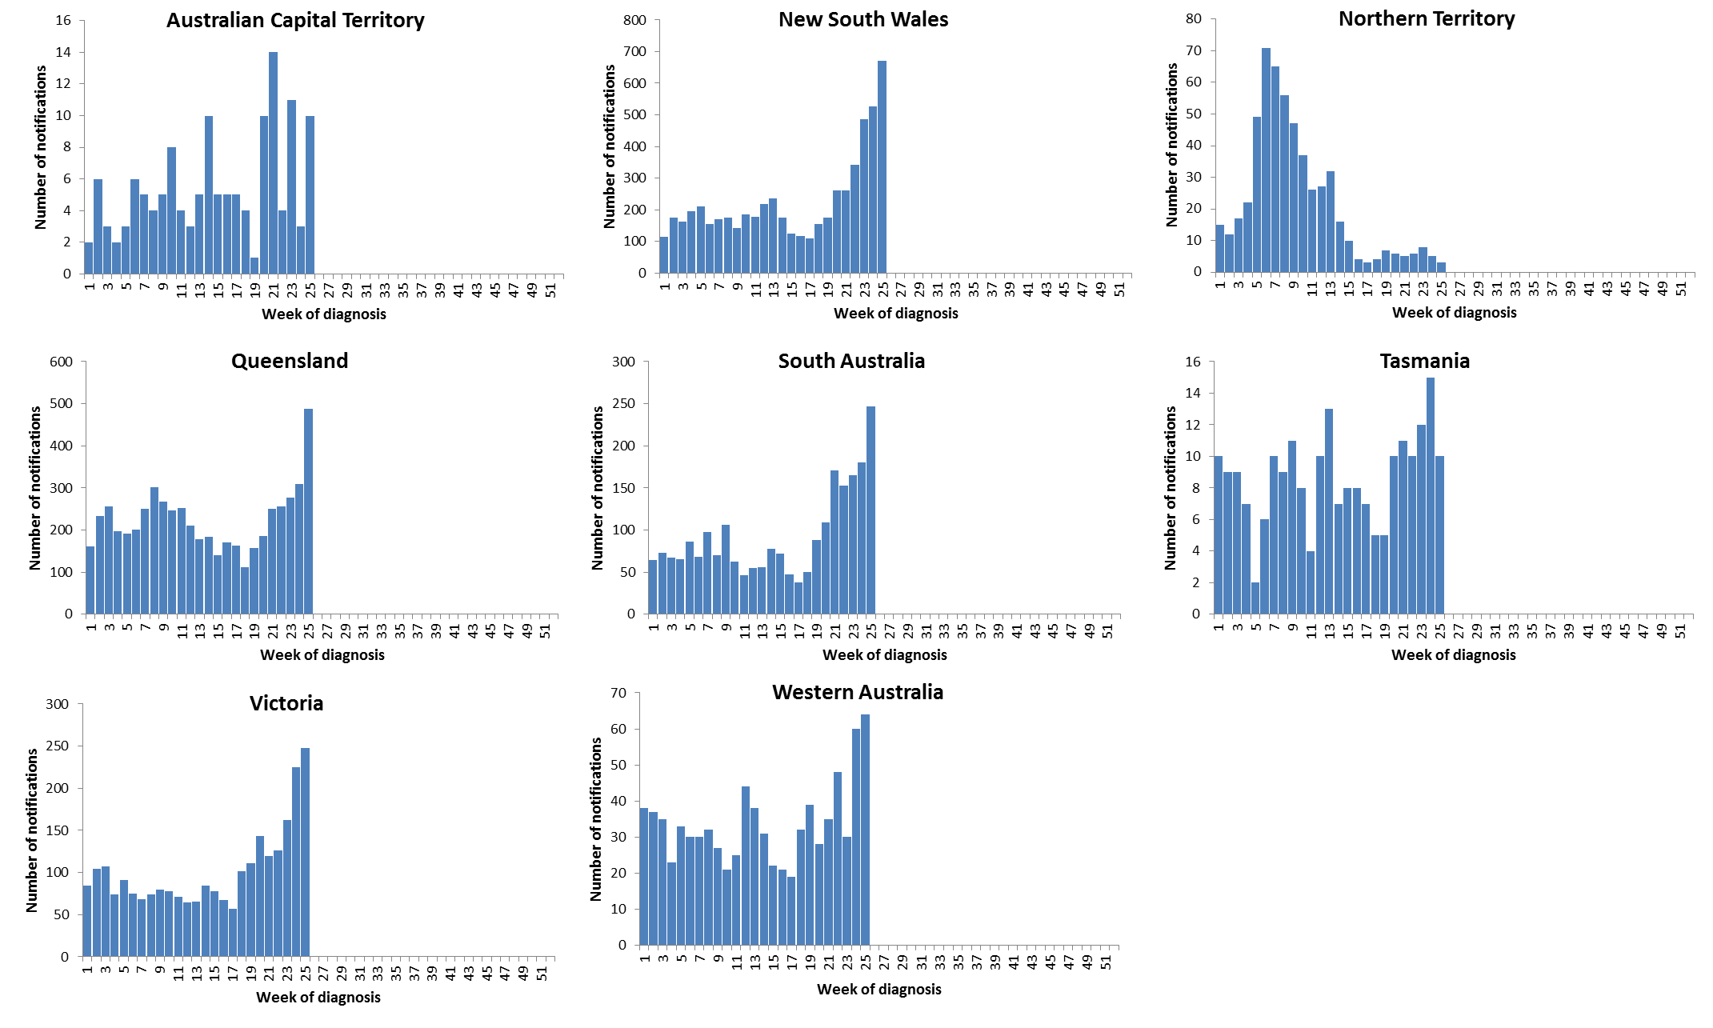

Source: NNDSS

Figure 6. Per cent of notifications of laboratory confirmed influenza, Australia, 1 January to 23 June 2017, by subtype and state or territory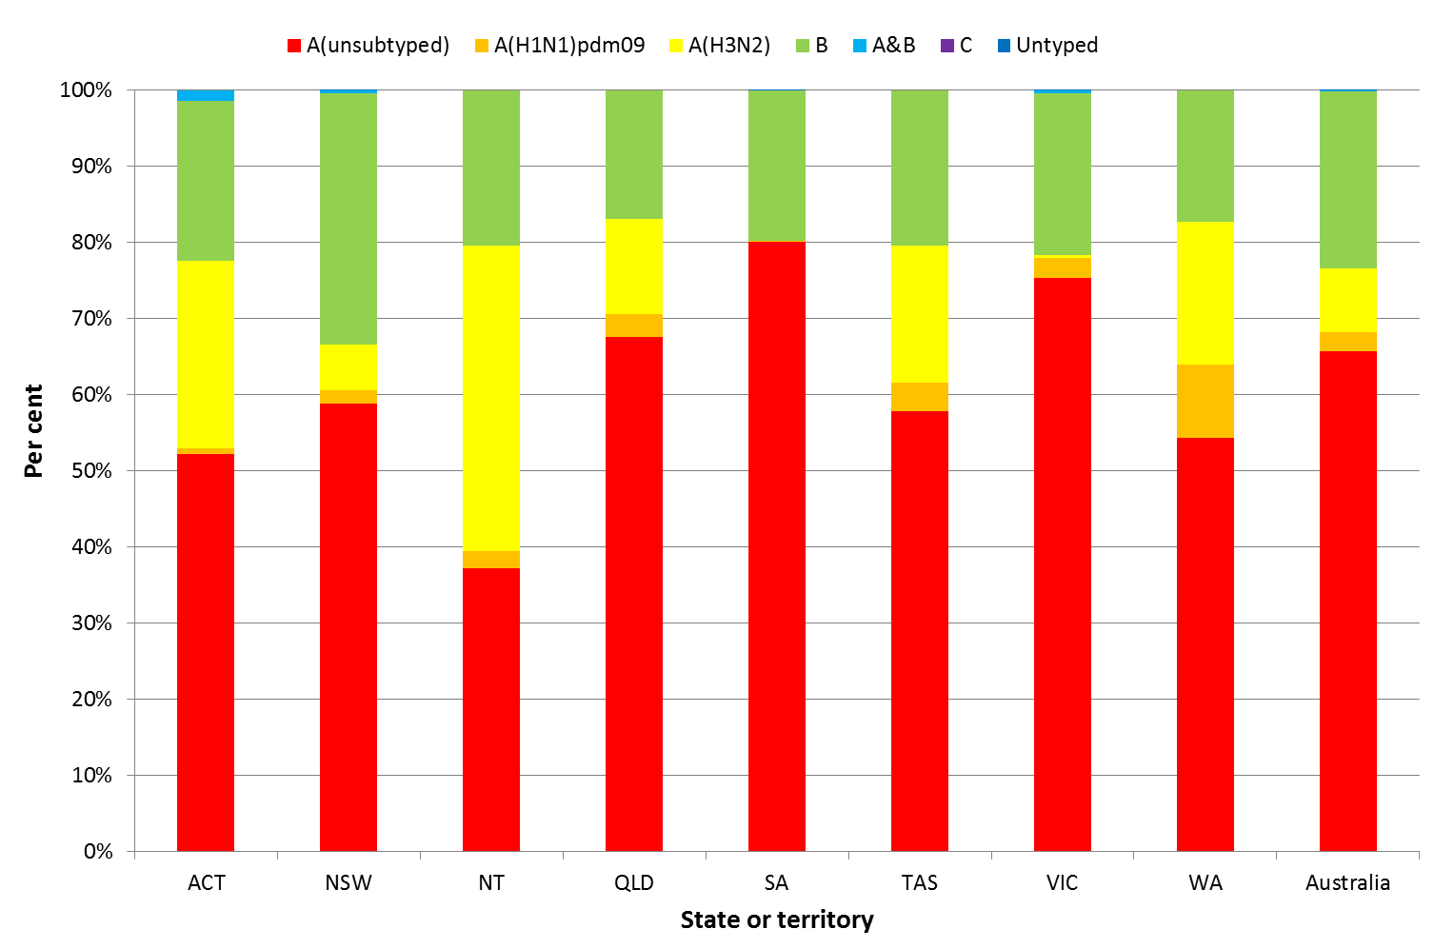

Source: NNDSS

Figure 7. Per cent of laboratory confirmed influenza, Australia, 1 January to 23 June 2017, by subtype and week

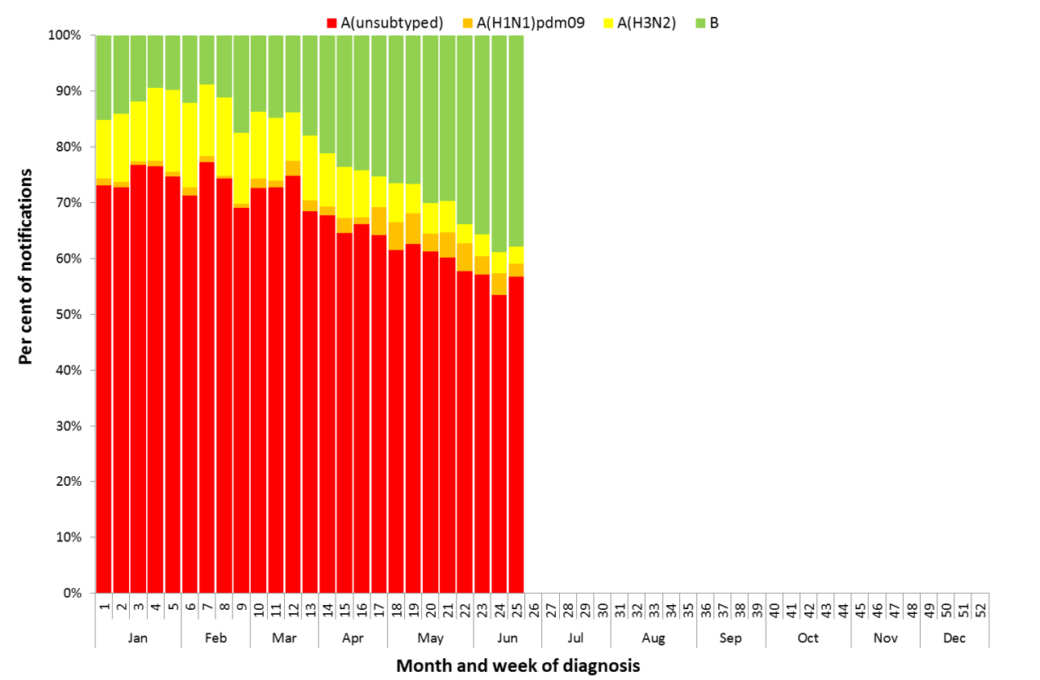

Source: NNDSS

Figure 8. Notifications of laboratory confirmed influenza by week of diagnosis and cumulative year-to-date, Australia,   
1 January to 23 June 2017, by subtype and age group

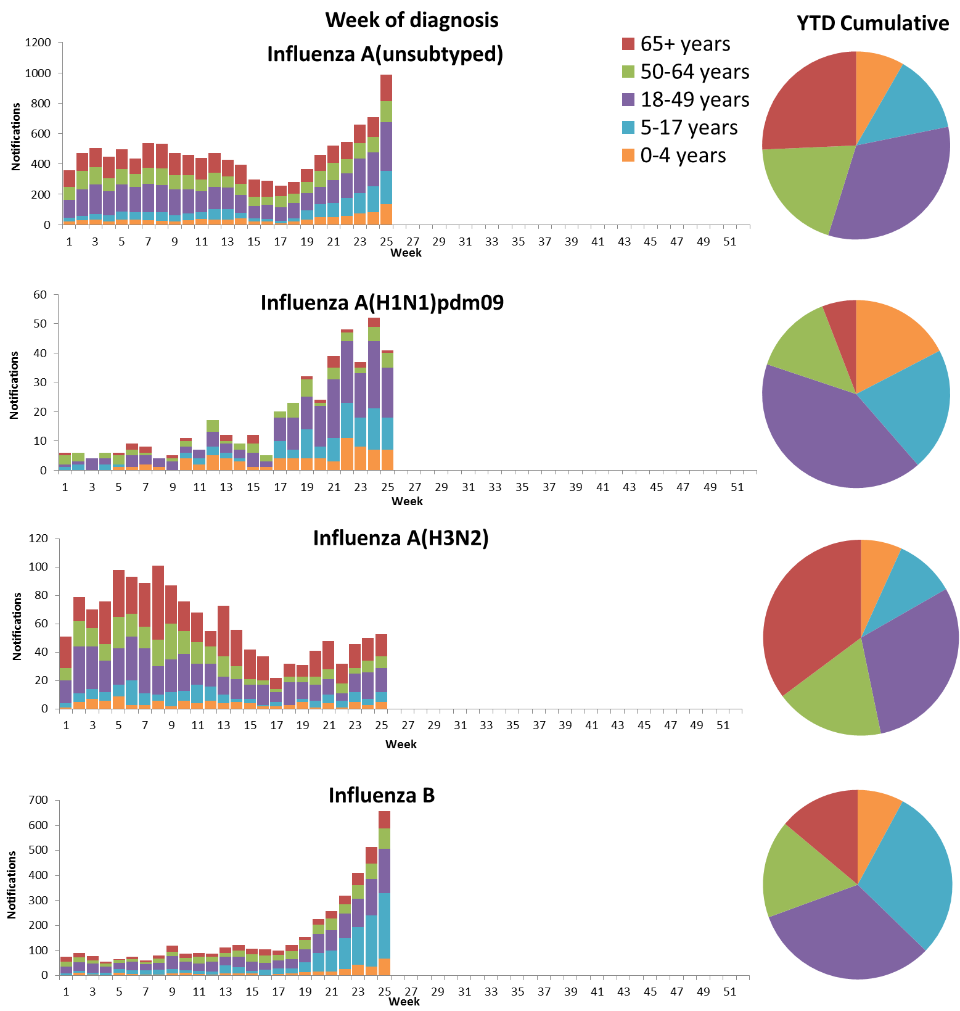

Source: NNDSS

Figure 9. Rate of notifications of laboratory confirmed influenza, Australia, 1 January to 23 June 2017, by age group and subtype

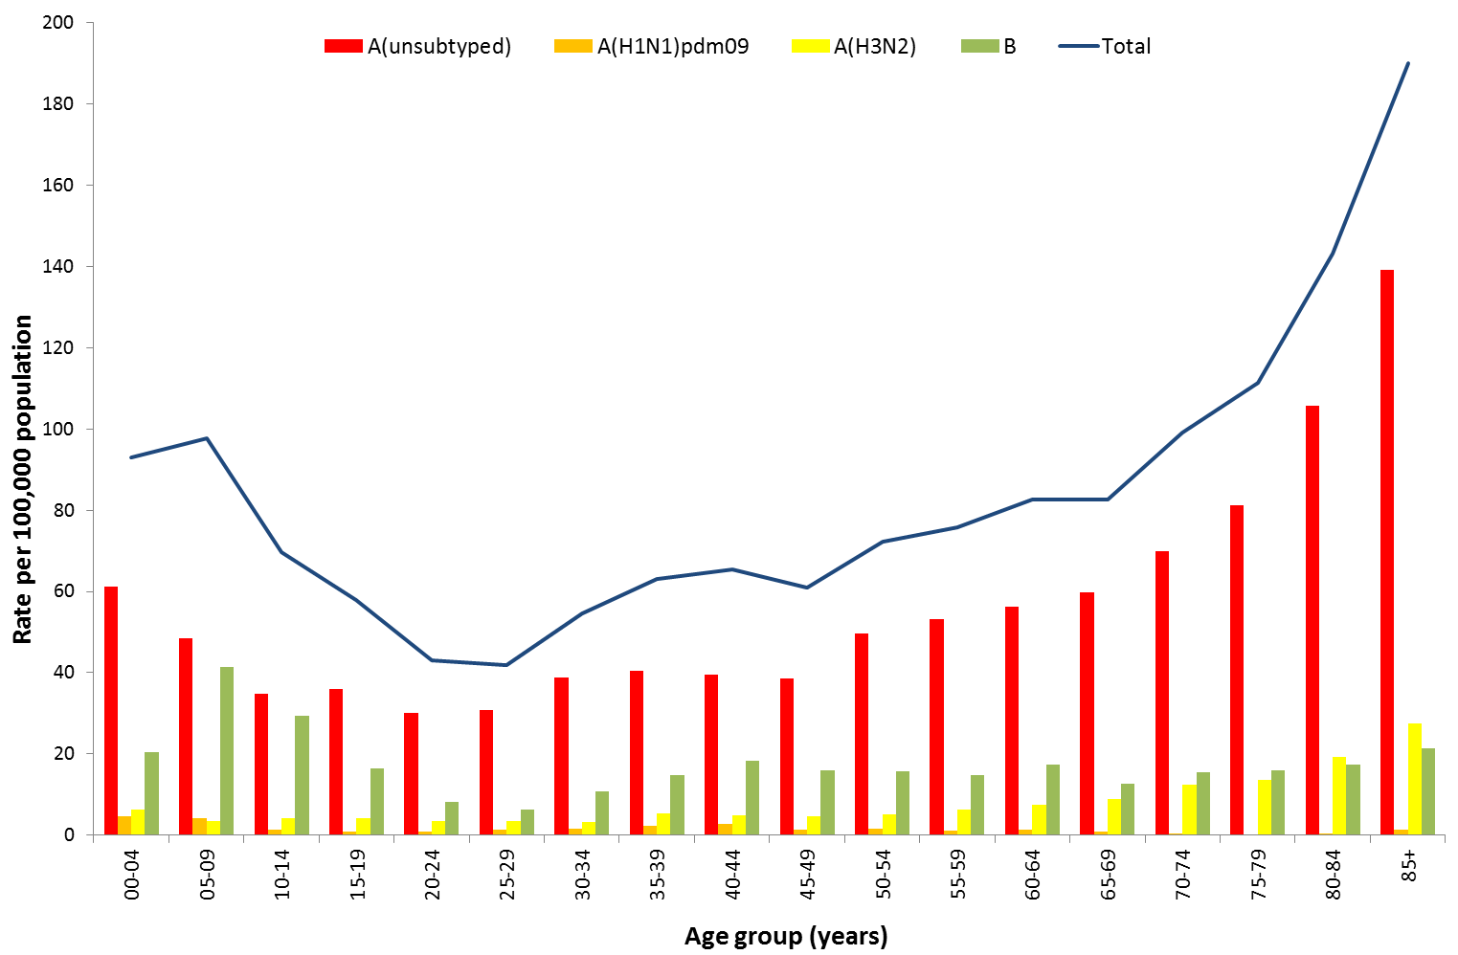

Source: NNDSS

Figure 10. Notifications of laboratory confirmed influenza by week of diagnosis and cumulative year-to-date, Australia, 1 January to 23 June 2017, by age group and subtype

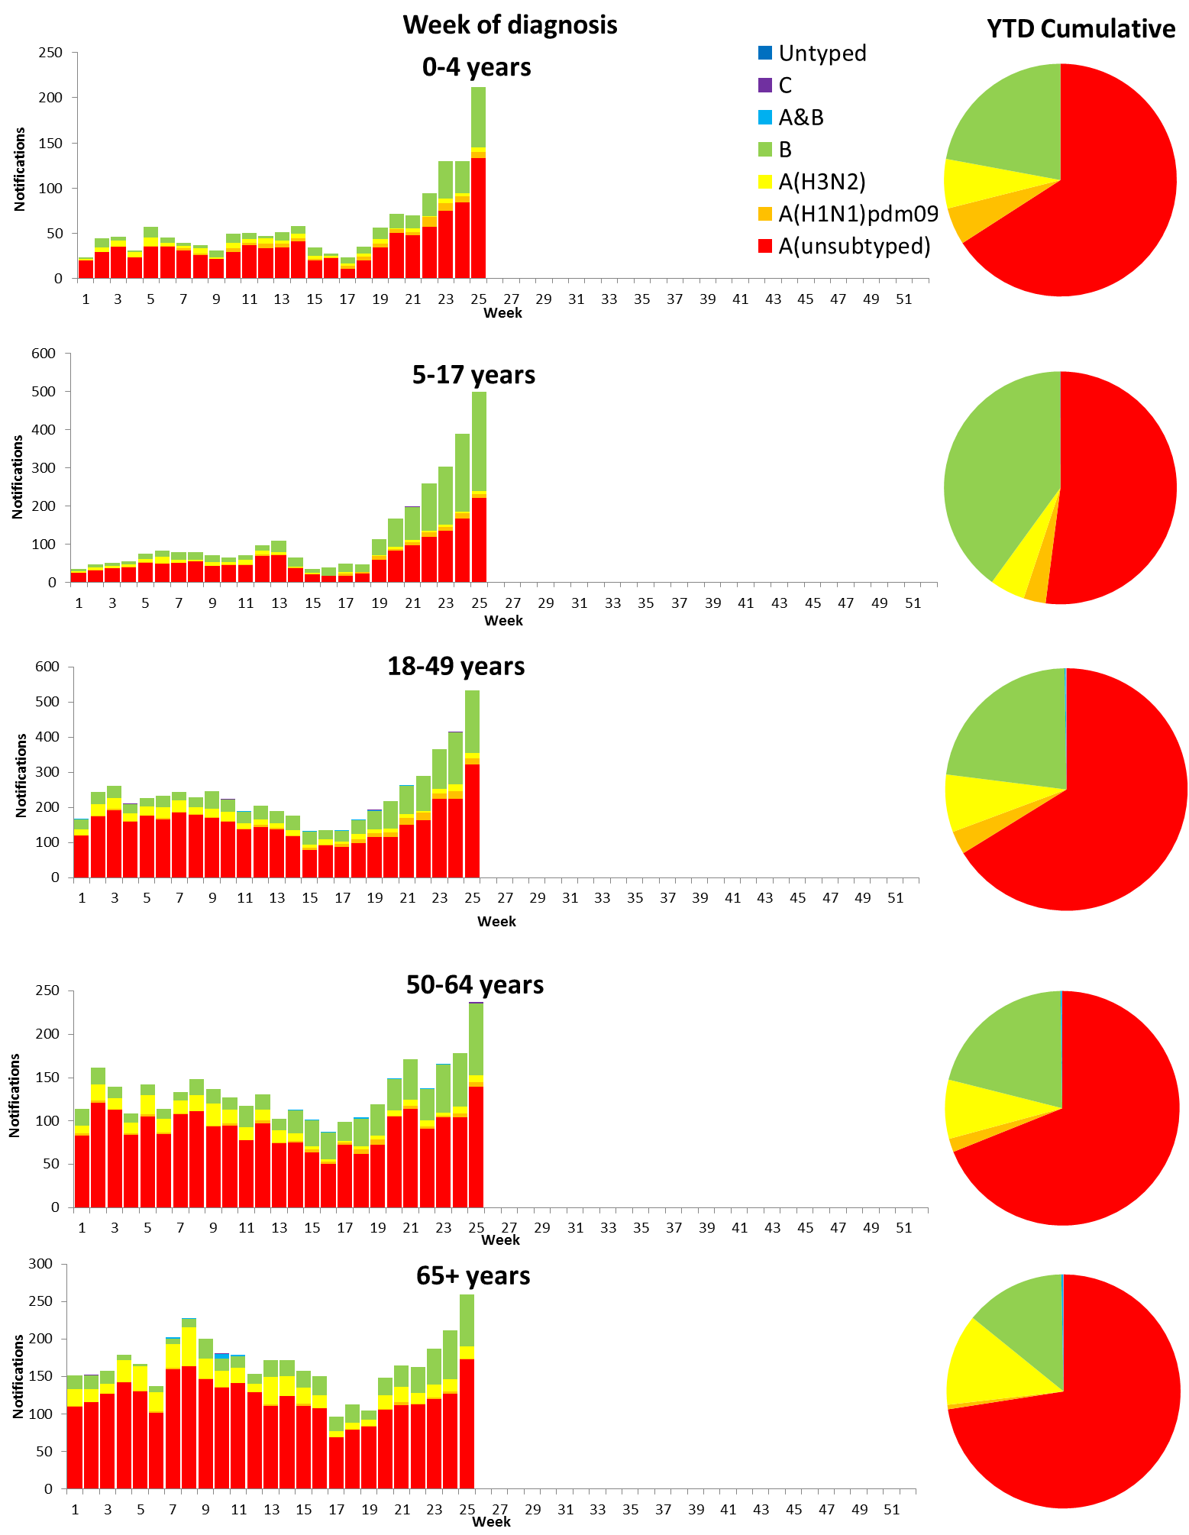

Source: NNDSS

## 2. Influenza-like Illness Activity

### Community Level Surveillance

FluTracking, a national online system for collecting data on ILI in the community, indicated that rates of ILI among participants remained at low levels this reporting fortnight (Figure 11). ILI activity among participants, reported as fever and cough, declined slightly from week 24 (1.9%) to 25 (1.8%). So far this year 61% of all participants and 79% of participants who identify as working face-to-face with patients reported receiving the seasonal influenza vaccine.[1]

Figure 11. Proportion of fever and cough among FluTracking participants, Australia, between May and October, 2013 to 2017, by month and week

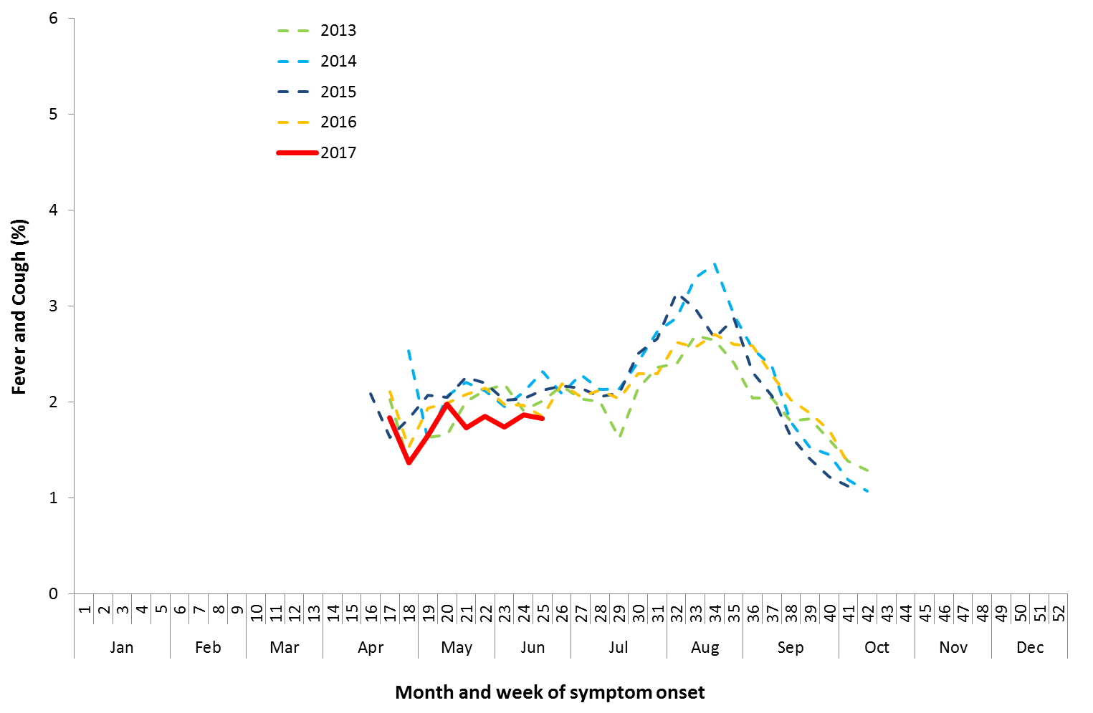

Source: FluTracking

### Sentinel General Practice Surveillance

Sentinel general practitioner ILI consultations have varied this fortnight with 4.3 per 1,000 consultations in week 24 and 5.4 per 1,000 consultations in week 25 (Figure 12). ILI consultations in the last fortnight are lower than rates reported at the same time in recent years.

Of the 36 specimens taken from ILI patients seen by Australian Sentinel Practices Research Network (ASPREN) sentinel practitioners during the current reporting fortnight, 6 (17%) were positive for influenza, consisting of 3 samples positive for A(unsubtyped) and 3 positive for influenza B (Figure 13). Rhinovirus was the most common non-influenza virus detected this fortnight, representing 32% of tests processed.

Figure 12. Unweighted rate of ILI reported from sentinel GP surveillance systems, Australia, 1 January 2013 to 25 June 2017, by month and week

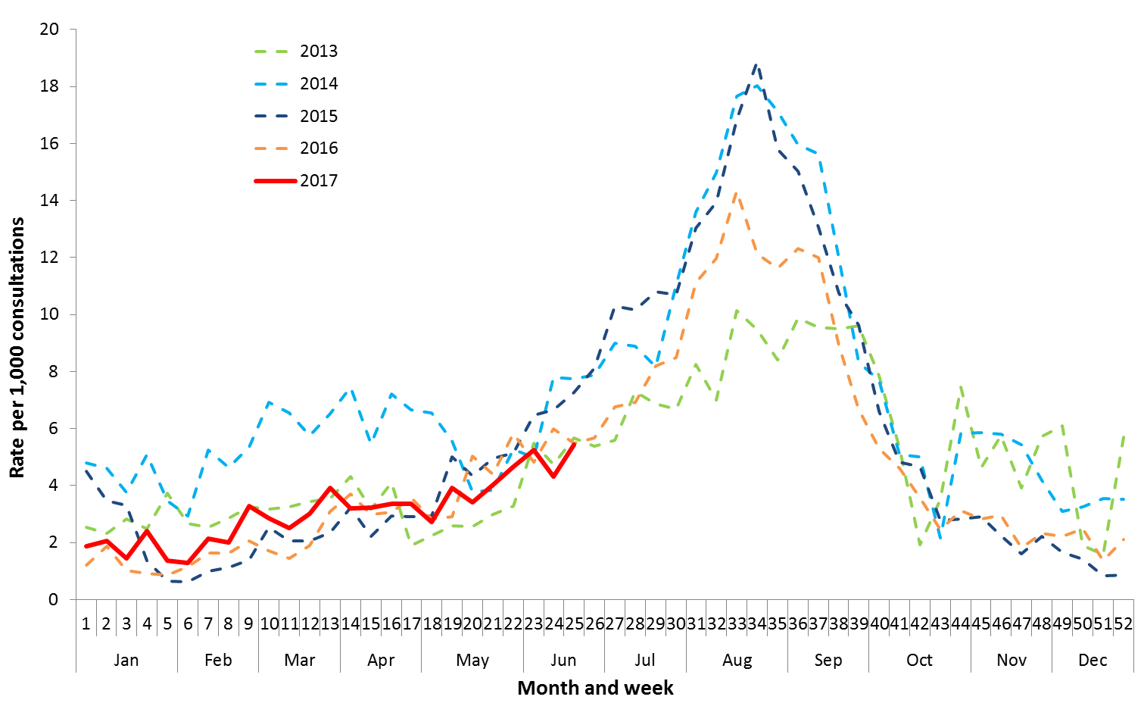

Source: ASPREN and VicSPIN

Figure 13. Proportion of respiratory viral tests positive for influenza in ASPREN ILI patients and ASPREN ILI consultation rate, Australia, 1 January to 25 June 2017, by month and week

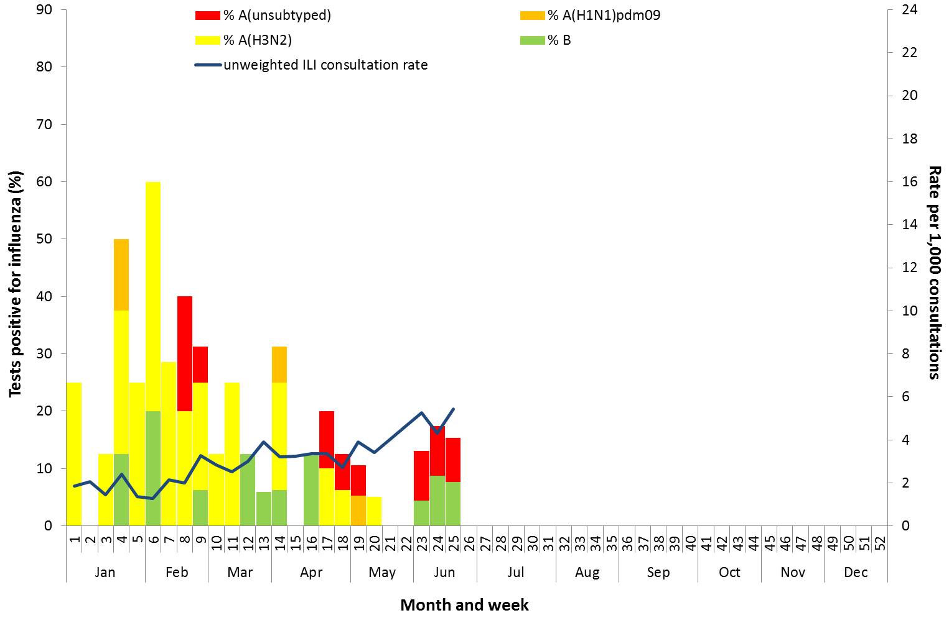

Source: ASPREN

## 3. Hospitalisations

### Sentinel Hospital Surveillance

Admissions with confirmed influenza to sentinel hospitals remained relative stable across the reporting fortnight (Figure 14), with 20 patients admitted in week 24, and 23 in week 25. Since seasonal surveillance commenced through the Influenza Complications Alert Network (FluCAN) sentinel hospital surveillance system on 3 April 2017, a total of 185 people have been admitted with confirmed influenza, of which 41 (22%) were children aged less than 15 years and 83 (45%) were adults aged 65 years or older. Approximately 6% of influenza patients have been admitted directly to ICU; with all but one of the ICU cases related to infection with influenza A (Figure 15). For the year to 23 June, 74% of notifications of admissions with confirmed influenza to sentinel hospitals were influenza A (58% A(unsubtyped), 3% influenza A(H1N1)pdm09 and 12% influenza A (H3N2)), 25% were influenza B and less than 1% were mixed influenza infections. Consistent with notification data, the proportion of admissions due to influenza B was higher in children.

Figure 14. Number of influenza hospitalisations at sentinel hospitals, between March and October, 2013 to 2017 by month and week

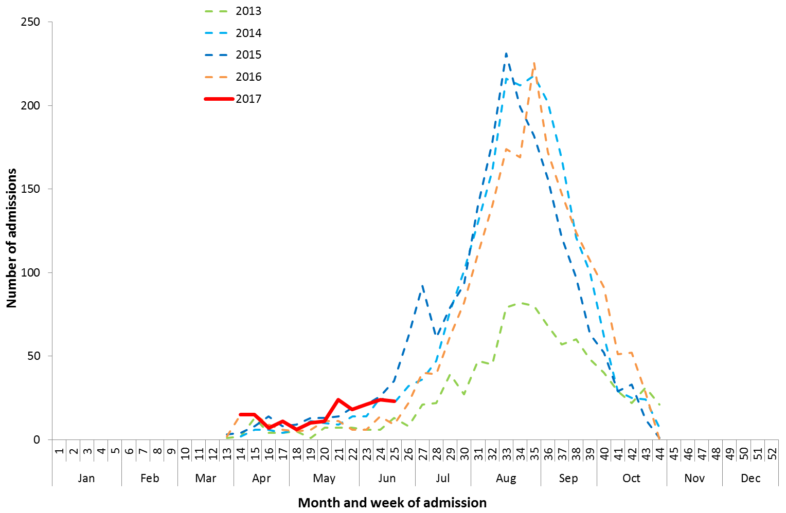

Source: FluCAN

Figure 15. Number of influenza hospitalisations at sentinel hospitals by subtype and ICU admission, 3 April to 9 June 2017, by month and week

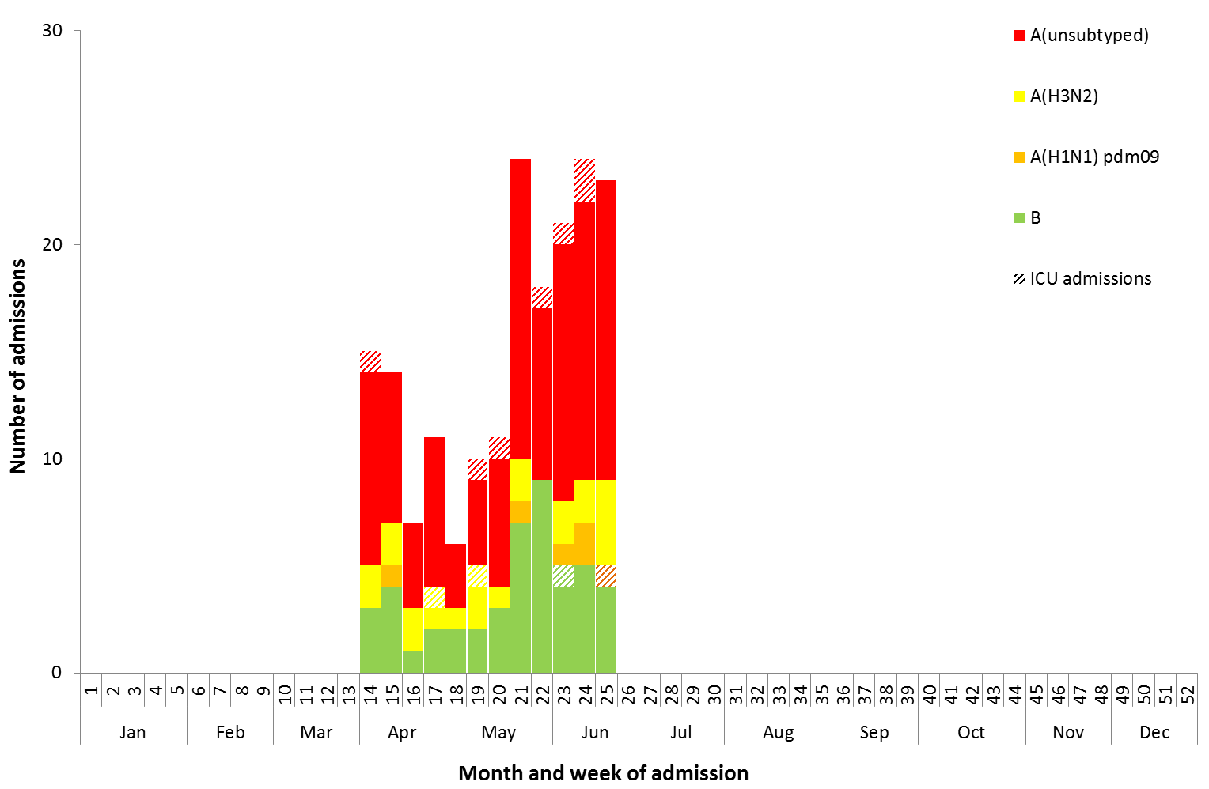

Source: FluCAN

### Paediatric Severe Complications of Influenza

The Australian Paediatric Surveillance Unit (APSU) conducts seasonal surveillance between June and September annually of children aged 15 years and under who are hospitalised with severe complications of influenza. Between 1 June 2017 and 25 June 2017, there have been no hospitalisations associated with severe complications of influenza reported to APSU. The hospitalisation reported last fortnight has been discarded as the admission date of the hospitalisation was outside of the study period, that is, prior to 1 June 2017.

## 4. Deaths Associated with Influenza and Pneumonia

### Nationally Notified Influenza Associated Deaths

So far in 2017, 20 influenza associated deaths have been notified to the NNDSS. The majority of deaths were due to influenza A (70%, n = 14). The median age of deaths notified was 78 years (range 29 to 97 years). The number of influenza associated deaths reported to the NNDSS is reliant on the follow up of cases to determine the outcome of their infection and most likely does not represent the true mortality associated with this disease.

### New South Wales Influenza and Pneumonia Death Registrations

Death registration data from NSW for the week ending 12 May 2017 show that there were 1.07 “pneumonia and influenza” deaths per 100,000 NSW population, which was below the epidemic threshold of 1.61 per 100,000 NSW population (Figure 16).[2]

Figure 16. Rate of deaths classified as influenza and pneumonia from the NSW Registered Death Certificates, 2012 to 12 May 2017

Please refer above for description and interpretation.

Source: NSW Registry of Births, Deaths and Marriages

## 5. Virological Surveillance

### Australian Influenza Vaccines Composition 2017

The influenza virus strains included in the 2017 seasonal influenza vaccines in Australia are:

* A/Michigan/45/2015, (H1N1)pdm09-like virus;
* A/Hong Kong/4801/2014, (H3N2)-like virus;
* B/Brisbane/60/2008-like virus, Victoria lineage;
* B/Phuket/3073/2013-like virus, Yamagata lineage.

### Typing and Antigenic Characterisation

From 1 January to 26 June, the World Health Organization Collaborating Centre for Reference and Research on Influenza (WHOCC) characterised 392 influenza viruses (Table 1). When further characterised for similarity to the vaccine components, isolates appeared to be well matched. All the influenza B and influenza A(H1N1)pdm09 isolates were characterised as similar to the vaccine components. A small number of influenza A(H3N2) isolates (n=22) were characterised as low reactors. An additional 117 influenza A(H3) isolates were unable to be characterised in the HI assay due to insufficient titre.

Table 1. Australian influenza viruses typed by HI from the WHOCC, 1 January to 26 June 2017.

|  |  |  |  |  |  |  |  |  |  |
| --- | --- | --- | --- | --- | --- | --- | --- | --- | --- |
| **Type/Subtype** | **ACT** | **NSW** | **NT** | **QLD** | **SA** | **TAS** | **VIC** | **WA** | **TOTAL** |
| **A(H1N1) pdm09** | 1 | 23 | 1 | 23 | 5 | 1 | 2 | 8 | 64 |
| **A(H3N2)** | 5 | 75 | 16 | 24 | 51 | 1 | 3 | 7 | 182 |
| **B/Victoria lineage** | 0 | 0 | 0 | 1 | 1 | 0 | 0 | 0 | 2 |
| **B/Yamagata lineage** | 1 | 20 | 9 | 9 | 9 | 0 | 0 | 1 | 49 |
| Total | 7 | 118 | 26 | 57 | 66 | 2 | 5 | 16 | 297 |

SOURCE: WHO CC

Note: Viruses tested by the WHO CC are not necessarily a random sample of all those in the community.

State indicates the residential location for the individual tested, not the submitting laboratory.

There may be up to a month delay on reporting of samples.

### Antiviral Resistance

The WHOCC reported that from 1 January to 26 June 2017, of the 434 influenza viruses tested for neuraminidase inhibitor resistance, none of the samples demonstrated reduced inhibition to the antiviral drugs Oseltamivir or Zanamivir.

## 6. International Surveillance

The World Health Organization reported that based on data up to 11 June, in the temperate zone of the southern hemisphere, influenza activity continued to increase and was above seasonal threshold levels in South America but remained low in general in Oceania.[3] Influenza activity in the temperate zone of the northern hemisphere continued to decrease. Worldwide, influenza A(H3N2) and B viruses co-circulated.

# DATA CONSIDERATIONS

The NNDSS data provided were extracted on 29 June 2017. Due to the dynamic nature of the NNDSS, data in this report is subject to retrospective revision and may vary from data reported in published NNDSS reports and reports of notification data by states and territories. Detailed notes on interpreting the data presented in this report are available at the Department of Health’s [Australian Influenza Surveillance Report website](http://www.health.gov.au/flureport) (www.health.gov.au/flureport).

The Australian Influenza Surveillance Report and Activity Updates are compiled from a number of data sources, which are used to monitor influenza activity and severity in the community. These data sources include laboratory-confirmed notifications to the NNDSS; influenza associated hospitalisations; sentinel influenza-like illness (ILI) reporting from general practitioners and emergency departments; and community level surveys; and sentinel laboratory testing results. The information in this report is reliant on the surveillance sources available to the Department of Health at the time of production.

While every care has been taken in preparing this report, the Commonwealth does not accept liability for any injury or loss or damage arising from the use of, or reliance upon, the content of the report. Delays in the reporting of data may cause data to change retrospectively. For further details about information contained in this report please contact the [Influenza Surveillance Team](mailto:flu@health.gov.au) ([flu@health.gov.au](mailto:flu@health.gov.au)).

# REFERENCES

1. FluTracking, FluTracking Weekly Interim Report, Week ending 25 June 2017. Available from [FluTracking Reports](http://www.flutracking.net/Info/Reports) (http://www.flutracking.net/Info/Reports) [Accessed 29 June 2017].
2. NSW Health, Influenza Monthly Epidemiology Report, NSW, April 2017. Available from NSW Health Influenza Surveillance Reports (http://www.health.nsw.gov.au/Infectious/Influenza/Pages/reports.aspx)[Accessed 8 June 2017].
3. WHO, Influenza Update No. 292, 26 June 2017. Available from the [WHO website](http://www.who.int/influenza/surveillance_monitoring/updates/latest_update_GIP_surveillance/en/) (http://www.who.int/influenza/surveillance_monitoring/updates/latest_update_GIP_surveillance/en/) [Accessed 29 June 2017].