| Logo | **Australian Influenza**  **SURVEILLANCE REPORT**  **No. 4, 2017**  **Reporting period 24 June – 7 July 2017** |
| --- | --- |

The Department of Health acknowledges the providers of the many sources of data used in this report and greatly appreciates their contribution.

# KEY MESSAGES

* Influenza activity is increasing in the majority of Australian jurisdictions, while remaining stable and sporadic in the rural south and northern regions of Western Australia, the Northern Territory and the tropical region of Queensland.
* Positive test results for influenza have increased significantly over the reporting fortnight, particularly in Victoria. Respiratory viruses other than influenza, in particular rhinovirus and RSV, were most commonly detected by sentinel laboratories.
* Nationally, notifications of laboratory confirmed influenza B viruses have continued to increase over the reporting fortnight; however the proportion of total notifications has decreased. Influenza A(H1N1)pdm09 and influenza A(H3N2) are also co-circulating in some parts of the country.
* Influenza-like illness (ILI) in the community was increased slightly but remained low this reporting fortnight, while ILI presentations to sentinel GPs increased significantly.
* To date, the seasonal influenza vaccines appear to be a good match for circulating virus strains.

# ANALYSIS

## 1. Geographic Spread of Influenza Activity in Australia

In the fortnight ending 7 July 2017 (week 27), influenza activity was reported by state and territory health departments as increased when compared to the previous fortnight in the majority of regions in Australia, excepting the rural south region of Western Australia (WA), the Northern Territory (NT) and, the tropical region of Qld. (Figure 1). The geographic spread of influenza activity was reported as widespread in New South Wales (NSW), South Australia (SA) and Victoria (Vic); regional in the southern and central regions of Qld; localised in the Australian Capital Territory (ACT), the rural south region of WA and Tasmania (Tas) and sporadic in those northern regions that reported unchanged activity. Influenza-like illness (ILI) activity reported from syndromic surveillance systems when compared with the previous fortnight was reported as increased in NSW, SA, Victoria and WA unchanged in all other states and territories.

Figure . Map of influenza activity by state and territory, Australia, 27 May -7 July 2017.

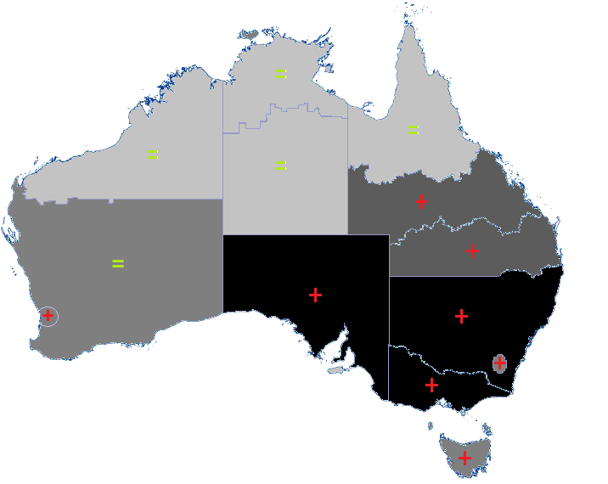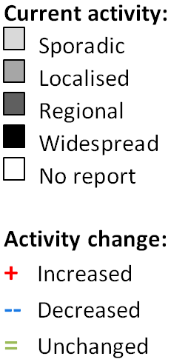

## 2. Laboratory Confirmed Influenza Activity

### Sentinel Laboratory Surveillance

Influenza was detected by sentinel laboratories at increasing levels over the reporting fortnight (Figure 2). The pooled percentage of tests positive for influenza across all sentinel laboratories increased from 9.2% in week 26 to 13.8% in week 27. The percentage of tests positive for influenza increased in all contributing laboratories and jurisdictions over the reporting fortnight, particularly in Victoria, where it increased from 12.2% in week 26 to 33.3% in week 27.

Testing for influenza increased over the reporting fortnight (Figure 3). RSV and rhinovirus were reported as the most commonly detected respiratory viruses this fortnight.

Figure . Proportion of sentinel laboratory tests positive for influenza, 1 January to 7 July 2017, by contributing laboratory or jurisdiction and month and week.

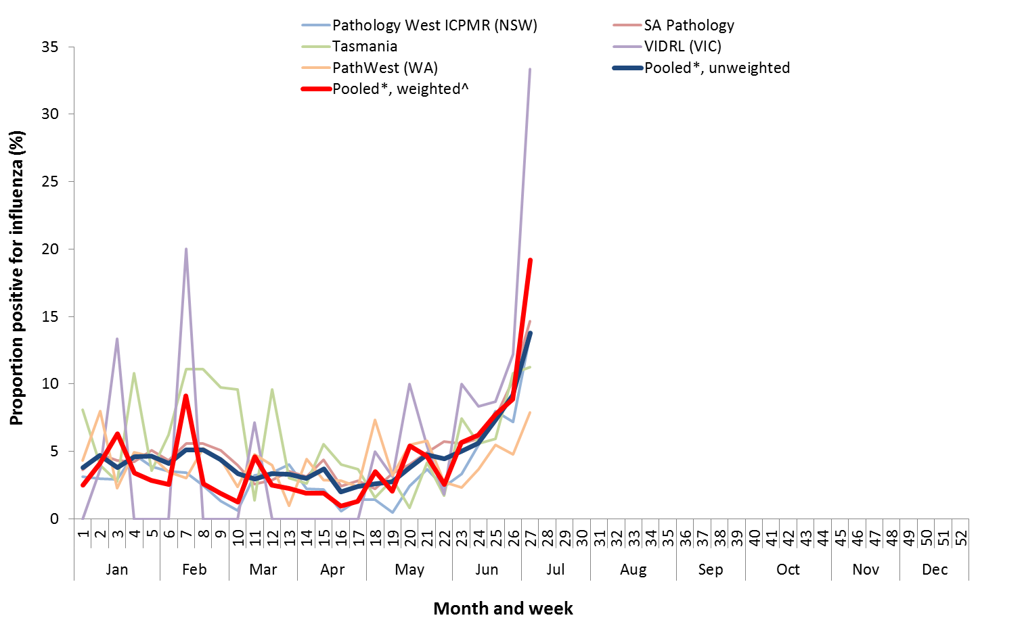

* Pooled percentage positive indicators should be interpreted with caution, noting that collectively pooled contributing laboratories are not representative of testing across Australia and individually contributing laboratories may not be representative of the jurisdiction in which they are located.

^ Weighted according to jurisdictional population in which laboratories are located.

* The percentage of tests positive for influenza in the interseasonal period should be interpreted with caution due to small numbers of tests being undertaken in this time, resulting in high variability in the indicators.

Figure . Proportion of sentinel laboratory tests positive for influenza and total number of specimens tested, 1 January to 7 July 2017, by subtype and month and week.

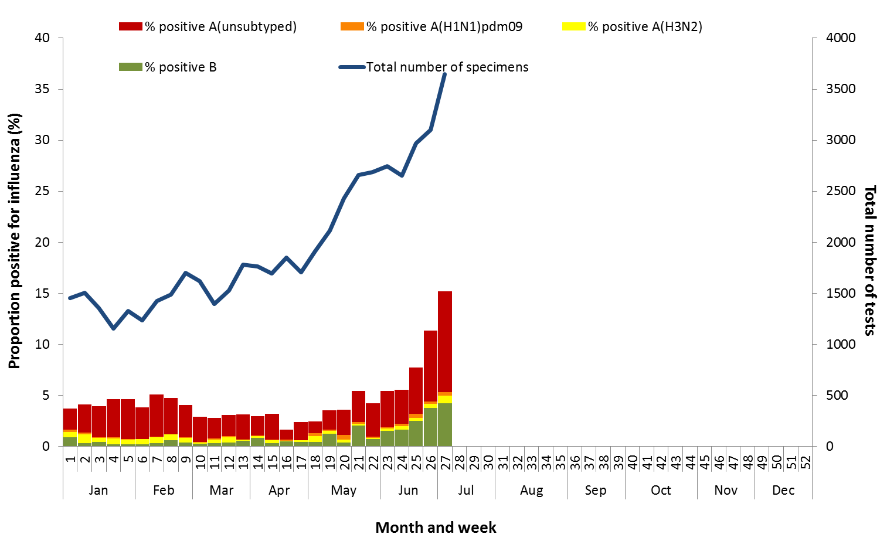

### Notifications of Influenza to Health Departments

Notifications of laboratory confirmed influenza to the National Notifiable Diseases Surveillance System (NNDSS) have continued to increase this reporting fortnight (Figure 4). For the year to 7 July, a total of 23,919 notifications of laboratory confirmed influenza were reported to the NNDSS: 8,311 in NSW; 6,784 in QLD; 3,517 in VIC; 3,304 in SA; 992 in WA; 571 in the NT; 256 in TAS and 184 in the ACT. Notifications of laboratory confirmed influenza increased in ACT, NSW, NT, QLD, SA, TAS and VIC over the reporting fortnight and remained relatively stable in WA (Figure 5).

For the year to 7 July, 74% of notifications of laboratory confirmed influenza to the NNDSS were influenza A (65% A(unsubtyped), 3% influenza A(H1N1)pdm09 and 7% influenza A (H3N2)), 25% were influenza B and less than 1% were influenza C, influenza A&B co-infections or untyped (Figure 6). The proportion of all notifications year to date reported as influenza A has ranged across jurisdictions from 63% in NSW to 83% in WA. Detections of influenza A subtypes have varied across jurisdictions also. Nationally, for every one notification of influenza A(H1N1)pdm09 reported to the NNDSS, 2.9 notifications of influenza A(H3N2) were received. This ratio has ranged from 1:0.1 in VIC to 1:49 in the ACT.

In the most recent fortnight, 68% of notifications of laboratory confirmed influenza to the NNDSS were influenza A (63% influenza A(unsubtyped), 2% influenza A(H1N1)pdm09 and 3% influenza A (H3N2)), 32% were influenza B and less than 1% were influenza A&B co-infections or untyped (Figure 7). The proportion of all notifications this reporting fortnight reported as influenza B ranged across jurisdictions from 17% in WA to 4% in NSW. The number of influenza B notifications continued to increase this fortnight, with the proportion of influenza B of all notifications declining slightly over the fortnight from 33% in week 24 to 30% in week 25 (Figure 7 and Figure 8).

So far in 2017, notification rates have tended to increase with increasing age. Age-specific notification rates of influenza overall have been highest in adults aged 75 years or older (175.3 notifications per 100,000), with a secondary smaller peak in children aged 5-9 years (156.3 per 100,000) (Figure 9). Influenza A(H1N1)pdm09 was highest in children aged less than 5 years, influenza A(H3N2) was highest in the elderly aged 85 years and older and influenza B was highest in children aged 5 to 9 years (69.5 notifications per 100,000 population).

Increases in notifications have been seen across all broad age groups this reporting fortnight (Figure 10). The distribution of influenza types and subtypes differed across age groups, with 42% of 5-17 year olds notified with influenza being detected with influenza B, while only 15% of adults aged 65 years and older detected with influenza B. While influenza A(H3N2) is detected across all age groups, it accounted for a greater proportion of influenza A where subtyping is available in adults aged 65 years or older, at 12%, than in any other age group.

Figure . Notifications of laboratory confirmed influenza, Australia, 1 January 2013 to 7 July 2017, by month and week of diagnosis

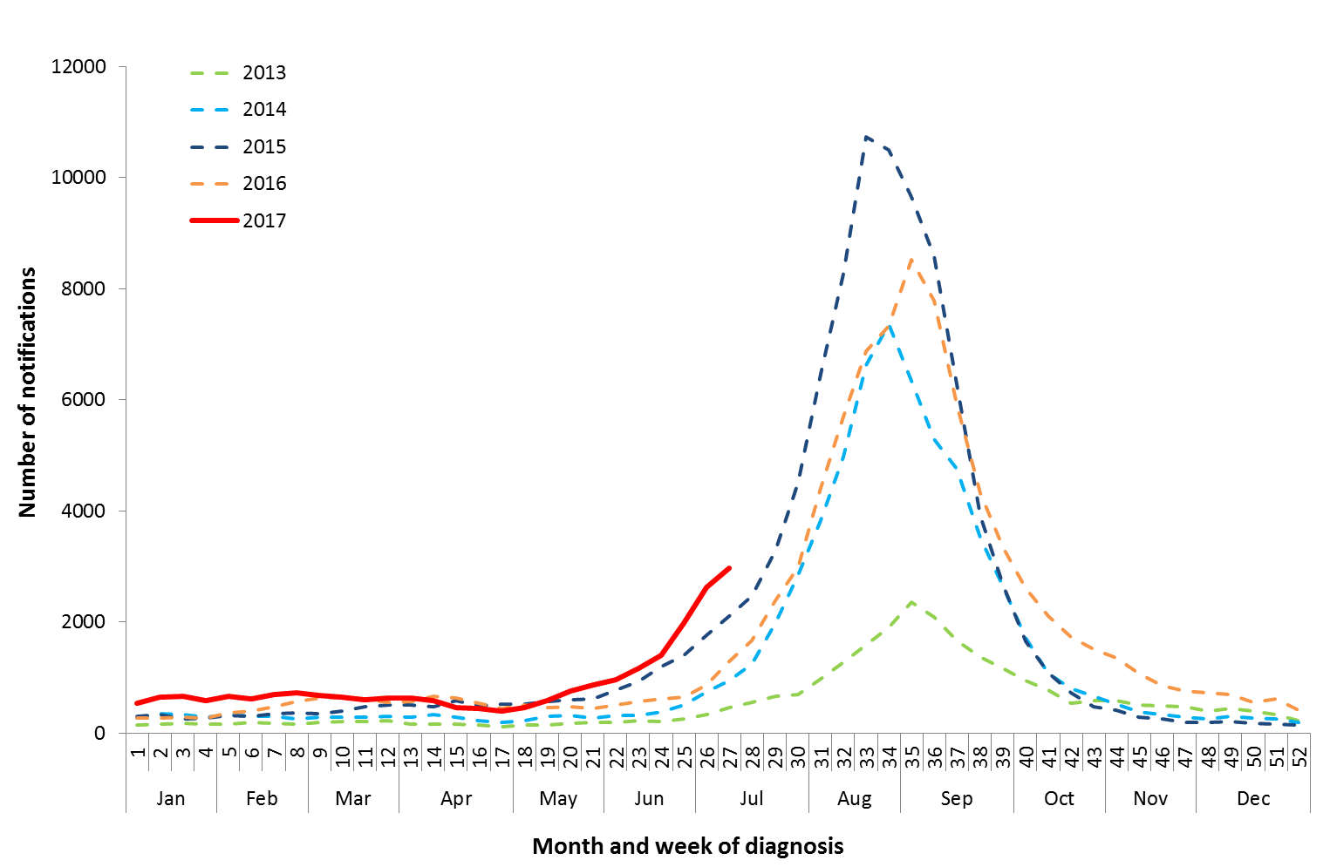

Source: NNDSS

Figure . Notifications of laboratory confirmed influenza, 1 January to 7 July 2017, by state or territory and week

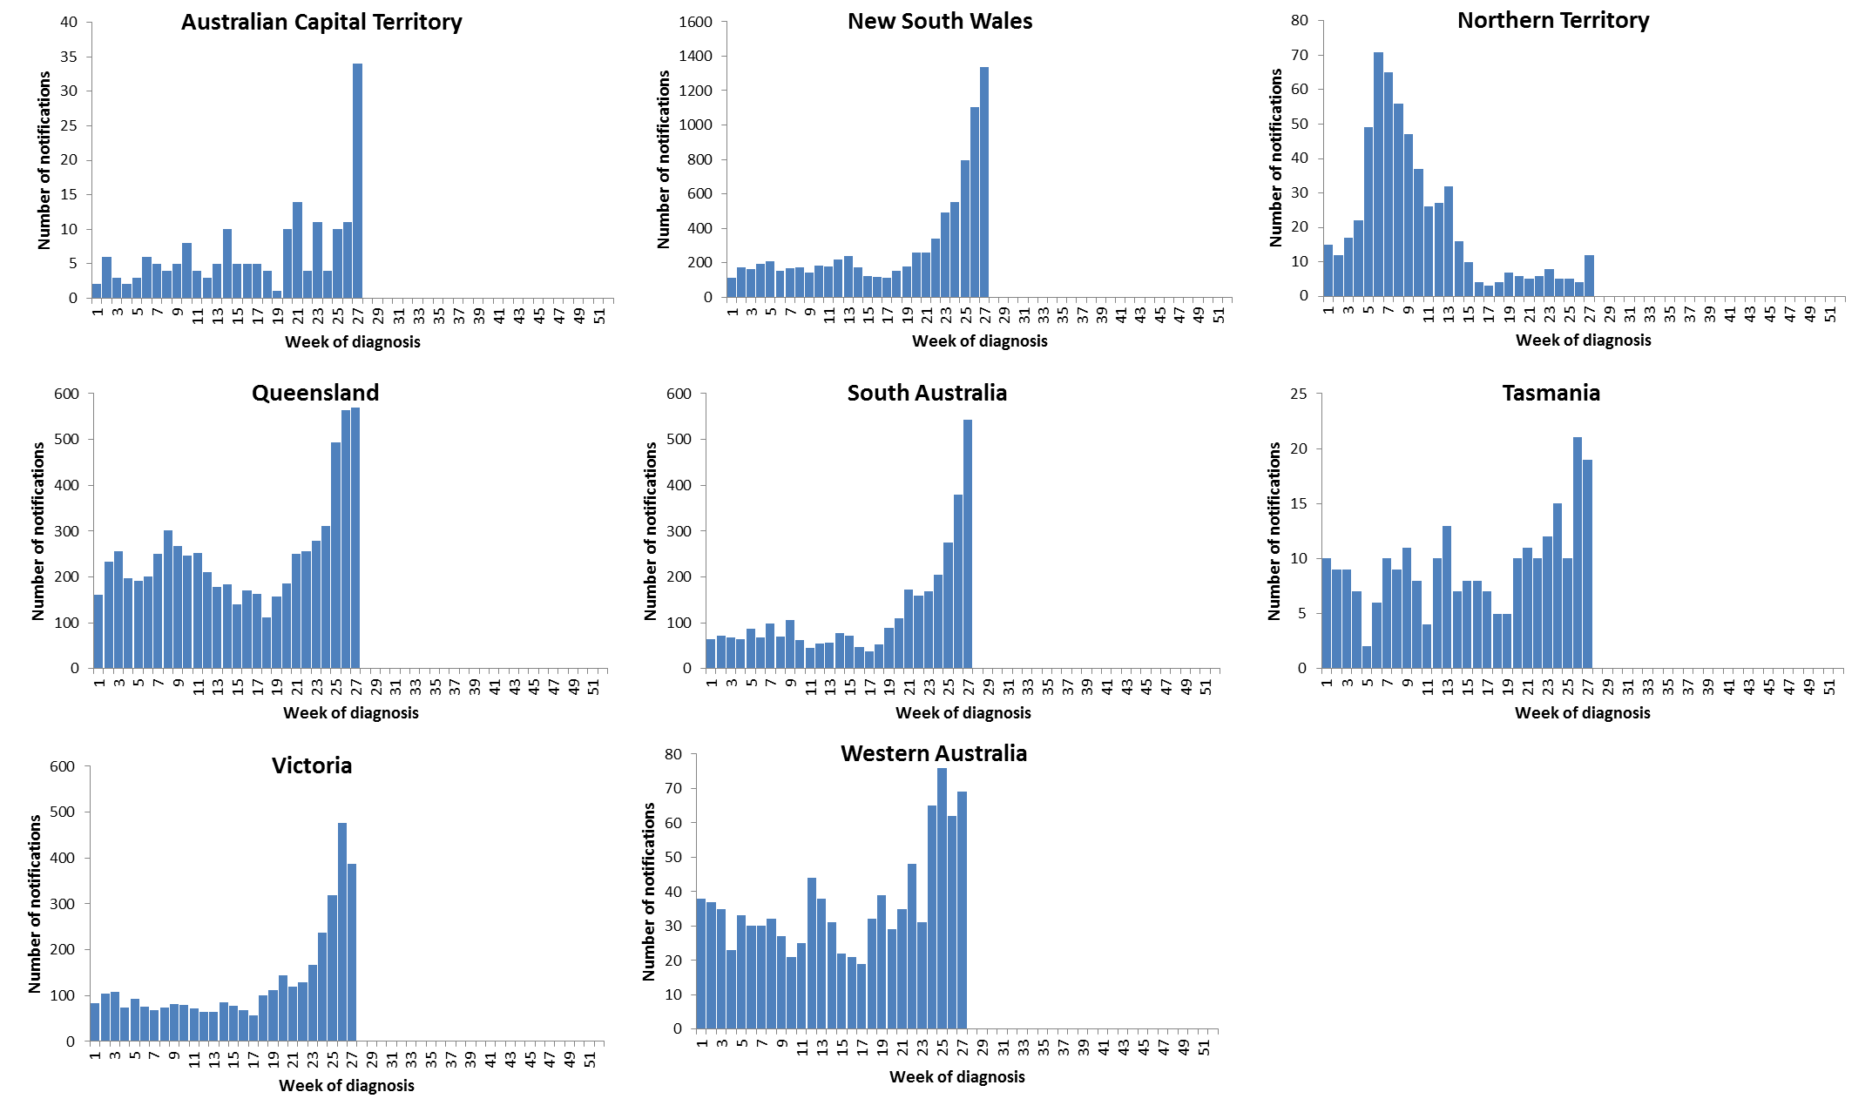

Source: NNDSS

Figure . Per cent of notifications of laboratory confirmed influenza, Australia, 1 January to 7 July 2017, by subtype and state or territory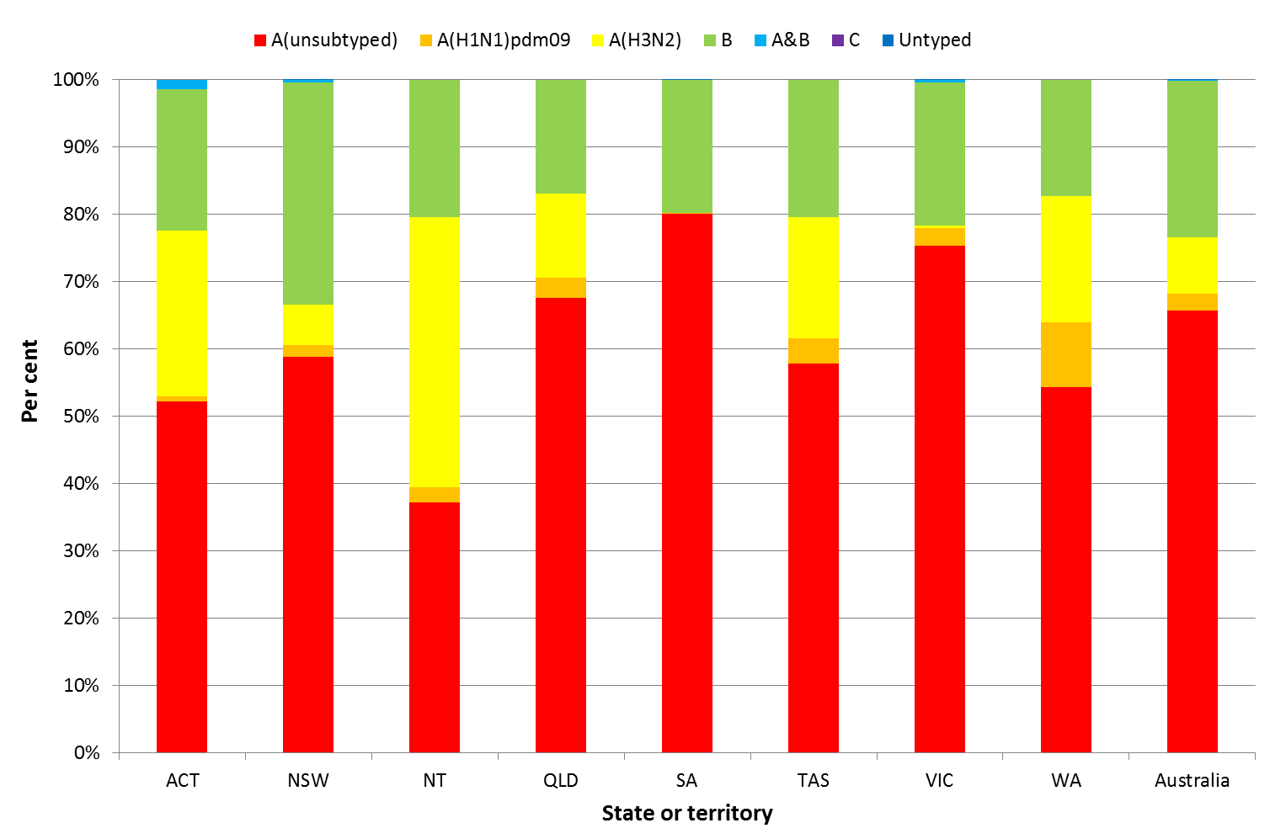

Source: NNDSS

Figure . Per cent of laboratory confirmed influenza, Australia, 1 January to 7 July 2017, by subtype and week

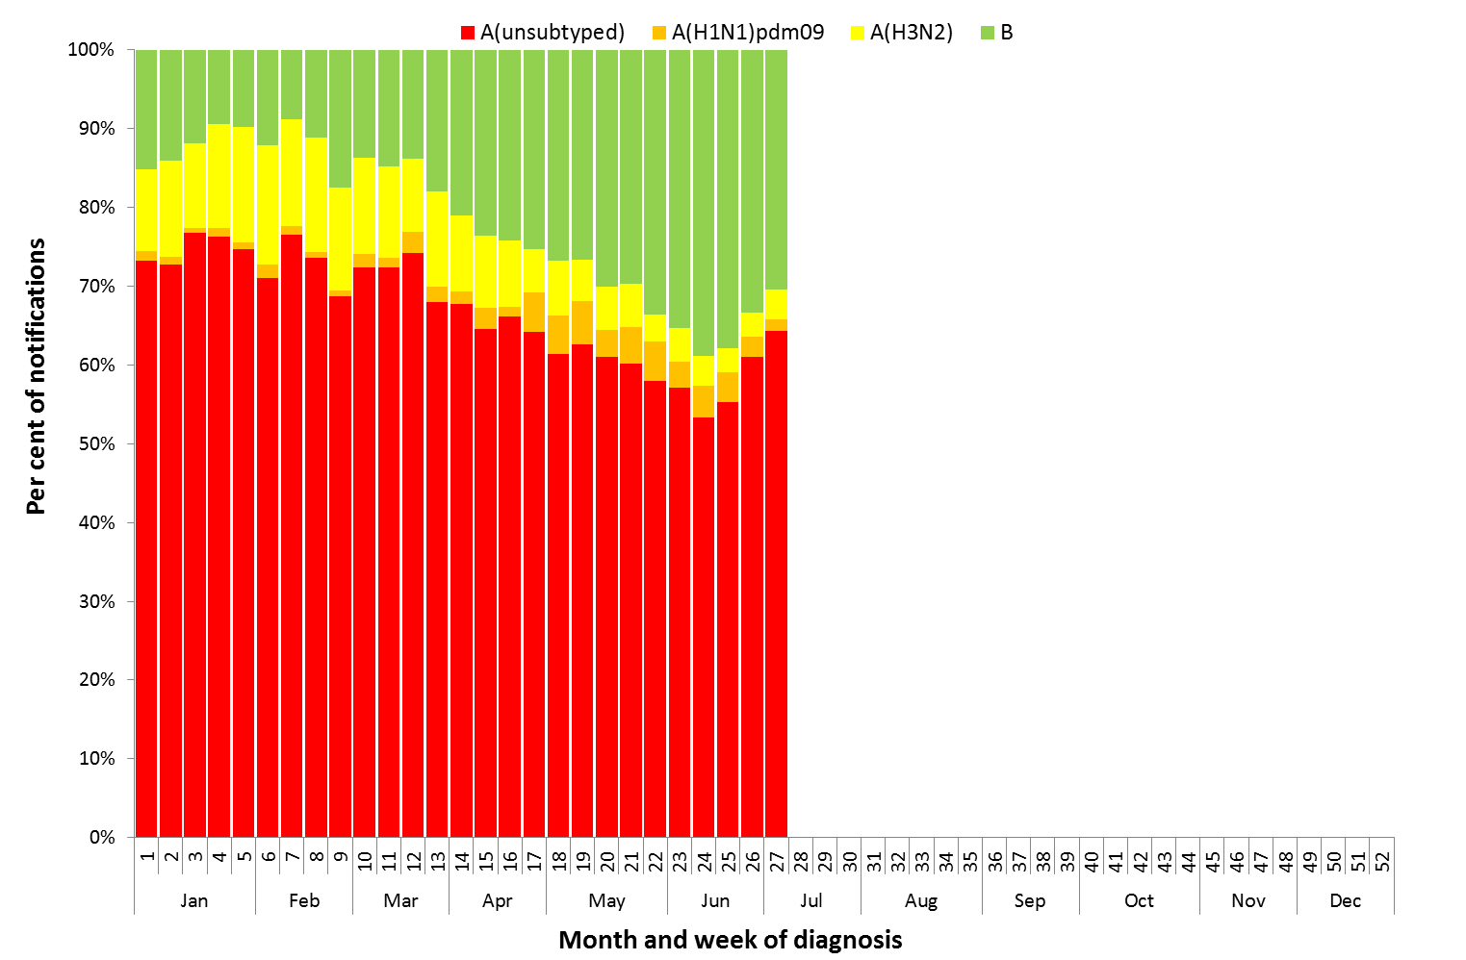

Source: NNDSS

Figure . Notifications of laboratory confirmed influenza by week of diagnosis and cumulative year-to-date, Australia,   
1 January 7 July 2017, by subtype and age group

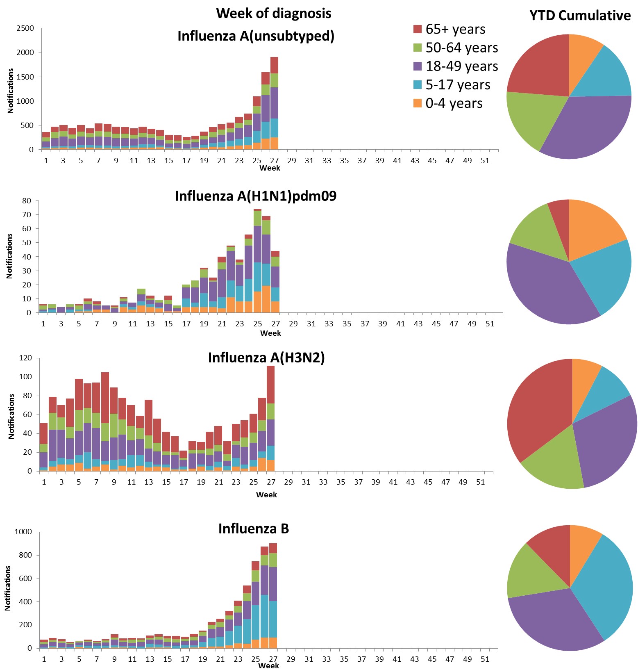

Source: NNDSS

Figure . Rate of notifications of laboratory confirmed influenza, Australia, 1 January to 7 July 2017, by age group and subtype

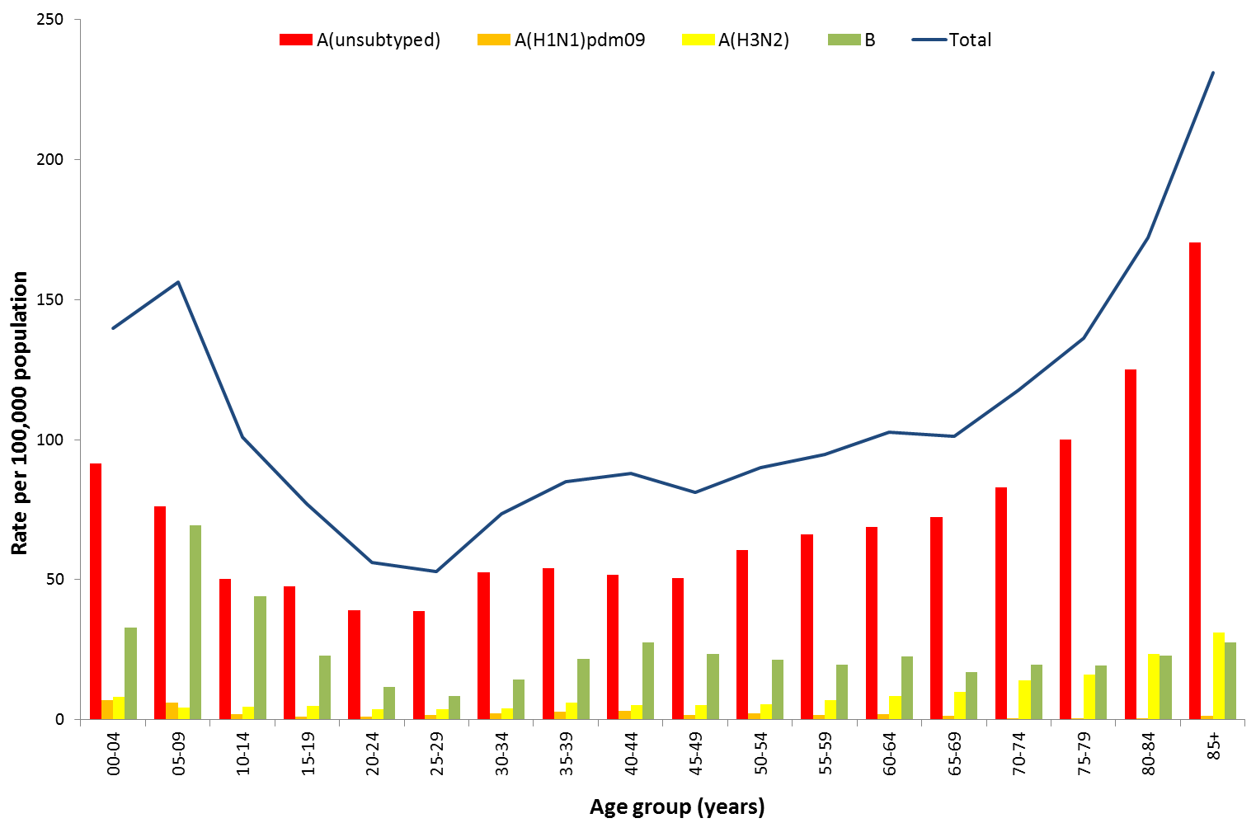

Source: NNDSS

Figure . Notifications of laboratory confirmed influenza by week of diagnosis and cumulative year-to-date, Australia, 1 January to 7 July 2017, by age group and subtype

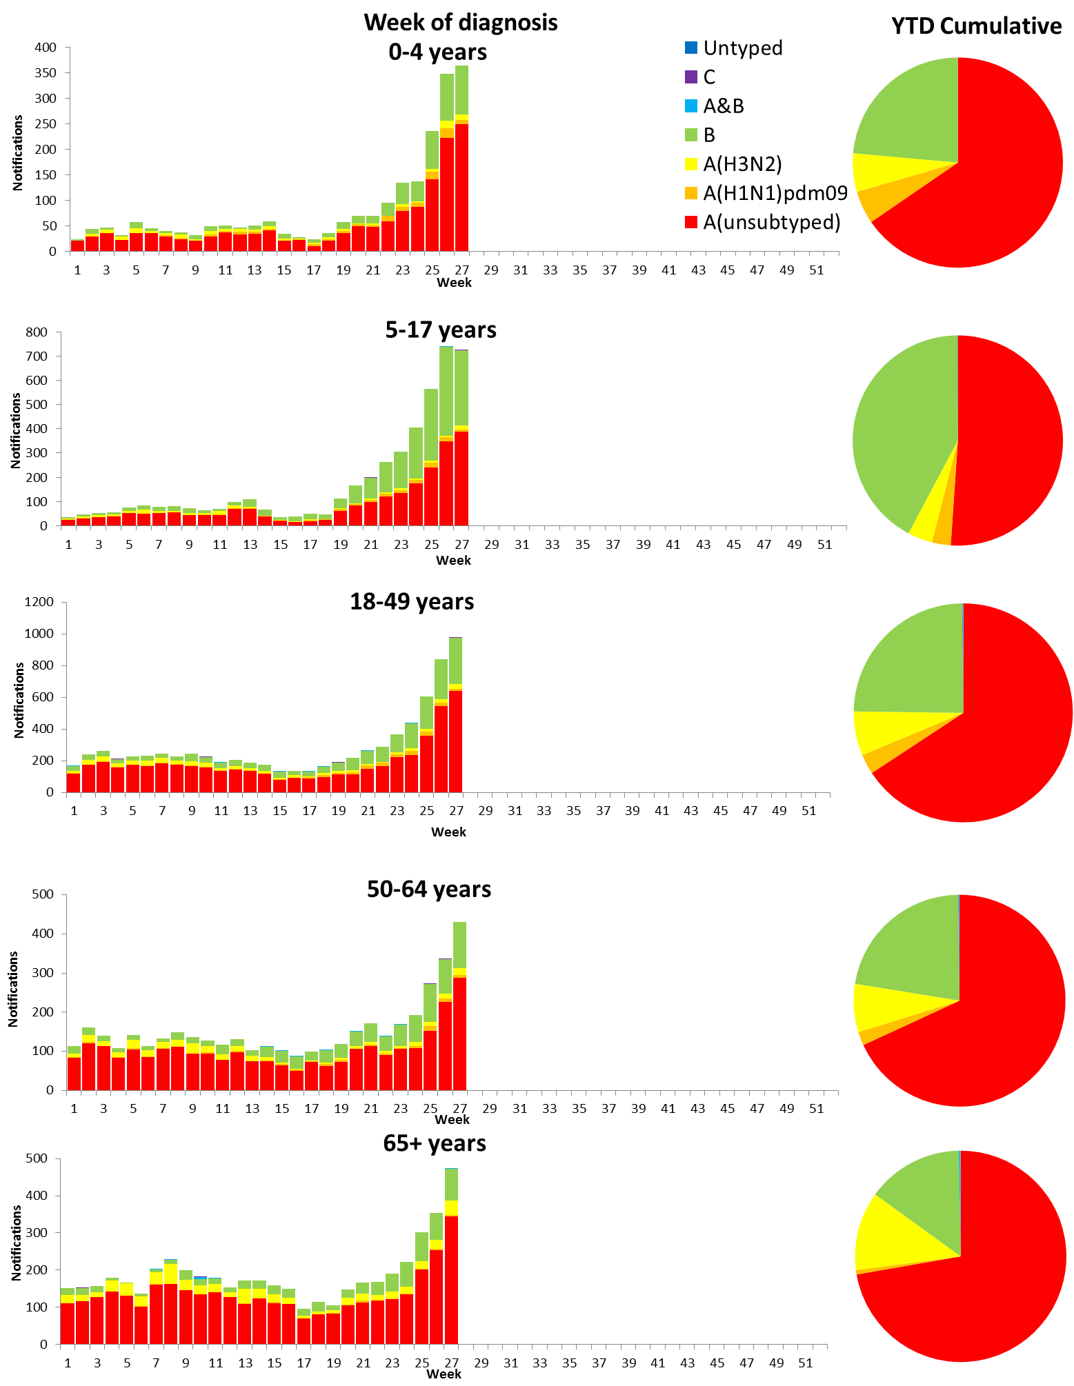

Source: NNDSS

## 2. Influenza-like Illness Activity

### Community Level Surveillance

FluTracking, a national online system for collecting data on ILI in the community, indicated that rates of ILI among participants remained at low levels this reporting fortnight (Figure 11). ILI activity among participants, reported as fever and cough, increased slightly from week 26 (2.0%) to 27 (2.2%). So far this year 62.5% of all participants and 80.4% of participants who identify as working face-to-face with patients reported receiving the seasonal influenza vaccine.[1]

Figure . Proportion of fever and cough among FluTracking participants, Australia, between May and October, 2013 to 2017, by month and week

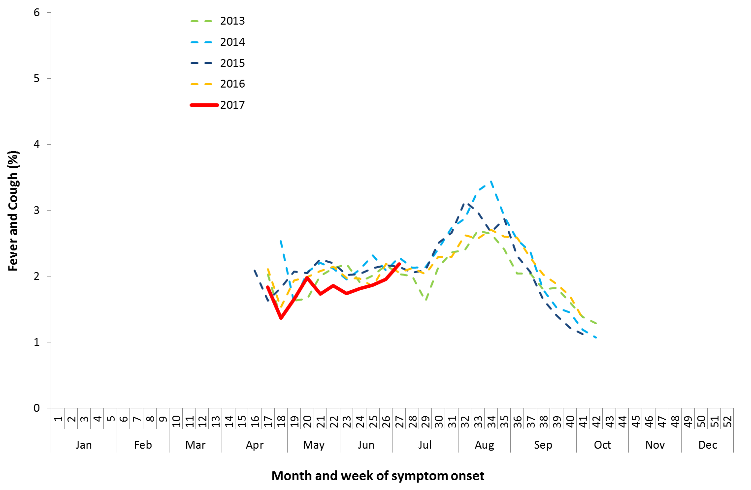

Source: FluTracking

### Sentinel General Practice Surveillance

Sentinel general practitioner ILI consultations have increased this fortnight with 6.5 per 1,000 consultations in week 26 and 7.3 per 1,000 consultations in week 27 (Figure 12). ILI consultations in the last fortnight are within the range of recent seasons for this time of year.

Of the 77 specimens taken from ILI patients seen by Australian Sentinel Practices Research Network (ASPREN) sentinel practitioners during the current reporting fortnight, 28 (36%) were positive for influenza, consisting of 20 samples positive for A(unsubtyped), 1 sample positive for A(H3N2) and 7 positive for influenza B (Figure 13). While influenza was the most common virus detected this fortnight, rhinovirus was the most common non-influenza virus detected, representing 19.5% of tests processed.

Figure . Unweighted rate of ILI reported from sentinel GP surveillance systems, Australia, 1 January 2013 to 9 July 2017, by month and week

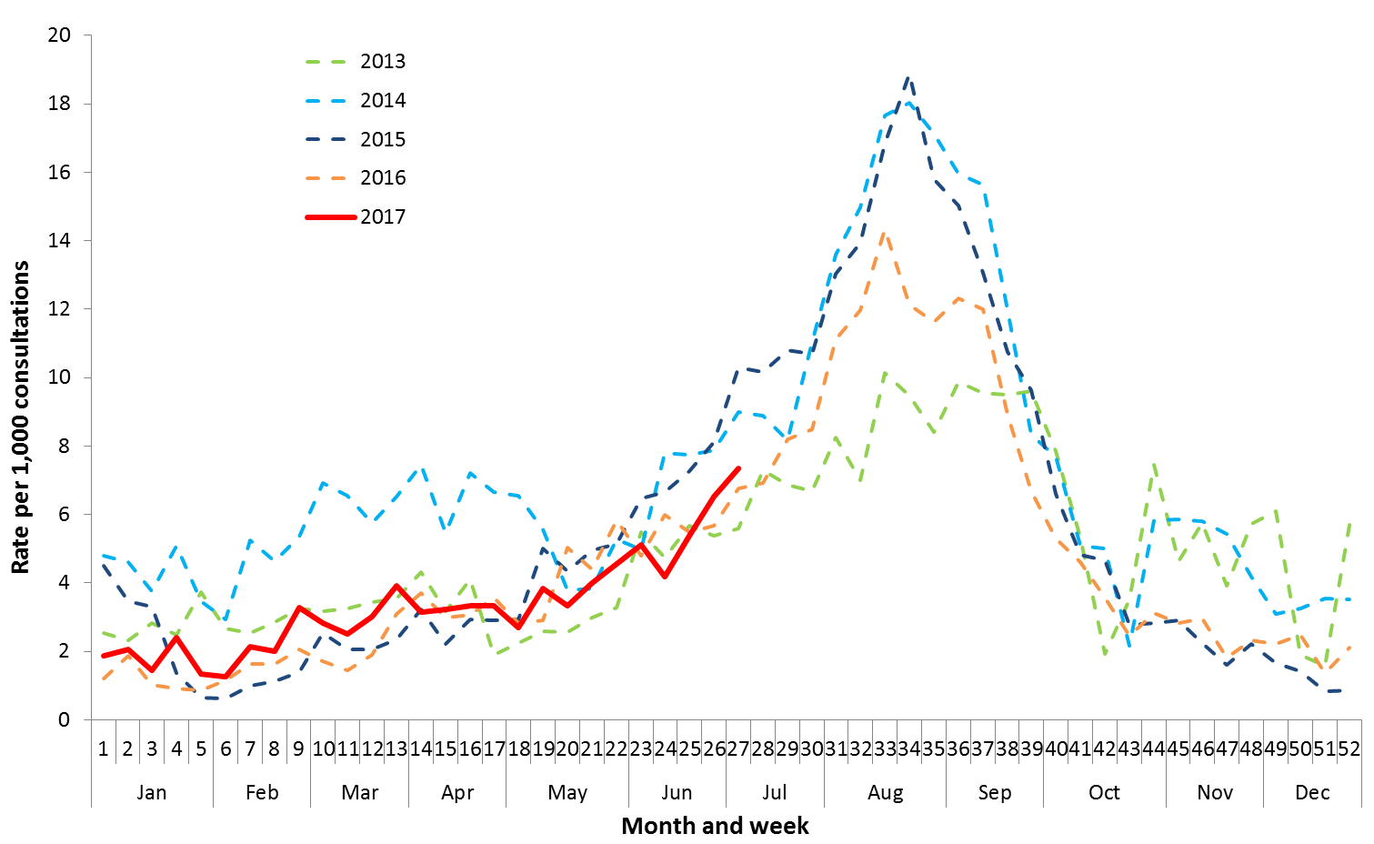

Source: ASPREN and VicSPIN

Figure . Proportion of respiratory viral tests positive for influenza in ASPREN ILI patients and ASPREN ILI consultation rate, Australia, 1 January to 9 July 2017, by month and week

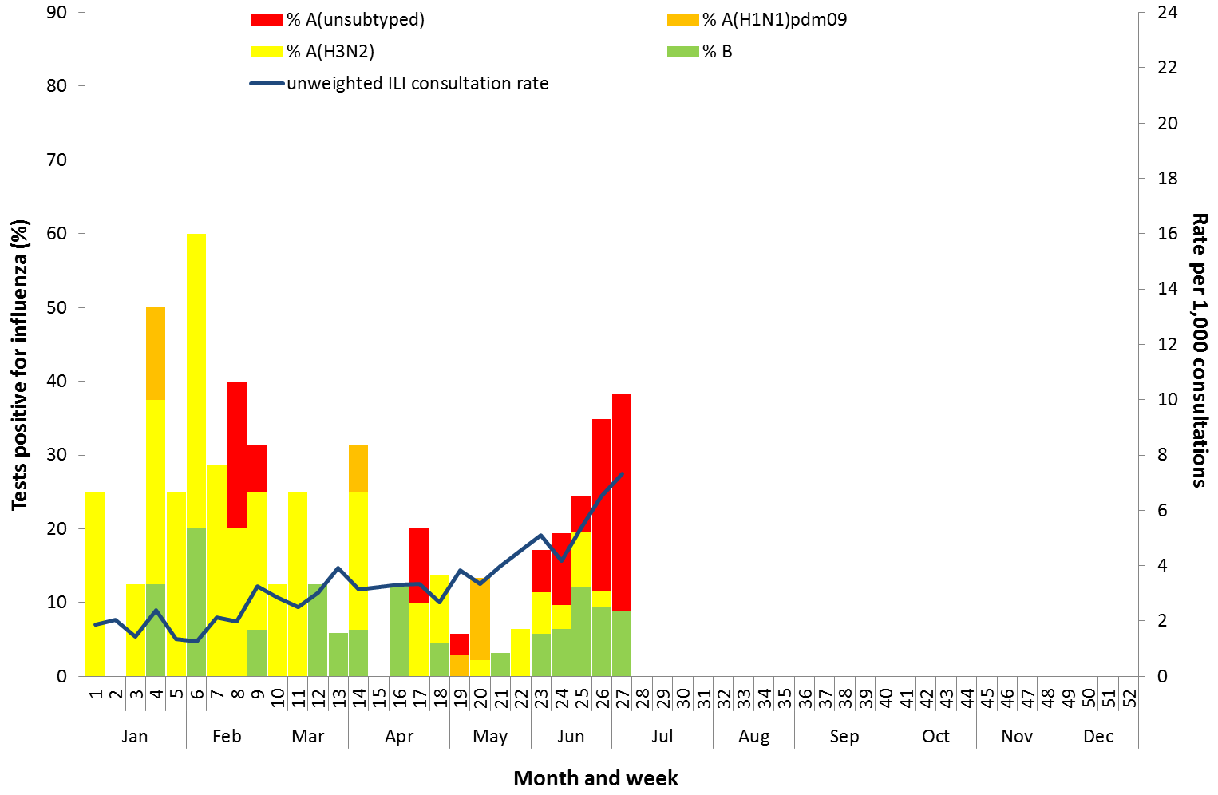

Source: ASPREN

## 3. Hospitalisations

### Sentinel Hospital Surveillance

Admissions with confirmed influenza to sentinel hospitals increased markedly across the reporting fortnight (Figure 14), with 45 patients admitted in week 26, and 71 in week 27. Since seasonal surveillance commenced through the Influenza Complications Alert Network (FluCAN) sentinel hospital surveillance system on 3 April 2017, a total of 311 people have been admitted with confirmed influenza, of which 75 (24.1%) were children aged less than 15 years and 130 (41.9%) were adults aged 65 years or older. Approximately 6.1% of influenza patients have been admitted directly to ICU; with all but three of the ICU cases related to infection with influenza A (Figure 15). For the year to 7 July, 74% of notifications of admissions with confirmed influenza to sentinel hospitals were influenza A (59% A(unsubtyped), 3% influenza A(H1N1)pdm09 and 12% influenza A (H3N2)), 26% were influenza B and less than 1% were mixed influenza infections. Consistent with notification data, the proportion of admissions due to influenza B was higher in children.

Figure . Number of influenza hospitalisations at sentinel hospitals, between March and October, 2013 to 2017 by month and week

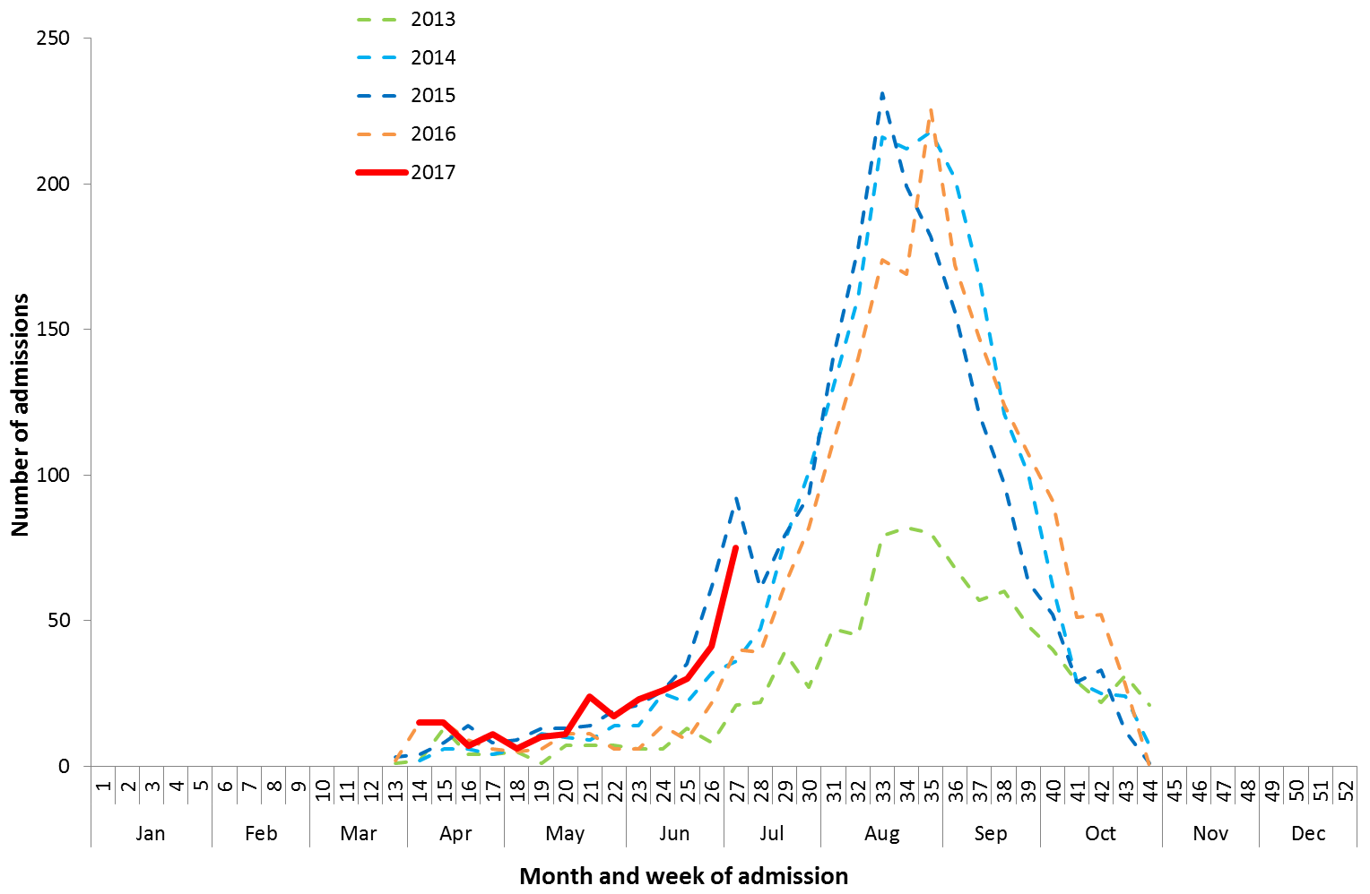

Source: FluCAN

Figure . Number of influenza hospitalisations at sentinel hospitals by subtype and ICU admission, 3 April to 7 July 2017, by month and week

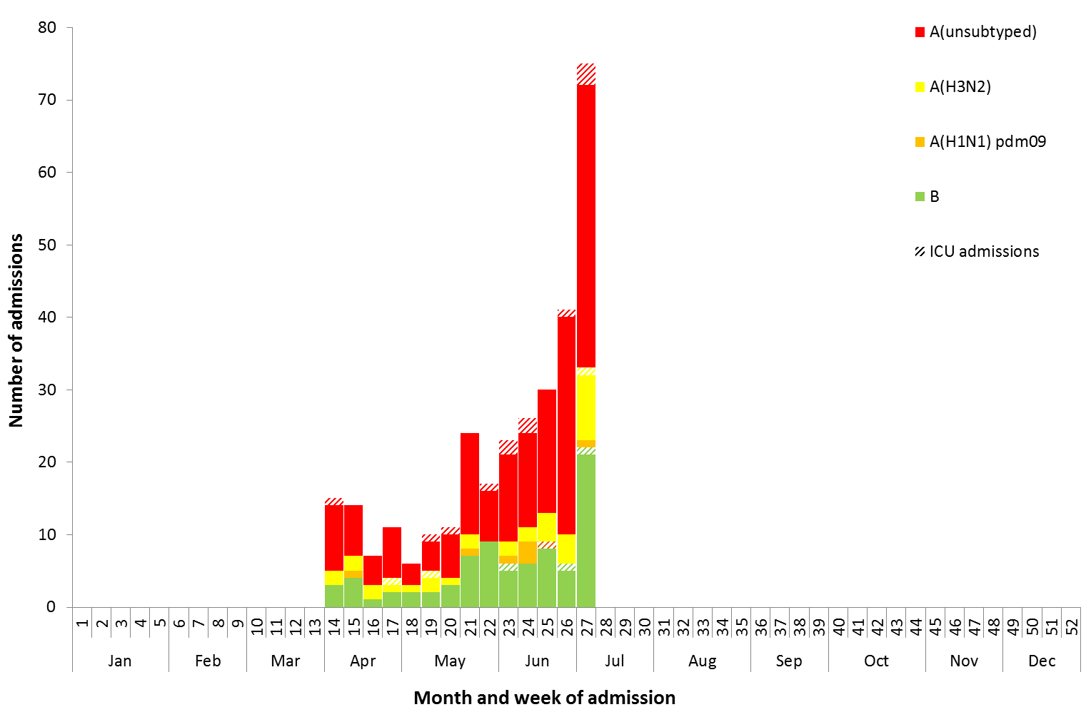

Source: FluCAN

### Paediatric Severe Complications of Influenza

The Australian Paediatric Surveillance Unit (APSU) conducts seasonal surveillance between June and September annually of children aged 15 years and under who are hospitalised with severe complications of influenza. Between 26 June 2017 and 9 July 2017, there has been one hospitalisation associated with severe complications of influenza reported to APSU. This was in a 3 year old female who was treated for confirmed pneumonia and was discharged with no ongoing problems.

## 4. Deaths Associated with Influenza and Pneumonia

### Nationally Notified Influenza Associated Deaths

So far in 2017, 21 influenza associated deaths have been notified to the NNDSS. The majority of deaths were due to influenza A (71%, n = 15). The median age of deaths notified was 78 years (range 29 to 97 years). The number of influenza associated deaths reported to the NNDSS is reliant on the follow up of cases to determine the outcome of their infection and most likely does not represent the true mortality associated with this disease.

### New South Wales Influenza and Pneumonia Death Registrations

Death registration data from NSW for the week ending 9 June 2017 show that there were 1.25 “pneumonia and influenza” deaths per 100,000 NSW population, which was below the epidemic threshold of 1.80 per 100,000 NSW population (Figure 16).[2]

Figure . Rate of deaths classified as influenza and pneumonia from the NSW Registered Death Certificates, 2012 to 9 June 2017

Please refer above for description and interpretation.

Source: NSW Registry of Births, Deaths and Marriages

## 5. Virological Surveillance

### Australian Influenza Vaccines Composition 2017

The influenza virus strains included in the 2017 seasonal influenza vaccines in Australia are:

* A/Michigan/45/2015, (H1N1)pdm09-like virus;
* A/Hong Kong/4801/2014, (H3N2)-like virus;
* B/Brisbane/60/2008-like virus, Victoria lineage;
* B/Phuket/3073/2013-like virus, Yamagata lineage.

### Typing and Antigenic Characterisation

From 1 January to 10 July, the World Health Organization Collaborating Centre for Reference and Research on Influenza (WHOCC) characterised 363 influenza viruses (Table 1). When further characterised for similarity to the vaccine components, isolates appeared to be well matched. All the influenza B and influenza A(H1N1)pdm09 isolates were characterised as similar to the vaccine components. A small number of influenza A(H3N2) isolates (n=30) were characterised as low reactors. An additional 166 influenza A(H3) isolates were unable to be characterised in the HI assay due to insufficient titre.

Table . Australian influenza viruses typed by HI from the WHOCC, 1 January to 10 July 2017.

|  |  |  |  |  |  |  |  |  |  |
| --- | --- | --- | --- | --- | --- | --- | --- | --- | --- |
| **Type/Subtype** | **ACT** | **NSW** | **NT** | **QLD** | **SA** | **TAS** | **VIC** | **WA** | **TOTAL** |
| **A(H1N1) pdm09** | 1 | 23 | 1 | 23 | 5 | 1 | 2 | 8 | 77 |
| **A(H3N2)** | 5 | 75 | 16 | 24 | 51 | 1 | 3 | 7 | 230 |
| **B/Victoria lineage** | 0 | 0 | 0 | 1 | 1 | 0 | 0 | 0 | 7 |
| **B/Yamagata lineage** | 1 | 20 | 9 | 9 | 9 | 0 | 0 | 1 | 49 |
| Total | 7 | 118 | 26 | 57 | 66 | 2 | 5 | 16 | 363 |

SOURCE: WHO CC

Note: Viruses tested by the WHO CC are not necessarily a random sample of all those in the community.

State indicates the residential location for the individual tested, not the submitting laboratory.

There may be up to a month delay on reporting of samples.

### Antiviral Resistance

The WHOCC reported that from 1 January to 10 July 2017, of the 492 influenza viruses tested for neuraminidase inhibitor resistance, none of the samples demonstrated reduced inhibition to the antiviral drugs Oseltamivir or Zanamivir.

## 6. International Surveillance

The World Health Organization reported that based on data up to 25 June, in the temperate zone of the southern hemisphere, influenza activity continued to increase and was above seasonal threshold levels in South America, with some countries in Central America, the Caribbean and South East Asia also reporting increased influenza activity.[3] Influenza activity in the temperate zone of the northern hemisphere was reported at low levels. Worldwide, influenza A(H3N2) and B viruses co-circulated.

# DATA CONSIDERATIONS

The NNDSS data provided were extracted on 12 July 2017. Due to the dynamic nature of the NNDSS, data in this report is subject to retrospective revision and may vary from data reported in published NNDSS reports and reports of notification data by states and territories. Detailed notes on interpreting the data presented in this report are available at the Department of Health’s [Australian Influenza Surveillance Report website](http://www.health.gov.au/flureport) (www.health.gov.au/flureport).

The Australian Influenza Surveillance Report and Activity Updates are compiled from a number of data sources, which are used to monitor influenza activity and severity in the community. These data sources include laboratory-confirmed notifications to the NNDSS; influenza associated hospitalisations; sentinel influenza-like illness (ILI) reporting from general practitioners and emergency departments; and community level surveys; and sentinel laboratory testing results. The information in this report is reliant on the surveillance sources available to the Department of Health at the time of production.

While every care has been taken in preparing this report, the Commonwealth does not accept liability for any injury or loss or damage arising from the use of, or reliance upon, the content of the report. Delays in the reporting of data may cause data to change retrospectively. For further details about information contained in this report please contact the [Influenza Surveillance Team](mailto:flu@health.gov.au) ([flu@health.gov.au](mailto:flu@health.gov.au)).

# REFERENCES

1. FluTracking, FluTracking Weekly Interim Report, Week ending 9 July 2017. Available from [FluTracking Reports](http://www.flutracking.net/Info/Reports) (http://www.flutracking.net/Info/Reports) [Accessed 11 July 2017].
2. NSW Health, Influenza Surveillance Report, Week 27: 3 to 9 July, 2017. Available from NSW Health Influenza Surveillance Reports (http://www.health.nsw.gov.au/Infectious/Influenza/Pages/reports.aspx)[Accessed 14 July 2017].
3. WHO, Influenza Update No. 293, 10 July 2017. Available from the [WHO website](http://www.who.int/influenza/surveillance_monitoring/updates/latest_update_GIP_surveillance/en/) (http://www.who.int/influenza/surveillance_monitoring/updates/latest_update_GIP_surveillance/en/) [Accessed 12 July 2017].