| Logo | **Australian Influenza**  **SURVEILLANCE REPORT**  **No. 6, 2017**  **Reporting period 22 July – 4 August 2017** |
| --- | --- |

The Department of Health acknowledges the providers of the many sources of data used in this report and greatly appreciates their contribution.

# KEY MESSAGES

* Influenza activity at the national level continued to increase this reporting fortnight with many surveillance systems at levels comparable to the peak of the 2016 season.
* High levels of influenza activity in the community are likely to continue for the next few weeks.
* There has been almost two and a half times the number of laboratory confirmed notifications of influenza reported to the National Notifiable Diseases Surveillance System this year when compared with the same period last year. An earlier season onset and introduction of rapid testing have contributed, in part, to this increase.
* Influenza-like illness (ILI) is increasing nationally. Influenza was the most common cause of ILI presentations to sentinel general practitioners this fortnight, with almost half of all patients presenting to sentinel general practitioners with ILI and tested were positive for influenza.
* Influenza A(H3N2) is currently the predominant circulating virus nationally, however influenza B viruses also continue to circulate.
* Notification rates this year to date have been highest in adults aged 85 years or older, with a secondary peak in young children, aged 5 to 9 years.
* Hospitalisations with confirmed influenza have increased overall this reporting fortnight, but have declined in the most recent week.
* Clinical severity for the season to date, as measured through the proportion of patients admitted directly to ICU and deaths attributed to pneumonia or influenza, is low.
* To date, based on antigenic characterisation of circulating influenza viruses, the seasonal influenza vaccines appear to be a moderate to good match for circulating virus strains, depending on the strain. Vaccine effectiveness estimates, which provide an indication of how well the vaccine provides protection against influenza, are only available towards the end of the influenza season.

# ANALYSIS

## 1. Geographic Spread of Influenza Activity in Australia

In the fortnight ending 4 August 2017 (week 31), influenza activity was reported by state and territory health departments as increased when compared to the previous fortnight in all regions of Australia with the exception of Western Australia (WA) where activity was unchanged in all regions excepting Perth (Figure 1). The geographic spread of influenza activity varied across jurisdictions, but was widespread in the south eastern regions, including the Australian Capital Territory (ACT), New South Wales (NSW), the Central and Southern regions of Queensland (QLD); South Australia (SA); Tasmania (TAS) and Victoria (VIC), as well as in the Perth Metro Region of WA. Influenza activity was reported as regional in the Rural South region of WA; localised in the Northern Territory (NT), the Tropical region of QLD and the Northwest region of WA.

Influenza-like illness (ILI) activity reported from syndromic surveillance systems when compared with the previous fortnight was reported as increased in all jurisdictions, excepting the Rural South and Northwest regions of WA, which remained unchanged.

Figure . Map of influenza activity by state and territory, Australia, 22 July – 4 August 2017.

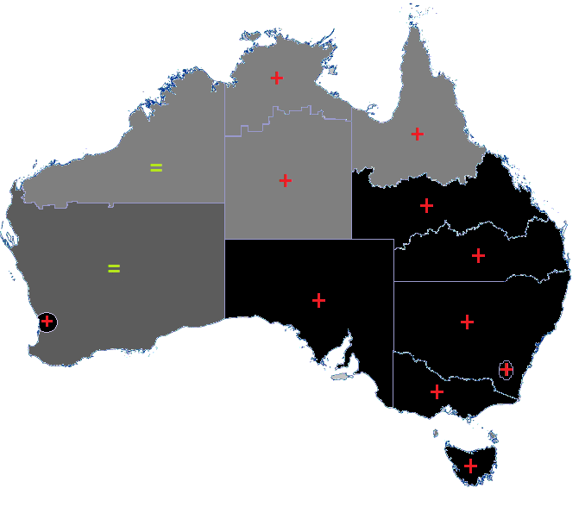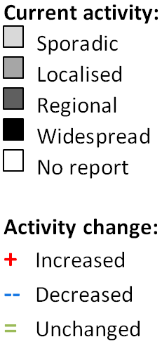

## 2. Laboratory Confirmed Influenza Activity

### Sentinel Laboratory Surveillance

Influenza was detected at increasing levels or remained steady across the sentinel laboratories this reporting fortnight (Figure 2). The greatest increase was reported by SA Pathology, with the percentage of tests positive for influenza increased from 30.7% in week 29 to 41.4% in week 31. The pooled unweighted percentage of tests positive for influenza across all sentinel laboratories increased from 20.7% in week 29 to 26.8% in   
week 31. From the sentinel laboratories where influenza subtyping was undertaken (Tasmania, Victoria Infectious Disease Reference Laboratory (VIDRL) and PathWest), influenza A(H3N2) was detected more frequently than influenza A(H1N1)pdm09.

Testing for influenza increased this reporting fortnight (Figure 3). Influenza A was reported as the most commonly detected respiratory virus this fortnight by Pathology West ICPMR, Tasmania and VIDRL, while respiratory syncytial virus (RSV) was reported as the most commonly detected respiratory virus this fortnight by PathWest. Influenza A replaced RSV in week 31 as the most commonly detected respiratory virus by   
SA Pathology.

Figure . Proportion of sentinel laboratory tests positive for influenza, 1 January to 4 August 2017, by contributing laboratory or jurisdiction and month and week.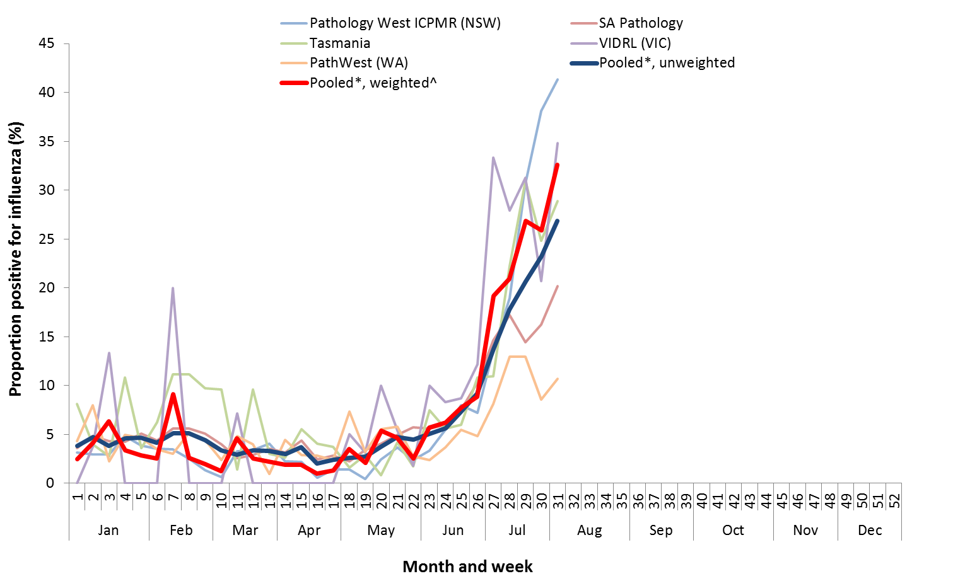

* Pooled percentage positive indicators should be interpreted with caution, noting that collectively pooled contributing laboratories are not representative of testing across Australia and individually contributing laboratories may not be representative of the jurisdiction in which they are located.

^ Weighted according to jurisdictional population in which laboratories are located.

* The percentage of tests positive for influenza in the interseasonal period should be interpreted with caution due to small numbers of tests being undertaken in this time, resulting in high variability in the indicators.

Figure . Proportion of sentinel laboratory tests positive for influenza and total number of specimens tested, 1 January to 4 August 2017, by subtype and month and week.

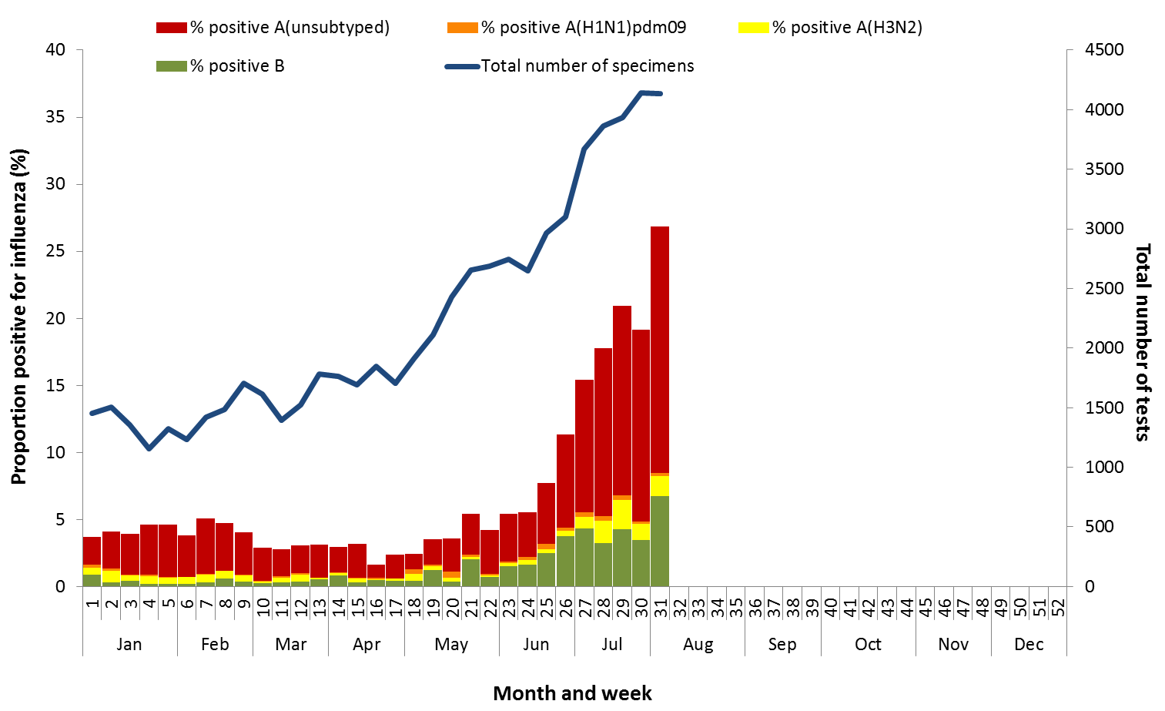

### Notifications of Influenza to Health Departments

Notifications of laboratory confirmed influenza to the National Notifiable Diseases Surveillance System (NNDSS) have continued to increase this reporting fortnight (Figure 4). For the year to 4 August, a total of 58,063 notifications of laboratory confirmed influenza were reported to the NNDSS: 26,151 in NSW; 14,511 in QLD; 7,731in VIC; 6,261 in SA; 1,552in WA; 635 in the NT; 620 in TAS and 602 in the ACT. Notifications of laboratory confirmed influenza increased in the ACT, NSW, QLD and SA over the reporting fortnight and remained relatively stable or declined in NT, SA, TAS and WA. While notifications from VIC appear to have decreased, this is likely due to an administrative backlog in data entry the state is current experiencing   
(Figure 5).

For the year to 4 August, 74% of notifications of laboratory confirmed influenza to the NNDSS were influenza A (66% A(unsubtyped), 2% influenza A(H1N1)pdm09 and 6% influenza A(H3N2)), 26% were influenza B and less than 1% were influenza A&B co-infections or untyped (Figure 6). The proportion of all notifications year to date reported as influenza A has ranged across jurisdictions from 66% in TAS to 83% in the ACT and WA. For the year to date, detections of influenza A subtypes have varied across jurisdictions also. Nationally, for every one notification of influenza A(H1N1)pdm09 reported to the NNDSS, 2.9 notifications of influenza A(H3N2) were received. This ratio has ranged from 1:0.1 in VIC to 1:15.8 in the ACT. VIC is the only jurisdiction where notifications received year to date for influenza A(H1N1)pdm09 are greater than for influenza A(H3N2).

In the most recent fortnight, 73% of notifications of laboratory confirmed influenza to the NNDSS were influenza A (68% influenza A(unsubtyped), 1% influenza A(H1N1)pdm09 and 4% influenza A (H3N2)), 27% were influenza B and less than 1% were influenza A&B co-infections or untyped (Figure 7). The proportion of all notifications this reporting fortnight reported as influenza B ranged across jurisdictions from 13% in WA to 46% in TAS. The number and proportion of influenza B notifications increased this fortnight (Figure 7 and Figure 8).

So far in 2017, notification rates have tended to increase with increasing age. Age-specific notification rates of influenza overall have been highest in adults aged 85 years or older (709.1 notifications per 100,000), with a secondary smaller peak in children aged 5-9 years (385.7 per 100,000) (Figure 9). Influenza A(H1N1)pdm09 was highest in children aged less than 5 years (13.8 per 100,000), influenza A(H3N2) was highest in the elderly aged 85 years and older (76.4 per 100,000) and influenza B was highest in children aged 5 to 9 years (161.6 notifications per 100,000 population).

Increases in notifications occurred in all broad age groups this reporting fortnight (Figure 10). The distribution of influenza types and subtypes differed across age groups, with 41% of 5-17 year olds notified with influenza being detected with influenza B, while only 16% of adults aged 65 years and older detected with influenza B. While influenza A(H3N2) is detected across all age groups, it accounted for a greater proportion of influenza A, where subtyping is available, in adults aged 65 years or older, than in any other age group.

Figure . Notifications of laboratory confirmed influenza, Australia, 1 January 2013 to 4 August 2017, by month and week of diagnosis.

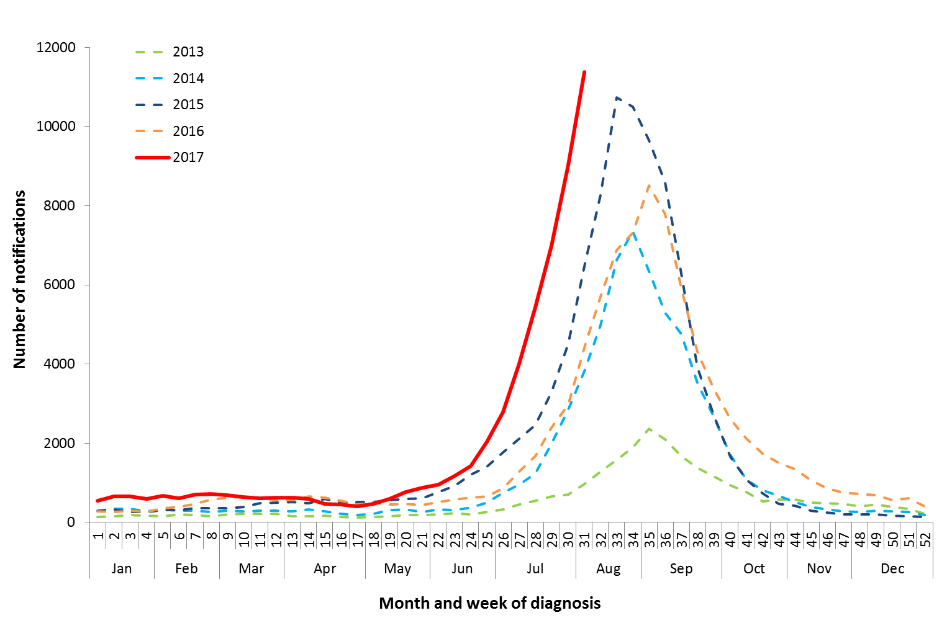

Source: NNDSS

Figure . Notifications of laboratory confirmed influenza, 1 January to 4 August 2017, by state or territory and week.

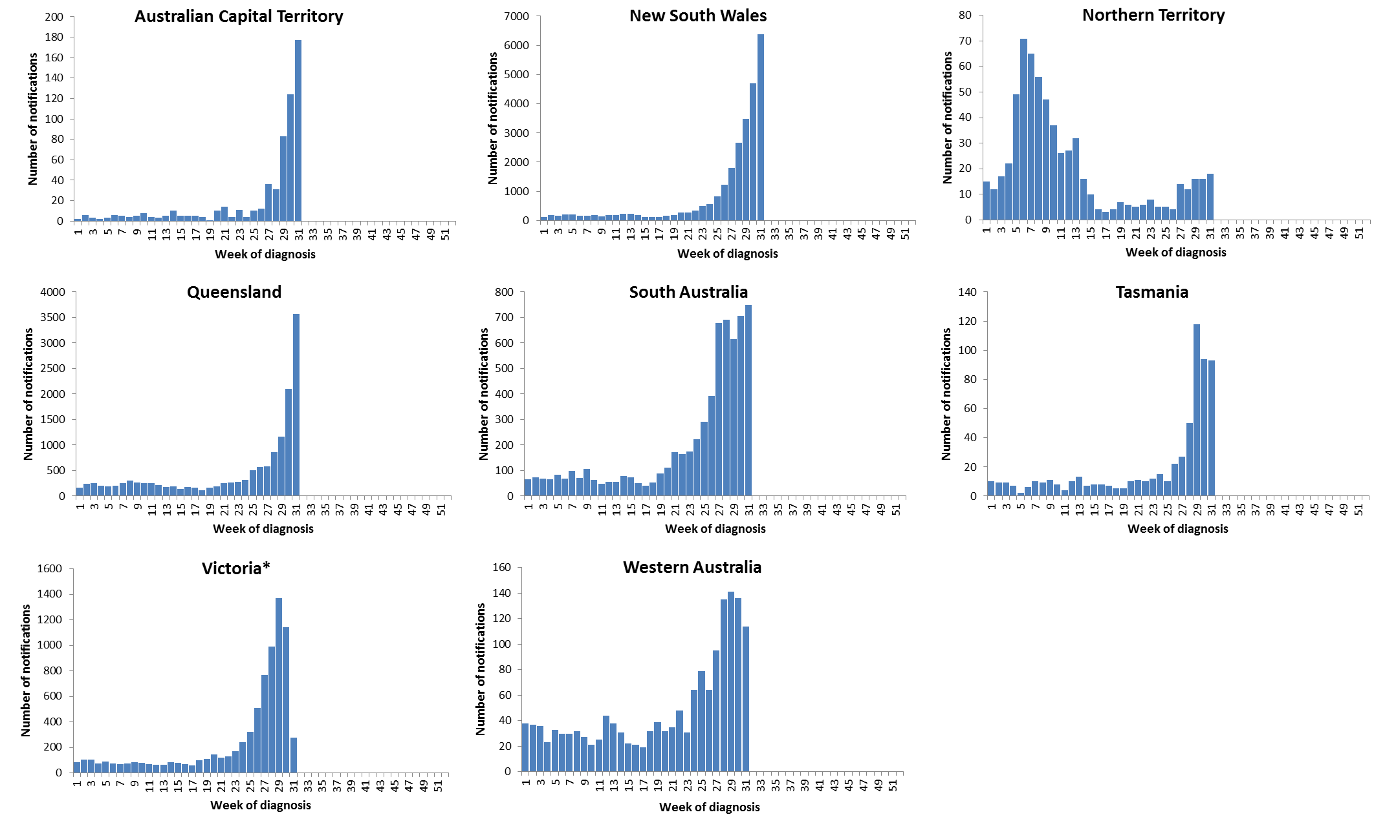

Source: NNDSS

*Victoria is currently experiencing a backlog of influenza notifications to be entered into the NNDSS.

Figure . Per cent of notifications of laboratory confirmed influenza, Australia, 1 January to 4 August 2017, by subtype and state or territory.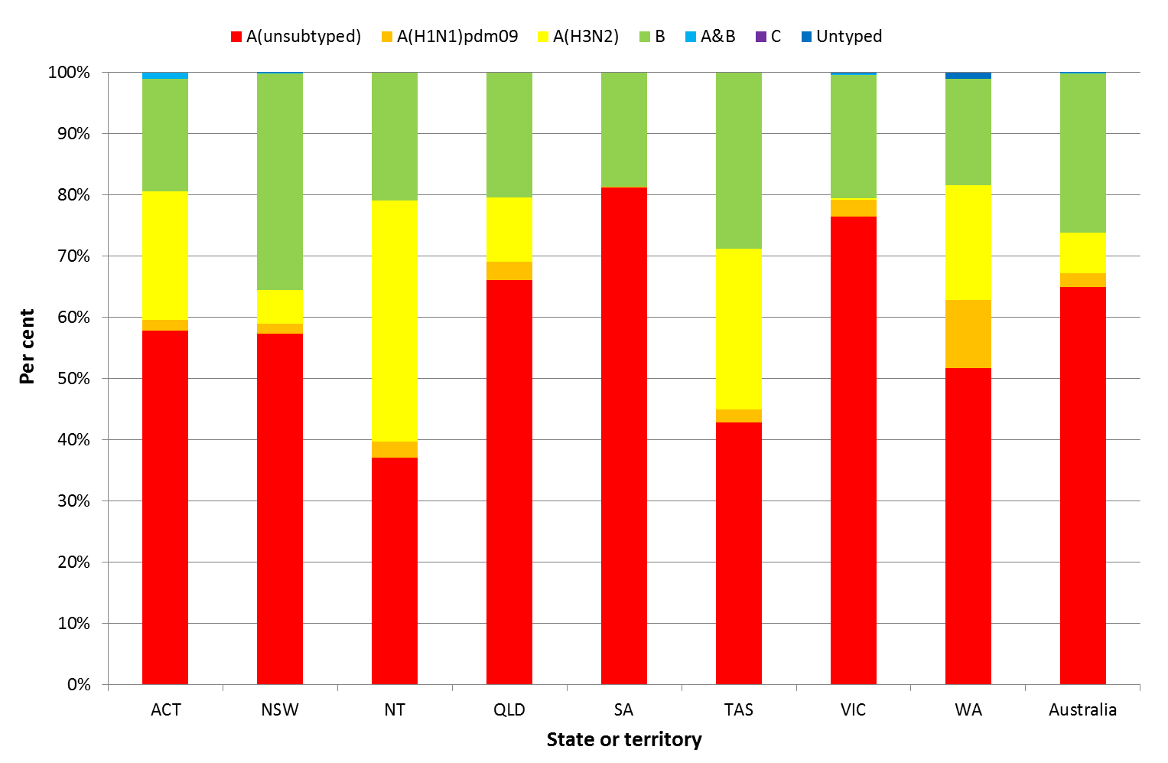

Source: NNDSS

Figure . Per cent of laboratory confirmed influenza, Australia, 1 January to 4 August 2017, by subtype and week.

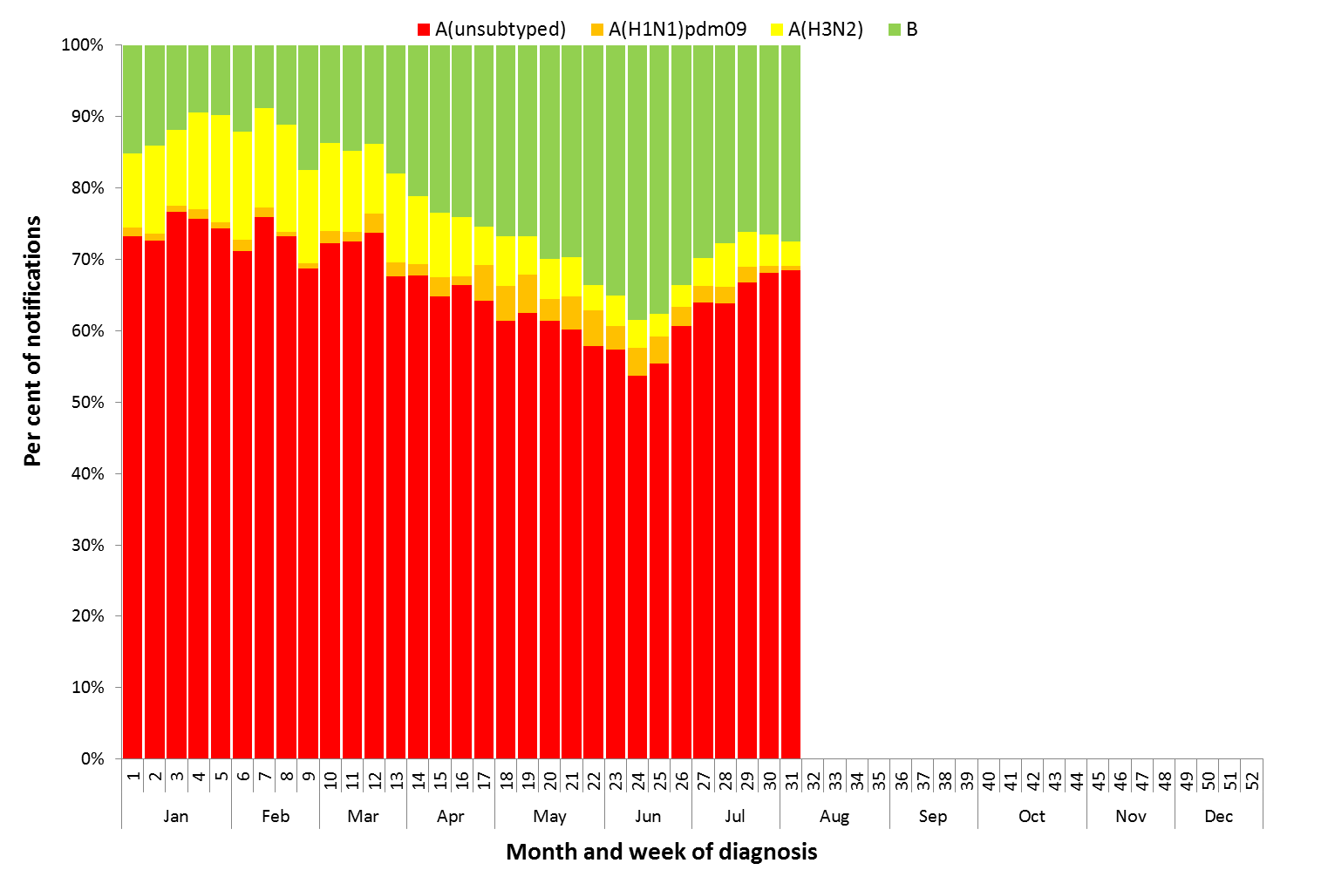

Source: NNDSS

**Figure 8. Notifications of laboratory confirmed influenza by week of diagnosis and cumulative year-to-date, Australia,   
1 January 8 August 2017, by subtype and age group.**

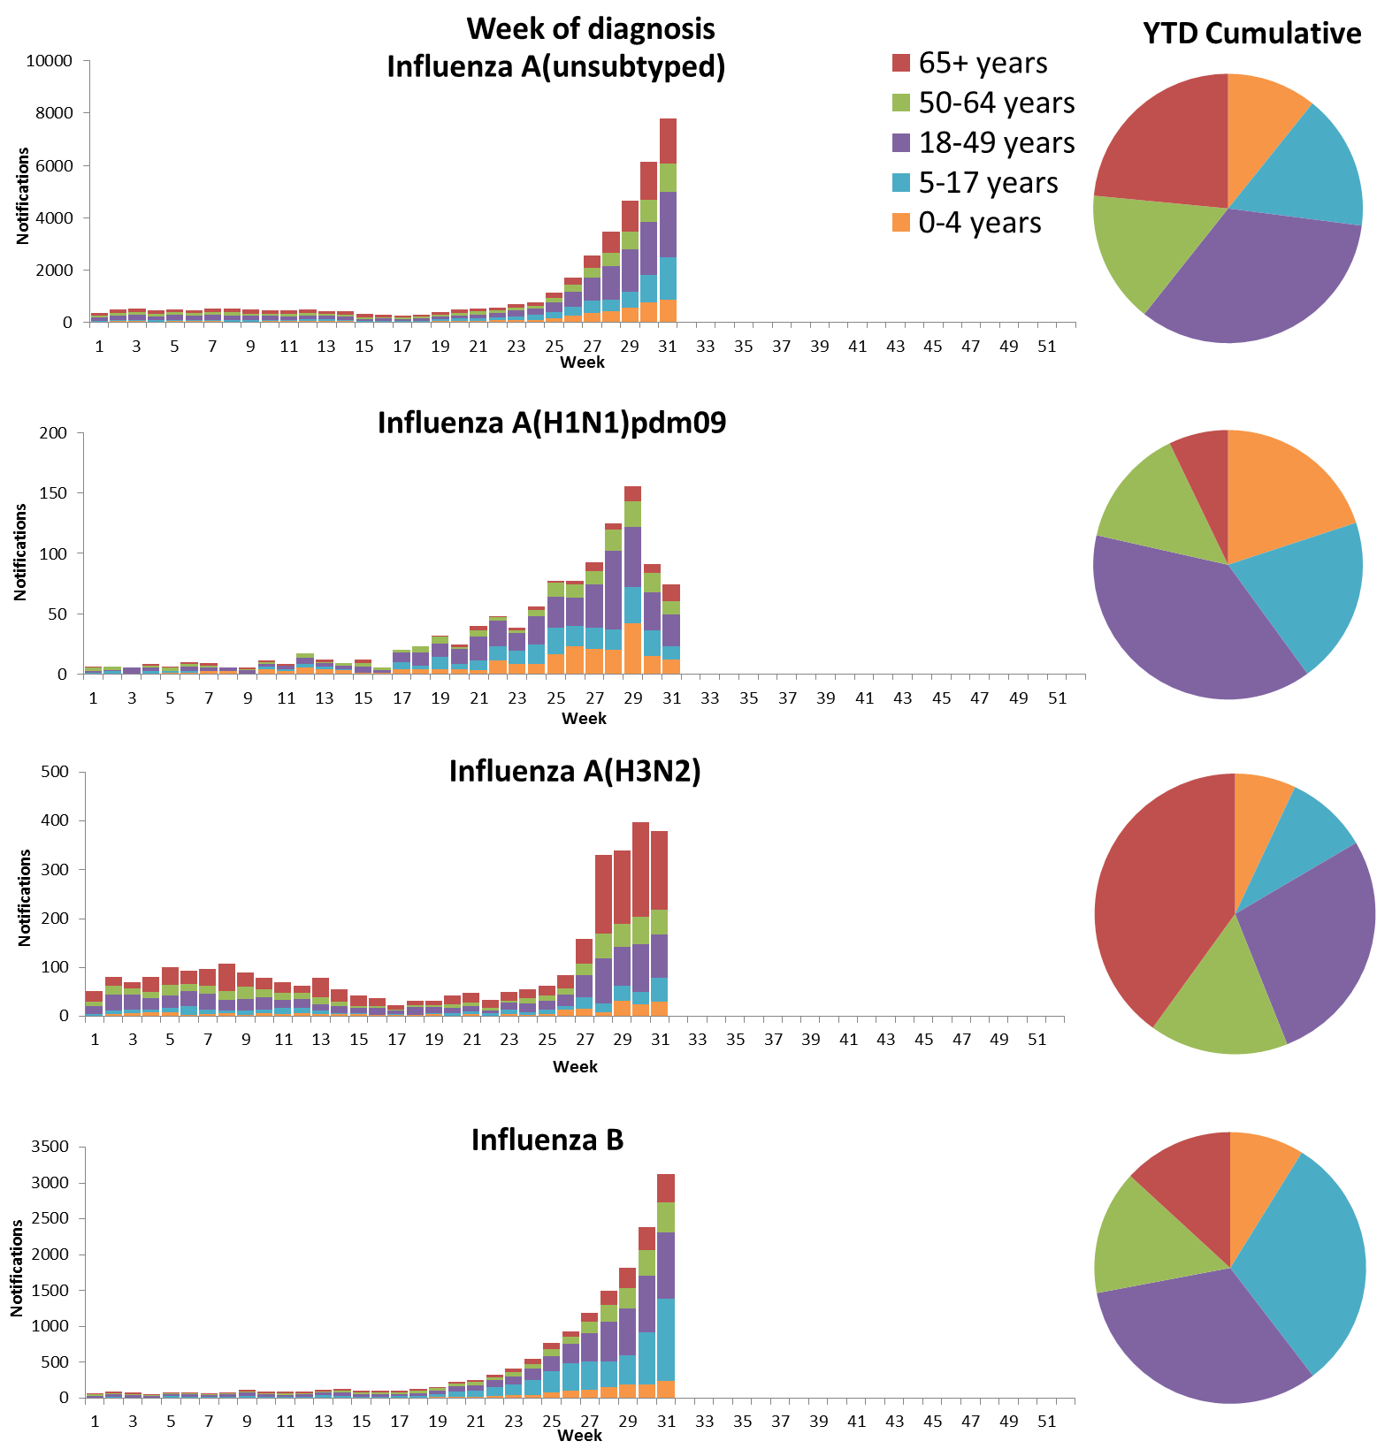

Source: NNDSS

Figure . Rate of notifications of laboratory confirmed influenza, Australia, 1 January to 8 August 2017, by age group and subtype.

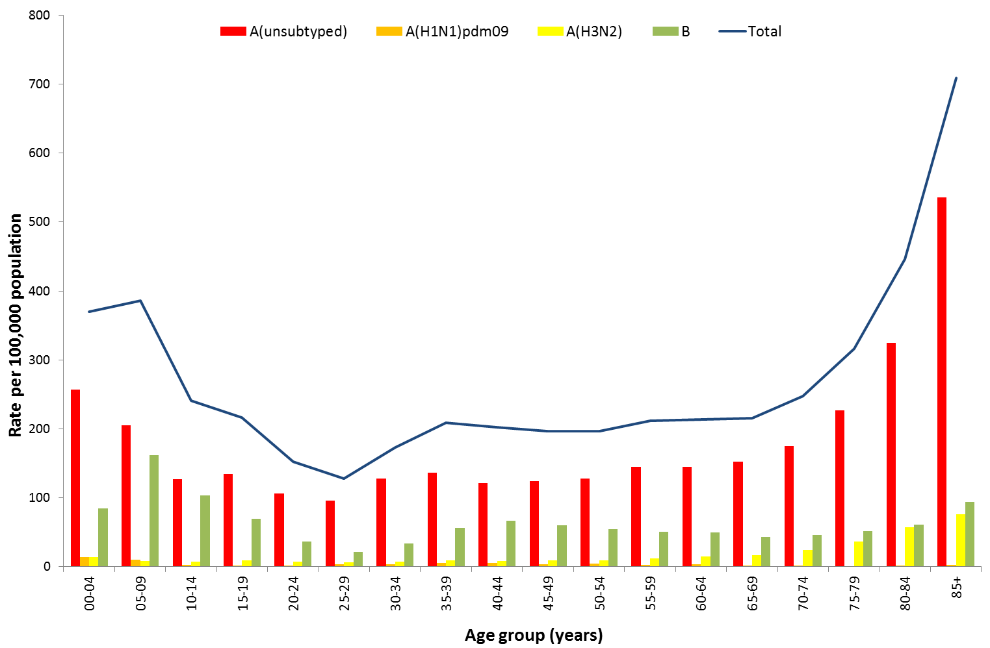

Source: NNDSS

Figure . Notifications of laboratory confirmed influenza by week of diagnosis and cumulative year-to-date, Australia, 1 January to 8 August 2017, by age group and subtype.

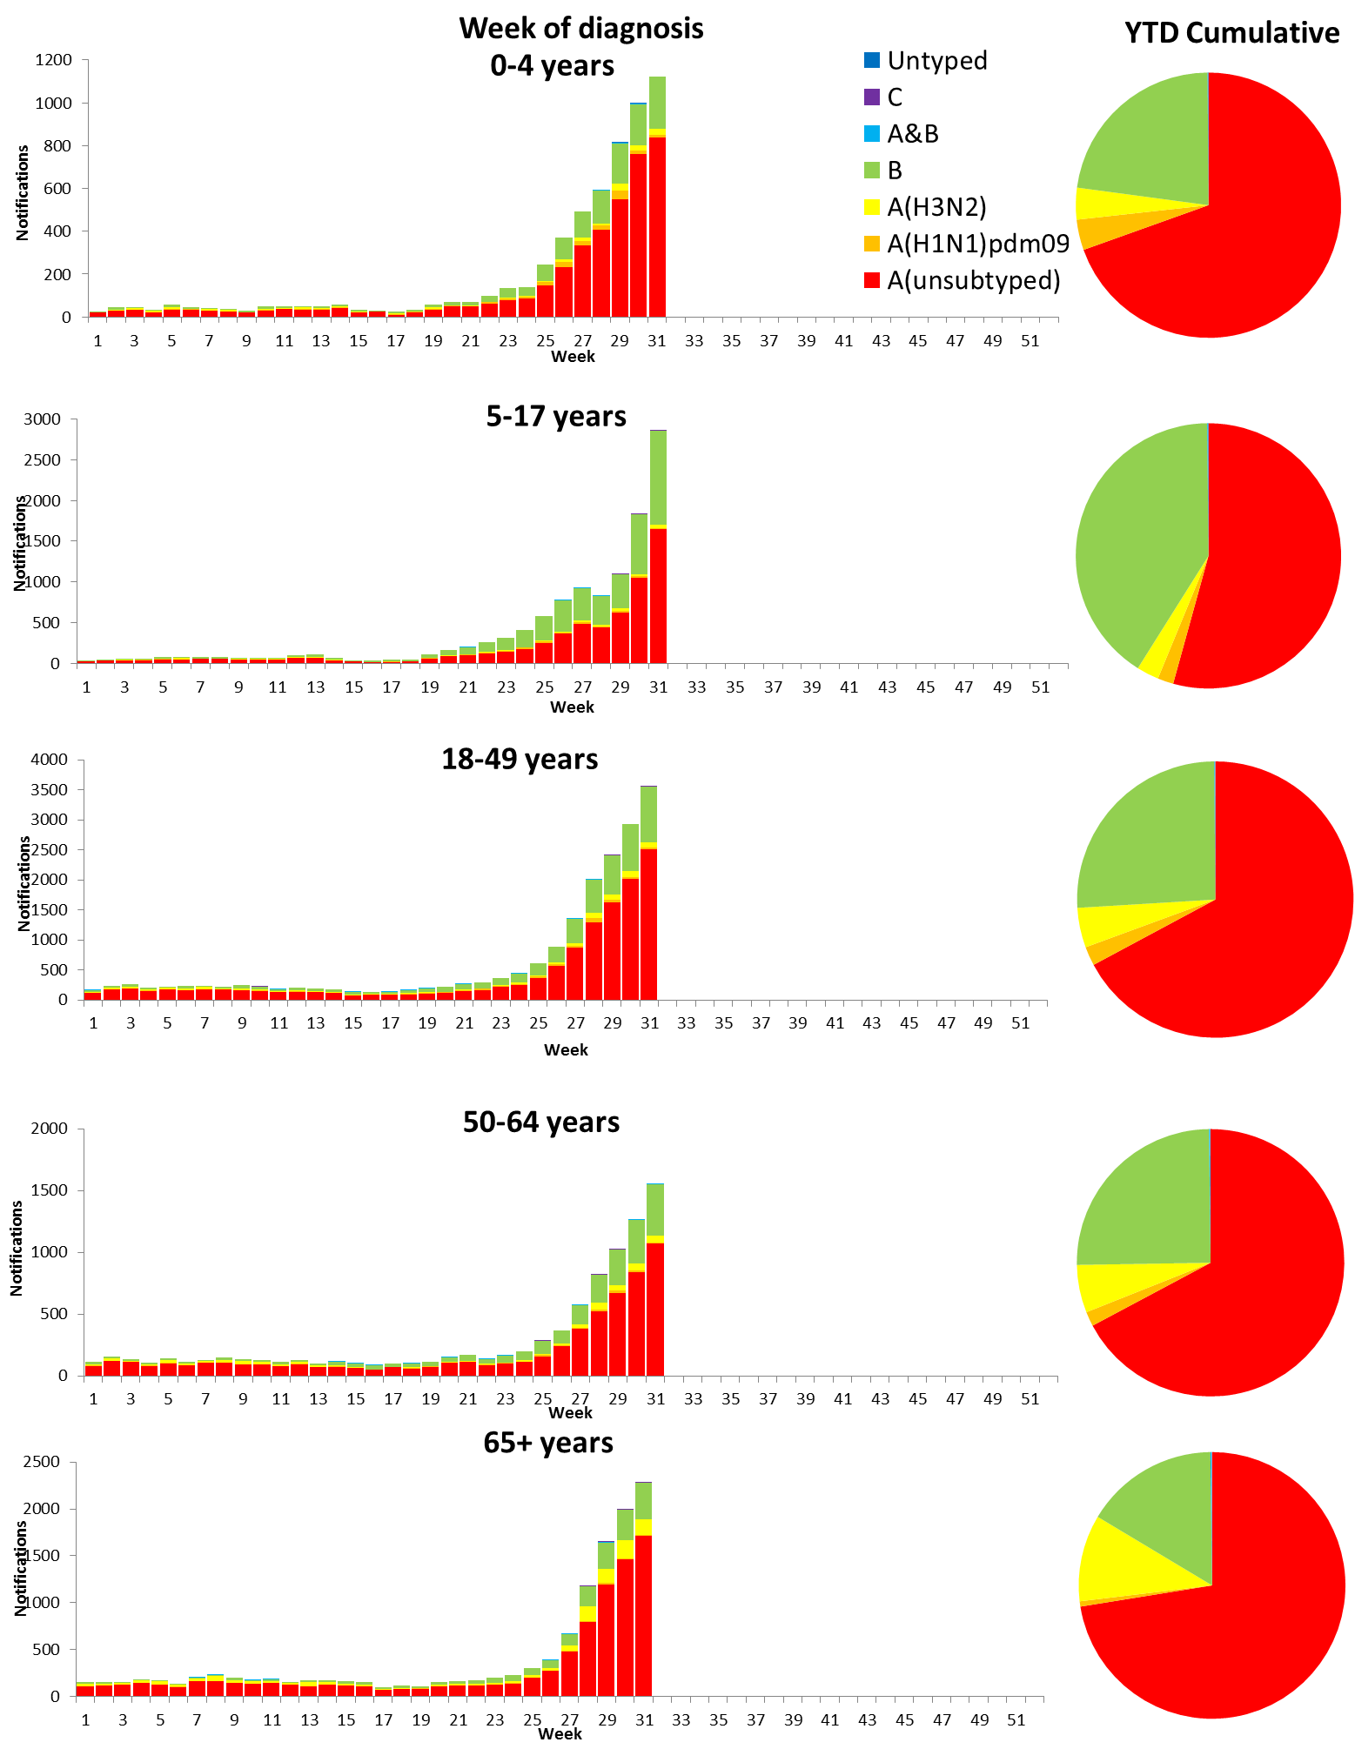

Source: NNDSS

## 2. Influenza-like Illness Activity

### Community Level Surveillance

FluTracking, a national online system for collecting data on ILI in the community, indicated that rates of ILI among participants increased this reporting fortnight (Figure 11). ILI activity among participants, reported as fever and cough, increased from 2.2% at the end of last fortnight (week 29) to 3.2% in week 31. So far this year 62.4% of all participants and 80.4% of participants who identify as working face-to-face with patients reported receiving the seasonal influenza vaccine.[1]

Figure . Proportion of fever and cough among FluTracking participants, Australia, between May and October, 2013 to 2017, by month and week.

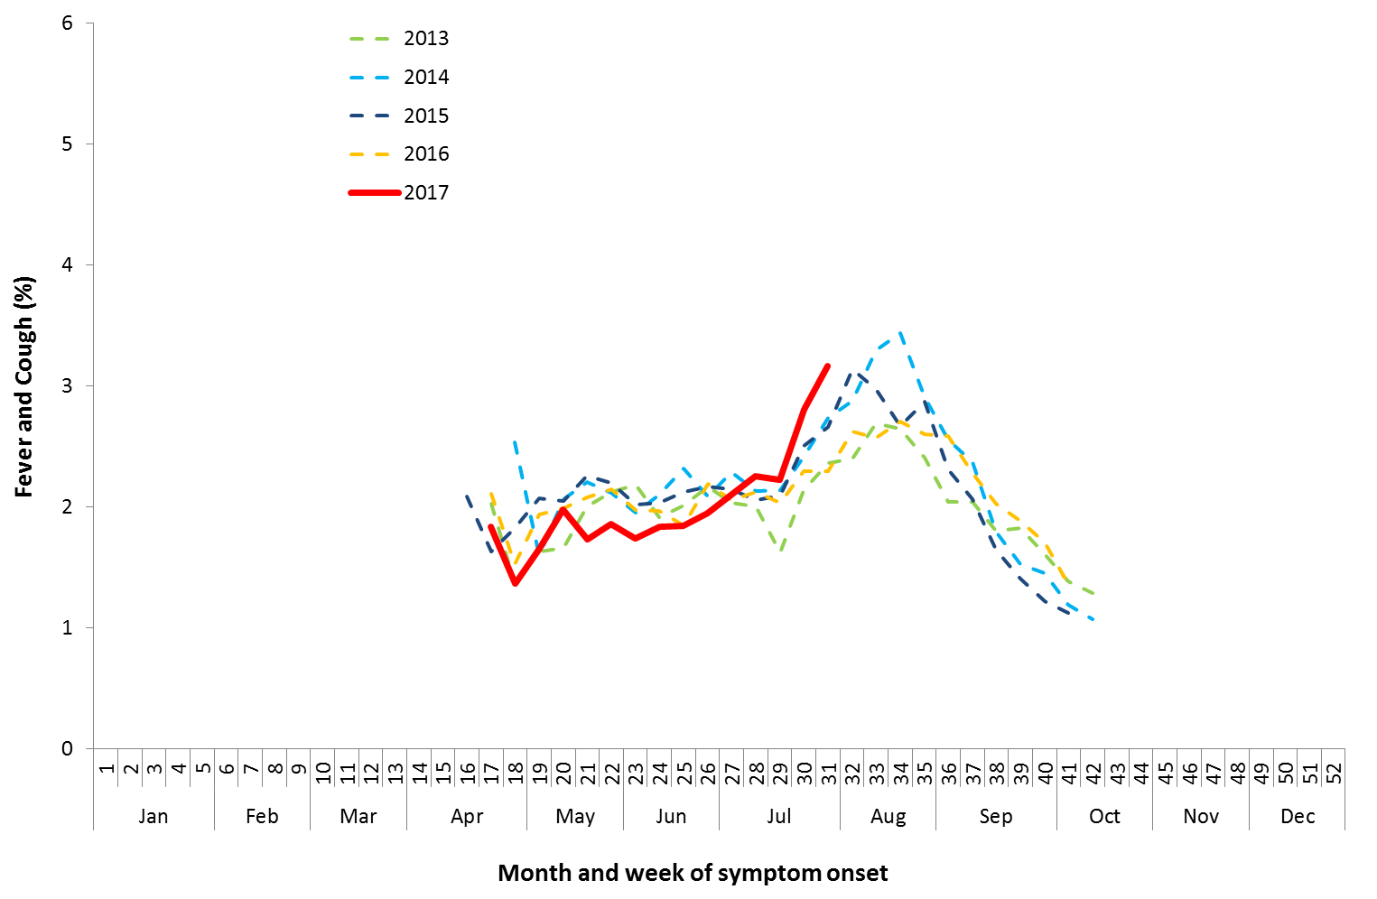

Source: FluTracking

### Sentinel General Practice Surveillance

Sentinel general practitioner ILI consultations increased this reporting fortnight, with 10.9 per 1,000 consultations in week 30 and 14.3 per 1,000 consultations in week 31 (Figure 12). This is an increase from the 9.9 per 1,000 consultations reported in week 29. ILI consultations in the last fortnight are within the range of recent seasons for this time of year.

Of the 218 specimens taken from ILI patients seen by Australian Sentinel Practices Research Network (ASPREN) sentinel practitioners during the current reporting fortnight, influenza was the most common respiratory virus detected (n=107, 49.1%), consisting of 64 samples positive for A(unsubtyped), 3 samples positive for A(H3N2) and 40 positive for influenza B (Figure 13).

Figure . Unweighted rate of ILI reported from sentinel GP surveillance systems, Australia, 1 January 2013 to 6 August 2017, by month and week.

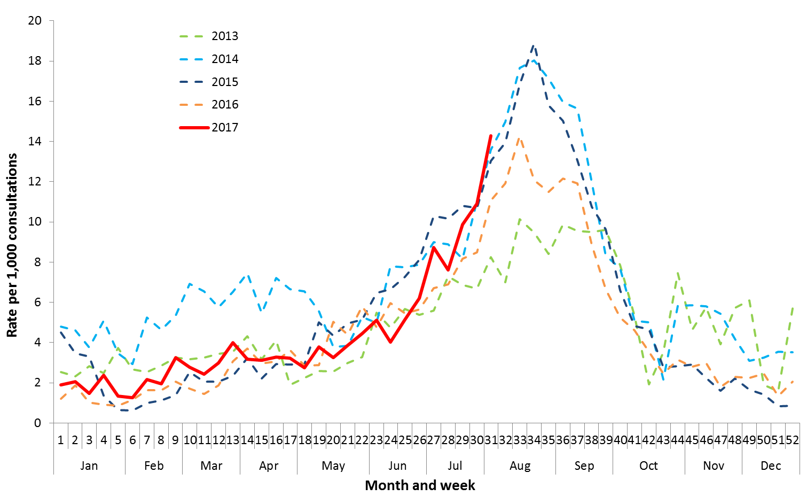

Source: ASPREN and VicSPIN

Figure . Proportion of respiratory viral tests positive for influenza in ASPREN ILI patients and ASPREN ILI consultation rate, Australia, 1 January to 6 August 2017, by month and week.

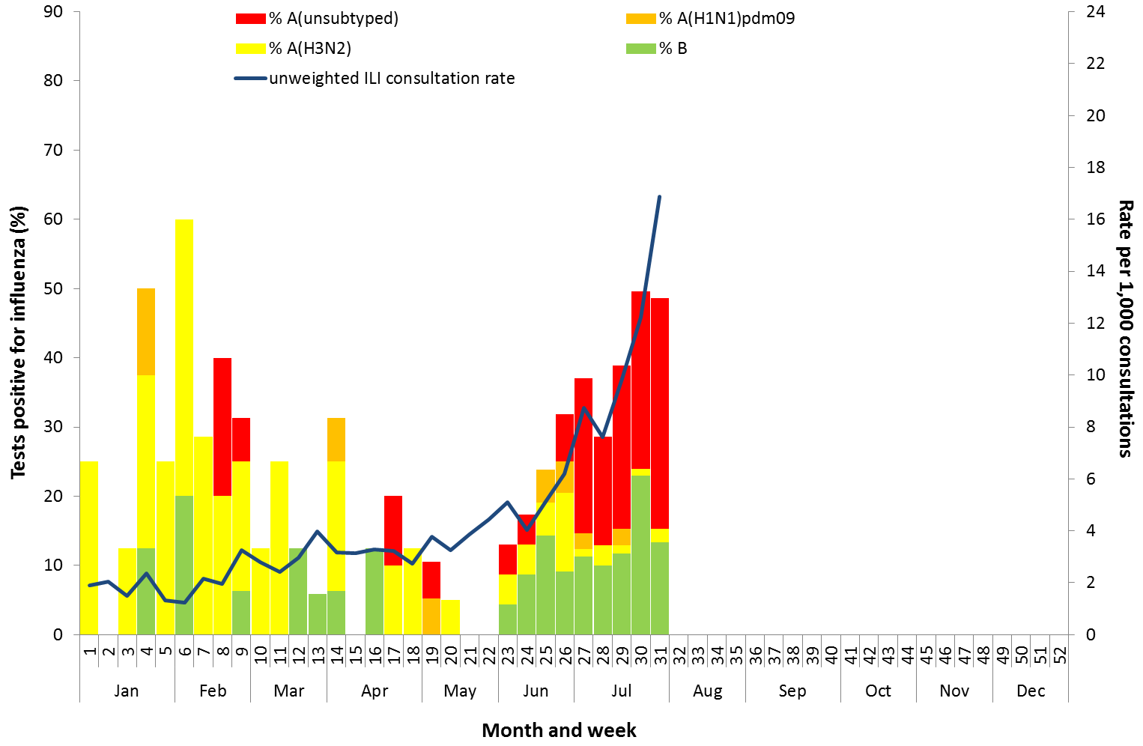

Source: ASPREN

## 3. Hospitalisations

### Sentinel Hospital Surveillance

Admissions with confirmed influenza to sentinel hospitals declined within the reporting fortnight (Figure 14), with 180 patients admitted in week 30, and 155 in week 31. This is an increase on the total number of patients admitted in the previous reporting fortnight (n=264). Since seasonal surveillance commenced through the Influenza Complications Alert Network (FluCAN) sentinel hospital surveillance system on 3 April 2017, a total of 959 people have been admitted with confirmed influenza, of which 161 (16.8%) were children aged less than 15 years. Approximately 7.7% of influenza patients have been admitted directly to ICU (n=74); lower than the proportion reported in recent years (range 8.7% to 14.2%).

For the year to 4 August, 76% of admissions with confirmed influenza to sentinel hospitals were influenza A (63% A(unsubtyped), 3% influenza A(H1N1)pdm09 and 10% influenza A (H3N2)), 24% were influenza B and less than 1% were mixed influenza infections. Consistent with notification data, the proportion of admissions due to influenza B was higher in children.

Figure . Number of influenza hospitalisations at sentinel hospitals, between March and October, 2013 to 2017 by month and week.

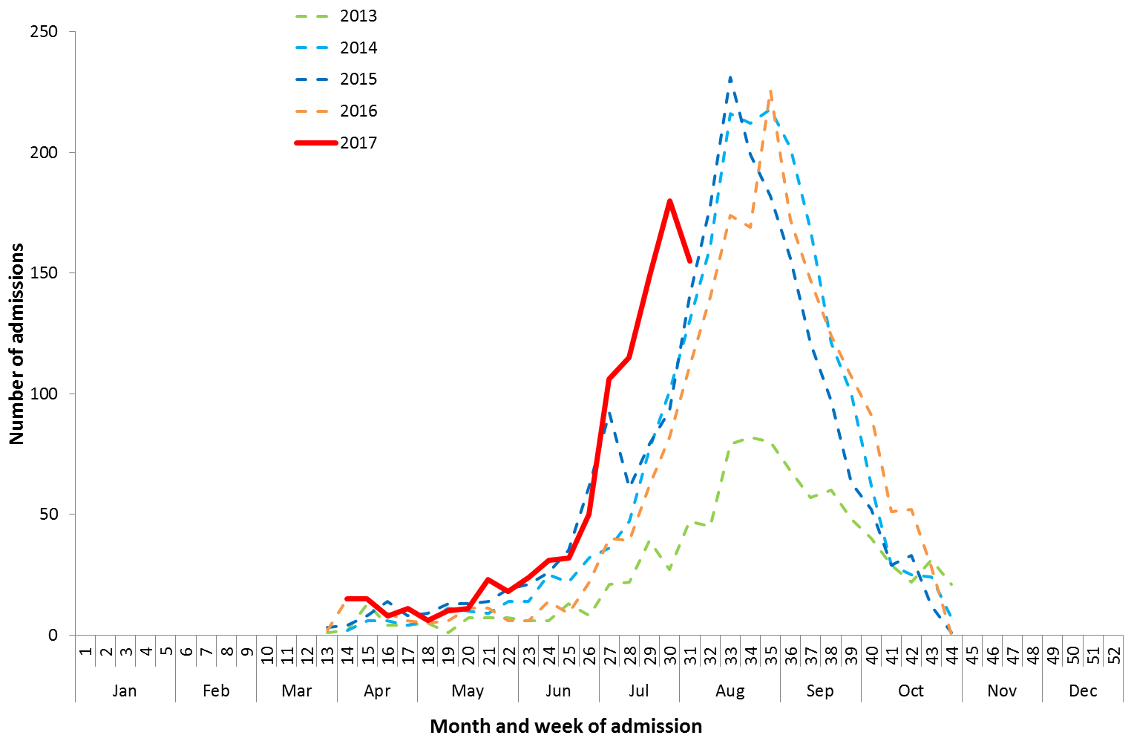

Source: FluCAN

Figure . Number of influenza hospitalisations at sentinel hospitals by subtype and ICU admission, 3 April to 4 August 2017, by month and week.

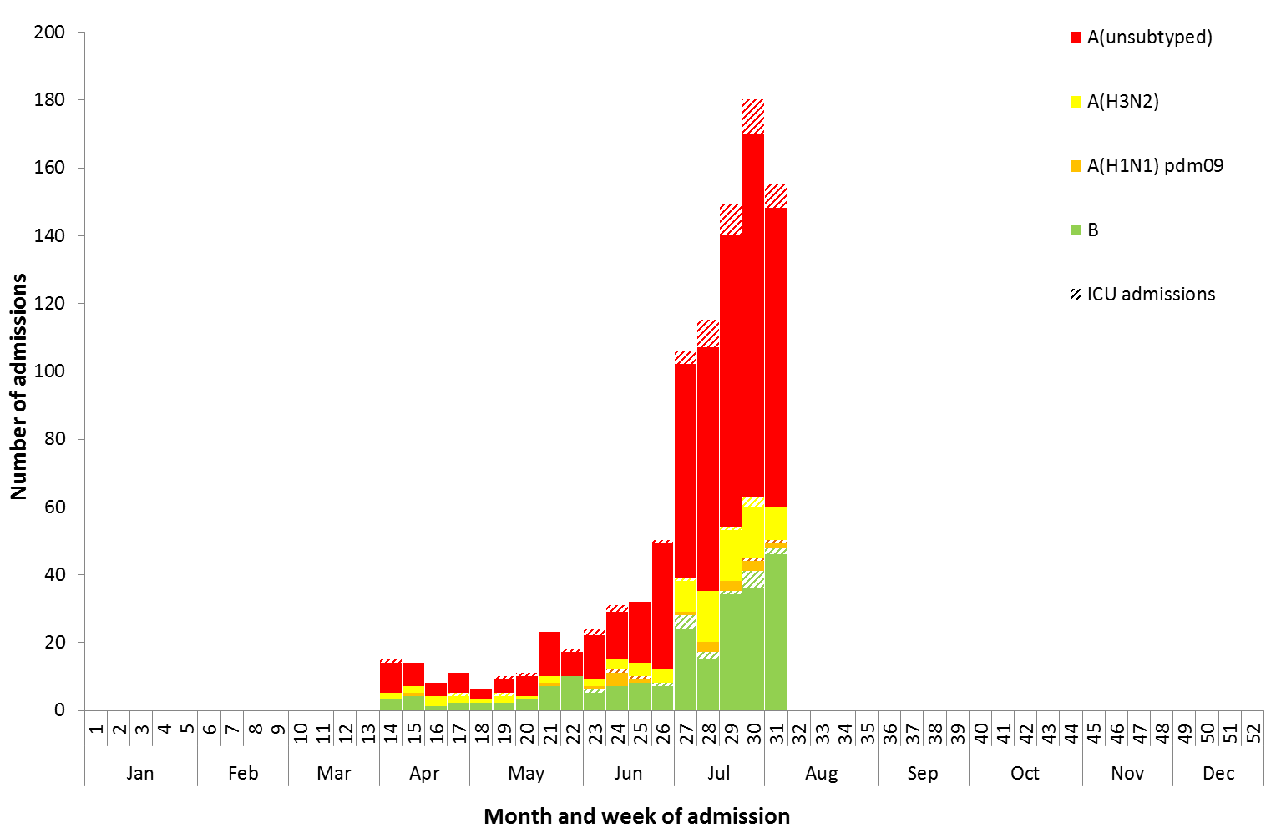

Source: FluCAN

### Paediatric Severe Complications of Influenza

The Australian Paediatric Surveillance Unit (APSU) conducts seasonal surveillance between June and September annually of children aged 15 years and under who are hospitalised with severe complications of influenza. Since seasonal surveillance commenced through APSU on 24 July to 6 August 2017, there have been a total of ten hospitalisations associated with severe complications of influenza reported. Eight cases were female and two male, with an age range of 2 to 13 years, and seven infected with influenza A and three with influenza B. Vaccination status was known for five of the patients, with one being vaccinated against influenza. Nine patients were discharged with no ongoing problems, with one remaining in ICU at time of reporting.

## 4. Deaths Associated with Influenza and Pneumonia

### Nationally Notified Influenza Associated Deaths

So far in 2017, 43 influenza associated deaths have been notified to the NNDSS. The majority of deaths were due to influenza A (81%, n = 35). The median age of deaths notified was 81 years (range 13 to 97 years). The number of influenza associated deaths reported to the NNDSS is reliant on the follow up of cases to determine the outcome of their infection and most likely does not represent the true mortality associated with this disease.

### New South Wales Influenza and Pneumonia Death Registrations

Death registration data from NSW for the week ending 14 July 2017 show that there were 1.36 “pneumonia and influenza” deaths per 100,000 NSW population, which was below the epidemic threshold of 1.89 per 100,000 NSW population (Figure 16).[2]

Figure . Rate of deaths classified as influenza and pneumonia from the NSW Registered Death Certificates, 2012 to   
14 July 2017.

Please refer above for description and interpretation.

Source: NSW Registry of Births, Deaths and Marriages

## 5. Virological Surveillance

### Australian Influenza Vaccines Composition 2017

The influenza virus strains included in the 2017 seasonal influenza vaccines in Australia are:

* A/Michigan/45/2015, (H1N1)pdm09-like virus;
* A/Hong Kong/4801/2014, (H3N2)-like virus;
* B/Brisbane/60/2008-like virus, Victoria lineage;
* B/Phuket/3073/2013-like virus, Yamagata lineage.

### Typing and Antigenic Characterisation

From 1 January to 7 August, the World Health Organization Collaborating Centre for Reference and Research on Influenza (WHOCC) characterised 486 influenza viruses (Table 1). When further characterised for similarity to the corresponding vaccine components, influenza A(H1N1)pdm09 viruses and viruses from both influenza B lineages appeared to be mostly antigenically similar to the corresponding vaccine components. The influenza A(H3N2) isolates that were able to be assessed by haemagglutination inhibition assay appeared to be reasonably well matched, although there are ongoing technical issues that significantly limit the WHOCC’s capacity to fully assess the similarity of circulating viruses to the vaccine strain.

The best way to determine how well the vaccine protects against circulating viruses during the season is by determining the vaccine effectiveness. These estimates provide an indication of how effective the vaccine was in providing protection against influenza infection, but can only be determined towards the end of the influenza season.

Virtually all the influenza B and influenza A(H1N1)pdm09 isolates characterised by the WHOCC were antigenically similar to the corresponding vaccine components. A small number of influenza A(H3N2) isolates (n=32) were characterised as low reactors. An additional 327 influenza A(H3) isolates were unable to be characterised in the HI assay due to insufficient haemagglutination titre.

Table . Australian influenza viruses typed by HI from the WHOCC, 1 January to 7 August 2017.

|  |  |  |  |  |  |  |  |  |  |
| --- | --- | --- | --- | --- | --- | --- | --- | --- | --- |
| **Type/Subtype** | **ACT** | **NSW** | **NT** | **QLD** | **SA** | **TAS** | **VIC** | **WA** | **TOTAL** |
| **A(H1N1) pdm09** | 3 | 35 | 1 | 38 | 14 | 1 | 22 | 11 | 125 |
| **A(H3N2)** | 5 | 109 | 16 | 32 | 68 | 1 | 24 | 8 | 263 |
| **B/Victoria lineage** | 0 | 5 | 0 | 3 | 3 | 1 | 2 | 0 | 14 |
| **B/Yamagata lineage** | 1 | 33 | 9 | 11 | 17 | 0 | 11 | 2 | 84 |
| Total | 9 | 182 | 26 | 84 | 192 | 3 | 59 | 21 | 486 |

SOURCE: WHO CC

Note: Viruses tested by the WHO CC are not necessarily a random sample of all those in the community.

State indicates the residential location for the individual tested, not the submitting laboratory.

There may be up to a month delay on reporting of samples.

### Antiviral Resistance

The WHOCC reported that from 1 January to 7 August 2017, of the724 influenza viruses tested for neuraminidase inhibitor resistance, one sample of influenza A(H1N1) demonstrated reduced inhibition to the antiviral drug Zanamivir.

## 6. International Surveillance

The World Health Organization reported that based on data up to 23 July, in the temperate zone of the southern hemisphere, high levels of influenza activity continue to be reported, with some countries in Central America, the Caribbean and South East Asia also reporting increased influenza activity.[3] Influenza activity in the temperate zone of the northern hemisphere was reported at low levels. Worldwide, influenza A(H3N2) and the predominant circulating virus.

# DATA CONSIDERATIONS

The NNDSS data provided were extracted on 9 August 2017. Due to the dynamic nature of the NNDSS, data in this report is subject to retrospective revision and may vary from data reported in published NNDSS reports and reports of notification data by states and territories. Detailed notes on interpreting the data presented in this report are available at the Department of Health’s [Australian Influenza Surveillance Report website](http://www.health.gov.au/flureport) (www.health.gov.au/flureport).

The Australian Influenza Surveillance Report and Activity Updates are compiled from a number of data sources, which are used to monitor influenza activity and severity in the community. These data sources include laboratory-confirmed notifications to the NNDSS; influenza associated hospitalisations; sentinel influenza-like illness (ILI) reporting from general practitioners and emergency departments; and community level surveys; and sentinel laboratory testing results. The information in this report is reliant on the surveillance sources available to the Department of Health at the time of production.

While every care has been taken in preparing this report, the Commonwealth does not accept liability for any injury or loss or damage arising from the use of, or reliance upon, the content of the report. Delays in the reporting of data may cause data to change retrospectively. For further details about information contained in this report please contact the [Influenza Surveillance Team](mailto:flu@health.gov.au) ([flu@health.gov.au](mailto:flu@health.gov.au)).

# REFERENCES

1. FluTracking, FluTracking Weekly Interim Report, Week ending 6 August 2017. Available from [FluTracking Reports](http://www.flutracking.net/Info/Reports) (http://www.flutracking.net/Info/Reports) [Accessed 10 August 2017].
2. NSW Health, Influenza Monthly Epidemiology Report, NSW, Week 31: 31 July to 6 August, 2017. Available from NSW Health Influenza Surveillance Reports (http://www.health.nsw.gov.au/Infectious/Influenza/Pages/reports.aspx) [Accessed 11 August 2017].
3. WHO, Influenza Update No. 295, 7 August 2017. Available from the [WHO website](http://www.who.int/influenza/surveillance_monitoring/updates/latest_update_GIP_surveillance/en/) (http://www.who.int/influenza/surveillance_monitoring/updates/latest_update_GIP_surveillance/en/) [Accessed 9 August 2017].