| Logo | **Australian Influenza**  **SURVEILLANCE REPORT**  **No. 9, 2017**  **2 – 15 September 2017** |
| --- | --- |

The Department of Health acknowledges the providers of the many sources of data used in this report and greatly appreciates their contribution.

# KEY MESSAGES

* Influenza activity at the national level decreased this reporting fortnight after reaching a peak in   
  mid-August. Despite the national decline, high levels of activity continue to be reported across the country, with seasonal activity in some states and territories yet to have reached a peak.
* The peak week of national influenza activity this season has been at comparable or higher levels than in recent years, with high activity persisting for a number of weeks.
* Moderate to high levels of influenza activity in the community are likely to continue for the next few weeks.
* There has been more than two and a half times the number of laboratory confirmed notifications of influenza reported to the National Notifiable Diseases Surveillance System (NNDSS) this year when compared with the same period last year. An earlier season onset and introduction of rapid testing have contributed, in part, to this increase. Administrative backlogs in data entry experienced in some jurisdictions are likely to alter the pattern of notifications once the backlog is resolved.
* National indicators of influenza-like illness (ILI) declined in the last fortnight, further supporting that the season has peaked nationally. The proportion of patients presenting to sentinel general practitioners with ILI and testing positive for influenza remained stable this fortnight, indicating that influenza remains a significant cause of ILI in the community.
* Influenza A(H3N2) is currently the predominant circulating influenza A virus nationally. Influenza B viruses also continue to circulate, with the proportion of total notifications attributed to influenza B increasing this reporting fortnight.
* Notification rates this year to date have been highest in adults aged 80 years or older, with a secondary peak in young children, aged 5 to 9 years. This is consistent with previous seasons where influenza A(H3N2) and influenza B, respectively, have predominated.
* Admissions to sentinel hospitals with confirmed influenza decreased this reporting fortnight, following a peak in week 33. High levels of admissions have persisted for the last 6 weeks, consistent with the higher than average influenza activity in the community.
* Clinical severity for the season to date, as measured through the proportion of patients admitted directly to ICU, and deaths attributed to pneumonia or influenza, is low to moderate. The proportion of patients admitted directly to ICU has been lower than in recent years.
* To date, based on antigenic characterisation of circulating influenza viruses, the seasonal influenza vaccines appear to be a moderate to good match for circulating virus strains, depending on the strain. Vaccine effectiveness estimates, which provide an indication of how well the vaccine provides protection against influenza, are only available towards the end of the influenza season.

# ANALYSIS

## 1. Geographic Spread of Influenza Activity in Australia

In the fortnight ending 15 September 2017 (week 37), influenza activity was reported as widespread in all regions of the country with the exception of the Northwest region of Western Australia (WA), where activity was regional.

When compared to the previous fortnight influenza activity was reported as increased in the Top End region of the Northern Territory (NT), South Australia (SA), Tasmania (TAS) and all regions of WA; unchanged in all regions of Queensland (QLD) and Victoria (VIC); and decreased in New South Wales (NSW) and the Central Australia region of the NT.

Influenza-like illness (ILI) activity reported from syndromic surveillance systems when compared with the previous fortnight was reported as increased in the SA, TAS and WA; unchanged in the NT and QLD and decreased in NSW and VIC.

Figure 1. Map of influenza activity by state and territory, Australia, 2 – 15 September 2017.

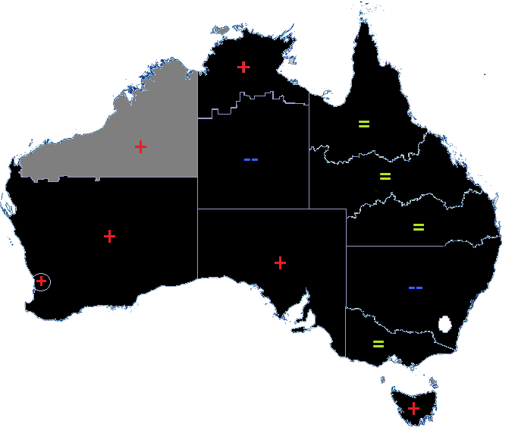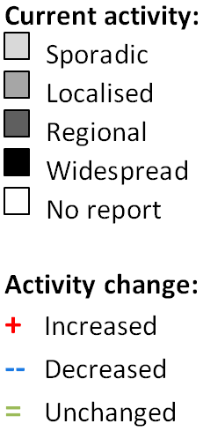

## 2. Laboratory Confirmed Influenza Activity

### Sentinel Laboratory Surveillance

Influenza was detected at varying levels across the sentinel laboratories this reporting fortnight (Figure 2). SA Pathology and PathWest (WA) reported increasing detections this fortnight, while Tasmania and Victoria Infectious Disease Reference Laboratory (VIDRL) reported fluctuating detections. Pathology West ICPMR (NSW) continued to report a decrease in detections from the peak reached in week 32.

The pooled unweighted percentage of tests positive for influenza across all sentinel laboratories rose from 32.4% reported in the second week (week 35) of last fortnight, to 35.5% in week 36 and declined slightly to 34.2% in week 37.

Testing for influenza continued to increase this reporting fortnight (Figure 3). Influenza A was reported as the most commonly detected respiratory virus this fortnight by all sentinel laboratories, with the exception of VIDRL where influenza A and influenza B were detected at similar levels in week 37. From the sentinel laboratories where influenza subtyping was undertaken (Tasmania, VIDRL and PathWest), influenza A(H3N2) was detected more frequently than influenza A(H1N1)pdm09.

Figure 2. Proportion of sentinel laboratory tests positive for influenza, 1 January to 15 September 2017, by contributing laboratory or jurisdiction and month and week.

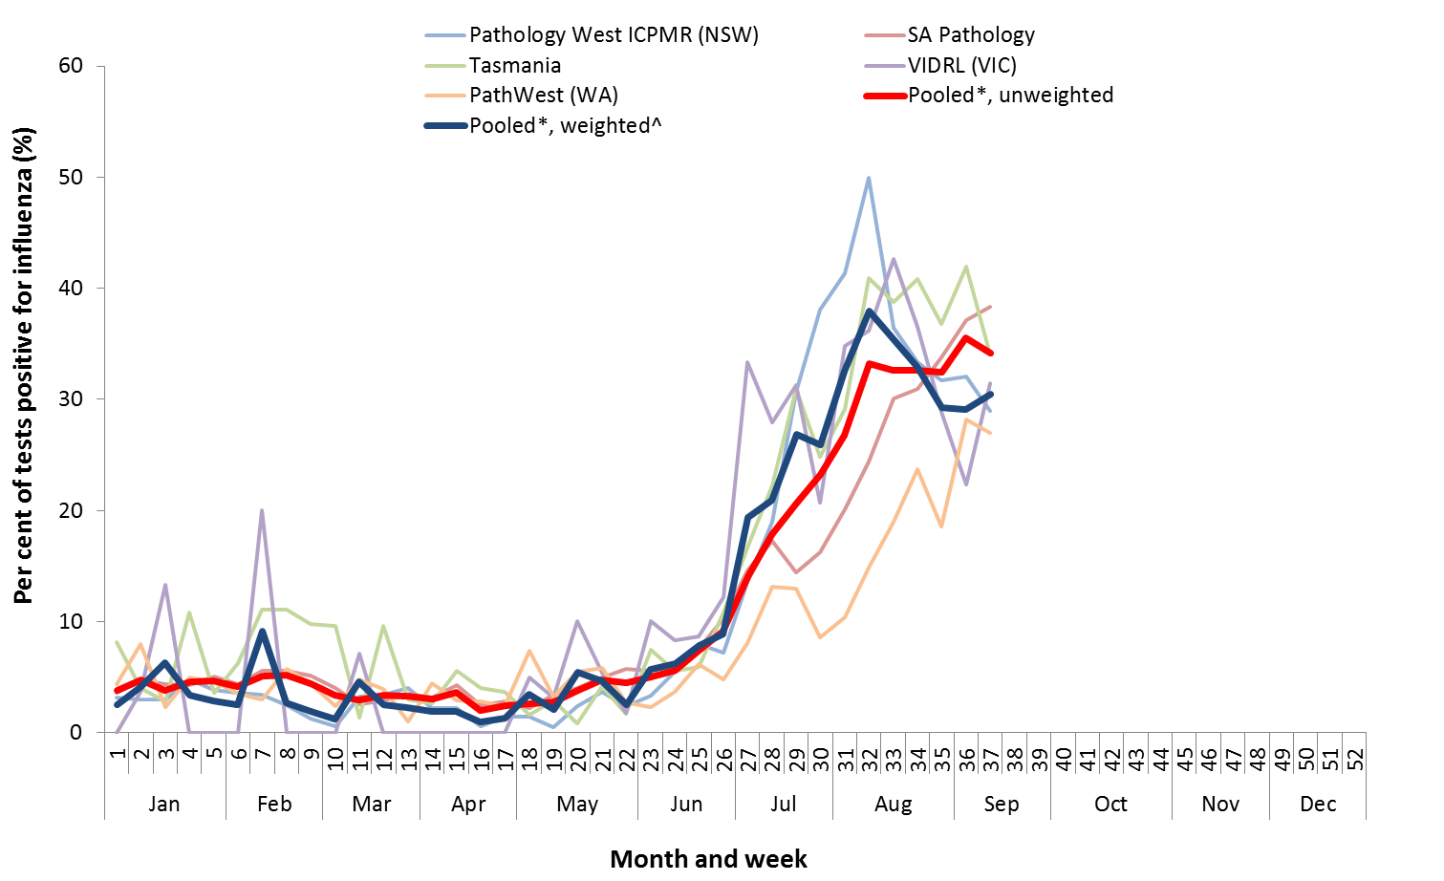

* Pooled percentage positive indicators should be interpreted with caution, noting that collectively pooled contributing laboratories are not representative of testing across Australia and individually contributing laboratories may not be representative of the jurisdiction in which they are located.

^ Weighted according to jurisdictional population in which laboratories are located.

The percentage of tests positive for influenza in the interseasonal period should be interpreted with caution due to small numbers of tests being undertaken in this time, resulting in high variability in the indicators.

Figure 3. Proportion of sentinel laboratory tests positive for influenza and total number of specimens tested, 1 January to 15 September 2017, by subtype and month and week.

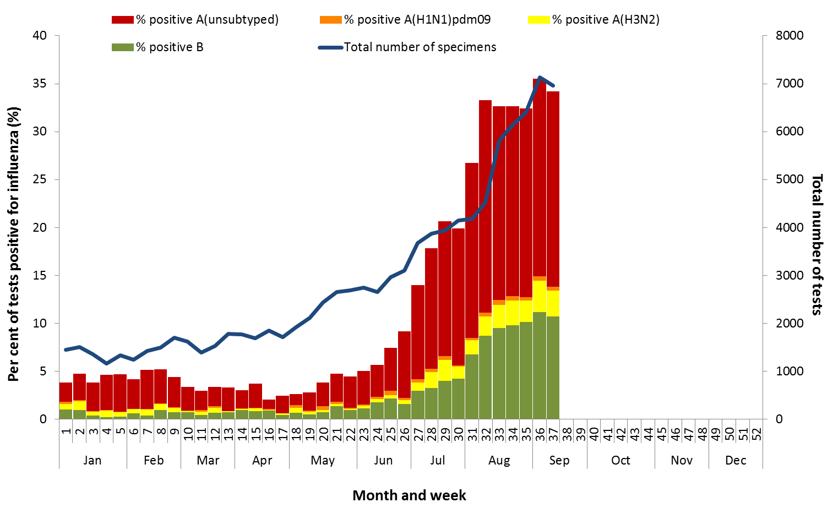

### Notifications of Influenza to Health Departments

Notifications of laboratory confirmed influenza to the National Notifiable Diseases Surveillance System (NNDSS) have declined this reporting fortnight, from a peak reached in week 33 (Figure 4). For the year to 15 September, a total of 172,247 notifications of laboratory confirmed influenza were reported to the NNDSS: 86,567 in NSW; 44,866 in QLD; 17,326 in SA; 13,654 in VIC; 3,656 in WA; 2,707 in TAS; 2,352 in the ACT and 1,119 in the NT. When comparing this reporting fortnight to the previous fortnight, notifications of laboratory confirmed influenza were variable across the jurisdictions, with an increase in WA; fluctuating weekly notifications in the ACT and TA; and decreases in NSW, NT and QLD. SA and VIC are currently experiencing administrative backlogs in data entry, due to the heightened number of laboratory-confirmed influenza cases this season, which is likely contributing to the decrease in reported cases this fortnight and will alter the pattern of notifications once the backlog is resolved.

For the year to 15 September, 67% of notifications of laboratory confirmed influenza to the NNDSS were   
influenza A (60% influenza A(unsubtyped), 1% influenza A(H1N1)pdm09 and 5% influenza A(H3N2)), 33% were influenza B and less than 1% were influenza A&B co-infections or untyped (Figure 6). The proportion of all notifications year to date reported as influenza A has ranged across jurisdictions from 61% in NSW to 84% in WA. For the year to date, detections of influenza A subtypes have varied across jurisdictions also. Nationally, for every one notification of influenza A(H1N1)pdm09 reported to the NNDSS, 3.9 notifications of   
influenza A(H3N2) were received. This ratio has ranged from 1:0.1 in VIC to 1:13.4 in the ACT. VIC is the only jurisdiction where notifications received year to date for influenza A(H1N1)pdm09 are greater than for influenza A(H3N2).

In the most recent fortnight, 58% of notifications of laboratory confirmed influenza to the NNDSS were influenza A (54% influenza A(unsubtyped), 1% influenza A(H1N1)pdm09 and 3% influenza A (H3N2)), 42% were influenza B and less than 1% were influenza A&B co-infections or untyped (Figure 7). The proportion of all notifications this reporting fortnight reported as influenza B ranged across jurisdictions from 13% in WA to 50% in NSW. The proportion of influenza B notifications increased this fortnight and while the number of influenza B notifications decreased this fortnight they remain at high levels (Figure 7 and Figure 8).

So far in 2017, notification rates have tended to increase with increasing age. Age-specific notification rates of influenza overall have been highest in adults aged 85 years or older (2,240 notifications per 100,000) and adults aged 80 to 84 years (1,314 notifications per 100,000) with a secondary peak in children aged 5 to 9 years (1,237 per 100,000) (Figure 9). The notification rate in infants aged less than 5 years is also high   
(1,134 per 100,000). Where subtyping information is available, notifications of influenza A(H1N1)pdm09 were highest in children aged less than 5 years (30.3 per 100,000), notifications of influenza A(H3N2) were highest in the elderly aged 85 years and older (194.6 per 100,000) and notifications of influenza B were highest in children aged 5 to 9 years (585.6 notifications per 100,000 population).

Decreases in notifications occurred in all broad age groups since the last reporting fortnight (Figure 10). The distribution of influenza types and subtypes differed across age groups, with 48% of 5 to 17 year olds notified with influenza being detected with influenza B, while only 23% of adults aged 65 years and older detected with influenza B. While influenza A(H3N2) is detected across all age groups, it accounted for a greater proportion of influenza A, where subtyping was available, in adults aged 65 years or older, than in any other age group.

Figure 4. Notifications of laboratory confirmed influenza, Australia, 1 January 2013 to 15 September 2017, by month and week of diagnosis.

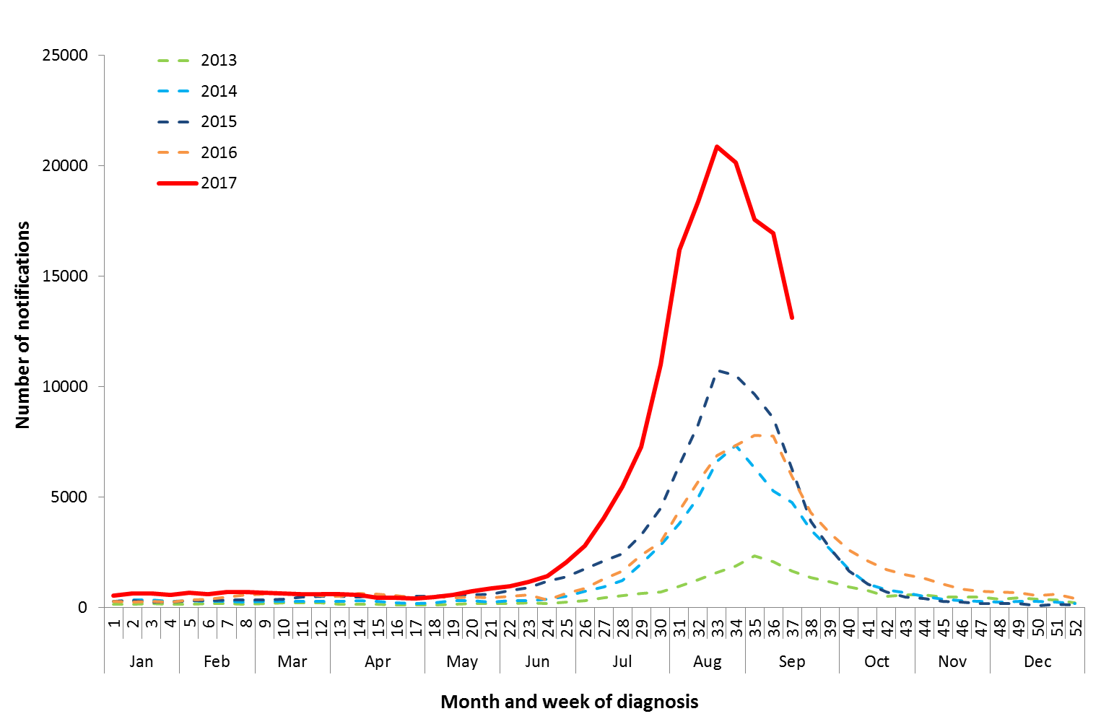

Source: NNDSS

Figure 5. Notifications of laboratory confirmed influenza, 1 January to 15 September 2017, by state or territory and week.

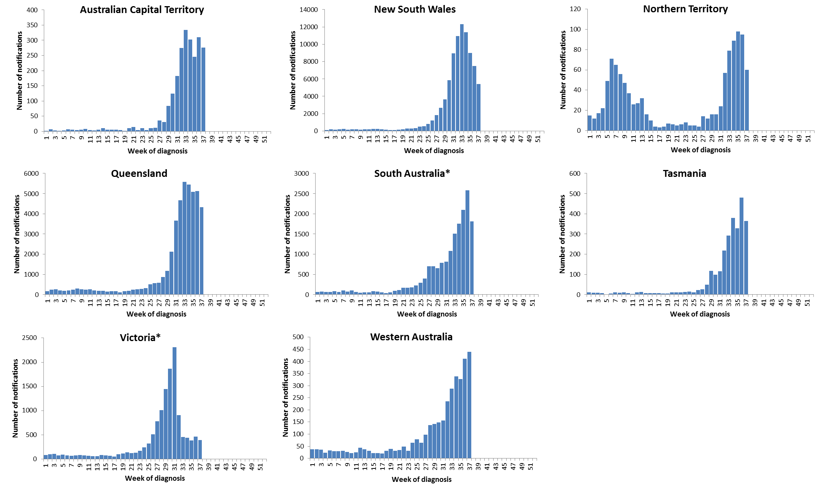 Source: NNDSS

*South Australia and Victoria are currently experiencing a backlog of influenza notifications to be entered into the NNDSS.

Figure 6. Per cent of notifications of laboratory confirmed influenza, Australia, 1 January to 15 September 2017, by subtype and state or territory.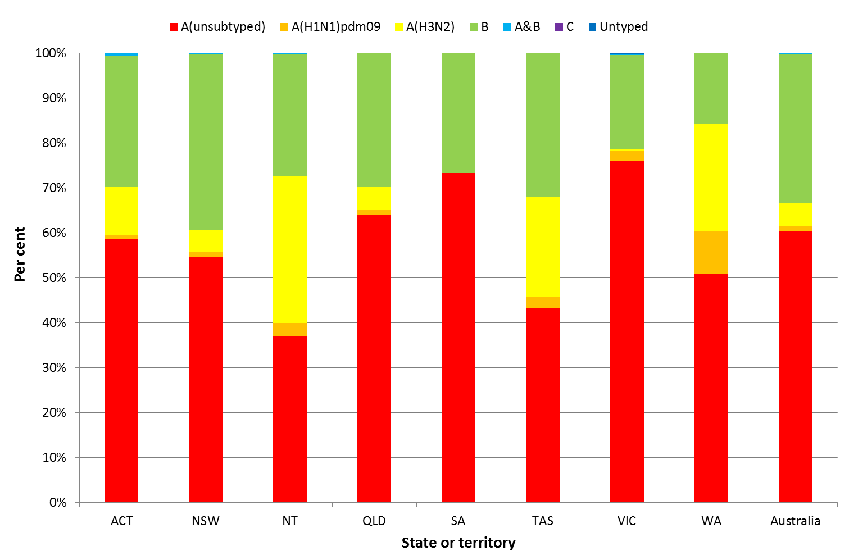

Source: NNDSS

Figure 7. Per cent of laboratory confirmed influenza, Australia, 1 January to 15 September 2017, by subtype and week.

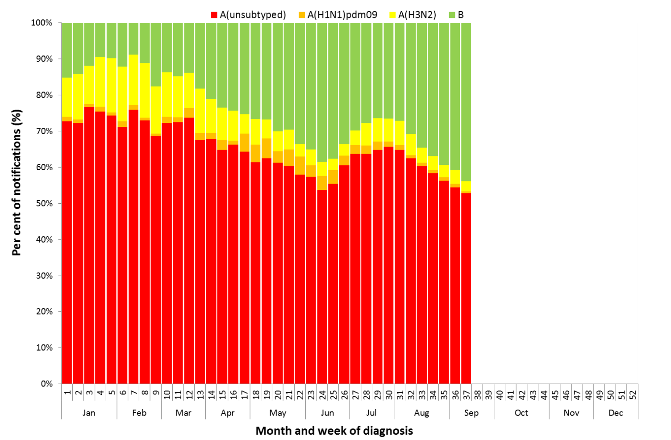

Source: NNDSS

**Figure 8. Notifications of laboratory confirmed influenza by week of diagnosis and cumulative year-to-date, Australia,   
1 January to 15 September 2017, by subtype and age group.**

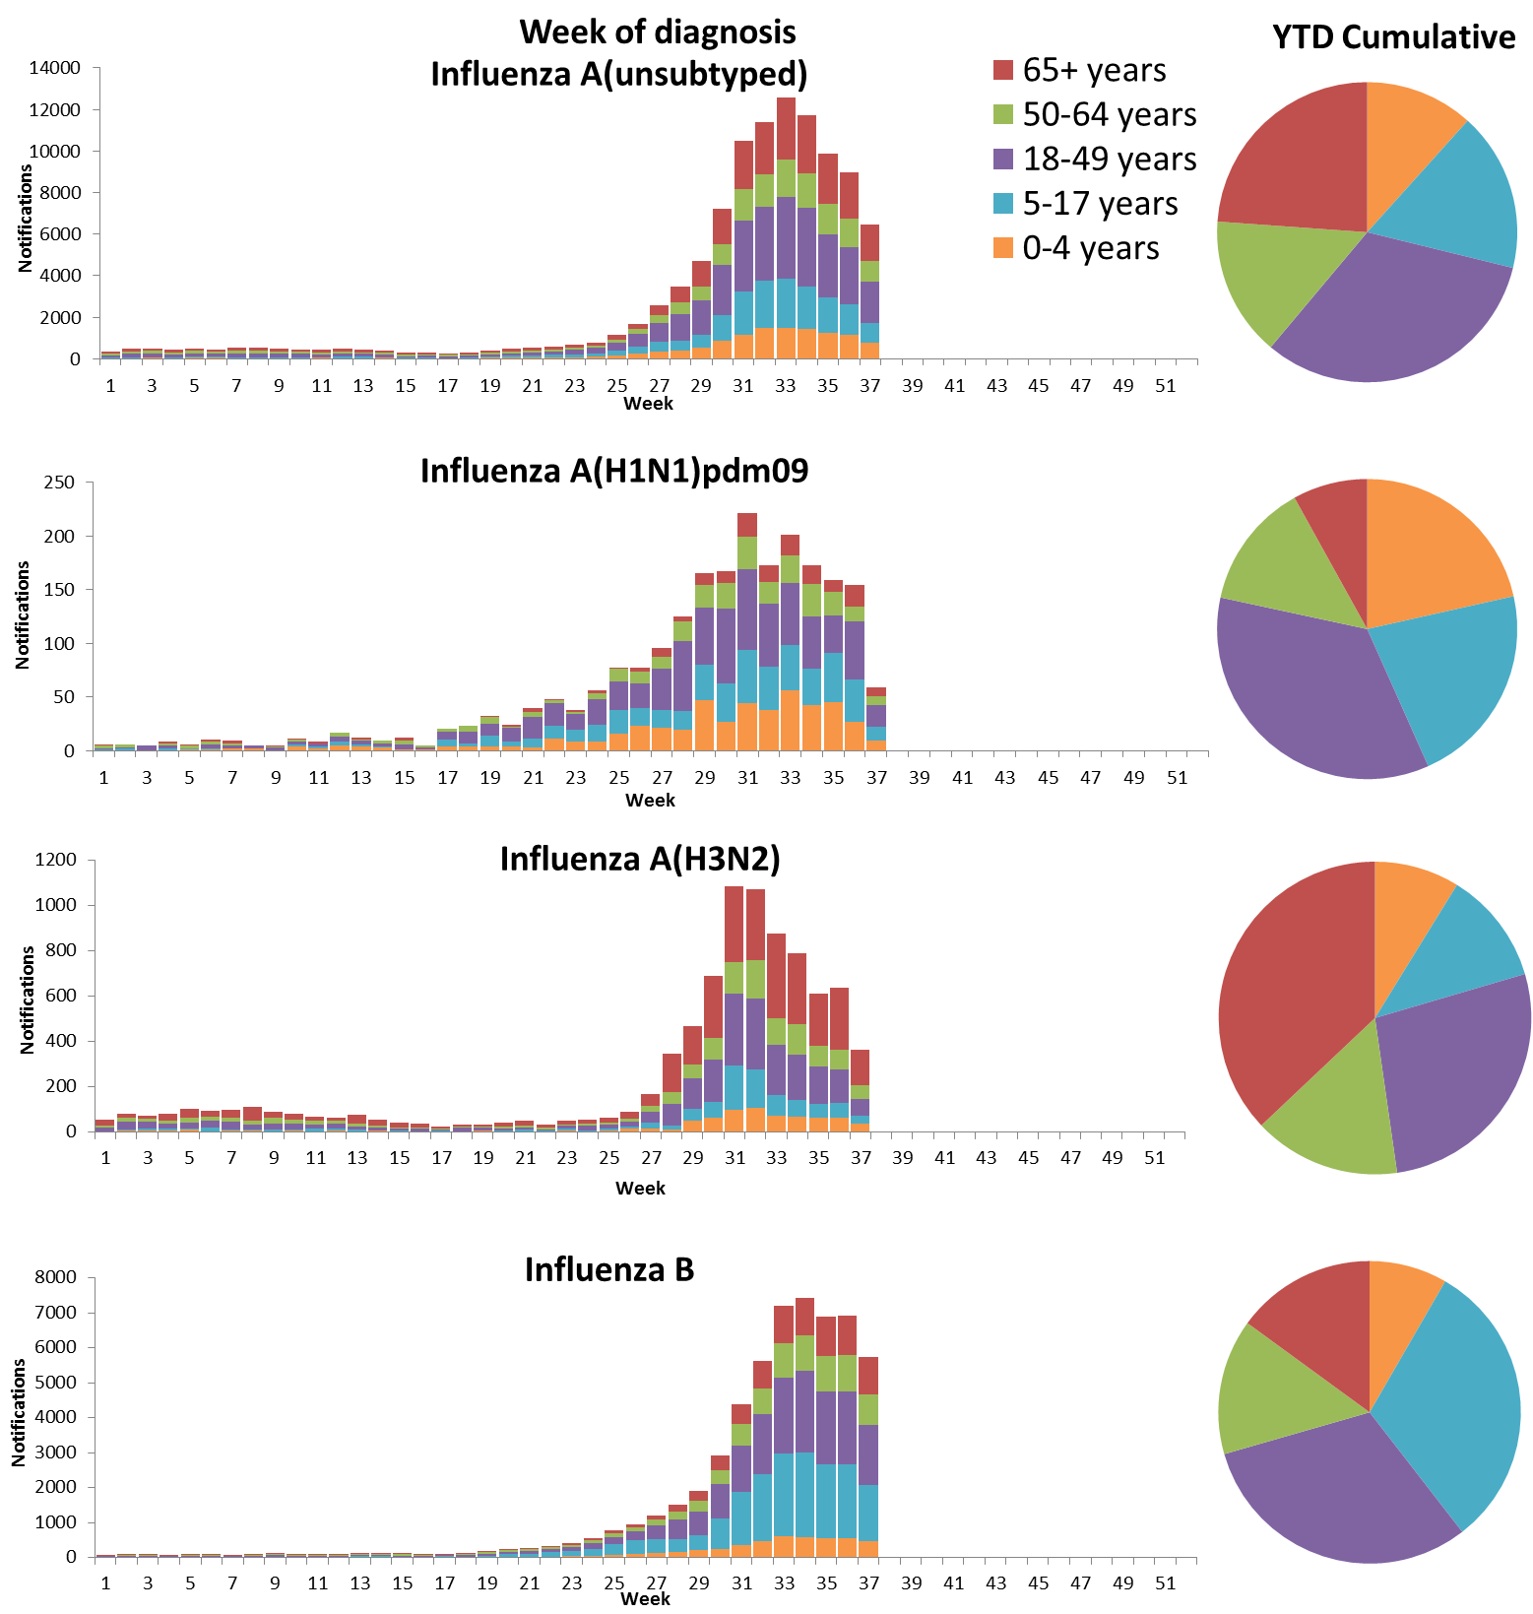

Source: NNDSS

Figure 9. Rate of notifications of laboratory confirmed influenza, Australia, 1 January to 15 September 2017, by age group and subtype.

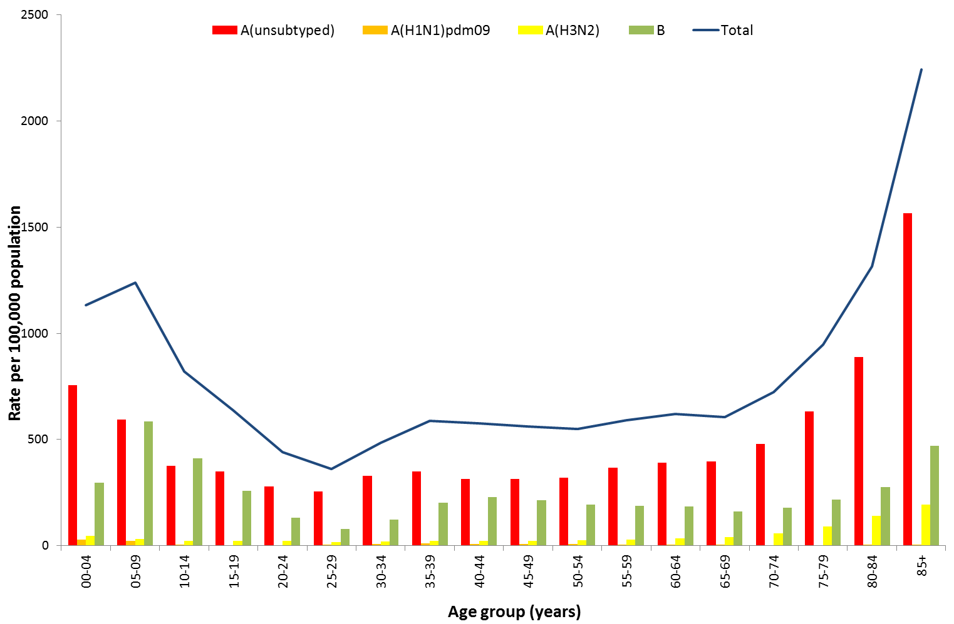

Source: NNDSS

Figure 10. Notifications of laboratory confirmed influenza by week of diagnosis and cumulative year-to-date, Australia, 1 January to 15 September 2017, by age group and subtype.

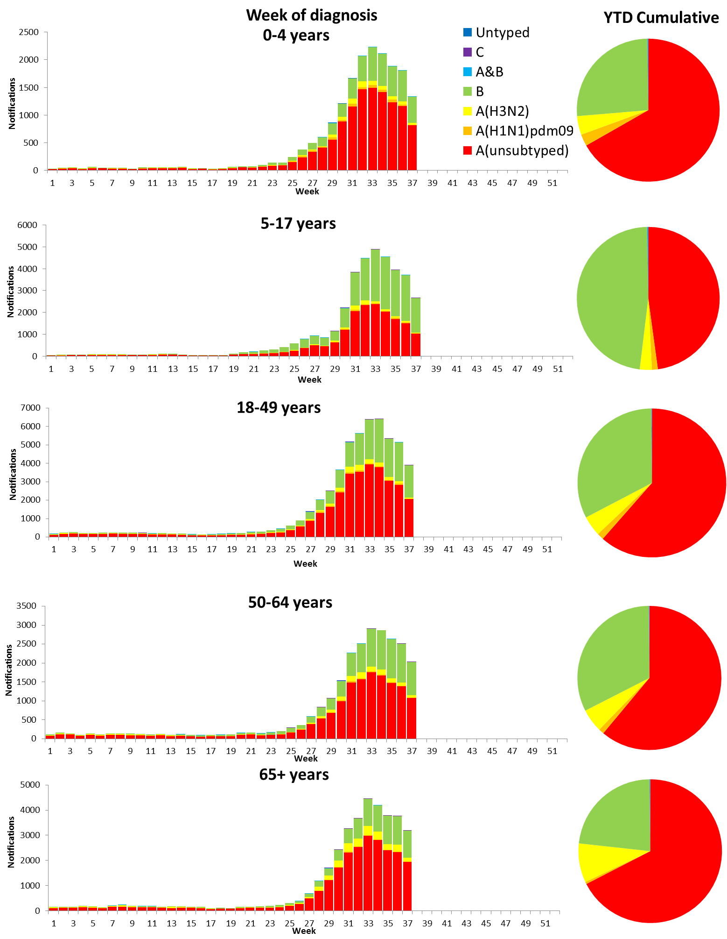

Source: NNDSS

## 2. Influenza-like Illness Activity

### Community Level Surveillance

FluTracking, a national online system for collecting data on ILI in the community, indicated that rates of ILI among participants continued to decrease this reporting fortnight, from a peak reached in week 33 (Figure 11). ILI activity among participants, reported as fever and cough, remained stable at 3.0% from the end of last fortnight (week 35) to week 36, and decreased in week 37 to 2.5%. So far this year 63% of all participants and 81% of participants who identify as working face-to-face with patients reported receiving the seasonal influenza vaccine.[1]

Figure 11. Proportion of fever and cough among FluTracking participants, Australia, between May and October, 2013 to 2017, by month and week.

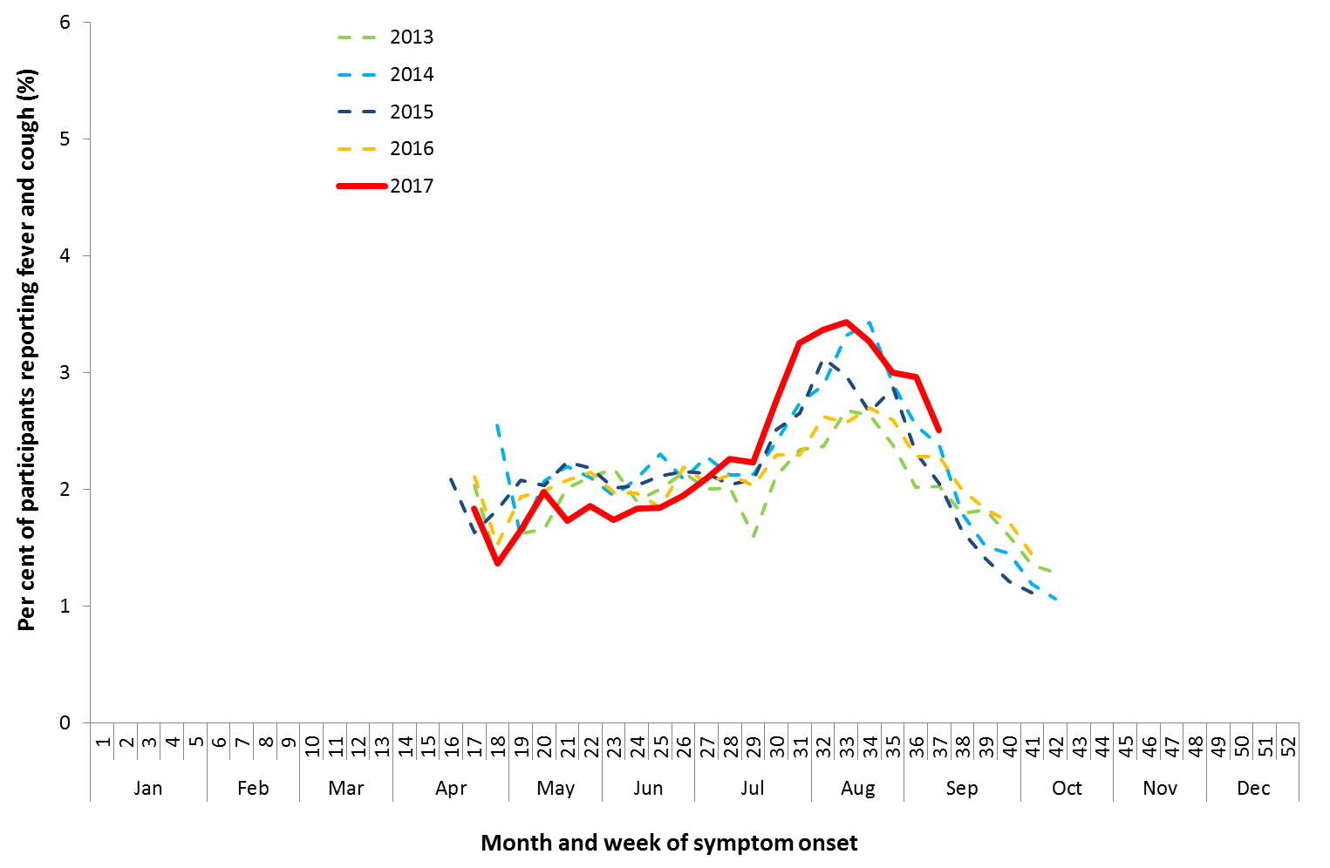

Source: FluTracking

### Health Call Centre Surveillance

ILI related calls to the National Health Call Centre Network (NHCCN) decreased this reporting fortnight, with 10.1% reported in week 36 and 9.7% reported in week 37 (Figure 12). This continues a decline from the peak in week 33 of 11.4%.

**Figure 12. Per cent of calls to the NHCCN related to ILI, Australia, 1 January 2013 to 17 September 2017, by month and week of call**

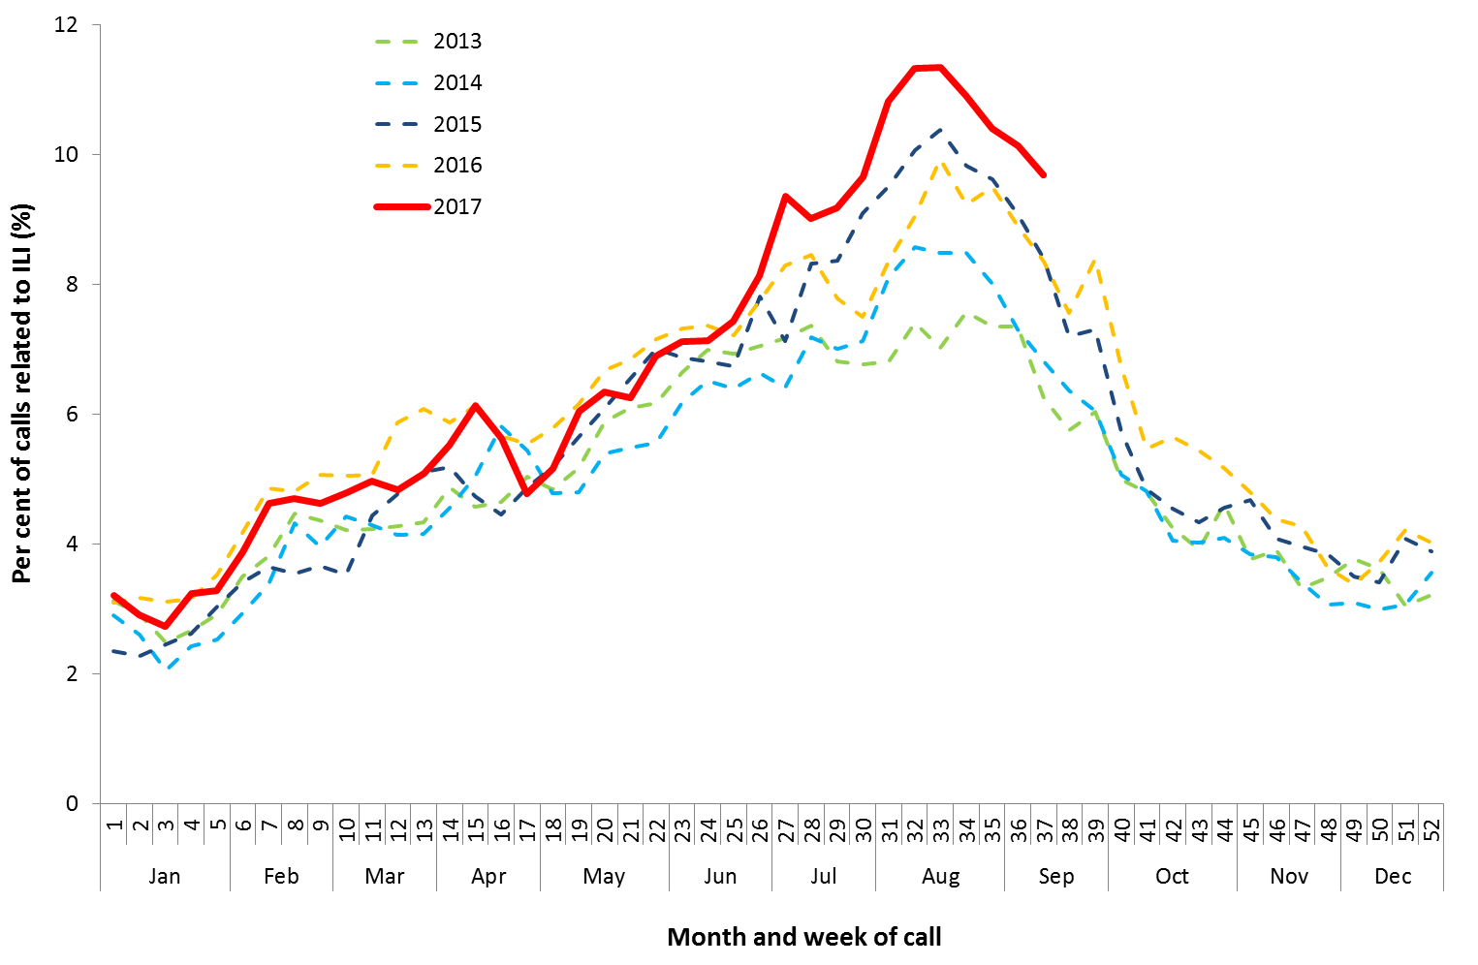

### Sentinel General Practice Surveillance

Sentinel general practitioner ILI consultations decreased this reporting fortnight, with 21.9 per 1,000 consultations in week 36 and 19.2 per 1,000 consultations in week 37 (Figure 13). This is a decrease from a peak of 23.2 per 1,000 consultations reported in week 34. ILI consultations this reporting fortnight, while declining, are still high when compared to the range of recent seasons for this time of year.

Of the 263 specimens taken from ILI patients seen by Australian Sentinel Practices Research Network (ASPREN) sentinel practitioners during the reporting fortnight, influenza was the most common respiratory virus detected (n=143, 54%), consisting of 79 samples positive for A(unsubtyped), 14 samples positive for A(H3N2), 3 sample positive for A(H1N1) and 47 positive for influenza B (Figure 14).

Figure 13. Unweighted rate of ILI reported from sentinel GP surveillance systems, Australia, 1 January 2013 to 17 September 2017, by month and week.

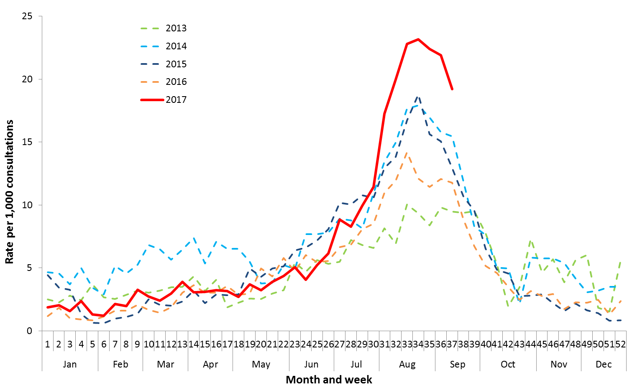

Source: ASPREN and VicSPIN

Figure 14. Proportion of respiratory viral tests positive for influenza in ASPREN ILI patients and ASPREN ILI consultation rate, Australia, 1 January to 17 September 2017, by month and week.

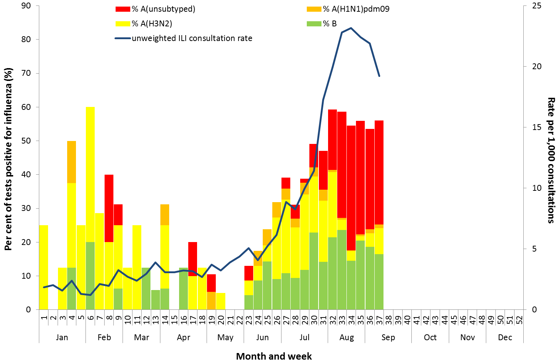

Source: ASPREN

## 3. Hospitalisations

### Sentinel Hospital Surveillance

Admissions with confirmed influenza to sentinel hospitals decreased this reporting fortnight (Figure 15), with 290 patients admitted in the last week of the previous fortnight (week 35), followed by 270 in week 36 and 218 in week 37. Since seasonal surveillance commenced through the Influenza Complications Alert Network (FluCAN) sentinel hospital surveillance system on 3 April 2017, a total of 2,691 people have been admitted with confirmed influenza, of which 391 (15%) were children aged 15 years or younger, 910 (34%) were adults aged between 16 and 64 years and 1,359 (51%) were adults aged 65 years and older. Information on age was not reported for 31 patients.

Approximately 8.3% of influenza patients have been admitted directly to ICU (n=224); lower than the proportion reported in recent years (range 8.7% in 2015 to 14.2% in 2013). The proportion of patients admitted directly to ICU this year to date has ranged by age, from 7.0% in adults aged 65 years and older to 10.2% in adults aged between 16 and 64 years.

For the year to 1 September, 73% of admissions with confirmed influenza to sentinel hospitals were influenza A (60% A(unsubtyped), 3% influenza A(H1N1)pdm09 and 9% influenza A (H3N2)), 27% were influenza B and less than 1% were mixed influenza infections (Figure 16). The proportion of patients admitted directly to ICU was higher in patients infected with influenza A(H1N1)pdm09 (14.6%), than in admitted patients infected with influenza A(H3N2) (8.0%) and influenza B (7.4%).

Figure 15. Number of influenza hospitalisations at sentinel hospitals, between March and October, 2013 to 2017 by month and week.

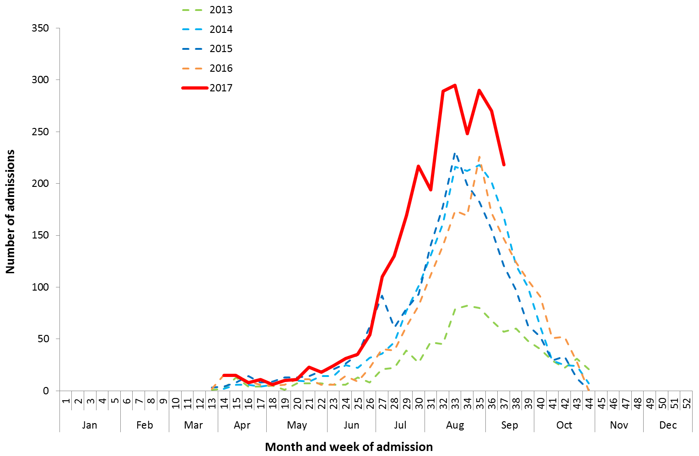

Source: FluCAN

Figure 16. Number of influenza hospitalisations at sentinel hospitals by subtype and ICU admission, 3 April to 15 September 2017, by month and week.

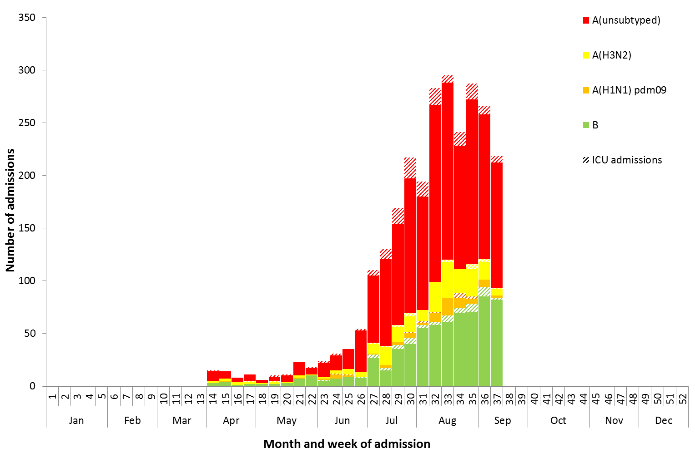

Source: FluCAN

### Paediatric Severe Complications of Influenza

The Australian Paediatric Surveillance Unit (APSU) conducts seasonal surveillance between June and September annually of children aged 15 years and under who are hospitalised with severe complications of influenza. Since seasonal surveillance commenced through APSU to 17 September 2017, there have been a total of 30 hospitalisations associated with severe complications of influenza reported. Eighteen cases were female and 12 male, with an age range of 0 to 13 years, and 20 infected with influenza A and 10 with influenza B. Vaccination status was known for 15 of the patients, with one being vaccinated against influenza and the remainder unvaccinated. One death was recorded, 23 patients were discharged with no ongoing problems, three were discharged and experiencing ongoing problems and three remain in hospital at time of reporting.

## 4. Deaths Associated with Influenza and Pneumonia

### Nationally Notified Influenza Associated Deaths

So far in 2017, 121 influenza associated deaths have been notified to the NNDSS. The majority of deaths were due to influenza A (87%, n=105). The median age of deaths notified was 83 years (range 8 to 100 years).

The number of influenza-associated deaths reported to the NNDSS does not represent the true mortality associated with this disease.The number of deaths is reliant on the follow up of cases to determine the outcome of their infection. The follow up of cases is not a requirement of notification, and are only inclusive of laboratory-confirmed cases of influenza. Due to retrospective revision, the variation across jurisdictions in methodology, representativeness and timeliness of death data, and reporting of an outcome of infection not being a requirement of notification, year on year comparisons of deaths in notified cases of influenza may not be reliable.

### New South Wales Influenza and Pneumonia Death Registrations

Death registration data from NSW for the week ending 18 August 2017 show that there were 2.58 “pneumonia and influenza” deaths per 100,000 NSW population, which exceeded the usual variation upper limit of 1.91 per 100,000 NSW population, and a notable increase on the previous reported rate of 1.90 for the week ending 4 August (Figure 17).[2]

Figure 17. Rate of deaths classified as influenza and pneumonia from the NSW Registered Death Certificates, 2012 to   
18 August 2017.

Figure 17. Rate of deaths classified as influenza and pneumonia from the NSW Registered Death Certificates, 2012 to 

Source: NSW Registry of Births, Deaths and Marriages

## 5. Virological Surveillance

### Australian Influenza Vaccines Composition 2017

The influenza virus strains included in the 2017 seasonal influenza vaccines in Australia are:

* A/Michigan/45/2015, (H1N1)pdm09-like virus;
* A/Hong Kong/4801/2014, (H3N2)-like virus;
* B/Brisbane/60/2008-like virus, Victoria lineage;
* B/Phuket/3073/2013-like virus, Yamagata lineage.

### Typing and Antigenic Characterisation

From 1 January to 18 September, the World Health Organization Collaborating Centre for Reference and Research on Influenza (WHOCC) characterised 885 influenza viruses (Table 1). When further characterised for similarity to the corresponding vaccine components, influenza A(H1N1)pdm09 viruses and viruses from both influenza B lineages appeared to be mostly antigenically similar to the corresponding vaccine components. The influenza A(H3N2) isolates that were able to be assessed by haemagglutination inhibition assay appeared to be reasonably well matched, although there are ongoing technical issues that significantly limit the WHOCC’s capacity to fully assess the similarity of circulating viruses to the vaccine strain.

The best way to determine how well the vaccine protects against circulating viruses during the season is by determining the vaccine effectiveness. These estimates provide an indication of how effective the vaccine was in providing protection against influenza infection, but can only be determined towards the end of the influenza season.

A small number of influenza A(H3N2) isolates (n=90) and influenza B(Victoria) isolates (n=1) were characterised as low reactors. An additional 547 influenza A(H3) isolates were unable to be characterised in the HI assay due to insufficient haemagglutination titre.

Table 1. Australian influenza viruses typed by HI from the WHOCC, 1 January to 18 September 2017.

|  |  |  |  |  |  |  |  |  |  |
| --- | --- | --- | --- | --- | --- | --- | --- | --- | --- |
| **Type/Subtype** | **ACT** | **NSW** | **NT** | **QLD** | **SA** | **TAS** | **VIC** | **WA** | **TOTAL** |
| **A(H1N1) pdm09** | 6 | 35 | 1 | 53 | 19 | 2 | 41 | 17 | 174 |
| **A(H3N2)** | 19 | 175 | 16 | 53 | 107 | 19 | 90 | 14 | 493 |
| **B/Victoria lineage** | 0 | 5 | 0 | 4 | 3 | 1 | 3 | 0 | 16 |
| **B/Yamagata lineage** | 7 | 48 | 16 | 27 | 36 | 24 | 40 | 4 | 202 |
| Total | 32 | 263 | 33 | 137 | 165 | 46 | 174 | 35 | 885 |

SOURCE: WHO CC

Note: Viruses tested by the WHO CC are not necessarily a random sample of all those in the community.

State indicates the residential location for the individual tested, not the submitting laboratory.

There may be up to a month delay on reporting of samples.

### Antiviral Resistance

The WHOCC reported that from 1 January to 18 September 2017, of the 1,354 influenza viruses tested for neuraminidase inhibitor resistance, one sample of influenza A(H1N1) demonstrated reduced inhibition to the antiviral drug Zanamivir.

## 6. International Surveillance

The World Health Organization reported that based on data up to 3 September 2017, in the temperate zone of the southern hemisphere and in some countries of South and South East Asia, high levels of influenza activity continue to be reported. Some countries in Central America and the Caribbean are reporting continued influenza activity.[3] Influenza activity in the temperate zone of the northern hemisphere remained at low levels. Worldwide, influenza A(H3N2) is the predominant circulating virus.

# DATA CONSIDERATIONS

The NNDSS data provided were extracted on 22 September 2017. Due to the dynamic nature of the NNDSS, data in this report is subject to retrospective revision and may vary from data reported in published NNDSS reports and reports of notification data by states and territories. Detailed notes on interpreting the data presented in this report are available at the Department of Health’s [Australian Influenza Surveillance Report website](http://www.health.gov.au/flureport) (www.health.gov.au/flureport).

The Australian Influenza Surveillance Report and Activity Updates are compiled from a number of data sources, which are used to monitor influenza activity and severity in the community. These data sources include laboratory-confirmed notifications to the NNDSS; influenza associated hospitalisations; sentinel influenza-like illness (ILI) reporting from general practitioners and emergency departments; and community level surveys; and sentinel laboratory testing results. The information in this report is reliant on the surveillance sources available to the Department of Health at the time of production.

While every care has been taken in preparing this report, the Commonwealth does not accept liability for any injury or loss or damage arising from the use of, or reliance upon, the content of the report. Delays in the reporting of data may cause data to change retrospectively. For further details about information contained in this report please contact the [Influenza Surveillance Team](mailto:flu@health.gov.au) ([flu@health.gov.au](mailto:flu@health.gov.au)).

# REFERENCES

1. FluTracking, FluTracking Weekly Interim Report, Week ending 10 September 2017. Available from [FluTracking Reports](http://www.flutracking.net/Info/Reports) (http://www.flutracking.net/Info/Reports) [Accessed 7 September 2017].
2. NSW Health, Influenza Monthly Epidemiology Report, NSW, Week 34: 11 to 17 September, 2017. Available from NSW Health Influenza Surveillance Reports (http://www.health.nsw.gov.au/Infectious/Influenza/Pages/reports.aspx) [Accessed 22 September 2017].
3. WHO, Influenza Update No. 298, 18 September 2017. Available from the [WHO website](http://www.who.int/influenza/surveillance_monitoring/updates/latest_update_GIP_surveillance/en/) (http://www.who.int/influenza/surveillance_monitoring/updates/latest_update_GIP_surveillance/en/) [Accessed 21 September 2017].