| Logo | **Australian Influenza**  **SURVEILLANCE REPORT**  **No. 10, 2017**  **16 – 29 September 2017** |
| --- | --- |

The Department of Health acknowledges the providers of the many sources of data used in this report and greatly appreciates their contribution.

# KEY MESSAGES

* Influenza activity at the national level continued to decline this reporting fortnight after reaching a peak in   
  mid-August. Despite the national decline, high levels of activity continue to be reported across the country, with seasonal activity in some areas of the country yet to have reached a peak.
* The peak week of national influenza activity this season has been at comparable or higher levels than in recent years, with high activity persisting at the peak of the season for a number of weeks.
* Moderate levels of influenza activity in the community are likely to continue for the next few weeks as the season returns to baseline levels.
* There has been more than two and a half times the number of laboratory confirmed notifications of influenza reported to the National Notifiable Diseases Surveillance System (NNDSS) this year when compared with the same period last year. An earlier season onset and introduction of rapid testing have contributed, in part, to this increase. Administrative backlogs in data entry experienced in some jurisdictions are likely to alter the pattern of notifications once the backlog is resolved.
* National indicators of influenza-like illness (ILI) continued to decline in the last fortnight, further supporting that the season has peaked nationally. The proportion of patients presenting to sentinel general practitioners with ILI and testing positive for influenza declined this fortnight but remained at moderate levels, indicating that influenza remains a significant cause of ILI in the community.
* Influenza A(H3N2) is currently the predominant circulating influenza A virus nationally, however influenza B is predominating in a number of jurisdictions and circulating at high levels in many others. The proportion of total notifications attributed to influenza B continued to increase nationally this reporting fortnight.
* Notification rates this year to date have been highest in adults aged 80 years or older, with a secondary peak in young children, aged 5 to 9 years. This is consistent with previous seasons where influenza A(H3N2) and influenza B, respectively, have predominated.
* Admissions to sentinel hospitals with confirmed influenza decreased this reporting fortnight, following a peak in late August. The large number of admissions this season is consistent with the higher than average influenza activity in the community.
* Clinical severity for the season to date, as measured through the proportion of patients admitted directly to ICU, and deaths attributed to pneumonia or influenza, is low to moderate. The proportion of patients admitted directly to ICU has been on the lower range reported in recent years. There have been a number of reported deaths due to influenza and pneumonia and the majority have been in the elderly, which is consistent with a season predominated by influenza A(H3N2).
* To date, based on antigenic characterisation of circulating influenza viruses, the seasonal influenza vaccines appear to be a moderate to good match for circulating virus strains, depending on the strain. Vaccine effectiveness estimates, which provide an indication of how well the vaccine provides protection against influenza, will not be completed until the end of the influenza season.

# ANALYSIS

## 1. Geographic Spread of Influenza Activity in Australia

In the fortnight ending 29 September 2017 (week 39), influenza activity was reported as widespread in all regions of the country with the exception of the Central Australia region of the Northern Territory (NT), where activity was regional.

When compared to the previous fortnight, influenza activity was reported as decreased in the Australian Capital Territory (ACT), New South Wales (NSW), Queensland (QLD), Tasmania (TAS) and Victoria (VIC), unchanged in South Australia (SA) and the Rural South region of Western Australia (WA) and increased in the Northwest region of WA and the Top End region of the NT.

Influenza-like illness (ILI) activity reported from syndromic surveillance systems when compared with the previous fortnight was reported as decreased in the ACT, NSW, TAS and WA; and unchanged in the NT, SA and VIC.

Figure 1. Map of influenza activity by state and territory, Australia, 2 – 29 September 2017.

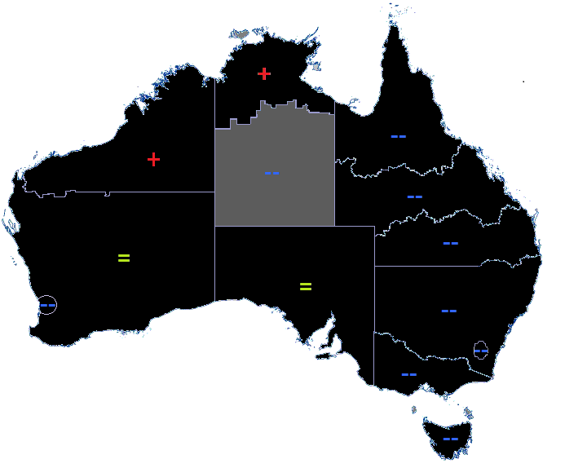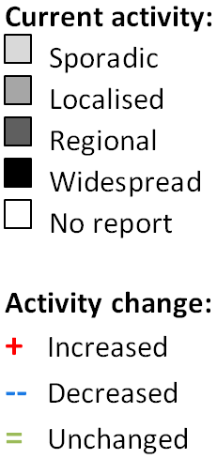

## 2. Laboratory Confirmed Influenza Activity

### Sentinel Laboratory Surveillance

Influenza A remains the most commonly detected respiratory virus this fortnight by all sentinel laboratories, with the exception of Victoria Infectious Disease Reference Laboratory (VIDRL) where influenza B was most commonly detected in week 38. While remaining at high levels, detections of influenza decreased across all sentinel laboratories, with the exception of VIDRL, this reporting fortnight (Figure 2). The pooled unweighted percentage of tests positive for influenza across all sentinel laboratories declined from 34.3% at the end of last fortnight (week 37) to 32.4% in week 38 and 26.8% in week 39. This follows a high level of influenza detections since week 32.

From the sentinel laboratories where influenza subtyping was undertaken (Tasmania, VIDRL and PathWest), influenza A(H3N2) was detected more frequently than influenza A(H1N1)pdm09 both this reporting fortnight and year to date. Influenza B accounted for an increasing proportion of detections across the peak weeks of the seasonal epidemic, increasing from 18% of influenza detections in week 28 to 42% in week 39.

Testing for influenza decreased this reporting fortnight, continuing to decline from the peak in testing reached in week 36 (Figure 3).

Figure 2. Proportion of sentinel laboratory tests positive for influenza, 1 January to 29 September 2017, by contributing laboratory or jurisdiction and month and week.

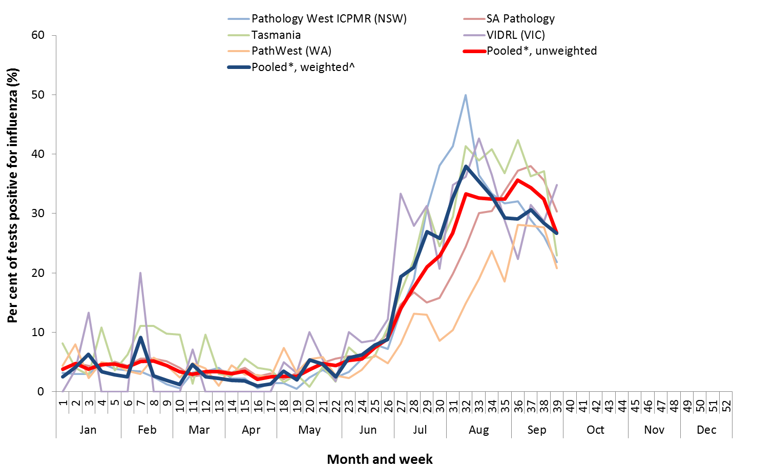

* Pooled percentage positive indicators should be interpreted with caution, noting that collectively pooled contributing laboratories are not representative of testing across Australia and individually contributing laboratories may not be representative of the jurisdiction in which they are located.

^ Weighted according to jurisdictional population in which laboratories are located.

The percentage of tests positive for influenza in the interseasonal period should be interpreted with caution due to small numbers of tests being undertaken in this time, resulting in high variability in the indicators.

Figure 3. Proportion of sentinel laboratory tests positive for influenza and total number of specimens tested, 1 January to 29 September 2017, by subtype and month and week.

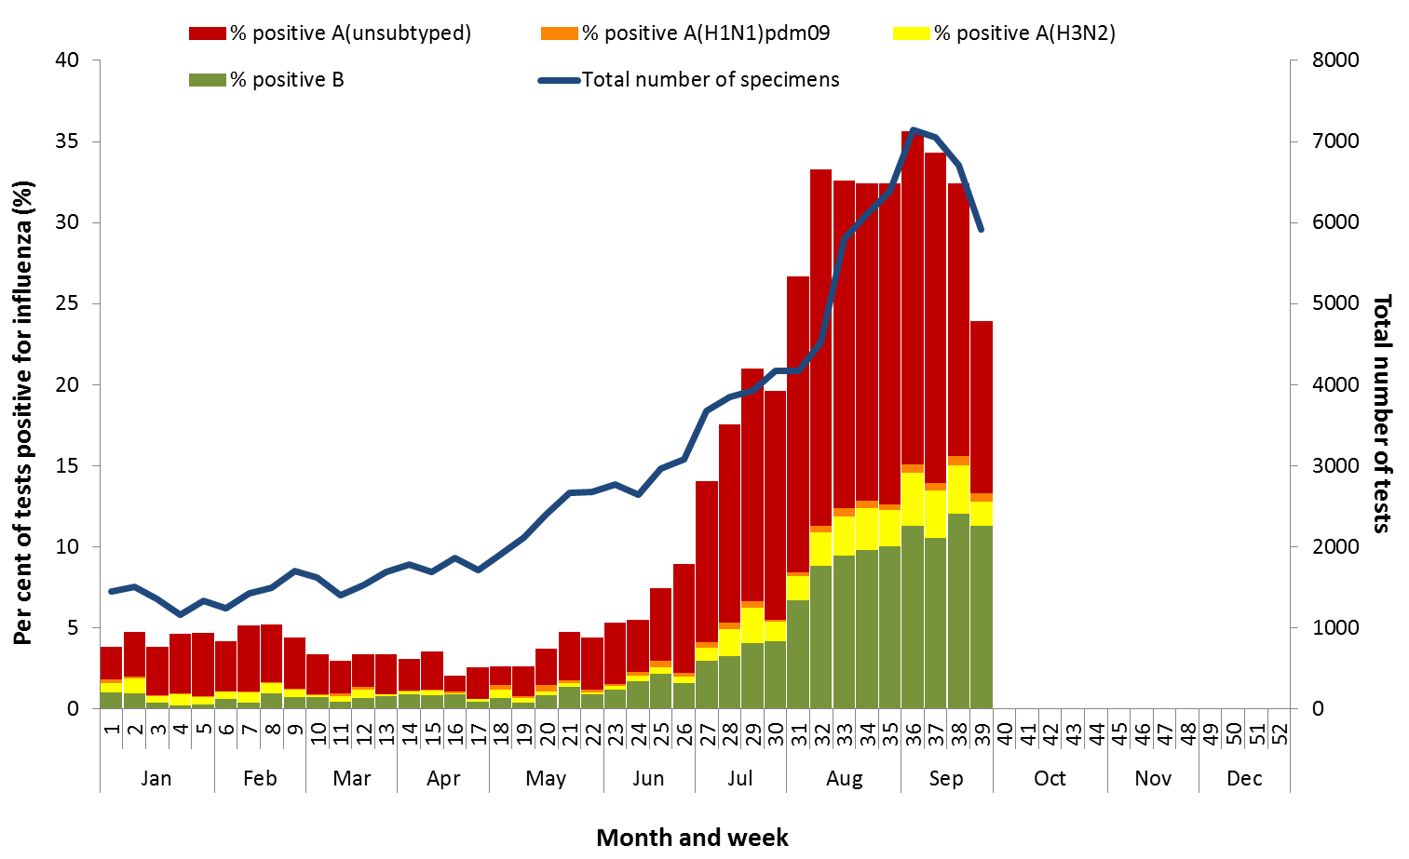

### Notifications of Influenza to Health Departments

Notifications of laboratory confirmed influenza to the National Notifiable Diseases Surveillance System (NNDSS) have declined this reporting fortnight, from a peak reached in week 33 (Figure 4). For the year to 29 September, a total of 195,312 notifications of laboratory confirmed influenza were reported to the NNDSS: 96,423 in NSW; 50,665 in QLD; 21,669 in SA; 14,975 in VIC; 4,416 in WA; 3,160 in TAS; 2,781 in the ACT and 1,223 in the NT. When comparing this reporting fortnight to the previous fortnight, notifications of laboratory confirmed influenza declined in each jurisdiction. SA and VIC are currently experiencing administrative backlogs in data entry, due to the heightened number of laboratory-confirmed influenza cases this season, which is likely contributing to the decrease in reported cases this fortnight and will alter the pattern of notifications once the backlog is resolved.

For the year to 29 September, 65% of notifications of laboratory confirmed influenza to the NNDSS were   
influenza A (59% influenza A(unsubtyped), 1% influenza A(H1N1)pdm09 and 5% influenza A(H3N2)), 35% were influenza B and less than 1% were influenza A&B co-infections or untyped (Figure 6). The proportion of all notifications year to date reported as influenza A has ranged across jurisdictions from 59% in NSW to 83% in WA. For the year to date, detections of influenza A subtypes have varied across jurisdictions also. Nationally, for every one notification of influenza A(H1N1)pdm09 reported to the NNDSS, 3.8 notifications of   
influenza A(H3N2) were received. This ratio has ranged from 1:0.1 in VIC to 1:10 in the NT.

In the most recent fortnight, 51% of notifications of laboratory confirmed influenza to the NNDSS were influenza A (48% influenza A(unsubtyped), 1% influenza A(H1N1)pdm09 and 3% influenza A (H3N2)), 49% were influenza B and less than 1% were influenza A&B co-infections or untyped (Figure 7). The proportion of all notifications this reporting fortnight reported as influenza B ranged across jurisdictions from 19% in WA to 61% in the ACT. The proportion of influenza B notifications increased this fortnight and while the number of influenza B notifications decreased this fortnight they remain at high levels (Figure 7 and Figure 8).

So far in 2017, notification rates have tended to increase with increasing age. Age-specific notification rates of influenza overall were highest in adults aged 85 years or older (2,581 notifications per 100,000) and adults aged 80 to 84 years (1,520 notifications per 100,000) with a secondary peak in children aged 5 to 9 years (1,382 per 100,000) (Figure 9). The notification rate in infants aged less than 5 years was also high (1,287 per 100,000). Where subtyping information is available, notifications of influenza A(H1N1)pdm09 were highest in children aged less than 5 years (33.7 per 100,000), notifications of influenza A(H3N2) were highest in the elderly aged 85 years and older (212.3 per 100,000) and notifications of influenza B were highest in children aged 5 to 9 years (671.5 notifications per 100,000 population).

Decreases in notifications occurred in all broad age groups since the last reporting fortnight (Figure 10). The distribution of influenza types and subtypes differed across age groups, with 49% of 5 to 17 year olds notified with influenza being detected with influenza B, while only 25% of adults aged 65 years and older detected with influenza B. While influenza A(H3N2) is detected across all age groups, it accounted for a greater proportion of influenza A, where subtyping was available, in adults aged 65 years or older, than in any other age group.

Figure 4. Notifications of laboratory confirmed influenza, Australia, 1 January 2013 to 29 September 2017, by month and week of diagnosis.

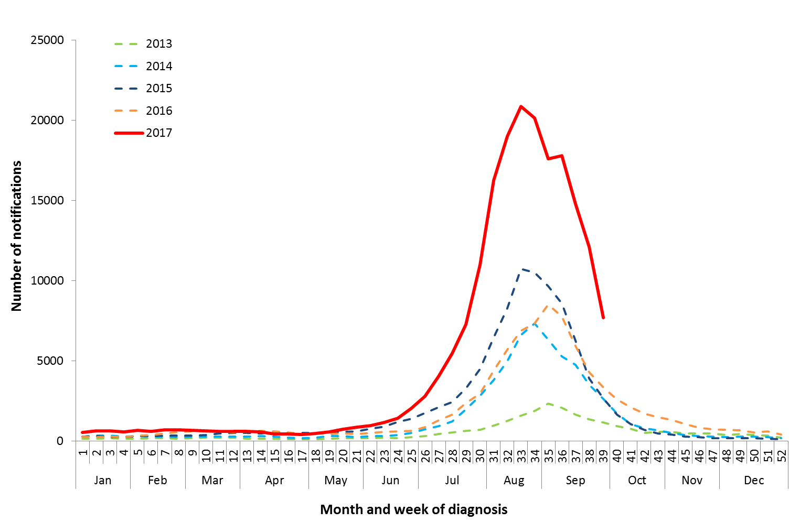

Source: NNDSS

Figure 5. Notifications of laboratory confirmed influenza, 1 January to 29 September 2017, by state or territory and week.

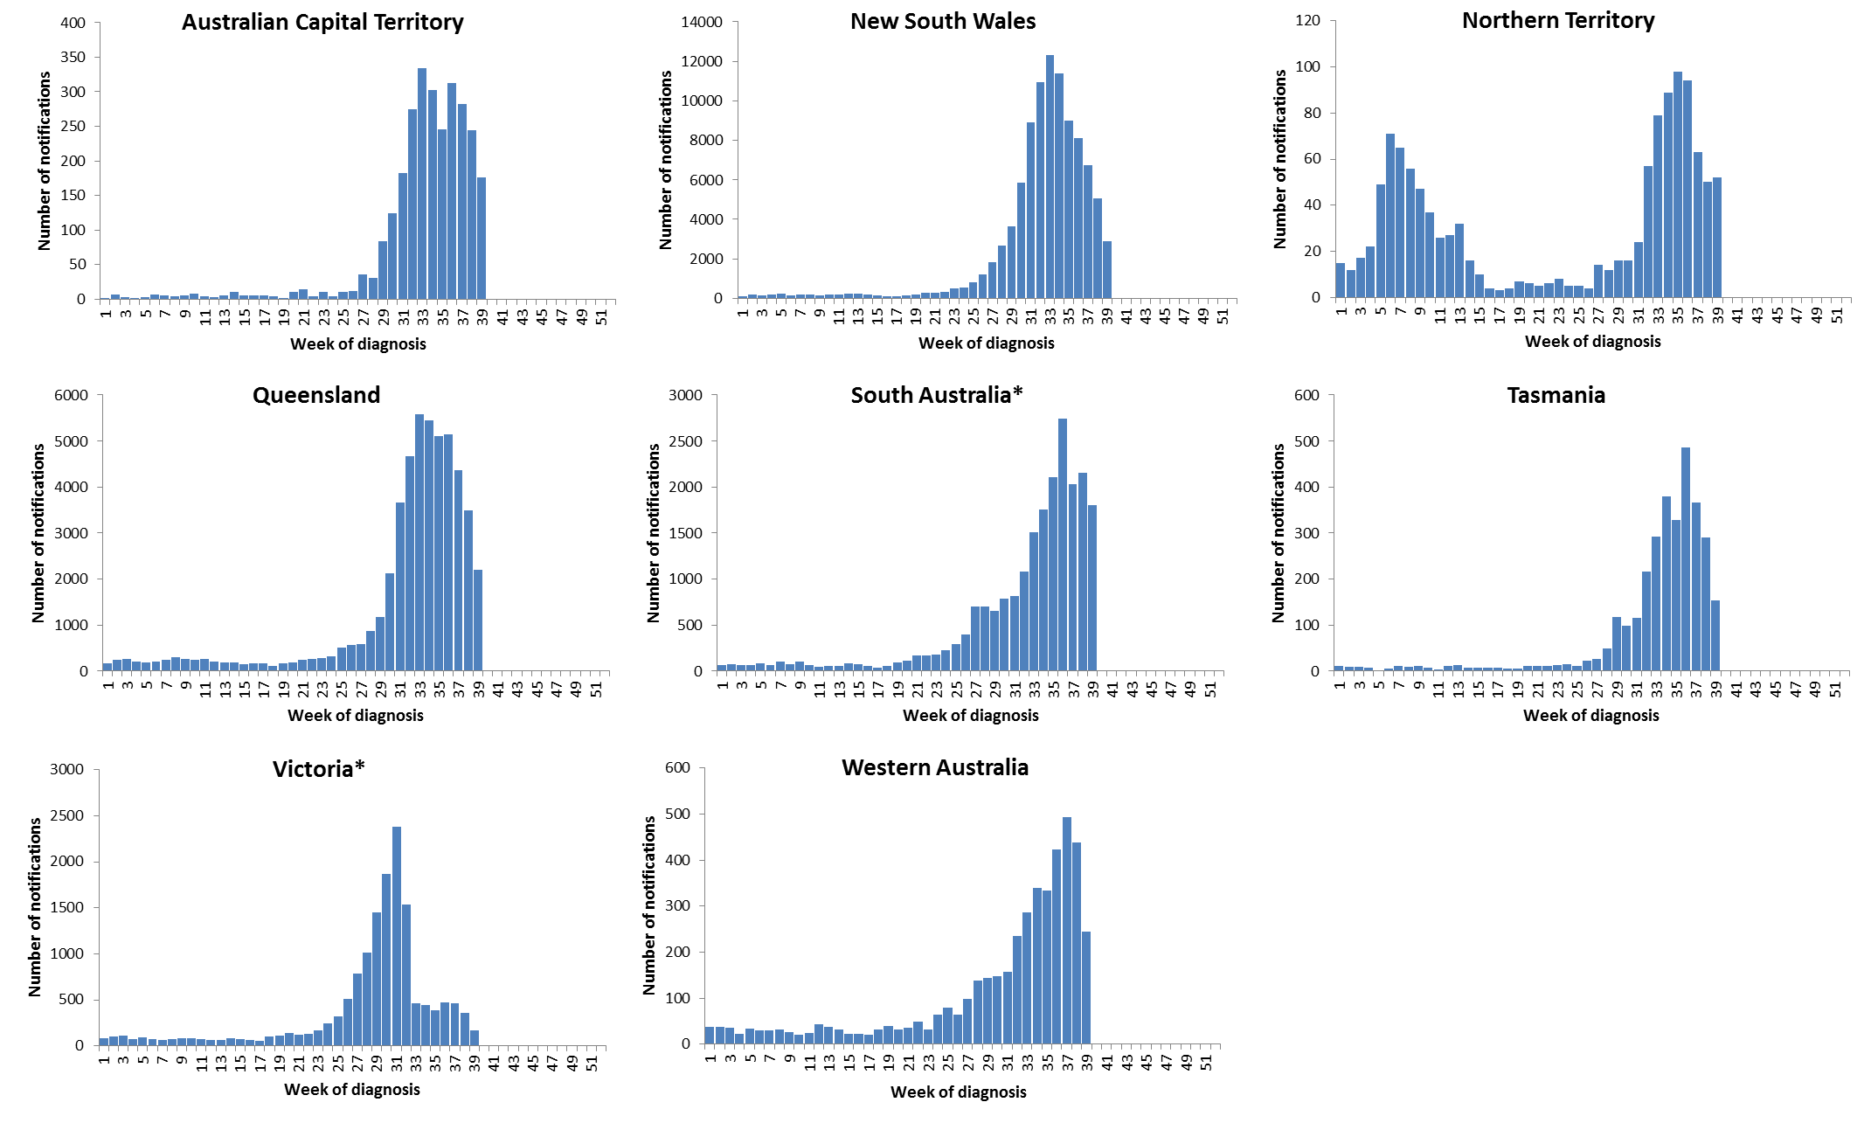

Source: NNDSS

*South Australia and Victoria are currently experiencing a backlog of influenza notifications to be entered into the NNDSS.

Figure 6. Per cent of notifications of laboratory confirmed influenza, Australia, 1 January to 29 September 2017, by subtype and state or territory.

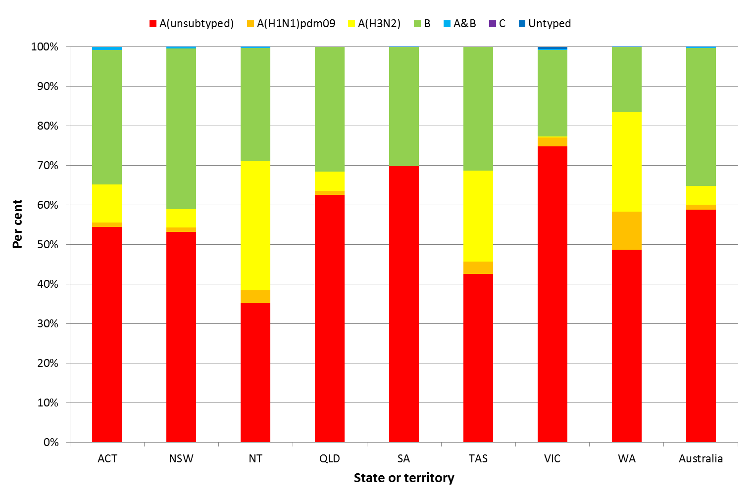

Source: NNDSS

Figure 7. Per cent of laboratory confirmed influenza, Australia, 1 January to 29 September 2017, by subtype and week.

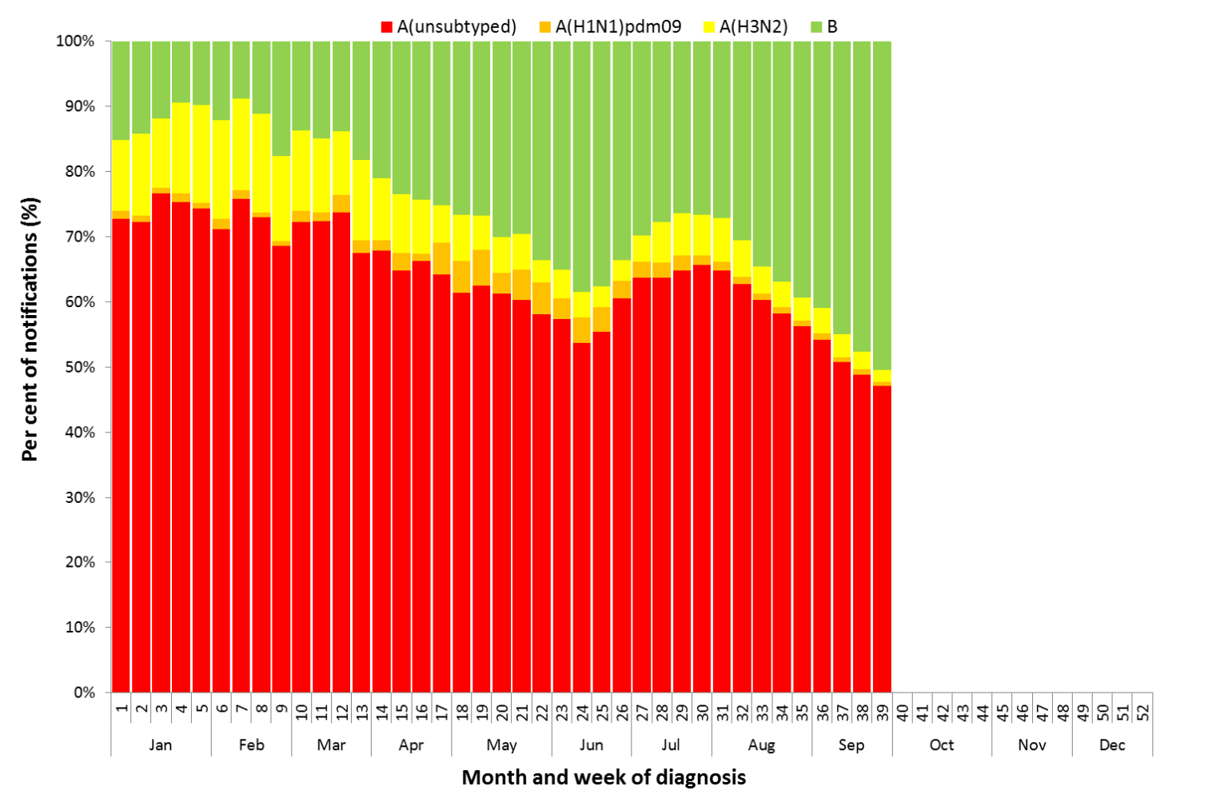

Source: NNDSS

**Figure 8. Notifications of laboratory confirmed influenza by week of diagnosis and cumulative year-to-date, Australia,   
1 January to 29 September 2017, by subtype and age group.**

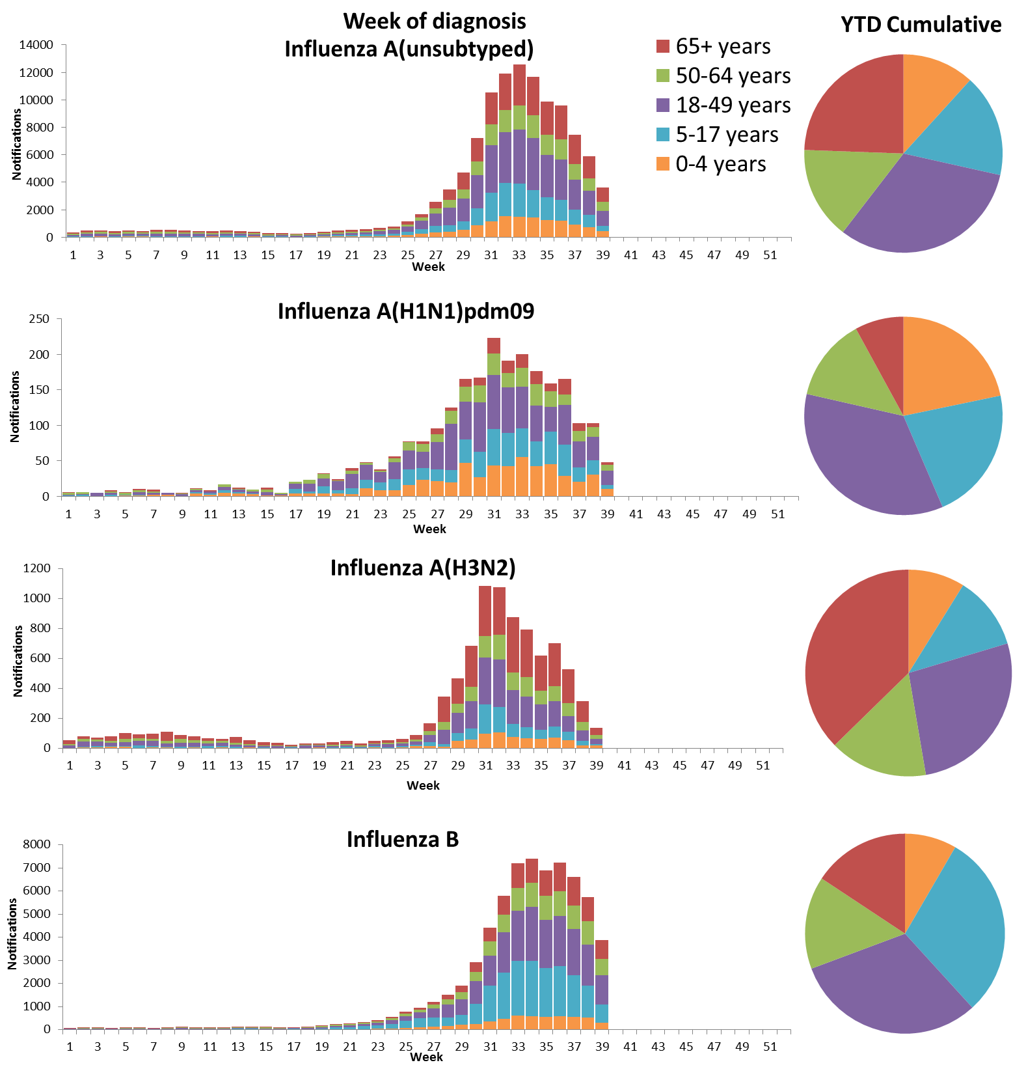

Source: NNDSS

Figure 9. Rate of notifications of laboratory confirmed influenza, Australia, 1 January to 29 September 2017, by age group and subtype.

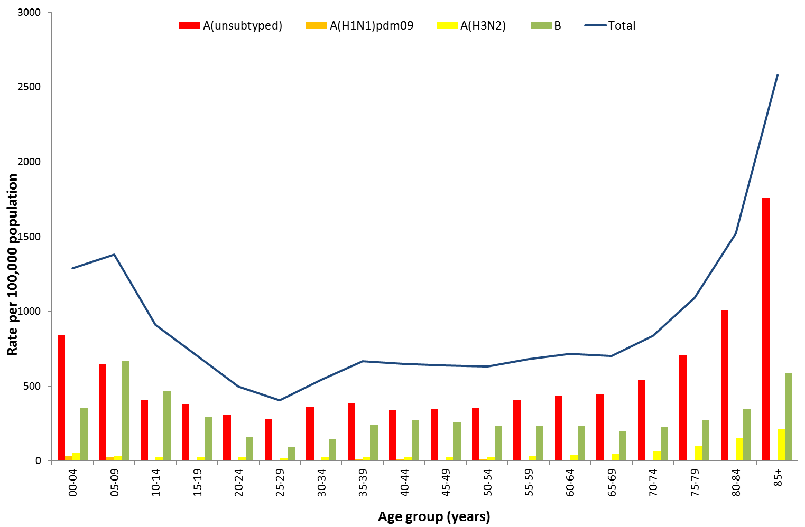

Source: NNDSS

Figure 10. Notifications of laboratory confirmed influenza by week of diagnosis and cumulative year-to-date, Australia, 1 January to 29 September 2017, by age group and subtype.

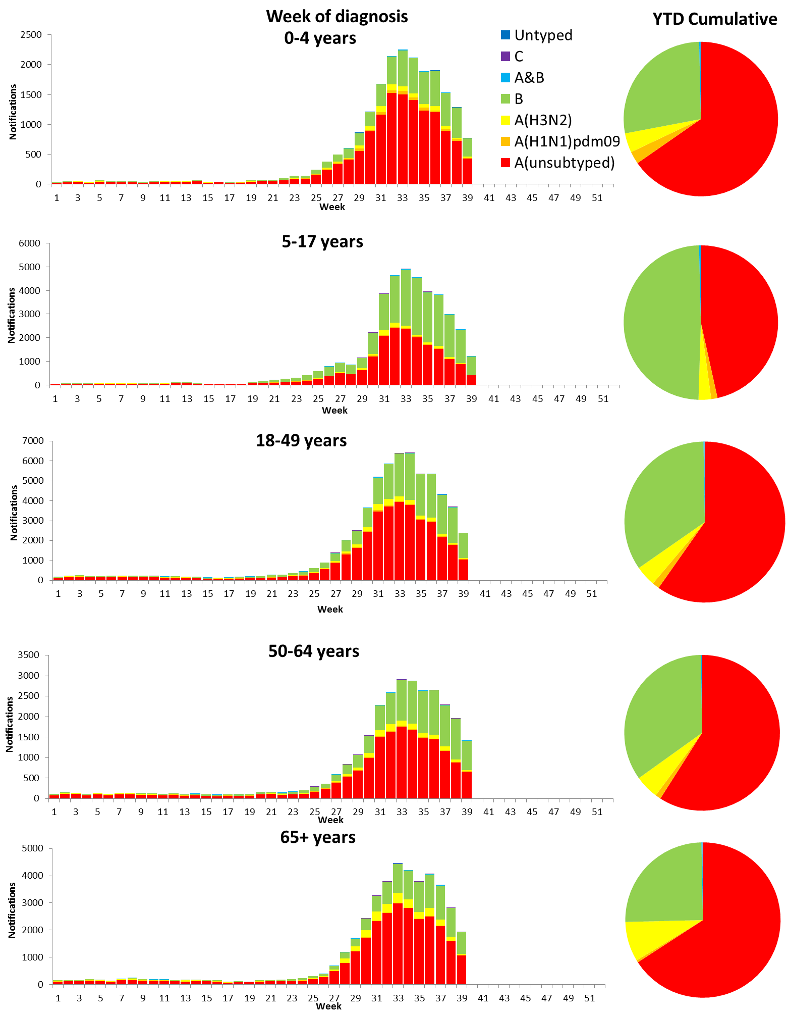

Source: NNDSS

## 2. Influenza-like Illness Activity

### Community Level Surveillance

FluTracking, a national online system for collecting data on ILI in the community, indicated that rates of ILI among participants continued to decrease this reporting fortnight, from a peak reached in week 33 (3.4%) (Figure 11). ILI activity among participants, reported as fever and cough, declined from 2.5% at the end of last fortnight (week 37) to 2.2% in week 38 and 1.9% in week 39. So far this year 64% of all participants and 81% of participants who identify as working face-to-face with patients reported receiving the seasonal influenza vaccine.[1]

Figure 11. Proportion of fever and cough among FluTracking participants, Australia, between May and October, 2013 to 2017, by month and week.

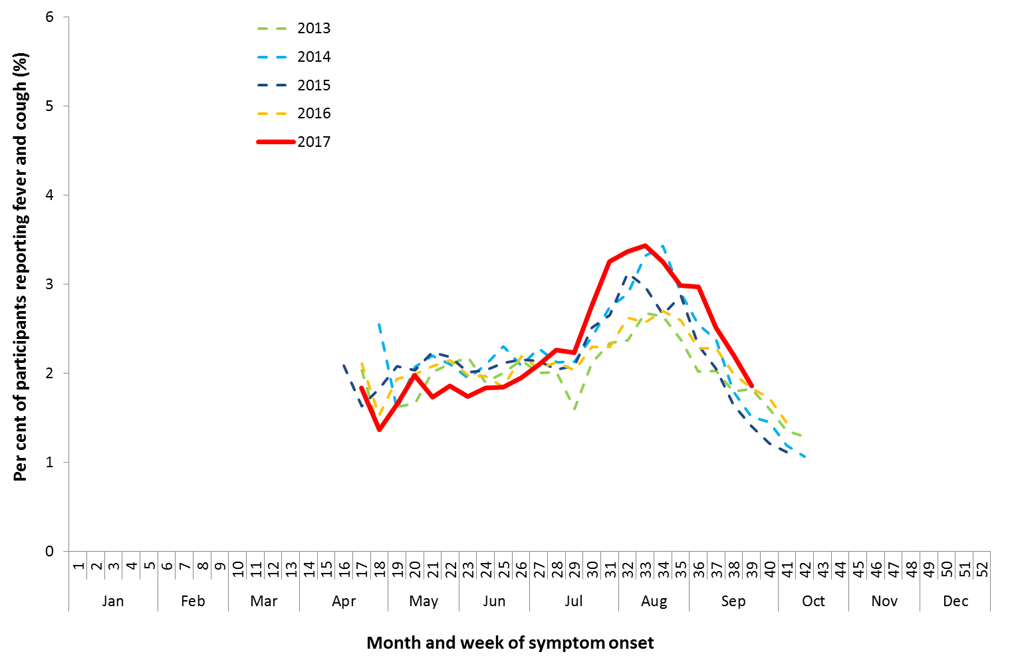

Source: FluTracking

### Health Call Centre Surveillance

ILI related calls to the National Health Call Centre Network (NHCCN) declined from 9.7% of calls at the end of last fortnight (week 37) to 9.1% in week 38 and 8.4% in week 39 (Figure 12). This continues a decline from the peak in week 33 of 11.4%.

**Figure 12. Per cent of calls to the NHCCN related to ILI, Australia, 1 January 2013 to 1 October 2017, by month and week of call**

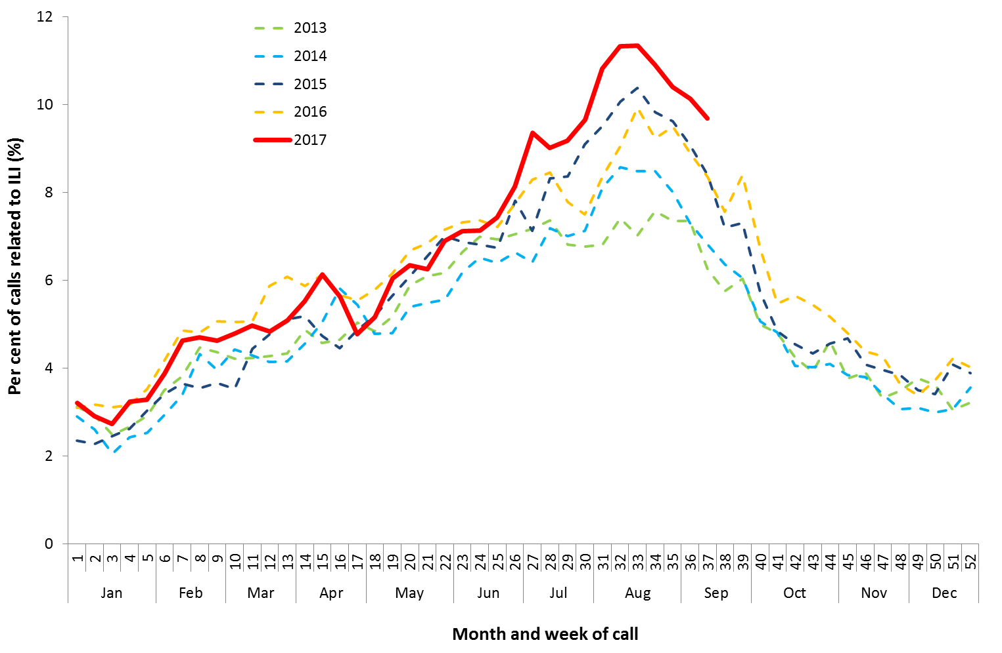

Source: NHCCN, Healthdirect

### Sentinel General Practice Surveillance

Sentinel general practitioner ILI consultations decreased this reporting fortnight, with 18.9 per 1,000 consultations in week 38 and 14.1 per 1,000 consultations in week 37 (Figure 13). This is a decrease from a peak of 23.4 per 1,000 consultations reported in week 34. ILI consultations this reporting fortnight, while declining, are still high when compared to the range of recent seasons for this time of year.

Of the 191 specimens taken from ILI patients seen by Australian Sentinel Practices Research Network (ASPREN) sentinel practitioners during the reporting fortnight, influenza was the most common respiratory virus detected (n=71, 37.2%), consisting of 34 samples positive for A(unsubtyped), 4 samples positive for A(H3N2), 2 sample positive for A(H1N1) and 31 positive for influenza B (Figure 14).

Figure 13. Unweighted rate of ILI reported from sentinel GP surveillance systems, Australia, 1 January 2013 to   
1 October 2017, by month and week.

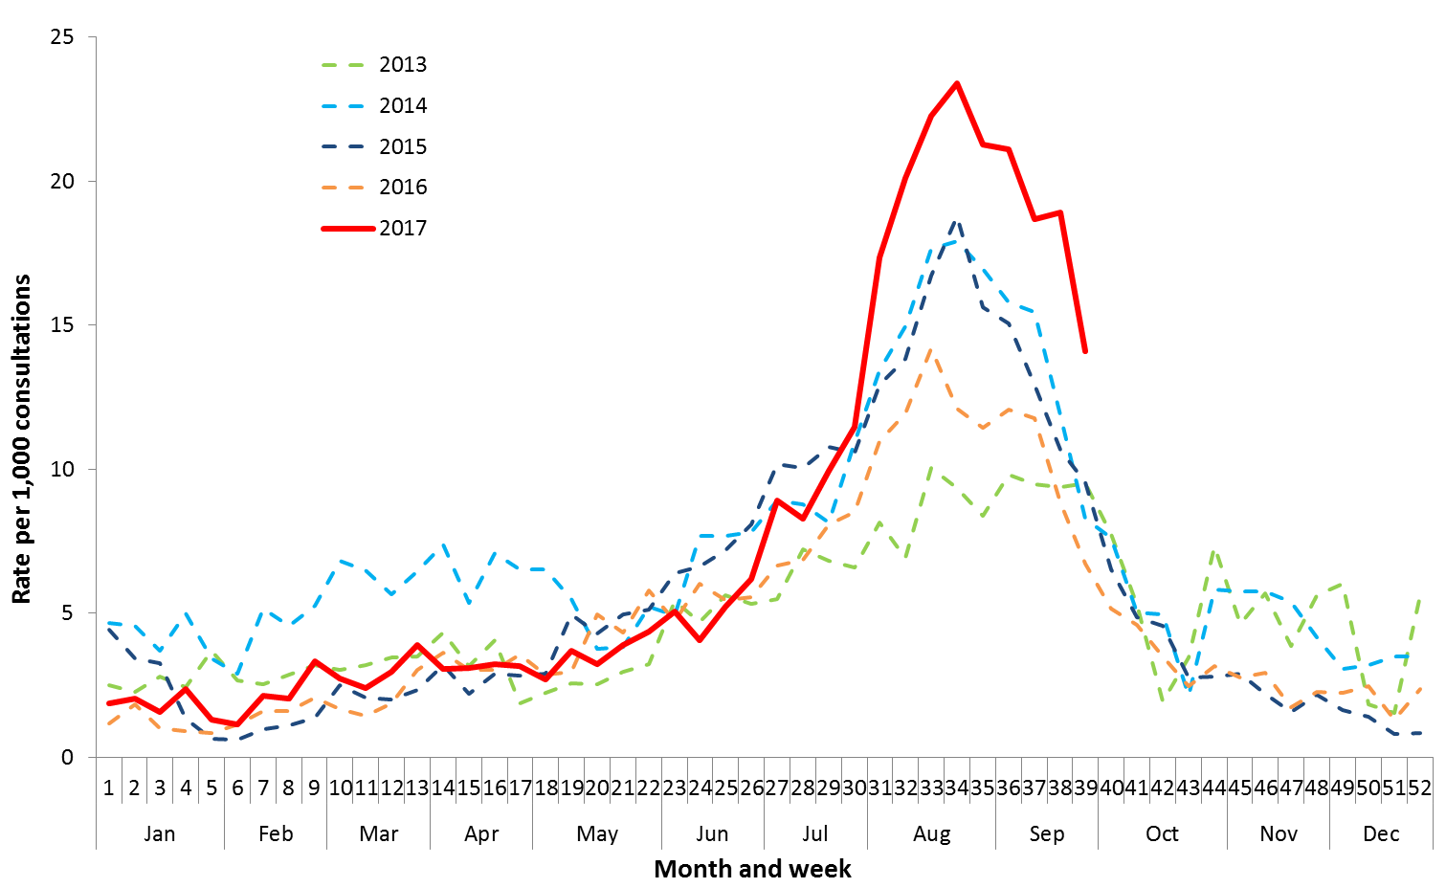

Source: ASPREN and VicSPIN

Figure 14. Proportion of respiratory viral tests positive for influenza in ASPREN ILI patients and ASPREN ILI consultation rate, Australia, 1 January to 1 October 2017, by month and week.

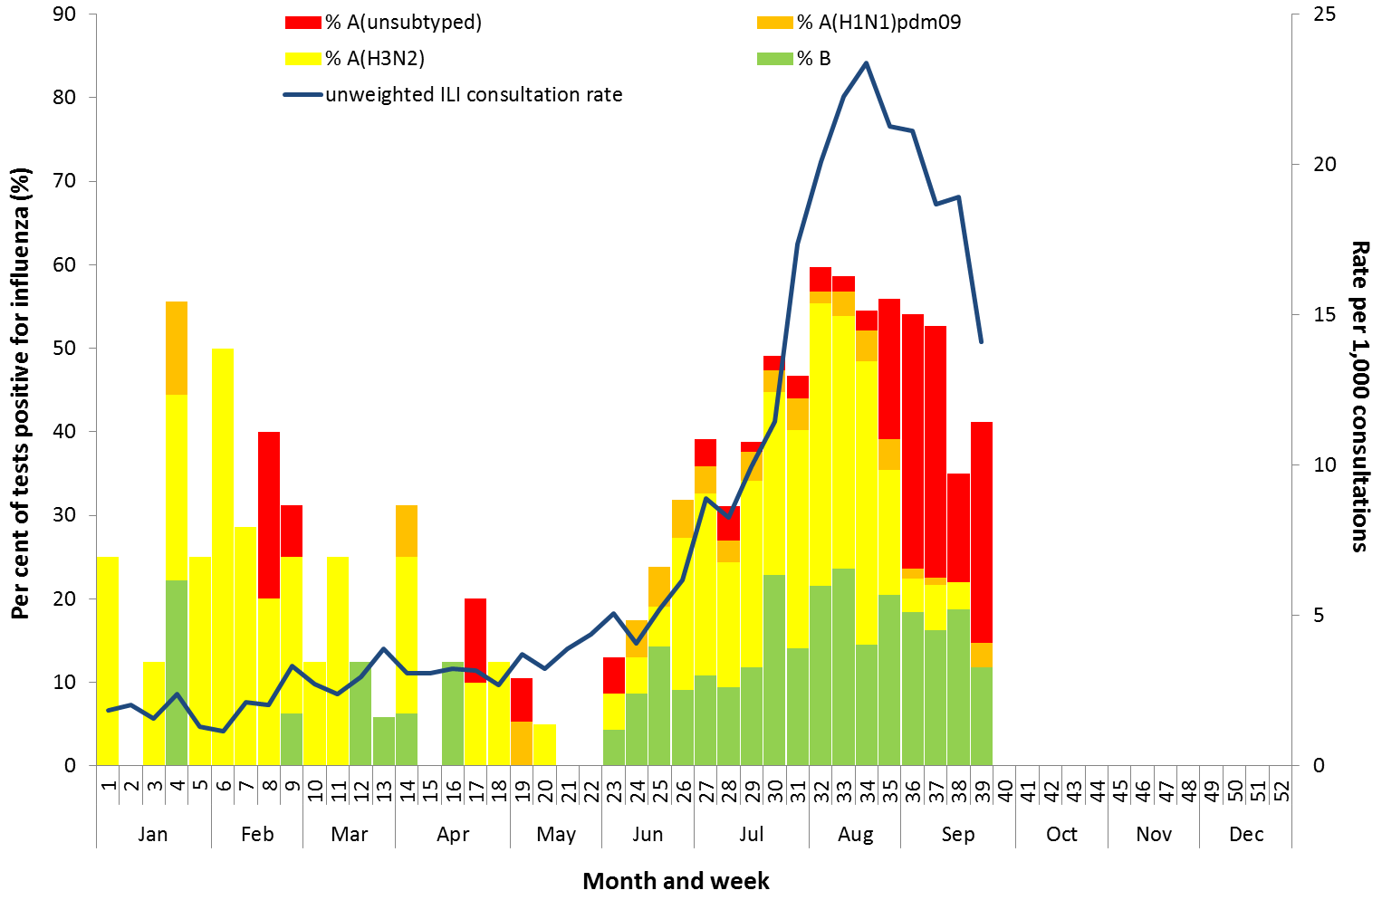

Source: ASPREN

## 3. Hospitalisations

### Sentinel Hospital Surveillance

Admissions with confirmed influenza to sentinel hospitals decreased this reporting fortnight (Figure 15), with 289 patients admitted in the last week of the previous fortnight (week 37), followed by 256 patients in   
week 38 and 183 patients in week 39. Since seasonal surveillance commenced through the Influenza Complications Alert Network (FluCAN) sentinel hospital surveillance system on 3 April 2017, a total of 3,536 people have been admitted with confirmed influenza, of which 527 (15%) were children aged 15 years or younger, 1,157 (33%) were adults aged between 16 and 64 years and 1,818 (51%) were adults aged 65 years and older. Information on age was not reported for 34 patients.

Approximately 8.9% of influenza patients have been admitted directly to ICU (n=315), which is in the lower range reported in recent years (range 8.7% in 2015 to 14.2% in 2013). The proportion of patients admitted directly to ICU this year to date has ranged by age, from 6.8% in adults aged 65 years and older to 11.7% in adults aged between 16 and 64 years.

For the year to 1 September, 71% of admissions with confirmed influenza to sentinel hospitals were influenza A (57% A(unsubtyped), 3% influenza A(H1N1)pdm09 and 10% influenza A (H3N2)), 29% were influenza B and less than 1% were influenza C and mixed influenza infections (Figure 16). The proportion of patients admitted directly to ICU was higher in patients infected with influenza A(H1N1)pdm09 (15.6%), than in admitted patients infected with influenza A(H3N2) (8.9%) and influenza B (8.6%).

Figure 15. Number of influenza hospitalisations at sentinel hospitals, between March and October, 2013 to 2017 by month and week.

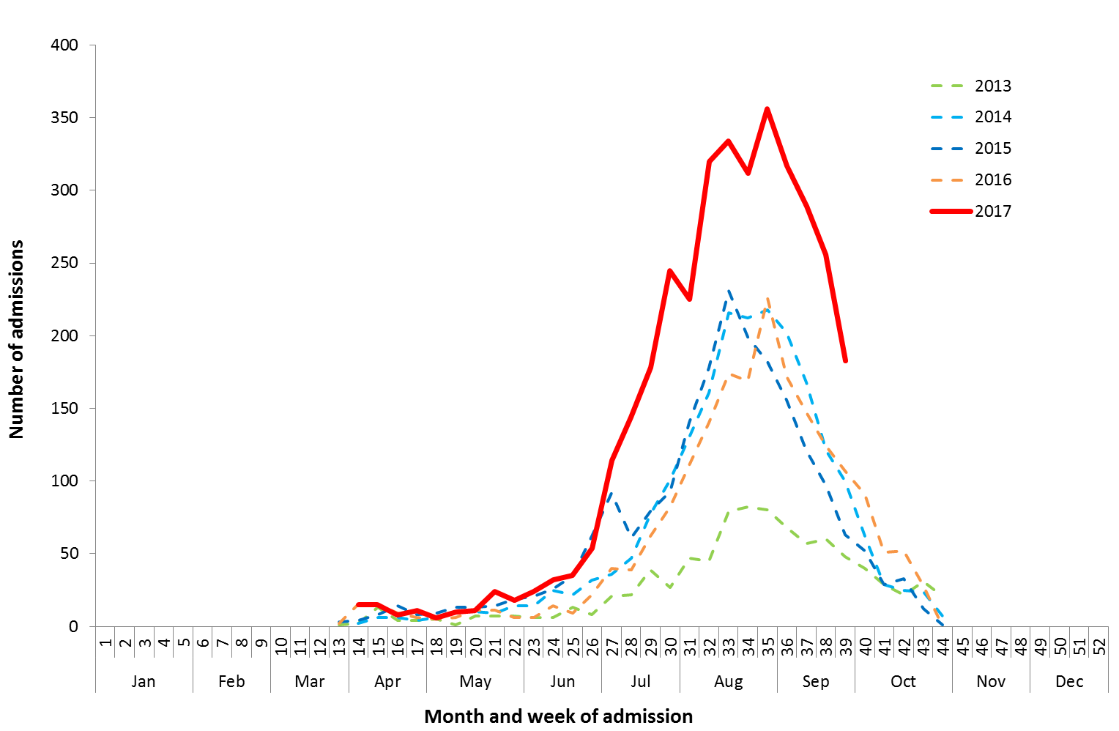

Source: FluCAN

Figure 16. Number of influenza hospitalisations at sentinel hospitals by subtype and ICU admission, 3 April to 29 September 2017, by month and week.

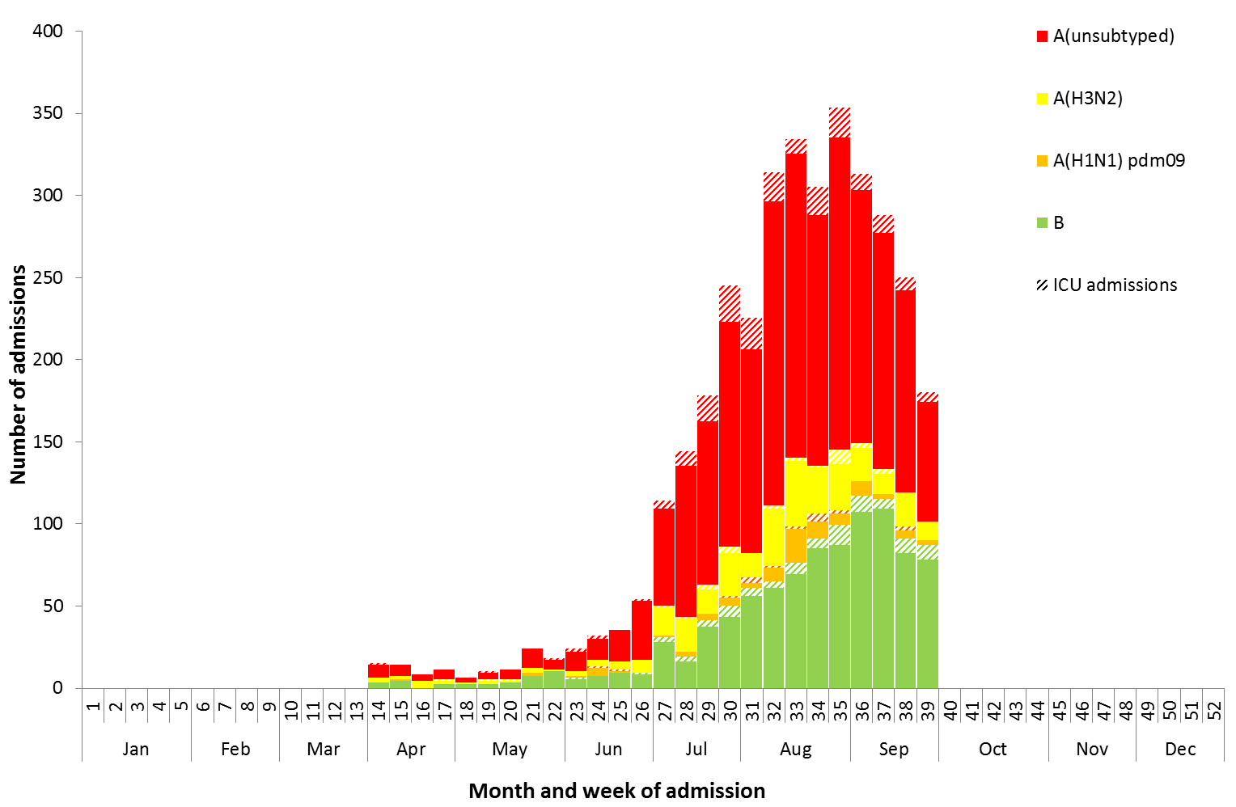

Source: FluCAN

### Paediatric Severe Complications of Influenza

The Australian Paediatric Surveillance Unit (APSU) conducts seasonal surveillance between June and September annually of children aged 15 years and under who are hospitalised with severe complications of influenza. Since seasonal surveillance commenced through APSU to 1 October 2017, there have been a total of 41 hospitalisations associated with severe complications of influenza reported. Twenty-four cases were female and 17 male; with an age range of 0 to 13 years; and 30 infected with influenza A and 11 with influenza B. Vaccination status was known for 17 of the patients, with one being vaccinated against influenza and the remainder unvaccinated. One death was recorded, 33 patients were discharged with no ongoing problems, three were discharged and experiencing ongoing problems and four remain in hospital at time of reporting.

## 4. Deaths Associated with Influenza and Pneumonia

### Nationally Notified Influenza Associated Deaths

So far in 2017, 417 influenza associated deaths have been notified to the NNDSS. The majority of deaths were due to influenza A (81%, n=337). The median age of deaths notified was 85 years (range 0 to 107 years). The large increase in deaths since the last Australian Influenza Surveillance Report is mostly due to a change in system processes in NSW that improves reporting of a death outcome against a notification.

The number of influenza-associated deaths reported to the NNDSS does not represent the true mortality associated with this disease. The number of deaths is reliant on the follow up of cases to determine the outcome of their infection. The follow up of cases is not a requirement of notification, and are only inclusive of laboratory-confirmed cases of influenza. Due to retrospective revision, the variation across jurisdictions in methodology, representativeness and timeliness of death data, and reporting of an outcome of infection not being a requirement of notification, year on year comparisons of deaths in notified cases of influenza may not be reliable.

### New South Wales Influenza and Pneumonia Death Registrations

Death registration data from NSW for the week ending 18 August 2017 show that there were 2.58 “pneumonia and influenza” deaths per 100,000 NSW population, which exceeded the usual variation upper limit of 1.91 per 100,000 NSW population, and a notable increase on the previous reported rate of 1.90 for the week ending 4 August (Figure 17).[2]

Figure 17. Rate of deaths classified as influenza and pneumonia from the NSW Registered Death Certificates, 2012 to   
18 August 2017.

Figure 17. Rate of deaths classified as influenza and pneumonia from the NSW Registered Death Certificates, 2012 to 

Source: NSW Registry of Births, Deaths and Marriages

## 5. Virological Surveillance

### Australian Influenza Vaccines Composition 2017

The influenza virus strains included in the 2017 seasonal influenza vaccines in Australia are:

* A/Michigan/45/2015, (H1N1)pdm09-like virus;
* A/Hong Kong/4801/2014, (H3N2)-like virus;
* B/Brisbane/60/2008-like virus, Victoria lineage;
* B/Phuket/3073/2013-like virus, Yamagata lineage.

### Typing and Antigenic Characterisation

From 1 January to 18 September, the World Health Organization Collaborating Centre for Reference and Research on Influenza (WHOCC) characterised 1,074 influenza viruses (Table 1). When further characterised for similarity to the corresponding vaccine components, influenza A(H1N1)pdm09 viruses and viruses from both influenza B lineages appeared to be mostly antigenically similar to the corresponding vaccine components. The influenza A(H3N2) isolates that were able to be assessed by haemagglutination inhibition assay appeared to be reasonably well matched, although there are ongoing technical issues that significantly limit the WHOCC’s capacity to fully assess the similarity of circulating viruses to the vaccine strain.

The best way to determine how well the vaccine protects against circulating viruses during the season is by determining the vaccine effectiveness. These estimates provide an indication of how effective the vaccine was in providing protection against influenza infection, but can only be determined towards the end of the influenza season.

A small number of influenza A(H3N2) isolates (n=96) and influenza B(Victoria) isolates (n=1) were characterised as low reactors. An additional 603 influenza A(H3) isolates were unable to be characterised in the HI assay due to insufficient haemagglutination titre.

Table 1. Australian influenza viruses typed by HI from the WHOCC, 1 January to 2 October 2017.

|  |  |  |  |  |  |  |  |  |  |
| --- | --- | --- | --- | --- | --- | --- | --- | --- | --- |
| **Type/Subtype** | **ACT** | **NSW** | **NT** | **QLD** | **SA** | **TAS** | **VIC** | **WA** | **TOTAL** |
| **A(H1N1) pdm09** | 7 | 57 | 1 | 65 | 33 | 3 | 75 | 21 | 262 |
| **A(H3N2)** | 19 | 175 | 16 | 55 | 107 | 20 | 126 | 15 | 533 |
| **B/Victoria lineage** | 0 | 7 | 0 | 5 | 4 | 1 | 8 | 1 | 26 |
| **B/Yamagata lineage** | 7 | 71 | 16 | 34 | 41 | 24 | 55 | 5 | 253 |
| Total | 33 | 310 | 33 | 159 | 185 | 48 | 264 | 42 | 1074 |

SOURCE: WHO CC

Note: Viruses tested by the WHO CC are not necessarily a random sample of all those in the community.

State indicates the residential location for the individual tested, not the submitting laboratory.

There may be up to a month delay on reporting of samples.

### Antiviral Resistance

The WHOCC reported that from 1 January to 2 October 2017, of the 1,427 influenza viruses tested for neuraminidase inhibitor resistance, one sample of influenza A(H1N1) demonstrated reduced inhibition to the antiviral drug Zanamivir.

## 6. International Surveillance

The World Health Organization reported that based on data up to 17 September 2017, influenza activity remained at low levels in the temperate zone of the northern hemisphere.[3] High levels of influenza activity continued to be reported in the temperate zone of the southern hemisphere and in some countries of South and South East Asia. In Central America and the Caribbean, low influenza activity was reported in a few countries. Worldwide, influenza A(H3N2) viruses predominated.

# DATA CONSIDERATIONS

The NNDSS data provided were extracted on 5 October 2017. Due to the dynamic nature of the NNDSS, data in this report is subject to retrospective revision and may vary from data reported in published NNDSS reports and reports of notification data by states and territories. Detailed notes on interpreting the data presented in this report are available at the Department of Health’s [Australian Influenza Surveillance Report website](http://www.health.gov.au/flureport) (www.health.gov.au/flureport).

The Australian Influenza Surveillance Report and Activity Updates are compiled from a number of data sources, which are used to monitor influenza activity and severity in the community. These data sources include laboratory-confirmed notifications to the NNDSS; influenza associated hospitalisations; sentinel influenza-like illness (ILI) reporting from general practitioners and emergency departments; and community level surveys; and sentinel laboratory testing results. The information in this report is reliant on the surveillance sources available to the Department of Health at the time of production.

While every care has been taken in preparing this report, the Commonwealth does not accept liability for any injury or loss or damage arising from the use of, or reliance upon, the content of the report. Delays in the reporting of data may cause data to change retrospectively. For further details about information contained in this report please contact the [Influenza Surveillance Team](mailto:flu@health.gov.au) ([flu@health.gov.au](mailto:flu@health.gov.au)).

# REFERENCES

1. FluTracking, FluTracking Weekly Interim Report, Week ending 1 October 2017. Available from [FluTracking Reports](http://www.flutracking.net/Info/Reports) (http://www.flutracking.net/Info/Reports) [Accessed 5 October 2017].
2. NSW Health, Influenza Monthly Epidemiology Report, NSW, Week 34: 11 to 17 September, 2017. Available from NSW Health Influenza Surveillance Reports (http://www.health.nsw.gov.au/Infectious/Influenza/Pages/reports.aspx) [Accessed 22 September 2017].
3. WHO, Influenza Update No. 299, 2 October 2017. Available from the [WHO website](http://www.who.int/influenza/surveillance_monitoring/updates/latest_update_GIP_surveillance/en/) (http://www.who.int/influenza/surveillance_monitoring/updates/latest_update_GIP_surveillance/en/) [Accessed 5 October 2017].