| 17 Logo | **Australian Influenza**  **SURVEILLANCE REPORT**  **No. 12, 2017**  **14 – 27 October 2017** |
| --- | --- |

The Department of Health acknowledges the providers of the many sources of data used in this report and greatly appreciates their contribution.

# KEY MESSAGES

* Nationally, influenza activity declined this reporting fortnight after reaching a peak in mid-August. Surveillance systems indicate that national activity levels have returned to or are approaching baseline levels.
* The peak week of national influenza activity this season has been at comparable or higher levels than in recent years, with high activity persisting at the peak of the season for a number of weeks.
* There has been more than two and a half times the number of laboratory confirmed notifications of influenza reported to the National Notifiable Diseases Surveillance System (NNDSS) this year when compared with the same period last year. An earlier season onset and introduction of rapid testing have contributed, in part, to this increase. Administrative backlogs in data entry experienced in some jurisdictions are likely to alter the pattern of notifications once the backlog is resolved.
* National indicators of influenza-like illness (ILI) continued to decline in the reporting fortnight and are within historical ranges for this time of year. The most commonly detected respiratory virus in patients presenting to sentinel general practitioners with ILI this reporting fortnight was rhinovirus.
* While influenza A(H3N2) was the dominant circulating influenza virus throughout the season, influenza B is currently the dominant circulating influenza virus nationally and in many jurisdictions.
* Notification rates this year to date have been highest in adults aged 80 years and older, with a secondary peak in young children, aged 5 to 9 years. This is consistent with previous seasons where influenza A(H3N2) and influenza B, respectively, have dominated.
* Admissions to sentinel hospitals with confirmed influenza decreased this reporting fortnight, following a peak in late August. The large number of admissions this season is consistent with the higher number of cases in the community, and not necessarily reflecting an increase in severity of infection.
* The severity of infection in people hospitalised with influenza was on the low end of the historic range.
* While an increased number of deaths have been reported in 2017, mortality is consistent with recent years when taking into account the significant increase in notifications of laboratory confirmed influenza and the predominance of influenza A(H3N2) throughout the season. Most of the reported deaths have been in the elderly.
* The effectiveness of the 2017 seasonal influenza vaccine has been preliminarily estimated to be low.[1]
* This will be the final Australian Influenza Surveillance Report for 2017, unless unusual activity becomes apparent over the summer months.

# ANALYSIS

## 1. Geographic Spread of Influenza Activity in Australia

In the fortnight ending 27 October 2017 (week 43), influenza activity was reported as widespread in South Australia (SA); regional in Victoria (VIC) and the Northwest region of Western Australia (WA); localised in the Australian Capital Territory (ACT), both regions of the Northern Territory (NT), all three regions of Queensland (QLD), Tasmania (TAS) and the Perth Metro and Rural South regions of WA; and sporadic in New South Wales (NSW) (Figure 1).

When compared to the previous fortnight, influenza activity was reported as decreased in all regions of the country.

Influenza-like illness (ILI) activity reported from syndromic surveillance systems when compared with the previous fortnight was reported as decreased in all states and territories, with the expect of NT where it was reported as increased and TAS where information was not available.

Figure . Map of influenza activity by state and territory, Australia, 14 to 27 October 2017.

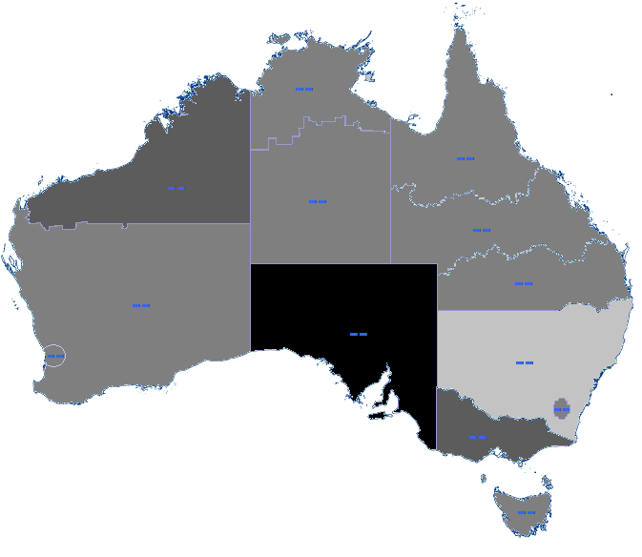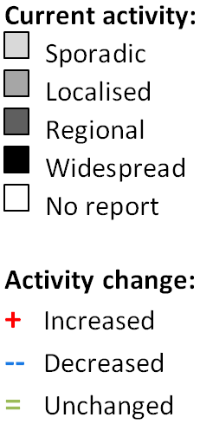

## 2. Laboratory Confirmed Influenza Activity

### Sentinel Laboratory Surveillance

Rhinovirus was the respiratory virus most commonly detected by Pathology West ICPMR, SA Pathology and Tasmania this reporting fortnight. Influenza B was the most commonly reported respiratory virus in the first week of the reporting fortnight (week 42) by the Victoria Infectious Disease Reference Laboratory (VIDRL), followed by picornavirus and influenza A in the second week of the fortnight (week 34). Influenza A was the respiratory virus most commonly detected by PathWest this reporting fortnight.

Detections of influenza decreased across all sentinel laboratories this reporting fortnight (Figure 2). The pooled unweighted percentage of tests positive for influenza across all sentinel laboratories declined from 17.6% at the end of last fortnight (week 41) to 13.6% in week 42 and 8.0% in week 43. This continues the decline since the peak reached in week 36 of 35.6%.

From the sentinel laboratories where influenza subtyping was undertaken (Tasmania, VIDRL and PathWest), influenza A(H3N2) was detected more frequently than influenza A(H1N1)pdm09 both this reporting fortnight and year to date (Figure 3).

Figure . Proportion of sentinel laboratory tests positive for influenza, 1 January to 27 October 2017, by contributing laboratory or jurisdiction and month and week.

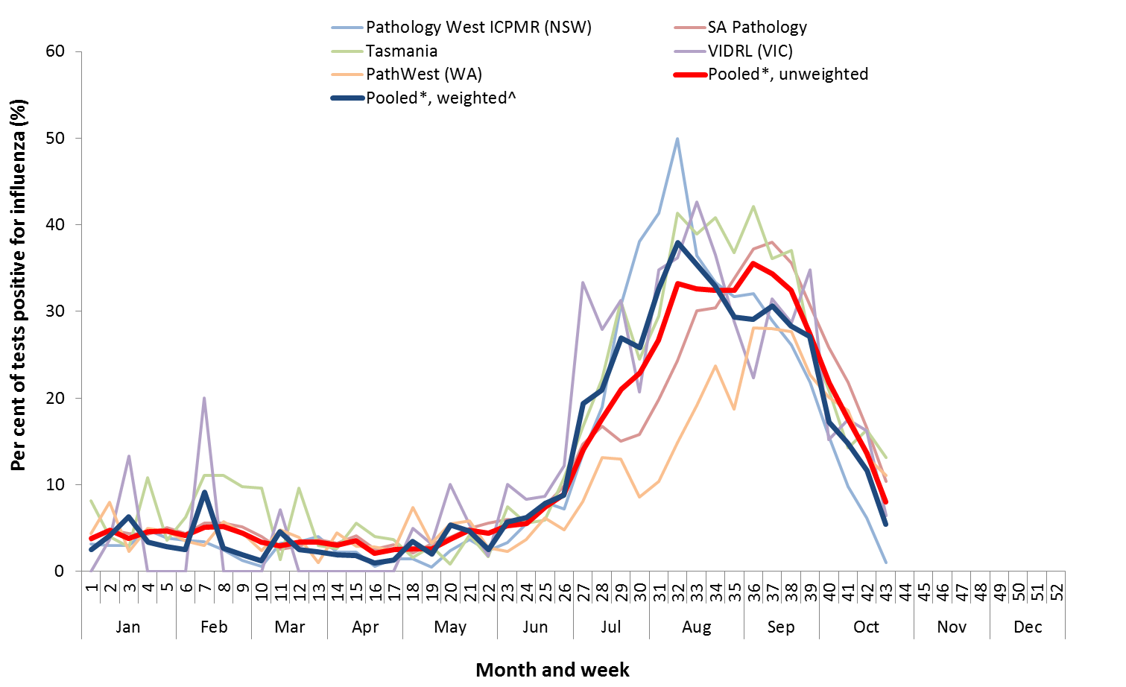

* Pooled percentage positive indicators should be interpreted with caution, noting that collectively pooled contributing laboratories are not representative of testing across Australia and individually contributing laboratories may not be representative of the jurisdiction in which they are located.

^ Weighted according to jurisdictional population in which laboratories are located.

The percentage of tests positive for influenza in the interseasonal period should be interpreted with caution due to small numbers of tests being undertaken in this time, resulting in high variability in the indicators.

Figure . Proportion of sentinel laboratory tests positive for influenza and total number of specimens tested, 1 January to 27 October 2017, by subtype and month and week.

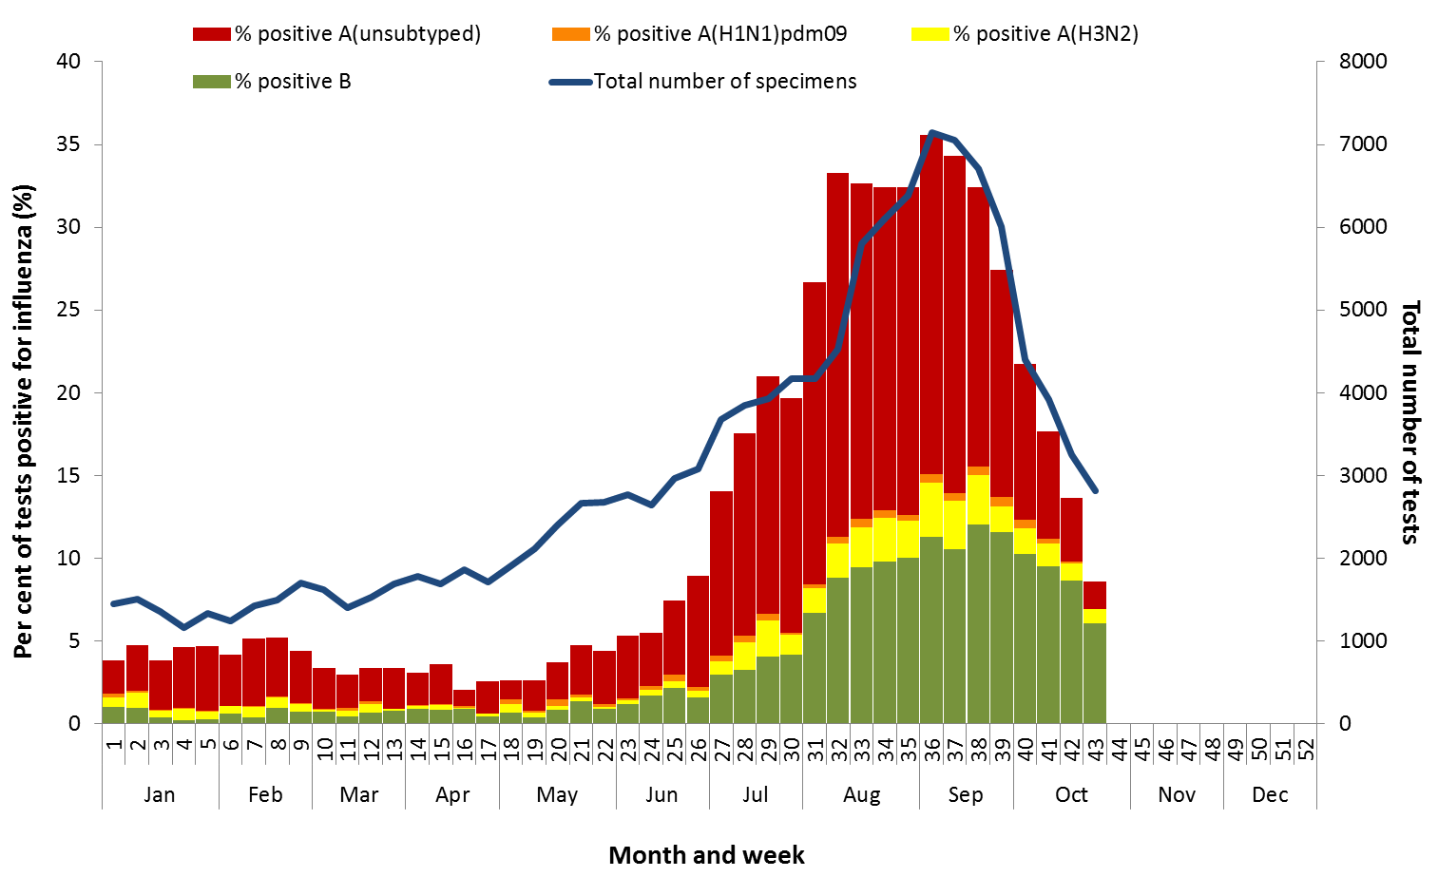

### Notifications of Influenza to Health Departments

Notifications of laboratory confirmed influenza to the National Notifiable Diseases Surveillance System (NNDSS) have declined this reporting fortnight, from a peak reached in week 33 (Figure 4). For the year to 27 October, a total of 229,579 notifications of laboratory confirmed influenza were reported to the NNDSS: 102,476 in New South Wales (NSW); 54,075 in Queensland (QLD); 34,766 in Victoria (VIC); 25,108 in South Australia (SA); 5,336 in WA; 3,410 in Tasmania (TAS); 3,301 in the Australian Capital Territory (ACT) and 1,377 in the NT. When comparing this reporting fortnight to the previous fortnight, notifications of laboratory confirmed influenza declined in each jurisdiction. SA and VIC are currently experiencing administrative backlogs in data entry, due to the heightened number of laboratory-confirmed influenza cases this season that will alter the pattern of notifications once the backlog is resolved.

For the year to 27 October, 63% of notifications of laboratory confirmed influenza to the NNDSS were   
influenza A (57% influenza A(unsubtyped), 1% influenza A(H1N1)pdm09 and 4% influenza A(H3N2)), 37% were influenza B and less than 1% were influenza A&B co-infections or untyped (Figure 6). The proportion of all notifications year to date reported as influenza A has ranged across jurisdictions from 58% in NSW to 81% in WA. For the year to date, detections of influenza A subtypes have varied across jurisdictions also. Nationally, for every one notification of influenza A(H1N1)pdm09 reported to the NNDSS, 3.1 notifications of   
influenza A(H3N2) were received. This ratio has ranged from 1:0.1 in VIC to 1:10.3 in the NT.

In the most recent fortnight, 41% of notifications of laboratory confirmed influenza to the NNDSS were influenza A (37% influenza A(unsubtyped), 1% influenza A(H1N1)pdm09 and 4% influenza A (H3N2)), 59% were influenza B and less than 1% were influenza A&B co-infections or untyped (Figure 7). The proportion of all notifications this reporting fortnight reported as influenza B ranged across jurisdictions from 33% in WA to 73% in the ACT. While the proportion of influenza B notifications continued to increase this fortnight, the number decreased (Figure 7 and Figure 8).

So far in 2017, notification rates have tended to increase with increasing age. Age-specific notification rates of influenza overall were highest in adults aged 85 years and older (2,901 notifications per 100,000) and adults aged 80 to 84 years (1,802 notifications per 100,000) with a secondary peak in children aged 5 to 9 years (1,588 per 100,000) (Figure 9). The notification rate in infants aged less than 5 years was also high   
(1,477 per 100,000). Where subtyping information is available, notifications of influenza A(H1N1)pdm09 were highest in children aged less than 5 years (44.0 per 100,000), notifications of influenza A(H3N2) were highest in the elderly aged 85 years and older (231.2 per 100,000) and notifications of influenza B were highest in children aged 5 to 9 years (795.3 notifications per 100,000 population).

Decreases in notifications occurred in all broad age groups since the last reporting fortnight (Figure 10). The distribution of influenza types and subtypes reported year to date differed across age groups, with 51% of   
5 to 17 year olds notified with influenza detected with influenza B, while only 28% of adults aged 65 years and older and 29% of children aged under 5 years were detected with influenza B. While influenza A(H3N2) was detected across all age groups, it accounted for a greater proportion of influenza A, where subtyping was available, in adults aged 65 years and older, than in any other age group.

Figure . Notifications of laboratory confirmed influenza, Australia, 1 January 2013 to 27 October 2017, by month and week of diagnosis.

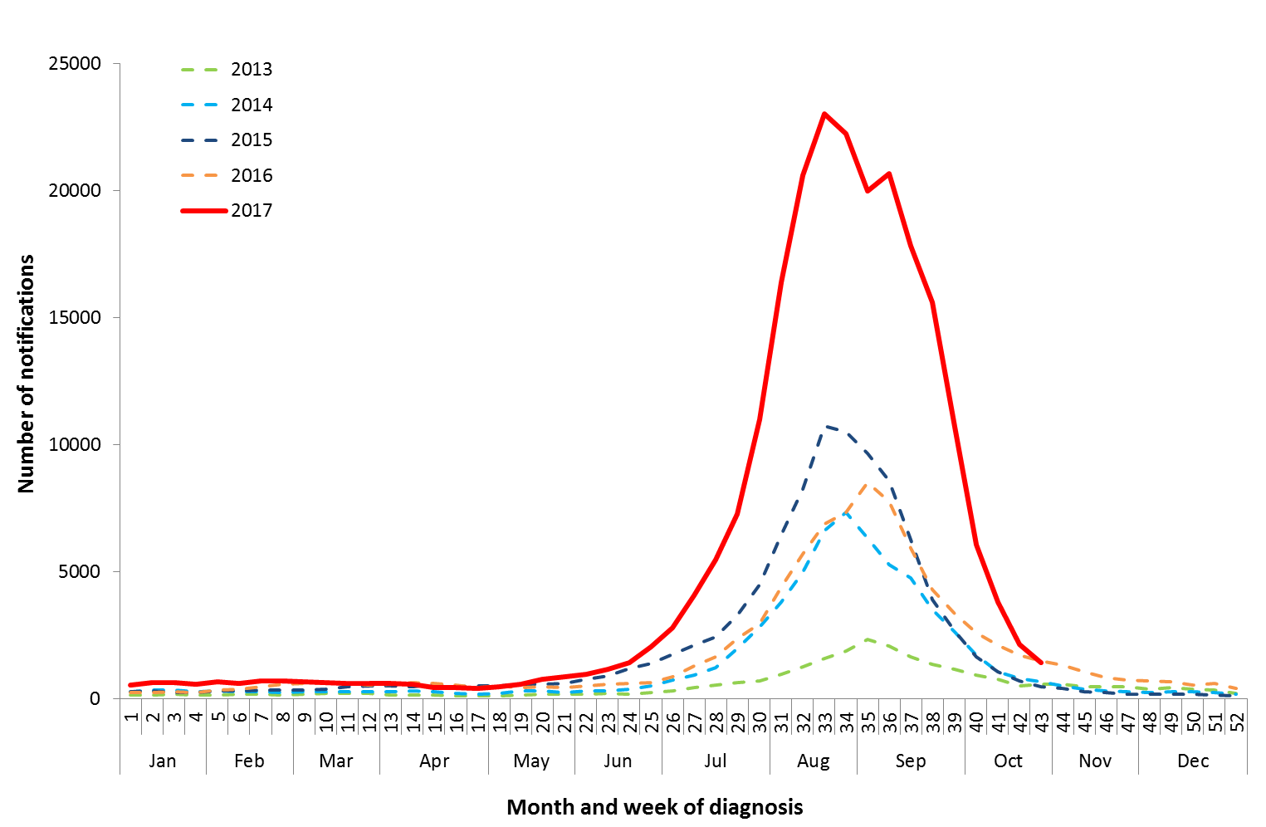

Source: NNDSS

Figure . Notifications of laboratory confirmed influenza, 1 January to 27 October 2017, by state or territory and week.

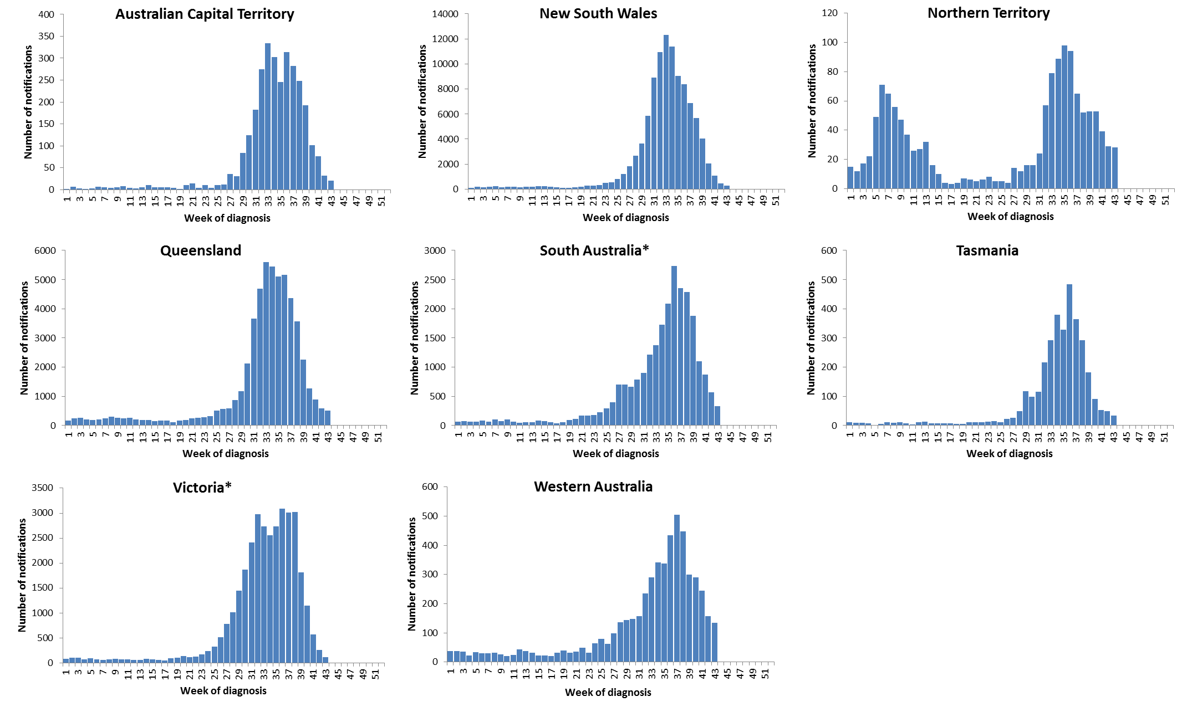

Source: NNDSS

*South Australia and Victoria are currently experiencing a backlog of influenza notifications to be entered into the NNDSS.

Figure . Per cent of notifications of laboratory confirmed influenza, Australia, 1 January to 27 October 2017, by subtype and state or territory.

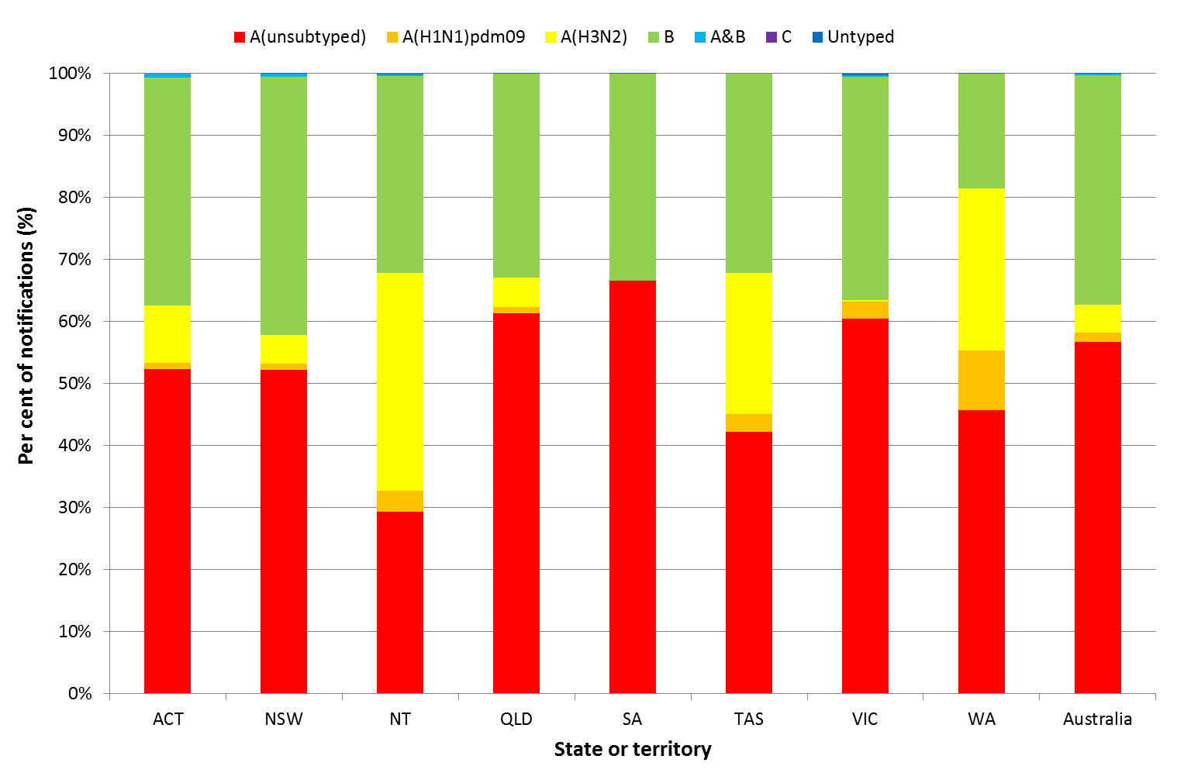

Source: NNDSS

Figure . Per cent of laboratory confirmed influenza, Australia, 1 January to 27 October 2017, by subtype and week.

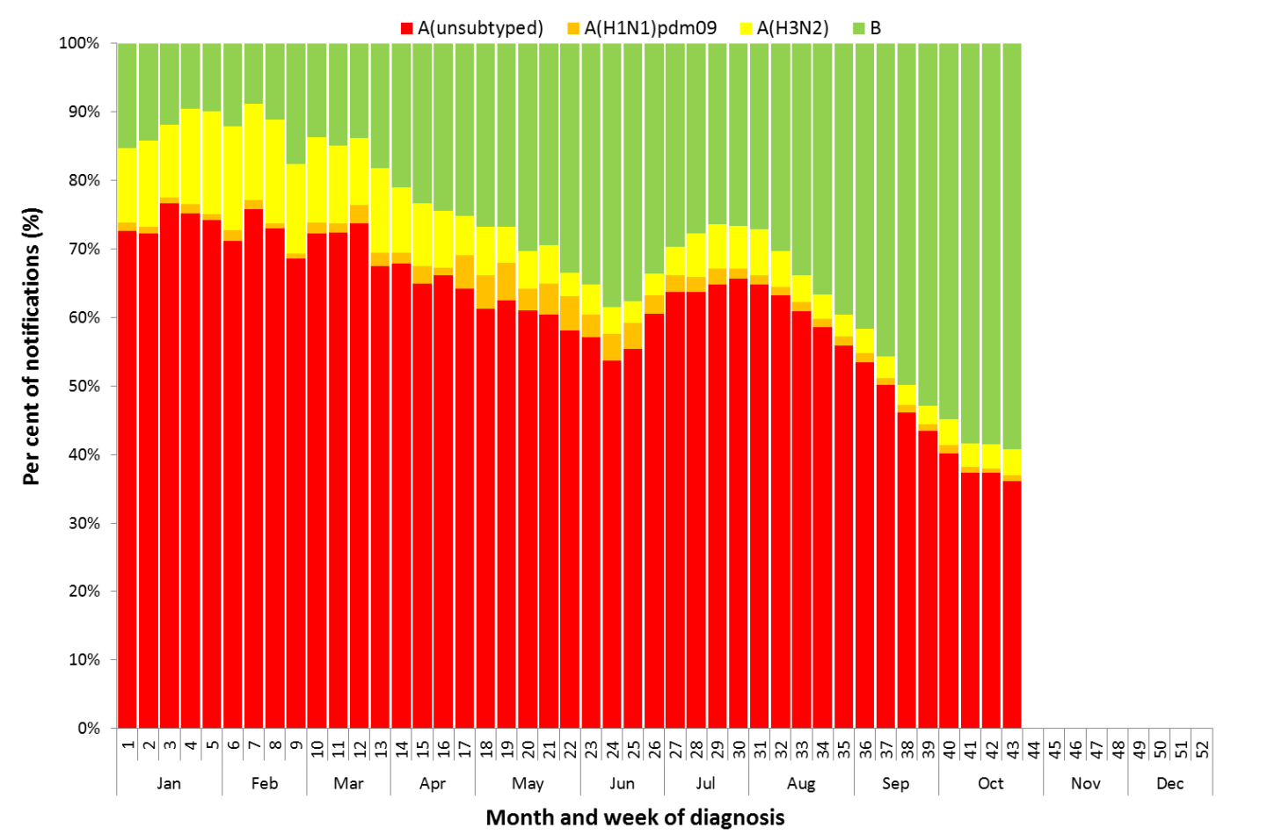

Source: NNDSS

**Figure 8. Notifications of laboratory confirmed influenza by week of diagnosis and cumulative year-to-date, Australia,   
1 January to 27 October 2017, by subtype and age group.**

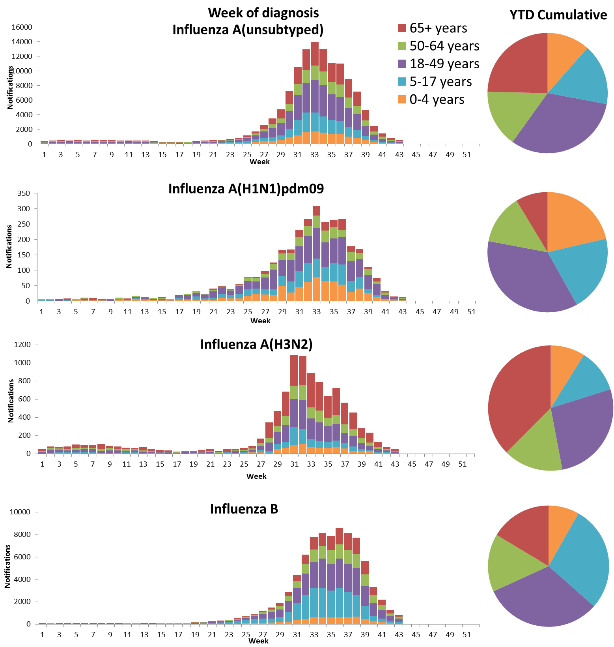

Source: NNDSS

Figure . Rate of notifications of laboratory confirmed influenza, Australia, 1 January to 27 October 2017, by age group and subtype.

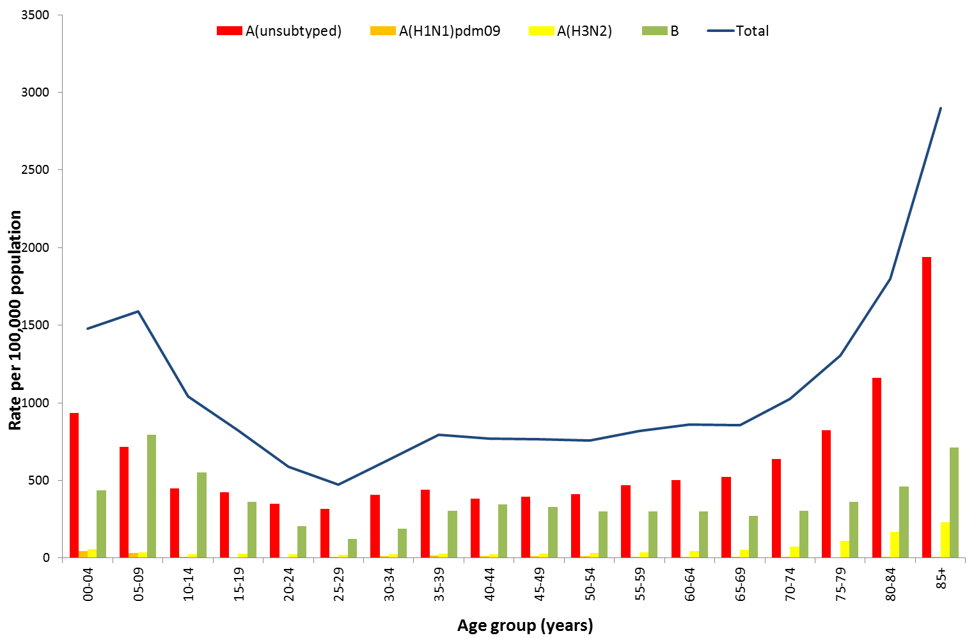

Source: NNDSS

Figure . Notifications of laboratory confirmed influenza by week of diagnosis and cumulative year-to-date, Australia, 1 January to 27 October 2017, by age group and subtype.

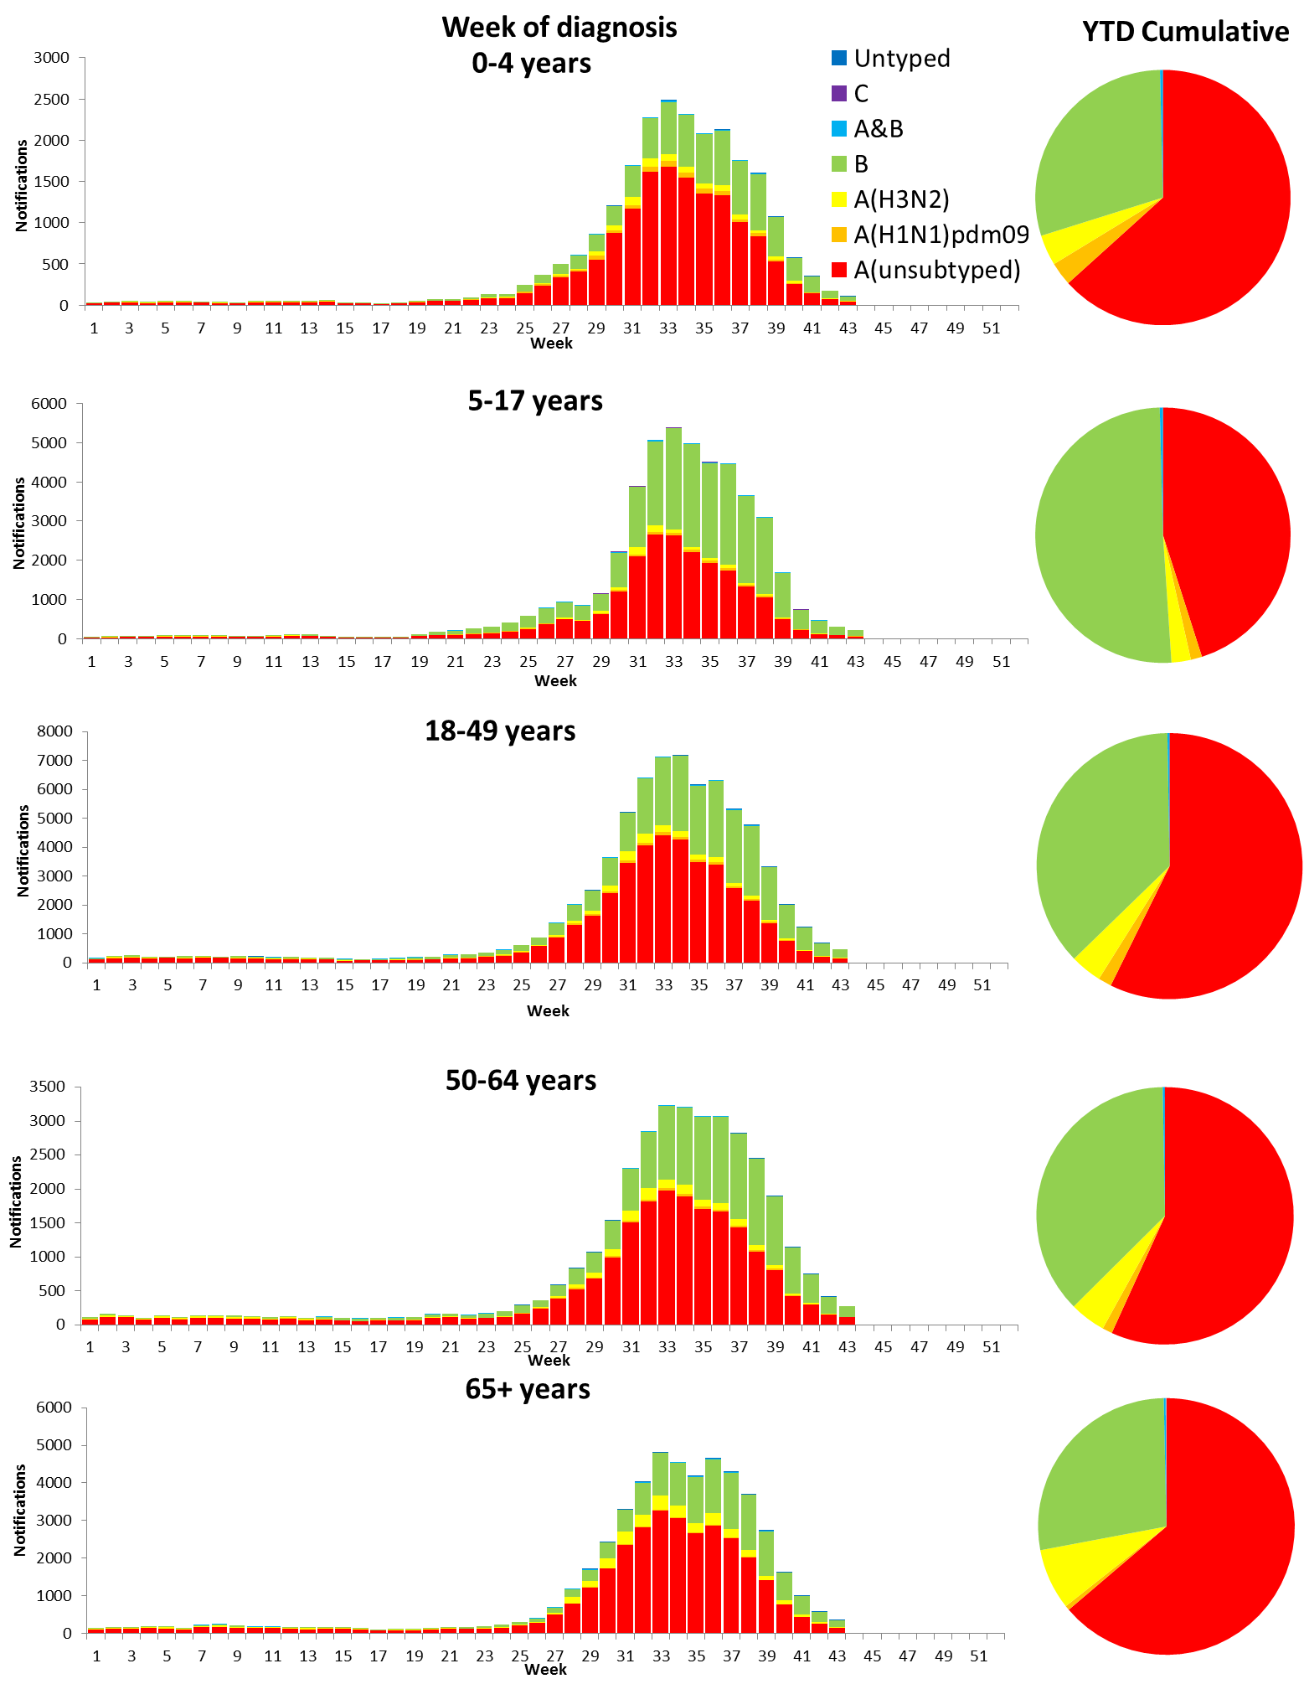

Source: NNDSS

## 2. Influenza-like Illness Activity

### Community Level Surveillance

There are no new data to present this report as surveillance through the FluTracking system ceased for the 2017 season on 15 October. ILI among Flutracking participants began to increase in mid-June this year and reached a peak in week 33 (3.4%) (Figure 11). ILI activity exceeded the historical range for most weeks between weeks 31 and 38, after which activity returned to the historical range.

This year 63% of all participants and 81% of participants who identify as working face-to-face with patients reported receiving the seasonal influenza vaccine.[2]

Figure . Proportion of fever and cough among FluTracking participants, Australia, between May and October, 2013 to 2017, by month and week.

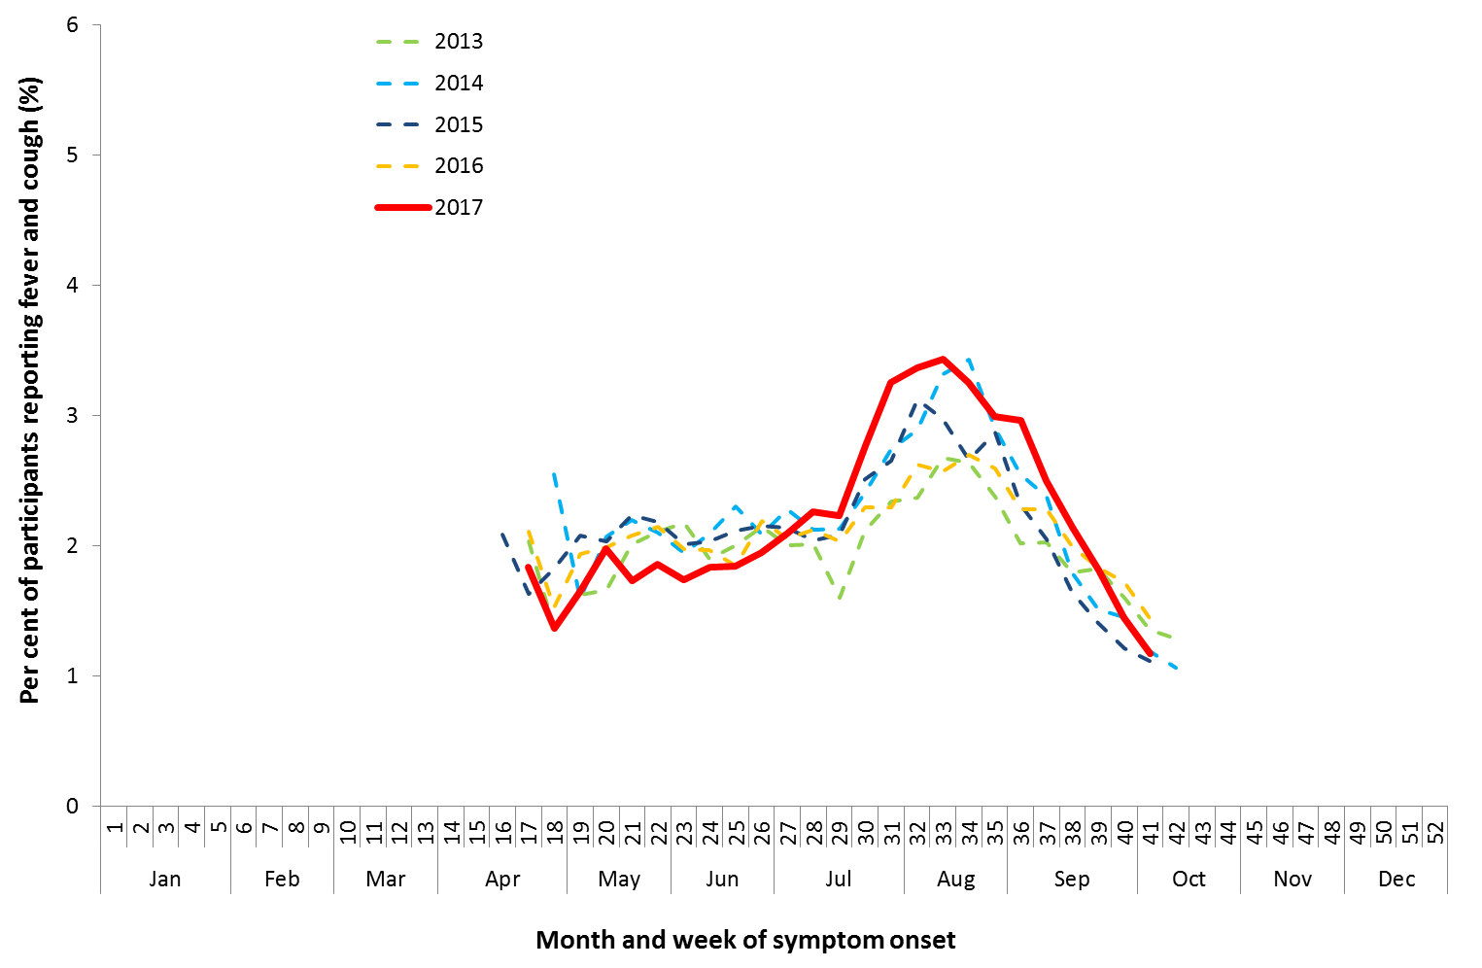

Source: FluTracking

### Health Call Centre Surveillance

ILI related calls to the National Health Call Centre Network (NHCCN) declined from 5.5% of calls at the end of last fortnight (week 41) to 5.0% in week 40 and increased to 5.5% in week 41 (Figure 12). The slight uptick in the most recent week is not unusual for this time of year.

The proportion of calls related to ILI this year exceeded the historical range between weeks 25 and 41 and reached a peak in week 33 of 11.4%.

**Figure 12. Per cent of calls to the NHCCN related to ILI, Australia, 1 January 2013 to 29 October 2017, by month and week of call.**

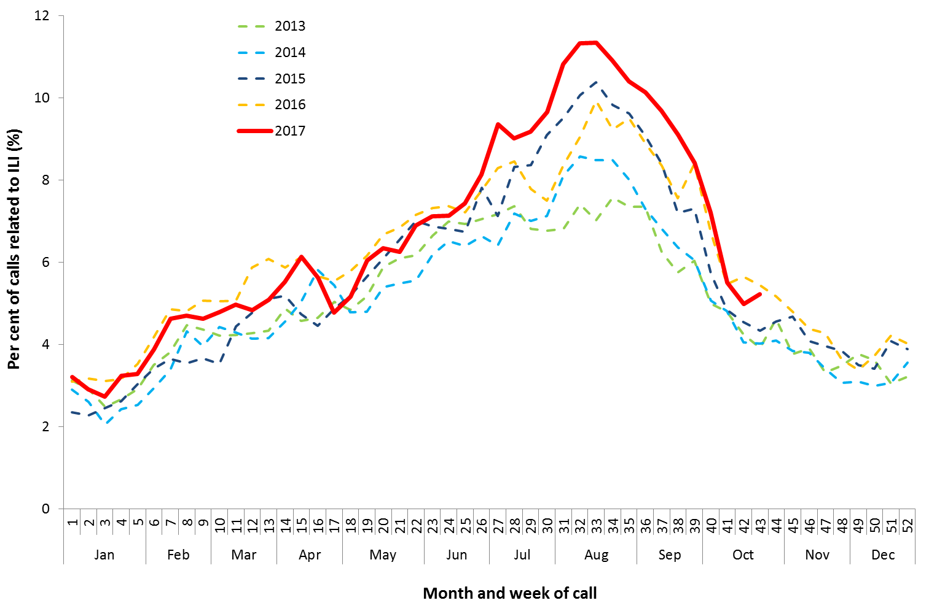

Source: NHCCN, Healthdirect

### Sentinel General Practice Surveillance

Sentinel general practitioner ILI consultations declined from 7.5 per 1,000 consultations at the end of last fortnight (week 41) to 5.9 per 1,000 consultations in week 42 and 5.3 per 1,000 consultations in week 43 (Figure 13). This continues the decrease from the seasonal peak of 23.6 per 1,000 consultations reported in week 34. ILI consultations this year exceeded the historical range from week 30 and remains slightly above the historic range at week 43.

Of the 115 specimens taken from ILI patients seen by Australian Sentinel Practices Research Network (ASPREN) sentinel practitioners during the reporting fortnight, rhinovirus was the most common respiratory virus detected (n=23, 20.0%). Influenza positivity declined this fortnight to 16.5% (n=19) (Figure 14).

Figure . Unweighted rate of ILI reported from sentinel GP surveillance systems, Australia, 1 January 2013 to   
29 October 2017, by month and week.

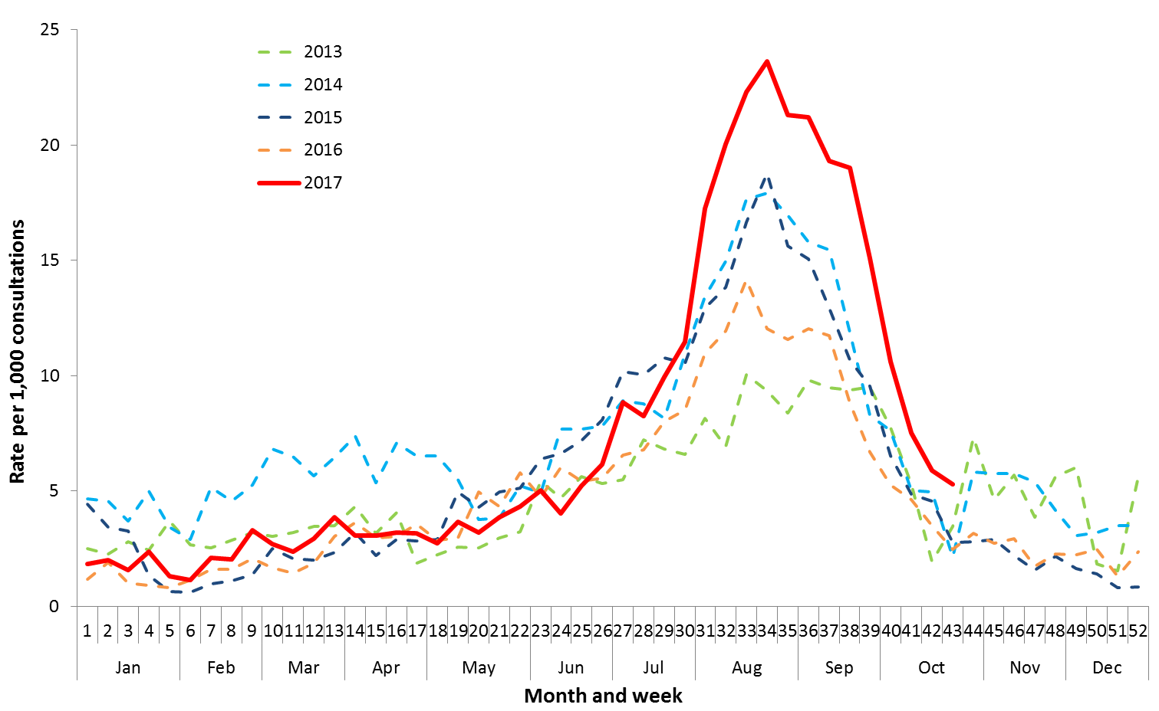

Source: ASPREN and VicSPIN

Figure . Proportion of respiratory viral tests positive for influenza in ASPREN ILI patients and ASPREN ILI consultation rate, Australia, 1 January to 29 October 2017, by month and week.

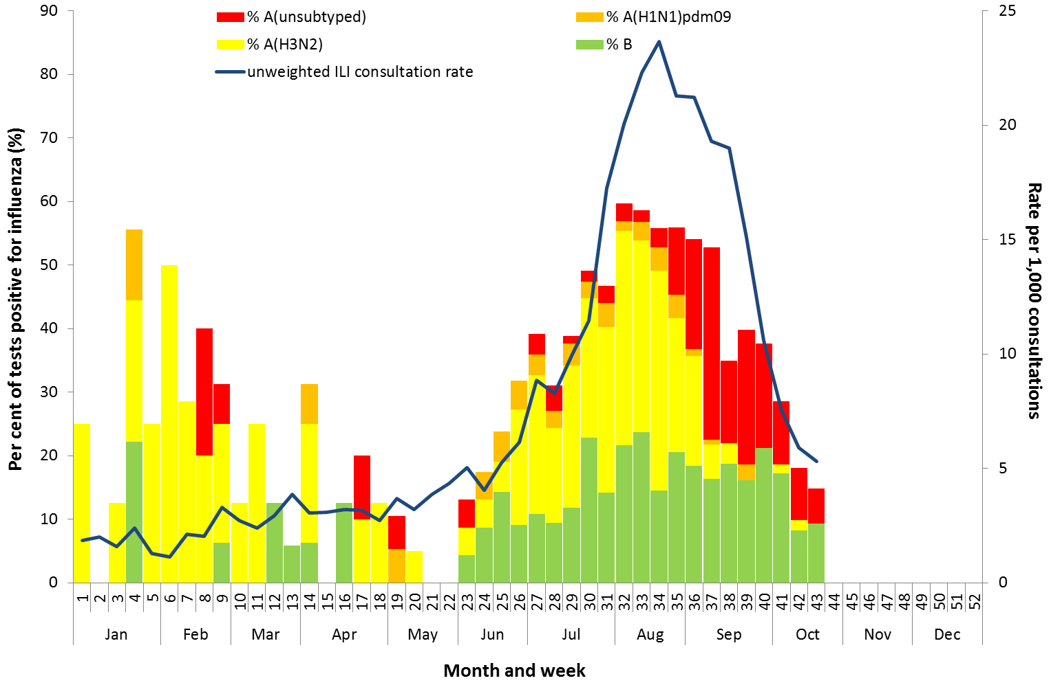

Source: ASPREN

## 3. Hospitalisations

### Sentinel Hospital Surveillance

Admissions with confirmed influenza to sentinel hospitals decreased this reporting fortnight (Figure 15), with 89 patients admitted in the last week of the previous fortnight (week 41), followed by 44 patients in   
week 42 and 21 patients in week 43. Since seasonal surveillance commenced through the Influenza Complications Alert Network (FluCAN) sentinel hospital surveillance system on 3 April 2017, a total of 3,969 people have been admitted with confirmed influenza, of which 572 (14%) were children aged 15 years and younger, 1,314 (33%) were adults aged between 16 and 64 years and 2,071 (52%) were adults aged 65 years and older. Information on age was not reported for 12 patients.

Approximately 8.9% of influenza patients have been admitted directly to ICU (n=355), which is in the lower range reported in recent years (range 8.7% in 2015 to 14.2% in 2013). The proportion of patients admitted directly to ICU this year to date has ranged by age, from 8.3% in adults aged 65 years and older to 11.9% in adults aged between 16 and 64 years.

For the year to 27 October, 69% of admissions with confirmed influenza to sentinel hospitals were influenza A (56% A(unsubtyped), 3% influenza A(H1N1)pdm09 and 10% influenza A (H3N2)), 30% were influenza B and less than 1% were mixed influenza infections (Figure 16). The proportion of patients admitted directly to ICU was higher in patients infected with influenza A(H1N1)pdm09 (15.8%), than in admitted patients infected with influenza A(H3N2) (8.6%) and influenza B (8.5%).

Figure . Number of influenza hospitalisations at sentinel hospitals, between March and October, 2013 to 2017 by month and week.

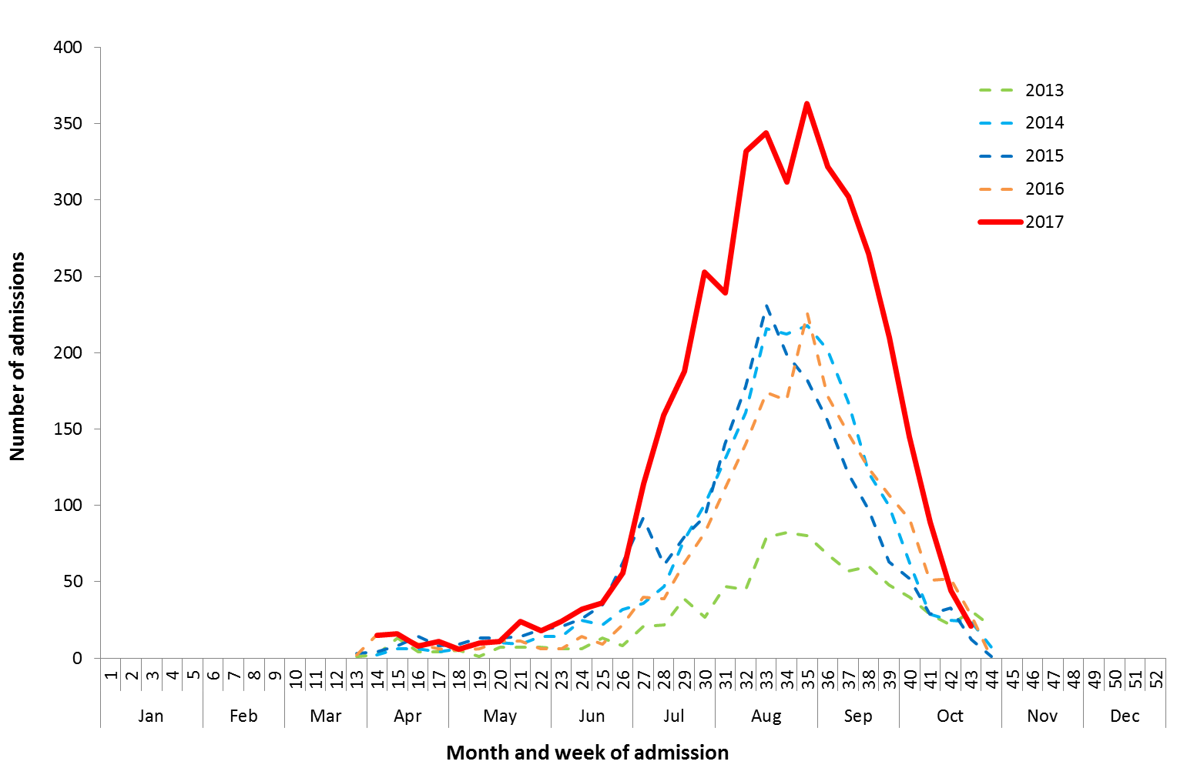

Source: FluCAN

Figure . Number of influenza hospitalisations at sentinel hospitals by subtype and ICU admission, 3 April to  
27 October 2017, by month and week.

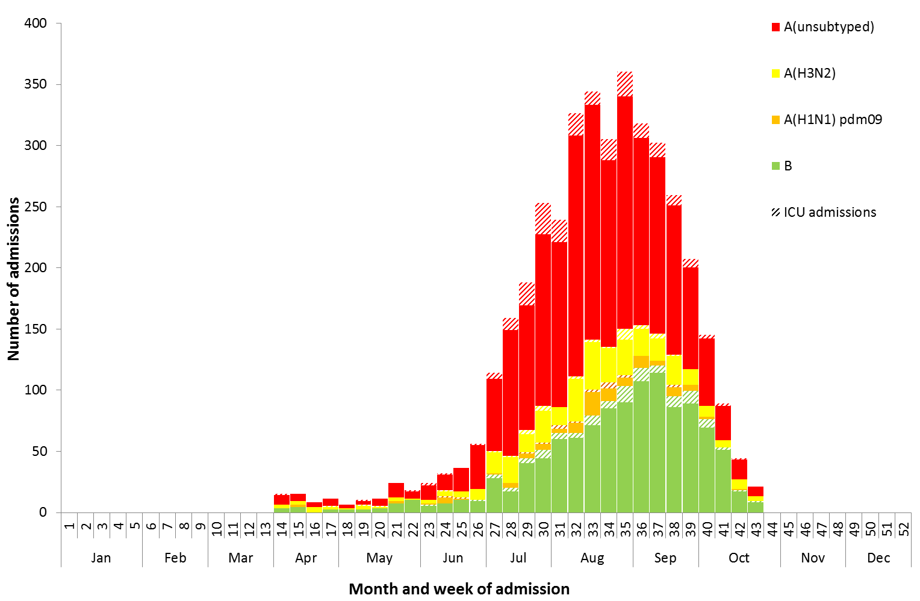

Source: FluCAN

### Paediatric Severe Complications of Influenza

The Australian Paediatric Surveillance Unit (APSU) conducts seasonal surveillance between June and September annually of children aged 15 years and under who are hospitalised with severe complications of influenza. For the APSU seasonal surveillance study period of 1 June to 30 September 2017, there were a total of 68 hospitalisations associated with severe complications of influenza reported. Thirty-nine cases were female and 28 were male and one case was reported without sex; with an age range of 0 to 14 years; and 51 were infected with influenza A and 16 with influenza B and one without an influenza type. Vaccination status was known for 36 of the patients, with two being vaccinated against influenza and the remainder unvaccinated. One death was recorded, 53 patients were discharged with no ongoing problems nine were discharged with ongoing problems and five with an unknown outcome at the time of reporting.

## 4. Deaths Associated with Influenza and Pneumonia

### Nationally Notified Influenza Associated Deaths

So far in 2017, 598 influenza associated deaths have been notified to the NNDSS. The majority of deaths were due to influenza A (78%, n=466). The median age of deaths notified was 85 years (range 0 to 107 years).

The number of influenza-associated deaths reported to the NNDSS does not represent the true mortality associated with this disease. The number of deaths is reliant on the follow up of cases to determine the outcome of their infection. The follow up of cases is not a requirement of notification, and are only inclusive of laboratory-confirmed cases of influenza. Due to retrospective revision, the variation across jurisdictions in methodology, representativeness and timeliness of death data, and reporting of an outcome of infection not being a requirement of notification, year on year comparisons of deaths in notified cases of influenza may not be reliable. The large increase in deaths between Australian Influenza Surveillance Report #9 and #10 was mostly due to a change in system processes in NSW that improves reporting of a death outcome against a notification.

### New South Wales Influenza and Pneumonia Death Registrations

Death registration data from NSW for the week ending 15 September 2017 show that there were 1.71 “pneumonia and influenza” deaths per 100,000 NSW population, which is below the usual variation upper limit of 1.83 per 100,000 NSW population (Figure 17).[3]

Figure . Rate of deaths classified as influenza and pneumonia from the NSW Registered Death Certificates, 2012 to   
15 September 2017.

Please refer above for description and interpretation.

Source: NSW Registry of Births, Deaths and Marriages

## 5. Virological Surveillance

### Australian Influenza Vaccines Composition 2017

The influenza virus strains included in the 2017 seasonal influenza vaccines in Australia are:

* A/Michigan/45/2015, (H1N1)pdm09-like virus;
* A/Hong Kong/4801/2014, (H3N2)-like virus;
* B/Brisbane/60/2008-like virus, Victoria lineage; and
* B/Phuket/3073/2013-like virus, Yamagata lineage.

### Typing and Antigenic Characterisation

From 1 January to 30 October, the World Health Organization Collaborating Centre for Reference and Research on Influenza (WHOCC) characterised 1,152 influenza viruses (Table 1). When further characterised for similarity to the corresponding vaccine components by haemagglutination inhibition (HI) assay, influenza A(H1N1)pdm09 viruses and viruses from both influenza B lineages appeared to be mostly antigenically similar to the corresponding vaccine components. The influenza A(H3N2) isolates that were able to be assessed by HI assay appeared to be reasonably well matched, although there are ongoing technical issues that significantly limit the WHOCC’s capacity to fully assess the similarity of circulating viruses to the vaccine strain.

The best way to determine how well the vaccine protects against circulating viruses during the season is by determining the vaccine effectiveness. These estimates provide an indication of how effective the vaccine was in providing protection against influenza infection, but can only be determined towards the end of the influenza season.

A small number of influenza A(H3N2) isolates (n=96) and influenza B(Victoria) isolates (n=1) were characterised as low reactors. An additional 633 influenza A(H3) isolates were unable to be characterised in the HI assay due to insufficient haemagglutination titre.

Table . Australian influenza viruses typed by HI from the WHOCC, 1 January to 30 October 2017.

|  |  |  |  |  |  |  |  |  |  |
| --- | --- | --- | --- | --- | --- | --- | --- | --- | --- |
| **Type/Subtype** | **ACT** | **NSW** | **NT** | **QLD** | **SA** | **TAS** | **VIC** | **WA** | **TOTAL** |
| **A(H1N1) pdm09** | 8 | 64 | 1 | 65 | 36 | 3 | 81 | 21 | 279 |
| **A(H3N2)** | 19 | 175 | 16 | 55 | 107 | 20 | 126 | 15 | 533 |
| **B/Victoria lineage** | 0 | 7 | 0 | 5 | 4 | 1 | 8 | 1 | 26 |
| **B/Yamagata lineage** | 11 | 100 | 24 | 38 | 46 | 30 | 160 | 5 | 414 |
| Total | 38 | 346 | 41 | 163 | 193 | 54 | 375 | 42 | 1252 |

SOURCE: WHO CC

Note: Viruses tested by the WHO CC are not necessarily a random sample of all those in the community.

State indicates the residential location for the individual tested, not the submitting laboratory.

There may be up to a month delay on reporting of samples.

### Antiviral Resistance

The WHOCC reported that from 1 January to 16 October 2017, of the 1,676 influenza viruses tested for neuraminidase inhibitor resistance, one sample of influenza A(H1N1) demonstrated reduced inhibition to the antiviral drug Zanamivir.

### Australian Influenza Vaccines Composition 2018

The Australian Influenza Vaccine Committee met on 11 October 2017 and recommended that the Therapeutic Goods Administration (TGA) adopt the WHO recommendation for the 2018 Southern Hemisphere influenza vaccines, issued on 28 September 2017. That is, that the trivalent influenza vaccine components for the Australian 2018 influenza season should contain the following:

* A/Michigan/45/2015, (H1N1)pdm09-like virus;
* A/Singapore/INFIMH-16-0019/2016, (H3N2)-like virus; and
* B/Phuket/3073/2013-like virus, Yamagata lineage.

The quadrivalent influenza vaccine for the Australian 2018 influenza season should contain the trivalent influenza vaccine components listed above, and the additional B strain:

* B/Brisbane/60/2008-like virus, Victoria lineage.

The TGA has accepted the recommendations of the AIVC.[4]

## 6. International Surveillance

The World Health Organization reported that based on data up to 15 October 2017, declining levels of influenza activity were reported in the temperate zone of the southern hemisphere and in some countries of South and South East Asia. In Central America and the Caribbean, low influenza activity was reported in a few countries. Influenza activity remained at low levels in the temperate zone of the northern hemisphere. Worldwide, influenza A(H3N2) and B viruses accounted for the majority of influenza detections.[5]

# DATA CONSIDERATIONS

The NNDSS data provided were extracted on 10 November 2017. Due to the dynamic nature of the NNDSS, data in this report is subject to retrospective revision and may vary from data reported in published NNDSS reports and reports of notification data by states and territories. Detailed notes on interpreting the data presented in this report are available at the Department of Health’s [Australian Influenza Surveillance Report website](http://www.health.gov.au/flureport) (www.health.gov.au/flureport).

The Australian Influenza Surveillance Report and Activity Updates are compiled from a number of data sources, which are used to monitor influenza activity and severity in the community. These data sources include laboratory-confirmed notifications to the NNDSS; influenza associated hospitalisations; sentinel influenza-like illness (ILI) reporting from general practitioners and emergency departments; and community level surveys; and sentinel laboratory testing results. The information in this report is reliant on the surveillance sources available to the Department of Health at the time of production.

While every care has been taken in preparing this report, the Commonwealth does not accept liability for any injury or loss or damage arising from the use of, or reliance upon, the content of the report. Delays in the reporting of data may cause data to change retrospectively. For further details about information contained in this report please contact the [Influenza Surveillance Team](mailto:flu@health.gov.au) ([flu@health.gov.au](mailto:flu@health.gov.au)).

# REFERENCES

1. Sullivan S et al, Low mid-season influenza vaccine effectiveness in Australia, 2017. Eurosurveillance rapid communication http://eurosurveillance.org/content/10.2807/1560-7917.ES.2017.22.43.17-00707
2. FluTracking, FluTracking Weekly Interim Report, Week ending 15 October 2017. Available from [FluTracking Reports](http://www.flutracking.net/Info/Reports) (http://www.flutracking.net/Info/Reports) [Accessed 20 October 2017].
3. NSW Health, Influenza Monthly Epidemiology Report, NSW, Week 40: 2 to 8 October, 2017. Available from NSW Health Influenza Surveillance Reports (http://www.health.nsw.gov.au/Infectious/Influenza/Pages/reports.aspx) [Accessed 20 October 2017].
4. Australian Government Department of Health Therapeutic Goods Administration, AIVC recommendations for the composition of influenza vaccine for Australia in 2018. 18 October 2017. Available from https://www.tga.gov.au/aivc-recommendations-composition-influenza-vaccine-australia-2018   
   [Accessed 20 October 2017].
5. WHO, Influenza Update No. 301, 30 October 2017. Available from the [WHO website](http://www.who.int/influenza/surveillance_monitoring/updates/latest_update_GIP_surveillance/en/) (http://www.who.int/influenza/surveillance_monitoring/updates/latest_update_GIP_surveillance/en/) [Accessed 10 November 2017].