| Logo | **Australian Influenza**  **SURVEILLANCE REPORT**  **No. 09, 2018**  **10 to 23 September 2018** |
| --- | --- |

The Department of Health acknowledges the providers of the many sources of data used in this report and greatly appreciates their contribution.

## KEY MESSAGES

* **Activity** –In the last fortnight, at the national level, there were declines in the majority of indicators for person to person transmission of influenza and influenza-like illness (ILI), signalling that nationally the season peaked in recent weeks or is nearing its peak. This is the first fortnight this season where influenza was the dominant cause of ILI among patients attending sentinel GPs and samples tested through sentinel laboratories.
* **Severity** –Clinical severity for the season to date, as measured through the proportion of patients admitted directly to ICU, and deaths attributed to influenza, is low.
* **Impact** – Currently, the impact of circulating influenza on society, as measured through the proportion of people with ILI taking time off work, and the burden on hospitals, is low.
* **Virology** – This fortnight, the majority of confirmed influenza cases reported nationally were   
  influenza A (88%), and where subtyping data were available, influenza A(H1N1)pdm09 was the dominant subtype.
* **At-risk populations:** Children aged less than 10 years appear to be more commonly infected with influenza; however the severity of illness in this population is on par with other age-groups.

## ANALYSIS

### Introduction

Each year, the influenza virus changes and different strains can circulate in the population. Particular strains and subtypes of influenza can affect different groups of the population more than others. Depending on the susceptibility of the population, the strains that are circulating and the changes to the virus itself, the influenza season can be very different year to year. Our surveillance systems help us to understand influenza activity, severity of the infection in individuals and impact of the illness on society in Australia. We are also able to monitor which influenza strains are circulating, which populations might be more affected, the effectiveness of the vaccine, and any resistance to antiviral drugs that has developed.

### Activity

*Activity measures the capacity of the circulating influenza viruses to spread person to person and may be measured indirectly through systems that monitor influenza-like illness and more directly through systems that monitor laboratory confirmed influenza.*

#### Influenza-like illness

Overall, ILI in the community is low and is within or below the historical range.

* **Flutracking:** 1.7% and 1.4% of Flutracking participants reported ILI (fever and cough) in the weeks 37 and 38, respectively, which is below the range of the last five years. (Figure 1). There has been a decreasing trend in activity since mid-August.
* **Healthdirect:** 7.2% and 7.4% of calls to the Healthdirect public health hotline were related to ILI in weeks 37 and 38, respectively (Figure 2). Following a small peak in early July, activity levels have remained relatively stable.
* **Sentinel General Practitioners (ASPREN and VicSPIN):** 5.6 per 1,000 consultations in sentinel general practices were due to ILI in week 38 (Figure 3). This is a decrease on the previous week of 6.8/1,000 consultations. ILI consultations are below the historical range for this time of year.

#### Confirmed influenza

Influenza is circulating at low levels and is an increasing cause of ILI this fortnight.

* **Proportion of ILI with confirmed influenza seen by sentinel GPs:** Of the 122 ILI cases presenting to sentinel ASPREN GPs this fortnight who were tested for influenza, 19 (15.6%) had a positive result. This is a slight increase from the previous fortnight when 14.7% (27/184) of swabbed ILI patients tested positive for influenza. In the reporting fortnight, 12.3% of swabbed patients were infected with influenza A, which was the most common respiratory virus detected. This was followed by respiratory syncytial virus (n=11, 9.0%). This is the first fortnight this season where influenza was the dominant cause of ILI among patients attending sentinel GPs.
* Proportion of ILI with confirmed influenza in sentinel labs: There has been an overall increasing trend in detections of influenza across sentinel laboratories since early July, however detections have remained low (Figure 4). The pooled unweighted percentage of tests positive for influenza across all sentinel laboratories was 9.5% in week 38, a decrease from 11.3% reported in week 37. The most commonly detected respiratory virus this fortnight was:
  + influenza A in week 37, and human metapneumovirus and rhinovirus in week 38 by the Institute of Clinical Pathology and Medical Research;
  + Influenza A for both weeks 37 and 38 by the Victorian Infectious Disease Reference Laboratory (VIDRL);
  + influenza A(H1N1)pdm09 for both weeks 37 and 38 by PathWest; and
  + parainfluenza in week 37 and rhinovirus in week 38 by Tasmania.
* **NNDSS notifications**: This fortnight there were 4,765 notifications of laboratory confirmed influenza to the National Notifiable Diseases Surveillance System (NNDSS), which is a decrease in reported cases compared to the previous fortnight (n=5,424). There have been 36,305 notifications year to date. Notifications remain low and have been declining following a small peak in early September (Figure 5).
* **FluCAN**: Since seasonal sentinel hospital surveillance began on 3 April 2018, a total of 485 people have been admitted with confirmed influenza (Figure 6). This is fewer hospitalisations than the 5 year average for the same period (n=1,945). The number of hospitalisations per week has been declining following a peak in early September.

Figure . Proportion of fever and cough among FluTracking participants, Australia, between May and October, 2013 to 2018, by month and week.

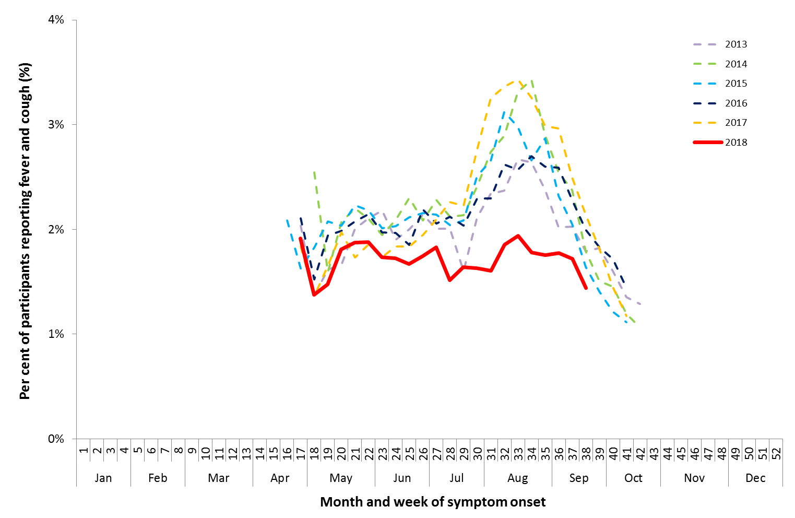

Source: FluTracking

**Figure 2. Per cent of calls to Healthdirect related to ILI, Australia, 1 January 2013 to 23 September 2018, by month and week of call.**

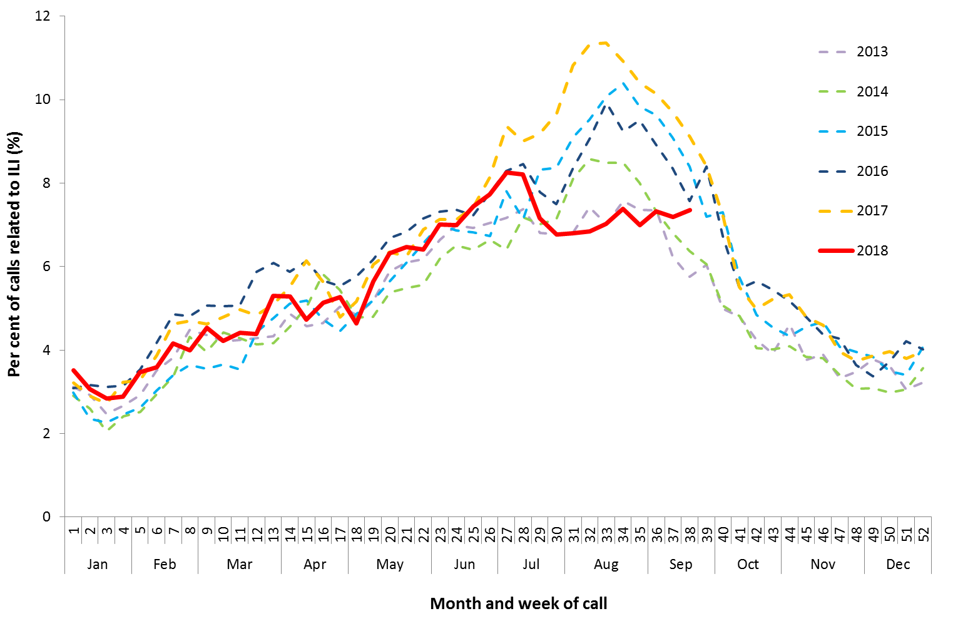

Source: Healthdirect

Figure . Unweighted rate of ILI reported from sentinel GP surveillance systems, Australia, 1 January 2013 to 23 September 2018, by month and week.

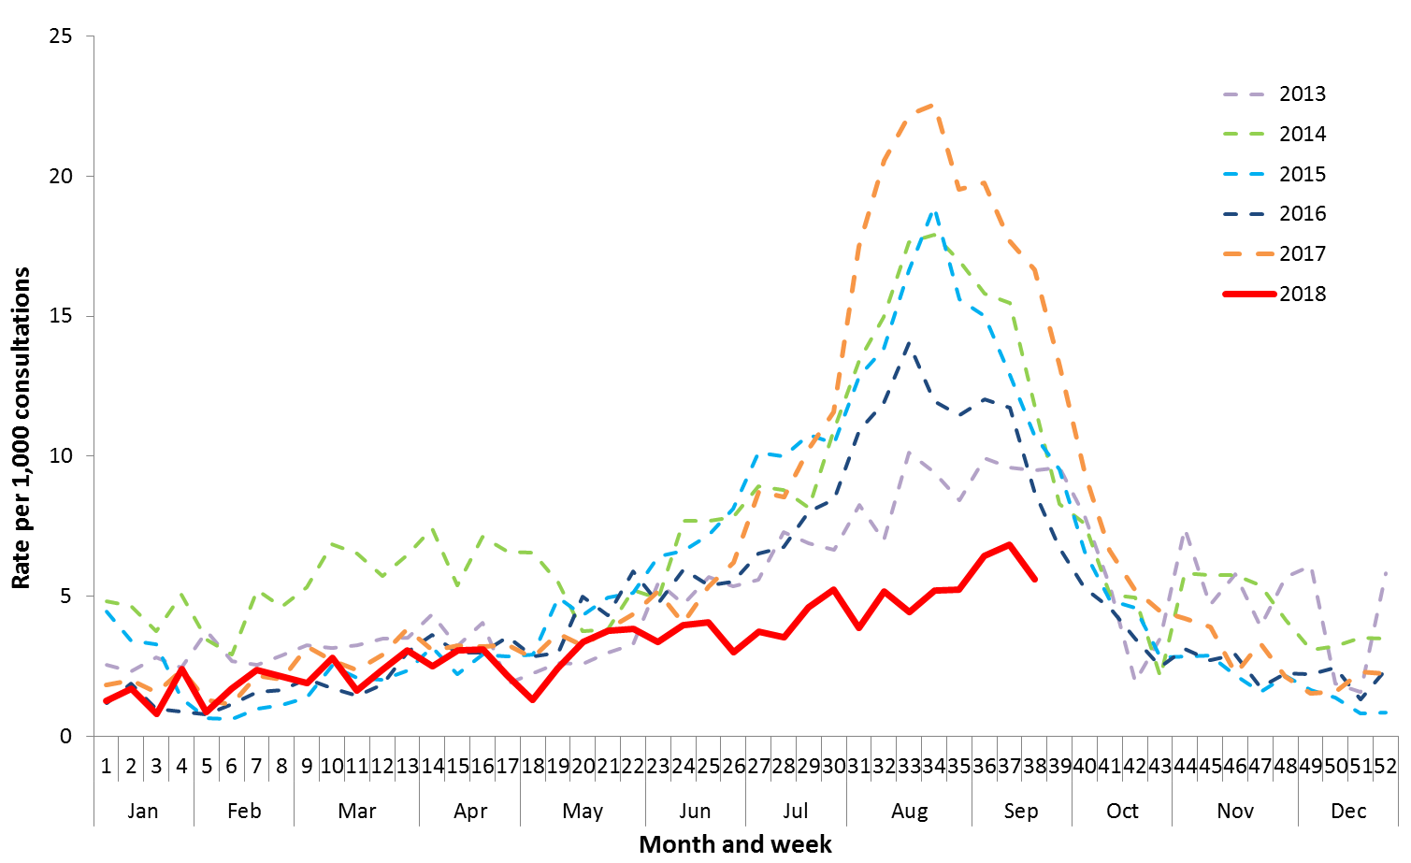

Source: ASPREN and VicSPIN

Figure . Proportion of sentinel laboratory tests positive for influenza, 1 January to 23 September 2018, by contributing laboratoryor jurisdiction and month and week.

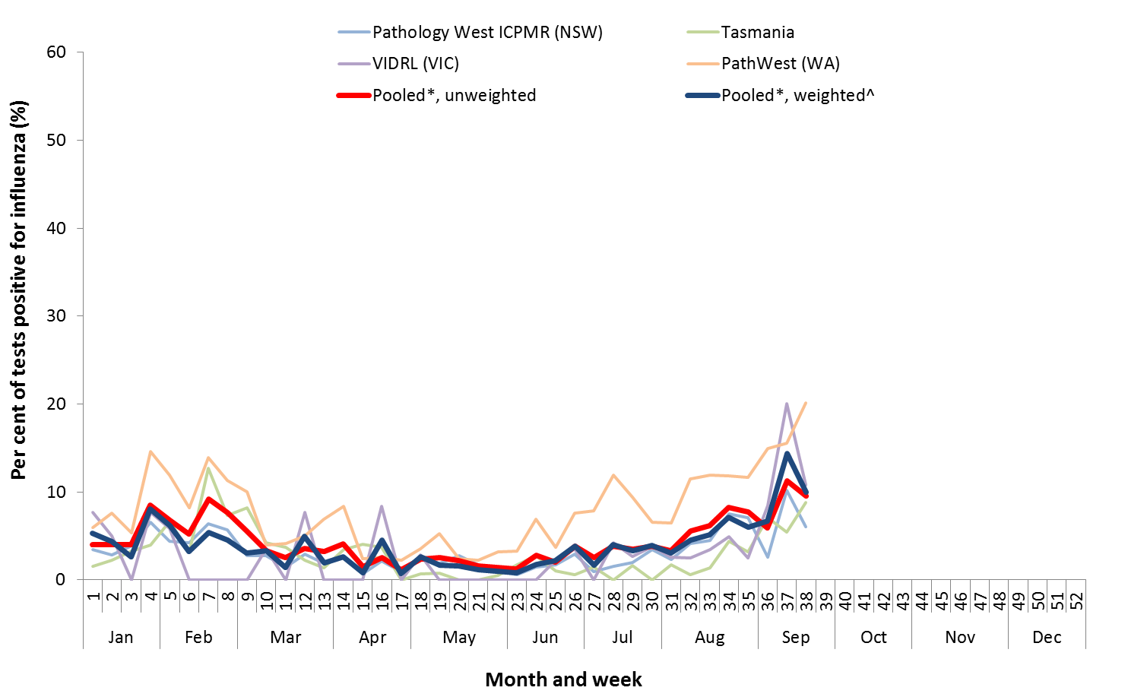

* Pooled percentage positive indicators should be interpreted with caution, noting that collectively pooled contributing laboratories are not representative of testing across Australia and individually contributing laboratories may not be representative of the jurisdiction in which they are located.

^ Weighted according to jurisdictional population in which laboratories are located.

The percentage of tests positive for influenza in the interseasonal period should be interpreted with caution due to small numbers of tests being undertaken in this time, resulting in high variability in the indicators.

Figure . Notifications of laboratory confirmed influenza, Australia, 1 January 2013 to 23 September 2018, by month and week of diagnosis.

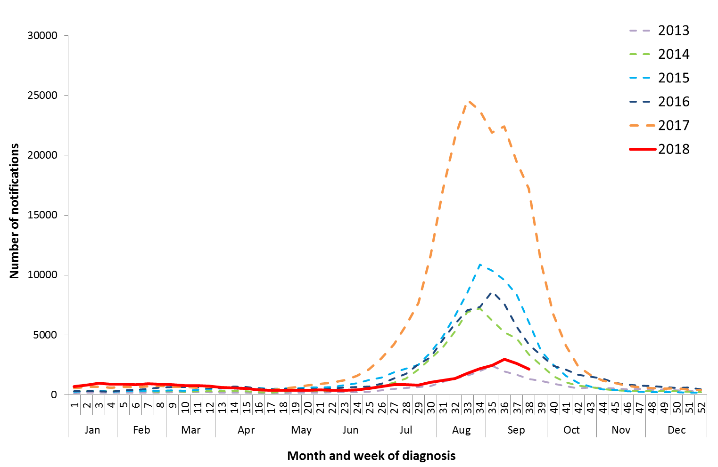

Source: NNDSS

Figure . Number of influenza hospitalisations at sentinel hospitals, between March and October, 2013 to 2018 by month and week.

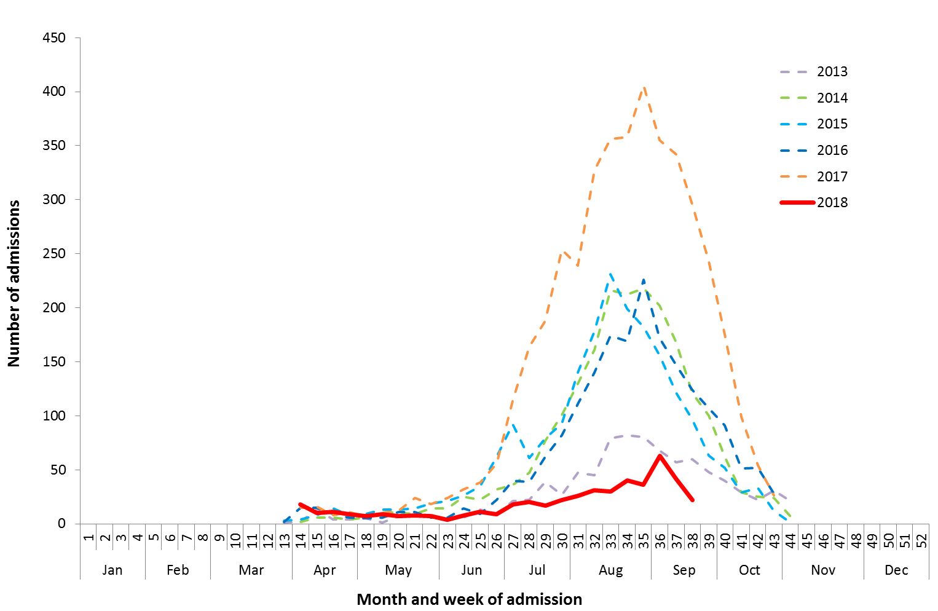

Source: FluCAN

#### Geographical distribution of activity

* **Jurisdictional reports**: In the fortnight ending 23 September 2018, the geographic spread of influenza activity was reported by state and territory health departments as being sporadic in both regions of Northern Territory (NT), Tasmania (TAS) and the Northwest region of Western Australia (WA). Activity was reported as being localised in the Australian Capital Territory (ACT), in the Southern and Tropical regions of QLD, and the Rural South region of WA. New South Wales (NSW), the Central region of Queensland (QLD), South Australia (SA) and Victoria reported regional levels of activity. Widespread levels of activity were reported in the Perth metro region of WA. There was no change in influenza activity compared to the previous fortnight in both regions of NT, and the Peth metro and Rural South regions of WA. An increase in activity was reported for ACT, SA, TAS, VIC and the Northwest region of WA. NSW and all regions of QLD reported a decreased in activity (Figure 7).
* **NNDSS**: Of the 4,765 notifications of influenza reported to the NNDSS in the last fortnight, 1,657 were from NSW, 1,225 from QLD, 904 from VIC, 461 from SA, 426 from WA, 47 from ACT, 33 from TAS and 12 from NT (Figure 8). Of the 36,305 notifications of influenza reported to the NNDSS this year to 23 September 2018, 13,067 from NSW, 10,196 were from QLD, 5,601 from VIC, 4,072 from WA, 2,620 from SA, 354 from ACT, 231 from TAS and 164 from the NT.

For further information regarding influenza activity at the jurisdictional level, please refer to the following State and Territory health surveillance reports:

* ACT: [Influenza report](http://health.act.gov.au/node/41) (http://health.act.gov.au/node/41)
* NSW: [Influenza Surveillance Report](http://www.health.nsw.gov.au/Infectious/Influenza/Pages/reports.aspx) (http://www.health.nsw.gov.au/Infectious/Influenza/Pages/reports.aspx)
* QLD: [Statewide Weekly Influenza Surveillance Report](https://www.health.qld.gov.au/clinical-practice/guidelines-procedures/diseases-infection/surveillance/reports/flu) (https://www.health.qld.gov.au/clinical-practice/guidelines-procedures/diseases-infection/surveillance/reports/flu)
* SA: [Weekly Epidemiological Summary](http://www.sahealth.sa.gov.au/wps/wcm/connect/public+content/sa+health+internet/about+us/health+statistics/surveillance+of+notifiable+conditions) (Influenza section) (http://www.sahealth.sa.gov.au/wps/wcm/connect/public+content/sa+health+internet/about+us/health+statistics/surveillance+of+notifiable+conditions)
* TAS: [fluTAS Reports](http://www.dhhs.tas.gov.au/publichealth/communicable_diseases_prevention_unit) (http://www.dhhs.tas.gov.au/publichealth/communicable_diseases_prevention_unit)
* VIC: [Influenza Surveillance Reports](https://www2.health.vic.gov.au/public-health/infectious-diseases/infectious-diseases-surveillance/seasonal-influenza-reports) (https://www2.health.vic.gov.au/public-health/infectious-diseases/infectious-diseases-surveillance/seasonal-influenza-reports)
* WA: [Virus WAtch](http://ww2.health.wa.gov.au/Articles/F_I/Infectious-disease-data/Virus-WAtch) (http://ww2.health.wa.gov.au/Articles/F_I/Infectious-disease-data/Virus-WAtch)

Figure . Map of influenza activity by state and territory, Australia, 18 June to 23 September 2018.

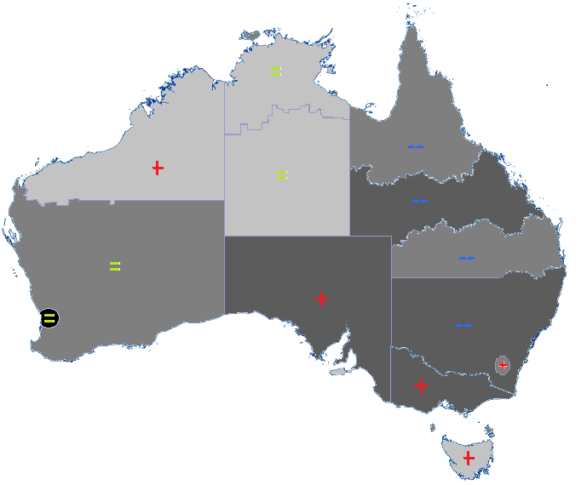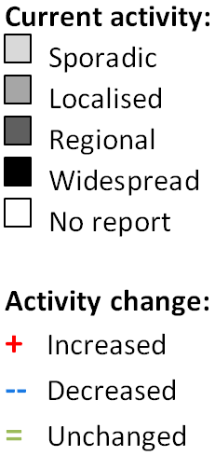

**Figure 8. Notifications of laboratory confirmed influenza, 1 January to 23 September 2018, by state or territory and week.**

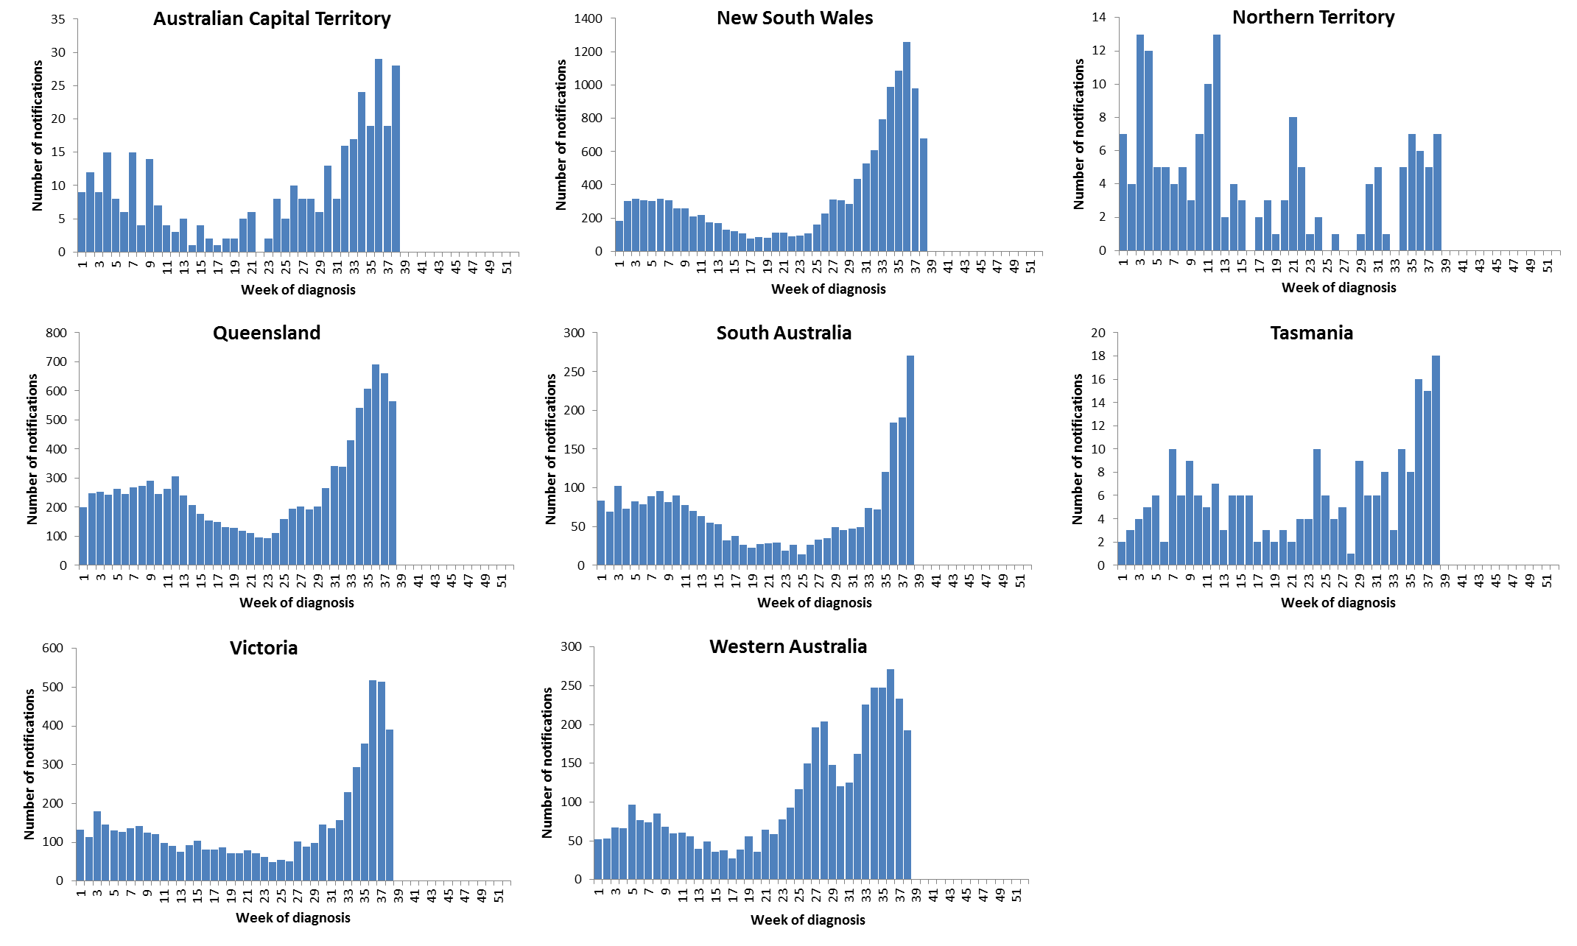

Source: NNDSS

### Severity

*Severity is a measure of adverse outcomes or complications as a result of influenza or influenza-like illness (ILI) such as hospital referrals, admissions, need for intensive care and deaths. Measuring and understanding the severity of circulating influenza is difficult to establish at the beginning of the influenza season. The proportion of confirmed influenza cases with serious outcomes might be skewed initially because there are only a small number of people notified with influenza at the beginning of the season. This means that the measure of severity will vary substantially fortnight to fortnight until after the peak of the season when there is enough data for measurements to stabilise. An assessment of severity be provided once the signals become clearer.*

The clinical severity of circulating influenza this fortnight is low.

#### Intensive care admissions

* **FluCAN**: This fortnight, 5 of the 64 people admitted to sentinel hospitals with confirmed influenza were admitted to ICU (7.8%). Since seasonal sentinel hospital surveillance began on 3 April 2018, 45 (9.3%) of the 485 people admitted to sentinel hospitals with confirmed influenza were admitted to ICU.

#### Deaths in confirmed influenza cases

* **NNDSS**: So far in 2018, 48 influenza associated deaths have been notified to the NNDSS. The majority of deaths were due to influenza A (71%, n=34). The median age of deaths notified was 80 years (range 1 to 100 years). The number of influenza-associated deaths reported to the NNDSS does not represent the true mortality associated with this disease. The number of deaths is reliant on the follow up of cases to determine the outcome of their infection. The follow up of cases is not a requirement of notification, and are only inclusive of laboratory-confirmed cases of influenza. Due to retrospective revision, the variation across jurisdictions in methodology, representativeness and timeliness of death data, and reporting of an outcome of infection not being a requirement of notification, year on year comparisons of deaths in notified cases of influenza may not be reliable.

### Impact

*Impact measures how the influenza epidemic affects society, including stress on health-care resources and societal and economic consequences.*

Currently the impact of circulating influenza on society and the healthcare system is low.

#### Absenteeism

* **Flutracking**: 1.2% and 0.9% of Flutracking survey respondents reported having ILI and taking time off regular duties while unwell in the weeks 37 and 38, respectively. This is a low level of impact when compared to trends in recent years.

#### Use of hospital beds

* **FluCAN:** Since seasonal sentinel hospital surveillance began on 3 April 2018, 7% of hospital beds available in FluCAN hospitals were occupied by patients with confirmed influenza. This is a low level of impact when compared to temporal trends.

### Virology

#### National notification data

* **NNDSS:** In the reporting fortnight, 88% of notifications of laboratory confirmed influenza to the NNDSS were influenza A (82% influenza A(unsubtyped), 5% influenza A(H1N1)pdm09 and 1% influenza A(H3N2)), 12% were influenza B, and less than 1% were influenza A&B co-infections or untyped. (Figure 9).
* **NNDSS:** For the year to 23 September 2018, 75% of notifications of laboratory confirmed influenza to the NNDSS were influenza A (65% influenza A(unsubtyped), 7% influenza A(H1N1)pdm09 and 3% influenza A(H3N2)), 25% were influenza B, and less than 1% were influenza C, influenza A&B co-infections or untyped. The proportion of all notifications year to date reported as influenza A has ranged across jurisdictions from 60% in the NT to 79% in NSW (Figure 10). Unlike other jurisdictions, NT has reported a greater proportion of influenza A (H3N2) than influenza A(H1N1)pdm09.

#### Reference Laboratory data

* **World Health Organization Collaborating Centre for Reference and Research on Influenza (WHOCC):** From 1 January to 24 September 2018, the WHOCC characterised 756 influenza viruses. Of these, 55% were influenza A(H1N1)pdm09, 24% were influenza A(H3N2), 19% were influenza B Yamagata lineage, 1% were influenza B Victoria lineage and 1% were influenza A(H1N1) and influenza A(H3N2) co-infections.

#### Sentinel laboratory surveillance

* In the reporting fortnight, 96% of influenza positive samples detected in sentinel laboratories were influenza A (54% were influenza A(unsubtyped), 37% influenza A(H1N1)pdm09, and 5% were influenza A(H3N2)) and 4% were influenza B (Figure 11).

#### Sentinel GP surveillance

* **ASPREN**: Of the 19 influenza positive samples detected this fortnight through swab testing patients presenting with ILI to ASPREN sentinel GPs, 10 were influenza A(unsubtyped), 5 were influenza A(H1N1)pdm09 and 4 were influenza B (Figure 12).

#### Sentinel hospital surveillance

* **FluCAN**: Since seasonal sentinel hospital surveillance began on 3 April 2018, 85% of confirmed influenza to sentinel hospitals were influenza A (58% A(unsubtyped), 26% influenza A(H1N1)pdm09 and 1% influenza A (H3N2)) and 15% were influenza B. (Figure 13). Of the 45 patients admitted directly to ICU, 87% were infected with influenza A (60% influenza A(unsubtyped) and 27% influenza A(H1N1)pdm09) and 13% were infected with influenza B.
* **FluCAN**: The proportion of patients admitted directly to ICU was higher in patients infected with influenza A(H1N1)pdm09 (9.5%), than in admitted patients infected with influenza A(H3N2) (0%) and influenza B (8.2%).

**Figure 9. Per cent of laboratory confirmed influenza, Australia, 1 January to 23 September 2018, by subtype and week.**

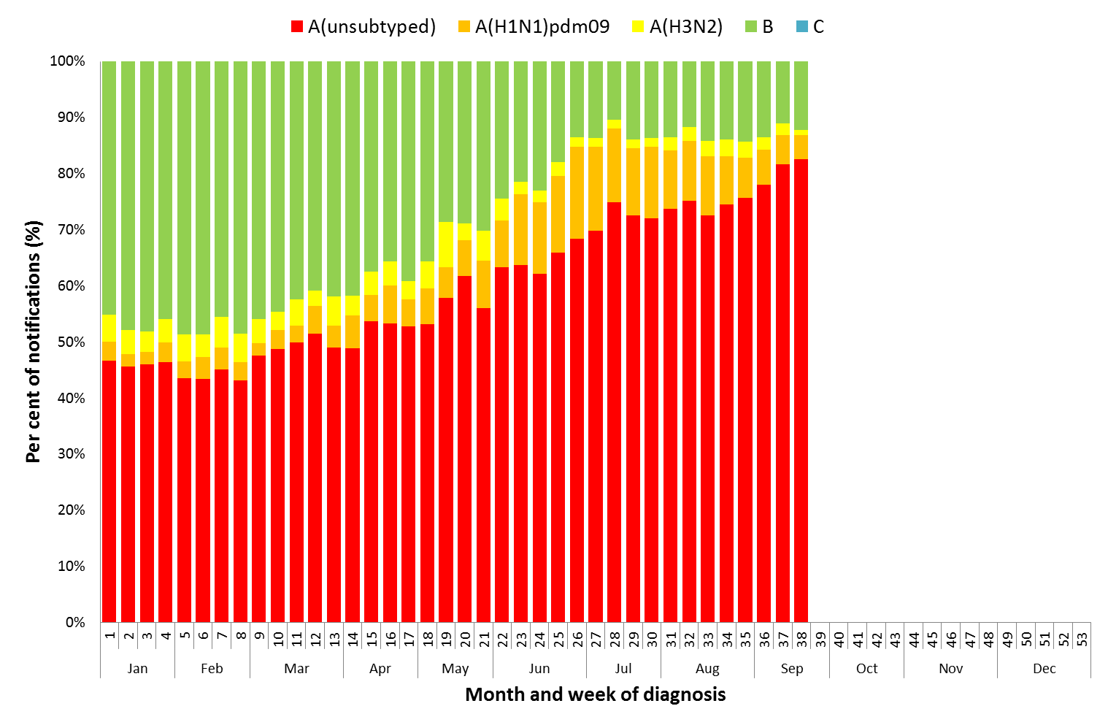

Source: NNDSS

Figure . Per cent of notifications of laboratory confirmed influenza, Australia, 1 January to 23 September 2018, by subtype and state or territory.

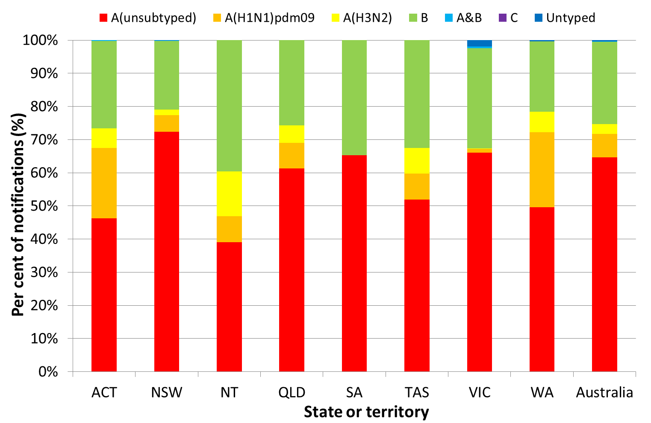

Source: NNDSS

Figure . Proportion of sentinel laboratory tests positive for influenza and total number of specimens tested, 1 January to 23 September 2018, by subtype and month and week.

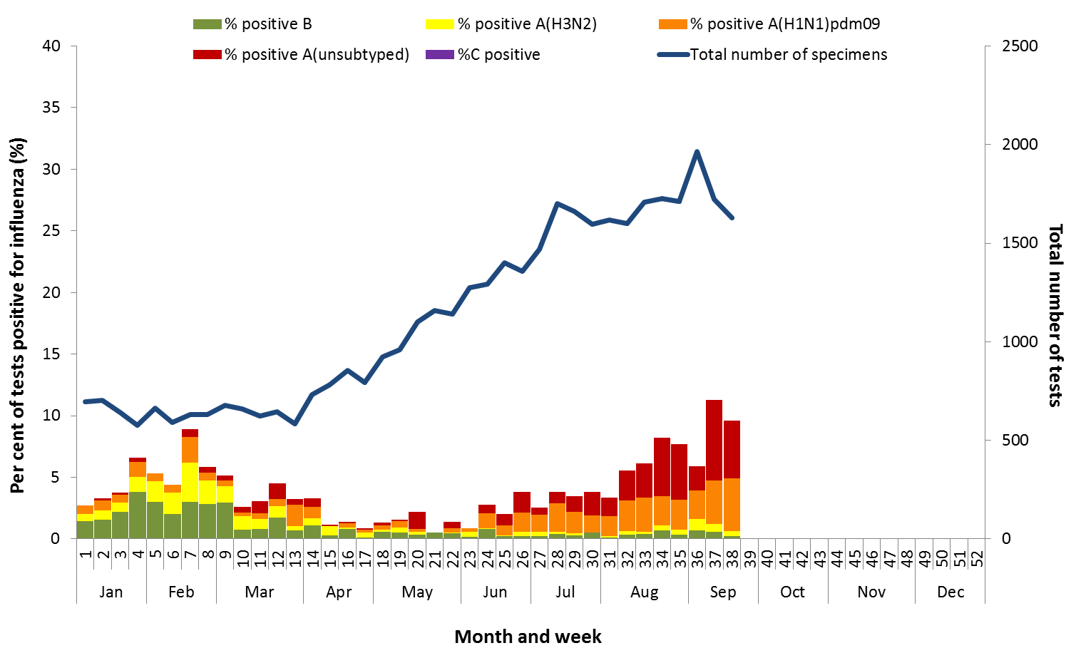

Figure . Proportion of respiratory viral tests positive for influenza in ASPREN ILI patients and ASPREN ILI consultation rate*, Australia, 1 January to 23 September 2018, by month and week.

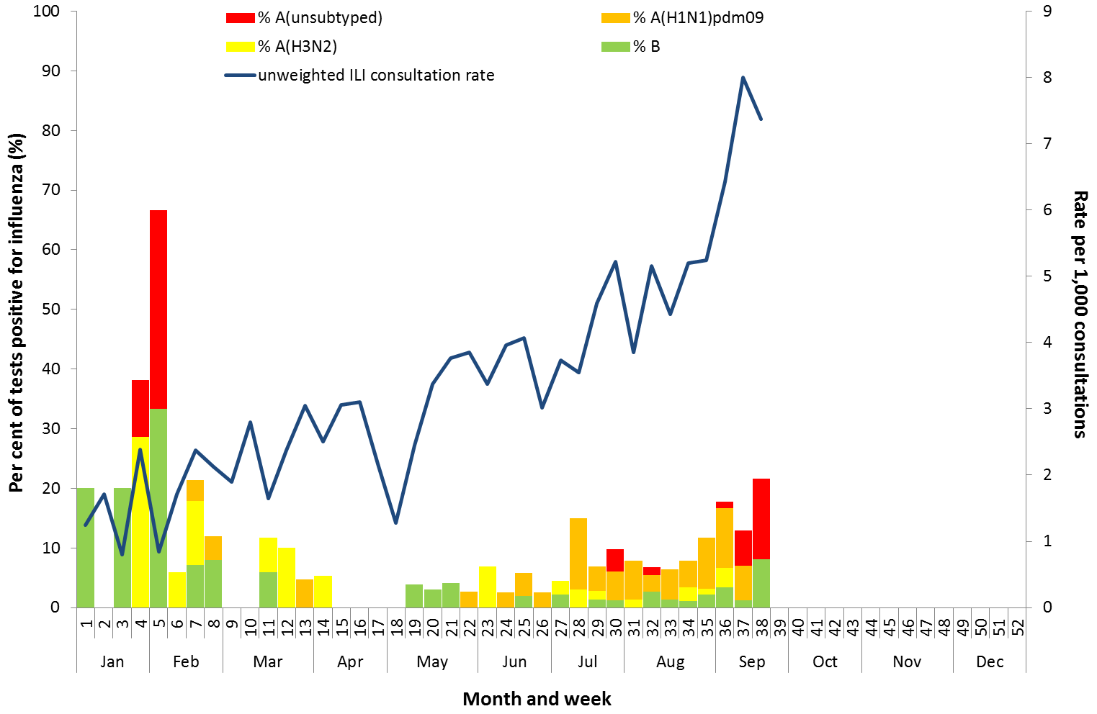

Source: ASPREN

Figure . Number of influenza hospitalisations at sentinel hospitals by subtype and ICU admission, 3 April to 23 September 2018, by month and week.

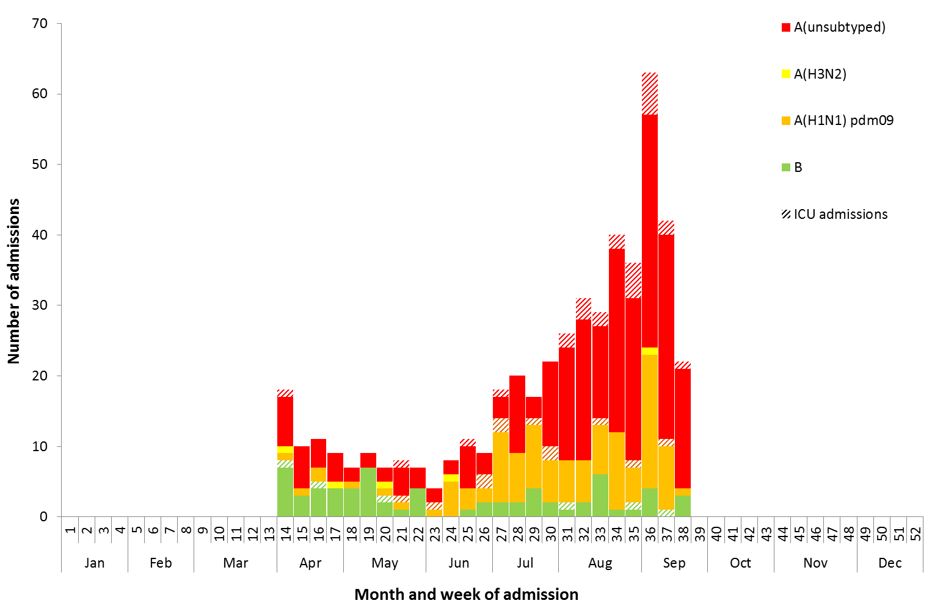

Source: FluCAN

### At-risk Populations

#### National notification data

* **NNDSS:** So far in 2018, notification rates have been highest in children aged under 10 years (288.4 notifications per 100,000), with a secondary smaller peak in adults aged 80 years or older (187.1 notifications per 100,000) (Figure 14). Where subtyping information is available, notifications of influenza A(H1N1)pdm09 were highest in children aged less than 10 years (27.0 per 100,000) and notifications of influenza A(H3N2) were highest in adults aged 80 years and older (16.4 per 100,000). Notification rates for influenza B were highest in adults aged 85 years and over (63.2 per 100,000), followed by children aged 5-9 (55.5 per 100,000).
* **NNDSS:** Where subtyping information was available, influenza A (H1N1)pdm09 was the predominant strain in all age groups except in adults aged 65 years and older, where influenza A(H3N2) accounted for a greater proportion of influenza A. (Figure 15).

#### Sentinel hospital surveillance

* **FluCAN:** Since seasonal sentinel hospital surveillance began on 3 April 2018, 37.6% of people admitted with confirmed influenza were children aged 15 years and younger, 38.4% were adults aged between 16 and 64 years, and 24% were adults aged 65 years and older. Of the children admitted with confirmed influenza to date, 9.3% were admitted to ICU. Similarly, 10.2% of adults aged between 16 and 64 years and 7.8% of adults aged 65 years and older were admitted to ICU.

Figure . Rate of notifications of laboratory confirmed influenza, Australia, 1 January to 23 September 2018, by age group and subtype.

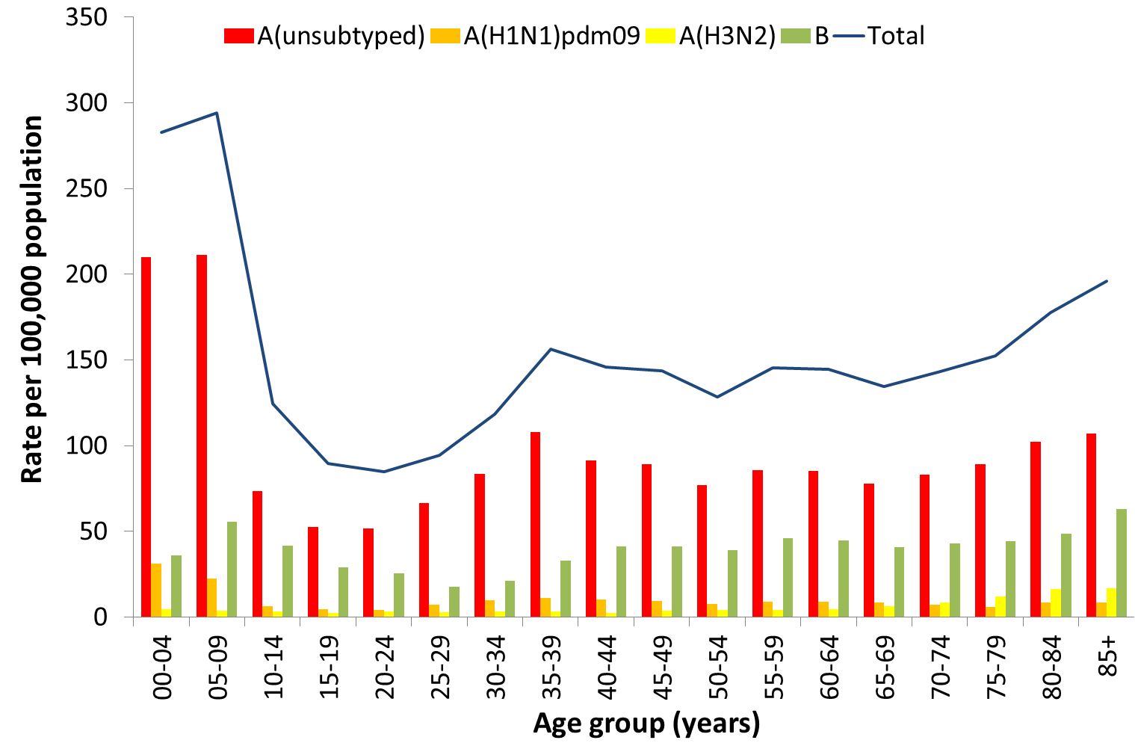

Source: NNDSS

Figure . Notifications of laboratory confirmed influenza by week of diagnosis and cumulative year-to-date, Australia, 1 January to 23 September 2018, by age group and subtype.

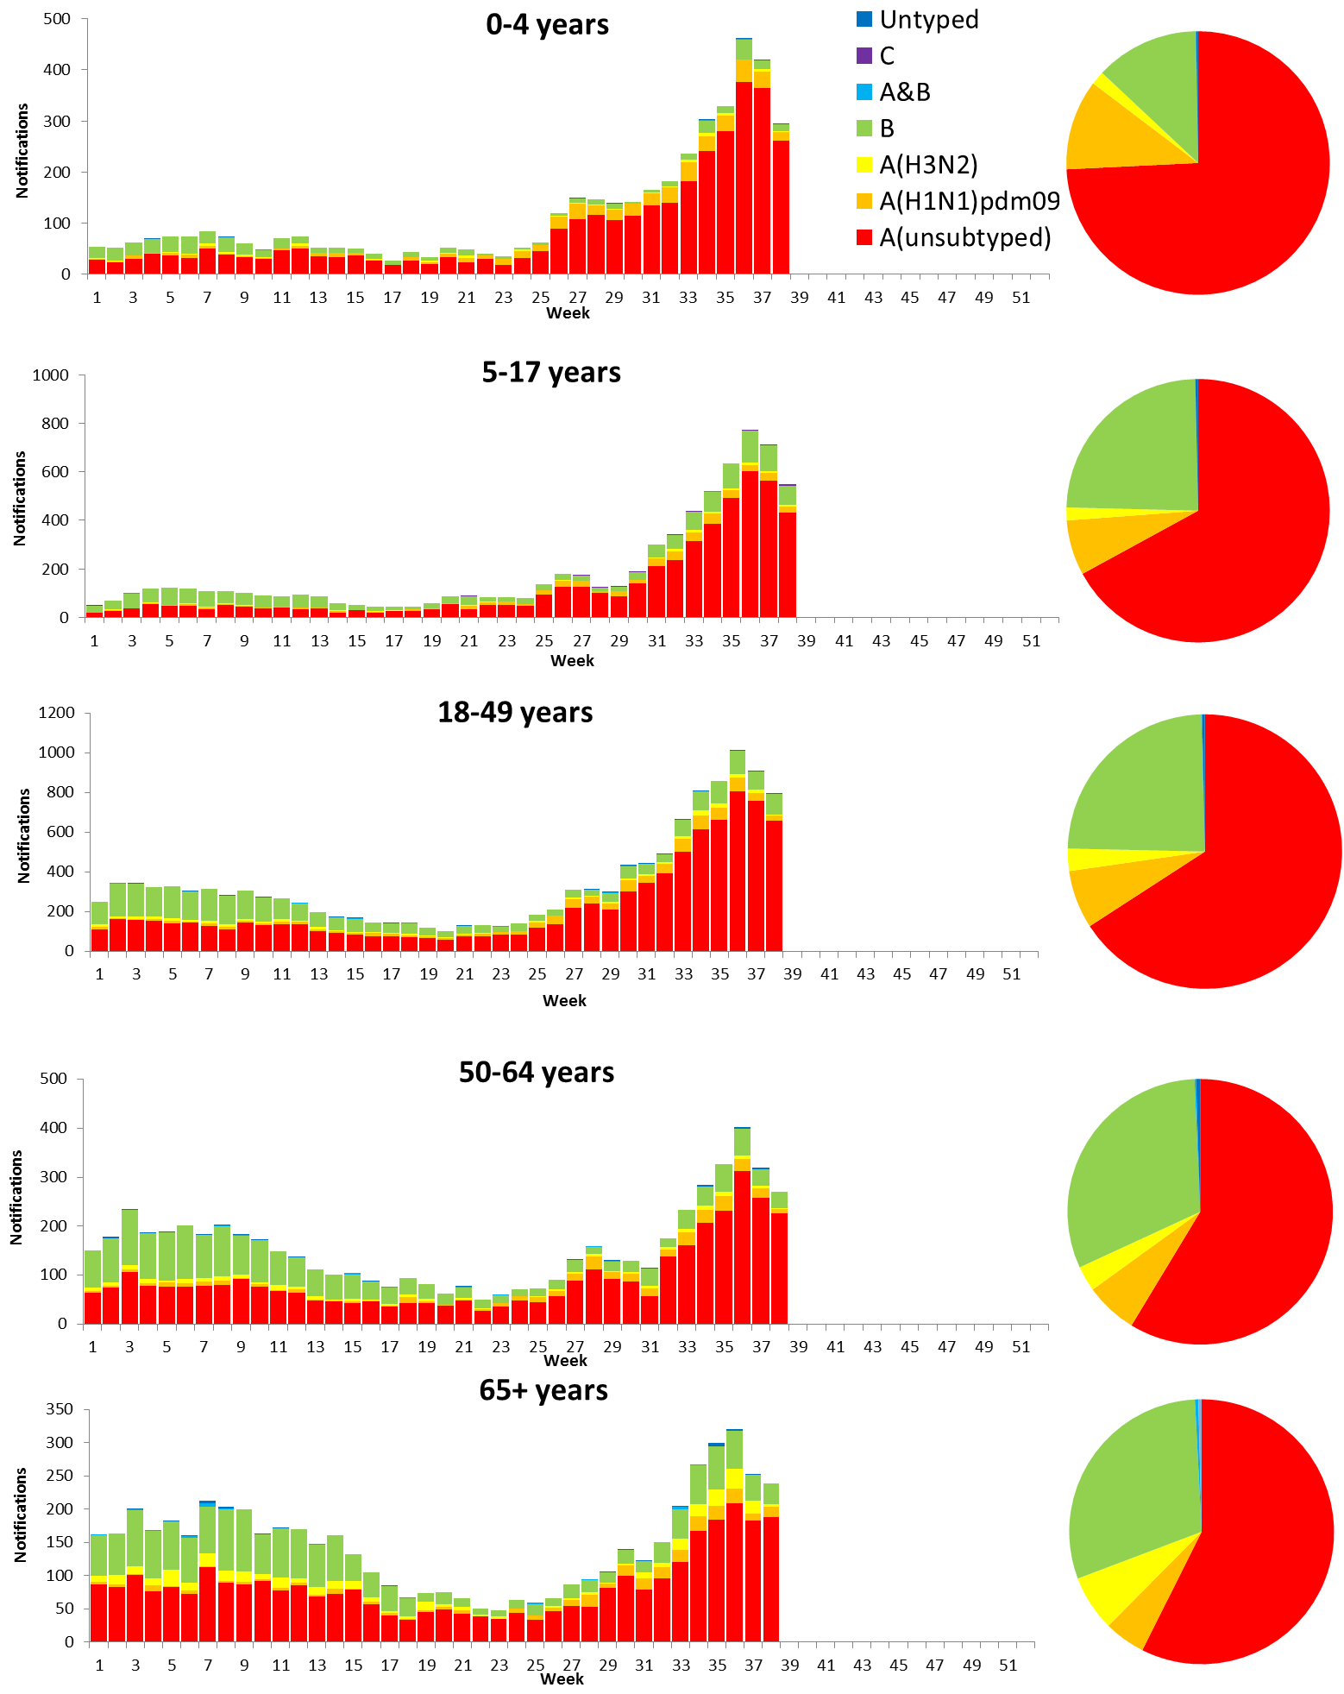

Source: NNDSS

### Vaccine effectiveness

#### Australian Influenza Vaccines Composition 2018

The influenza virus strains included in the 2018 seasonal influenza vaccines in Australia are:

* A/Michigan/45/2015, (H1N1)pdm09-like virus;
* A/Singapore/INFIMH-16-0019/2016, (H3N2)-like virus; and
* B/Phuket/3073/2013-like virus, Yamagata lineage.
* B/Brisbane/60/2008-like virus, Victoria lineage.

The best way to determine how well the vaccine protects against circulating viruses during the season is by determining the vaccine effectiveness. These estimates provide an indication of how effective the vaccine was in providing protection against influenza infection, but can only be determined towards the end of the influenza season.

WHOCC

From 1 January to 24 September 2018, 542 isolates were characterised for similarity to the corresponding vaccine components by haemagglutination inhibition (HI) assay (Table 1). Influenza A(H1N1)pdm09 viruses and viruses from both influenza B lineages appeared to be antigenically similar to the corresponding vaccine components. Two each of Influenza A(H1N1)pdm09 and influenza B(Yamagata), and no influenza B(Victoria) isolates were characterised as low reactors. The influenza A(H3N2) isolates that were able to be assessed by HI assay appeared to be reasonably matched, although there are ongoing technical issues that significantly limit the WHOCC’s capacity to fully assess the similarity of circulating viruses to the vaccine strain. Eight influenza A(H3N2) isolates were characterised as low reactors, and an additional 25 isolates were unable to be characterised in the HI assay due to insufficient haemagglutination titre.

**Table 1. Australian influenza viruses typed by HI from the WHOCC, 1 January to 24 September 2018.**

|  |  |  |  |  |  |  |  |  |  |
| --- | --- | --- | --- | --- | --- | --- | --- | --- | --- |
| **Type/Subtype** | **ACT** | **NSW** | **NT** | **QLD** | **SA** | **TAS** | **VIC** | **WA** | **TOTAL** |
| **A(H1N1) pdm09** | **14** | **133** | **2** | **95** | **9** | **0** | **4** | **39** | 296 |
| **A(H3N2)** | **4** | **45** | **3** | **45** | **7** | **0** | **1** | **4** | 109 |
| **B/Victoria lineage** | **0** | **2** | **1** | **2** | **0** | **0** | **0** | **0** | 5 |
| **B/Yamagata lineage** | **5** | **75** | **10** | **30** | **6** | **0** | **0** | **6** | 132 |
| Total | 23 | 255 | 16 | 172 | 22 | 0 | 5 | 49 | 542 |

SOURCE: WHO CC

Note: Viruses tested by the WHO CC are not necessarily a random sample of all those in the community.

State indicates the residential location for the individual tested, not the submitting laboratory.

There may be up to a month delay on reporting of samples.

### Antiviral Resistance

The WHOCC reported that from 1 January to 24 September 2018, none of the 304 influenza viruses tested for neuraminidase inhibitor resistance, demonstrated reduced inhibition to the antiviral drugs Zanamivir or Oseltamivir.

### Data considerations

No one single system, including notification data, provides the full picture on influenza, because influenza is a common disease and its presenting symptoms are non-specific. The epidemiology of influenza is informed by a number of different systems based in the community, laboratories, primary care and hospitals, as well as official deaths and notifiable diseases data. The information in this report is reliant on the surveillance sources available to the Department of Health at the time of production.

Data in this summary is reported by International Organization for Standardization (ISO) 8601 weeks, with the week ending on Sunday. Throughout the summary, where the year to date is presented, this includes data from 1 January to 23 September 2018. NNDSS data were extracted on 26 September 2018. Due to the dynamic nature of the NNDSS and other surveillance systems, data in this report are subject to retrospective revision and may vary from data reported in other national reports and reports by states and territories. Detailed notes on interpreting the data presented in this report are available at the Department of Health’s [Australian Influenza Surveillance Report website](http://www.health.gov.au/flureport) (www.health.gov.au/flureport).

While every care has been taken in preparing this report, the Commonwealth does not accept liability for any injury or loss or damage arising from the use of, or reliance upon, the content of the report. Delays in the reporting of data may cause data to change retrospectively. For further details about information contained in this report please contact the [Influenza Surveillance Team](mailto:flu@health.gov.au) (flu@health.gov.au).