1.Write a simple "Hello World" program in two different programming languages of
your choice. Compare the structure and syntax.
Ans:
C Code:
#include<stdio.h>
#include<conio.h>
void main(){
printf("Hello World");
}
Python Code:
print("Hello World");

2.Explain in your own words what a program is and how it functions.
Ans:
Program Is A Set Of Instruction To Perform Specific Task.

3.What is Programming?
Ans:
Programming It Means To Write Code And Do Something;

4.What are the key steps involved in the programming process?
Ans:
Get Defination
Requirement Gathering
Design
Implemantation

5.Types of Programming Languages
Ans:
There Are Two Types Of Programming Languages:
- Procedural Programming Language
- Functional Programming Language
- Object-Oriented Programming Language
- Scripting programming Language
- Logic Programming

6.What are the main differences between high-level and low-level programming
languages?
Ans:
- High-Level:-in this human understandable form of writing,reading.
- Low-Level:-in this in computer readble for only in (0 and 1’s)

7.World Wide Web & How Internet Works
Ans:
World Wide Web is a collection of websites
A server which stores websites and give response as per user requirement, User Can request in internet for something and server returns as per the user’s request

8.Research and create a diagram of how data is transmitted from a client to a server
over the internet.
Ans:
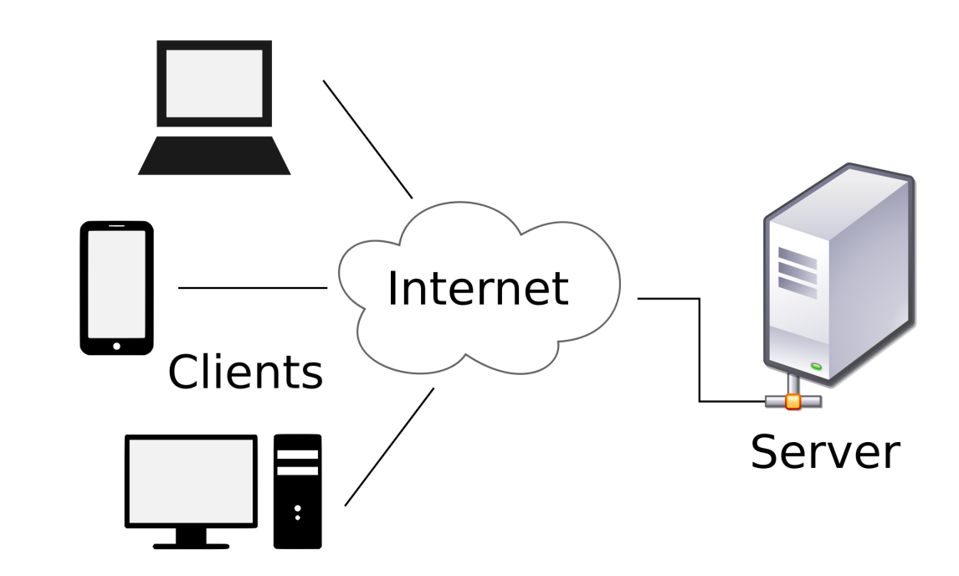

9.Describe the roles of the client and server in web communication
Ans:
Client can request to server for something
Server respond to as per client’s request

10.Network Layers on Client and Server
Ans:
Network Layer Client Side:Routing Using IP Address
Network Layer Server Side:reads IP address

11.Design a simple HTTP client-server communication in any language.
Ans:

- Explain the function of the TCP/IP model and its layers.
Ans:
TCP/IP:Transmission Control Protocol Reliable Data Transfer

13.Client and Servers
Ans:

14.Explain Client Server Communication
Ans:
Client Sends Request To server And Get Response From Server As Per The Request

15.Types of Internet Connections
Ans:
Wired Internet
Wirless Internet

16.Research different types of internet connections (e.g., broadband, fiber, satellite)
and list their pros and cons.
Ans:
Broadband Internet:Fast,
Fiber Optic Internet:Highly reliable and stable
Satellite:Available almost everywhere

17.How does broadband differ from fiber-optic internet?
Ans:
Broad band Speed is 10Mbps to 200Mbps
Fiber Speed is 100Mbps to 10Gbps

18.Protocols
Ans:
Potocols It Means Set Of Rules

19.Simulate HTTP and FTP requests using command line tools (e.g., curl)
Ans:
HTTP:Hyper Text Transfer Protocol
FTP:File Transfer Protocol

20.What are the differences between HTTP and HTTPS protocols?
Ans:
HTTP:Hyper Text Transfer Protocol Is Not Secure
HTTPS:Hyper Text Transfer Protocol Is Secure

21.Application Security
Ans:
Application Security It Means Securing Application From Cyber Attacks

22.Identify and explain three common application security vulnerabilities. Suggest
possible solutions.
Ans:
Check The Cradantials
Check Login ID And Password Are Authentiacte Or Not

23.What is the role of encryption in securing applications?
Ans:
Encryption It Means Encrypting data it means change original text into some other format
Techniques of encryption is ceaser cipher

24.Software Applications and Its Types
Ans:
System Software
Application Software
General Purpose Application Software
Custom Software

25.Identify and classify 5 applications you use daily as either system software or
application software.
Ans:
Visual Studio Code
Whatsapp
Instagram
Snapchat
Microsoft Word
Microsoft Excel

26.What is the difference between system software and application software?
Ans:
System Software It Means Default Downloaded In Our System
Application Software It Means We Can Download it from either play store or app store

27.Software Architecture
Ans:
Software Architecture is Blue print of building software

28.Design a basic three-tiersoftware architecture diagram for a web application.
Ans:

29.What is the significance of modularity in software architecture?
Ans:
- Presntation Layer:-What We View On Screen
- Application Layer:-Handles Main Programs
- Buisneess Layer:-Actual Logic Of Application
- Persistance Layer:-Data Access Layer
- Database Layer:-System Stores All Data

30.Layers in Software Architecture
Ans:
- Presntation Layer
- Application Layer
- Buisneess Layer
- Persistance Layer
- Database Layer

31.Create a case study on the functionality of the presentation, business logic, and data
access layers of a given software system.
Ans:
Presntation Layer:Displays Data
Buisneess Layer:Logic of application
Database Layer:Stores Data

32.Why are layers important in software architecture?
Ans:
Layers Are Important in Software Architecture to divede all things in saperate parts.

33.Software Environments
Ans:
Staging Environment
Production Environment
This Environment shows Where Our Software is Running Now

34.Explore different types of software environments (development, testing, production).
Set up a basic environment in a virtual machine.
Ans:

35.Explain the importance of a development environment in software production.
Ans:
In Deployment Environment all things get make sure that code is running properly, test the software.

36.Source Code
Ans:
Code Of Software

37.Write and upload your first source code file to Github.
Ans:
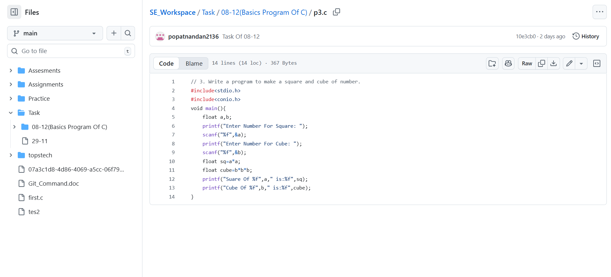
38.What is the difference between source code and machine code?
Ans:
Source Code Is Written By Programmer
Machine Code Is Written By Computer For Example .class File in java

39.Github and Introductions
Ans:
Github Is Used For Storing,Sharing and managing code between multiple programers who working on same Project

40.Create a Github repository and document how to commit and push code changes
Ans:
Done Created
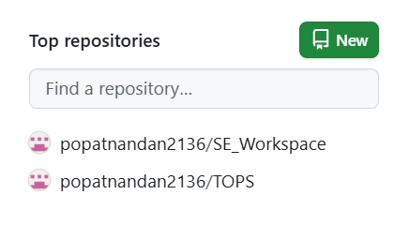

41.Why is version control important in software development?
Ans:
Version Control Is Impotant Beacause Provide New User Expireiance

42.Student Account in Github
Ans:
Done

43.Create a student account on Github and collaborate on a small project with a
classmate.
Ans:
Done

44.What are the benefits of using Github for students?
Ans:
Easy To Share Code And in Group Project Easy To Work as Group

45.Types of Software
Ans:
System Software
Application Software

46.Create a list of software you use regularly and classify them into the following
categories: system, application, and utility software
Ans:
System Software:Windows,Android OS,Mac OS,IOS
Application Software:Visual Studio Code,Whatsapp,Instagram

47.What are the differences between open-source and proprietary software?
Ans:
Open Source Software are available free for use
Proprietary Software are which created by any company for their company use

48.GIT and GITHUB Training
Ans:
Done

49.Follow a GIT tutorial to practice cloning, branching, and merging repositories.
Ans:
Done

50.How does GIT improve collaboration in a software development team?
Ans:
GIT improve collaboration in a software development team By Allowing Team To Share Code With Whole Team

51.Application Software
Ans:
Visual Studio Code
Whatsapp
Instagram
Snapchat
Microsoft Word
Microsoft Excel

52.Write a report on the various types of application software and how they improve
productivity.
Ans:
Word:-by providing effactive tamplates

53.: What is the role of application software in businesses?
Ans:
To make buisness easier

54.Software Development Process
Ans:

- Prasentaion
- Application
- Buisness
- Persistence
- Database

55.Create a flowchart representing the Software Development Life Cycle (SDLC).
Ans:
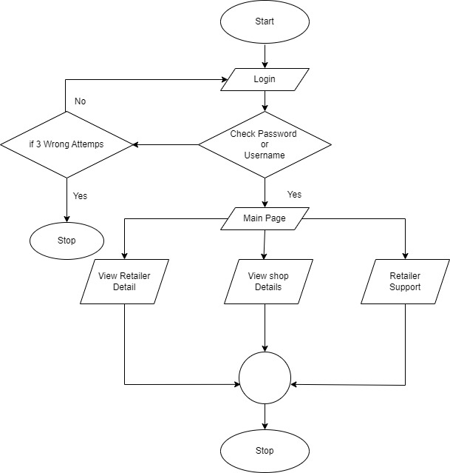
56.What are the main stages of the software development process?
Ans:
- Requirement Analysis
- System Design
- Implementation (Coding)
- Testing
- Deployment
- Maintenance

57.Software Requirement
Ans:
In Software Requirement what are features we have to get in Our App

58.Write a requirement specification for a simple library managementsystem.
Ans:
Librarian:
Add new book as availabel
View available books
Student:
Get Book
View Book List

59.Why is the requirement analysis phase critical in software development?
Ans:
Because We Have Must Know That What We Have To Add In Our Software In Future

60.Software Analysis
Ans:
In This We Have To Analysis Software What are Specification Added.

61.Perform a functional analysis for an online shopping system.
Ans:
User Type:
- Customer/Buyer
- Admin
User Management
Payment Handling

61.: What is the role of software analysis in the development process?
Ans:
Understand User Requirements
Define Functional and Non-Functional Requirements
Reduce Development Errors

62.System Design
Ans:
Designing System

63.Design a basic system architecture for a food delivery app.
Ans:
Mobile/App
Application Layer:
Authentication

Database Layer:
Users
Resturent

External Services:
Payment Gateway

64.What are the key elements of system design?
Ans:

- Data Design
- Interfaace Design
- Module Design
- Security Design
- Performance Design

65.Software Testing
Ans:
Test The Software In All Ways And Then Deploy It

66.Develop test cases for a simple calculator program.
Ans:
Calculator Test Case:
Check All Buttons Working Properly Or Not
Then Check All Operations

67.Why is software testing important?
Ans:
Software Testing Is Important Because To Check Software Is Running Properly Or Not

68.Maintenance
Ans:
After Deployment Get Updates In Application That Cost Called As Maintenance

69.Document a real-world case where a software application required critical
maintenance.
Ans:
Server Cost Is Called As Maintenance
- Corrective Maintenance
- Adaptive Maintenance
- Perfective Maintenance

70.What types of software maintenance are there?
Ans:
- Corrective Maintenance
- Adaptive Maintenance
- Perfective Maintenance

71.Development
Ans:
Deploying Product

72.What are the key differences between web and desktop applications?
Ans:
Web It Means Live On Browser Directly
Web App Means We Can Install It In Our Desktop Or PC Web App With .exe Format

73.Web Application
Ans:
Web Application Example is Social Media Apps In Desktop Or PC

74.What are the advantages of using web applications over desktop applications?
Ans:
Web app run in browser

75.Designing
Ans:
Designing It Means That We Can Design

76.: Whatrole does UI/UX design play in application development?
Ans:
Predifne Design Idea It Mans How Application or Website is Look Like After Proper Development

77.Mobile Application
Ans:
Instagram
Whatsapp
Snapchat

78.What are the differences between native and hybrid mobile apps?
Ans:
Native Apps:- Created Only For Specific OS For Example Android Or IOS
Hybrid Apps:- Are Created For All OS In One Technology

79.DFD (Data Flow Diagram)
Ans:
DFD (Data Flow Diagram) Shows The Flow Of Diagram

80.Create a DFD for a hospital managementsystem.
Ans:
Created For Money Transfer
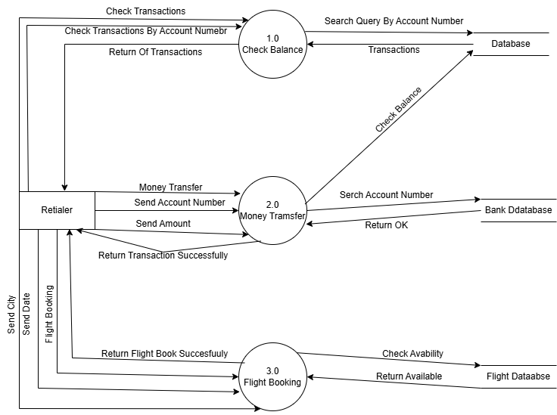

81.What is the significance of DFDs in system analysis?
Ans:
It Shows The Flow Of a System Of System Will Work

82.Desktop Application
Ans:
- Microsoft Word
- Excel
- Visual Studio Code
- Any ERP System
- VLC Media Player

83.Build a simple desktop calculator application using a GUI library.
Ans:

84.What are the pros and cons of desktop applications compared to web
applications?
Ans:
Desktop Application We Can Easily run in our Desktop Or PC
And Is Difficult To Update It And It Occupy Memory Locally In Our Storage

85.Flow Chart
Ans:
Shows Flow Of System

86.Draw a flowchart representing the logic of a basic online registration system.
Ans:
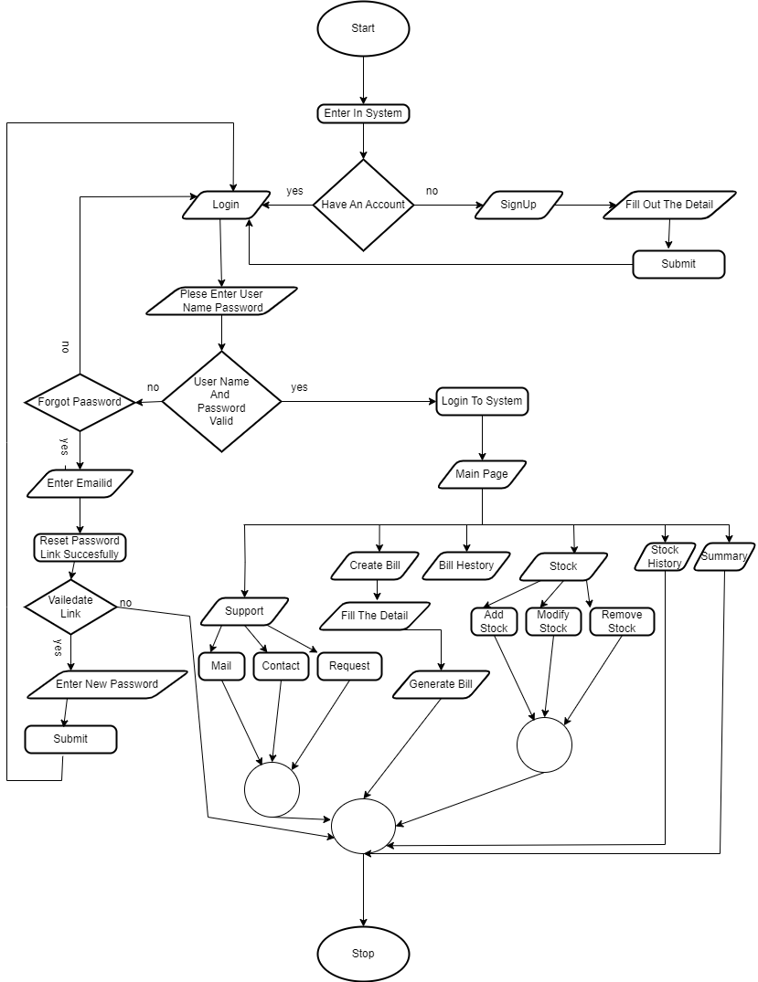

87. How do flowcharts help in programming and system design?
Ans:
It Help By Providing Conditions How Conditions Are Work

